UserManual

Prerequisites:
- This framework supports Struts 1.2/1.3 and JUnit 3.8.1
Steps To integrate:
- Copy the following jar files to your class path:
- strutstest-2.1.3.jar
- strutsTestFramework.jar (This is the framework jar which includes the struts test case framework code.)
- slf4j-jcl-1.5.2
- slf4j-api-1.5.2
- dbunit-2.4.8
- JUnit 3.8.1
- Extend the test case from StrutsTestAutomationBase.java
- Override the setup and teardown method if required.
- This framework expects a property file named- “strutsTestPaths.properties”, which contains all the paths for the data file, report file etc. All the properties of this file are described below:
- data.file.path: Specify the name of the CSV data file with absolute path.
- detailed.report.file.dir: Specify the name of the file with absolute path in which you want the detailed report.
- summary.report.file.dir: Specify the name of the file with absolute path in which you want the summary report.
- login.testcase.name: name of the login test case.
- login.testcaseClass.name: fully qualified name of the login test case class.
- logout.testcase.name: name of the logout test case.
- logout.testcaseClass.name: fully qualified name of the logout test case class.
- init.testcase.name: name of the intialization test case, which is responsible for setting up the environment for the test cases.
- init.testcaseclass.name: fully qualified name of the class of the initialized test case.
- install.properties.file.path : location of the install.properties file.
- truncate.tables.file.path:This file contains the cleaning scripts. Currently, this feature is not implemented .
- expecteddataset.dir.path: name of the directory where we store expected datasets.
- actualDataset.sql.dir.path: name of the directory where we store files containing sql statements to fetch actual datasets.

Below is the sample of the strutsTestPaths.properties file:

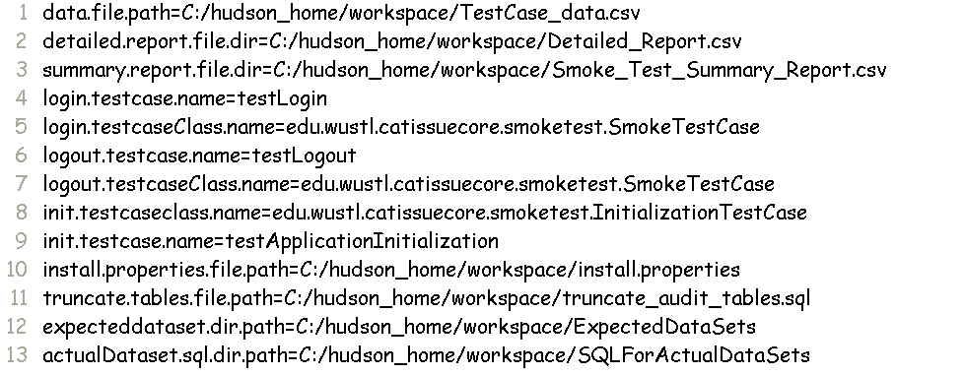

- This framework accepts input through comma separated file. All the attributes of comma separated file are described below:

- TMT_TestId: identifier of the test case in Task Management Tool.
- TestCaseName: name of the test case to be executed.
- TestCaseClassName: name of the file containing the test case.
- UserName: caTissue username to login into caTissue Application.
- Password:Password of the user.
- Values: values to be used by the test case. To pass multiple values for a test case use “|” as delimiter.
- ExpectedDataSet: name of the expected dataset xml file.
- SQLForActualDataSet: name of the file containing sql statements to fetch actual dataset.

Below is the sample of Test_data.csv file:

