Collection Protocol Edit

Version: caTissue 1.1

This program adds child specimen requirements in the given CP as well as updates parent specimens with given details in excel file. If given event does not exist in CP then it will create new events too.

Structure of the Events would be like this:

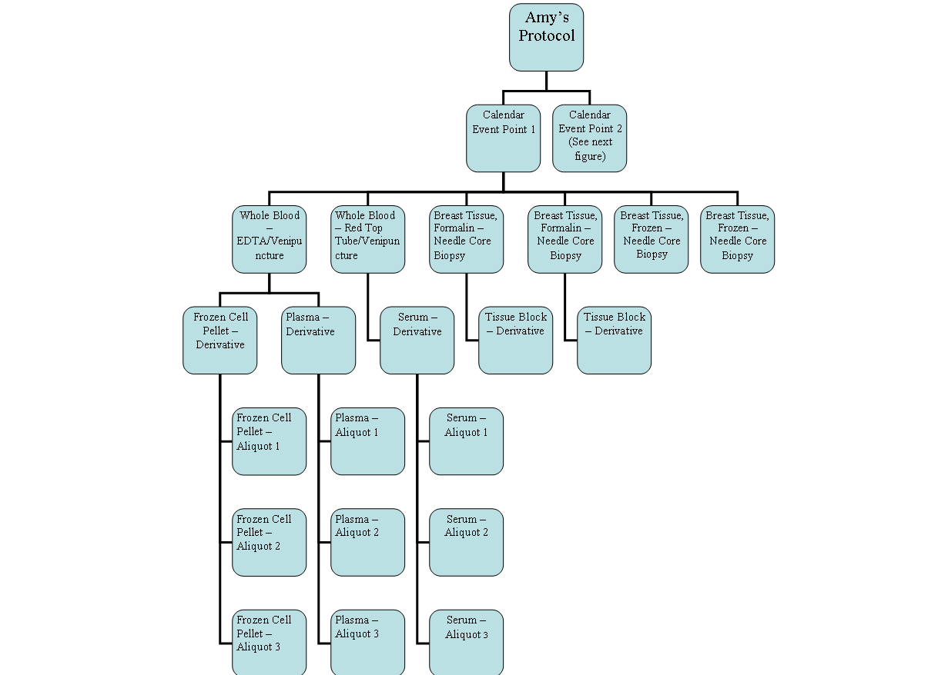

Input: Excel sheet having format:

Cp short title : Short Title of the CP , which is being edited.
Study calendar event point: event point of the event of the CP which needs to be edited.
Days: days of the event of the CP which needs to be edited.
Sequence: current sequence of parents specimen requirements. This could be blank as it is not used in program.
Parent Specimen: Parent Specimen Name. This is not label.
Parent Storage: updates parent specimen requirement with given storage type.
Old Parent Specimen Class: Class of the specimen requirement which needs to be updated.
Parent Specimen Class: New class of the specimen requirement.
Old Parent Specimen Type: Type of the specimen requirement which needs to be updated.
Parent Specimen Type: New Type of the specimen requirement.
Parent Specimen Site: Parent specimen requirement will be updated with the given site.
Pathological Status: Parent specimen requirement will be updated with the given Pathological Status.
Specimen Label example: Just an example. This is not used in program so this field could be blank.
Collection Details: Format for this field is Collection Procedure, Collection Event Container. If Collection Even Container is not given then default is set to Not Specified.
Derivative #: This is number of derivative.
Derivative Parent #: Parent of derivative.
Derivative Label Example: label of Derivative.
Derivative class: Class of the derivative specimen requirement.
Derivative Type: Type of the derivative specimen requirement.
Derivative Storage: Storage type of that derivative specimen requirement.
Aliquot #: Total number of aliquot specimen requirements of that derivative.
Parent # (Derivative): Parent of the aliquots .Which should be a derivative.
Aliquot Label Example: label of aliquots.
Aliquot count: Total quantity of aliquot specimen requirements. This should be multiplication of each Aliquot qty * Aliquot #:.
Aliquot qty: Each aliquot quantity.
Aliquot storage: Storage type of that aliquot specimen requirement

Output: To check its output on UI:
- Go to Administrtive tab
- Go to edit Collection Protocol
- Type short title of Collection Protocol
- Press Submit

ShiftSpecimenInSCG

This program updates specimen collection group in specimens.

Version: caTissueV1.1

Input: Excel sheet having format:

Protocol Title: CP short title to which specimen collection group belongs.
Participant Protocol Identifier: PPI to which specimen collection group belongs.
Participant Last Name: Last Name of participant to which specimen collection group belongs
Participant First Name: First Name of participant to which specimen collection group belongs
Study Calendar Event Point: This is of the current SCG of the specimen, which is to be shifted.
Specimen Collection Group Identifier: identifier of the current SCG of the specimen, which is to be shifted.
Collection Point Label: of the current SCG of the specimen which is to be shifted.
Identifier: Identifier of the specimen which is to be shifted.
Parent Specimen Identifier: This could be blank as it is not used in the code.
Label: Label of the specimen which is to be shifted.
Class: Class of the Specimen which is to be shifted.
Type: Type of the Specimen which is to be shifted.
Created On: Created on date of the specimen which is to be shifted.
Correct SCG: SCG name in which specimens need to be shifted.

If Correct SCG is not present for the given Participant then it will create it first and then It will move specimen in it.

Output: To check its output on UI:
- Go to Biospecimen tab
- Select Collection protocol given in the excel
- Select Participant as given the excel
- Check in SCG tree whether specimens are transferred to this SCG or not

SiteAssociation

This program associates given sites with given users and given collection protocols.

Version: caTissueV1.1

Input: Excel sheet having format:

Login Name: User: User to whom site will be associated.
Site: Site which is to be associated.
CP: Short Title: CP which is to be associated with site.

Output: To check its output on UI:
- Go to Adiminstartive tab
- Search User given in the excel
3 ) Check if site has associated with this user or not.

.

AddAnticipatedSCGInParticipant

This program creates anticipated Specimen Collection Group for already registered participants in the given CPs before adding new events.

Version: pCaTissueVp2.4

Input: Excel sheet having format:

Cp short title: Short title of the Collection Protocol.

Output: To check its output on UI:
- Go to Biospecimen tab
2) Select Collection protocol given in the excel
- Select each Participant and check whether all the events are created or not

Data Migration

Java file : DebounDataMigration.java

It registers participants to the given Collection Protocol, collects SCG and specimen, and
Collects and Creates aliquots of derivative specimen.

Input: Excel sheet having format:

Collection Protocol: CP short title
Participant Protocol Identifier: PPI of the Participant to be created.
Participant Last Name: Last name of Participant.
Participant First Name: First name of participant.
Participant Middle Name: Middle name of Participant
Date of Birth: Date of Birth of Participant.
Date Specimen Collected: Specimen’s created on date.
Procedure: Collection Procedure of events.
Container: Collection Container of events.
Collection site (institution): Site of collection

Study Calendar Event Point: Study Calendar Event Point /label of SCG.
Specimen Label: label of the derivative specimen.
Class: Class of the derivative specimen.
Type: Type of the derivative specimen.
Tissue Site: site for the specimen characteristics.
Pathological Status: Pathological Status of derivative specimen.
Initial Quantity: Derivative initial quantity
# of Cry vials (aliquots): Number of child aliquots to be created from derivative specimen.
Storage Container: container for aliquots.

Output: To check its output on UI:
1) Go to Biospecimen tab
2) Select Collection protocol given in the excel
3)slelect each Participant and check whether event and specimens are collected or not

