Introduction

caTissue/C3PR integration works in bi-directional fashion:
- Registrations (and changes to them) created in C3PR will also appear in caTissue,
- CPRs (and changes to them) created in caTissue will also appear in C3PR.

For a number of reasons, #1 and #2 differ in implementation and error handling; details are provided below.

C3PR-to-caTissue

Whenever a subject or a registration is created or updated in C3PR, it is transferred to caTissue and placed into an internal processing queue. The queue is processed in asynchronous fashion. If the queue contains an item that cannot be processed due to an error, the entire queue is blocked until caTissue user either removes the item or eliminates the error condition.

List of potential errors that can occur when a registration from C3PR is transferred to caTissue:
- Participant matching routine detected potential participant duplicates,
- Unable to find a site that corresponds to C3PR organization with the given CTEP code,
- Unable to find a collection protocol that corresponds to C3PR study with the given identifier,
- Participant has a non-MRN type of identifier that is not supported in caTissue,

caTissue user can review errors using Clinical Data Review screen:
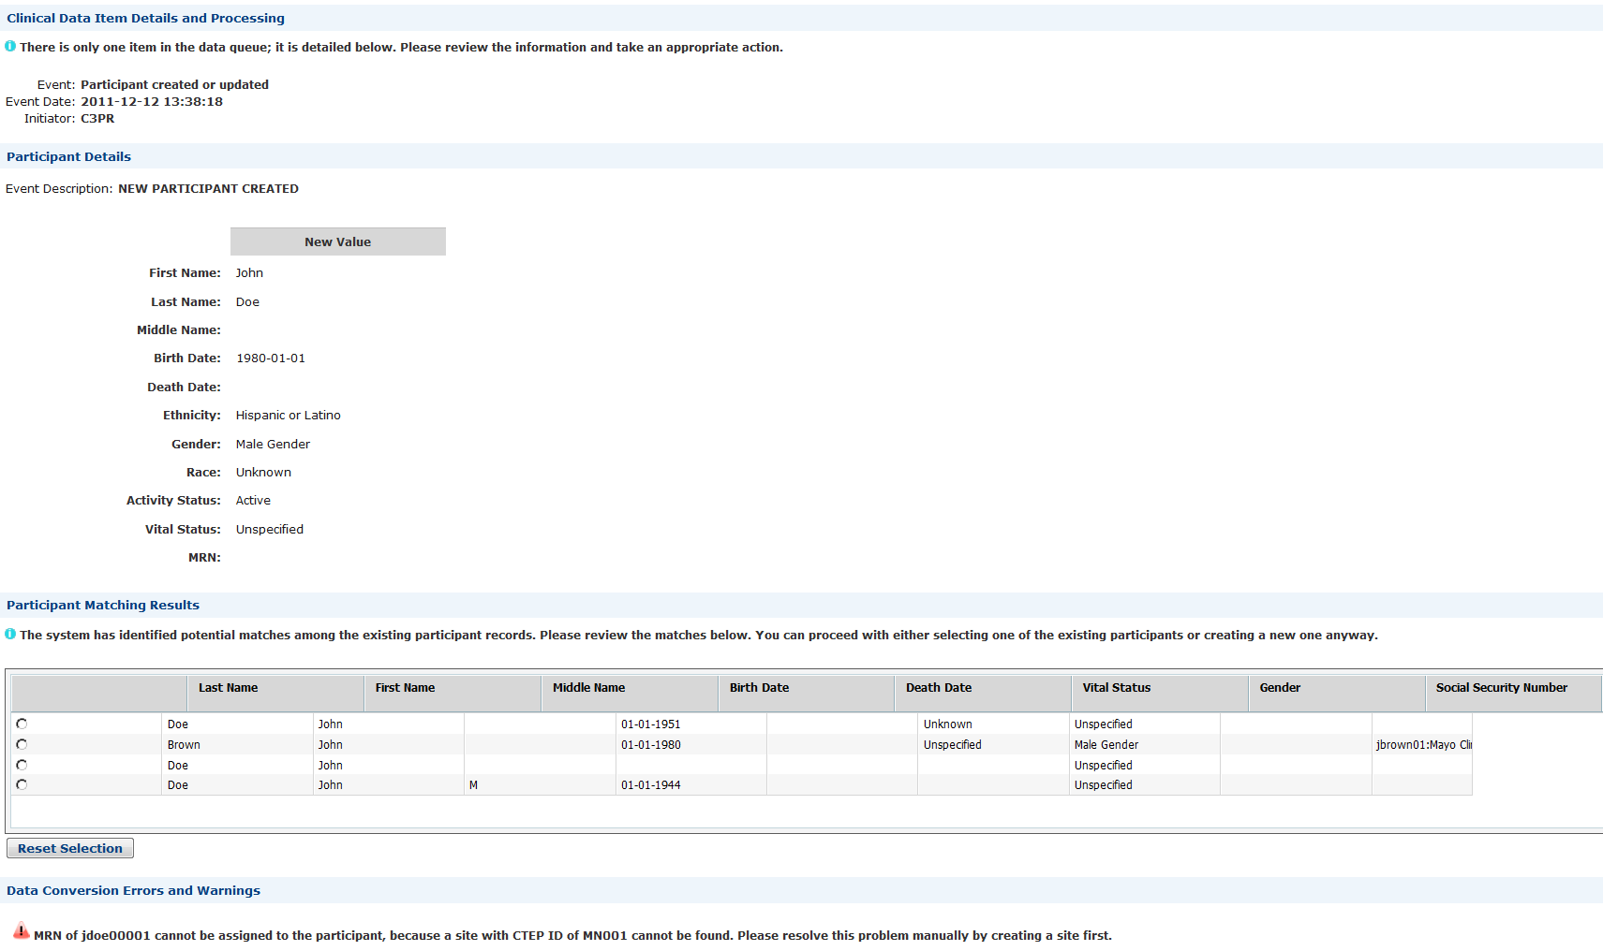

The processing of the queue resumes once the user either eliminates the error condition (e.g. by creating a site with the given CTEP ID) or discards the queue item altogether.

caTissue-to-C3PR

Whenever a participant is registered on a collection protocol in caTissue, caTissue attempts to create the same registration in C3PR using C3PR’s implementation of the Registration Service. In contrast to the above, this happens synchronously right when “Register Participant” button is clicked. If Registration Service returns an error, the error is displayed to the user:

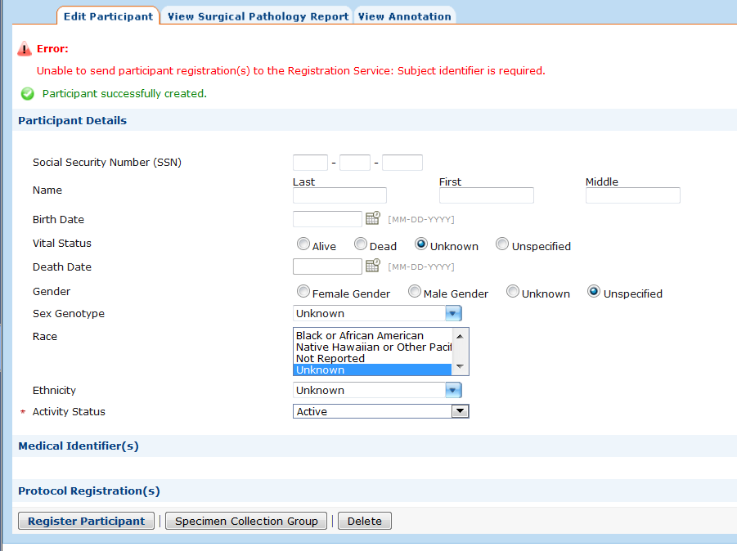

Registration Service may return an error even if the registration was successfully created in caTissue itself, because C3PR has different registration requirements. The following is a list of potential error conditions that can cause a caTissue registration to be rejected by C3PR’s Registration Service:
- MRN is not specified,
- MRN site does not match any C3PR organization by CTEP ID,
- Participant Protocol ID is not specified,
- Collection Protocol does not match any C3PR study

