caTissue Suite Clinical Annotations

Design Document

Document Version 1.0

[Insert approval date of document]

Document Change Record
Version Number | Date | Author | Description
1.0 | 01 Feb 08 | WashU | Design document for CA
TABLE OF CONTENTS
1 Introduction 5
1.1 Overview 6
1.2 Specifications 7
1.3 References 7
1.4 Definitions, Acronyms and Abbreviations 7
2 High level architecture 8
3 Metadata Repository (MDR) 10
3.1 Overview 10
3.2 UML metadata 11
3.2.1 Permissible values and default values 14
3.3 User interface metadata 15
3.4 Data model metadata 16
3.4.1 Entity Creation 17
3.4.2 Populating the entity metadata records: 18
3.4.3 Creating the entity tables 18
3.4.4 Association data table creation 18
3.4.5 Rollback Strategy in case of data table creation/modification 22
4 Persisting data from UI 24
5 Validation service 27
6 Exception/Error handling 30
6.1 Layer wise exception handling 30
7 Integration with host application 32
7.1 Using user interface of DE 32
7.1.1 Restrictions on host application 34
7.2 Using APIs provided by DE 34
7.2.1 Restrictions on host application 35
8 Creating forms by importing XMI 35
9 Exporting Metadata into XMI 35

Table 1: CA models 5
Table 2 Design specifications 7
Table 3: Definitions, Acronyms and abbreviations 7
Table 4: RuleConfigurations.xml 28

Figure 1 Architecture diagram for DE 8
Figure 2: Metadata Repository backbone 10
Figure 3 Dynamic extension basic metadata 11
Figure 4 Attribute type metadata 13
Figure 5 Attribute data element and default value 14
Figure 6 Entity user interface metadata 15
Figure 7 Control types 16
Figure 8 Entity data table metadata 17
Figure 9 RuleConfigurations.xml 27
Figure 10 ControlConfigurations.xml 28
Figure 11 DE exceptions 30
Figure 12: Application data flow diagram 32
Figure 13: Sequence diagram to define a new form 33

Introduction
Pathology, imaging, and clinical data elements required to annotate biospecimens, patient/participant encounters, and patients/participants are unique to the complex disease being studied. Developing highly specified models to capture ALL of the required annotations to describe the clinical and pathological background surrounding participants or biospecimens is an untenable solution. However, it is possible to identify highly reusable annotations related to specimens, accessions or specimen collection groups, and participants. Such annotations have been identified and included in Suite, the list annotations are listed in the below table.

Clinical Data | Pathology annotations
Smoking and Alcohol Use  Family History  Lab Values  Treatment Information  Comorbidities  Followup Information | Staging for all tumor types  Breast  CNS  Colorectal  Heme  Kidney  Lung  Melanoma  Exocrine Pancreas  Prostate
Table 1: CA models

In order to include these annotations in Suite, Dynamic extensions (DE) feature has been used. The following figure depicts the workflow of how this was achieved:

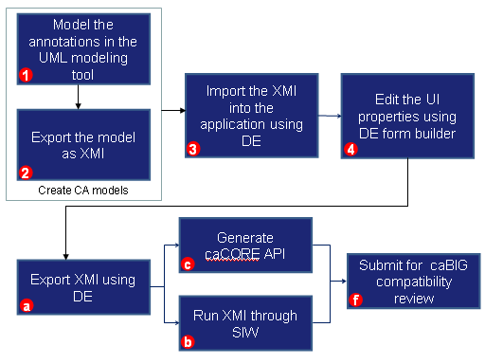
This document describes the design of the DE project along with the following details:
- High level architecture
- Metadata storage design for UML model, user interface and data model
- Persisting data using DE objects
- Integrating DE objects with static models
  - Overview
DE is a caBIG™ compatible way to extend any static UML model to include additional UML classes and attributes.
It is developed with the following high-level design goals:
- Should be possible to create classes (also referred as entity) which can contain primitive attributes and/or associated objects
- Should be possible to associate UI controls with the attributes and dynamically create data entry pages
- Should be possible to associate data storage properties with each attribute
- Should be able to integrate with another parent application (like caTissue) so that its static model can be extended
- There should be no dependency on any particular domain, workspace, or application (so that DE can be integrated with any other application)
- Should be able to use DE without using the user interface

Being part of caBIG™, it is very important for the design to make sure that the extended classes are also caBIG™ compatible. Therefore the following caBIG™ specific design goals:
- Should be possible to associate concept codes and definitions as part of metadata for class, attribute and permissible values
- Export metadata into an XMI such that
  - Can be sent for caDSR loading
  - Generating silver level caCORE APIs
  - caGrid enabled data services

  - Specifications
Following table enlists the application specifications:
# | Purpose | Technology
 | UI Framework | Apache Struts 1.2
 | Object relationship management tool | Hibernate 2.1.7
 | Application Server | JBoss 4.0.0
 | Database | Oracle 10g, MySQL 4.1, PostgreSql 8.1
 | Java | JDK 1.5
Table 2 Design specifications
  - References
- caTissueSuiteV10_DynamicExtensions_Usecases_and_SRS.doc
- DynamicExtensions.ppt
  - Definitions, Acronyms and Abbreviations
Abbreviation/Terms | Definition
DE | Dynamic Extension
Entity | Entity or UML class is a dynamic object that user wants to create using DE.
Attribute | Attribute is a property of an entity that user wants to be part of an entity.
Association | Relationship between any two entities.
Metadata | Data that is used by DE to build the data tables and dynamic pages.
Dynamic data | Data associated with DE
Table 3: Definitions, Acronyms and abbreviations

High level architecture
This section describes the high level architecture of how to use DE as part of another application. The current architecture of DE is such that it cannot be deployed as a stand-alone system. It will have to be integrated with some other host application such as caB2B, caTissue Suite or caElmir.
This integration could be at two levels:
User interface level: The user interface of DE is integrated with that of the host application. For example, caTissue Suite and caElmir integrate DE at UI level to extend the static UML model.
API level: DE is integrated directly at the API level to either store entity metadata or to store data for those entities. For example, caTissue and caB2B query interface
- Uses the entity metadata to perform metadata search and dynamically generate criteria UI pages.
- Uses the data storage mechanism to save query results
The diagram below explains the high architecture of various layers and interaction between them.
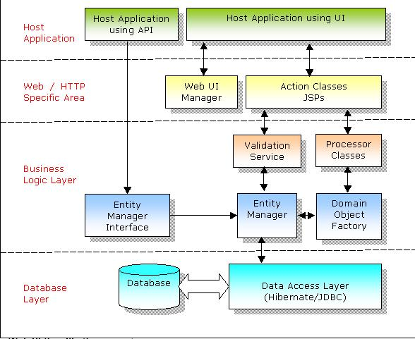
Figure 1 Architecture diagram for DE

Web UI specific components
These components handle the web based protocol specific operations like handling the HTTP request and building the HTTP response. These components will have to be enhanced if the user interface of DE is needs to support non-web based application.
These components include:
Web UI manager: This component interacts with the host application to provide URLs and constants to perform specific operations on DE. For example, it provides the URL that host application must be redirected to in order to define a new form.
JSP/ Action classes: These are the Struts framework related components that are used for the presentation layer. User interface of DE is displayed using these components. For example, “DefineFormAction” action class is used to display the “defineForm.jsp” page where user can create a new form.
Functionality of these components is explained in more details in section Integration with host.
Business logic layer
The business logic layer contains the following components:
Validation service: The data entered by the user is validated using the validation service. The validation service is configurable wherein new validations can be plugged in without making any additional code changes.
Refer to Validation service for more details.
Processor classes: Processor classes contain implementation for common functionalities that are frequently needed by the user interface layer. These components perform generic manipulation of metadata like defining, editing entities etc.
The Validation service and Processor components are independent of the technology used in the host application. Hence they can be used even if the user interface is changed to non-web based framework (like Java Swing).
Entity manager (EntityManager) is the centralized component that is responsible for all the database related operations on the metadata. It contains the methods that are required to operate on the metadata information.
Domain object factory provides uniform way to create new instances of the DE’s domain objects. The processor classes use this factory to create the required domain objects.

Database layer
This component handles the database related operations like transaction and rollback. Entity manager uses these objects to persist the objects in the database.

Metadata Repository (MDR)
MDR is capable of storing metadata information for one or more UML models. The UML model could have been built either statically (using tools like Enterprise Architect) or dynamically (using DE metadata creation UI).
MDR stores metadata for the following types of information:
- UML model related information
- User interface related information
- Data model related information
Following are some of the applications of MDR:
- caB2B uses MDR to store the metadata information for any caBIG application. It pulls the model directly from caDSR, processes it and loads into MDR.
- caTissue Suite uses MDR to store its static UML model. The query interface is built on top of MDR.
- caTissue Suite’s query interface is also capable of querying across the static and dynamic extensions. For example, if there is a dynamic extension called Smoking History on the Participant object, then you can query for “all male participants who smoke greater than 10 cigarettes a day”. This is possible because both static and dynamic objects are stored in the same MDR.

Overview
The basic backbone of MDR is as shown in the Figure 2: Metadata Repository backbone
UML Model
Class
Attributes
1..*
1..*
1..*
Permissible Values
1..*
caDSR
EVS
Concept Code
Concept Code

Figure 2: Metadata Repository backbone
MDR contains the following metadata information for a domain model:
- Classes
- Attributes and data types
- Associations
- Concept codes
- Permissible values
In addition, MDR contains the UI display properties and the database mapping information for each attribute. The metadata for the user interface contains:
- Type of UI control (for example, edit box, drop down, list box, radio button and so forth)
- Properties like height, width, password like string and so forth
- Other information like: default value, mandatory parameter, password like string, PHI data, unique value constraint
- RDBMS table to which the entity maps and column to which the attribute maps
  - UML metadata
This contains all the information expected to be present in a caBIG™ UML model like class, attributes, permissible values, associations along with concept code related information.

Following diagram shows the classes involved in entity creation along with the relationships involved in these classes.

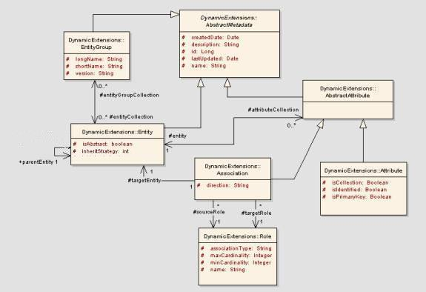
Figure 3 Dynamic extension basic metadata

AbstractMetadata: This is an abstract base class from which the backbone metadata objects are derived. This class contains generic attributes that are part of all objects (like create date, last updated and so forth).
EntityGroup: An entity group is a logical collection of entities. For example, all classes of an application are created under one entity group.
Entity: This class represents an UML class. Some of the important associations of this class are:
- EntityGroup: An entity can belong to one or many entity groups.
- AbstractAttribute: An entity can contain multiple attributes.
- Entity: One of the main aspects of any application is the inheritance between its entities. This association preserves the inheritance in DE.
The following attributes of the Entity class contains the information about inheritance:
isAbstract: This flag maintains whether the entity is an abstract entity.
inheritStrategy: This attribute stores the Hibernate storage strategy to persist the data in the database. The allowed values for this attribute are:
- Joined subclass
- Subclass
- Table per concrete class

Attribute related classes:
AbstractAttribute: An entity can either have zero or more primitive attributes, or have zero or more associated classes. The AbstractAttribute class represents this property. It is the base class for Association and Attribute classes.
Attribute: This class represents any primitive attribute. For example, userName is an attribute of the User entity.
Attribute can be of following types:
- String attribute
- Double attribute
- Short attribute
- Long attribute
- Boolean attribute
- Date attribute
- ByteArray (for BLOB/CLOB)
Following diagram shows how attribute type is defined or changed in attribute.
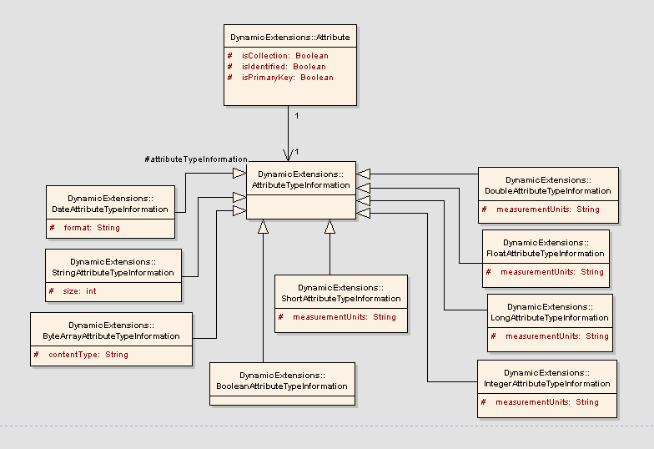
Figure 4 Attribute type metadata
Attribute class is associated with the class “AttributeTypeInformation” that specifies the type of the attribute.
AttributeTypeInformation: This class represents the type of the attribute. Attribute type can be any of the above-mentioned types. This class is an abstract class which is extended by all the specific primitive attribute types like DoubleAttributeTypeInformation or StringAttributeTypeInformation.
Association: This class represents the associations that an entity can have with other entities. E.g. a User entity is associated with Institute entity.
Role:
This class describes an association’s cardinality and the association type. The class has the following attributes
- name: The role name of the association.
- associationType: This could be two types of association: containment and linking.
Containment association type is one of Person and Address where the Person entity will contain Address entity within it. The Address object does not exist on its own.
Linking association type is one of User and Study where both the objects can be created independently. The user can be part of multiple studies and a study can contain multiple users.
- maxCardinality: Maximum cardinality of association (for example, 1 or many)
- minCardinality: Minimum cardinality of association (for example, 0, 1 or many)
The Association class has the following two associations with the Role class:
- sourceRole: This represents the role of the association from the source context.
- targetRole: This represents the role of the association from the target context.

Permissible values and default values
An attribute can have values that are derived from a particular source (like caDSR) or some user defined set of allowable values. For example, Gender attribute can have permissible values like Male and Female. Additionally, an attribute can also have one of them as a default value.
The following diagram describes the model for storing permissible and default values.
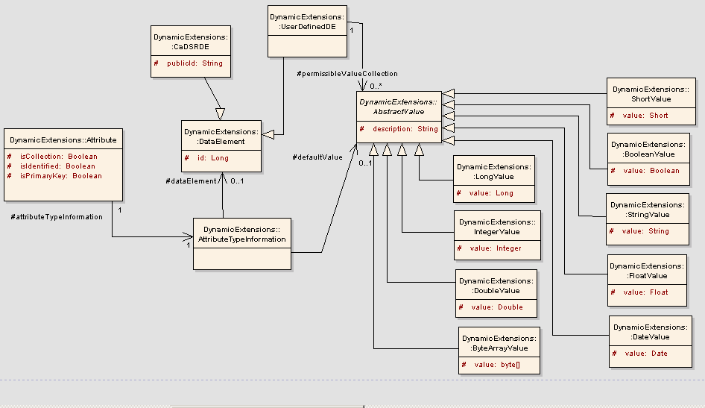
Figure 5 Attribute data element and default value
DataElement: This class represents the source of the permissible values for an attribute. This class holds all the common information for all the types of data elements.
Some of the associations of this class are:
AttributeTypeInformation: AttributeTypeInformation class is associated with the DataElement to store the source of the permissible values.
AbstractValue: This class represents a value an attribute can have. This value can be used as a default value or as one of the allowable values. The class acts as a base class for all attribute type specific values.
Associations for this class are:
AttributeTypeInformation: This class is associated with AbstractValue as one to one association to represent the default value of the attribute.

User interface metadata
When user creates an entity using the user interface of DE, it is associated with the user interface related information for all the attributes. It represents the presentation layer related information.
To display all the attributes of entity on the user page, every attribute is associated with a control. The Control object represents the user interface related information of attribute. It holds information like how the attribute is to be displayed on the page, which HTML control is to be displayed for the attribute etc.
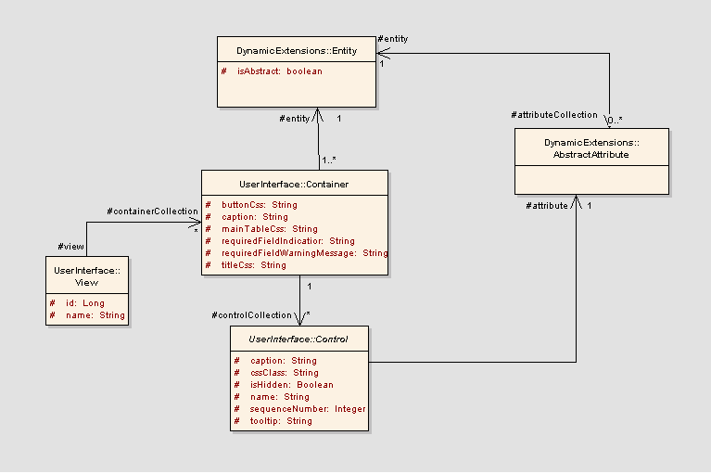
Figure 6 Entity user interface metadata
The Container object holds the presentation layer details for entity. Entity can be shown in different ways depending on the context in which it is to be displayed. Container represents each of these contexts.
Association for this class is:
Entity: Container is always associated with one entity at any time.
Control: Control object holds the presentation layer details for the attribute.
Association for this class is:
AbstractAttribute: Each control is associated with only one attribute at any time.

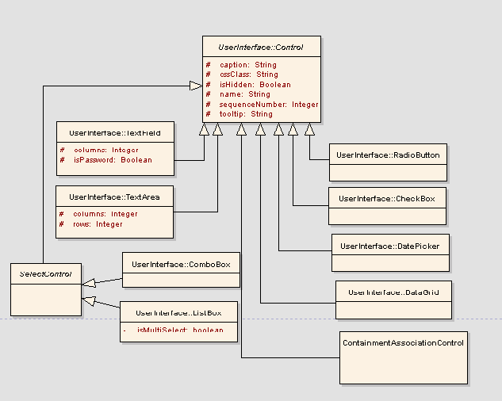
Figure 7 Control types
Control is the base object for all the different control types. Above diagram represents the control type hierarchy.

Data model metadata
Once an entity is created, it has to be associated with its persistence layer. Note that the design of the persistence layer has to be generic such that data for any entity can be stored.
One solution to this problem is the Entity Attribute Value (EAV) database design pattern. In this case, the entity and attribute values are stored as key-value pairs. While this is a very widely used and highly flexible approach, the disadvantages are:
- Cannot generate caCORE-like system
- Performance in case of entities that have large amount of data
The other approach is to use a RDBMS database design and have a one-to-one mapping between tables and entities, and columns and attributes. When a new entity is created, a new table is created for that entity in which all the records for that entity are persisted. This table is henceforth called as “data table” for the entity.
E.g. If user creates an entity called as Employee a table is created say DYEXTN_ENTITY_1. So when a user inserts a new employee record, that record is stored in this table. The naming convention is explained later.
The Entity and Attribute classes contain information about the data model mapping.
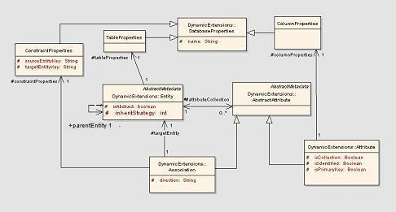
Figure 8 Entity data table metadata
TableProperties:
This class defines metadata to store an entity in the database. This class is associated with with the following:
- DatabaseProperties: Table properties is a type of database property
- Entity: Each table property instance is associated with a single entity. Each Entity contains a single table property instance
ColumnProperties:
This class defines the column name that is associated with the attribute. The associations for this class are:
- DatabaseProperties: Column properties is a type of database property
- Attribute: Each column property instance is associated with a single primitive attribute. Each primitive attribute contains a single column property instance.
ConstraintProperties:
This object represents the data table related information in case of associations. The significance of this object is explained in detail in Data table creation for association.

Entity Creation
Definition of entity (creating a new entity) consists of two distinct operations on database.
- Persisting the metadata information of entity into the database: Please refer to the “EntityManager.persistEntity()” method to store the new entity with dynamic creation of data table for the entity. Also please refer to the “EntityManager.persistEntityMetadata ()” method to store the entity metadata information without creation of data table.
- Creating the data tables associated with the entity: When a new entity is created, a separate table is created for that entity in which all the records for that entity are persisted.
Please refer to the “EntityManager.postSaveProcessEntity()” method to see the formation of data table naming for the entity passed to it as an argument.
These two operations are always performed as a transaction. Rollback strategy for this transaction is explained later in this document.

Populating the entity metadata records:
Entity metadata is populated using OR mapping tool hibernate. Metadata information of entity includes information like:
- Entity related information viz. name, description created date etc.
- Attributes and associations of that entity
- Entity group that entity belongs to.
- Database properties (data table name) of the entity.
Please refer to the “EntityManager.persistEntityMetadata()” method for persisting the entity metadata.

Creating the entity tables
DynamicExtensionBaseQueryBuilder::getCreateEntityQueryList()
Every entity is associated with its own data table to store its records. This section explains the creation of this data table and all the issues regarding it. The data table is created in following way:
- An entity is associated with the TableProperties object which is the unique name of the data table. This name is defined using following naming convention: DE_E_<unique entity identifier>
- Data table has a column for each of the attributes of the entity. The Attribute object contains an attribute called columnProperties which is the unique name of the column associated with that attribute. This unique column name is defined using following naming convention: DE_AT_<unique attribute identifier>
- Also there can be some constraints defined on the columns while defining the attributes viz. UNIQUE and NOT NULL. These constraints are also taken into consideration while creating the data table.
- There is a separate XML configuration file (e.g. primitiveAttributeDataTypes_MYSQL.xml), which maps the data type of the column and the type of the attribute. This is made configurable because the data type of column is database specific. A separate configuration file is maintained per database
- Using all this information a query is prepared to create the data table for the entity

Association data table creation
An entity can have one or more associations with different entities. This section explains creation of association and the data table creation of association.

Creation of association
The creation of association between two entities can be explained using the following example:
Consider two entities Study and User where each study has a primary investigator and a user can be a primary investigator for many studies. So this relationship can be represented using the ‘Association” in following way.
Create an association for study (i.e. this association is an attribute of “Study”). Set “user” as its target entity. Set direction as “Source to destination”. Create a source role with max cardinality as many. Create target role with cardinality as one. Give target role name as “primary investigator”. In this way the created association will represent the above-mentioned relationship between the involved entities. Creation of such association can be best explained in detail with following steps.
- Create Study entity
- Create User entity
- Create an Association instance from the domain object factory
- Set name of the association as “primary investigator”
- Set direction of the association to “SRC-DESTINATION”.
- Set target entity of the association to User entity.
- Set sourceRole of the association
  - associationType as “association”
  - minCardinality as “ZERO”
  - maxCardinality as “Many”
  - name as “study”
- Set targetRole of the association
  - associationType as “association”
  - minCardinality as “ONE”
  - maxCardinality as “ONE”
  - name as “primary investigator”
- Add the created association in the attributes collection of Study entity. This step marks Study entity as the source entity of the association.
- Save the source entity (i.e. study) using entity manager’s API viz. “EntityManager.persistEntity()”.

Data table creation for association
EntityManager::populateConstraintProperties()
As explained earlier, every entity has a data table associated with it to store the records for that entity. Whenever an entity has one or more associations, the creation of these data tables need to follow some rules. These rules depend on the direction and the cardinalities of the association. These rules are described below.
Rule | Data table description
Cardinality is “one-to-one” or “one-to-many”  E.g. User can belong to multiple institutes. | Target data table will have a foreign key to the source data table.
Cardinality is “many-to-one”  E.g. Many Users can belong to one study. | Source data table will have a foreign key to the target data table.
Cardinality is “many-to-many”  E.g. one study can belong to many users and one user can belong to many studies. | Mapping table is created to store the identifiers for both the entities involved in the association.

Case 1: Cardinality is “one-to-one” or “one-to-many”
In this case of association, the data table for the target entity needs to have the identifier of the source entity data table as a foreign key (according to the rule that “many” side holds the foreign key of “one” side). So when this association is to be processed, an extra column is added to the target entity data table.
Naming convention for this column in this case is:
“DE_E_<<sourceEntity identifier>>_<<association identifier>>_IDENTIFIER”.
In the above naming convention DE stands for “Dynamic Extension”, E stands for “Entity”.
This name of the column represents the source entity data table’s key in the data table of target entity. This name is stored in the constraintProperty object of the association as “sourceEntityKey” attribute.
Example of case 1:
Source entity: User (with entity identifier 1)
Target entity: Institute (with entity identifier 2)
Association: A user can belong to one or more institutes. (With association identifier 3)
For this example the column that is added to institute’s data table is “DE_E_1_3_IDENTIFIER”.
Case 2: Cardinality is “many to one”
In this case of association, the data table for the source entity needs to have the identifier of the target entity data table as a foreign key. So an extra column gets added to the source entity data table.
Naming convention for this column in this case is:
“DE_E_<<targetEntity identifier>>_<<association identifier>>_IDENTIFIER”
This name of the column represents the target entity data table’s key in the data table of source entity. This name is stored in the constraintProperty object of the association as “targetEntityKey” attribute.
Example of case 2:
Source entity: Study (with identifier 1)
Target entity: User (with identifier 2)
Association: Multiple studies can have the same user as its primary investigator. (With identifier 3)
For this example the column that is added to study entity’s data table is “DE_E_1_3_IDENTIFIER”.
Case 3: Cardinality is ”many to many”
In this case, a mapping table is created to store the identifiers for both the entities involved in the association. It contains three columns: its own system identifier and two other columns to store the source and target entities’ identifier.
Naming convention for the source column key is:
“DE_E_S_<<sourceEntity identifier>>_<<association identifier>>_IDENTIFIER”
Naming convention for the target column key is:
“DE_E_T_<< targetEntity identifier>>_<<association identifier>>_IDENTIFIER”
In above naming convention, S stands for “Source” and T stands for “Target”.
These names of the columns represent the source and target entity data table’s key in the data table of target and source entity respectively. These names are stored in the constraintProperty object of the association as “sourceEntityKey” and “targetEntityKey” attribute.
The naming convention of the mapping table is:
DE_AS_<<sourceEntity identifier>>_<<targetEntity identifier>>_<<association identifier>>

In above naming convention, AS stands for “Association”.
These naming conventions of the columns and the table ensure their uniqueness in all the cases of associations.
Example of case 3:
Source entity: Study (with identifier 1)
Target entity: User (with identifier 2)
Association: A study can have many users and a user can be present for many studies. (With identifier 3)
For this example,
The name of the generated mapping table is “DE_AS_1_2_3”
The name of the source column key is “DE_1_3_IDENTIFIER”.
The name of the target column key is “DE_2_3_IDENTIFIER”.

Case 4: Direction: “Bi-directional”
In this case, when the association is bi-directional, it means that the association should also be a part of target entity’s attributes collection. So to represent the bi-directional relationship correctly, a new system generated association is created internally which is a replica of the original association but represents the target entity’s perspective.
This newly generated association is then added to the target entity’s attribute collection so that when target entity’s attributes are fetched, this association will also feature in that collection. To mark this system generated association separate from the user added association, a field is added to the association, which acts as a Boolean flag and is called “isSystemGenerated”. This field is set to “true” when a system-generated association is created. The default value for this field is “false”.
Please refer to the “populateSystemGeneratedAssociation ()” method from “EntityManager” for above mentioned case and “populateConstraintProperties” method for formation of column names for association.

Example of case 4:
Source entity: study (with identifier 1)
Target entity: user (with identifier 2)
Association: Study can have many users and one user can be present for many studies. (With identifier 3)
In this case, the system-generated association is created and added to the user’s attributes collection.
In this way, associations are processed while creating the data tables for the entity.
Please refer to the “getCreateAssociationsQueryList()” method from “DynamicExtensionBaseQueryBuilder” for creation of data tables for association

Rollback Strategy in case of data table creation/modification
As mentioned above defining an entity consists of two distinct operations i.e. persisting the metadata and creating the data tables. These operations have to be performed in a transaction to avoid any inconsistency in the database.
Entity cannot be termed as created until both these operations are performed successfully. So if any error occurs while performing either operation, other operation is to be rolled back. This section explains this rollback strategy for entity creation.
Steps to create the entity are as follows:
- Step 1:Entity metadata is saved but the transaction is not committed
- Step 2:Data table queries are formed and executed in the same transaction.
After this there are different cases that could occur
- If both the steps are successful
In this case transaction is committed
- If Step 2 is unsuccessful
In this case entity metadata is not committed
- If step 2 is successful but step 1 is not, or there is some error in committing the transaction.
In this case step 2 is rolled back
Special handling is needed for case 3 since, once the “CREATE TABLE” query is executed, since it is a DDL (data definition language) query, there is no uniform approach across the databases to roll it back.

So when situation occurs where we need to roll back the “CREATE TABLE” or “ALTER TABLE”, DE creates a separate opposite query (hereafter called as “rollback query”) for every create or alter table query which cancels its effect and recreates the original state of the database.

There are scenarios when more than one DDL queries need to be executed for successful creation or modification of entity. For example in case an association is added to entity, DDL queries need to be executed on both the entities involved. In such scenarios, DE maintains the stack for rollback queries. So if Q1, Q2, Q3 are the three DDL queries, the rollback queries RQ1, RQ2, RQ3 are prepared and pushed on the stack so if exception occurs that they are executed in RQ3, RQ2, RQ1 sequence to maintain the integrity.

Please refer to the “getCreateMainTableQuery()” method from “DynamicExtensionBaseQueryBuilder” class for the formation of rollback queries.

Please refer to the “EntityManger.logFatalError ()” method for details of scenario when rollback strategy fails to successfully rollback the transaction.

Persisting data from UI
This section explains how to insert data records for the entity from the dynamically generated UI.
The Container object represents the UI context of the entity. It
- Prepares the skeleton for the data insertion form
- Contains different controls
- Appends HTML for the each control and finally generates the form
Linking type association:
- An object of type AssociationControl is created while defining metadata.
- A combo box is shown when the cardinality of the association is one-to-one.
- A list box is shown when the cardinality of the association relation is one-to-many.
Containment type association:
- An object of type ContainmentAssociationControl is created while defining metadata. This control has a reference to the child container.
- When the cardinality of the containment relation is one-to-one, the HTML for the child container is embedded within the main form view.
- When the cardinality of the containment relation is one-to-many, the HTML for the child container is shown in the spreadsheet view.
Let us consider a simple example: a PathologyCase object can contain many Tissue objects and a Tissue object can contain many Slide objects. Thus there is a one-to-many containment relationship between PathologyCase and Tissue, and also between Tissue and Slide.
Since the relation between PathologyCase and Tissue is one-to-many containment, the Tissue object is shown in the spreadsheet view on the same page. Each row of the spreadsheet represents a tissue object. Thus a user can insert data for a pathology case and multiple tissues from one page.
A tissue contains many slides. A link is shown for data entry of slide in each row of tissue spreadsheet. On click of this link user is taken to the next page. The next page displays tissue object in the form view. As the relation between tissue and slide is one-to-many containment, the slide object is shown in the spreadsheet view on the same page. User can insert data for the tissue object and multiple slide objects. ON submission of this page user is taken back to case page.
Please refer to the “EntityManager.insertData ()” for storing the data for a particular entity. Also refer to the “EntityManager.editData ()” for editing the existing data.
The above-mentioned flow is depicted in the following sequence diagram
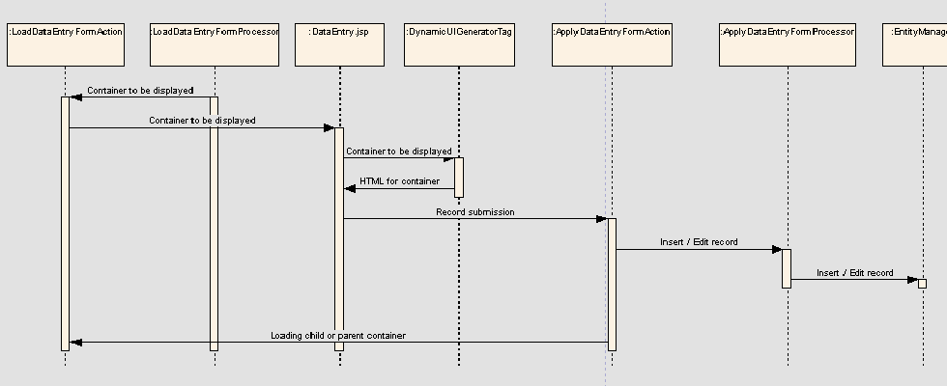
Figure 11 Data insertion for an entity

- LoadDataEntryFormAction class loads the container to be displayed. It expects the container identifier from request. Using Dynamic extensions utility method viz DynamicExtensionUtil.getcontainerByIdentifier(), it loads the container from database into the DataEntryForm. The control is forwarded to DataEntry.jsp.
- DataEntry.jsp uses DynamicUIGeneratorTag to generate the user interface. The DynamicUIGeneratorTag generates user interface using container’s generate HTML method viz. Container.getEditModeHTML () or Container.getViewModeHTML() .
- Each UI control is given a unique name as <Control_> <Container Identifier> <Control Sequence Number>.
- Dynamic UI generator framework uses two stack objects viz. ContainerStack and ValueMapStack. Whenever a container is to be displayed, Container and valueMap of the container are pushed on the respective stacks.
- Whenever user submits the form, control is forwarded to ApplyDataEntryFormAction. This action class extracts user inputs from request and generates a map of values. The user input is validated against validation rules using the validation services framework. If there are any validation errors, control is again forwarded to DatEntry.jsp. If user input is correct valueMapStack is updated for the user input values.
- If user input is correct and user wants to submit data, control is forwarded to ApplyDataEntryFormProcessor. This processor calls EntityManager’s insertRecord or editRecord methods depending on the operation.
- If user wants to insert data for child container, user is taken to next page. In this case valueMapStack is updated for user inputs. Then child’s Container object and child valueMap are pushed on the stack and child container is displayed on the next page.
- If user wants to submit child container data valueMapStack is updated for user inputs. Also ContainerStack and ValueMapStack are popped and parent container is displayed on next page.

Validation service
The data submitted by the user has to be validated before inserting into the database. During creation of the entity user can specify one or more rules for each attribute. These rules are invoked during record insertion for that particular entity. If any rule is violated, an appropriate message is displayed to the user.
This framework allows
- To add new rules in the system by adding its entry in a configuration file (RuleConfiguration.xml). Currently following rules are supported:
  - Mandatory: Makes attribute value mandatory
  - Range: validates range for text and date
  - Number: accepts only valid number
  - Date: checks for valid date
  - Unique: makes sure that value of attribute is unique
- To associate/remove a rule to a particular control
- To validate data against defined rules
Following are the required configuration files for this framework:
- RuleConfigurations.xml: This file provides information regarding each rule. Typical structure of this file is as follows:
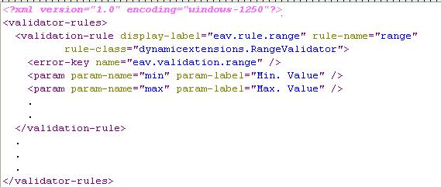
Figure 9 RuleConfigurations.xml
Some important tags are explained in following table:
# | Field | Explanation
 | display-label | It is a key in resource bundle for the label of the rule. This label is displayed on the define control screen.
 | rule-name | Unique name of the rule. This is used to associate a rule to a control.
 | rule-class | Fully qualified name of java class that implements ValidatorRuleInterface. Validate method of this interface is invoked when a rule is called.
 | param | It defines name of the parameter that rule may require. For example range validator requires minimum and maximum range as a parameter.
 | error-key | It is a key in resource bundle for the error message of the rule. During data entry if rule is violated, this message is displayed to user.
Table 4: RuleConfigurations.xml
- ControlConfigurations.xml: This file maps a control and its applicable rules. Using this file, one or more rules can be associated to the control. Typical structure of this file is as follows:
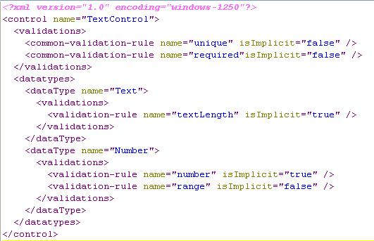
Figure 10 ControlConfigurations.xml
The tags are explained in following table:
# | Field | Explanation
 | common-validation-rule | Some controls may have more than one data types associated with it, e.g. Textbox can be used to show text as well as numbers.  This tag defines rules that are applicable to all data types of this control.
 | name | Name of the rule which is defined in RuleConfigurations.xml
 | isImplicit | Some rules are implicit for the control. For example, for a number edit box, input has to be a valid number. Rules marked as isImplicit are not shown in UI, but are applied implicitly during data entry.
 | dataTypes | This tag lists all applicable data type of the control and corresponding validation rules.

Overall flow of the validation is explained below:
- ControlConfigurationsFactory provides all applicable rules for the selected combination of control and its data type. It uses ControlConfigurations.xml to find out such applicable rules for control.
- While defining the control, user selects rules as per his requirements along with any parameter values.
- When user inserts data for that entity, ValidatorUtil is called to validate user input before storing the data.
- ValidatorUtil gets all the rules for a particular control and its parameters from database.
- It creates an instance of the rule class using class name that is specified in RuleConfigurations.xml.
- On this rule instance validate method is invoked. It checks for the validity and if rule is violated it throws DynamicExtensionsValidationException.
- ValidatorUtil converts each such exception into an error message.
- Error messages are displayed to the user in case if any of the validation fails, otherwise normal flow of application continues.

Exception/Error handling
This section explains the exception handling that can be used in dynamic extensions application that is going to be integrated with other applications like CaElmir or caTissue Suite.
Dynamic extension application will have two types of exceptions viz.
- Dynamic extension application exceptions: These are the application specific exceptions for which application can show some warning/error message for the user. Examples of application exceptions are:
  - Duplicate name exception for entity or entity group.
  - Validation exceptions. (Business validation exceptions for user defined validations)
    - Dynamic extension System Exceptions: These are the system level exceptions for which application cannot do anything but to redirect the control to the error page and do the logging operations for the exceptions. Examples of application exceptions are:
      - JDBC connection is reset or lost.
      - DAO exceptions.
      - Hibernate exception.
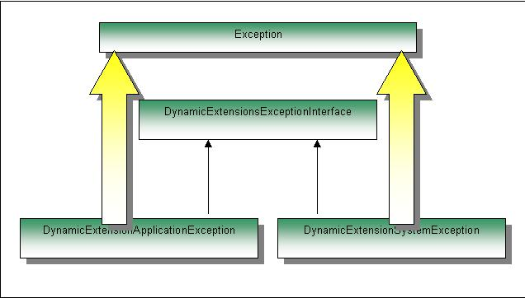
Figure 11 DE exceptions

The diagram above depicts the type of the exceptions in DE and their structure.

Layer wise exception handling
If DE is being accessed via API, then only first two layers are used. Otherwise if the DE is being used via its UI, then all the mentioned layers are used.
DAO layer:
DE is using common package’s classes viz HibernateDAO and JdbcDao to do all the database related operations. At this layer all the runtime exceptions are wrapped under “DAOException” and thrown back to the caller.
EntityManager layer:
Entity manager is going to call the DAO layer methods to save or update the entities into the database. So entity manager is going to receive the DAOException in case of any error conditions. Entity manager will wrap this exception under “DynamicExtensionSystemException” or in some cases “DynamicExtensionApplicationException” and then it will do the required logging operations and then will re-throw the exception as either DynamicExtensionSystemException or DynamicExtensionApplicationException with proper error code/message.
Processor class layer:
These classes will just throw any exceptions that they may come across, without doing any operations on them.
Action class layer:
Action class will have a centralized method that will receive the exception. Depending on the type of exception it will either redirect the control to the error page or will populate the error list from the error code that is set inside the exception. Dynamic extension application has a base class called “DynamicExtensionBaseAction” which has a method called as “handleException” which processes all the exceptions which are caught in action classes. This method takes the instance of throwable and the list for the error codes as parameters. The method returns true if the exception is system exception otherwise returns false. Method populates the passed list with all the required error codes using which error messages are shown on user interface.

Integration with host application
DE application can be integrated with host application in following two ways:
- Using user interface of DE
- Using APIs provided by DE
Following diagram explains the application data flow for host application and DE.
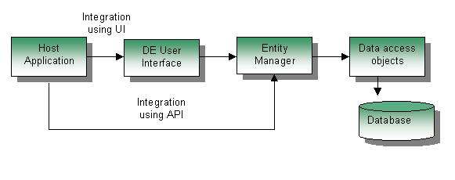
Figure 12: Application data flow diagram
  - Using user interface of DE
If host application wants to use the user interface to define entities, insert records or view or edit the existing entities, they can do so by including the WAR file of DE application into their deployment environment. Steps involved in using the DE’s user interface from the host application are mentioned below.
  - Add the DE WAR file in the deploy folder of the application server.
  - Place the “DynamicExtensionsCommunication.jar” into the class path of the host application. This jar file contains all the classes of DE, which act as an interface between DE and host application e.g. “WebUIManager” class. The significance of this class is mentioned in the next section.
Following sequence diagram explains the flow of events that takes place when user tries to define a new form using the user interface of DE.

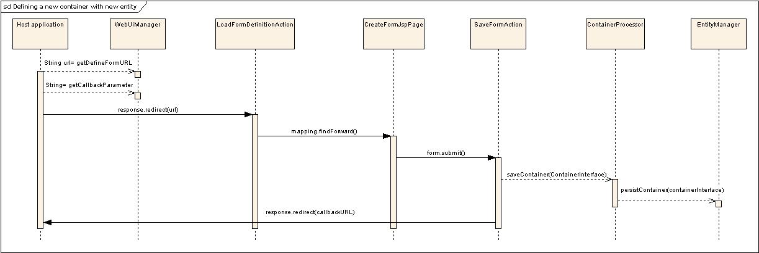
Whenever host application is using DE’s user interface to perform operations like create entities, insert records, Web-UI manager of DE acts as an interface between the host application and DE.
Figure 13: Sequence diagram to define a new form
The major responsibilities of WEB-UI manager are:
- URL Factory: This manager class will be responsible to return the required URLs for any of the operations that host application wants to perform. E.g. Web-UI manager will have a method viz. “getDefineFormURL” (as mentioned in the diagram above) that will give the exact URL that host application needs to call in order to define a new entity.
- URL Parameter Factory: WEB-UI manager returns names of parameters to be appended to URL specifying an operation. The method, which does this, is getcallBackParameter . For example getCallbackParameter will return the name of the request parameters that DE application expects while processing URL request to define a form .in
Following is the flow of events when host application tries to define a new entity using DE’s user interface.
- Host application will call the method getDefineFormURL on WEB-UI manager.
- Host application will call other required methods to get all the required request parameters. Using these request parameters, Host application will form the exact URL and then it will redirect the response to this URL.
- When host application calls this URL, control there after comes in the DE application wherein it will call an action class viz LoadFormDefinitionAction, which will eventually display the form definition page.
- User will enter all the required information to create a new entity. On submitting the information, SaveFormAction action class will be called.
- This action class will then call the ContainerProcessor class to save the container and entity into the database.
- ContainerProcessor class will call “EntityManager” class’ “persistContainer ()” method to save the form into the database.
- On successful completion control will be passed back to the host application using the callback URL passed by the host application with the success status message.

Restrictions on host application
- If the host application wants the DE user interface in a particular part of the page of host application, in such cases host application must use either “FRAMESET” or “IFRAME” or something equivalent for the display of DE pages. So that when the page of DE is submitted, only the particular part of the page is refreshed.
- Currently DE does not perform any security credentials verification of the logged in user. Checking of required privileges to access the DE is completely within the control of host application. Once control is within the DE application, there is no restrictions imposed on the user by DE based on his security credentials
- Host application specific session timeout handling is not yet incorporated

  - Using APIs provided by DE
If host application wants to interact with DE programmatically to define and operate on entities and their records, they can include the DynamicExtensions.jar into their class path and then invoke DE APIs.
This jar file contains all the interfaces that are required by host application to work with DE metadata objects. DE does not expose the actual objects to host application. DE provides interfaces to the host application so that the actual implementation is hidden from the host application.
Two of the most important classes for this type of integration are mentioned below:
DomainObjectFactory: This factory class exposes methods to create the new instances of metadata objects. For example if host application wants to create new entity, this class exposes a method viz. “createEntity” which internally creates a new instance of Entity metadata object and returns the “EntityInterface” which is the interface exposed by the actual object. So once user gets this interface by calling the mentioned method, user can operate on it for the required manipulation.
EntityManager: This class is responsible to handle all the database related operations of DE objects. It exposes methods that allow the user to perform the CRUD operations on DE objects. For example if user has created a new entity using the domain object factory mentioned above and then user wants to save it to the database, in such cases entity manager exposes a method viz “persistEntityMetadata (EntityInterface)” which persists the given entity in the database.

Restrictions on host application
When user invokes any API and in DE if there is any exception, transaction is rolled back for that API and DE throws the exception back to the caller. Please refer to the “exception handling design” document for further explanation about exceptions. In such cases, transaction rollback strategy for host application is completely within the control of host application. DE will just throw an exception as notice to the host application that transaction is rolled back at DE.

Creating forms by importing XMI
The XML Metadata Interchange (XMI) is an OMG standard for exchanging metadata information via Extensible Markup Language (XML). It can be used for any metadata whose meta model can be expressed in Meta-Object Facility (MOF). The most common use of XMI is as an interchange format for UML models.

The UML models can be designed using software like Enterprise Architecture (EA). This model can be exported to an XMI which is imported in DE to create forms corresponding to the classes. This section explains the architecture of xmi importer.

JMI (Java Metadata Interface) API is used to parse the xmi. Following classes are used.

XmiImportProcessor: This is the processor class which processes the JMI objects and formulates them into DE objects. Please refer Section 3 for detailed description on DE objects. Following is the flow of execution of XMI Import Processor:
- Process the user defined UML package from the UML model
- Create an entity group or edit an existing entity group
- Create entities or edit existing entities
- Create attributes or edit existing attributes
- Add association
- Add Inheritance
- Create containers or edit existing containers
- Create controls or edit existing Controls
- Persist entity group with all containers

XmiImporterUtil: This class contains the utility methods for XMI import.

Exporting Metadata into XMI
The DE metadata created through the UI or by importing an xmi can be exported back into an xmi to facilitate metadata reuse across various sites. The following classes are used for this purpose.

XmiExportProcessor: This is the class which processes the DE UML model and DE data model and writes them to an xmi. Following is the flow of execution of Xmi Export Processor.
- Create UML model
- Create Data model
- Write Xmi

