Build caTissue from source code

Table of Content
1. Introduction 3
2. Prerequisites 3
3. Set up Development Environment (Eclipse IDE) 4
4. Get the Source 7
5. Setup caTissue Code in Eclipse IDE 8
6. Building dependent jar files 15
7. Compile, build and deploy 17

Introduction
This document describes the steps to build caTissue from source code and setting up the development environment for caTissue Suite source code. Following are the high level steps of building caTissue code:
- Install/Setup pre-requisite softwares.
- Setup Eclipse IDE.
- Checkout the code from CVS or download the source code archive
- Setup the build path of source code in Eclipse IDE.
- Run Ant commands to build application, deploy application, create database schemas.

Prerequisites
Before you try to build, make sure you have the correct tools, and have configured these tools correctly. This document does not contain pre-requisite configuration such as memory size configuration etc. For more details on this please refer to deployment guide of specific caTissue version,
JDK 1.5
Download the JDK 1.5 and install it to a desired location e.g. C:\JDK 1.5.

Eclipse http://www.eclipse.org/downloads/
Download the Eclipse 3.2.2 or higher version and install it to a desired location e.g. C:\ECLIPSE.

ANT http://ant.apache.org/
Download the ANT version (as supported by specific version of caTissue) and install it to a desired location e.g. C:\ANT.

MySQL/Oracle
Install the MYSQL/Oracle database version (as supported by specific version of caTissue) and install it to a desired location

JBoss
Download the JBoss version (as supported by specific version of caTissue) and install it to a desired location e.g. C:\JBOSS.
Following table list the supported version of pre-requisite of specific caTissue version.
Pre-requisites | caTissueSuite v1.1
JDK | 1.5
JBoss | 4.2.2 GA
MySQL | 5.0.45
Oracle | 10.2.0.2
Ant | 1.7
Table 1

Please refer following notations used throughout the document

Keyword | Comment
ECLIPSE_HOME | The folder location where Eclipse is installed e.g. F:\Eclipse
WORKSPACE | The folder location which is a eclipse workspace where you placed a source code. e.g. F:\Workspace
CATISSUE_HOME | The folder location where the caTissue placed source code is copied inside WORKSPACE e.g. F:\Workspace\Catissuecore
JAVA_HOME | The folder location where JDK is installed  e.g. C:\JDK1.5
JBOSS_HOME | The folder location where Jboss is installed  e.g. F:\Jboss 4.2.2.GA
ANT_HOME | The folder location where Ant is installed  e.g. C:\Ant
MYSQL_HOME | The folder location where MySQL client is installed  e.g. C:\MySQL
ORACLE_HOME | The folder location where Oracle client is installed  e.g. C:\Oracle
Table 2

Set up Development Environment (Eclipse IDE)
In this document Eclipse 3.2.2 IDE (on Windows platform) is used for demonstration. IDE setup includes configuring correct version of tools like JDK, Ant version.

- Open the Eclipse IDE

- Select the folder where you wish to check out the code i.e. ”WORKSPACE_HOME”

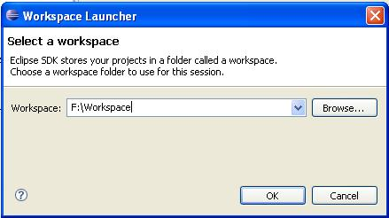

- Open Java Perspective from Windows -> Open Perspective -> Java

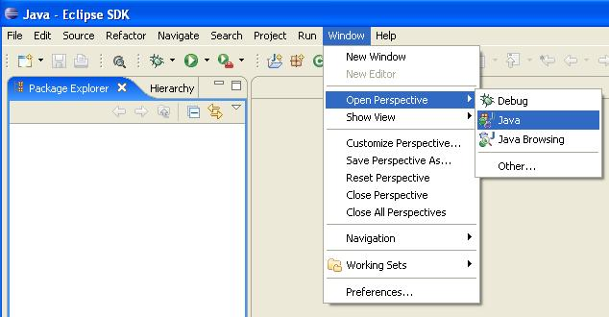

- Open Eclipse environment preferences window from menu Windows -> Preferences

- In Preference window from left hand side tree select Java -> Installed JREs and select JDK 1.5 or ”JAVA_HOME”

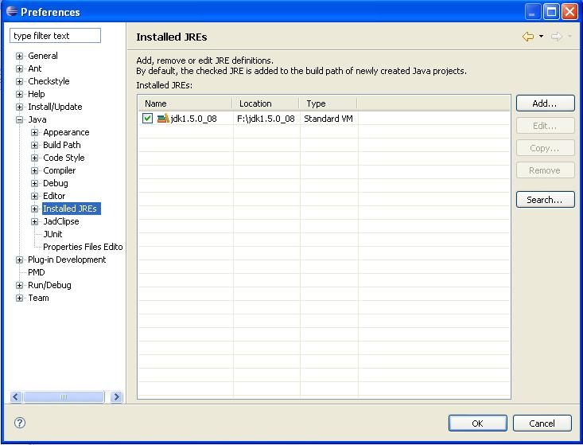

- Select Java -> Compiler and set Java Compiler to 5.0 in preference Window

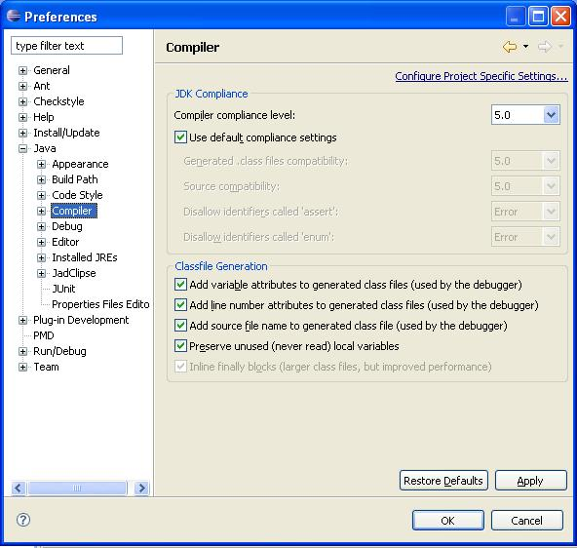

- Set “ANT_HOME” in Preference Window -> Ant -> Runtime

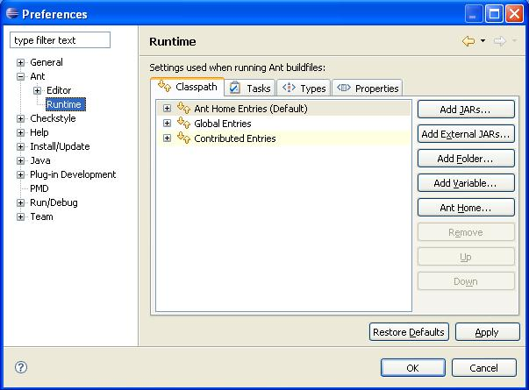

- Click Ant Home button and select the “ANT_HOME” folder
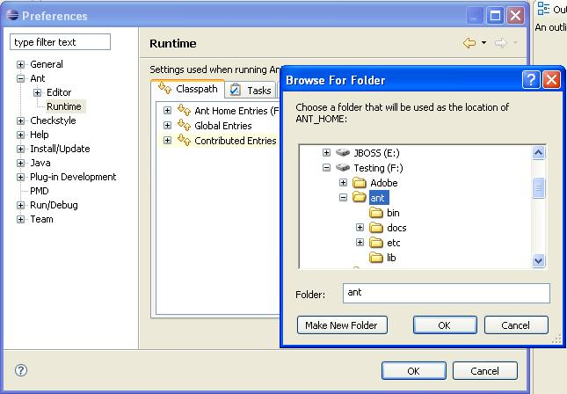

- Click OK and save the preferences.

Get the Source
Download the code from http://gforge.nci.nih.gov/frs/?group_id=18 under desired release package. (caTissue Suite v1.1 – RC4 Release)
After downloading the source code unzip it to desired location i.e. “CATISSUE_HOME”.

Setup caTissue Code in Eclipse IDE

Note: User can build caTissue without going through IDE by running ant commands from command prompt. Refer to Section 6.

For users who wish to use IDE, follow the below steps:

Setup the build path required for caTissue source code. This includes verifying the JRE/JDK version , configure the source code folder, add required libraries.

- Before any step please verify the JRE version used by eclipse for caTissue project. Right click caTissue project and select Project properties
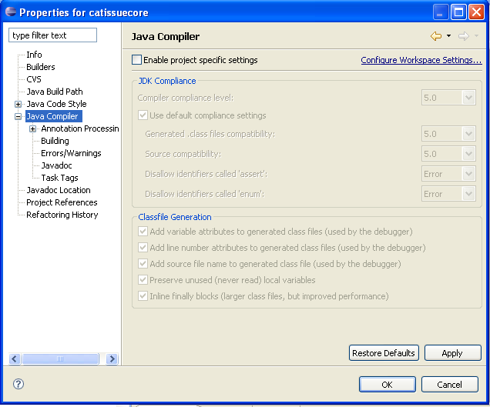

- Ensure project points to correct source code location. Select Java Build Path from left hand side tree of Properties window. In Source tab make sure the source folder points to CATISSUE_HOME/WEB-INF/src folder and default output folder points to CATISSUE_HOME/WEB-INF/classes
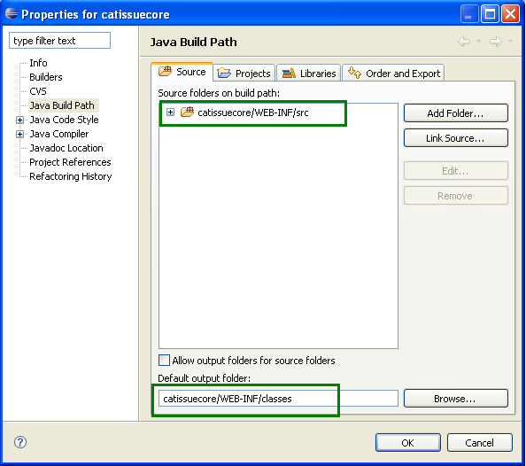

- Select Libraries Tab. In Libraries Tab remove the entries (If it is present) as shown below. Select the entries and click Remove button

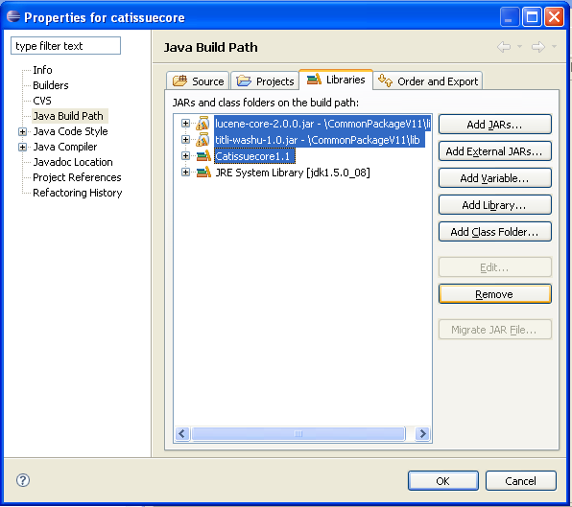

- From Libraries Tab create new User Libraries as follows
  - Click add Library
  - In Add Library window select User Library and click Next
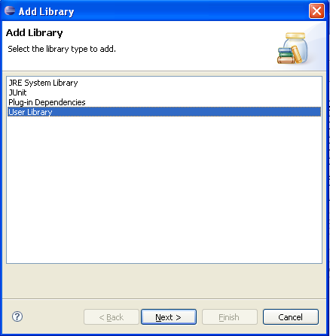
  - In User Library window click User Libraries button
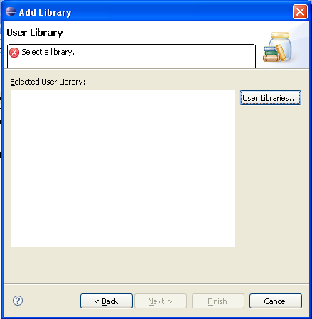
  - In Create User Libraries window click New
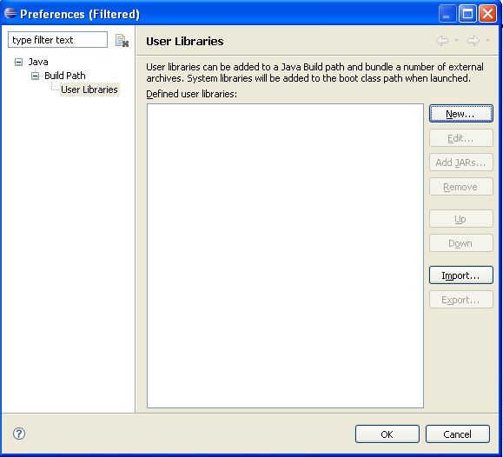
  - Enter the User library name and click OK
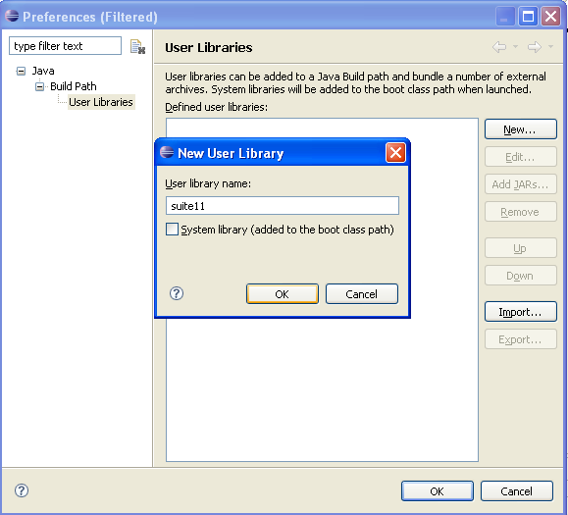
  - From User libraries window click Add jars button. In Jar selection Window Select all *.jar files from CATISSUE_HOME/WEB-INF/lib folder and click Open
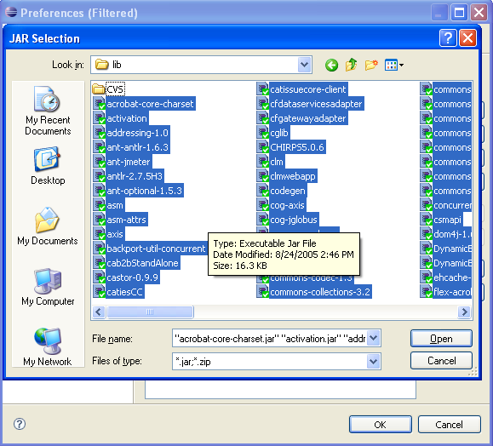
  - Click OK on User Libraries Window
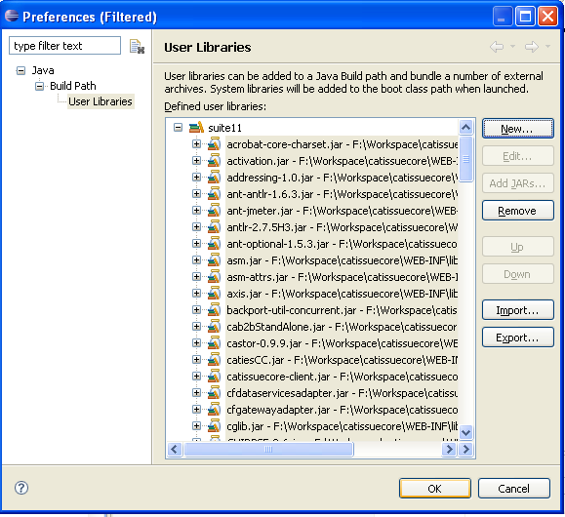
  - Ensure the created library is checked and click Finish button
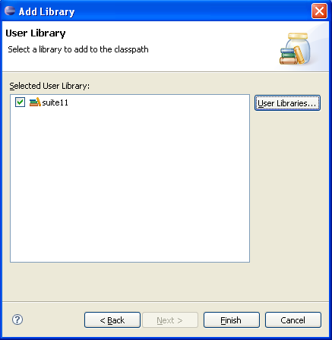
  - Make sure the created user library is added in Build Path and click OK on properties window
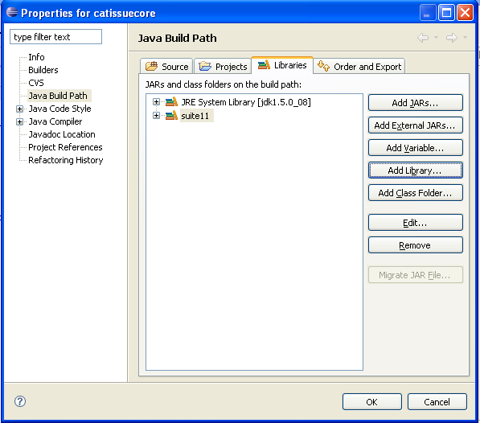
- Now the eclipse should able to compile the source code
- To build and deploy the caTissue web application archive use Ant targets available in CATISSUE_HOME/build.xml and CATISSUE_HOME/deploy.xml

Building dependent jar files

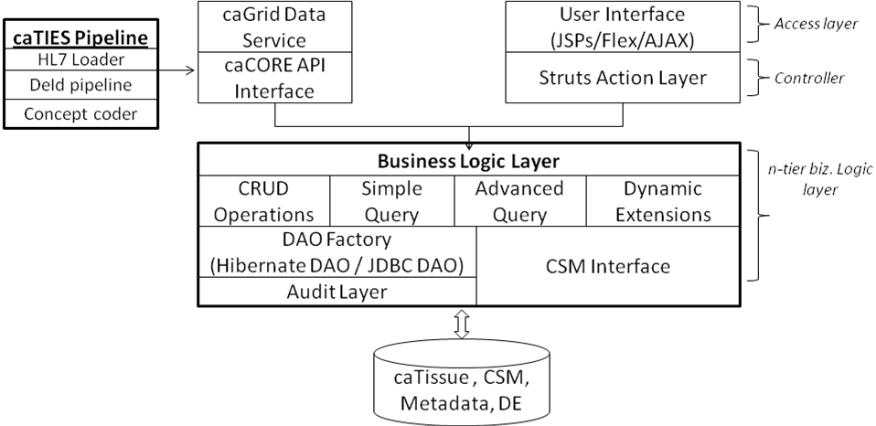
Figure 1: caTissue Architecture

As seen in the above architecture diagram, caTissue is divided into different modules like query, dynamic extensions. These modules are designed to be generic so that they can be reused in any project easily. Due to this, source code of such modules is not part of the main code base of caTissue but exist as separate projects. Only the jar files are included in the lib of caTissue. This section describes the process to generate the jars if one wishes to change the source code in any of these modules.

- Building dynamic extensions code – Execute the following ant targets from the root folder of dynamic extensions source code.
- Compile the code:
>ant compile
- Create dynamic extensions jar
>ant create_dyn_ext_interface_jar
This will create the jar in DynamicExtensionsInterface folder within dynamic extensions source code. Copy this and replace in <caTissue-SourceCodeFolder>/WEB-INF/lib
- Create DynamicExtensionsCommunication.jar
>ant create_dyn_ext_communication_jar
This will create DynamicExtensionsCommunication.jar in root folder of dynamic extensions source code. Copy this and replace in <caTissue-SourceCodeFolder>/WEB-INF/lib
- Finally create the dynamic extensions war
>ant build_app_war
This will create war file in root folder of dynamic extensions source code. Copy this and replace in <caTissue-SourceCodeFolder>
- Building caB2B code - Execute the following ant target from the build folder of caB2B source code:
>ant build.standalone.jar
This will compile the code and create the cab2bStandAlone.jar in the workarea folder of the caB2B source code. Replace this jar in <caTissue-SourceCodeFolder>/WEB-INF/lib
- Building common package code - Execute the following ant target from the common package source code folder:
>ant build_jar
This will compile the code and create the commonpackage.jar in the build folder of the caB2B source code. Replace this jar in <caTissue-SourceCodeFolder>/WEB-INF/lib
- Building Advance Query code – Execute the following ant target from the advance query source code folder:
>ant build.jar
This will compile the code and create the query.jar in the workarea folder of the Advance_Query source code. Replace this jar in <caTissue-SourceCodeFolder>/WEB-INF/lib
- Building Metadata code - Execute the following ant target from the metadata source code folder:
>ant build.jar
This will compile the code and create the metadata.jar in the workarea folder of the Metadata source code. Replace this jar in <caTissue-SourceCodeFolder>/WEB-INF/lib
- Building Washu-Commons code - Execute the following ant target from the Washu-Commons source code folder:
>ant build.jar
This will compile the code and create the washu-commons.jar in the workarea folder of the Washu-Commons source code. Replace this jar in <caTissue-SourceCodeFolder>/WEB-INF/lib
- Building ShippingTracking code –
  - Create the following folders
    - tempShippingTracking in base directory
    - classes folder in WEB-INF directory
  - Execute the following ant targets from the ShippingTracking source code folder:
    - >ant clean
    - ant st_build_jar

This will compile the code and create the shippingtracking.jar in the tempShippingTracking folder of the ShippingTracking source code. Replace this jar in <caTissue-SourceCodeFolder>/WEB-INF/lib
    - >ant st_create_zip
This will compile the code and create the shippingtracking.zip in the tempShippingTracking folder of the ShippingTracking source code. Replace this zip in <caTissue-SourceCodeFolder>
iv. > Shipping Tracking requires catissuecore.jar at compile time that is created from catissueSuitev11RC4 code base and copied into <ShippingTracking-SourceCodeFolder>/WEB-INF/lib
    - Go to caTissue-SourceCodeFolder
    - ant compile
    - ant build_client_jar_for_st
    - It will create catissuecore.jar in tempCatissuecore folder present in caTissue-SourceCodeFolder
    - Copy catissuecore.jar and paste it in <ShippingTracking-SourceCodeFolder>/WEB-INF/lib

Compile, build and deploy
The caTissue build systems uses Ant scripts to drive the code compilation, building web application archive, deploy, and DB schema creation. These ant targets are available in build.xml and deploy.xml located at root directory of “CATISSUE_HOME”.

- Open a command prompt and change your current directory to the one where you checked out the code.
- In this directory you must see a file by the name build.xml. Use the following syntax to run any ANT command:

>ant <target_name>

The ANT targets that are most frequently used are:
- To compile code:
>ant compile
- To create the installable zip file:
>ant create_zip

build.xml
Contains targets to build and prepare the web application archive:
Target | Description
init | Initializes the build process by creating required directories
clean | Clears the classes folder
compile | Compiles the java source code available at CATISSUE_HOME/WEB-INF/src folder
build_war | Build the catissuecore.war from the compiled source code. By default the war is configured for MySQL database.
deploy | Deploy the application to the specified JBoss location in caTissueInstall.properties. This deploys only web application archive (catissuecore.war, caTissuePrintwebservice.war and dynamicextension.war). One should use deploy_app of deploy.xml to do complete deployment including deploying required properties file should
installable_build_war | Build the catissuecore.war from the compiled source code. There is no database specific configuration. After this target one must use deploy_app to deploy the application.
create_zip | This is a major target used for creating caTissue Installable package. Create the installable zip file of the caTissue application which will be used for deploying the application.

deploy.xml
Contains ant targets to deploy the application, create DB schemas, upgrade from Suite 1.0 to Suite 1.1
Target | Description
deploy_all | Deploy the application to Jboss and also creates caTissue database schema
deploy_app | Deploy the application to Jboss
deploy_db | Create caTissue database schema
upgrade_all | Deploy the application to Jboss and also upgrade the caTissue database schema from previous caTissueSuite v1.0
upgrade_db | Upgrade the caTissue database schema from previous caTissueSuite v1.0

Generating caCORE API

If there are changes to the caTissue UML model, corresponding modified caCORE APIs have to be generated. Below are the steps to generate caCORE SDK.
- Copy the UML model in XMI format in CaCoreSDK_3_2_1\models\xmi
- Configure deploy.properties in CaCoreSDK_3_2_1\conf folder
- Set JBoss, mysql and Java parameters
- project_name= catissuecorecsm
- default_security_level=1
- disable_writable_api_generation=no
- model_filename = <XMI file name>
- fixed_filename = <Fixed_XMI file name>
An example file is provided within the CaCoreSDK_3_2_1\conf.
- Uncomment following lines in the file build-custom.properties present in CaCoreSDK_3_2_1 folder:
#generate-beans.main.ignore=yes
#generate-junit.main.ignore=yes
#generate-OR-mapping.main.ignore=yes
- Run target build-system from command prompt
>ant build-system
- After successful build go to CaCoreSDK_3_2_1\output\catissuecorecsm\package and open catissuecorecsm.war and delete the following files from catissuecorecsm.war /WEB-INF/classes
- xml.properties
- xml-mapping.xml
- unmarshaller-xml-mapping.xml
- catissuecore.csm.new.hibernate.cfg.xml
- server-config.wsdd
- deploy.wsdd
- hibernate.properties
- edu.wustl.catissuecore.domain.pathology.xsd
- edu.wustl.catissuecore.domain.shippingtracking.xsd
- edu.wustl.catissuecore.domain.xsd
- catissuecorecsm.war /WEB-INF/lib/mysql-connector-java-3.1.13-bin.jar

- Copy Web-INF/src/hibernate.cfg.xml from caTissue and paste it to catissuecorecsm.war/WEB-INF/classes as orm1.cfg.xml.
- After successful run go to CaCoreSDK_3_2_1\output\catissuecorecsm\package, copy the war (i.e catissuecorecsm.war) into caTissue source code.
- Copy catissuecorecsm-client.jar from CaCoreSDK_3_2_1\output\catissuecorecsm\package\client\lib to caTissueSuite_Client\lib in caTissue source code and rename it to catissuecore-client.jar. Copy the same jar under WEB-INF/lib of caTissue also.
- Change in catissuecore/Web-INF/web.xml to replace servlet name and servlet class

New Entry:
<servlet>
<servlet-name>sdkstartup</servlet-name>
<servlet-class>
gov.nih.nci.common.util.WebStartupUtil
</servlet-class>
<load-on-startup>1</load-on-startup>
</servlet>
<servlet-mapping>
<servlet-name>sdkstartup</servlet-name>
<url-pattern>/server/HTTPServer</url-pattern>
</servlet-mapping>

Old Entry:
<servlet>
<servlet-name>HTTPServer</servlet-name>
<servlet-class>gov.nih.nci.system.proxy.HTTPServer</servlet-class>
<load-on-startup>1</load-on-startup>
</servlet>
<servlet-mapping>
<servlet-name>HTTPServer</servlet-name>
<url-pattern>/server/HTTPServer</url-pattern>
</servlet-mapping>

- Copy SDKSpringBeanConfig.xml from CaCoreSDK_3_2_1\output\catissuecorecsm\src to /WEB-INf/src of caTissue.
- Open DAOConfig.xml and add entry for ReportLoaderQueue, ReportLoaderQueue is a part of caTIES that is not in caTissueSuite Model so user need to make manual entry of ReportLoaderQueue in DAOConfig.xml

Following is the ReportLoaderQueue entry:

edu.wustl.catissuecore.domain.pathology.ReportLoaderQueue,edu.wustl.catissuecore.domain.pathology.impl.ReportLoaderQueueImpl

