caTissue Suite V 1.1

Software Design Description

Contents
Software Design Description i
1. Introduction 3
1.1 References 3
2. Query Design 4
2.1 Overview 4
2.2 Custom Formula 4
2.3 Parameterized Query 4
2.4 Class diagrams 5
2.5 API Summary 6
3. MULTI SITE REPOSITORY 9
3.1 Introduction 9
3.2 Document Overview 9
3.3 MOdel CHANGEs 9
3.4 Assigning Privilege using CSM 10
3.4.1 Steps involved in assigning privileges to user 11
3.5 Flow diagram of adding privileges to the user 12
3.6 Authorization using CSM 12
3.6.1 Steps of authorization 13
3.7 APPENdix 14
3.7.1 Additional sequence diagrams and flow diagrams 14
4. DE – Separation of UI and Model 16
4.1 Proposed solution 16
4.2 Object model changes 17
4.3 Dynamic UI generation 20
4.4 Data storage for category 20
4.5 CategoryManager class 21
4.6 Category creation through CSV file 22
4.7 Permissible values for category attribute 22
4.8 Work flow of form creation 23

Introduction
This document elaborates the design for the three main features of caTissue Suite 1.1:
- Support of multiple repositories within single caTissue instance
- Temporal Queries
- Enhancement in Dynamic Extensions: Separation of Model and UI

References
caTissue Suite 1.1 Use Cases and Requirements Specification Document
caTissue Suite 1.0 Design Document

Query Design

Overview
The query-object (IQuery) provides the interfaces used to represent a user-defined query. The query consists of constraints (represented by IConstraints). User defined conditions (e.g. Participant.sex = ‘female’) are represented by ICondition. Conditions on different attributes of an entity are grouped together as a rule (represented by IRule). Various rules/expressions on an entity can be logically grouped into an expression (represented by IExpression). An expression thus consists of operands (i.e. rules or sub-expressions; this is represented by IExpressionOperand) connected by logical operators (AND, OR). Operands in an expression can also be parenthesized.
The various expressions thus formed need to be linked together. Two expressions are linked by an association (represented by IAssociation). These linkages among the expressions constitute the join graph (represented by IJoinGraph).
An expression can be marked as “in view”; this means that the entity corresponding to that expression will be included in the output of the query. Thus, all expressions that are “in view” constitute the output of the query.

Custom Formula
In addition to the constraints based on simple rules, the user can create arbitrarily complex constraints involving multiple attributes from various classes. Such a constraint is called a custom formula (represented by ICustomFormula). An example of a custom formula is
FixedEventParameters.timestamp – CollectedEventParameters.timestamp <= 30 minutes
The relational operator (<=) separates the custom formula into two parts: a left-hand side (LHS) and a right-hand side (RHS). Each side is referred to as a term (represented by ITerm).
A term can have literals (e.g. 30 minutes), and attributes (e.g. FixedEventParameters.timestamp) sourced from existing expressions. Thus, in order to create the LHS term above, two expressions, on FixedEventParameters and CollectedEventParameters should exist.
As the above example illustrates, a term contains arithmetic operands (represented by IArithmeticOperand); these operands are connected by binary arithmetic operators (+, -, *, /). An arithmetic operand can either be a literal (represented by ILiteral) or an attribute sourced from an expression (represented by IExpressionAttribute). The arithmetic operands in a term can also be parenthesized.
A custom formula, like a rule or sub-expression, is used an as operand in an expression.
A term can also be present in the output of a query; this is represented by IOutputTerm.

Parameterized Query
The user/admin may define a query which has some conditions/custom formulas as parameters. Such a parameter is represented by IParameter. A parameter can be defined on any object that is parameterizable (represented by the marker IParameterizable). Currently, conditions and custom formulas are parameterizable.
A query that has one or more parameters is called a parameterized query (represented by IParameterizedQuery).

Class diagrams
Note: The text on the generalization links refers to type parameters.
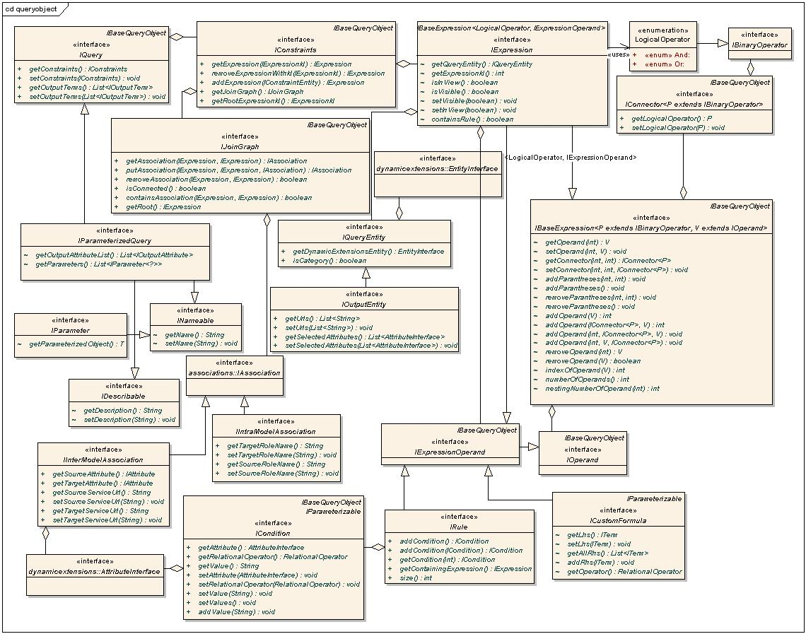
Interfaces that compose the basic query-object

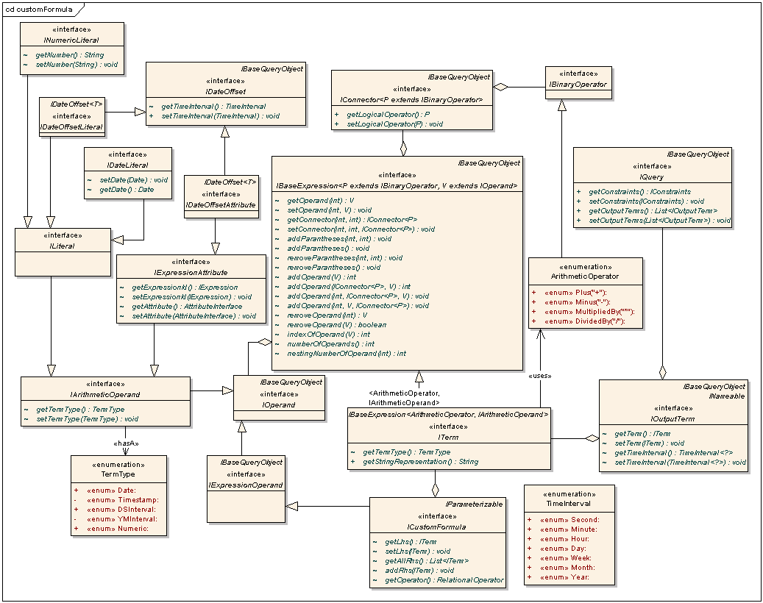
Interface that compose custom formulas and terms

API Summary
ICondition | A condition containing an attribute, relational operator and value(s). E.g. participant.sex = 'Male'
RelationalOperator | An enumeration of the relational operators (=, <, >, Between, In etc.)
IRule | A list of conditions on different attributes of an Entity.  Note: The conditions in a rule are implicitly linked by AND condition.
IQueryEntity | An entity that is associated with an expression.
IConstraints | Contains information about the constraints of a query. It contains a list of IExpression’s that is indexed by IExpressionId. This is global storage location for all expressions in a query. Only calling the addExpression() method here can create an IExpression. It also contains a join graph for specifying how the expressions are linked together.
IBaseExpression | A list of operands and the operators connecting them together form a base-expression. The operators are identified by the position of the operands on either side. The operator and operand types are parameterized.
IOperand | Represents an operand in an IBaseExpression.
IBinaryOperator | Represents the binary operator in an IBaseExpression.
IConnector | Represents a connector between two operands in an IBaseExpression. The nesting represents the number of parentheses (depth of parentheses) around the operator portion (e.g. AND, OR) of the connector. The operator type is parameterized.
IExpression | An IExpression is an IBaseExpression with operand of type IExpressionOperand and operator of type LogicalOperator.  An IExpression belongs to a constraint entity and constraints on another associated entity will be present as a sub expression on the associated entity. Conversely, if an expression has a sub-expression, there must an association in the join graph from the parent expression to the sub expression.
IExpressionOperand | A marker interface for an operand. An operand is either a sub expression (IExpression), or a rule (IRule).
LogicalOperator | An enumeration of the operators AND, OR.
IJoinGraph | A rooted, directed acyclic graph with expressions as vertices, and associations as edges. The graph will always contain all the expressions' ids (obtained from IConstraints) as vertices. The vertices will be added to/removed from the IJoingraph as and when expressions are added to/removed from IConstraints. The methods in IJoingraph can only add/remove associations among the vertices.  If v1 and v2 are two vertices, the direction will be v1->v2 if v2 is a sub expression of v1. The user of the API will generally build the join graph based on metadata, and in cases of ambiguity, the user will help forming this graph. This graph basically determines the join conditions in the query. E.g. for each edge (v1, v2) between two vertices v1 and v2, there will be a join between the functional classes of the expressions denoted by v1 and v2; and the join condition is determined by the info in the IAssociation.
IQuery | The query object. This is the final unit that is built from UI and persisted.
ITerm | An ITerm is an IBaseExpression with operand of type IArithmeticOperand and operator of type ArithmeticOperator. The type of a term can be obtained by calling getTermType (); the term-type (represented by TermType) is computed based on the term-types of the operands and operators in the term.
ArithmeticOperator | An enumeration of the arithmetic operators (+, - etc.)
IArithmeticOperand | Represents an operand in a term. Each operand has a term-type associated with it.
TermType | An enumeration of the types of terms (currently Date, Timestamp, Numeric, DSInterval, YMInterval).
ICustomFormula | Represents a custom formula as an LHS term and a list of RHS terms (relational operators such as Between, In have more than one RHS).
ILiteral | Represents a literal in a term.
INumericLiteral | Represents a numeric literal.
IDateLiteral | Represents a date literal.
IExpressionAttribute | Represents an attribute in a term.
IDateOffset | Contains a time interval for an operand that is to be used to offset a date.
TimeInterval | A compound enumeration of the time intervals Minute, Hour, Day, Week, Month, Quarter, Year
IDateOffsetLiteral | A literal that is used to offset a date.
IDateOffsetAttribute | An attribute that is used to offset a date.
IOutputTerm | A term that is present in the output of a query.
IParameterizable | A marker that implies that an instances of any implementing class can be parameterized.
IParameter | Represents a parameter of a query; contains a handle to the parameterized object (an instance of IParameterizable) and a user-defined name.
IParameterizedQuery | A query that contains one or more parameters.
QueryObjectFactory | Factory to create instances of the above interfaces.

MULTI SITE REPOSITORY

Introduction
This document describes the design for implementation of Multi Repository in Catissue.By Multi Site concept we mean running multiple banks on a single Catissue Instance,. Users of each site will have different privileges assigned and can consequently perform different actions. This document describes details of all the interfaces and classes required to implement this functionality.

Document Overview
The document starts with the changes required in the existing model and then proceeds to describe the modifications in execution flow in the Add User as well as add collection protocol (CP) functionality. Additionally the details of new interfaces and classes that will be required have been listed..

MOdel CHANGEs
This section describes the changes in the object model that are required to implement the MSR functionalities.
The most important objects related to MSR are
- Site: User can have administrative privileges on one or more sites E.g. One of the privileges that user can have on a site is “Storage administration” which means that if user wants to add a container to a site, he must have this privilege on that site.
- User: User object maintains the information related to the user – site mapping and user – collection protocol mapping.
- Collection protocol: User can have bio-specimen privileges on one or more CPs. E.g. One of the privileges that user can have on a CP is “Registration” which means that if a user wants to register a participant to a CP , he must have that this privilege on that CP.
Following is the description of all the model changes required for MSR.
- A collection protocol will always belong to one or more sites. So a mapping is required to reflect this relationship. So a “bi-directional” many to many association is added between “Site” and “Collection Protocol” This association means that a site may contain one or more CPs and a CP may belong to one or more sites.
- Similarly there needs to be a bidirectional association between Site and User as a user may be a site admin of two sites as well as a site can have many users. So a bi-directional many to many association is added between “Site” and “User”.
- Similarly user may work on one or more CPs at a time and CP may have many users. So a bi-directional many to many association is added between “Collection protocol” and “User”
Following diagram shows the above mentioned associations pictorially.
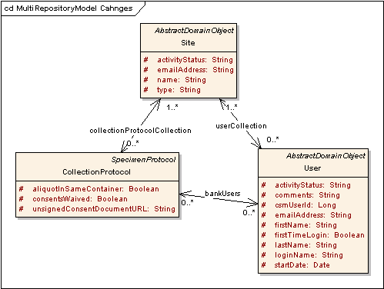
Figure 1 Model changes for MSR

Assigning Privilege using CSM
This section describes the process of mapping user privileges using CSM. Currently there are two base objects in the application viz. “Site” and “Collection protocol” which user can have different privileges on. All the user privileges except administrative data are mapped to one of these two objects.
Following are the classes and methods used in privilege mapping
- UserBizLogic/CollectionProtocolBizLogic
Method name | Description
insertAuthorizationData(int userId,List<Integer> cpList,List<string> privilegeList) | This method inserts all the privilege related data in the CSM tables.
insertCPPrivileges(Map) | This method inserts all the CP related privileges in the CSM tables.
insertSitePrivileges(Map) | This method inserts all the site related privileges in the CSM tables.

- PrivilegeUtility
Method name | Description
createRole(String roleName,List<String>) | Dynamically creates new role for given privileges with given name.
createProtectionGroup(String Name,Set protectionObjects) | Dynamically creates new Protection Group (PG) and assigns all Protection Objects to it.

- SiteUserRolePrivilegeBean.java
This bean will be populated during the assign privilege operation and will be used to display details on ViewSitePrivilegesSummary.jsp.
This bean represents user’s assigned privileges on site or CP.
Attribute name | Description
String SiteName | Name of the Site.
String UserName | Name of User to whom some Site privileges are assigned.
String Role | Role of User.(e.g. Admin,Scientist)
String List<String>Privileges | List of privileges assigned to a particular User.

Steps involved in assigning privileges to user
To explain how privileges are assigned to a user on either site or CP, a scenario is considered where administrator is trying to assign “Registration” privilege to a user on a particular CP.
- Whenever administrator assigns a privilege to a user on assign privilege page, a new object of class “SiteUserRolePrivilegeBean” is created and placed in a map which is kept in a user session. This instance of “SiteUserRolePrivilegeBean” class represents the user’s assigned privilege on the UI.
- When administrator submits the information, this map containing one or more instances of “SiteUserRolePrivilegeBean” is taken to the respective biz logic.
- In the biz logic class, for every instance of SiteUserRolePrivilegeBean, a new mapping of protection group and user group is formed dynamically based on the given information in the object.
- Then to assign the given set of privileges to this newly created mapping of protection group and user group, a new dynamic role is created and the assigned privileges are associated to this newly created role.
- This newly created role is then assigned to the mapping of protection group and user group.
- This complete mapping of role, protection group and user group means that the given “user group” (containing the user for which administrator is assigning privileges) has given “Role” for the given “Protection group”.

Flow diagram of adding privileges to the user
Following diagram represents the flow involved in assigning privileges to a user.
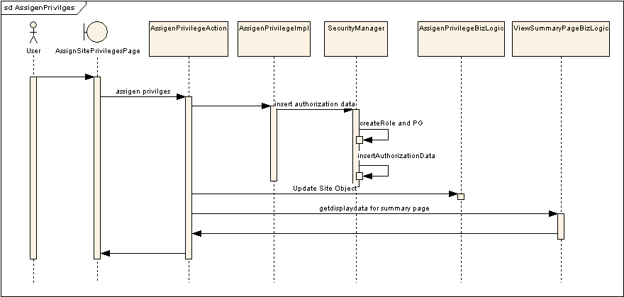
Figure 2 Assigning privileges to user

Authorization using CSM
This section describes the actual authorization based on all the privileges assigned to user at different places in the application. Authorization takes place whenever user tries to add or edit any object which requires special privilege.
Following are the classes and methods used in the authorization

- DefaultBizLogic
Method name | Description
getPrivilegeName(AbstractDomainObject) | Gives the privilege which should be used for authorization.
getObjectId(AbstractDomainObject  ,SessionDataBean) | Gives the name of the CSM protection element which is used for authorization.
isAuthorized(privilegeName, objectId,SessionDataBean) | Checks whether the logged in user has the required privilege on the protection group containing given protection element name (object id)

Steps of authorization
To explain how authorization takes place, a scenario is considered where user is trying to add a participant to a collection protocol.
To register a participant to a CP, user must have “Registration” privilege on that CP.
- When user submits the participant information, flow comes to the abstractBizLogic’s insert method.
- In the insert method, first “getPrivilegeName” method will be called on the bizlogic. This method is supposed to be extended by each biz logic. The method returns the privilege which needs to be checked for the given scenario. In this scenario, this method will return “Registration”.
- Next, “getObjectId” method will be called. This method returns a string which is the CSM protection element.This method is overridden by every biz logic class. The protection element naming convention is:
“<<Base Object full class name>>_<<base object id>>”
In our scenario it will be “edu.wustl.catissuecore.CollectionProtocol_1”
- Once privilege name and protection element name is obtained, “isAuthorized” method is called to check whether the logged in user has the given privilege on given protection element.
- If the above mentioned method returns “true” then object is added to the database. Otherwise “UserNotAuthorizedException” is thrown with all the details. This exception is then processed at action class level to display a proper error message to the user.
- The error message is displayed in following convention.
“Access denied to add / edit “<<Object name>>”. User does not have “<<privilege name>>” privilege on related “<<base object name>>”
In the considered scenario, the message will be
“Access denied to add / edit “Participant”. User does not have “Registration” privilege on related “CollectionProtocol”.
Following diagram describes the above mentioned flow of authorization.

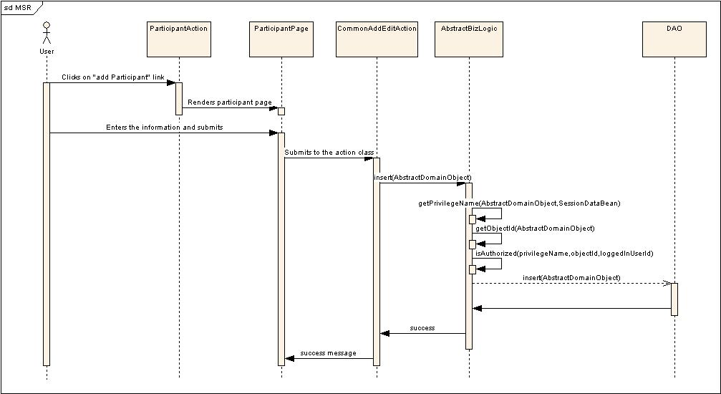
Figure 3 Authorization of privileges

APPENdix

Additional sequence diagrams and flow diagrams
This diagram will describe a flow to view a Privileges page which will be common for both User and Collection Protocol. Following diagram is more focused on Add User flow.
From Add User page when a user will click on Assign Privileges Button request will be forwarded to ViewAssignPrivilegPageAction.java.In this action the data required for AssignSitePrivileges.jsp and ViewSitePrivilegesSummary.jsp will be collected from respective biz logics and page will be displayed to a User.
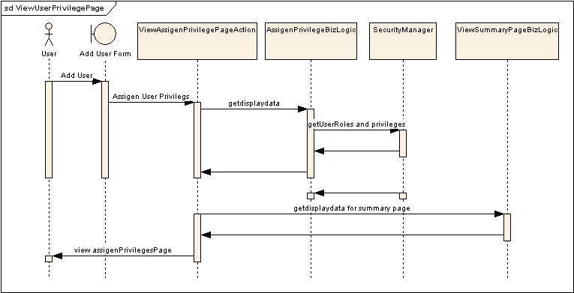
Figure 4 Viewing user's privileges

DE – Separation of UI and Model
In the current implementation, UI generated is too tightly coupled with model-metadata, which eliminates the possibility of changing the UI display of forms without changing the model-metadata (and limits the UI that can be created even by changing the model-metadata).
To combat this limitation of the system, new functionality is implemented within the Dynamic extensions component that enables the actor to accomplish tasks such as the below:
- Create new UI forms using existing metadata.
- Define new labels for forms and controls.
- Define new UI properties for a control.
- Define new permissible values for a control (New permissible values should a subset of original values).
- Define new validation rules for a control.
- Choose attribute from different classes to create a new form.
- Create read only/invisible attributes (Related attributes) with default values.

Proposed solution
As Administrator creates new forms, UI metadata of new forms needs to be captured. Newly created forms use existing UML metadata. This needed changes in the object model.

Object model changes

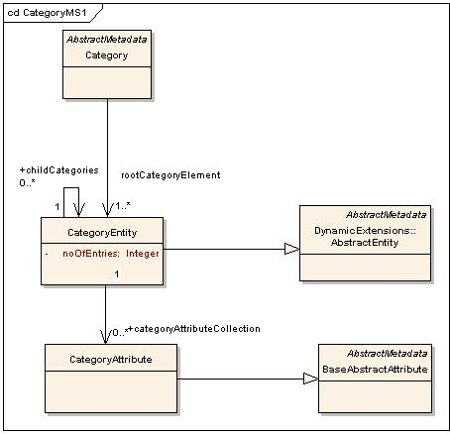
Figure 5: Category classes

- Category class added acts as metadata wrapper class for newly created form. For each form a category is created.
- Whenever attributes are selected from an entity for a new form creation, a new category entity is created. Category entity contains a reference of original entity. A category contains a tree of category entities. Category contains a reference of the root of category entity tree. Entity and category entity derive from abstract entity as category entity is a special kind of entity,
- A form can contain attributes from different entities. For each entity used in a form creation, a category entity is created.
- Same entity can be used multiple times for form creation. In this case multiple instances of category entities are created. All of them will point to same to same entity.
- Category entity contains a set of category attributes. When an attribute is selected for category creation, a category attribute is created. Category attribute contains a reference of original attribute. Category attribute and abstract attribute derive from BaseAbsratctAtribute as category attribute is a special kind of attribute.

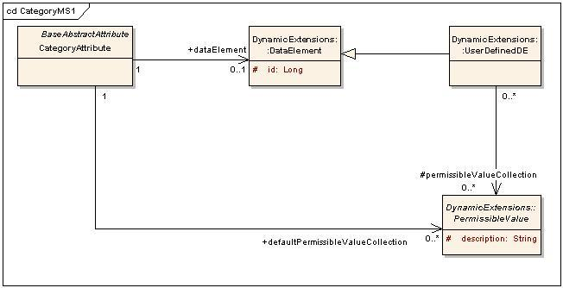
Figure 6 : Specify permissible values for category attribute

- User can select a subset of permissible values for category attribute. Category attribute will contain a data element which will be of type user defined data element. This data element will contain a set of abstract values selected by user. As the permissible values are now shared among many data elements, the cardinality is changed to *-*.
- A form can have a set of related attributes. The values of the related attributes are submitted implicitly at the time of data entry. Related attribute contains a collection of abstract values, which are to be submitted implicitly. Related attribute contains a reference to original attribute.
- Related attribute value can also be shown to user in read only mode. IsVisible attribute in category attribute class can be used for this purpose.

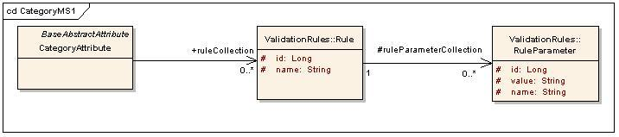
Figure 7 : Specify validation rules for category attribute

User can define a new set of rules for a category attribute. Category attribute contains a rule collection. Each rule can have a set of parameter values. If the rules are not overridden for the category attribute, then original attribute rules will be applied.

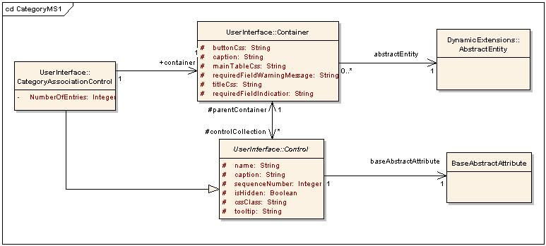
Figure 8 : UI classes

- Container class will be used for specifying display properties of a category entity. Container contains a reference of abstract entity which can be category entity or entity. So the same container class is used for generating UI of category or entity.
- Control class will be used for specifying display properties of the category attribute. Control contains a reference of base abstract attribute which can be category attribute or abstract attribute. So the same control class is used for generating UI of category attribute or entity attribute.
- CategoryAssociationControl class is added to represent relation between containers of two category entities. This control contains a reference of target category entity container. This control will generate HTML and will work on similar lines of Containment Association Control.
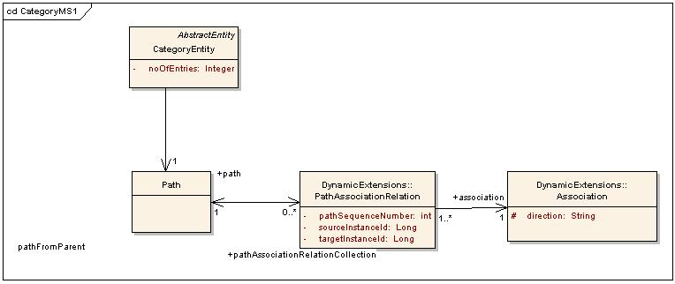
Figure 9 : Path of a category entity

Each category entity contains a path object. Path of a category entity is an ordered set of associations starting from entity of the root category entity and entity of the category entity. Path association relation class stores sequence number of the association.

Dynamic UI generation
- For each category entity, a container object is created. Container object contains UI properties of the form. Container contains a reference of category entity. For UI generation container needs metadata information. Category entity provides that information.
- For each category attribute a control is created. Control contains UI properties of an attribute. Control contains a reference of category attribute. For UI generation control needs metadata information. Category attribute provides that information.
- Category contains a tree of category entities. As there is a container for each category entity, a tree of containers is created.
- This tree of containers is used for displaying main forms and sub forms. Dynamic UI is generated using newly formed containers and controls.
- Containers in the tree are linked through category association control. So main form container is linked with sub form container through category association control.

Data storage for category
- Due to model and UI separation functionality, model structure and UI structure are totally different. A separate set of data tables is needed for maintaining category records.
- For each category entity in a category, a data table is created. That table contains references of original entity records. There will be three columns in the data table. First column will have category entity identifier, second column will have entity record identifier and third column will be a foreign key column which will have a reference of parent category entity record.
- So when a record is inserted for a category, a record will be inserted in original entity and one in the data table for category entity. Record in category entity table will have a foreign key reference of original entity record.
- As a form can contain attributes from multiple entities, a record will be inserted in each of the entities used.
- As category entities are linked to form a tree structure, data tables of category entity are also linked in the form a tree structure using foreign key relations.
- Each category entity has a path object. Path is an ordered set of associations starting from root entity to entity in consideration. A record will be inserted for each entity in the path.
- A form can have related attributes. Related attributes are the attributes whose values are submitted implicitly at the time of data entry.
- It might be the case that same entity is used multiple times for category creation. So multiple records will be inserted for that entity. So path object stores instance information of entities as well.

CategoryManager class

CatgeoryManager class is used for dealing with categories. This class extends from AbstractMetadataManager class.
This class is used by UI processor classes to create categories and to do category data handling.
Following are the methods from CatgeoryManager class.
- Following method is used for category creation.
public CategoryInterface persistCategory(CategoryInterface categoryInterface) throws DynamicExtensionsSystemException,
DynamicExtensionsApplicationException
This method stores category metadata and creates data tables for category entities.
- Following method is used for inserting data for the category
public Long insertData(CategoryInterface category, Map<BaseAbstractAttributeInterface, Object> dataValue, Long... userId) throws DynamicExtensionsApplicationException, DynamicExtensionsSystemException
First argument to this method is the category for which data is to be inserted. Second argument is the map that stores data entered by the user. Key of the map is the BaseAbstractAttributeInterface. So CategoryAttribute and CategoryAssociation can be used as key. When CategoryAttribute is used as a key value part is of type String. When CategoryAssociation is used as a key value part is a list of maps. Maps in the list follow the same structure as parent map.

A similar method with same arguments is used for edit data.
Following method is used for retrieving category data,
public Map<BaseAbstractAttributeInterface, Object> getRecordById(CategoryEntityInterface rootCategoryEntity, Long recordId) throws DynamicExtensionsSystemException, DynamicExtensionsApplicationException, SQLException

First argument to this method is the category whose record is to be retrieved. Second argument is the record id of the category record to be retrieved.

Category creation through CSV file

Category creation is supported through a csv file right now. User interface will be provided for category creation in the later phases of development. Following is the high level structure of category csv file.
- The csv file will contain information about main form and sub forms to be created.
- It will have label for main form. A main form can have attributes from different entities and can have sub forms. Sub forms can also have attribute from different entities. Attribute and sub form information will be specified below main form.
- Each attribute will have a UI label. User can also specify UI properties for the attribute.
- For each entity used in category creation, path will be provided. It will list all the entities in the path starting from root entity to entity in consideration.
- As same entity can be used multiple times for category creation, instance information is also specified in the path.
- An ant task will be provided that will read csv files and create category accordingly.

Permissible values for category attribute

- Administrator can define a new set of permissible values for a category attribute. These new values should be a subset of original attribute values.
- User can specify permissible values directly in the category csv file or he can specify path of permissible value file in the category csv file.
- An ant task is provided for category creation will also read permissible values from file.
- A new data element is created for each category attribute with permissible values. This data element contains a set of permissible values to be shown. This data element will be used at the time of dynamic UI generation so that user is displayed with new set of permissible values.

Work flow of form creation
- Create UML model using enterprise architect and export the UML metadata information. This will generate XMI file having UML metadata information.
- Import the XMI file in Dynamic extensions. This completes the UML metadata model import part. Now administrator can create different forms using this information.
- Create a new csv file for form (category) creation. This file contains all form information as specified above.
- Use form creation ant task which uses category csv file.
- Now the new forms are available for data entry.
- In this way one can reuse UML metadata to create new forms with different UI properties.
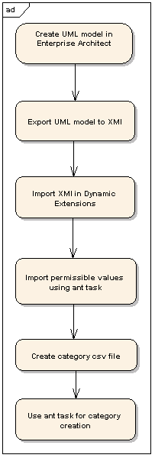
Figure 10 : Category creation flow

