caTissue issues in using caCORE API

This document describes the overall issues raise regarding using caCORE API “as-is” for caTissue and design/code changes made in caCORE SDK 3.2.1 to support most of caTissue use cases. This document also contains overall summary/comments from caCORE SDK team during discussion.

Steps and modification of caCORE SDK code fro API generation for caTissue 2
Problems using caCORE generated code/hbm in caTISSUE 6
Summary of discussion with caCORE team 7

Steps and modification of caCORE SDK code fro API generation for caTissue
This section describes the generation of caCORE API for caTissue and modification done in caCORE code to satisfy caTissue use cases. Following diagram depicts high level flow of data between caTissue and caCORE

Application Server

Client
caCORE SDK API
caTissue
caTissue Database
Delegate
caTissue Application

The caCORE code has been modified in such way that all call to API i.e. insert/update/delete has been delegate to caTissue bizlogic classes. For API search/query the special handling for CSM filtering has been added after getting result from caCORE.

Code Modification insert/update/search

- ApplicationServiceServerImpl.java
Each method such as createObject(), updateObject(),search(),query() has been modified to delegate the call. For instance following code shows the modification done in createObject()

public Object createObject(ClientInfo clientInfo, Object
domainobject) throws ApplicationException
{
/*
* Since we are checking authorization & priviledges in caTissue core application, security check is not required.
*/
// method name for add
String methodName = "delegateAdd";
// calls the caTissue delegator
return callDelegator(methodName,clientInfo,domainobject);
}

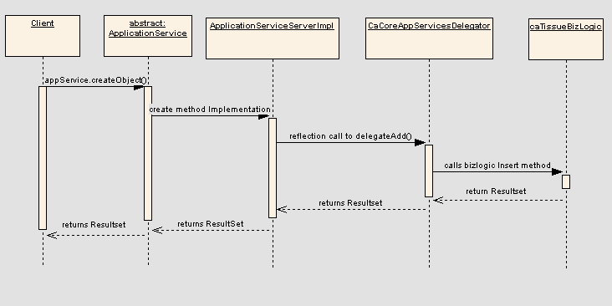
Figure 1 Sequence diagram for insert/update
- The caTissue client invokes abstract method createObject() of class ApplicationService.
- ApplicationServiceServerImpl provides implementation of createObject() method.
- callDelegator method of ApplicationServiceServerImpl uses reflection to call delegateAdd() method of caCoreAppServiceDelegator, caCoreAppServiceDelegator is a delegater class which invokes bizlogic methods of catissue objects.
- delegateAdd() methods of caCoreAppServiceDelegator call bizlogic.insert() method of the domain object passed.

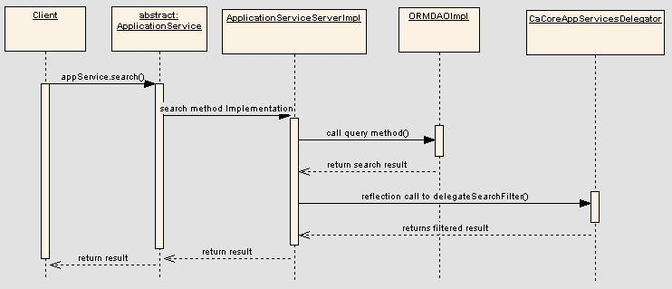
Figure 2 Sequence diagram for search/query
- The caTissue client invokes abstract method search() of class ApplicationService.
- ApplicationServiceServerImpl provides implementation of search().
- ApplicationServiceServerImpl invokes query method of ORMDAOImpl class and return search result.
- callDelegator method of ApplicationServiceServerImpl uses reflection to call delegateSearchFilter() method of caCoreAppServiceDelegator. The delegateSearchFilter method filters the list of objects returned by the search depending on the privilege of the user on the objects. Also sets the identified data to null if the user doesn't have privilege to see the identified data.

Code Modification for adding new APIs

For adding new API method following classes has been modified
- ApplicationServiceImpl.java
- ApplicationService.java
- ApplicationServiceProxy.java
- ApplicationServiceServerImpl.java
- ApplicationServiceClientImpl.java

Code modification for security

1. Change related to security i.e caTissue is already integrated with CSM so no need to check for security thus we removed security check.

public List getObjects(Object domainobject) throws ApplicationException
{
if (securityEnabler.getSecurityLevel() > 0)
{
String domainObjectName =
domainobject.getClass().getName();
if (!securityEnabler.hasAuthorization(domainObjectName, "READ"))
{
throw new ApplicationException("User does not have privilege to READ " + domainObjectName + " object");
}
}
return writableDAO.getObjects(domainobject);
}

Removed security check from the above method.

public List getObjects(Object domainobject) throws
ApplicationException
{
return writableDAO.getObjects(domainobject);
}

caCORE API generation steps

- Download caCORE SDK 3.2.1
- Configure deploy.properties
- Copy custom java beans and HBM files in caCORE SDK/custom/catissuecore folder
- Modify code to satisfy caTissue requirements as given above.
- run ant build-system.
- Copy the war generated by caCORE viz. catissuecorecsm.war in caTissue Core Code base.
- Run ant build-war of caTissueCore application.
  - This target compiles code of catissue and creates the war viz. Catissuecore.war
  - Then merge two war catissuecore.war and catissuecorecsm.war in a single i.e. catissuecore.war. This final catissuecore.war contains catissue application specific classes + all caCORE API related classes.

Problems using caCORE generated code/hbm in caTISSUE

Problem 1 caCORE insert/update API

a) In caCORE there is no provision where we can insert/update multiple objects in one transaction. And also caTissue has a use case of validating domain objects, inserting authorization data while insert/update. Thus we found there is need of modifying caCORE code where we delegate a call to caTissue BizLogic where the same bizlogic is from both UI and caCORE API.

Problem 2 caCORE generated HBM

a) In caCORE generated HBM there is no concept of cascade-save update which we have to use at many places

b) In caCORE generated HBM uses assigned generator. That is before inserting object we need to set the identifier by calling max(identiifer)

We can modify the caCORE code to generate cascade-save-update, and use native generator with sequence name for each class. But there is a caCORE code modification. This is a reason we use custom HBM.

Problem 3 caCORE generated Code.

a) In getter methods of code generated by caCORE ApplicationService.search() implementation is added to get associated object. This creates a problem while inserting/updating domain objects. Because while inserting domain object hibernate also calls getter to insert association and at that time if there is implementation in getter methods that will execute to get association from DB which is yet to be insert.

b) Also we populate domain object from ActionForm and get the association of that object calling getter. This also creates a problem where we don’t want object from DB but whatever is set from web UI.

Solution to this problem can be like add null check in getter methods as follows:
Participant.java

getParticipantMedicalIdentifierCollection()
{
if(participantMedicalIdentifierCollection==null)
{
participantMedicalIdentifierCollection = ApplicationService.search
("ParticipantMedicalIdentifier",participant);
}
return participantMedicalIdentifierCollection;
}

There is also a problem in this solution where we explicitly set null, and we want null if called getter, but here there will ApplicationService call. Also there is again code change in caCORE generated code.

Problem 4 CSM filter

a) We need a CSM filtering for all searched object through caCORE API. For this we need to modify caCORE code where we set PHI attributes to null if user is not authorized to see PHI.

Problem 5 Multiple Client Session

a) caCORE does not allow to create multiple ClientSession pointing different service

Summary of discussion with caCORE team

caTissue team currently uses SDK 3.2.1 and is facing problems in primarily following categories
- SDK generated hibernate mapping files are not sufficient for writable API the reasons being the following
  - SDK do not allow specifying identity generator in graceful manner
  - SDK do not have mechanism to specify cascade properties of the association
  - Nullable and not nullable columns cannot be specified on foreign keys
- SDK generated Java beans do not work appropriately with writable API
  - SDK mapping HBM files do not have cascade settings so everything works fine
  - As cascade settings are enabled, hibernate invokes on the getter methods of the associations to update them which goes back to the database for no reason for newly created objects
- CSM filters
  - SDK needs to be extended to null out certain attributes for certain users
- Connecting to multiple remote service
  - SDK do not allow the users to use different CSM accounts to connect to different SDK generated remote services
  - The underlying problem is ClientSession is singleton which holds information for only one user at a time
- Extending application service
  - In order to support additional operations on the SDK generated system, the ApplicationService needs to be extended.
  - caTissue team currently modifies SDK’s source code and adds operations in the ApplicationService

As discussed, all the problems are currently present in the SDK 3.2.1. The problems identified are more of feature request then defects. Below is the response from the SDK team
- SDK 4.0 has all the mentioned features present except for
  - Hibernate mapping files are not adequate for writable API and
  - writable API are not available
- If needed, caTissue team can use JDK 5 compliant Java beans and SDK supported HBM files (files that include features that SDK supports) with SDK 4.0
- SDK 4.0 generated systems will be compatible with cagrid 1.2 which is due release in next month
- SDK team advised caTissue to migrate to SDK 4.0 and suggested that SDK 3.2.1 will be updated only for the defect fixes and not for the feature enhancements. SDK team will continue supporting SDK 3.2.1 only from usage and defects perspective
- caTissue team will send across design documents for the caTissue pertaining to the SDK by Tuesday so that SDK team can further assess the integration points requirements

