Tailoring the Right Configuration
caTissue Suite v1.1 Hardware and Software Specifications
 The Right Partner for all your caTissue needs
caTissue_support@persistent.co.in

INTRODUCTION
caTissue is the next generation biospecimen banking application from caBIG. It has, as its foundation, a thin-client architecture developed to provide caTissue users, both internal and external to the laboratory, with the ability to access the application from any Internet access device utilizing Microsoft® Internet Explorer® 7.0, Mozilla Firefox 2.0.0.14+ and Apple Safari 3.1+. caTissue users can also access the application through caBIG compatible silver API and gold level caGrid API.
caTissue’s scalable, high performance environment is based on a client/server architecture and allows organizations to configure an environment tailored to its specific workload and required system performance.

SUPPORTED OPERATING SYSTEM OR SERVER
caTissueSuite v1.1. server can be deployed on Windows 2000/XP and all flavors of Linux Server.

SUPPORTED DATABASES
caTissue Suite v1.1 supports Oracle 10.2.0.2.0, and MySQL 5.0.45 databases with a single server license for Oracle.

SUPPORTED CLIENTS
Operating System: Windows 2000/XP, Mac 10.4.6, Linux.
Browser: Microsoft Internet Explorer 7.0, Mozilla Firefox 2.0.0.14+ and Apple Safari 3.1 browsers.
Plug-in: Adobe Flash Player.
Java Enabled: Browser should support Applet execution. Required JRE1.5

APPLICATION SERVER – JBOSS v4.2.2 GA
The Application Server is the main processing component for caTissue, and is CPU and network intensive. As a result, the Application Server tier is the tier most sensitive to performance bottlenecks. When configuring the Application Server, Persistent suggests that organizations should specifically consider the number of concurrent users and the complexity of the operations that the software will have to perform. For example, data submitted by tissue banks are much lighter compared to the complex queries fired by investigators. caTissue application requires Jboss-4.2.2 GA application server with tomcat servlet container. The application doesn’t support JBoss with jetty container.

DATABASE SERVER – MYSQL 5.0.45 or ORACLE 10.2.0.2.0
caTissue currently supports Oracle and MySQL, the two industry-leading database management systems. MySQL also provides a cost-effective option since it is a free open source database.
The Database Server is the repository for all caTissue information and data, including metadata. caTissue is designed for best performance when it is processing on the Application Server.
As a result, the Database Server is not CPU intensive; it tends to be I/O bound, so Persistent recommends that a high throughput RAID based disk sub system be utilized. When configuring the Database Server, organizations should specifically consider the number of concurrent users, the amount of historical data, and the database engine to be used.

HARDWARE SIZING
Although there is no exact science to calculate hardware requirements, Persistent has experience in implementing caTissue in many biospecimen banks. To simplify the configuration in enterprise environments and to minimize costs, Persistent recommends the following configuration as the Base System (BS):
Processor: High performance server class processor (e.g. Intel Xeon Processor 5300 Series 1U Server/Blade)
Memory: 2GB RAM minimum

Persistent recommends one Base System each for the Database server and the Application server. Additional storage, as in the case of the Database Server, would be of a high performance external disk subsystem such as a U320 array or SAN (this is not necessary for the Application Server and the Report Server tiers).
Persistent recommends a minimum base system as mentioned in the following table:
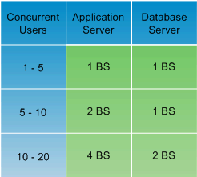

SOFTWARE PRE-REQUISITES
The software prerequisites for the caTissue Suite v1.1 is as described in the following table:
Software Element Name | Version | Type
Windows | 2000/XP | Server and Client
Mac | 10.4.6 | Client
Linux | RedHat 9 or RedHat Enterprise ES/AS 2.1 or higher | Server
JBoss | 4.2.2 GA | Application Server
JDK | 1.5 | Java
Oracle | 10.2.0.2.0 | Database
MySQL | 5.0.45 | Database
Internet Explorer | 7.0 | Web Browser
Mozilla Firefox | 2.0.0.14 | Web Browser
Safari (Mac) | 3.1 | Web Browser
Apache Ant | 1.7 | Build Tool

Note: Oracle/MySQL client should be installation the machine hosting JBoss server

TYPICAL CONFIGURATION FOR PRODUCTION
Database Server
Two dual/quad core Xeon >= 2.0 GHz, 2-4 MB cache, 16-32 GB memory, RAID based disk 100 GB. Usually the Dell 2950/2970 is a good fit.
Data growth sizing estimates
The data growth is very reasonable in the region of 50 MB for every 10K new specimens.

Minimum Privileges requirement for Database User
Minimum list of privileges required for caTissue schema owner:
- create table
- create sequence
- create trigger
- create procedure
- create session
- QUOTA UNLIMITED on tablespace created for caTissue schema

Application Server
Two dual/quad core Xeon >= 2.0 GHz 4-6 MB cache, 16-32 GB memory, RAID 1 for OS drive (at least 146 GB). Usually the Dell 1950 is a good fit.

TYPICAL CONFIGURATION FOR TESTING
Database Server
Two dual/quad core Xeon >= 2.0 GHz, 4-6 MB cache, 2-4 GB memory, RAID disk of ~100 GB
Application Server
Two dual/quad core Xeon >= 2.0 GHz, 4-6 MB cache, 2-4 GB memory, RAID 1 for OS drive (at least 40 GB).

Sharing data On NCI’s caGrid
caTissue Suite v1.1 allows you to share data on the caGrid. This section explains the different methods of sharing data on the grid, and the hardware and software requirements.
Note: Setting up a grid instance is an optional step. This is not necessary to use caTissue as a biospecimen banking application in your center.
Software pre-requisite for caGRID service instance
Software Element Name | Version | Type
Windows | 2000/XP | Server and Client
Mac | 10.4.6 | Client
Linux | RedHat 9 or RedHat Enterprise ES/AS 2.1 or higher | Server
JBoss | 4.0.4 GA | Application Server
Apache Ant | 1.7 | Build Tool
caGRID | 1.2 | caBIG Application
Globus Toolkit | 4.0.3 | Application container

Setting up a grid instance
To share your data on the caGrid, you will have to do the following:
- Setup a “private” instance of caTissue within the institution’s firewall, i.e. both the web server and database both within the firewall.
- Setup a “public” instance of the caTissue caGrid instance on a server outside the institution’s firewall, i.e. both the web server and public deidentified database both outside the firewall.
- Install the private-public data migration tool to de-identify and migrate the data from the private database to the public database. The migration tool is installed within the firewall.
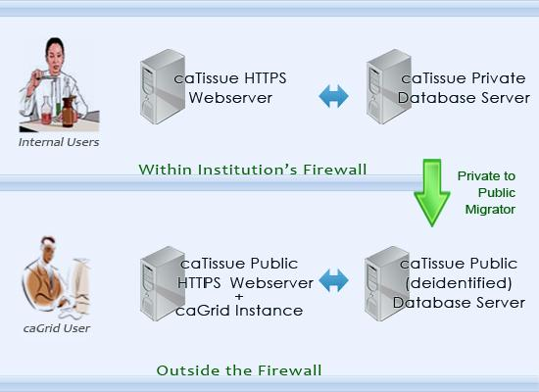

MINIMUM CONFIGURATION
Minimum configuration required for caTissue application server, database server and client are described in the following table:
