caTissue Suite
V 1.0

Technical Administration

Guide

caBIG™ is an initiative of the National Cancer Institute, NIH, DHHS
Copyright and License page
Copyright 2008 WashU. This software was developed in conjunction with the National Cancer Institute, and so to the extent government employees are co-authors, any rights in such works shall be subject to Title 17 of the United States Code, section 105.

Redistribution and use in source and binary forms, with or without modification, are permitted provided that the following conditions are met:

Redistributions of source code must retain the above copyright notice, this list of conditions and the disclaimer of Article 3, below. Redistributions in binary form must reproduce the above copyright notice, this list of conditions and the following disclaimer in the documentation and/or other materials provided with the distribution.

The end-user documentation included with the redistribution, if any, must include the following acknowledgment: "This product includes software developed by the Persistent Systems Pvt Ltd. (PSPL), Washington University and the National Cancer Institute (NCI).” If no such end-user documentation is to be included, this acknowledgment shall appear in the software itself, wherever such third-party acknowledgments normally appear.

The names "The National Cancer Institute", "NCI", “Washington University”, and "PSPL" must not be used to endorse or promote products derived from this software.

This license does not authorize the incorporation of this software into any proprietary programs. This license does not authorize the recipient to use any trademarks owned by either NCI or PSPL.

THIS SOFTWARE IS PROVIDED "AS IS," AND ANY EXPRESSED OR IMPLIED WARRANTIES, (INCLUDING, BUT NOT LIMITED TO, THE IMPLIED WARRANTIES OF MERCHANTABILITY AND FITNESS FOR A PARTICULAR PURPOSE) ARE DISCLAIMED. IN NO EVENT SHALL THE NATIONAL CANCER INSTITUTE, PSPL, WashU OR THEIR AFFILIATES BE LIABLE FOR ANY DIRECT, INDIRECT, INCIDENTAL, SPECIAL, EXEMPLARY, OR CONSEQUENTIAL DAMAGES (INCLUDING, BUT NOT LIMITED TO, PROCUREMENT OF SUBSTITUTE GOODS OR SERVICES; LOSS OF USE, DATA, OR PROFITS; OR BUSINESS INTERRUPTION) HOWEVER CAUSED AND ON ANY THEORY OF LIABILITY, WHETHER IN CONTRACT, STRICT LIABILITY, OR TORT (INCLUDING NEGLIGENCE OR OTHERWISE) ARISING IN ANY WAY OUT OF THE USE OF THIS SOFTWARE, EVEN IF ADVISED OF THE POSSIBILITY OF SUCH DAMAGE.

Names of developers | Names of technical writers and reviewers | Names of program managers
Sachin Lale | Sachin Lale | Srikanth Adiga
Vaishali Khandelwal | Virender Mehta | Rakesh Nagarajan
Vijay Pande | Poornima Govindrao | Mark Watson
Prafull Kadam | Abhijit Naik
Abhishek Mehta | Falguni Sachde
Virender Mehta
Ashish Gupta
Poornima Govindrao
Chetan Patil
Deepti Shelar
Kalpana Thakur
Abhijit Naik
Falguni Sachde
Kalpana Thakur

Contacts and Support
catissue_support@mga.wustl.edu | https://gforge.nci.nih.gov/forum/forum.php?forum_id=766

LISTSERV Facilities Pertinent to software teams
LISTSERV | URL | Name
catissue | https://gforge.nci.nih.gov/forum/forum.php?forum_id=766 | caTissue discussion forum
caTissuecore | http://nagarajanlab.wustl.edu/bugs/ | caTissue bug logging system

Table of Contents

Chapter 1 Introduction 8
Organization of the Technical Guide 8
Chapter 2 Overview of the Software 9
Software Overview 9
Architecture 11
Chapter 3 Security Management 13
Software Authorization 13
Role requirements in caTissue Suite 14
Data Model Implementation of Fine Grained ROLE Requirements 15
Mapping of caTissue Roles with CSM data 22
Redefining privileges of a Role 24
Chapter 4 API Access 25
An application program interface (API) 25
Institution 30
Department 31
CancerResearchGroup 31
User 32
Site 35
StorageType 37
StorageContainer 39
CollectionProtocol 41
DistributionProtocol 44
Participant 46
CollectionProtocolRegistration 48
SpecimenCollectionGroup 50
Specimen 51
Distribution 55
Ordering System 58
Chapter 5 Label & Barcode Print Service 65
Developing Customized PrintService Implementation 66
Implementation details for caTissuePrintWebService 68
Chapter 6 Label and Barcode Generation 75
Barcode Generation 78
Appendix B: Auditing Functionality 84
Appendix C: Modifying permissible values 85
Appendix D: CSM configuration 86
Giving Privilege to a Supervisor to Add or Edit a Collection Protocol 86
Giving privilege to a Technician to view PHI data 89

Figure 1 caTissue Suite Architecture 11
Figure 2:Role based PHI data view 15
Figure 3:Institution 30
Figure 4:Department 31
Figure 5:CancerResearchGroup 31
Figure 6:User 32
Figure 7:Site 35
Figure 8:StorageType 37
Figure 9:Storage Container 39
Figure 10:CollectionProtocol 41
Figure 11:DistributionProtocol 44
Figure 12:Participant 46
Figure 13:CollectionProtocolRegistration 48
Figure 14:SpecimenCollectionGroup 50
Figure 15:Specimen 52
Figure 16:Distribution 55
Figure 17 Ordering System 58
Figure 18: Print Service Work Flow 65
Figure 19: PrintService Implementation 66
Figure 20: Class diagram related to caTissuePrintWebService 73
Figure 21:Label generator model 76
Figure 22: Barcode Generation Model 78
Figure 23: Auditing model 84
Figure 24: Actions for add/edit of collection protocol 87
Figure 25: Actions assigned to supervisor group 87
Figure 26: Objects for add/edit of collection protocol 88
Figure 27: Objects assigned to supervisors group 88
Figure 28: Privilege for identified data access 89
Figure 29: Identified data access assigned 90

- Introduction
This guide focuses on administrative tasks associated with the use of caTissue Suite and mainly focuses on using the application program interface in the caTissue Suite application for data entry and query operations.

Organization of the Technical Guide

Chapters | Chapter Contents
Introduction | This chapter orients the first time user to the contents of this document.
Overview of the Software | This chapter gives an overview of the application and its architecture.
Security and Security management | This chapter outlines authorization rules of the application.
API Access | This chapter outlines how to use the API and also includes examples.
Label and Barcode Print Service | This chapter outlines how to customize the label and barcode printing
Label and Barcode Generation | This chapter outlines how to customize the format of the label and barcodes
- Overview of the Software

Software Overview
caTissue Suite is the next-generation tissue banking application which integrates the functionality of the existing caBIG™ TBPT (Tissue bank and pathology Tools) applications. The following three applications developed by the TBPT Workspace are integrated in this release of caTissue Suite:
- caTissue Core v1.2: caTissue Core provides the central biospecimen management functionalities needed in biobanking facilities.
- cancer Text Information Extraction System (caTIES): caTIES automates the process of coding, de-identifying, storing and retrieving data from free-text pathology reports.
- Clinical Annotations (CA): CA allows for the annotation of biospecimen with anatomical and clinical pathology, and cancer registry/outcomes data, that is annotation types.
In addition to or as part of integrating the functionality of caTIES and CA within caTissue Core, there are many new features which are listed below:Load, view, and query free-text surgical pathology reports.
- Record discrete CAP based clinical and pathology data for some diseases.
- Add new classes and attributes dynamically to record boutique annotations.
- Record and track consent.
- Order Biospecimen through a system.
- Define collection protocols including information about specimens collected per protocol and perform bulk data entry based on the protocol definition.
- Query any caTissue object and save queries through a new query interface .
- Perform bulk operations on specimens, for example: transfer, dispose, and bulk edit.
Supported Software and Technology
Software Element Name | Version | Type and Other Notes
Windows | 2000/XP | Operating system
Solaris | 5.8 or higher | Operating system
Linux | RedHat 9 or RedHat Enterprise ES/AS 2.1 or higher | Operating system
JBoss | 4.0.0 | Application server
JDK | 1.5 | Java
Oracle | 9i or 10g | Database
MySQL | 4.1 | Database
Internet Explorer | 6.0, 7.0 | Web browser
Mozilla Firefox | 1.5.0.8 | Web browser
Safari | 2.0.3 | Web browser
CSM and caCORE SDK | 3.2 | Versions used in the application
Table 1: System requirements

Architecture

The caTissue Suite comprises of an n-tiered architecture as illustrated in figure 1. The client layer contains applications on the client side that request operations on the server side. The Web browser and API are two client programs in caTissue Suite. The presentation layer provides a Web interface as well as support for the API. The object layer is the heart of the application and contains domain objects, model classes, and the data access layer. The object layer fulfills all tissue banking related business requirements. The backend of the application is a local database stores all the tissue banking information.
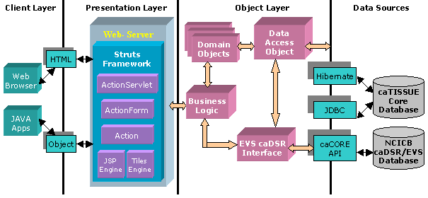
Figure 1 caTissue Suite Architecture
The main components of the application are as follows:
- Web interface: Web pages and APIs
- Business logic
- Data access object
- EVS/caDSR interface
The design follows the Model View Controller (MVC) design approach wherein the view, that is, the user interfaces, and the model, that is, the actual application logic, are completely insulated.
The Web interfaces communicate with external data sources such as caDSR, EVS, and caTissue Suite’s database through an intermediate interface. The of these interfaces is to insulate the core application logic from any changes in the external data source. Interaction with the database is either through Hibernate or JDBC.

Prerequisites
Before reading this document, it is recommended that you are familiar with the software. Please refer to the following reference documents before moving to the next sections.
References:
- caTissue Requirements: This document captures the use cases and software requirements for caTissue.
- caTissue Design: This document describes the design of caTissue.
- caTissue installation: This document describes the steps involved in installing the application.

Security Management
caTissue Tissue uses Common Security Module (CSM) software to accomplish the security requirements. CSM is the part of the caBIG™ infrastructure module chartered to provide a comprehensive solution to common security objectives. It provides solutions for Authentication and Authorization, and also provides a Web-based User Provisioning Tool (UPT). This chapter describes authorization rules of the application.

Software Authorization
At the time of application deployment, the system provides default roles and privileges. You can use the User Provisioning Tool provided by CSM for managing these privileges.
The data entered in to caTissue Suite can be categorized into two different groups, Administrative and Biospecimen. Administrative data is the data required to set up the tissue bank. For example, Collection Protocols, Distribution Protocols, Biohazards, Sites, Storage containers, Users, Departments, Institutions, Cancer Research Groups, Storage Types, and Array Types. The Biospecimen data is entered by supervisors and/or technicians. It includes details on patient demographics, specimen quantity, storage locations, and samples distributed by the bank. The majority of the day-to-day operations of the tissue bank are centered on entering and updating the Biospecimen data.

Prerequisites for CSM configuration
Please review the following documents as a prerequisite for a better understanding of the CSM configuration and functionality:
- CSM_WS_Guide_ApplicationDevelopers
- UPT_User_Guide

Role requirements in caTissue Suite
Following are different user groups in caTissue Suite:
User | Role
Administrator | - Is a super-user who manages the caTissue Suite .  - Has privileges to submit, edit, disable, and query all types of data in the system.  - Approves and manages user registration process.  - Creates new protocols.  - Adds a new storage container type and storage containers.  - Can see all the identified data.
Supervisor | - Is similar to Administrator but does not have access to administrative functions, that is, protocols, storage container , and so on.  - Submits, edits and, disables participant and biospecimen data in the system.  - Has read only privilege to administrative data.
Technician | - User role assigned to an individual who is in-charge of entering biospecimen data into the system.  - Handles curation, storage, and distribution of biospecimens.  - Does not have access to identified data.  - Has read only access to all de-identified data..
Scientist | - Anyone having general research interest.  - Has read-only access to de-identified data.
Table 2 : User groups in caTissue
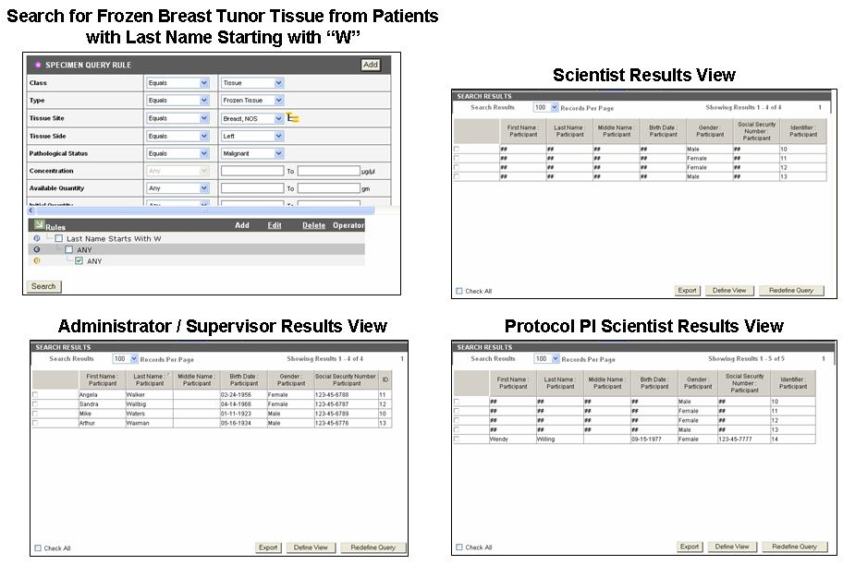
Figure 2:Role based PHI data view

Data Model Implementation of Fine Grained ROLE Requirements
caTissue Suite uses the CSM to protect against unauthorized actions and data access. The CSM database tables store all the security data required for caTissue Suite. This section explains the data model that is implemented to enable authorization in caTissue Suite.

User Groups
Roles in caTissue, as explained in the previous section, map to User Groups of CSM that is, each role is a CSM user group. For each role, a user group in caTissue Suite is created in the csm_group table as shown below:

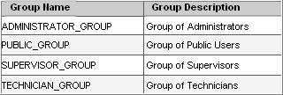
Table 3: User groups in caTissue
User provisioning is performed by the system at runtime in caTissue implementation. Once a user is created via caTissue Suite, a User object is created and inserted into the csm_user table. The user is then assigned to the appropriate user group by the application. The user is associated with the Administrator, Supervisor, Technician, or Public(Scientist) group based on the role that user is assigned.

Roles and Privileges
Following are the main roles and privileges based on the use cases defined for caTissue Suite. The system assigns privileges to each role to enable appropriate access for that type of user. The roles are then assigned to respective user groups mentioned in the previous section.
Note: These roles are not the roles defined in caTissue Suite. These are CSM roles.A role in CSM denotes a set of privileges. User groups,caTissue specific roles as explained in the previous section, have various CSM roles on different protection groups that is sets of data. Unless specified, subsequent references to role refer to those defined by the CSM.

The following table lists the role names and describes each role:
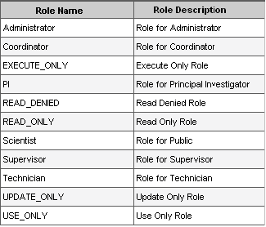
Table 4: All CSM Roles
The following table lists the privilege names and describes each privilege:
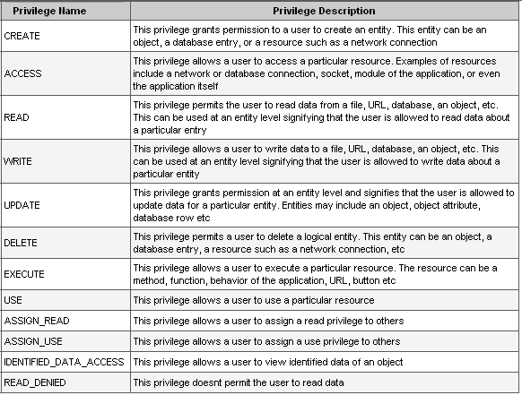
Table 5: Privileges and descriptions
The following table lists the role and privilege:
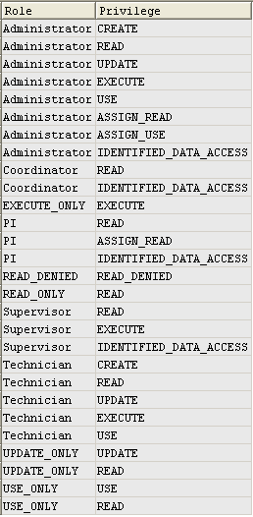
Table 6: Roles and their mapping privileges

Protection Elements
A Protection Element is any entity that has controlled access. In caTissue Suite, the following categories of entities are identified that need controlled access:

Category | Description
Actions | All actions in the caTissue Suite form a protection element in CSM. Users/groups must have EXECUTE privilege on these actions to perform the corresponding operations. For example, to access the add operation of collection protocol, users/groups must have EXECUTE privilege on CollectionProtocol Add Action.
Classes | All classes in the caTissue Suite form a protection element in CSM. Users/groups must have CREATE/UPDATE privilege on these to add or update the corresponding objects.
Objects | Protection elements are added for the new objects created, for which object level privileges are to be checked. Users are given appropriate rights to these objects.
Table 7: Protection elements in caTissue Suite

Protection groups
The use of protection groups is critical to the structure and foundation for implementation of the data model. caTissue Suite utilizes the protection groups to store collections of related protection elements.
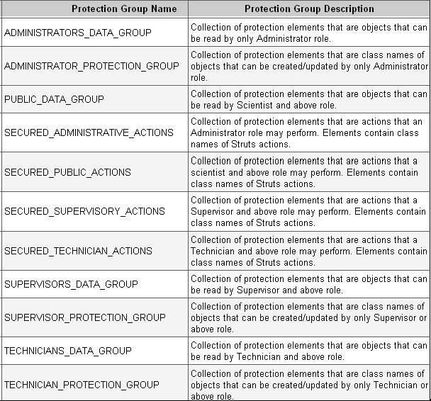
Table 8: Protection groups in caTissue Suite

Mapping of caTissue Roles with CSM data
This section describes the mapping between current caTissue Suite user groups and associated CSM roles.

Administrator
The Administrator group in caTissue Suite has privilege to view all data and perform all actions in caTissue Suite. The roles and groups associated with the Administrator user groups are listed below:
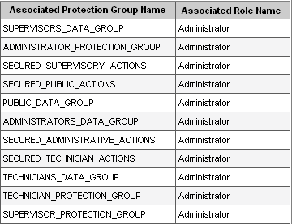
Table 9: Associated protection groups of Administrators

Supervisor
The Supervisor group in caTissue Suite has privilege to view PHI, add or edit biospecimen data, and view administrative data. Users in this group do not have privilege to add/edit administrative data. The protection groups associated with the Supervisor user group and roles are listed below:
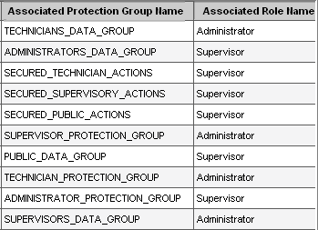
Table 10: Associated protection groups of Supervisors

Technician
Technicians in caTissue Suite does not have privilege to view PHI though they can add/edit biospecimen data and view administrative data. The protection groups associated to the Technician user group and roles are listed below:
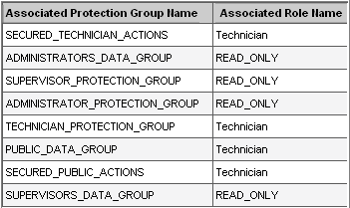
Table 11: Associated protection groups of Technicians

Scientist
The Scientist group in caTissue Suite has privilege to view all de-identified data. Users in this group do not have privileges to add/edit administrative data. The roles associated to the protection group are listed below:
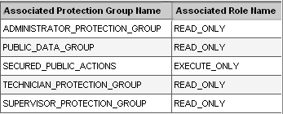
Table 12: Associated protection groups of Scientists

Redefining privileges of a Role
The security data is provisioned in caTissue Suite at the time of application setup. Although this covers all the basic use cases related to caTissue Suite security, customization of privileges can be done at each adoption center using the User Provisioning Tool (UPT). UPT which is part of the overall CSM, is a Web application used to configure an application’s authorization data. For more information on how to configure and use UPT refer to UPT user guide - UPT_User_Guide

Managing privileges using UPT
Apart from creation of new roles in the system, it is possible to provision almost all privileges that exist in caTissue Suite. Some possibilities of user provisioning are outlined below:
- Redefining privileges to execute actions in the system. For example, giving supervisors the privilege to execute add/edit actions of collection protocol.
- Redefining privileges to create/update different types of objects. For example, giving technicians the privilege to add storage containers.
- Redefining privileges to view PHI data. For example, all technicians can be given privilege to view PHI data of related objects.
Note: Appendix D: CSM configuration describe some of these examples in detail.

API Access
This chapter outlines how to use the API. It also includes examples of using the API.

An application program interface (API)
An application program interface (API) provides the ability to interface/interact with external systems. The caTissue Suite API is generated using the caBIG™ caCORE SDK toolkit. You can use these APIs to add, edit, and query for data.
caCORE is an open-source enterprise architecture for NCI-supported research information systems. caCORE is built using formal techniques from the software engineering and computer science communities. The four characteristics of caCORE include:
- Model Driven Architecture (MDA)
- n-tier architecture with open APIs
- Use of controlled vocabularies, wherever possible
- Registered metadata
The use of MDA and n-tier architecture, both standard software engineering practices, allows easy access to data by other applications. The use of controlled vocabularies and registered metadata, less common in conventional software practices, requires specialized tools that are generally unavailable.
The documentation related to the caCORE can be found at the following location:
http://ncicb.nci.nih.gov/NCICB/infrastructure/cacoresdk
The following steps describes how to use APIs for data entry and query:
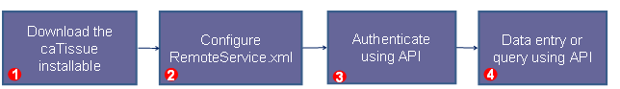

Step 1: Download the caTissue Suite installable from the location.
http://cabigcvs.nci.nih.gov/viewcvs/viewcvs.cgi/catissuecore/CODE%20AND%20TESTING/Latest%20Code/Installable%20zip/caTissue_Suite_Installable_v1.0.zip. Extract the contents of the installable zip to any desired location. This location is referred to as CATISSUE_HOME here after. The client code required to use the API is present at
CATISSUE_HOME/caTissueSuite_Client
Step 2: Configure the following parameter in the remoteService.xml file present in cATISSUE_HOME/caTissueSuite_Client/conf:
<property name="serviceUrl">
<value>http://{host}:{port}/catissuecore/http/remoteService</value>
</property>

Parameter | Details
{host}:{port} | Host URL of the application to which caCORE client connects. Replace the host parameter with http host:port at which the server is configured. For example, to access the demo site of caTissue Suite you can configure this as ‘catissuecore.wustl.edu:80’.

Step 3: Authenticate: In order to connect to the caTissue database, provide the login credentials.
The following code snippet shows how to log in to the caTissue Suite application through API:
ApplicationServiceProvider asp = new ApplicationServiceProvider();
ApplicationService appService= ApplicationServiceProvider.getApplicationService();
//Start the session by giving proper credentials to startSession() method.
ClientSession cs = ClientSession.getInstance();
Provide the login name and password to the application
cs.startSession("<login-name>","<password>");

Configure Client for HTTPS
caTissue Suite contains patient identified information, so it is important to deploy it in a secure environment. For more information read http://en.wikipedia.org/wiki/Https. To deploy caTissue Suite as a HTTPS based secure Web application refer to the deployment guide.
Use API to authenticate to a caTissue Suite which is deployed as HTTPS:
- Generate the keystore file on the client machine. To generate the keystore file, perform the first step mentioned in the section “Configuring JBoss Server to deploy caTissue as HTTPS” of the deployment guide.
- Update the client API code in the authentication section to set the path of the keystore file to the system property javax.net.ssl.trustStore.
For example, if the keystore created is stored in
c://catissue/catissue.keystore, add the following code:
System.setproperty("javax.net.ssl.trustStore", “c://catissue/catissue.keystore”);
- In the remoteService.xml file, set the value for the property service URL to https://{host}:{port}/catissuecore/http/remoteService

Step 4a: Query using API
caTissue Suite API provides the following methods for querying any class present in the caTissue model:
- public List query(DetachedCriteria detachedcriteria, String targetClassName)
Specimen specimen = new Specimen();
DetachedCriteria criteria=DetachedCriteria.forClass(Specimen.class);
criteria.add(Restrictions.lt("id", new Long(4)));
List resultList = appService.query(criteria, Specimen.class.getName());
Detached criteria uses Hibernate detached criteria objects to provide a greater level of control over the results of a search, such as boolean operations, ranges of values, and so on.
Some applications need to create criteria queries in detached mode, where the Hibernate session is not available. This class can be instantiated anywhere, and then a Criteria can be obtained by passing a session to getExecutableCriteria().

Method signature description: Returns a List conforming to the criteria specified by detachedCriteria. The resulting objects of the list are of the type specified by targetClassName.

- public List query(HQLCriteria hqlcriteria, String targetClassName)
Participant participant = new Participant();
String hqlQuery="select elements(p.participantMedicalIdentifierCollection)"+" from edu.wustl.catissuecore.domain.Participant as p";
HQLCriteria hqlCriteria= new HQLCriteria(hqlQuery);
List medicalIdentifierCollection= appService.query(hqlCriteria, Participant.class.getName());

HQL searches: Provides the ability to use the Hibernate Query Language for the greatest flexibility in forming search criteria.
Method signature description: Returns a List of objects of the type specified by targetClassName that conform to the query in HQL syntax contained in hqlCriteria.

- public List search(Class targetClass, Object obj)
Biohazard biohazard = new Biohazard();
List resultList = appService. search(Biohazard.class,biohazard);

Simple searches: Take one or more objects from the domain models as inputs and return a collection of objects from the data repositories that meet the criteria specified by the input objects.
Method signature description: Returns a List containing objects of type targetClass that conform to the criteria defined by obj.

- public List search(String path, Object obj)
SpecimenArray specimenArray = new SpecimenArray();
List specimenArrayList = null;
specimenArrayList=appService.search("edu.wustl.catissuecore.domain.StorageContainer,edu.wustl.catissuecore.domain.SpecimenArray", specimenArray);

Nested searches: Take domain objects as inputs, but determine the type of objects in the result set by traversing a known path of associations from the domain model.
Method signature description: Returns a List containing objects conforming to the criteria defined by obj. The resulting objects of the list are of the type reached by traversing the node graph specified by path

In the caTissue Suite, the lazy initialization property of hibernate is set to true due to performance reasons. If this property is set to false, a query executed to retrieve a specimen object results in getting all the associated objects in a nested manner resulting in lot of data being loaded into memory. The impact of setting Hibernate lazy loading to true is that you cannot do resultsObj.getAssociatedObject() kind of queries that is fetching associated. In order to get the associated data, the API search must use the method search(String path, Object obj) where you mention what objects you want in the results.

Step 4b: Data entry operations through API:
caTissue Suite API uses createObject method of appService for adding domain object into database.
Consider the following example to insert a Participant object:
Participant participant = new Participant();
participant.setLastName("Duck");
participant.setFirstName("Donald");
participant.setGender("Male Gender");
participant.setVitalStatus("Alive");
participant.setEthnicity("Unknown");
participant.setSexGenotype("XX");

Collection raceCollection = new HashSet();
raceCollection.add("White");
raceCollection.add("Asian");
participant.setRaceCollection(raceCollection);
participant.setActivityStatus("Active");
participant.setEthnicity("Hispanic or Latino");
participant = (Participant)
appService.createObject(participant);

Similarly for updating any class, caTissue API uses updateObject method of appService. Search for the data you want to update and set the values in this result that need to be updated.

Example code to update participant data:

participant.setVitalStatus("Alive");
participant.setGender("Male Gender");
participant.setSexGenotype("");

Collection raceCollection = new HashSet();
raceCollection.add("Black or African American");
raceCollection.add("Unknown");
participant.setRaceCollection(raceCollection);
participant = (Participant)
appService.updateObject(participant);
Note: If you are looking for more examples of API code, please refer to section “Running the Test Case Suite (API)” in the deployment guide.
This section describes all the objects that can be added using API along with the information about mandatory fields and associated objects. An important consideration in using the API is handling of associated objects. There are two types of associated objects:
- Data association: Data association objects are those objects which are created and added along with the main object, for example, Address and Password are data associated objects of a User.
- Reference association: Reference association is when the associated object is expected to exist before adding the current object and would be referenced in the object being added. For example, Institution, Department and CancerResearchGroup are reference associations of User.

Institution

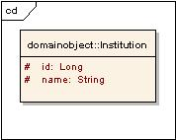
Figure 3:Institution
Institution
Attribute / Constituent Object | Datatype/Class | Mandatory
Id | Long | Yes
Name | String | Yes
Table 13:Institution attributes

Department

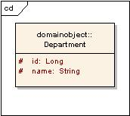
Figure 4:Department
Department
Attribute / Constituent Object | Datatype/Class | Mandatory
Id | Long | Yes
Name | String | Yes
Table 14:Department attributes

CancerResearchGroup

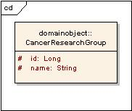
Figure 5:CancerResearchGroup

CancerResearchGroup
Attribute / Constituent Object | Datatype/Class | Mandatory
Id | Long | Yes
Name | String | Yes
Table 15:CancerResearchGroup attributes

User

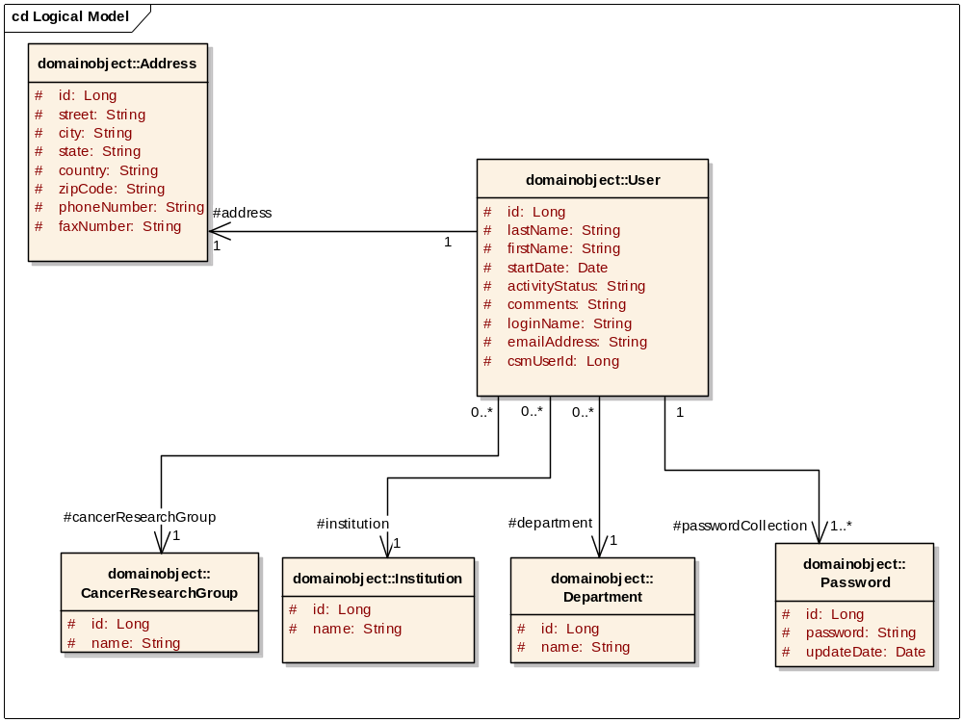
Figure 6:User

Associated object | Type
Address | Data
Password | Data
Institution | Reference
CancerResearchGroup | Reference
Department | Reference
Table 16: Associated objects of User

Address
Attribute/Constituent Object | Datatype/Class | Mandatory
Id | Long | Yes
Street | String | Yes
City | String | Yes
State | String | Yes
Country | String | Yes
Zipcode | String | Yes
phoneNumber | String | No
faxNumber | String | No
Table 17:Address attributes

User
Attribute / Constituent Object | Datatype/Class | Mandatory
Id | Long | Yes
emailAddress | String | Yes
lastName | String | Yes
firstName | String | Yes
activityStatus | String | Yes
Address | Address attributes | Yes
Institution | Institution attributes | Yes
Department | Department attributes | Yes
cancerResearchGroup | CancerResearchGroup attributes | Yes
Table 18:User attributes

Site

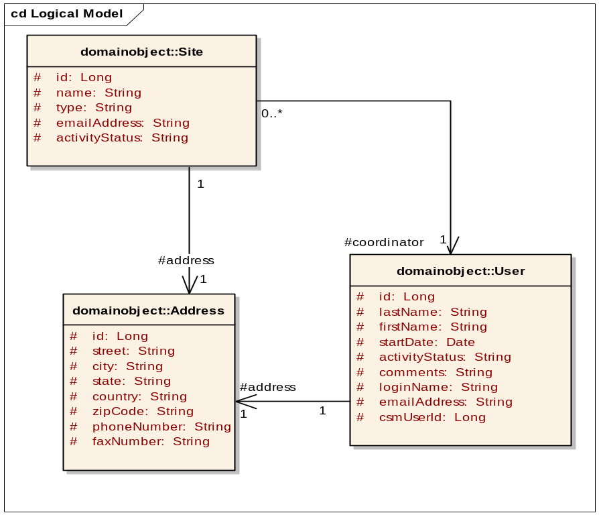
Figure 7:Site

Associated object | Type
Address | Data
User | Reference
Table 19: Associated objects of Site

Site
Attribute / Constituent Object | Datatype/Class | Mandatory
Id | Long | Yes
Name | String | Yes
Type | String | Yes
emailAddress | String | No
activityStatus | String | Yes
Address | Address attributes | Yes
Coordinator | User attributes | Yes
Table 20:Site attributes

StorageType
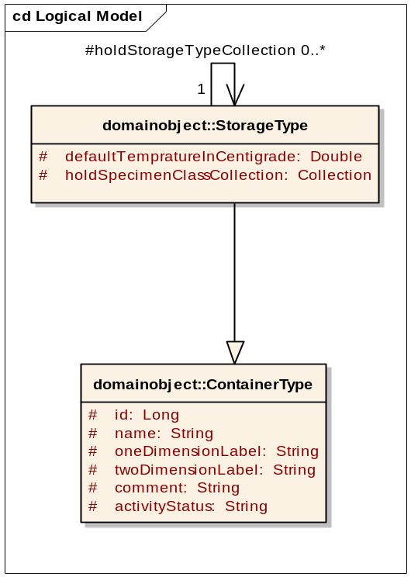
Figure 8:StorageType
StorageType is not associated to any other object. As indicated in the above diagram, StorageType is inherited from the parent class ContainerType.

ContainerType
Attribute/Constituent Object | Datatype/Class | Mandatory
Id | Long | Yes
Name | String | Yes
oneDimensionLabel | String | Yes
twoDimensionLabel | String | Yes
Comment | String | No
Capacity | Capacity attributes | Yes
Table 21:ContainerType attributes

StorageType
Attribute/Constituent Object | Datatype/Class | Mandatory
defaultTempratureInCentigrade | Double | No
holdsStorageTypeCollection | Collection | No
holdsSpecimenClassCollection | Collection | No
activityStatus | String | Yes
Table 22:Storage Type attributes

StorageContainer

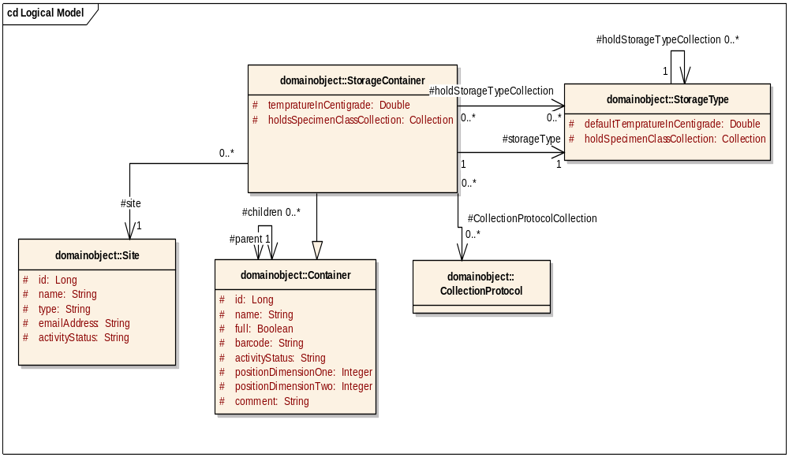
Figure 9:Storage Container
Associated object | Type
Container | Data
Site | Reference
CollectionProtocol | Reference
StorageType | Reference
Table 23: Associated objects of StorageContainer
Capacity
Attribute/Constituent Object | Datatype/Class | Mandatory
Id | Long | Yes
oneDimensionCapacity | Integer | No
twoDimensionCapacity | Integer | No
Table 24:Capacity attributes

Container
Attribute/Constituent Object | Datatype/Class | Mandatory
Id | Long | Yes
Full | Boolean | Yes
Name | String | Yes
barcode | String | No
activityStatus | String | Yes
positionDimensionOne | Integer | Yes
positionDimensionTwo | Integer | Yes
comment | String | No
capacity | Capacity attributes | Yes
children | Collection | No
parent | Container attributes | No
Table 25:Container attributes
StorageContainer
Attribute/Constituent Object | Datatype/Class | Mandatory
tempratureInCentigrade | Double | No
storageType | Storage Type attributes | Yes
site | Site attributes | No
collectionProtocolCollection | Collection | No
holdsStorageTypeCollection | Collection | No
holdsSpecimenClassCollection | Collection | No
Table 26:StorageContainer attributes

CollectionProtocol
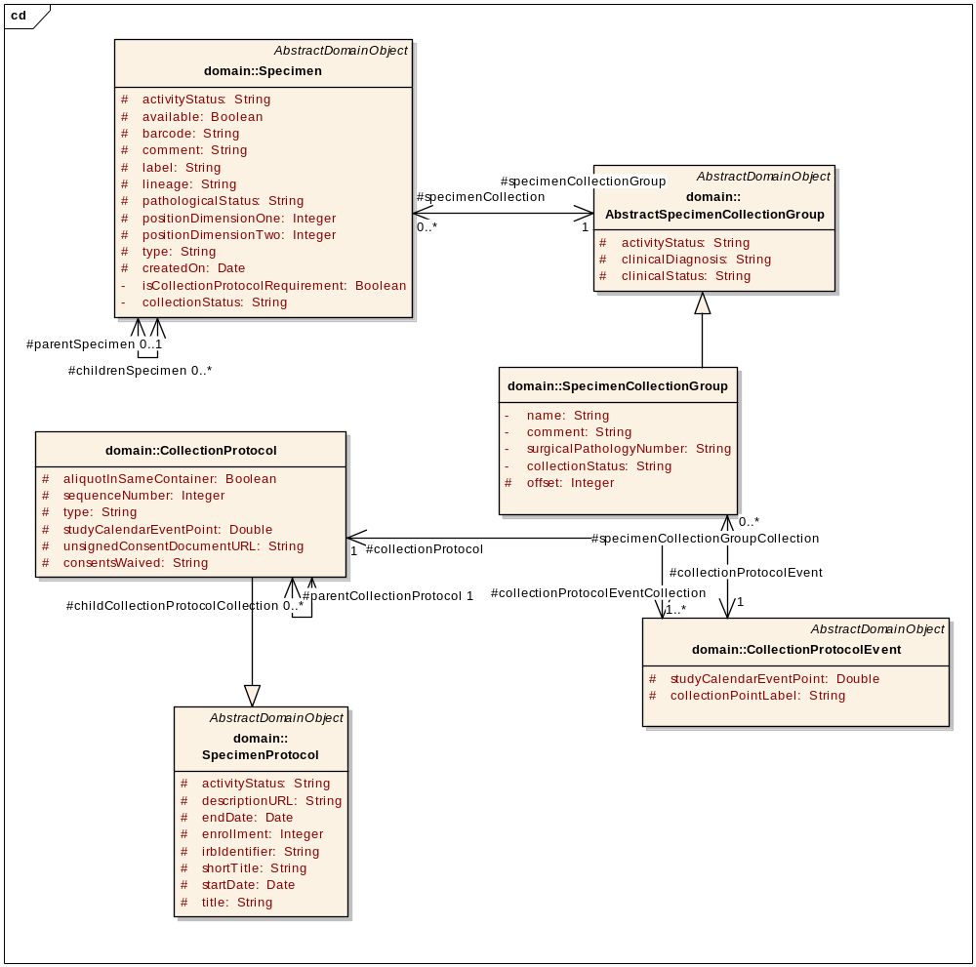
Figure 10:CollectionProtocol
Associated object | Type
SpecimenProtocol | Derived
User | Reference
CollectionProtocolEvent | Data
SpecimenCollectionRequirementGroup | Data
CollectionProtocolRegistration | Data
Specimen | Data
ConsentTier | Data
Table 27: Associated objects of CollectionProtocol

SpecimenProtocol
Attribute/Constituent Object | Datatype/Class | Mandatory
id | Long | Yes
title | String | Yes
shortTitle | String | Yes
irbIdentifier | String | Yes
startDate | Date | Yes
endDate | Date | No
enrollment | Integer | Yes
descriptionURL | String | Yes
principalInvestigator | User attributes | Yes
Table 28:SpecimenProtocol attributes

CollectionProtocol
Attribute / Constituent Object | Datatype / Class | Mandatory?
distributionProtocolCollection | Collection | No
userCollection | Collection | No
collectionProtocolEventCollection | Collection | Yes
consetTierCollection | Collection | No
Table 29:Collection Protocol attributes

CollectionProtocolEvent
Attribute/Constituent Object | Datatype/Class | Mandatory
id | Long | Yes
clinicalStatus | String | Yes
studyCalendarEventPoint | Double | Yes
specimenRequirementCollection | Collection | Yes
collectionProtocol | Collection Protocol attributes | Yes
Table 30:CollectionProtocolEvent attributes

ConsentTier
Attribute/Constituent Object | Datatype/Class | Mandatory
Id | Long | Yes
Statement | String | Yes
Table 31 ConsentTier attributes

DistributionProtocol

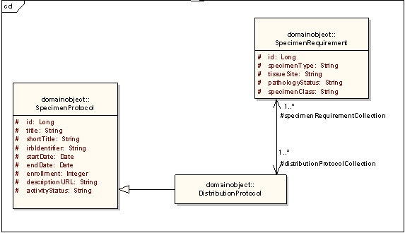
Figure 11:DistributionProtocol

Associated object | Type
SpecimenProtocol | Derived
SpecimenRequirement | Data
Table 32: Associated objects of DistributionProtocol
SpecimenProtocol
Attribute / Constituent Object | Datatype / Class | Mandatory?
id | Long | Yes
title | String | Yes
shortTitle | String | Yes
irbIdentifier | String | Yes
startDate | Date | Yes
endDate | Date | No
enrollment | Integer | Yes
descriptionURL | String | Yes
principalInvestigator | User attributes | Yes
Table 33:SpecimenProtocol attributes

DistributionProtocol
Attribute/Constituent Object | Datatype/Class | Mandatory
specimenRequirementCollection | Collection | Yes
CollectionProtocolCollection | Collection | No
Table 34:DistributionProtocol attributes

Participant

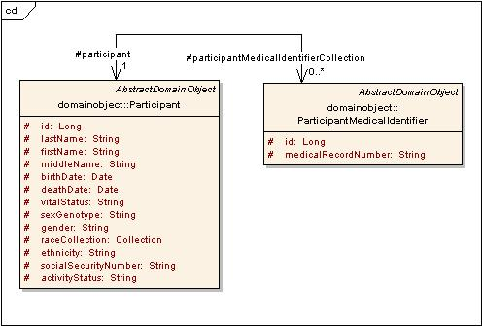
Figure 12:Participant
Associated object | Type
ParticipantMedicalIdentifier | Data
Table 35: Associated objects of Participant

Participant
Attribute/Constituent Object | Datatype/Class | Mandatory
Id | Long | Yes
LastName | String | No
FirstName | String | No
MiddleName | String | No
BirthDate | Date | No
DeathDate | Date | No
SexGenotype | String | No
ethnicity | String | No
socialSecurityNumber | String | No
vitalStatus | String | No
gender | String | No
participantMedicalIdentifierCollection | Collection | No
collectionProtocolRegistrationCollection | Collection | No
raceCollection | Collection | No
Table 36:Participant attributes

ParticipantMedicalIdentifier
Attribute / Constituent Object | Datatype / Class | Mandatory?
Id | Long | Yes
medicalRecordNumber | String | Yes
Site | Site attributes | Yes
Table 37:ParticipantMedicalIdentifier attributes

CollectionProtocolRegistration

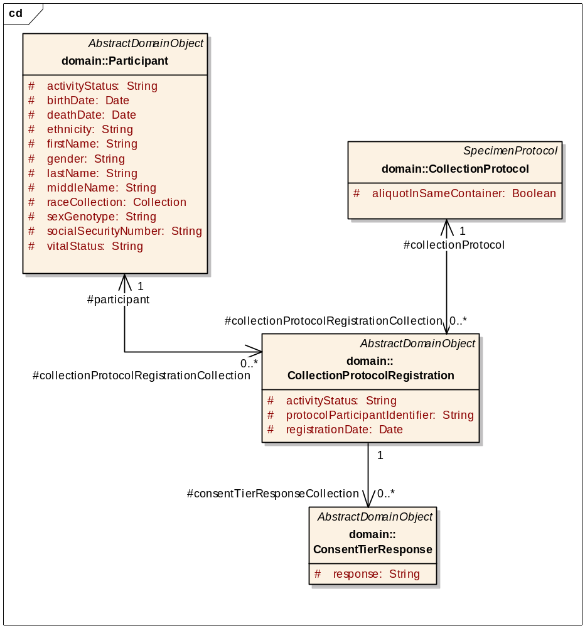
Figure 13:CollectionProtocolRegistration
Associated object | Type
Participant | Reference
CollectionProtocol | Reference
ConsentTierResponse | Data
Table 38: Associated objects of CollectionProtocolRegistration

CollectionProtocolRegistration
Attribute/Constituent Object | Datatype/Class | Mandatory
Id | Long | Yes
protocolParticipantIdentifier | String | No
registrationDate | Date | Yes
activityStatus | String | Yes
participant | Participant attributes | No
collectionProtocol | Collection Protocol attributes | Yes
consentTierResponseCollection | Collection | No
Table 39:CollectionProtocolRegistration attributes

ConsentTierStatus
Attribute / Constituent Object | Datatype / Class | Mandatory?
Id | Long | Yes
status | String | Yes
Table 40 ConsentTierStatus attributes

SpecimenCollectionGroup
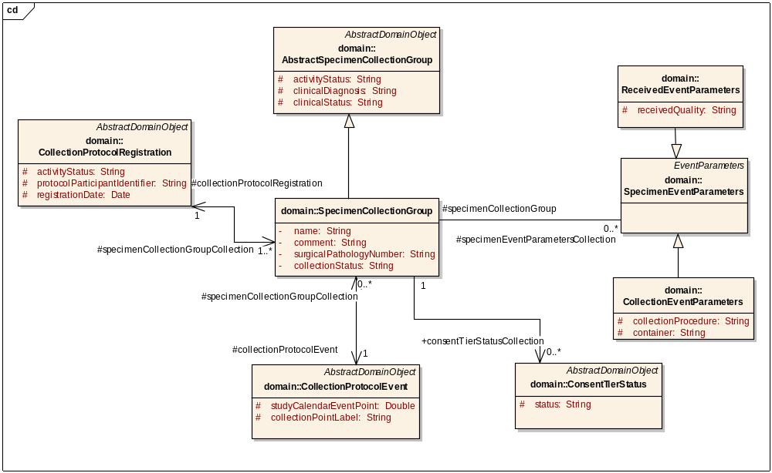
Figure 14:SpecimenCollectionGroup
Associated object | Type
CollectionProtocolEvent | Reference
CollectionProtocolRegistration | Reference
Site | Reference
SpecimenEventParameters | Reference
AbstractSpecimenCollectionGroup | Derived
ConsentTierStatus | Data
Table 41: Associated objects of SpecimenCollectionGroup

SpecimenCollectionGroup
Attribute / Constituent Object | Datatype / Class | Mandatory?
id | Long | Yes
name | String | Yes
clinicalDiagnosis | String | Yes
activityStatus | String | Yes
site | Site attributes | Yes
collectionProtocolEvent | CollectionProtocolEvent attributes | Yes
surgicalPathologyNumber | String | No
specimenCollection | Collection | No
collectionProtocolRegistration | CollectionProtocolRegistration attributes | Yes
specimenEventParametersCollection | Collection | Yes
comment | String | No
consentTierStatusCollection | Collection | No
Table 42:SpecimenCollectionGroup attributes

Specimen
Specimens can be one of the four different classes: Molecular, Fluid, Tissue, and Cell. Each specimen class is represented by a different UML Class in the model.
There are three categories of specimens:
- New specimen
- Derivative
- Aliquot
The lineage attribute must be set to New, Aliquot, or Derived. In order to create aliquot or derivative specimen, you must set an existing specimen as the parent specimen. You must populate the Parent specimen object. The parent specimen object must exist in the database. Aliquot and derived specimen objects contain this parent specimen object.
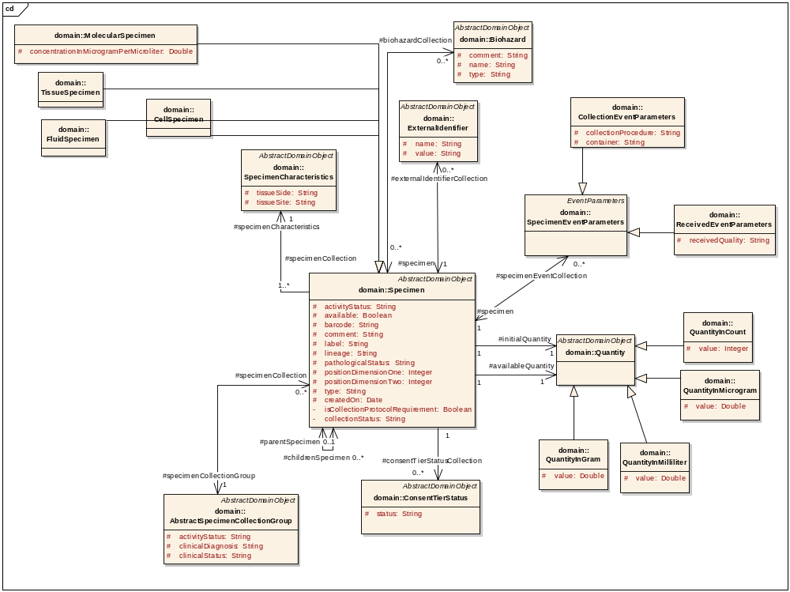
Figure 15:Specimen

Associated object | Type
ExternalIdentifier | Data
Biohazard | Reference
AbstractSpecimenCollectionGroup | Reference
SpecimenCharacteristics | Reference
Quantity | Data
StorageContainer | Reference
SpecimenEventParameter | Data
ConsentTierStatus | Data
Table 43:Associated objects of Specimen
Specimen
Attribute/Constituent Object | Datatype/Class | Mandatory
Id | Long | Yes
Type | String | Yes
Available | Boolean | Yes
positionDimensionOne | Integer | Yes
positionDimensionTwo | Integer | Yes
Barcode | String | No
Comments | String | No
ActivityStatus | String | Yes
pathologicalStatus | String | Yes
lineage | String | No
label | String | Yes
quantity | Quantity | Yes
availableQuantity | Quantity | Yes
parentSpecimen | Specimen attributes | No
storageContainer | StorageContainer attributes | Yes
specimenCollectionGroup | SpecimenCollectionGroup attributes | No
specimenCharacteristics | SpecimenCharacteristics attributes | Yes
biohazardCollection | Collection | No
specimenEventCollection | Collection | No
childrenSpecimen | Collection | No
externalIdentifierCollection | Collection | No
createdOn | Date | No
consentTierStatusCollection | Collection | No
isCollectionProtocolrequirement | Boolean | Yes
collectionStatus | String | Yes
Table 44:Specimen attributes

SpecimenCharacteristics
Attribute/Constituent Object | Datatype/Class | Mandatory
id | Long | Yes
tissueSite | String | Yes
tissueSide | String | Yes
Table 45:SpecimenCharacteristics attributes

Biohazard
Attribute/Constituent Object | Datatype/Class | Mandatory
Id | Long | Yes
Name | String | Yes
Type | String | Yes
Comments | String | No
Table 46:Biohazard attributes

Distribution
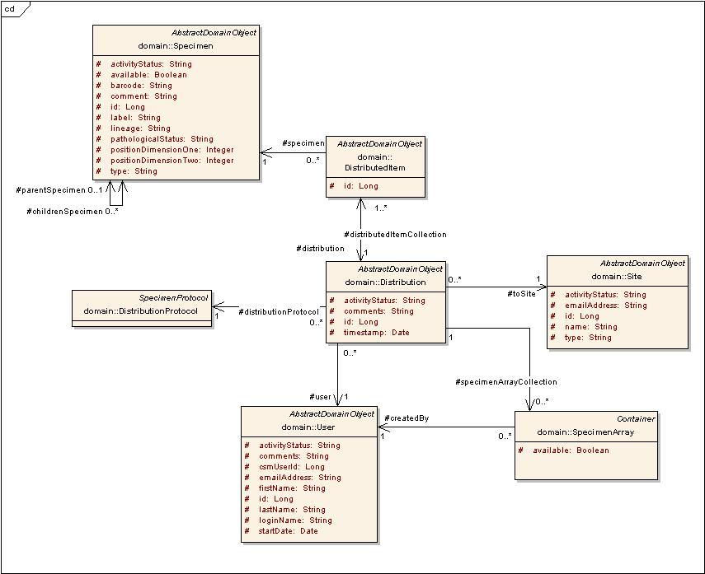
Figure 16:Distribution

Associated object | Type
Site | Reference
DistributedItem | Data
DistributionProtocol | Reference
User | Reference
Specimen | Reference
SpecimenArray | Reference
Table 47: Associated objects of Distribution
Distribution
Attribute/Constituent Object | Datatype/Class | Mandatory
activityStatus | String | Yes
toSite | Site attributes | Yes
distributionProtocol | DistributionProtocol attributes | Yes
distributedItemCollection | Collection | Yes
specimenArrayCollection | Collection | No
Table 48:Distribution attributes

DistributedItem
Attribute/Constituent Object | Datatype/Class | Mandatory
id | Long | Yes
quantity | Double | Yes
specimen | Specimen attributes | Yes
distribution | Distribution attributes | Yes
Table 49:DistributedItem attributes
ConsentTierResponse
Associated object | Type
ConsentTier | Reference
CollectionProtocolRegistration | Data
Table 50 Associated objects of ConsentTierResponse
ConsentTierStatus
Associated object | Type
ConsentTier | Reference
SpecimenCollectionGroup | Reference
Specimen | Reference
Table 51 Associated objects of ConsentTierStatus

Ordering System
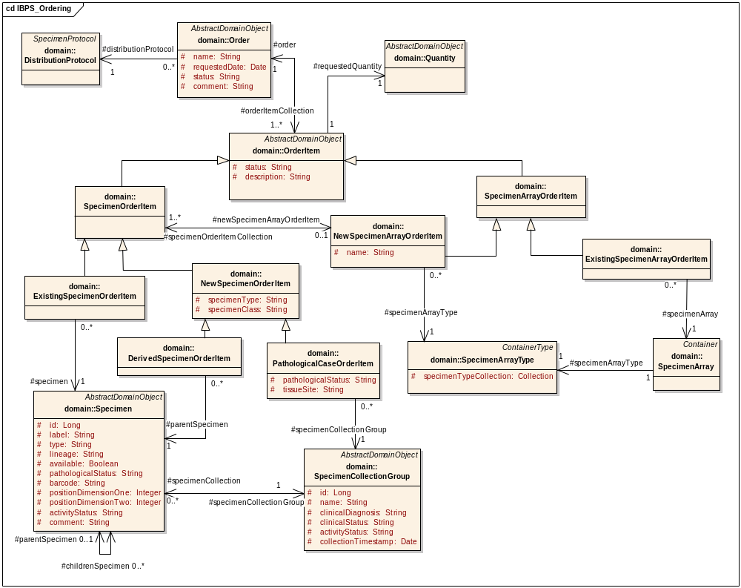
Figure 17 Ordering System
Ordering System module includes following classes:
Order
Associated object | Type
OrderItem | Data
Distribution | Reference
DistributionProtocol | Reference
Table 52 Associated objects of Order

Order
Attribute/Constituent Object | Datatype/Class | Mandatory
Id | Long | Yes
Name | String | Yes
requestedDate | Date | Yes
Status | String | Yes
Comment | String | Yes
Table 53 Order attributes
OrderItem
OrderItem can be of two types SpecimenOrderItem, SpecimenArrayOrderItem
Associated object | Type
Order | Reference
Quantity | Reference
DistributedItem | Reference
Table 54 Associated objects of OrderItem
OrderItem
Attribute/Constituent Object | Datatype/Class | Mandatory
Id | Long | Yes
Status | String | Yes
Description | String | Yes
Table 55 OrderItem attributes

SpecimenOrderItem
SpecimenOrderItem has a generalization link from class NewSpecimenOrderItem and ExistingSpecimenOrderItem.
Associated object | Type
NewSpecimenArrayOrderItem | Data
Table 56 Associated objects of SpecimenOrderItem
SpecimenOrderItem
Attribute/Constituent Object | Datatype/Class | Mandatory
Id | Long | Yes
Name | String | Yes
requestedDate | Date | Yes
status | String | Yes
comment | String | Yes
Table 57 SpecimenOrderItem attributes

NewSpecimenOrderItem
NewSpecimenOrderItem has a generalization link from class DerivedSpecimenOrderItem and PathologicalCaseOrderItem.

DerivedSpecimenOrderItem
Associated object | Type
Specimen | Reference
Table 58 Associated objects of DerivedSpecimenOrderItem

PathologicalCaseOrderItem
Associated object | Type
SpecimenCollectionGroup | Reference
Table 59 Associated objects of PathologicalCaseOrderItem

PathologicalCaseOrderItem
Attribute/Constituent Object | Datatype/Class | Mandatory
pathologicalStatus | String | Yes
tissueSite | Date | Yes
Table 60 PathologicalCaseOrderItem attributes

ExistingSpecimenOrderItem
Associated object | Type
Specimen | Reference
Table 61 Associated objects of ExistingSpecimenOrderItem
SpecimenArrayOrderItem
SpecimenArrayOrderItem has a generalization link from class NewSpecimenArrayOrderItem and ExistingSpecimenArrayOrderItem.
Associated object | Type
SpecimenOrderItem | Reference
SpecimenArrayType | Reference
SpecimenArray | Reference
Table 62 Associated objects of SpecimenArrayOrderItem

Dynamic Extensions API
The caCORE APIs generated from dynamic extensions and the static model are not integrated. For this reason, the data entry and query involves some extra steps that are described in the following sections.

Query
To query the dynamic extensions through API, two queries have to be executed by the user. The first query is executed for the static data to which the annotations are associated.The second query is executed on the other desired annotations after setting the resultant static object in it.
Consider the query to look for all the participants born before 1974, and who also have a smoking history of five years.
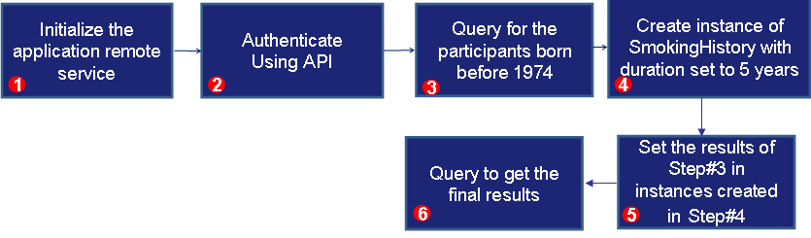
Note: The issue of different APIs will be solved in the next iteration of caTissue Suite, thus using API for dynamic extensions will become seamless.
- Initialize the Application Remote Services.
appServiceCatissue = ApplicationServiceProvider.getRemoteInstance("http://localhost:8080/catissuecore/http/remoteService");
appServiceDEEntity = ApplicationServiceProvider.getRemoteInstance("http://localhost:8080/CA/http/remoteService");
- Authenticate using API
ClientSession cs = ClientSession.getInstance();
cs.startSession("admin@admin.com", "Login123");
- Query for caTissue static objects
String hql1 = "from edu.wustl.catissuecore.domain.Participant as participant where participant.birthDate < 1974";
HQLCriteria criteria1 = new HQLCriteria(hql1);
List participantList = (List)appServicecaTissue.query(criteria1, Participant.class.getName());
- Create instance of Annotations
SmokingHistory smokingHistory = new SmokingHistory();
smokingHistory.setDuration(5);
- smokingHistory.setParticipant(participant);
- Query for Annotations
appServiceDEEntity.search(SmokingHistory.class,smokingHistory);

Inserting data for Annotations
To Insert data for the dynamically created Annotations, following steps have to be followed:
- Query for the static hook object for which the annotation has been created.
- Set this static object in the new instance of the annotation and insert it.
- Update the DE Integration objects.
Consider the following example to insert the smoking history of 5 years for all participants born before 1974:
- Query for all participants who were born before 1974. This is described above in step 3 under Query.
- Create new instance of Smoking History.
SmokingHistory smokingHistory = new SmokingHistory();
smokingHistory.setDuration(5);
- Set static object obtained in step 1, in Smoking History.
smokingHistory.setParticipant(participant);
- Insert the annotation.
appServiceDEEntity.createObject(smokingHistory);
- Update DE objects.
Long entityId = entityManager.getEntityId(“SmokingHistory”);
Long staticEntityId = entityManager.getEntityId(entityName);
Long containerId = entityManager.getContainerIdForEntity(entityId);
EntityMap entityMap = new EntityMap();
entityMap.setStaticEntityId(staticEntityId);
entityMap.setContainerId(containerId);
appServiceDeIntegration.search(EntityMap.class,entityMap);

FormContext formContext = entityMap.getFormContext();
EntityMapRecord entityMapRecord = new EntityMapRecord();
entityMapRecord.setStaticEntityRecordId(participantId);
entityMapRecord.setDynamicEntityRecordId(smokingHistoryId);
entityMapRecord.setFormContext(formContext);

appServiceDeIntegration.createObject(entityMapRecord);

Updating data for Annotations:
To update data for the dynamically created Annotations, following steps have to be followed:
- Query for the desired annotation to be updated.
- Modify the data for the annotation and update it
Consider the example to update the smoking history of five years for all participants born before 1974 to smoking history of 10 years.
- Query for all participants who were born before 1974. This is described above in step 3 under Query.
- Query for Smoking History for five years for all these participants as described in steps 4, 5, and 6 under Query.
- Modify the annotation as desired.
smokingHistory.setDuration(10);
- Update the annotation.
appServiceDEEntity.updateObject(smokingHistory);

Label & Barcode Print Service
caTissue Suite provides a framework wherein an institution can plug-in a label or barcode printer interface without making any code change to the main the caTissue codebase. This section describes the framework for achieving this. The following flowchart describes the Print Service workflow:
Web Client
(caTissueSuite)
Web service
(caTissuePrintWebService)
invoke PrintService
receive status response
PrintService Module
invoke Web service
return status
Configuration file
Figure 18: Print Service Work Flow

Description of the Print Service workflow:
- Request comes from the caTissue Suite to print a label. For example, user selects print option from the specimen page.
- Request goes to PrintService class with all the data.
- Institution customizes the PrintService code to process the data and sends it to the PrintWebService in the desired format.
- PrintWebservice then forwards the formatted data to the printer.
Note: PrintWebService is not mandatory. It is required when the printer is not accessible to the application server machine.

Developing Customized PrintService Implementation
Currently, PrintService module has the framework to support printing of labels using Specimen and SpecimenCollectionGroup. The following figure depicts the steps to develop PrintService implementation:
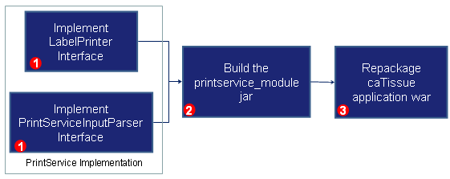
Figure 19: PrintService Implementation
- In order to have the customized PrintService implementation, you must write a class which implements LabelPrinter and another class which implements PrintServiceInputParserInterface.
The following example describes how to implement LabelPrinter:
- Implement LabelPrinter : You need to write a code to generate data that has to be printed when print label from UI is invoked.
public class SpecimenLabelPrinterImplforXYZ implements LabelPrinter {
public boolean printLabel(AbstractDomainObject abstractDomainObject, String ipAddress, User userObj)
{
//Write implementation here regarding Specimen object
//Call to customized PrintServiceInputParserInterface implementation
}
public boolean printLabel(List<AbstractDomainObject> abstractDomainObjectList, String ipAddress, User userObj)
{
//Write implementation here regarding Specimen object
//Call to customized PrintServiceInputParserInterface implementation
}

- Implement PrintServiceInputParserInterface – You need to write this code to process the data obtained from the LabelPrinter. The data is processed into particular format, such as XML format, and is sent to the Print Webservice.
public class PrintServiceInputXYZParser implements PrintServiceInputParserInterface
{
public boolean callPrintService(Object listData) throws Exception
{
//write implementation regarding how to print Object's data
//how to generate dynamic XML of object data
//Make condition whether to call caTissueprintwebservice
}
}
Note: By default, XML format is supported in the current implementation, but it can be customized to any format.
If implementation requires making a call to PrintWebService, you mudy mention its endpointURL as shown in sample properties file.
- Unwar the caTissue Suite war file and include these classes in printservice_module.jar which is present in WEB-INF/lib folder. Edit configuration file for PrintServiceImplementor.properties, which is present in the printservice_module.jar file. Modify the value of key specimen with fully qualified class name.
- Run build_war target of caTissueSuite’s build.xml file and deploy the caTissue application again.
Alternatively, you can create your own jar. In that case, you must remove the default jar named printservice_module.jar from WEB-INF/lib in caTissuecore.war and repackage catissurecore.war by adding your custom jar in WEB-INF/lib directory.
Note: The PrintServiceImplementor.properties is important for PrintService module for providing information about LabelPrinter Implementation class. You must make sure that your new jar file contains the properties file at the root of the jar and its key names are same as mentioned above in steps.

Implementation details for caTissuePrintWebService
Building an XML-RPC style caTissuePrintWebService involves the following main tasks:
- Design and code the caTissuePrintWebService endpoint Interface.
- Implement the caTissuePrintWebService endpoint Interface.
- Write the configuration File.
- Generate the mapping files.
- Use the deploytool or ant to package the service in a WAR file and deploy it.

Design and code the PrintWebService Endpoint Interface
The endpoint interface contains declaration of methods that a Web service remote client can invoke on the service. PrintService is a default interface.
The folder structure of caTissuePrintWebService is as follows:

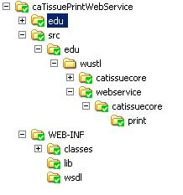

Implement the Service Endpoint Interface
The PrintServiceImpl implements the PrintService interface. Depending upon configuration PrintWebServiceFactory returns the PrintServiceClient instance and calls its print() method. The PrintServiceClient interface is specific to a University specific PrintService Client implementation. The fully qualified class name of the client implementation needs to be specified by user as value of printer.webServiceClient property in the printer.properties file present in the caTissuePrintWebService directory. For example, WashUPrintServiceClient is specific to Washington University.

Write a Configuration File:
The next step is to define a configuration file config.xml. The wscompile tool refers to the configuration file for webservice interface class file.
<?xml version="1.0" encoding="UTF-8"?>
<configuration xmlns="http://java.sun.com/xml/ns/jax- rpc/ri/config">
<service name="PrintWebService" targetNamespace="http://edu.wustl.webservice.caTissuecore.print.jboss.org/" typeNamespace="http://edu.wustl.webservice.caTissuecore.print.jboss.org/types"
packageName="edu.wustl.webservice.caTissuecore.print">
In the configuration file, describe the name of the service, namespace of the service, the package name, and the name of the interface PrintService.
According to config.xml the wscompile creates a WSDL file with the following information:
- The service name is PrintWebService.
- The WSDL namespace.
- The classes for the service are in which package.
- The service endpoint interface is PrintService.
The wscompile requires Webservice.xml file that contains the name of the service, service component, WSDL port, and service endpoint interface and so on.
<webservices xmlns="http://java.sun.com/xml/ns/j2ee"
xmlns:xsi="http://www.w3.org/2001/XMLSchema-instance"
xsi:schemaLocation="http://java.sun.com/xml/ns/j2ee http://www.ibm.com/webservices/xsd/j2ee_web_services_1_1.xsd" version="1.1">
<webservice-description>
<webservice-description-name>PrintWebService
</webservice-description-name>
<wsdl-file>WEB-INF/wsdl/PrintWebService.wsdl</wsdl-file>
<jaxrpc-mapping-file>WEB-INF/mapping.xml</jaxrpc-mapping-file>
<port-component>
<port-component-name>PrintService</port-component-name>
<wsdl-port>PrintServicePort</wsdl-port>
<service-endpoint-interface>edu.wustl.webservice.caTissuecore.print.PrintService</service-endpoint-interface>

Generate the Necessary Mapping File
Use the wscompile tool to generate the necessary files. Consider the following command executed from the caTissuePrintWebService directory:
If you have already set the classpath of all the jar files, then you can directly run the com.sun.xml.rpc.tools.wscompile.Main class. See the ant description for more details.
<target name="WsCompile">
<java classname="com.sun.xml.rpc.tools.wscompile.Main" fork="true">
<classpath refid="web.classpath"/>
<classpath>
<pathelement location="./bin"/>
</classpath>
<arg value="-gen:server"/>
<arg value="-f:rpcliteral"/>
<arg line="-mapping WEB-INF/mapping.xml"/>
<arg value="config.xml"/>
This command, which reads the config.xml file created earlier, creates the PrintWebService.wsdl file and mapping.xml in the WEB-INF directory.
The WSDL file PrintWebService.wsdl, generated by the wscompile tool, is in the current working directory. This file provides an XML description, based on WSDL, of the service that clients can invoke.

Packaging and Deploying the Service
A JAX-RPC Web service is a Servlet or a Web component, in J2EE terminology, and hence it is deployed on the Web Server. You can also use the Ant for creating the necessary files and deploy the caTissuePrintWebService to Jboss server.
For deploying the Web service, printer.properties file must be updated. Following table explains meaning of the each property specified in it.
# | Property Name | Description
1 | printer.webServiceClient | Fully qualified class name for the PrintService Client implementation.
2 | Printer.directory | The directory in which, the WashuLabelFileWriter class will be creating label files.
3 | Printer.labelFile | The path of Brady Printer specific Label file, which will be used to print labels.
4 | Jboss.home.dir | The path of jboss home, in which Webservice will be deployed. It may or may not be the same jboss in which catissuesuite is deployed

<target name="copyFiles">
<copy file="PrintWebService.wsdl" todir="./WEB-INF/wsdl"/>
<copy todir="./WEB-INF/classes">
<fileset dir="./bin"></fileset>
</copy>
</target>
<target name="build_war" depends="copyFiles">
<war destfile="caTissuePrintWebService.war" webxml="./WEB-INF/web.xml" >
<fileset dir="${base.dir}">
<include name="WEB-INF/**" />
<include name="edu/**" />
</fileset>
</war>
</target>
<target name="deploy_caTissue_print_web_service'" depends="clean_temp_dir_war,WsCompile,copyFiles,build_war">
<copy file="caTissuePrintWebService.war" todir="${jboss.home.dir}/server/default/deploy" />
</target>
<target name="clean_temp_dir_war" description="delete temp directory used for caCORE unpack">

Creating Client for the caTissuePrintWebService
The caTissuePrintWebservice client makes RPC call. You must specify the service endpoint interface address, operation name, parameter names, types, modes, and port type at the client side. Using the call object, the client can invoke the methods of the Web service. As the PrintService module acts as Webservice client, the implementation of client is available in it.
For example, for Washington University the data input for PrintService is XML format. So the PrintServiceInputXMLParser class, which implements PrintServiceInputParserInterface, has functionality to generate XML input message, call caTissuePrintWebservice, and return result message.
The dynamic generation of input XML data will be different for different types of objects. For example, for Specimen type of object the implementation is provided by SpecimenLabelPrinterImpl:
<?xml version="1.0" encoding="UTF-8"?>
<Properties>
<!--This is a simple File that contain specimens object data-->
<object class="Tissue" id="215">
<property>
<name>label</name>
<value>167</value>
</property>
<property>
<name>barcode</name>
These implementation classes are available in PrintService module. The PrintService module invokes the caTissuePrintWebService with XML data input and in return receives the status.

Class Diagram
The class diagram for caTissuePrintWebService can be described as follows. This diagram shows classes related to a WebService:

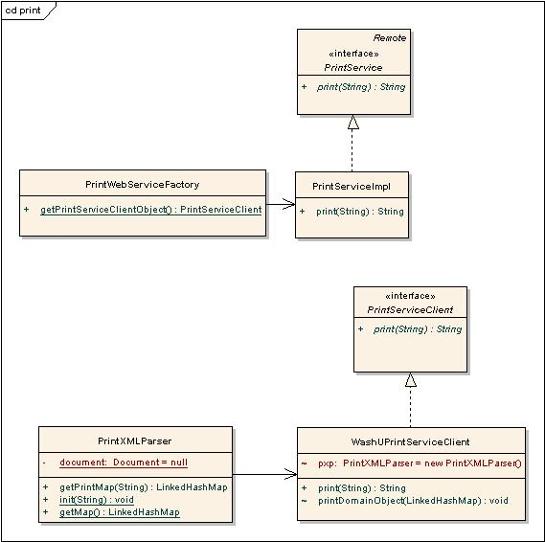
Figure 20: Class diagram related to caTissuePrintWebService

# | Class Name | Description
1 | PrintService | This interface has the method print(String, which is implemented by every PrintService Implementation class.
2 | PrintServiceImpl | This class implements interface PrintService. It invokes PrintServiceClient depending on Factory class settings.
3 | PrintServiceClient | This interface provides method, which is implemented by every PrintService Client.
4 | PrintXMLParser | This class parses input XML string and returns collection of DomainObjects to PrintServiceClient.

Label and Barcode Generation
caTissue Suite provides a framework wherein an institution can plug-in a label or barcode generation interface without making any code change to the caTissue Suite codebase. Currently, automatic label generation is implemented for Specimen, SpecimenCollectionGroup, and StorageContainer type of objects.
If automatic label generation is specified, then you will not be able to manually enter the label at the time of adding the object through UI screen. The label of object will be auto-generated at the time of object creation.
If automatic label generation is not specified, then you must provide value for the label at the time of adding the object through UI screen.
Sample entries in LabelGenerator.Properties related to Label Generation are as follows:
specimenLabelGeneratorClass=edu.wustl.caTissuecore.namegenerator.DefaultSpecimenLabelGenerator
storageContainerLabelGeneratorClass=edu.wustl.caTissuecore.namegenerator.DefaultStorageContainerLabelGenerator
speicmenCollectionGroupLabelGeneratorClass=edu.wustl.caTissuecore.namegenerator.DefaultSCGLabelGenerator
Following table shows the key name of corresponding label generator classes for Specimen, SpecimenCollectionGroup, and StorageContainer.
Object type | Key Name | Value
Specimen | specimenLabelGeneratorClass | classname
SpecimenCollectionGroup | speicmenCollectionGroupLabelGeneratorClass | classname
StorageContainer | storageContainerLabelGeneratorClass | classname
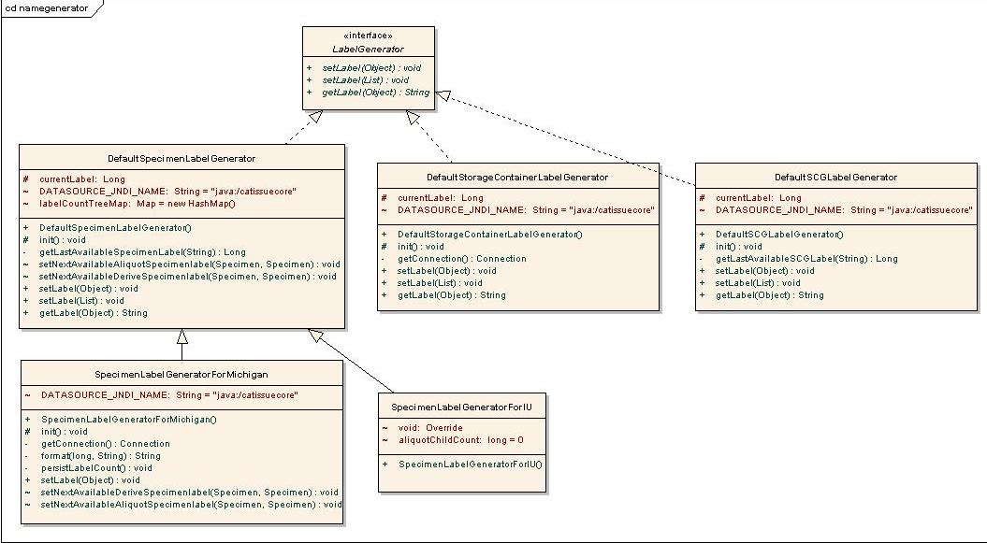
Figure 21:Label generator model
# | Class Name | Description
1 | LabelGenerator | This interface has the method setLabel (Object), setLabel (List<Object>) and getLabel (Object), which will be implemented by Label Generator Classes.
2 | DefaultSpecimenLabelGenerator | This class provides default implementation related to the Specimen type of object.
3 | DefaultStorageContainerLabelGenerator | This class provides default implementation related to the StorageContainer type of object.
4 | DefaultSCGLabelGenerator | This class provides default implementation related to the SpecimenCollectiongGroup type of object.
Table 63:Label generator classes

Folder Structure and Deployment Details
The source folder of all generator classes is caTissueSuite/WEB-INF/src. The package edu.wustl.caTissuecore.namegenerator contains all the class files.
The label and barcode generation related classes are available in two JAR files:
- label_barcode_gen_client.jar: This JAR file contains interface and factory classes for label and barcode generation. It contains the following:
  - LabelGenerator
  - LabelGeneratorFactory
  - BarcodeGenerator
  - BarcodeGeneratorFactory
- Default_label_barcode_gen.jar: This JAR file contains default implementation of label and barcode generator for different type of objects. It contains the following:
  - LabelGenerator.Properties
  - DefaultSCGLabelGenerator
  - DefaultSpecimenLabelGenerator
  - DefaultStorageContainerLabelGenerator
  - DefaultStorageContainerBarcodeGenerator
  - DefaultSpecimenBarcodeGenerator
For deployment, the ant tasks provided in build.xml file of caTissue Suite are: Default_Label_BarCode_Generator and Label_BarCode_Generator_Client
This task is included in build_war target, so every time the build_war target is run these jars are created and added into build path of caTissue Suite during deployment.

Barcode Generation
The barcode generation also follows the same logic as label generator design. The automatic barcode generation is specified in LabelGenerator.Properties. Currently, automatic barcode generation is implemented for Specimen and StorageContainer type of objects.
If automatic barcode generation is specified, then you cannot enter the barcode at the time of adding the object through UI screen. The barcode is auto-generated at the time of creation.
If automatic barcode generation is not specified, then you are able to enter it manually.
Sample entries in LabelGenerator.Properties related to barcode generation are as follows:
specimenBarcodeGeneratorClass=edu.wustl.caTissuecore.namegenerator.DefaultSpecimenBarcodeGenerator
storageContainerBarcodeGeneratorClass=edu.wustl.caTissuecore.namegenerator.DefaultStorageContainerBarcodeGenerator
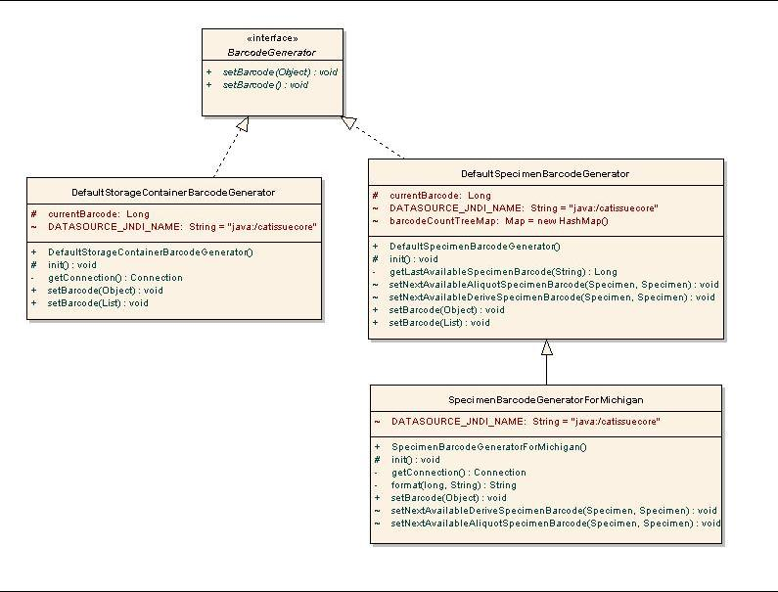
Figure 22: Barcode Generation Model

# | Class name | Description
1 | BarcodeGenerator | This interface has the method setBarcode (Object) and setBarcode (List<Object>), which will be implemented by Barcode Generator Classes.
2 | DefaultSpecimenBarcodeGenerator | This class provides default implementation related to Specimen type of Object.
3 | DefaultStorageContainerBarcodeGenerator | This class provides default implementation related to StorageContainer type of Object.
Table 64:Barcode generator classes

Developing Customized Label and Barcode Generator
You can customize the label and barcode generation process according to your requirements.
The LabelGenerator and BarcodeGenerator are main Interfaces The customized class requires to implement the appropriate interface.
For example, if an university named XYZ wants to run its own algorithm for label generation or barcode generation, then it is possible by just writing their own class which implements the necessary interface that is, LabelGenerator / BarcodeGenerator.
Assume XYZ university has written customized label generator named, SpecimenLabelGeneratorforXYZ as follows:
public class SpecimenLabelGeneratorForXYZ implements LabelGenerator
{ public SpecimenLabelGeneratorForXYZ() {
}
public void setLabel(Object obj) {
//Implementation specific to University
Specimen objSpecimen = (Specimen)obj; objSpecimen.setLabel("xyz_"+UniqueNumber) ;
}
public void setLabel(List objList)
{ for (int index=0;index <objList.size();index++) {
Specimen objSpecimen = (Specimen)objList.get(index); setLabel(objSpecimen);
}
}
public String getLabel(Object object){
Specimen objSpecimen = (Specimen)obj;
return objSpecimen.getLabel();
}
}
After implementation, include this class in Default_label_barcode_gen.jar and edit configuration file LabelGenerator.Properties. Provide fully qualified class name to modify the value of key specimenLabelGeneratorClass. Run build_war target of caTissue Suite’s build.xml file and deploy the caTissue Suite application again.
Alternatively, you can create your own jar file. In that case, you must remove the default jar named, Default_label_barcode_gen.jar from WEB-INF/lib in caTissuecore war and repackage caTissue war by adding your custom jar in WEB-INF/lib directory.
Note: The LabelGenerator.Properties is important for initializing label generator and barcode generator. Therefore make sure your new jar file contains this file at the root of the jar and its key names are same as mentioned above.

Appendix A–Longitudinal protocols
Longitudinal collection protocols are complex protocols that can contain sub-protocols as well as time points. Sub-protocol can contain any other sub-protocol and time points. caTissue Suite allows you to define longitudinal collection protocols using the API, but you cannot define longitudinal collection protocols through UI. The following sections describe how this can be achieved:
Term | Definition
Sub-Protocol | A part of a protocol that represents phases, arms, and cycles.
Phase | Study phases are successive pathways which may or may not apply in the cause of a treatment for one participant. Some phases may apply to all participants and some phases are used for unplanned course of disease progression or relapse.
Arm | Study arms are alternative pathways, with alternative visit timelines and participants assigned to one of these alternative arms by inclusion criteria and/or randomization. Collection time points are often different on different arms.
Cycle | Cycles are successive steps of treatment that belong to a particular phase.
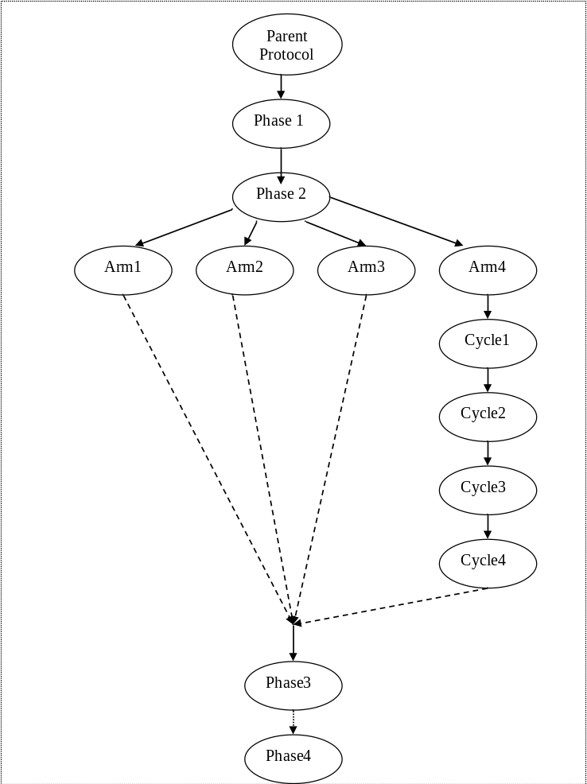
The following image depicts one such collection protocol: Osteosarcoma CP

Under parent protocol, 4 phases are present.
Under Phase2, 4 arms are present
And under Arm4, there are 4 cycles.

Collection Protocol model changes:
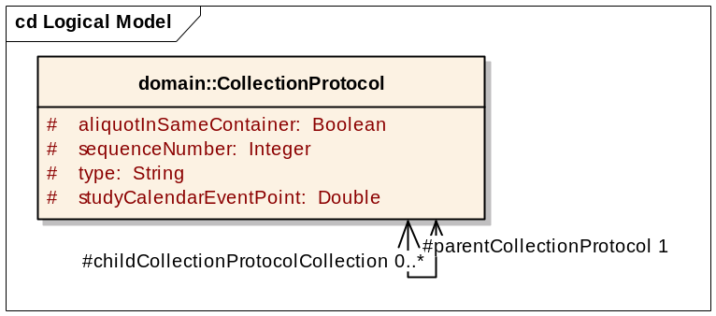
The following changes are made to the model to accommodate this requirement:
- childCollectionProtocolCollection added to hold child collectionProtocol.
- parentCollectionProtocol holds the parent of the collectionProtocol.
- Type is a type of the collection protocol that is Phase, Arm, Cycle, or Parent.

For adding complex collectionProtocol following attributes must to be set:
CollectionProtocol collectionProtocol = new CollectionProtocol();
//for setting type
collectionProtocol.setType(“Phase”);

//for setting child childCollectionProtocol collection.
collectionProtocol.setChildCollectionProtocolCollection(childCpCollection)
//for setting parent collectionProtocol.
collectionProtocol.setParentCollectionProtocol(parentProtocol)

Appendix B: Auditing Functionality
Every add, edit, and query operation in caTissue Suite application is audited in the AuditEvent tables in the database.
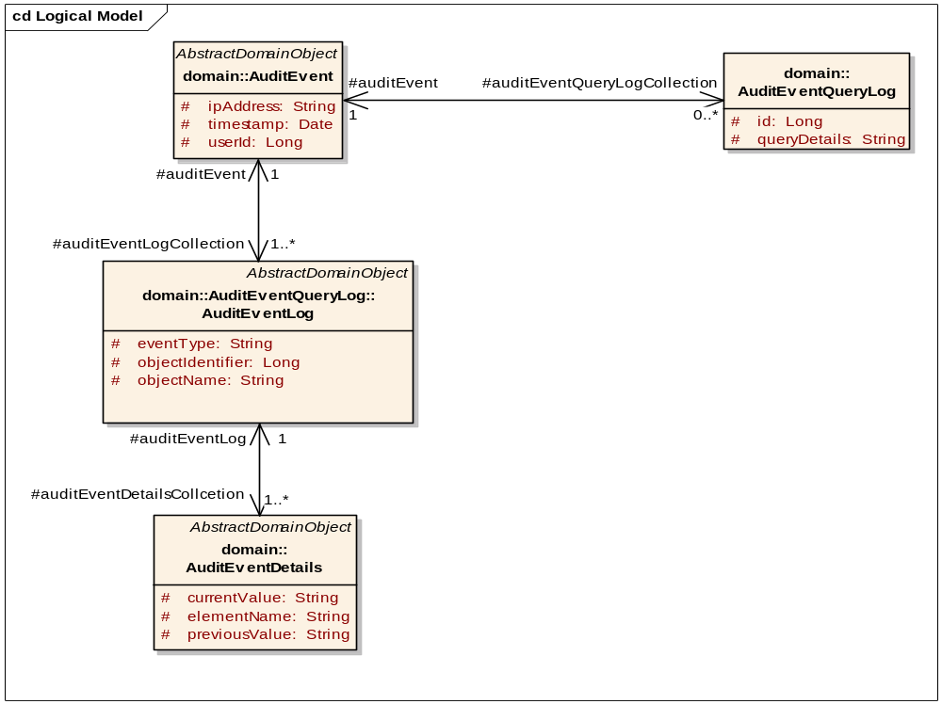
Figure 23: Auditing model
As seen in the above model, all the details about the activities of the logged in user are audited in the database. To know the audit details, you can query against the audit table to get the desired information. Audit table descriptions are given below:
- catissue_audit_event: Details about the user like user id and ipaddress of the machine. It also has the details about when the event was carried out by the user.
- catissue_audit_event_log: Details about the which data was added/changed.
- catissue_audit_event_details: Details about the old and new values of the data that was added/modified.
- catissue_audit_event_query_log: SQL queries that were executed by the user.
The only way to get these details is through database query.

Appendix C: Modifying permissible values
In the caTissue Suite application, there are many attributes or fields for which the permissible values are pre-defined. Such attributes are known as enumerated attributes. For example, the specimen class has predefined set of permissible values including Fluid, Cell, Molecular, and Tissue. Any adopting institution can change these default values according to local requirements. However, the caTissue Suite cautions that adding values may make the application not caBIGTM compatible. For all enumerated fields, all the required values identified by the system adopters during the course of development will be included. Before adding any new value, you must double check whether the existing values satisfy the requirement. If an available value for some attribute is irrelevant and is of no use for the institution, the value can be removed.
Database tables related to permissible values:
- catissue_cde:All the attributes that are enumerated are listed in this table. Each attribute is given a unique identifier called PUBLIC_ID.
- catissue_permissible_value: Permissible values for all the enumerated fields are listed in this table. These are associated with the catissue_cde table by the PUBLIC_ID field.
In order to modify any value in the permissible value list, you have to get the PUBLIC_ID corresponding to that attribute from catissue_cde and query against that in catissue_permissible_value. The new values for the same PUBLIC_ID can be added or existing values can be removed. The Value field is the column which stores the actual permissible value in catissue_permissible_value table. Another field in catissue_permissible_value is the PARENT_IDENTIFIER. The parent identifier field is used for attributesthat have hierarchical data such as clinical diagnosis and tissue site. In such cases, appropriate parent_id should also be set.
For example:
If you need to add a specimen type under a particular specimen class:
- Find public id for specimen class. Select public_id from catissue_cde where <search based on definition or long name’.
- Using the above public id. Select identifier from catissue_permissible_value where public_id=<public_id>.
- Find the max identifier in table catissue_permissible_value.
- Add a new entry for the new specimen type under fluid as: Insert into catissue_permissible_value values (<max_identifier, null, null, <identifier found in step 2>, <new type>, null.

Appendix D: CSM configuration
Using the User Provisioning Tool (UPT) provided by the CSM, you can customize the privileges of different users to meet the requirements of the institution. You can find the UPT installer and documentation at https://gforge.nci.nih.gov/frs/?group_id=12

Giving Privilege to a Supervisor to Add or Edit a Collection Protocol
By default, a supervisor cannot add/edit any administrative data. This includes collection protocol data. If there is a requirement at any center to allow all supervisors to add/edit some specific administrative data, you need to configure the privileges in two steps:
- Giving privilege on actions
- Giving privilege on objects
You can do this using the UPT as explained in detail in the following sections. The example given here is one of updating collection protocol privileges, however, the process is applicable to any administrative data.

Giving privilege on the appropriate actions for add/edit of collection protocol
All actions that need privileges for execution are added as protection elements in the CSM tables. The caTissue Suite categorizes the actions based on the rights of various user groups as follows:
- Administrative
- supervisory
- technician
- public actions
To be able to execute these actions you need EXECUTE privilege on them.
Since collection protocol is a part of administrative data, the protection elements corresponding to actions for adding or editing collection protocol are by default added to SECURED_ADMINISTRATIVE_ACTIONS protection group. If you want to give supervisors the privilege of adding or editing collection protocol, these protection elements must also be assigned to SECURED_SUPERVISORY_ACTIONS. You can do this through UPT as described in the screenshots below. To reach this screen search for SECURED_SUPERVISORY_ACTIONS protection group through UPT and then click Associated PEs.
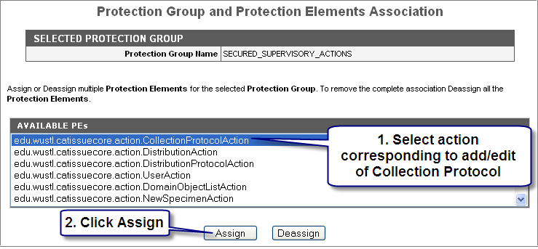
Figure 24: Actions for add/edit of collection protocol
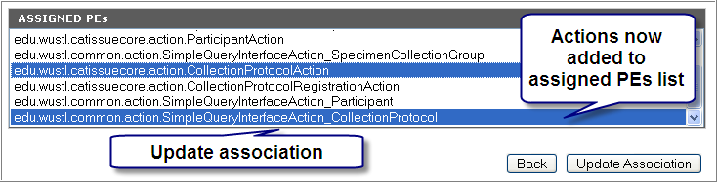
Figure 25: Actions assigned to supervisor group
These steps can be further elaborated as follows:
- Select the actions corresponding to add or edit of collection protocol from available PEs. For adding collection protocol the action name is : edu.wustl.catissuecore.action.CollectionProtocolAction and for editing the action name is: edu.wustl.common.action.SimpleQueryInterfaceAction_CollectionProtocol
- Click Assign.
The ASSIGNED PEs list displays the selected actions.
- Click Update Association to confirm the changes.
By following these steps the required actions are made supervisory actions, hence, all supervisors get the privilege to execute actions for add or edit of collection protocol.

Giving privilege on appropriate objects for add/edit
The previous section describes how adding or editing data from the UI is achieved by controlling access on the respective actions. This can be sufficient if adding or deleting data happens only via the UI. Since data can also be added or updated using APIs, this restriction is inadequate. Thus there is another security layer that is added at the object level for preventing add or edit of objects based on their type. All objects that can be added only by administrators are assigned to ADMINISTRATOR_PROTECTION_GROUP. Similarly, the objects that can be added only by supervisors or administrators are assigned to SUPERVISOR_PROTECTION_GROUP. Since collection protocol is administrative data, the corresponding protection elements are by default a part of ADMINISTRATOR_PROTECTION_GROUP. To allow collection protocol’s add or edit by supervisors, these protection elements must also be made a part of SUPERVISOR_PROTECTION_GROUP. This can be done though UPT as explained in following figures. To reach this screen search for SUPERVISOR_PROTECTION_GROUP protection group through UPT and click Associated PEs.
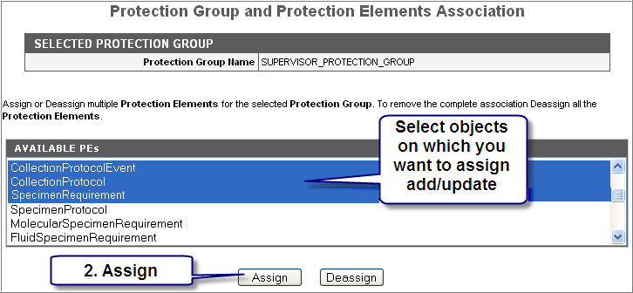
Figure 26: Objects for add/edit of collection protocol
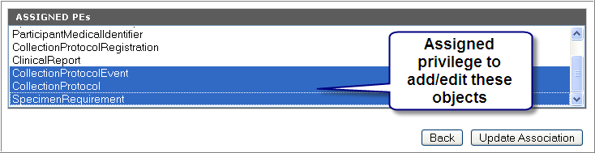
Figure 27: Objects assigned to supervisors group

These steps can be elaborated as follows:
- Select the objects on which add or edit privilege is required. While adding CollectionProtocol you can also add CollectionProtocolEvent and SpecimenRequirement objects so select all the three options.
- Click Assign.
The ASSIGNED PEs list displays all the selected objects.
- Click Update Association to confirm the changes.
Following these steps the required object types are assigned to supervisors group and all the supervisors get the privilege to add or edit of collection protocol.

Giving privilege to a Technician to view PHI data
In caTissue Suite Core access to identified data is prevented based on a privilege named IDENTIFIED_DATA_ACCESS. You must have this privilege to be able to view identified information of the associated data. Technicians by default cannot view PHI data. To give this privilege to the technicians, they must be assigned IDENTIFIED_DATA_ACCESS on the public data. You can do this through UPT as described in the figures below. To reach this screen search for Technician role through UPT and click on Associated Privileges.
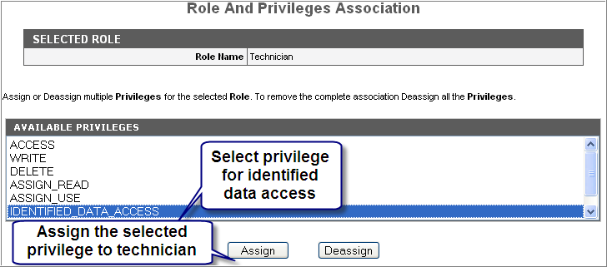
Figure 28: Privilege for identified data access
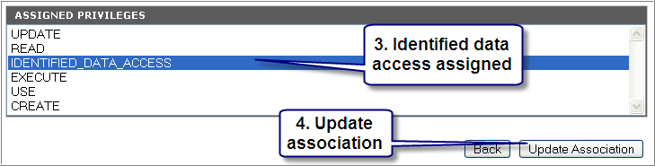
Figure 29: Identified data access assigned

These steps can be further explained as follows:
- In the details page of Technician role select IDENTIFIED_DATA_ACCESS from AVAILABLE PRIVILEGES list.
- Click Assign.
The ASSIGNED PRIVILEGES list displays the IDENTIFIED_DATA_ACCESS privilege.
- Click Update Association to confirm the changes.
These steps allow technicians to obtain the privilege for viewing PHI.

