caTissue Suite v1.1

Dynamic Extensions single API
Design Document
Version 1.0

Revision History
Date | Version | Description
29 May 2008 | 0.5 | Initial draft
12 Nov 2008 | 1.0 | Incorporated adopter comments

1 Overview 3
1.1 References 3
2 Detailed design 4
2.1 Prototype 4
2.2 Prototype Summary 5
2.3 Next steps 5
2.4 Proposed workflow 6

Overview

caTissue Suite v1.0 includes the caCORE API enabling a user to insert, update, and query any data available in the static model. Another functionality of caTissue Suite is the ability to extend the static model dynamically using the Dynamic Extensions (DE) feature. Once the extensions are created, the current version of caTissue Suite also allows the user to generate a caCORE API which can then be used to add/update or query data programmatically.
As per the current design, each DE has to be deployed as an independent caCORE API system i.e. each DE can be accessed from its own caCORE API URL. Therefore, the clients will have to access each URL independently, fetch data and join them.

This is the reason why there are multiple APIs to query or insert data when DE classes are involved. Additionally, in case of insert, you need to insert data into additional DE metadata classes.

The goal of the single-API design is to eliminate this complexity and be able to query and insert in a single caCORE API query.

References

- caTissue Suite 1.1 design document
- caTissueSuite_DynamicExtensions_DesignDoc

Detailed design
The solution to this problem is to integrate DE API with caTissue static API and have a single API and URL to access it

Challenges of this approach:

- How to integrate the WAR (Java binaries) DE API with caTissue WARs API?
- This will need the server to be restarted every time a DE is created or edited.
- DEs are associated with classes of a hook object within caTissue (i.e. Participant, Specimen Collection Group, Specimen). To create this association, the POJOs and HBM files of the hook objects will need to be modified.
- More importantly, all the above needs to be done programmatically to avoid human errors.

Prototype
The goal of the prototype was to do the following:
- Create a test DE
- Generate its caCORE API
- Manually integrate it with caTissue Participant object
- Execute an API and test for success

Prototype Summary
The findings of the prototype so far are:
- The prototype worked fine. We were able to use the caCORE API to perform a single API query or insert.
- We could also use the DE caCORE API within the DE business logic to insert or edit data. This will be major and much needed code refactoring exercise in DE to remove the current logic of using direct SQLs with caCORE APIs to read and write.
- The server will have to be manually restarted if a DE is added or edited. This should be fine because we do not expect that a DE will be edited or added as a frequent operation. Also, we expect DEs will be created or edited on a test server before moving to production.
- Each class from the core model to which DEs may be attached should be accompanied by a “hook class” in the static model. E.g. Participant will have a ParticipantAnnotation class, Specimen will have a SpecimenAnnotation class. All the DEs will be connected to this intermediate class rather than the main class. This will avoid modifying the main static Java classes and HBM files.

Next steps

For this to be implemented in Construction, one of the key stumbling block is it is the dependency on the availability of caCORE SDK 4.1. Current SDK (v4.0) does not generate the Java classes and Hibernate mapping definition in a way it can be consumed with an application. These issues have been raised with the SDK team, and they will be providing a SDK release 4.1 in June, 08. The prototype was implemented by manually editing the Hibernate mapping definition and Java classes automatically generated by the SDK.
We can proceed on the actual implementation of this task only after SDK 4.1 is released.

Proposed workflow

The following image describes the proposed workflow

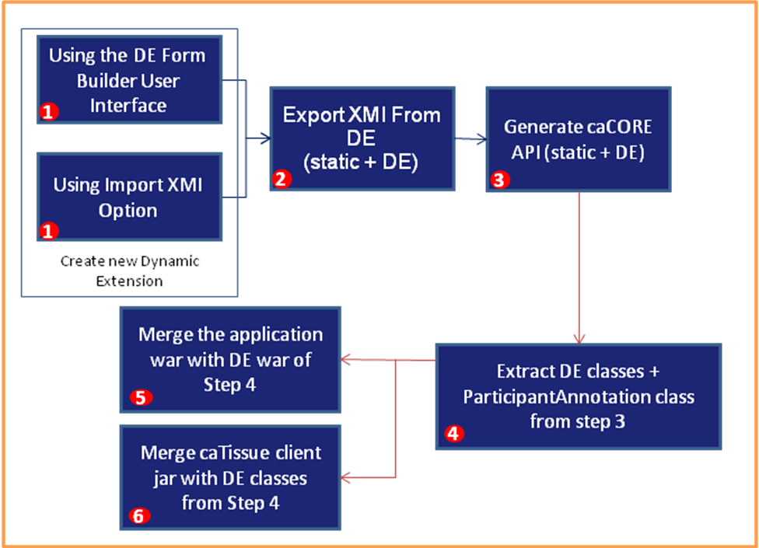

Note that all the steps will be automated in one ANT task. So the system administrator needs to only do the following:
- Create DE either through UI or import XMI
- Run an ANT script, say "ant createDEAPI"
- The ANT script will stop the server, perform all the steps, start the server

