Minimal Data Sharing (MDS)
The ability to expose the content of a bio-repository and the distributions made from it is a desirable aspect of data sharing. Both the content (inventory) and distributions are described at the level of specimen type and collection protocol. At this level, aggregated information, without concerns about exposing PHI, is desirable. Thus a simple model that many bio-repositories could provide irrespective of the systems that they use at their site can be provided.
In order to achieve the same, a simple model has been proposed and is prototyped with caTissue Suite 1.1. Below are the details of how one can share data from caTissue using this model:
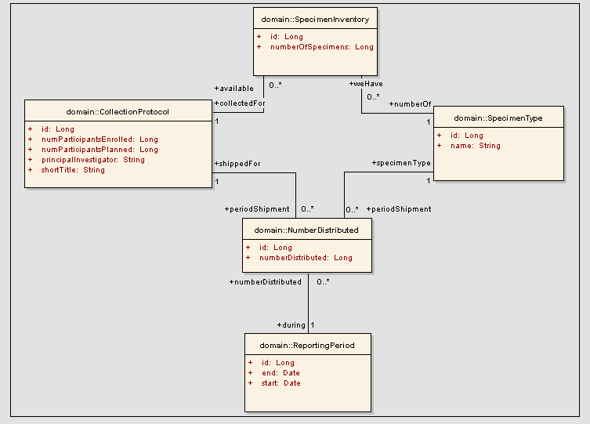
Figure 1: Snapshot of the model
Prerequisite:
- Installation of caTissue with data inserted for collection protocol, specimens collected and distributed under that protocol
- Empty DB created for MDS on same DB server as caTissue
Typical scenario is:
caTissue is migrated into public instance using private-public migrator. On the public instance, MDS is deployed.

Deployment:
Following are the steps for creating the minimal model (DB and API) for MySQL or Oracle DB:

Step 1: Download the caTissue Suite installable from the location.
https://gforge.nci.nih.gov/frs/download.php/5408/caTissue_Suite_v1.1_Installable.zip

Extract the contents of the installable zip to any desired location. This location is referred to as CATISSUE_HOME here after. MDS code is present at CATISSUE_HOME/minimalDataSharing
Step 2: Configure the following parameter in the MinimalDataSharing.properties file present in CATISSUE_HOME/minimalDataSharing/MinimalDataSharing.properties

Configure the following parameters in the MinimalDataSharing.properties file:
Property Name | Description
JBOSS_HOME | Description: Should be set to JBOSS_HOME.  Note: Path must be separated by ‘/’ and not ‘\’  For example:  In Windows:  jboss.home.dir=c:/jboss-4.2.2.GA  In Linux:  jboss.home.dir= usr/local/jboss-4.2.2.GA
DB.TYPE | Description: Database type used in the application.  Permissible Values: : mysql, oracle
DB.HOST | Description: Hostname or IP address of the machine on which the database server is running.  There is only one DB.HOST as MDS and caTissue database always be on same Database Server
DB.PORT | Description: Port number to connect with the database server.  Default port for MySQL: 3306  Default port for Oracle: 1521
CATISSUE.DB.USERNAME  (Applicable only when DB.TYPE =oracle) | Description: The bio-repository database i.e. caTissue database username.  caTissue database username must have sufficient privileges to insert data into MDS database i.e. must have DBA privileges
CATISSUE.DB.PASSWORD  (Applicable only when DB.TYPE =oracle) | Description: The bio-repository database i.e. caTissue database password.
CATISSUE.DB.NAME | Description: Bio-repository database name i.e. caTissue database name, specify the same name that you have specified while creating the database  In case of oracle CATISSUE.DB.NAME = SID
MDS.DB.NAME | Description: MDS database name, specify the same name that you have specified while creating the database.  In case of oracle MDS.DB.NAME = SID
MDS.DB.USERNAME | Description: MDS database username.
MDS.DB.PASSWORD | Description: MDS database username.
Note: In case of oracle, MDS.DB.NAME and CATISSUE.DB.NAME must be same SID because both databases are on same database server.
Step 3: Deploying Minimal data sharing APIs:
- Open the command prompt and change the current directory to
CATISSUE_HOME/minimalDataSharing
- Execute below ANT task to deploy the application and extract the data out of caTissue the database in the command prompt. The syntax to run the ANT task is as follows:
ant build.xml extractData

Step 4: Testing the MDS application
Once the JBoss server is started, you can access the caCORE API query page(Happy.jsp) using a web browser. The following is the URL:
http://machine_name:port_number/minimalDataSharing

Step 5: Testing the MDS API
- Once the JBoss server is started, you can query through caCORE API query using MDS client.
- Open client file MinimalDataSharingClient.java located at CATISSUE_HOME\caTissueSuite_Client\mds_src\domain\MinimalDataSharingClient.java
- Open remoteService.xml client file located at CATISSUE_HOME\caTissueSuite_Client\conf\ remoteService.xml and edit value of property name “serviceUrl” as http://<Host name>:<Port no.>/minimalDataSharing/http/remoteService
Host name: IP Address of machine
Port no: Port no of the Application Server
- In the MSD Client file user can write the API test cases according to their requirement, please refer the example test cases already written.
- After writing test cases, for executing test cases run target “runMDSClient” of mds_build.xml present at CATISSUE_HOME\caTissueSuite_Client

The syntax to run the ANT task is as follows:
ant -f mds_build.xml runMDSClient
- To see the Minimal Data Sharing reports, go to CATISSUE_HOME\caTissueSuite_Client\ MDS_Report

