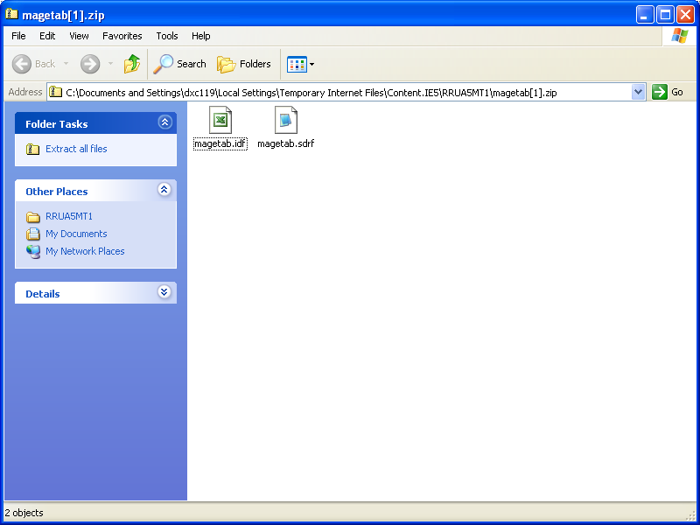

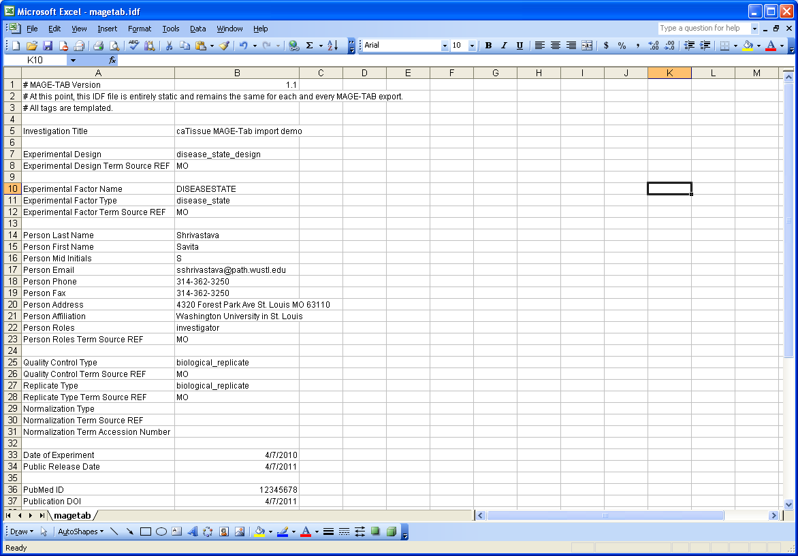Source Name Characteristics[Race] Term Source REF Characteristics[Ethnicity] Term Source REF Characteristics[Sex] Term Source REF Characteristics[Age] Term Source REF Characteristics[DiseaseState] Term Source REF Characteristics[PathologicalStatus] Term Source REF Characteristics[ExternalId] Characteristics[Global Specimen Identifier] Characteristics[Label] Characteristics[OrganismPart] Term Source REF Characteristics[SpecimenType] Term Source REF Characteristics[Collection Protocol Name] Characteristics[Protocol Participant ID] Characteristics[Clinical Status] Term Source REF Characteristics[Calendar Event Point Label] Provider Material Type Term Source REF Sample Name Characteristics[ExternalId] Characteristics[Global Specimen Identifier] Characteristics[Label] Characteristics[SpecimenType] Term Source REF Characteristics[Clinical Status] Term Source REF Characteristics[Calendar Event Point Label] Material Type Term Source REF Extract Name Characteristics[ExternalId] Characteristics[Global Specimen Identifier] Characteristics[Label] Characteristics[SpecimenType] Term Source REF Characteristics[Clinical Status] Term Source REF Characteristics[Calendar Event Point Label] Material Type Term Source REF
102 Unknown NCI Thesaurus Unknown NCI Thesaurus Male Gender NCI Thesaurus NCI Thesaurus Not Specified SNOMED-CT Malignant NCI Thesaurus b7cc5f4d-1064-49c7-b5fa-8788de4eb661 Abdomen, NOS ICD-O-3 Topography DNA NCI Thesaurus CP0 1234 New Diagnosis NCI Thesaurus 1 scientist, guru DNA MO 103 29c450b6-5669-4d5e-b71b-f4c910a1b069 DNA NCI Thesaurus New Diagnosis NCI Thesaurus 1 DNA MO 104 8f8d21c0-8e4c-48e2-bd7a-ab38f3dc5aa3 DNA NCI Thesaurus New Diagnosis NCI Thesaurus 1 DNA MO
127 Unknown NCI Thesaurus Unknown NCI Thesaurus Male Gender NCI Thesaurus NCI Thesaurus Not Specified SNOMED-CT Malignant NCI Thesaurus 4e72aa25-5230-4a2b-b00a-ea38c9fa2f52 Abdomen, NOS ICD-O-3 Topography Whole Genome Amplified DNA NCI Thesaurus NoStudyEvent 16_26 New Diagnosis NCI Thesaurus 12 Admin, Admin genomic_DNA MO 128 c5cbe2ea-d2a8-43ae-8843-87eecca81762 cDNA NCI Thesaurus New Diagnosis NCI Thesaurus 12 molecular_mixture MO 129 76f46ec9-f36b-48f2-a0cb-9f035df36f88 DNA NCI Thesaurus New Diagnosis NCI Thesaurus 12 DNA MO
130 Unknown NCI Thesaurus Unknown NCI Thesaurus Male Gender NCI Thesaurus NCI Thesaurus Not Specified SNOMED-CT Malignant NCI Thesaurus 7e5fb2e0-07c2-40c8-892d-7b85563116b4 Abdomen, NOS ICD-O-3 Topography Whole Genome Amplified DNA NCI Thesaurus NoStudyEvent 16_27 New Diagnosis NCI Thesaurus 12 Admin, Admin genomic_DNA MO 131 fd638bb2-08c8-4439-8a4d-3cde5aaa685f cDNA NCI Thesaurus New Diagnosis NCI Thesaurus 12 molecular_mixture MO 132 0854d4b1-67b1-49c4-9ff2-73186c386770 DNA NCI Thesaurus New Diagnosis NCI Thesaurus 12 DNA MO
136 Unknown NCI Thesaurus Unknown NCI Thesaurus Unspecified NCI Thesaurus NCI Thesaurus Not Specified SNOMED-CT Malignant NCI Thesaurus 844aaf04-bb8f-40a8-8337-016ce303277f Abdomen, NOS ICD-O-3 Topography Whole Genome Amplified DNA NCI Thesaurus NoStudyEvent 16_28 New Diagnosis NCI Thesaurus 12 Admin, Admin genomic_DNA MO 137 4a0595ad-3675-4549-917c-b810c4ff9d22 cDNA NCI Thesaurus New Diagnosis NCI Thesaurus 12 molecular_mixture MO 138 3673f854-b0f2-422b-9821-46557fe39320 DNA NCI Thesaurus New Diagnosis NCI Thesaurus 12 DNA MO
239 Unknown NCI Thesaurus Unknown NCI Thesaurus Male Gender NCI Thesaurus NCI Thesaurus Not Specified SNOMED-CT Malignant NCI Thesaurus 77f0fdc2-b8de-4033-b2cf-30e01301a467 Abdominal esophagus ICD-O-3 Topography Whole Genome Amplified DNA NCI Thesaurus MolecularSpecimen 20_46 New Diagnosis NCI Thesaurus 10.0 92 Admin, Admin genomic_DNA MO 240 9a59a451-79c3-4774-a733-3933c785e500 cDNA NCI Thesaurus New Diagnosis NCI Thesaurus 10.0 92 molecular_mixture MO 241 86fbce89-60fc-4909-8dcf-cf49833f6be3 DNA NCI Thesaurus New Diagnosis NCI Thesaurus 10.0 92 DNA MO
242 Unknown NCI Thesaurus Unknown NCI Thesaurus Unspecified NCI Thesaurus NCI Thesaurus Not Specified SNOMED-CT Malignant NCI Thesaurus 5d45ba04-808b-487e-a974-89bfd7210627 Abdominal esophagus ICD-O-3 Topography Whole Genome Amplified DNA NCI Thesaurus MolecularSpecimen 20_47 New Diagnosis NCI Thesaurus 10.0 92 Admin, Admin genomic_DNA MO 243 cab09bcd-f447-439b-ab66-96349f958f45 cDNA NCI Thesaurus New Diagnosis NCI Thesaurus 10.0 92 molecular_mixture MO 244 0b6a5cde-d1fb-4fd6-9307-b6cf65a81af1 DNA NCI Thesaurus New Diagnosis NCI Thesaurus 10.0 92 DNA MO
311 Black or African American NCI Thesaurus Unknown NCI Thesaurus Male Gender NCI Thesaurus NCI Thesaurus Not Specified SNOMED-CT Malignant NCI Thesaurus fd7ece60-22ad-4e9d-b47f-19338711bbbd Abdominal esophagus ICD-O-3 Topography Whole Genome Amplified DNA NCI Thesaurus MolecularSpecimen 20_59 New Diagnosis NCI Thesaurus 10.0 92 Admin, Admin genomic_DNA MO 312 f3c8e42a-3958-4861-8872-6b942df04874 cDNA NCI Thesaurus New Diagnosis NCI Thesaurus 10.0 92 molecular_mixture MO 313 678b59fd-000d-4d24-b462-53f70205a6e1 DNA NCI Thesaurus New Diagnosis NCI Thesaurus 10.0 92 DNA MO
32 Unknown NCI Thesaurus Unknown NCI Thesaurus Male Gender NCI Thesaurus NCI Thesaurus Not Specified SNOMED-CT Malignant NCI Thesaurus 32 743d53ee-c7c6-4886-b7ec-566dcbf38024 32 Abdomen, NOS ICD-O-3 Topography Whole Genome Amplified DNA NCI Thesaurus NoStudyEvent 16_27 New Diagnosis NCI Thesaurus 12 Admin, Admin genomic_DNA MO 33 33 9d91574b-c8f0-45a9-b8fa-fdfe7ea949ff 33 cDNA NCI Thesaurus New Diagnosis NCI Thesaurus 12 molecular_mixture MO 34 34 c400fd2f-631c-4f67-a2e8-d1ed54f1cacf 34 DNA NCI Thesaurus New Diagnosis NCI Thesaurus 12 DNA MO
73 Unknown NCI Thesaurus Unknown NCI Thesaurus Unspecified NCI Thesaurus NCI Thesaurus Not Specified SNOMED-CT Malignant NCI Thesaurus 73 2b155e8a-92ac-4e0f-9fa3-66fa398a407f 73 Abdominal esophagus ICD-O-3 Topography Whole Genome Amplified DNA NCI Thesaurus MolecularSpecimen 20_47 New Diagnosis NCI Thesaurus 10.0 92 Admin, Admin genomic_DNA MO 74 74 27806d2d-97bf-44d4-bccc-804e586d15de 74 cDNA NCI Thesaurus New Diagnosis NCI Thesaurus 10.0 92 molecular_mixture MO 75 75 829dfbd9-03b1-442b-b39f-909f0748cb7e 75 DNA NCI Thesaurus New Diagnosis NCI Thesaurus 10.0 92 DNA MO
82 Unknown NCI Thesaurus Unknown NCI Thesaurus Unknown NCI Thesaurus NCI Thesaurus Not Specified SNOMED-CT Malignant NCI Thesaurus 014b2231-8b66-4bb0-adb8-e71841ddce99 Abdomen, NOS ICD-O-3 Topography DNA NCI Thesaurus CP0 10_18 New Diagnosis NCI Thesaurus 1 scientist, guru DNA MO 83 be99d525-9a36-4bf2-860c-46b59c1179c4 DNA NCI Thesaurus New Diagnosis NCI Thesaurus 1 DNA MO 84 9bf76443-3a9f-4209-8292-cf14e8eccf6e DNA NCI Thesaurus New Diagnosis NCI Thesaurus 1 DNA MO
92 Unknown NCI Thesaurus Unknown NCI Thesaurus Unknown NCI Thesaurus NCI Thesaurus Not Specified SNOMED-CT Malignant NCI Thesaurus 88da11cf-ef39-41fd-b716-c363c8a486fd Abdomen, NOS ICD-O-3 Topography DNA NCI Thesaurus CP0 10_19 New Diagnosis NCI Thesaurus 1 scientist, guru DNA MO 93 6cfcc554-3040-4cf2-bd49-a5f62c9f1843 DNA NCI Thesaurus New Diagnosis NCI Thesaurus 1 DNA MO 94 f6d15eca-cbda-4cc6-8ea8-3463daaedea1 DNA NCI Thesaurus New Diagnosis NCI Thesaurus 1 DNA MO

