BioreposReport
Example of a Minimal Data Sharing from Biorepositories
Ian Fore June 30, 2008

BioreposReport is a prototype for a simple or minimal object model describing the content of a biorepository and the distributions made from it. Both the content (inventory) and distributions are described at the level of specimen type and collection protocol.

It is intended to address a number of purposes
- A simple model that many biorepositories could provide irrespective of the systems that they use at their site.
- A model which contains only summary data and which could therefore be shared on the grid without concerns about exposing PHI. The model contains no PHI.
- A model for which the overhead of semantic integration is minimal. First, the model is small and secondly by using a common model each site does not have to semantically integrate their own model.

Common model
The following simple model was set up. It is a model that is common to all the sites reporting data

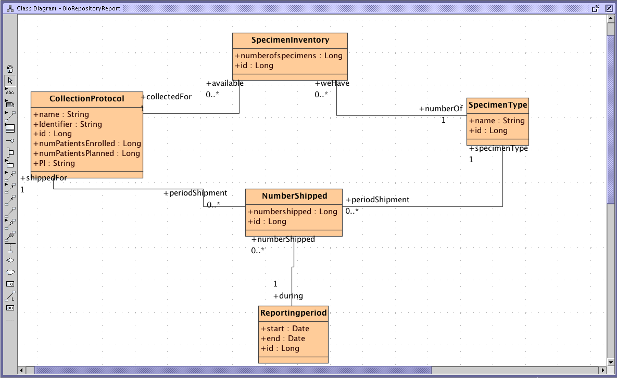

Generating the system from the model
The prototype was generated using the caCORE SDK 3.2. The model was generated using the community edition of MagicDraw 9.5.
The object relational mapping was performed “manually” as opposed to being entered in the model.

No semantic integration has been done on the prototype.

The model probably needs revision based on needs for functionality – but given the MDA paradigm it should be straightforward to regenerate a working system. The SDK will allow generation of a system from the revised model in a matter of minutes.

Files
The directory “For SDK” contains files that should be copied to the corresponding locations in the caCORE SDK file tree.

Generation from MagicDraw model

The caCORE SDK has a preprocessing step to convert XMI files to a standard form. A preprocessor was created for Magic Draw files
MagicDrawXMIPreprocessor.java
AutoXMIPreprocessor.java

Code for these is included in the src directory and should be copied to the corresponding place in the caCORE SDK src folder.

Conf
Deploy.properties is set up to generate the system.

Models
BiorepositoryReport.xml
Contains the model for the system

Custom
Contains the manual object relational mappings
Edit hibernate.cfg.xml to change database parameters

Direct mapping to a database
A database was created from hibernate mapping information. This gives a simple database that exactly reflects the data required in the report.

The file bioreposreportCT-ddl.sql creates the database and a user that owns it.

The custom folder contains mappings from the object model to the database.

Mapping to a database with a different model
The issue then becomes how do we map to other existing databases.

Object relational mapping
In some cases it may be possible to do this by mapping the object model to tables and columns in the target database. The current model relies on count information that may not be stored directly in the database. It may be possible to specify these summary fields as part of the object relational mapping (ORM).

Overriding SDK generated classes
It is possible that implementations could be written that override or provide alternative implementations to those generated by the caCORE SDK.

Extract, Transform & Load
In many ways the simplest way to implement the model against another database is to extract and load data into the directly mapped database schema created by the script above. The following describes that approach.

Extract, Transform, Load from caTissue
The database is loaded from the caTissue Core 1.2 schema using the SQL script extractLoad-ddl.sql.

clearReports.sql is used to clear the database before rerunning the script.

For now collection and distribution protocols are loaded by the script. Potentially the linkage between a collection protocol and a distribution protocol could be used to associate distributions with a collection protocol. This has not been done so far.

The script would need to be modified for caTissue Suite to exclude anticipated specimens in the extraction queries.

The extract does not rely on authorization mechanisms to determine which data in the database should be summarized. If a site needs to modify this they may do so by editing the SQL. The data in the CSM tables might be used as part of the query. This would allow filtering based on authorization data.

This script can be run at periodic intervals a timed batch job (e.g. using cron).

Notes on SDK 4.0
The manual ORM feature does not seem to be present in SDK 4.0. Probably the best route is to use caAdapter to perform the mapping.

At the time of writing the current version of the SDK is 4.0. The older version is still available here http://ncicb.nci.nih.gov/download/downloadcacoresdk.jsp.
“Manual” here refers to how the caCORE SDK describes it. In fact the mapping was performed using the Hibernate tools for Eclipse. The syntax checking/autocompletion features in Eclipse ensure checking of the mappings against both the database schema and the object model.

