caTissue Core V 1.2

Technical /Architecture

Guide

caBIG™ is an initiative of the National Cancer Institute, NIH, DHHS

Copyright and License page

THIS SOFTWARE IS PROVIDED "AS IS," AND ANY EXPRESSED OR IMPLIED WARRANTIES, (INCLUDING, BUT NOT LIMITED TO, THE IMPLIED WARRANTIES OF MERCHANTABILITY AND FITNESS FOR A PARTICULAR PURPOSE) ARE DISCLAIMED. IN NO EVENT SHALL THE NATIONAL CANCER INSTITUTE, PERSISTENT SYSTEMS, WASHINGTON UNIVERSITY OR THEIR AFFILIATES BE LIABLE FOR ANY DIRECT, INDIRECT, INCIDENTAL, SPECIAL, EXEMPLARY, OR CONSEQUENTIAL DAMAGES (INCLUDING, BUT NOT LIMITED TO, PROCUREMENT OF SUBSTITUTE GOODS OR SERVICES; LOSS OF USE, DATA, OR PROFITS; OR BUSINESS INTERRUPTION) HOWEVER CAUSED AND ON ANY THEORY OF LIABILITY, WHETHER IN CONTRACT, STRICT LIABILITY, OR TORT (INCLUDING NEGLIGENCE OR OTHERWISE) ARISING IN ANY WAY OUT OF THE USE OF THIS SOFTWARE, EVEN IF ADVISED OF THE POSSIBILITY OF SUCH DAMAGE.

caTissue Core v1.2
Development | Programmer’s guide |  | Program Management
Names of developers | Names of technical writers and reviewers |  | Names of program managers
Sachin Lale¹ | Poornima Govindrao¹ |  | Srikanth Adiga¹
Vaishali Khandelwal¹ | Sachin Lale¹ |  | Rakesh Nagarajan^{2,3}
Vijay Pande¹ |  |  | Mark Watson^{2,3}
Prafull Kadam¹
Aarti Sharma¹
Virender Mehta¹
Ashish Gupta¹
Poornima Govindrao¹
Chetan Patil¹
Deepti Shelar¹
¹ Persistent Systems |  | ³ Washington University
² Department of Pathology and Immunology

Contacts and Support
caTissue Application Support | catissue_support@mga.wustl.edu
caTissue GForge | https://gforge.nci.nih.gov/forum/forum.php?forum_id=766

Online resources pertinent to caTissue
Resource Name | URL | Description
catissuecore-v1.1 | https://gforge.nci.nih.gov/forum/forum.php?forum_id=766 | caTissue Core discussion forum
caTissue Core Bugzilla | http://nagarajanlab.wustl.edu/bugs/ | caTissue Core bug logging system

Table of Contents

Chapter 1 Introduction 7
Getting Started with this technical guide 7
Chapter 2 Prerequisites 8
Chapter 3 Overview of the Software 9
Software Overview 9
Architecture 10
Chapter 4 Administration 11
Chapter 5 Security and Security Management 12
Software Authorization 12
Configuring Software Authorizations 12
Chapter 6 API Access 13
An application program interface (API) 13
Department 14
CancerResearchGroup 15
User 16
Site 17
StorageType 18
StorageContainer 19
Biohazard 20
CollectionProtocol 21
DistributionProtocol 22
Participant 23
CollectionProtocolRegistration 24
SpecimenCollectionGroup 25
Specimen 26
Distribution 28
Chapter 7 Configuring Participant Matching algorithm 41
Appendix A–API Access 44
Login 44
Insert 45
Update 52
Appendix B– Method to auto populate label of Specimen 56

Figure 1 caTissue Core Architecture 10
Figure 2:Institution 14
Figure 3:Department 14
Figure 4:CancerResearchGroup 15
Figure 5:User 16
Figure 6:Site 17
Figure 7:StorageType 18
Figure 8:StorageContainer 19
Figure 9:Biohazard 20
Figure 10:CollectionProtocol 21
Figure 11:DistributionProtocol 22
Figure 12:Participant 23
Figure 13:CollectionProtocolRegistration 24
Figure 14:SpecimenCollectionGroup 25
Figure 15:Specimen 27
Figure 16:Distribution 28

- Introduction
This guide describes caTissue Core application software requirements, architecture, design and information for using API.

Getting Started with this technical guide
To get acquainted with the technical guide, the table below describes the topics covered in this technical guide.

Organization of the Technical Guide

Chapter in caTissue Technical Guide | Chapter Contents
Chapter 1 | Introduction: This chapter orients the first time user to what is contained within the document.
Chapter 2 | Prerequisites: This chapter includes the prerequisites to use this technical guide.
Chapter 3 | Overview of the Software: This chapter gives an overview of the application and its architecture.
Chapter 4 | Administration: This chapter describes how to administrate the caTissue Core application.
Chapter 5 | Security and Security management: This chapter describes authorization rules of the application.
Chapter 6 | API Access: This chapter includes the references to the documents required for API Access. It also explains the process to use the API with examples.
Chapter 7 | Configuring Participant Matching algorithm: This chapter explains the process for configuring the participant algorithm.

- Prerequisites
In order to use this technical guide, the user should be aware of the software. Please refer to the following reference documents before moving to the next sections.

References:
- caTissue Core Requirements: The following documents capture the use cases and software requirements for caTissue Core versions 1.2, 1.1 and 1.0, respectively:
- caTissue Core v1.2 requirements and use cases document
- caTissue Core v1.1 requirements and use cases document
- caTissue Core v1.0 requirements and use cases document
- caTissue Core Design: The following documents describe the design for all the new features implemented in the v1.2, v1.1 and v1.0 releases of caTissue Core, respectively:
- caTissue Core v1.2 Design Document
- caTissue Core v1.1 Design Document
- caTissue Core v1.0 Design Document
- caTissue Core Object Model: The following contains the comprehensive UML model for caTissue Core v1.2:
- caTissue Core v1.2 UML Model
- caTissue Core Installation: The following are references to documents required for installation of the software:
- caTissue Core Deployment Guide: This document describes the process to deploy and configure the caTissue Core application. It outlines installing, setting up, and configuring the application and databases.
- Deployment Support Document : This document can be referred to resolve deployment issues if any.
- Readme Document : This document describes the process to compile and build the source code of the caTissue Core application.
- Deployment issues should be logged to the application support forum on gForge using the following link:
http://gforge.nci.nih.gov/forum/forum.php?forum_id=49
- Environmental Needs : Section 4 of this document describes the system resources and corresponding versions required for each application.

- Overview of the Software

Software Overview

caTissue Core system is a tissue banking system that can accommodate biospecimen transaction data regardless of the nature of the transaction (e.g. banking, brokering, virtual registration) and the type of biospecimen involved in the transaction.
Advances in molecular technologies and sophistication in clinical trial design have increased the importance of biospecimen banks in collecting, processing, storing, and distributing human specimens for correlative science cancer research. Once regarded as “wax museums” that simply doled out paraffin tissue sections for immunohistochemical analysis, biospecimen banks are now responsible for collecting and distributing multiple human specimen types for molecular studies.
In order to accommodate the evolving functional complexity of the 21st century, biospecimen banks and their associated informatics systems need the functionality to track multiple specimens from the same participant, track refined materials (RNA, DNA, and Protein) that are used for molecular analysis, and annotate biospecimens with accumulating experimental data, as they are successively used for clinical correlative studies.
Existing tissue banking systems have some of these features; however, no single system currently provides all the features described. Some do tracking, some do financial management, some have automated pathology and clinical annotations, some may have experimental data associated with specimens, but no one system has it all. caTissue Core is capable of detailed biospecimen tracking.

Architecture

The caTissue Core application is comprised of an n-tiered architecture as depicted in the following figure. The client layer contains applications on the client side that request to perform operations on the server side. The web browser and API are two of the client programs in caTISSUE Core. The presentation layer provides a web interface as well as support for the API. The object layer is the heart of the application and contains domain objects, model classes, and the data access layer. This is the place where all tissue banking related business requirements are fulfilled. The backend of the application is a local database that stores all the tissue banking information.
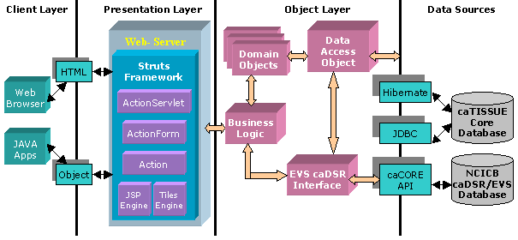
Figure 1 caTissue Core Architecture
The main components of the application are as follows:
- Web interface: Web pages and APIs
- Business Logic
- Data access object
- EVS/caDSR interface

The design follows the Model View Controller (MVC) design approach wherein the view (i.e. the user interfaces) and the model (i.e. the actual application logic) are completely insulated.
The web interfaces communicate with external data sources like caDSR, EVS and caTissue Core’s database through an intermediate interface. The intention of the interfaces is to insulate the core application logic from any changes in the external data source.
Interaction with the database is performed using either Hibernate or JDBC.

Administration
References:
caTissue Suite Deployment Guide: This document describes all the necessary administrative activities such as:
- Setting the application configuration parameters
  - Deployment parameters
  - Mail server configuration
  - Session timeout parameters
  - Participant duplicate matching parameters
- Creating and managing database
  - Creating new database
  - Upgrading database for different versions of the software
- Installing all the required software

Security and Security Management

Software Authorization

Same authorization rules that are applied through UI are applied while using API. The only feature not available through API is assigning different privileges.
caTissue Core data can be categorized in three different types:
- Administrative data: Collection protocol, Distribution protocol, Biohazards, Site, Storage container, User, Department, Institution, Cancer Group, Storage Type, Array Type.
- Participant data: Participant, Participant’s medical identifiers, Collection protocol registration, Specimen collection group, Clinical report.
- Biospecimen data: Specimen, Specimen external identifiers, Specimen events, Specimen distribution, Specimen array.

The following table describes different roles and privileges applicable in caTissue Core:
Administrator | - Has privileges to add, edit, and query all types of data in the system.
Supervisor | - Is similar to Administrator but does not have access to administrative data (i.e. protocols, storage container, etc).  - Has privileges to add and edit participant and biospecimen data in the system.  - Has read only privilege to other administrative data.
Technician | - Has privilege to add biospecimen data into the system.  - Has privilege to distribute specimens.  - Has access only to de-identified data.
Scientist | - Has read-only access to de-identified data
Table 1: Roles and privileges of caTissue Core system

Configuring Software Authorizations

Users with different roles are created by calling the API program to create User object and by setting the desired role field in the User object. Only an administrator has the privilege to create users.

- API Access

An application program interface (API)

An application program interface (API) is the interface that a computer system or application provides in order to allow requests for services to be made of it by other applications, and/or to allow data to be exchanged between them. The caTissue Core application provides the caCORE API support to add, edit and query data from the caTissue Core database
Since the API is a caCORE generated API, the documentation related to the caCORE can be found at the following location:
http://ncicb.nci.nih.gov/NCICB/infrastructure/cacoresdk

This section describes the usage of APIs to add/edit data since it involves issues like handling associated objects and mandatory parameters. Example code for add, edit can be found in the Appendix A–API Access

This section describes all the objects that can be added using API along with information about mandatory fields and associated objects. One important aspect to be handled is associated objects. There are two types of associated objects, data association and reference association. Data association objects are those objects which are created and added along with the main object e.g. Address and Password are data associated objects of a User. Reference association is when the associated object is expected to be existing before adding the current object and would just be referenced in the object being added. For example, Institution, Department and CancerResearchGroup are reference associations of User.
Institution

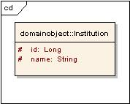
Figure 2:Institution
Institution is not associated to any other object.

Department

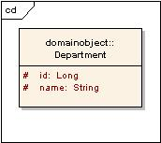
Figure 3:Department
Department is not associated to any other object.

CancerResearchGroup

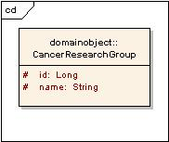
Figure 4:CancerResearchGroup
CancerResearchGroup is not associated to any other object.

User

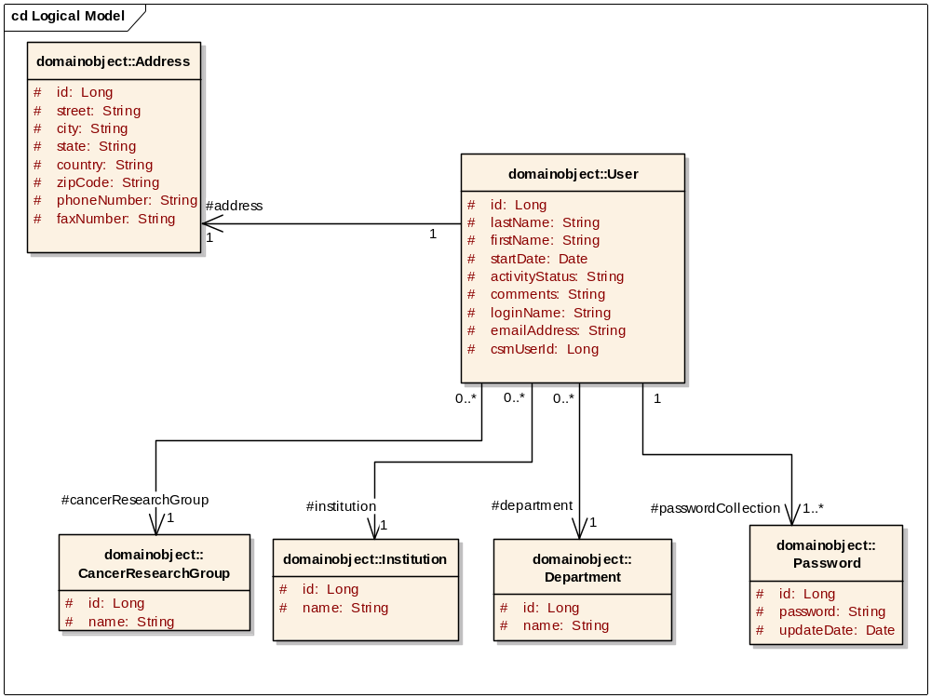
Figure 5:User
Associated object | Type
Address | Data
Password | Data
Institution | Reference
CancerResearchGroup | Reference
Department | Reference
Table 2: Associated objects of User

Site

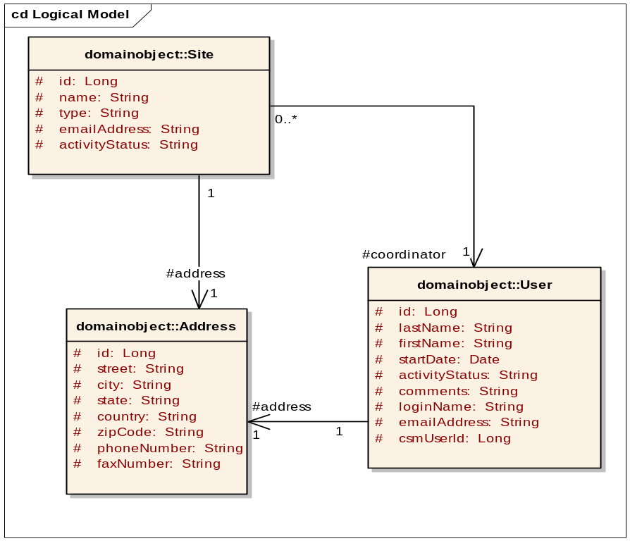
Figure 6:Site

Associated object | Type
Address | Reference
Site | Reference
Table 3: Associated objects of Site

StorageType
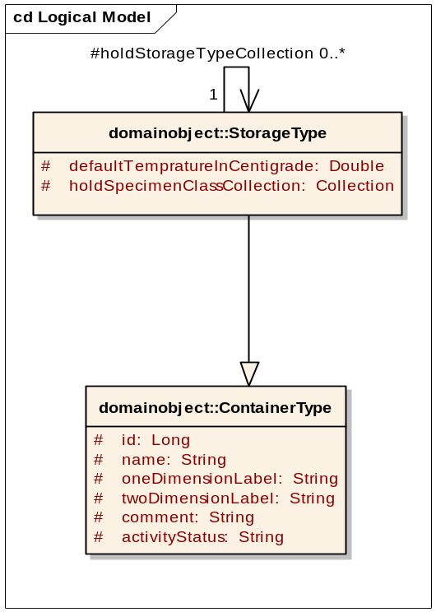
Figure 7:StorageType
StorageType is not associated to any other object. As indicated in the above diagram, StorageType is inherited from the parent class ContainerType.

StorageContainer

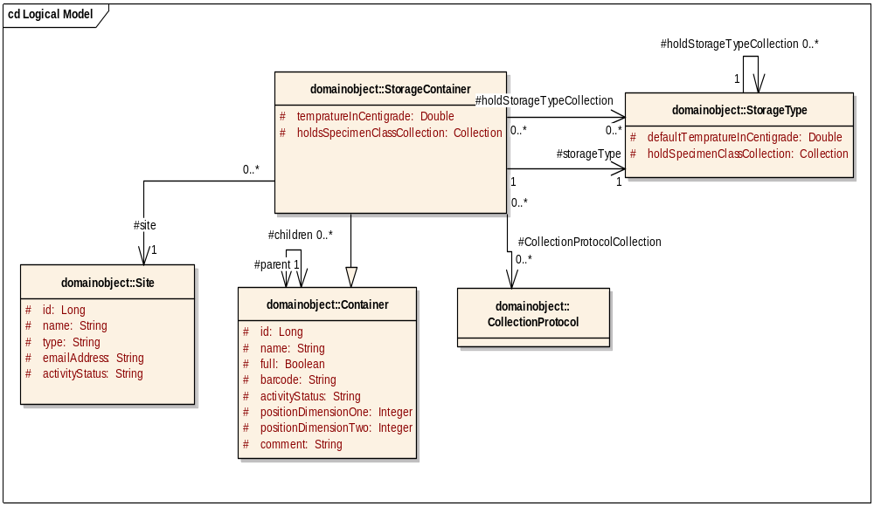
Figure 8:StorageContainer

Associated object | Type
Container | Data
Site | Reference
CollectionProtocol | Reference
StorageType | Reference
Table 4: Associated objects of StorageContainer

Biohazard
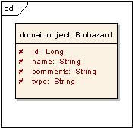
Figure 9:Biohazard

Associated object | Type
None
Table 5: Associated objects of Biohazard

CollectionProtocol
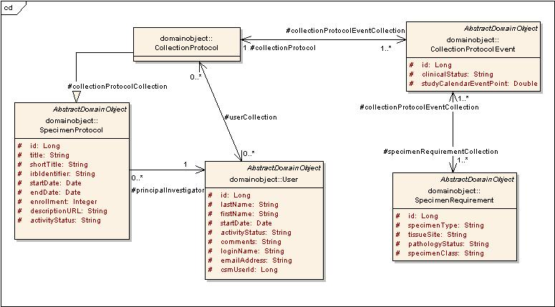
Figure 10:CollectionProtocol

Associated object | Type
SpecimenProtocol | Derived
User | Reference
CollectionProtocolEvent | Data
SpecimenRequirement | Data
Table 6: Associated objects of CollectionProtocol

DistributionProtocol

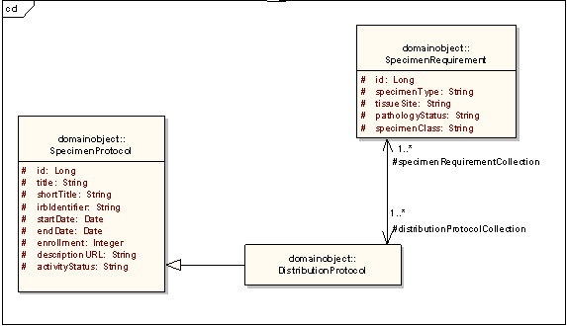
Figure 11:DistributionProtocol

Associated object | Type
SpecimenProtocol | Derived
SpecimenRequirement | Data
Table 7: Associated objects of DistributionProtocol

Participant
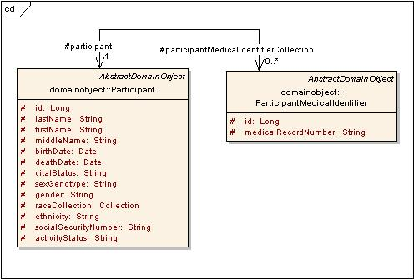
Figure 12:Participant

Associated object | Type
ParticipantMedicalIdentifier | Data
Table 8: Associated objects of Participant

CollectionProtocolRegistration
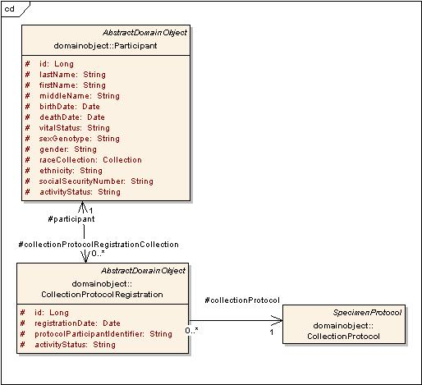
Figure 13:CollectionProtocolRegistration

Associated object | Type
Participant | Reference
CollectionProtocol | Reference
Table 9: Associated objects of CollectionProtocolRegistration

SpecimenCollectionGroup
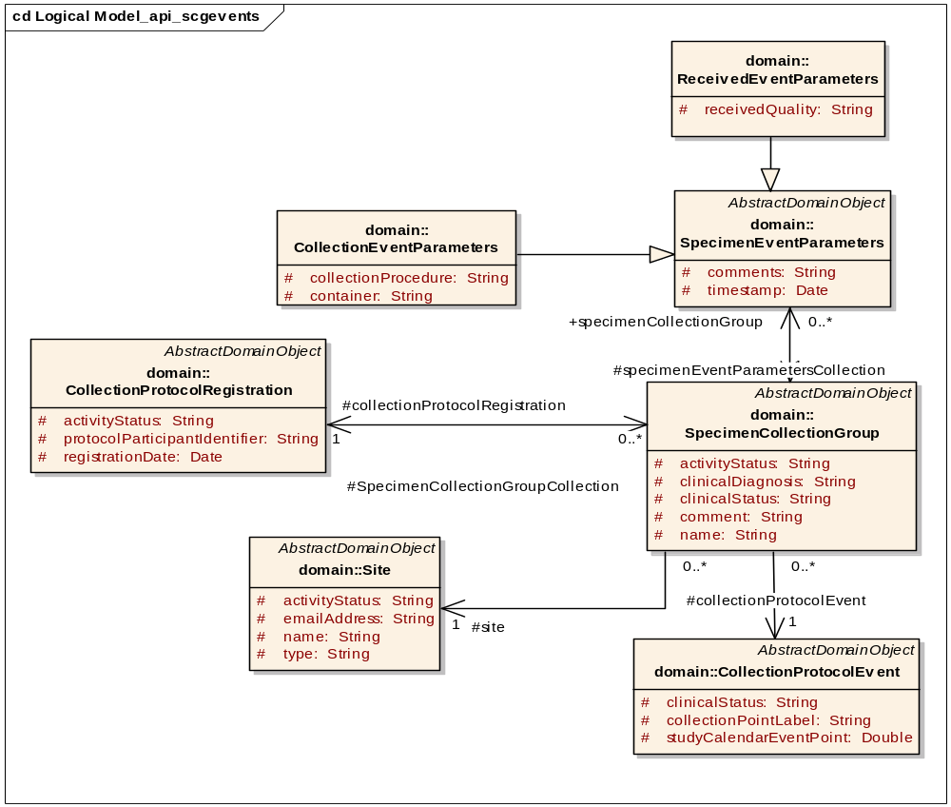
Figure 14:SpecimenCollectionGroup

Associated object | Type
CollectionProtocolEvent | Reference
CollectionProtocolRegistration | Reference
Site | Reference
SpecimenEventParameters | Reference
Table 10: Associated objects of SpecimenCollectionGroup

Specimen
Specimens can be one of four different classes: Molecular, Fluid, Tissue and Cell. Each specimen class is represented by a different UML Class in the model.
There are three categories of specimens:
- New specimen
- Derivative
- Aliquot
The lineage attribute should be set to New, Aliquot or Derived. In order to create aliquot or derivative specimen, you set an existing specimen as the parent specimen. Parent specimen object should be populated & exist in the database. Aliquot and derived specimen objects contain this parent specimen object. An example code for add or edit is found in the Appendix A–API Access

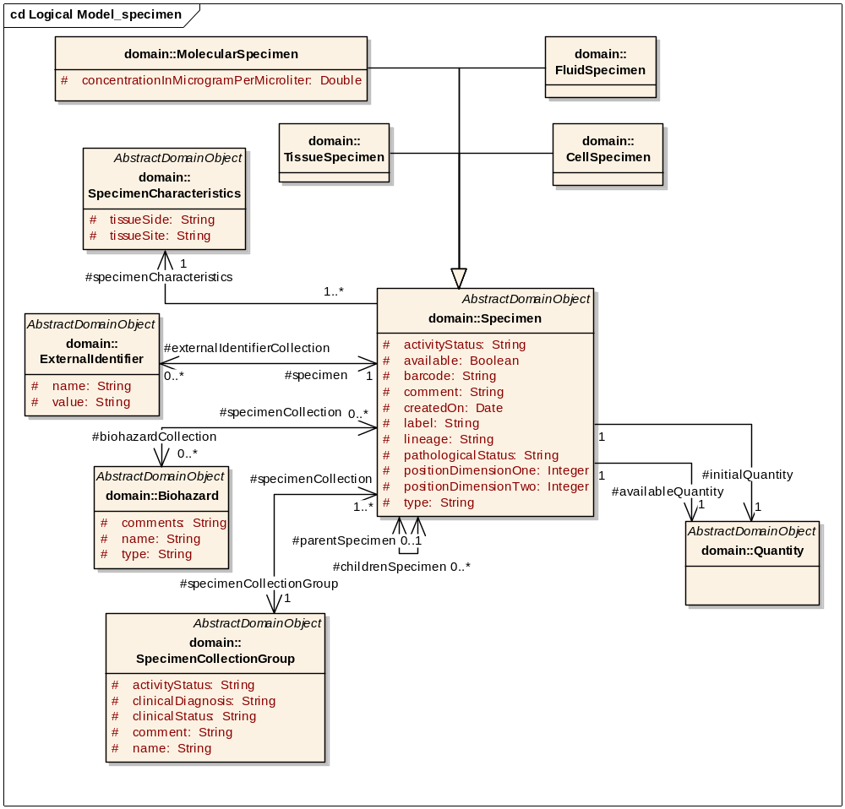
Figure 15:Specimen
Associated object | Type
ExternalIdentifier | Data
Biohazard | Reference
SpecimenCollectionGroup | Reference
SpecimenCharacteristics | Reference
Quantity | Data
Table 11:Associated objects of Specimen

Distribution
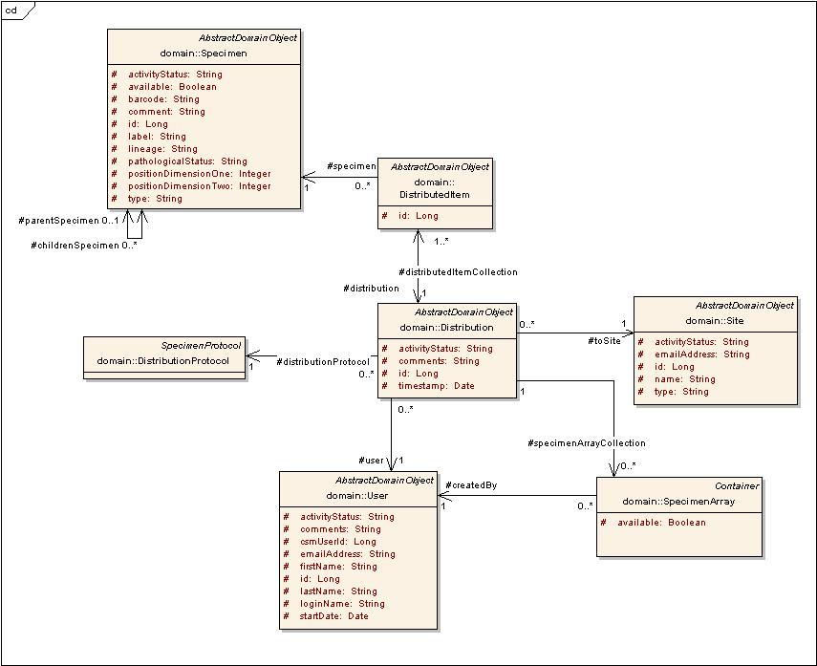
Figure 16:Distribution

Associated object | Type
Site | Reference
DistributedItem | Data
DistributionProtocol | Reference
User | Reference
Specimen | Reference
SpecimenArray | Reference
Table 12: Associated objects of Distribution

List of objects with attribute information:
Institution
Attribute / Constituent Object | Datatype / Class | Mandatory?
Id | Long | Yes
Name | String | Yes
Table 13:Institution attributes

Department
Attribute / Constituent Object | Datatype / Class | Mandatory?
Id | Long | Yes
Name | String | Yes
Table 14:Department attributes

CancerResearchGroup
Attribute / Constituent Object | Datatype / Class | Mandatory?
Id | Long | Yes
Name | String | Yes
Table 15:CancerResearchGroup attributes

Address
Attribute / Constituent Object | Datatype / Class | Mandatory?
Id | Long | Yes
Street | String | Yes
City | String | Yes
State | String | Yes
Country | String | Yes
Zipcode | String | Yes
phoneNumber | String | No
faxNumber | String | No
Table 16:Address attributes
User
Attribute / Constituent Object | Datatype / Class | Mandatory?
Id | Long | Yes
emailAddress | String | Yes
lastName | String | Yes
firstName | String | Yes
activityStatus | String | Yes
Address | Address attributes | Yes
Institution | Institution attributes | Yes
Department | Department attributes | Yes
cancerResearchGroup | CancerResearchGroup attributes | Yes
Table 17:User attributes

Site
Attribute / Constituent Object | Datatype / Class | Mandatory?
Id | Long | Yes
Name | String | Yes
Type | String | Yes
emailAddress | String | No
activityStatus | String | Yes
Address | Address attributes | Yes
Coordinator | User attributes | Yes
Table 18:Site attributes

ContainerType
Attribute / Constituent Object | Datatype / Class | Mandatory?
Id | Long | Yes
Name | String | Yes
oneDimensionLabel | String | Yes
twoDimensionLabel | String | Yes
Comment | String | No
Capacity | Capacity attributes | Yes
Table 19:ContainerType attributes

StorageType
Attribute / Constituent Object | Datatype / Class | Mandatory?
defaultTempratureInCentigrade | Double | No
holdsStorageTypeCollection | Collection | No
holdsSpecimenClassCollection | Collection | No
activityStatus | String | Yes
Table 20:StorageType attributes
Capacity
Attribute / Constituent Object | Datatype / Class | Mandatory?
id | Long | Yes
oneDimensionCapacity | Integer | No
twoDimensionCapacity | Integer | No
Table 21:Capacity attributes

Container
Attribute / Constituent Object | Datatype / Class | Mandatory?
Id | Long | Yes
Full | Boolean | Yes
Name | String | Yes
barcode | String | No
activityStatus | String | Yes
positionDimensionOne | Integer | Yes
positionDimensionTwo | Integer | Yes
comment | String | No
capacity | Capacity attributes | Yes
children | Collection | No
parent | Container attributes | No
Table 22:Container attributes
StorageContainer
Attribute / Constituent Object | Datatype / Class | Mandatory?
tempratureInCentigrade | Double | No
storageType | StorageType attributes | Yes
site | Site attributes | No
collectionProtocolCollection | Collection | No
holdsStorageTypeCollection | Collection | No
holdsSpecimenClassCollection | Collection | No
Table 23:StorageContainer attributes

SpecimenProtocol
Attribute / Constituent Object | Datatype / Class | Mandatory?
id | Long | Yes
title | String | Yes
shortTitle | String | Yes
irbIdentifier | String | Yes
startDate | Date | Yes
endDate | Date | No
enrollment | Integer | Yes
descriptionURL | String | Yes
principalInvestigator | User attributes | Yes
Table 24:SpecimenProtocol attributes

CollectionProtocol
Attribute / Constituent Object | Datatype / Class | Mandatory?
distributionProtocolCollection | Collection | No
userCollection | Collection | No
collectionProtocolEventCollection | Collection | Yes
Table 25:Collection Protocol attributes
DistributionProtocol
Attribute / Constituent Object | Datatype / Class | Mandatory?
specimenRequirementCollection | Collection | Yes
CollectionProtocolCollection | Collection | No
Table 26:DistributionProtocol attributes

Participant
Attribute / Constituent Object | Datatype / Class | Mandatory?
Id | Long | Yes
LastName | String | No
FirstName | String | No
MiddleName | String | No
BirthDate | Date | No
DeathDate | Date | No
SexGenotype | String | No
ethnicity | String | No
socialSecurityNumber | String | No
vitalStatus | String | No
gender | String | No
participantMedicalIdentifierCollection | Collection | No
collectionProtocolRegistrationCollection | Collection | No
raceCollection | Collection | No
Table 27:Participant attributes

ParticipantMedicalIdentifier
Attribute / Constituent Object | Datatype / Class | Mandatory?
Id | Long | Yes
medicalRecordNumber | String | Yes
Site | Site attributes | Yes
Table 28:ParticipantMedicalIdentifier attributes
CollectionProtocolRegistration
Attribute / Constituent Object | Datatype / Class | Mandatory?
Id | Long | Yes
protocolParticipantIdentifier | String | No
registrationDate | Date | Yes
activityStatus | String | Yes
participant | Participant attributes | No
collectionProtocol | Collection Protocol attributes | Yes
Table 29:CollectionProtocolRegistration attributes
SpecimenCollectionGroup
Attribute / Constituent Object | Datatype / Class | Mandatory?
id | Long | Yes
name | String | Yes
clinicalDiagnosis | String | Yes
activityStatus | String | Yes
site | Site attributes | Yes
collectionProtocolEvent | CollectionProtocolEvent attributes | Yes
clinicalReport | ClinicalReport attributes | No
specimenCollection | Collection | No
collectionProtocolRegistration | CollectionProtocolRegistration attributes | Yes
specimenEventParametersCollection | SpecimenEventParameters | Yes
comment | String | No
Table 30:SpecimenCollectionGroup attributes

ClinicalReport
Attribute / Constituent Object | Datatype / Class | Mandatory?
Id | Long | Yes
surgicalPathologyNumber | String | Yes
participantMedicalIdentifier | ParticipantMedicalIdentifier attributes | Yes
Table 31:ClinicalReport attributes

CollectionProtocolEvent
Attribute / Constituent Object | Datatype / Class | Mandatory?
id | Long | Yes
clinicalStatus | String | Yes
studyCalendarEventPoint | Double | Yes
specimenRequirementCollection | Collection | Yes
collectionProtocol | Collection Protocol attributes | Yes
Table 32:CollectionProtocolEvent attributes

Specimen
Attribute / Constituent Object | Datatype / Class | Mandatory?
Id | Long | Yes
Type | String | Yes
Available | Boolean | Yes
positionDimensionOne | Integer | Yes
positionDimensionTwo | Integer | Yes
Barcode | String | No
Comments | String | No
ActivityStatus | String | Yes
pathologicalStatus | String | Yes
lineage | String | No
label | String | Yes
quantity | Quantity | Yes
availableQuantity | Quantity | Yes
parentSpecimen | Specimen attributes | No
storageContainer | StorageContainer attributes | Yes
specimenCollectionGroup | SpecimenCollectionGroup attributes | No
specimenCharacteristics | SpecimenCharacteristics attributes | Yes
biohazardCollection | Collection | No
specimenEventCollection | Collection | No
childrenSpecimen | Collection | No
externalIdentifierCollection | Collection | No
createdOn | Date | No
Table 33:Specimen attributes

SpecimenCharacteristics
Attribute / Constituent Object | Datatype / Class | Mandatory?
id | Long | Yes
tissueSite | String | Yes
tissueSide | String | Yes
Table 34:SpecimenCharacteristics attributes
Distribution
Attribute / Constituent Object | Datatype / Class | Mandatory?
activityStatus | String | Yes
toSite | Site attributes | Yes
distributionProtocol | DistributionProtocol attributes | Yes
distributedItemCollection | Collection | Yes
specimenArrayCollection | Collection | No
Table 35:Distribution attributes

DistributedItem
Attribute / Constituent Object | Datatype / Class | Mandatory?
id | Long | Yes
quantity | Double | Yes
specimen | Specimen attributes | Yes
distribution | Distribution attributes | Yes
Table 36:DistributedItem attributes

Biohazard
Attribute / Constituent Object | Datatype / Class | Mandatory?
Id | Long | Yes
Name | String | Yes
Type | String | Yes
Comments | String | No
Table 37:Biohazard attributes

- Configuring Participant Matching algorithm

During the insertion of a new participant, the system checks for matching participants based on an algorithm and displays a list of possible matches. This avoids duplicate participants from being added into the system. The user may choose to select one of the matching participants or continue adding the new participant.

The algorithm used to find the matching participants is “MPI Matching Algorithm.” The algorithm is configurable in terms of matching algorithm used and fields used for matching. In most scenarios, the user would not need to change the configuration of the fields and the matching points. If the user does need to change the parameters, s/he can use a different matching algorithm. This task is completed by changing the “ParticipantLookupAlgo” property entry in “caTissueCore_Properties.xml.” This indicates the name of the class having the implementation for the matching algorithm. caTissue V 1.1 uses “edu.wustl.catissuecore.bizlogic.ParticipantLookupLogic” class for the MPI Matching Algorithm. This algorithm uses the additional parameters defined in caTissueCore_Properties.xml. These parameters indicate the fields considered to determine the score for participant matching. Points for each field are set in caTissueCore_Properties.xml and may be edited as required. Participant matching depends on the total points. Refer to the reference document for more details.

Configuration Parameter | Description | Points
SSNExact | Exact match for SSN field | 30
SSNPartial | Partial match for SSN field | 20
DOBExact | Exact match for date of birth field | 20
DOBPartial | Partial match for date of birth field | 15
LastNameExact | Exact match for last name field | 20
LastNamePartial | Partial match for last name field | 15
FirstNameExact | Exact match for first name field | 10
FirstNamePartial | Partial match for first name field | 5
MiddleNameExact | Exact match for middle name field | 10
MiddleNamePartial | Partial match for middle name field | 5
GenderExact | Exact match for gender field | 5
RaceExact | Exact match for race field | 10
RacePartial | Partial match for race field | 5
Bonus | Given for LastName, FirstName and DOB exact match | 15

Reference:

“MPI Matching Algorithm”

Appendix A–API Access
The following are the example code snippets that describe how to perform different operations (insert/update/search) through HTTP API and the prerequisites to perform the operations:
- User should be logged in.
- User should have the privilege to perform that operation.

Login
The following code snippet describes how to log in to the caTissue Core application through HTTP API:

/* Retrieve the instance of default application service which provides the methods
* to insert, update & search the domain objects.
*/
ApplicationServiceProvider asp = new ApplicationServiceProvider();
ApplicationService appService = ApplicationServiceProvider.getApplicationService();

//Start the session by giving proper credentials to startSession() method.
ClientSession cs = ClientSession.getInstance();
cs.startSession("admin@admin.com","login123");

Insert
The following code snippet describes a simple example of inserting an institution object through API:

Institution creation
/*
*Create an institution object.
*/
Institution institution=new Institution();

/* Set the id attribute to any arbitrary value while inserting the object, the system will
* generate the next number in the sequence automatically & will update the id attribute
* before inserting the object in the database.
*/
institution.setId(new Long(0));
//Set the value of name attribute which is mandatory
institution.setName("Washington University");

/* Insert the object in the database. The method createObject() returns the same
* object with the value of id attribute populated.
*/
institution = (Institution)appService.createObject(institution);
/*
*Print the value of id attribute of newly created object
*/
System.out.println("The identifier of the object created is " + institution.getId());

Collection Protocol object creation
To consider a more complex example of insertion, The following code snippet describes how to add an object of Collection Protocol in the database:

/*Create an object of CollectionProtocol*/
CollectionProtocol cp=new CollectionProtocol();
/* Set the id attribute to any arbitrary value while inserting the object, the system will
* generate the next number in the sequence automatically & will update the id attribute
* before inserting the object in the database.
*/
cp.setId(new Long(0));
/*Set the activity status*/
cp.setActivityStatus("Active");
/*Set the principal investigator of collection protocol*/
User pi=new User();
pi.setId(new Long(2));
cp.setPrincipalInvestigator(pi);
/*Set the protocol coordinators of collection protocol
* User with this Ids, e.g. here we are referring 1 & 21, must exist in database.
*/
User co1=new User();
co1.setId(new Long(1));
User co2=new User();
co2.setId(new Long(21));
HashSet set = new HashSet();
set.add(co1);
set.add(co2);
cp.setUserCollection(set);

/*Set the mandatory attributes title, short title, IRB identifier, start date*/
cp.setTitle("Collection Protocol");
cp.setShortTitle("CP");
cp.setIrbIdentifier("IRB_007");
Date startDate=new Date();
cp.setStartDate(startDate);
/*User can ignore the non mandatory attributes or can set those attributes*/
cp.setEndDate(null);
cp.setEnrollment(new Integer(5));
cp.setDescriptionURL("URL");
/*Set the collection of protocol events*/
CollectionProtocolEvent cpEvent=new CollectionProtocolEvent();
cpEvent.setClinicalStatus("New Diagnosis");
cpEvent.setStudyCalendarEventPoint(new Double(5));
cpEvent.setCollectionProtocol(cp);
CollectionProtocolEvent cpEvent1=new CollectionProtocolEvent();
cpEvent1.setClinicalStatus("Operative");
cpEvent1.setStudyCalendarEventPoint(new Double(2));
cpEvent1.setCollectionProtocol(cp);
/*Set the collection of specimen requirements*/
SpecimenRequirement specimenRequirement = new SpecimenRequirement();
specimenRequirement.setSpecimenClass("Molecular");
specimenRequirement.setSpecimenType("DNA");
specimenRequirement.setTissueSite("Placenta");
specimenRequirement.setPathologyStatus("Malignant");
Quantity quantity = new Quantity();
quantity.setValue(new Double(10));
specimenRequirement.setQuantity(quantity);
specimenRequirement.setId(new Long(1));

SpecimenRequirement specimenRequirement1 = new SpecimenRequirement();
specimenRequirement1.setSpecimenClass("Tissue");
specimenRequirement1.setSpecimenType("Fixed Tissue");
specimenRequirement1.setTissueSite("Blood");
specimenRequirement1.setPathologyStatus("Malignant");
Quantity quantity = new Quantity();
quantity.setValue(new Double(10));
specimenRequirement1.setQuantity(quantity);
specimenRequirement1.setId(new Long(2));

Collection spReqCollection=new HashSet();
spReqCollection.add(specimenRequirement);
cpEvent.setSpecimenRequirementCollection(spReqCollection);

Collection spReqCollection1=new HashSet();
spReqCollection1.add(specimenRequirement1);
cpEvent1.setSpecimenRequirementCollection(spReqCollection1);

Collection cpEventCollection=new ArrayList();
cpEventCollection.add(cpEvent);
cpEventCollection.add(cpEvent1);
cp.setCollectionProtocolEventCollection(cpEventCollection);

/*Insert the object in the database*/
cp = (CollectionProtocol) appService.createObject(cp);

Derived Specimen creation
To review the insertion of derived specimen, the following code snippet describes how to add a derived specimen in the database:

MolecularSpecimen molecularSpecimen = new MolecularSpecimen();
/* Specimen Collection Group must exist in database with specified ID*/
SpecimenCollectionGroup specimenCollectionGroup = new SpecimenCollectionGroup();
specimenCollectionGroup.setId(new Long(2));
molecularSpecimen.setSpecimenCollectionGroup(specimenCollectionGroup);
molecularSpecimen.setLabel("derived_spec_label");
molecularSpecimen.setBarcode("derived_spec_barcode”);

molecularSpecimen.setType("DNA");
molecularSpecimen.setAvailable(new Boolean(true));
molecularSpecimen.setActivityStatus("Active");

/* Specimen Characteristics object must exist in database with specified ID*/
SpecimenCharacteristics specimenCharacteristics = new SpecimenCharacteristics();
specimenCharacteristics.setTissueSide("Left");
specimenCharacteristics.setTissueSite("Placenta");
specimenCharacteristics.setId(new Long(1));
molecularSpecimen.setSpecimenCharacteristics(specimenCharacteristics);
molecularSpecimen.setPathologicalStatus("Malignant");

Quantity quantity = new Quantity();
quantity.setValue(new Double(10));
molecularSpecimen.setQuantity(quantity);
molecularSpecimen.setAvailableQuantity(quantity);
molecularSpecimen.setConcentrationInMicrogramPerMicroliter(new Double(10));
molecularSpecimen.setComments("");
/*set Lineage to “Derived” */
molecularSpecimen.setLineage("Derived");

/* StorageContainer object must exist in database with specified ID*/
StorageContainer sto = new StorageContainer();
sto.setId(new Long("1"));
molecularSpecimen.setStorageContainer(sto);
molecularSpecimen.setPositionDimensionOne(new Integer(1));
molecularSpecimen.setPositionDimensionTwo(new Integer(2));

Collection externalIdentifierCollection = new HashSet();
ExternalIdentifier externalIdentifier = new ExternalIdentifier();
externalIdentifier.setName("external_identifier”);
externalIdentifier.setValue("11");
externalIdentifier.setSpecimen(molecularSpecimen);
externalIdentifierCollection.add(externalIdentifier);
molecularSpecimen.setExternalIdentifierCollection(externalIdentifierCollection);
CollectionEventParameters collectionEventParameters = new CollectionEventParameters();
collectionEventParameters.setComments("");
/* User object must exist in database with specified ID.*/
User user = new User();
user.setId(new Long(1));
collectionEventParameters.setUser(user);
try
{
collectionEventParameters.setTimestamp(Utility.parseDate("08/15/1975", Utility
datePattern("08/15/1975")));
}
catch (ParseException e1)
{
e1.printStackTrace();
}
collectionEventParameters.setContainer("No Additive Vacutainer");
collectionEventParameters.setCollectionProcedure("Needle Core Biopsy");

ReceivedEventParameters receivedEventParameters = new
ReceivedEventParameters();
receivedEventParameters.setUser(user);
//receivedEventParameters.setId(new Long(0));
try
{
receivedEventParameters.setTimestamp(Utility.parseDate("08/15/1975", Utility
.datePattern("08/15/1975")));
}
catch (ParseException e)
{
e.printStackTrace();
}

receivedEventParameters.setReceivedQuality("Acceptable");
receivedEventParameters.setComments("");
Collection specimenEventCollection = new HashSet();
specimenEventCollection.add(collectionEventParameters);
specimenEventCollection.add(receivedEventParameters);
molecularSpecimen.setSpecimenEventCollection(specimenEventCollection);
/*Biohazard object must exist in database with specified ID*/
Biohazard biohazard = new Biohazard();
biohazard.setName("Biohazard1");
biohazard.setType("Toxic");
biohazard.setId(new Long(1));
Collection biohazardCollection = new HashSet();
biohazardCollection.add(biohazard);
molecularSpecimen.setBiohazardCollection(biohazardCollection);
/*Specimen object must exist in database with specified ID*/
Specimen parentSpecimen = new MolecularSpecimen();
parentSpecimen.setId(new Long(1));

molecularSpecimen.setParentSpecimen(parentSpecimen);

/*Insert the derived specimen object in the database*/
molecularSpecimen= (MolecularSpecimen) appService.createObject(molecularSpecimen);

Update
The following code snippet describes a simple example of updating an institution object through API:

Update of institution object
/*Update an institution object*/
Institution institution=new Institution();
/*Set the id attribute value of an object that is to be modified*/
institution.setId(new Long(1));

/*Modify the institution name*/
institution.setName("Washu");

/*Update the institution object with identifier 1*/
institution = (Institution)appService.updateObject(institution);

The following code snippet is a more complex example of updating CollectionProtocol object.

Update collection protocol object
/*Update an object of CollectionProtocol*/
CollectionProtocol cp=new CollectionProtocol();

/*Set the id attribute value of an object that is to be modified*/
cp.setId(new Long(1));
cp.setActivityStatus("Active");

/*Set the principal investigator of collection protocol*/
User pi=new User();
pi.setId(new Long(2));
cp.setPrincipalInvestigator(pi);

User co1=new User();
co1.setId(new Long(1));
User co2=new User();
co1.setId(new Long(21));
HashSet set = new HashSet();
set.add(co1);
set.add(co2);
cp.setUserCollection(set);

/*Set the mandatory attributes title, short title, IRB identifier, start date*/
cp.setTitle("Collection Protocol");
cp.setShortTitle("CP");

/*Modifying IRB identifier & start date*/
cp.setIrbIdentifier("IRB_007");
Date startDate=new Date();
cp.setStartDate(startDate);
cp.setEndDate(null);

/*Modifying enrollment & url*/
cp.setEnrollment(new Integer(10));
cp.setDescriptionURL("New URL");

/*Set the collection of protocol events*/
CollectionProtocolEvent cpEvent=new CollectionProtocolEvent();

/* Set the id attribute value of CollectionProtocolEvent object that is associated with
* this CollectionProtocol object.
*/
cpEvent.setId(new Long(1));
cpEvent.setClinicalStatus("New Diagnosis");
cpEvent.setStudyCalendarEventPoint(new Double(5));
cpEvent.setCollectionProtocol(cp);

CollectionProtocolEvent cpEvent1=new CollectionProtocolEvent();
cpEvent1.setId(new Long(2));
cpEvent1.setClinicalStatus("Operative");
cpEvent1.setStudyCalendarEventPoint(new Double(2));
cpEvent1.setCollectionProtocol(cp);

/*Set the collection of specimen requirements*/
SpecimenRequirement specimenRequirement = new SpecimenRequirement();
specimenRequirement.setSpecimenClass("Molecular");
specimenRequirement.setSpecimenType("DNA");
specimenRequirement.setTissueSite("Placenta");
specimenRequirement.setPathologyStatus("Malignant");
Quantity quantity = new Quantity();
quantity.setValue(new Double(10));
specimenRequirement.setQuantity(quantity);

specimenRequirement.setId(new Long(1));

SpecimenRequirement specimenRequirement1 = new SpecimenRequirement();
specimenRequirement1.setSpecimenClass("Tissue");
specimenRequirement1.setSpecimenType("Fixed Tissue");
specimenRequirement1.setTissueSite("Blood");
specimenRequirement1.setPathologyStatus("Malignant");
Quantity quantity = new Quantity();
quantity.setValue(new Double(10));
specimenRequirement1.setQuantity(quantity);
specimenRequirement1.setId(new Long(2));

Collection spReqCollection=new HashSet();
spReqCollection.add(specimenRequirement);
cpEvent.setSpecimenRequirementCollection(spReqCollection);

Collection spReqCollection1=new HashSet();
spReqCollection1.add(specimenRequirement1);
cpEvent1.setSpecimenRequirementCollection(spReqCollection1);

Collection cpEventCollection=new ArrayList();
cpEventCollection.add(cpEvent);
cpEventCollection.add(cpEvent1);
cp.setCollectionProtocolEventCollection(cpEventCollection);
/*Update the collection protocol object with identifier 1*/
cp = (CollectionProtocol)appService.updateObject(cp);

Appendix B– Method to auto populate label of Specimen
The label field of Specimen may be configured to auto populate to a default value. This is achieved by modifying the code. The following section describes the files/methods to be modified.

Auto population may be implemented through different ways. One of the suggested implementation techniques is described below:

Define a constant string in caTissueCore_Properties.xml which will decide the basis for generation of label for a particular specimen. The constant can have any one of the following values.
- Specimen Collection Group
- Site
- Collection Protocol
- Any other domain object
- None

A utility method should be written to auto populate the label which may look like the one below:
String generateLabelForSpecimen (parentSpecimenLabel, lineage,
domainObjectName,systemCount,aliquotSequenceNumber)
{
If(domainObjectName == null)
domainObjectName = “”;

if(parentSpecimenLabel!=null)
result = parentSpecimenLabel + lineage + systemCount;
else
result = domainObjectName + lineage + systemCount;
if (lineage.equals(“aliquot”))
result +=aliquotSequenceNumber;return result;
}

Description of the variables used in the method:
- parentSpecimenLabel - label of parent if present.
- lineage - lineage of specimen (New/Derived/Aliquot)
- domainObjectName - eg. SCG
- systemCount - Number of Specimens in the system or any unique thing (System time)
- aliquotSequenceNumber - Should be used in case of aliquots (Similar condition can be added for multiple specimen as well)

Call the above function from respective actions to generate the unique label for the specimen.
The following files have to be modified for auto population of label:
- NewSpecimenAction.java - For Specimen, call the label generation method from NewSpecimenAction.java (method executeSecureAction) and set the value generated in NewSpecimenForm.java.
- AliquotAction.java - For Aliquot, call the label generation method from AliquotAction.java (method distributeAvailableQuantity) and set the value generated in AliquotForm.java.
- CreateSpecimenAction.java - For Derived Specimen, call the label generation method from CreateSpecimenAction.java (method executeSecureAction) and set the value generated in CreateSpecimenForm.java.
- MultipleSpecimenTableModel.java - For Multiple Specimen, call the label generation method and set label in MultipleSpecimenTableModel.java (to create a new method same as setCollectionGroupInModel, see the flow of setting collection group). Then retrieve the labels from MultipleSpecimenTableModel.java and set labels in SpecimenColumnModel.java (Method instantiateObjects). Also refer Bug 3597 in Bugzilla.

Note that the name of the domain object is retrieved from database. Set the label generated by this method in action form of the action and it will pre-populate the UI with this label. The assignment of the auto generated label in the respective field of the form should be done based on the requirement (e.g. If label is dependent on SCG and SCG is selected from the page of New Specimen, the label should be set once the user selects the SCG.)
The label includes following fields according to the method:
- One property of specimen (eg. Site, Specimen Collection Group, etc.)
- Lineage of specimen
- Parent specimen label (if present)
eg. SCG_New_Specimen_122
SCG_Specimen_122_Derived_124,
SCG_Specimen_122_Aliquot_125
If label becomes too long, parent specimen label can be ignored.

