caTRIP
Translational Research Informatics Platform
Title of Publication

Technical Guide

Document Change History
Version Number | Date | Contributor | Description
0.1 | 5/4/2007 | Srini Akkala | Final Draft
1.0 | 5/23/2007 | Patrick McConnell | Final Release

caBIG™ is an initiative of the National Cancer Institute, NIH, DHHS
Copyright and License page

Copyright Notice. Copyright 2006 Duke Comprehensive Cancer Center (“caBIG™ Participant”). caTRIP was created with NCI funding and is part of the caBIG™ initiative. The software subject to this notice and license includes both human readable source code form and machine readable, binary, object code form (the “caBIG™ Software”).
This caBIG™ Software License (the “License”) is between caBIG™ Participant and You. “You (or “Your”) shall mean a person or an entity, and all other entities that control, are controlled by, or are under common control with the entity. “Control” for purposes of this definition means (i) the direct or indirect power to cause the direction or management of such entity, whether by contract or otherwise, or (ii) ownership of fifty percent (50%) or more of the outstanding shares, or (iii) beneficial ownership of such entity.
License. Provided that You agree to the conditions described below, caBIG™ Participant grants You a non-exclusive, worldwide, perpetual, fully-paid-up, no-charge, irrevocable, transferable and royalty-free right and license in its rights in the caBIG™ Software, including any copyright or patent rights therein that may be infringed by the making, using, selling, offering for sale, or importing of caBIG™ Software, to (i) use, install, access, operate, execute, reproduce, copy, modify, translate, market, publicly display, publicly perform, and prepare derivative works of the caBIG™ Software; (ii) make, have made, use, practice, sell, and offer for sale, and/or otherwise dispose of caBIG™ Software (or portions thereof); (iii) distribute and have distributed to and by third parties the caBIG™ Software and any modifications and derivative works thereof; and (iv) sublicense the foregoing rights set out in (i), (ii) and (iii) to third parties, including the right to license such rights to further third parties. For sake of clarity, and not by way of limitation, caBIG™ Participant shall have no right of accounting or right of payment from You or Your sublicensees for the rights granted under this License. This License is granted at no charge to You. Your downloading, copying, modifying, displaying, distributing or use of caBIG™ Software constitutes acceptance of all of the terms and conditions of this Agreement. If you do not agree to such terms and conditions, you have no right to download, copy, modify, display, distribute or use the caBIG™ Software.
- Your redistributions of the source code for the caBIG™ Software must retain the above copyright notice, this list of conditions and the disclaimer and limitation of liability of Article 6 below. Your redistributions in object code form must reproduce the above copyright notice, this list of conditions and the disclaimer of Article 6 in the documentation and/or other materials provided with the distribution, if any.
- Your end-user documentation included with the redistribution, if any, must include the following acknowledgment: “This product includes software developed by Duke Comprehensive Cancer Center.” If You do not include such end-user documentation, You shall include this acknowledgment in the caBIG™ Software itself, wherever such third-party acknowledgments normally appear.
- You may not use the names “Duke Comprehensive Cancer Center”, “The National Cancer Institute”, “NCI”, “Cancer Bioinformatics Grid” or “caBIG™” to endorse or promote products derived from this caBIG™ Software. This License does not authorize You to use any trademarks, service marks, trade names, logos or product names of either caBIG™ Participant, NCI or caBIG™, except as required to comply with the terms of this License.
- For sake of clarity, and not by way of limitation, You may incorporate this caBIG™ Software into Your proprietary programs and into any third party proprietary programs. However, if You incorporate the caBIG™ Software into third party proprietary programs, You agree that You are solely responsible for obtaining any permission from such third parties required to incorporate the caBIG™ Software into such third party proprietary programs and for informing Your sublicensees, including without limitation Your end-users, of their obligation to secure any required permissions from such third parties before incorporating the caBIG™ Software into such third party proprietary software programs. In the event that You fail to obtain such permissions, You agree to indemnify caBIG™ Participant for any claims against caBIG™ Participant by such third parties, except to the extent prohibited by law, resulting from Your failure to obtain such permissions.
- For sake of clarity, and not by way of limitation, You may add Your own copyright statement to Your modifications and to the derivative works, and You may provide additional or different license terms and conditions in Your sublicenses of modifications of the caBIG™ Software, or any derivative works of the caBIG™ Software as a whole, provided Your use, reproduction, and distribution of the Work otherwise complies with the conditions stated in this License.
- THIS caBIG™ SOFTWARE IS PROVIDED "AS IS" AND ANY EXPRESSED OR IMPLIED WARRANTIES (INCLUDING, BUT NOT LIMITED TO, THE IMPLIED WARRANTIES OF MERCHANTABILITY, NON-INFRINGEMENT AND FITNESS FOR A PARTICULAR PURPOSE) ARE DISCLAIMED. IN NO EVENT SHALL THE DUKE COMPREHENSIVE CANCER CENTER OR ITS AFFILIATES BE LIABLE FOR ANY DIRECT, INDIRECT, INCIDENTAL, SPECIAL, EXEMPLARY, OR CONSEQUENTIAL DAMAGES (INCLUDING, BUT NOT LIMITED TO, PROCUREMENT OF SUBSTITUTE GOODS OR SERVICES; LOSS OF USE, DATA, OR PROFITS; OR BUSINESS INTERRUPTION) HOWEVER CAUSED AND ON ANY THEORY OF LIABILITY, WHETHER IN CONTRACT, STRICT LIABILITY, OR TORT (INCLUDING NEGLIGENCE OR OTHERWISE) ARISING IN ANY WAY OUT OF THE USE OF THIS caBIG™ SOFTWARE, EVEN IF ADVISED OF THE POSSIBILITY OF SUCH DAMAGE.

Development Team
Development | User’s Guide | Program Management
Patrick McConnell¹ | Patrick McConnell¹ | Jamie Cuticchia¹
Ram Chilukuri² |  | Bob Annechiarico¹
Srini Akkala² |  | Patrick McConnell¹
Bill Mason³ |  | Ram Chilukuri²
Sanjeev Agarwal²
Mark Peedin¹
Christopher Hubbard¹
¹Duke Comprehensive Cancer Center
²Semantic Bits
³5AM Solutions

Contacts and Support
Enter training contact | catrip-training@gforge.nci.nih.gov

LISTSERV Facilities Pertinent to software teams
LISTSERV | URL | Name
catrip-users | catrip-users@gforge.nci.nih.gov | caTRIP Users Forum
catrip-general | catrip-general@gforge.nci.nih.gov | caTRIP General Forum
catrip-developers | catrip-developers@gforge.nci.nih.gov | caTRIP Developers Forum

Table of Contents

Introduction 1
Overview of caTRIP 1
Design and Architecture 2
GUI Design 2
Basic Query Builder 3
Advanced Query Builder 5
Federated Query Engine 6
DCQL 6
Federated Query Engine Execution 8
Security and Security Management 12
Authentication 12
Authorization 13
Delegation 13
Foreign CDEs 13
Information Models 13
Grid Services 14
Installing caTRIP 15
caTRIP Minimal System Requirements 15
Minimal System Requirements 15
caTRIP Software and Technology Requirements 16
Software Requirements 16
Preliminary Considerations 17
Installing Prerequisites 17
Downloading caTRIP 20
Installing the Components 20
Database setup 20
Database Test Data 21
Web Services 21
Hibernate Configuration Files 22
caTRIP Configuration Files 23
For more information on configuration files, refer Configuration files section in Creating new data service 24
Creating new data service 24
Domain model setup 24
Create data service using Introduce toolkit 26
Query Builder Configuration Files 31
Testing the Application 38
Creating a Webstart Application 40
Security 41
NT Authentication 41
Default Dorian Authentication 42
Authorization 42
Running the Application 43
Appendix I caTRIP Components 44
Contacting Technical Support 44
caTRIP Application Support 44

Introduction
This manual is intended as a guide to describe the technical details of caTRIP. It includes a description of the architecture, installation instructions for system administrators attempting to install caTRIP at their organization, and details on configuration for customizing caTRIP. It assumes prior understanding of what caTRIP is, and what it is trying to do. A brief introduction of caTRIP is included in the following section; however, we recommend that you read the Requirements specification and Design specification documents found at the caTRIP website at https://gforge.nci.nih.gov/projects/catrip/.

This manual is geared towards:

- Technically savvy end users that would like a better understanding of the caTRIP architecture and components. These users should have an understanding of N-tier architecture and service oriented architecture.
- System administrators that would like to install caTRIP locally and configure caTRIP. These users should have an understanding of Java, service containers, running command-line commands, Ant, and security (authentication, authorization, certificates).

Overview of caTRIP
In order to have an impact in society, discoveries in cancer research need to be translated into knowledge that can be directly applied to treatment and prevention. These discoveries usually start within the basic sciences, from experiments developed at the molecular level, slowly progressing to clinical research. Although this translational process is at the very basis of our ability to generate new biomedical knowledge, to date few tools have been developed to successfully link the basic and clinical science fields in a way so that researchers from both arenas can easily make connections between the two. More specifically, cancer research would benefit from the development of applications that could aggregate clinical and molecular data in a repository that is user-friendly, easily accessible, as well as compliant with regulatory requirements of privacy and security.
In line with the requirements outlined above, the Duke Comprehensive Cancer Center, in collaboration with SemanticBits LLC, has developed the Cancer Translational Research Informatics Platform, a translational research system for the Cancer Biomedical Informatics Grid (caBIG) project. caTRIP allows users to query across a number of caBIG data services, join on common data elements (CDEs), and view their results in a user-friendly interface. Having as its initial focus the enabling of outcomes analysis, caTRIP allows clinicians to query across data from existing patients with similar characteristics to find treatments that were administered with success. In doing so, caTRIP can help inform treatment and improve patient care, as well as enable the searching of available tumor tissue, locating patients for clinical trials, and investigating the association between multiple predictors and their corresponding outcomes such as survival. Of importance, caTRIP relies on the vast array of open source caBIG applications, including (1) Tumor Registry, a clinical system that is used to collect endpoint data; (2) the cancer Text Information Extraction System (caTIES, https://cabig.nci.nih.gov/tools/caties), a locator of tissue resources that works via the extraction of clinical information from free text surgical pathology reports while using controlled terminologies to populate caBIG-compliant data structures; (3) caTissue CORE ( https://cabig.nci.nih.gov/tools/catissuecore), a tissue bank repository tool for biospecimen inventory, tracking, and basic annotation; (4) Cancer Annotation Engine (CAE) ( https://cabig.nci.nih.gov/tools/cae), a system for storing and searching pathology annotations; (5) caIntegrator ( http://gforge.nci.nih.gov/projects/caintegrator/), a tool for storing, querying, and analyzing translational data, including SNP data.

Design and Architecture
The caTRIP application is divided into three major components: domain services, the distributed query engine, and the graphical user interface. The domain services are grid services that expose information models that encapsulate the translational data. The distributed query engine (DQE) takes in distributed common query language (DCQL) queries, decomposes the query into individual common query language queries (CQL), issues those queries to the domain services, aggregates the results, and returns it to the caller. The graphical user interface (GUI) provides a metadata driven interface for building DCQL to be issued against the DQE, as well as reporting utilities for data visualization. This N-tier architecture is developed using Java such that it can be deployed on any operating system. It is suitable to deployed locally at a single cancer, multiple instances at a single cancer center, or across cancer centers depending on the translational problem being faced.

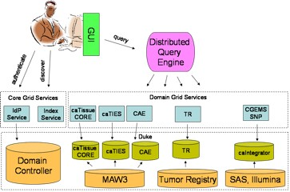

The following sections describe the major components of caTRIP top-down (UI to grid services).

GUI Design
The primary purpose of the caTRIP GUI is to enable users to create federated queries in a visual manner. The queries are converted into DCQL (distributed common query language), sent to the Federated Query Engine for processing, and the result is shown to the user in a tabular fashion.

caTRIP has two flavors of GUIs:

Advanced Query Builder: Targeted towards advanced users who are familiar with the UML domain modeling and technologies such as drag-and-drop. Data Managers and developers are the primary users of this interface.

Basic Query Builder: Targeted towards non technical users, who are not familiar with UML models. Clinicians and basic science researchers are the primary users of this interface.

Basic Query Builder
The diagram below explains the process of loading the configuration file and Domain model Metadata extract that is being bundled with the caTRIP user interface.

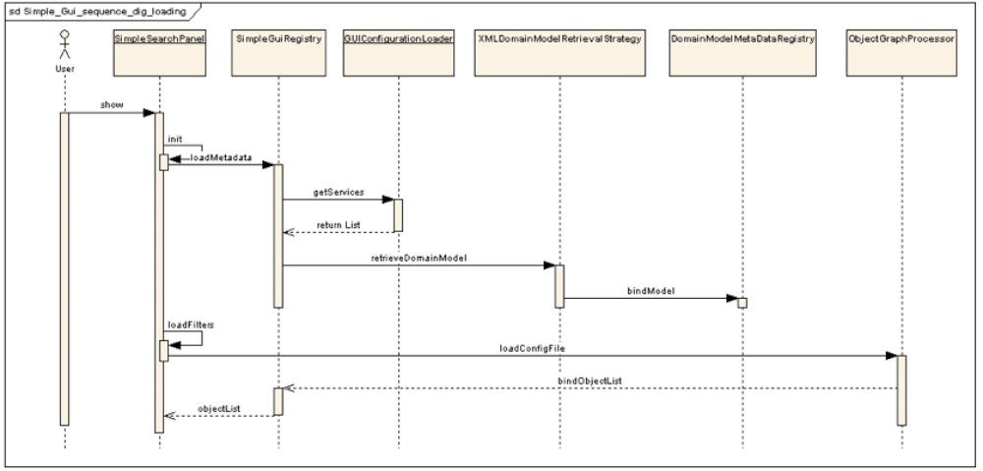

Currently, five Grid Data services are integrated with the Simple GUI, which are included out-of-the-box in the configuration files. Along with the simple GUI configuration file, the GUI also ships with the Domain Model metadata extract for these five services so that the relevant Semantic information can be shown in the GUI.

When a user launches the GUI, he or she is given a choice to use the default (Basic Query Builder) or Advanced Query Builder, which is explained in next section. When the user chooses the default option, the class SimpleSearchPanel, which is responsible for generating the Simple Query Interface, loads all the Metadata and simple GUI configuration during the Initialization process.

The SimpleSearchPanel class calls methods on SimpleGuiRegistry class, which is a storage of information about the Domain model and the simple GUI configuration. The SimpleGuiRegistry class than gets the list of Domain models for the services configured in the configuration file and load the metadata using utility classes (eg. XMLDomainModelRetrievalStrategy) and binds the model and semantic information with a Domain Model Metadata registry. The Domain Model Metadata registry has methods to bind and lookup the classes based on the unique class RefIds and fully classified class names. After the domain model metadata extract is loaded, the filters and other information about the services are loaded from the Simple GUI configuration file with the help of the class ObjectGraphProcessor and the information is bound to the Simple GUI Registry.

Execution of the Query

The UML sequence diagram below explains the event flow for the query execution in the Simple GUI.

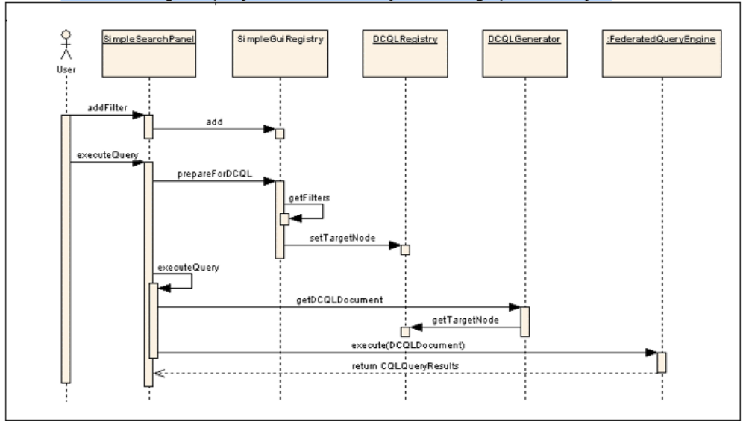

As soon as the user adds a filter to the query, the filter information gets added to the Simple GUI registry as well. The Registry has information about the filters, their respective classes and the service URLs, and other semantic information. Once the user clicks the Execute button, the Simple GUI Registry is asked to prepare for DCQL generation. This is an important step in the Simple GUI, as the associations and linking between the various filters across services is performed here. As per the CQL design, a CQL query has a Target Object and then an association structure specifying the filters in the form of attributes of other classes. The same association tree is built in this step of the query execution in the Simple GUI as opposed to the Advanced GUI where the user who is building the query associates the object on the graph manually.

Once the association tree is generated and a target node is assigned and bound to the DCQL Registry, the DCQL generator just picks up the Target Node reference and then traverses through the association tree to create appropriate DCQL with associations and foreign associations spanning across multiple Grid services.

After the DCQL generator generates a DCQL document (an XMLBeans generated object representing xml form of DCQL), it is passed to the Federated Query Engine (FQE) for execution.

The CQL Results returned from the FQE are then parsed via java Reflection and displayed on the output panel of the GUI.

Advanced Query Builder
The Advanced Query Builder is targeted towards more technically savvy users who are aware of the UML domain models of the Grid services being used in the caTRIP, as well as other technologies such as drag-and-drop and tree traversal.

The figure below explains the process of loading the caTRIP configuration file, the service specific domain model metadata, and building the class/CDE tree.

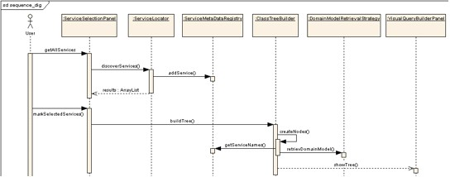

Advanced GUI: Loading of the configuration and metadata extract and Tree building

In the case of Advanced GUI, there are two options to load the services. The GUI can be configured to point to an Index service, which can then be used to discover services at run-time using the caGrid discovery API. It can also retrieve the list of services from a configuration file. In the first case, domain model metadata is accessed using the discovery API, but the in the later case it is stored locally on the file system as an XML extract. This is controlled by a configuration parameter in the GUI configuration file “catrip-config.xml”.

For both the options, the user is asked to search the services based on some parameters, or the user can perform a “Search All” operation.

If the discovery option using an Index service is selected, there is a Service locator that uses Discovery APIs to locate all the published services in the selected Index Service. The list is then shown to the user for selection. A Domain Model Retrieval Strategy class iterates over each selected service and also uses Discovery APIs to retrieve the Domain Model metadata extract to the client machine. Once the Domain model is downloaded, it is parsed, and the Domain Model Metadata Registry is populated with metadata information, which is then used to build the class tree.

Execution of the Query

The Query Execution process for the Advanced GUI is similar to the Simple GUI, except for the fact that the user links the class nodes on the Graph panel and creates an Association Tree. The user can select any class node as the Target Node by using the context menu option and thus bind it to the DCQLRegistry. Once there is a Target Node selected and the Association tree is defined on the Graph panel, the execution process follows the same path as in Simple GUI.

Federated Query Engine
The primary responsibility of federated query engine is to execute federated queries across the chosen caGRID data services. Queries written in the DCQL (distributed caBIG query language CQL) are the primary input to the engine. Federated Query Engine decomposes DCQL queries into individual CQL queries . These CQL queries are passed to individual data services where they get executed and results are passed back to federated query engine. The federated query engine aggregates the results from multiple services and sends back the result to client.

DCQL
DCQL is designed on top of the CQL query language. DCQL is defined in an XML document conforming to a well-defined schema, which is extended from CQL schema (see Figure DCQL schema).

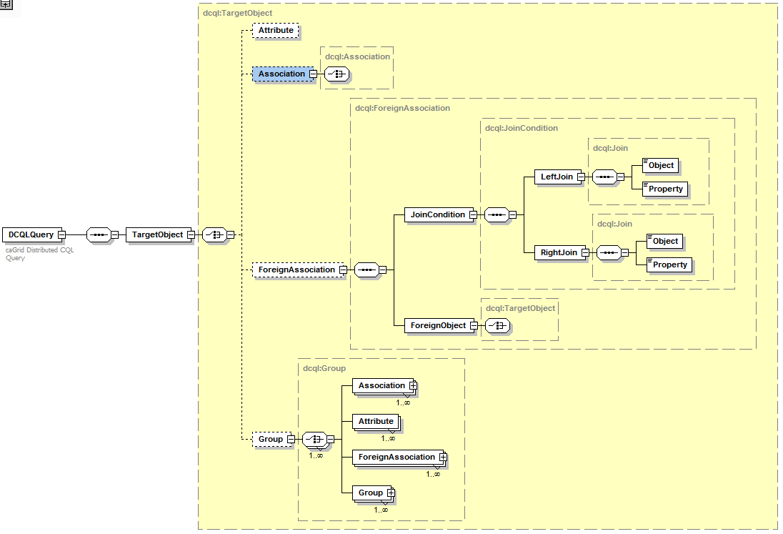

DCQL schema

DCQLQuery: DCQLQuery is a simple wrapper element at the head of every DCQL query document. It contains the target element.

TargetObject: The TargetObject element is of the type Object, and describes the data type that the query will return from a data service specified in the serviceURL property.

Object: The Object element contains the required attribute ‘name.’ This attribute’s value defines the caDSR class of the object. When the Object is the top level of a DCQL query, it identifies the target data type that will be returned by the caGrid Data Service. The Object allows for a choice between four child elements. The possible child elements are Attribute, Association, ForeignAssociation, and Group. Objects may have at most one of these child elements.

Attribute: Extended from CQL Attribute. An Attribute type in DCQL describes a restriction on an attribute of an Object. The Attribute contains three XML attributes, which define the restriction. The attribute ‘name’ defines the name of the attribute to be restricted. The attribute ‘value’ defines the restriction on the attribute. The attribute ‘predicate’ describes what type of restriction the attribute defines. Allowable predicates are defined by the schema’s simple type ‘Predicate’, which defines an enumeration of allowable values. The predicate values are generally self-descriptive: “EQUAL_TO",“NOT_EQUAL_TO", “LIKE", "LESS_THAN", "LESS_THAN_EQUAL_TO", “GREATER_THAN", and “GREATER_THAN_EQUAL_TO." Two additional predicates, "IS_NULL", and “IS_NOT_NULL" check only for the presence or absence, respectively, of an attribute, and do not restrict its value at all. Therefore, any ‘value’ attribute will be ignored when using these predicates.

Association: An association describes a related Object, which defines the associated object’s restrictions for the query, as well as the relationship from one object to another. Specifically, it defines the relationship down the object model tree. The Association complex type is an extension of Object. The Association has a single, optional attribute named ‘roleName.’ This attribute identifies which associated object field the Association is defining.

Group: Groups define logical joints of two or more conditions, and operate against the Object to which they are attached. Groups must have two or more children, which may be a mixture of type Attribute, Association, or Group. Groups also have an attribute named ‘logicOperator,’ whose type is defined in the schema’s simple type LogicalOperator. This type is an enumeration of the values “AND” and “OR.” The operator is applied to all children in the group. The “AND” operator requires that all conditions in the group be true for the group to evaluate as true. The “OR” operator requires that any condition in the group evaluate as true.

ForeignAssociation: A ForeignAssociation describes the relationship between data services.
JoinCondition defines the touch points between the services.
LeftJoin defines Object name and property name of local object
RightJoin defines Object name and property name of remote object.

The ForeignObject in ForeignAssociation becomes a “TargetObject” on the Foreign Service.

Federated Query Engine Execution
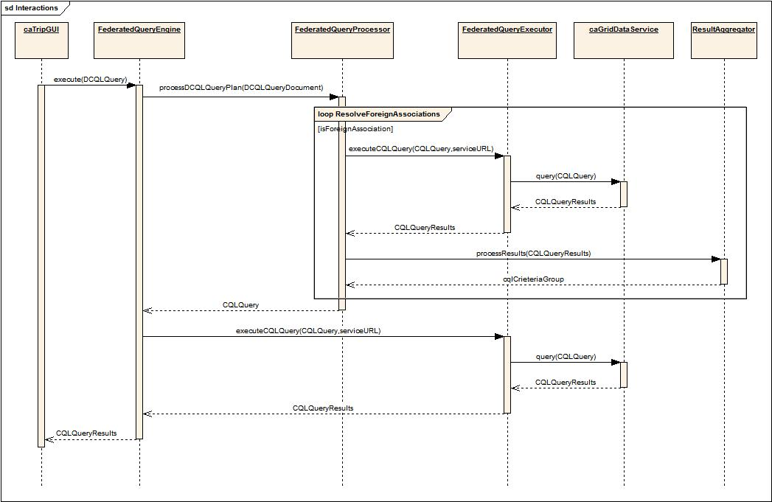

FederatedQueryProcessor
The Federated Query Processor decomposes the DCQL query into individual data service queries. After decomposing the query, federated query processor passes each CQL query and service URL of the data service to Federated Query Executor. After processing all the federated queries, the federated query processor builds a final CQL query and returns to Federated Query Engine.

FederatedQueryExecutor
Using a CQL query, the federated query processor generates, the federated query executor issues a data source specific query to corresponding data source. It uses the Service Client Factory to obtain a reference to an appropriate data source query handler that actually executes the query. Results obtained from a foreign data service are passed to the Result Aggregator for processing. Criteria group Result Aggregator is used as a ‘where’ clause to the higher level Query.

ResultAggregator
The Result Aggregator processes result sets obtained by executing data source specific queries. The Result Aggregator performs right and left joins on CDEs and builds criteria and returns the criteria as Group.

Data Services Design
caTRIP heavily relies on the caGrid 1.0 data services infrastructure. The domain systems such as caTissue Core and caTissue CAE are wrapped as data services and exposed to the FQE. Diagram below illustrates the steps involved in executing a query represented in CQL using a caGrid data service.
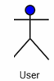
caGrid
Data Service

query(CQL Query)
Query Processor

processQuery(CQLQuery)
Data Source
createQuery(HQL Query)
ResultSet
CQLQueryResults
Serialized to XML
CQLQueryResults
Builds XML CQL query
Deserialized Data Objects
Data
Service
Client
- Client builds a CQL Query
- CQL query is submitted as part of request to the query() method of the caGrid data service via standard grid protocol
- Data service deserializes an XML representation of the CQL query into a CQLQuery object and then passes it to the configured CQL Query Processor implementation class
- CQL query processor converts CQL into HQL and queries the underlying data source to generate the result set.
- Results are serialized as XML and returned to the client as a single CQLQueryResults object.
- Introduce generated data service client iterates thru the result set and deserializes the XML into java objects if desired.

In caTRIP, we have two types of data services: caCORE SDK based and non caCORE SDK based. The following sequence diagram illustrates the various classes and interactions between them for a data service that is based on caCORE SDK generated data access API. The HQLCoreQueryProcessor (provided by the caGrid 1.0 infrastructure) translates the CQL query into an HQL query and uses the caCORE SDK’s application service class to execute it. This results in an additional network call, as the caCORE SDK’s application service is deployed in a different JVM.

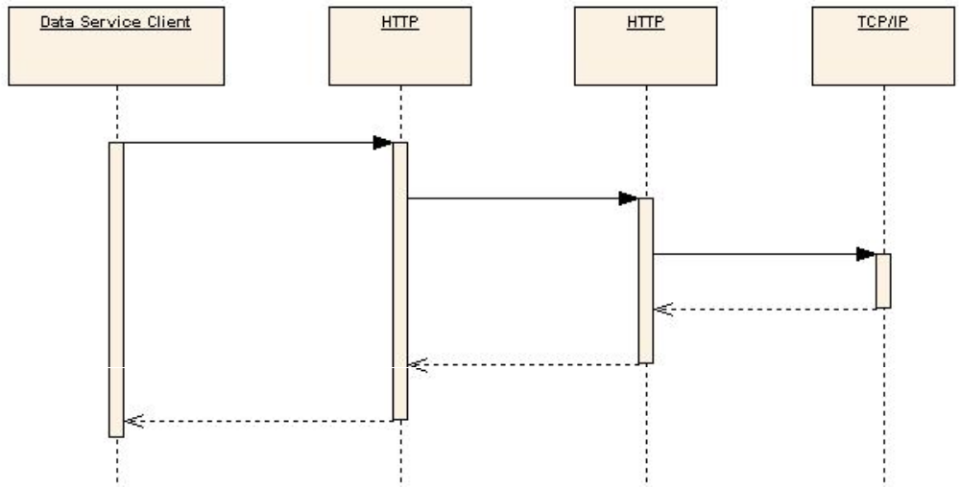

The following sequence diagram illustrates the various classes and the interactions for a data service that is not based on caCORE SDK generated data access API. The LocalHQLCoreQueryProcessor, which is an extension of HQLCoreQueryProcessor, translates the CQL query into an HQL query and uses the Hibernate query API to execute it. This eliminates an additional network call as the data access layer is packaged with the data service itself resulting in significant performance improvements.

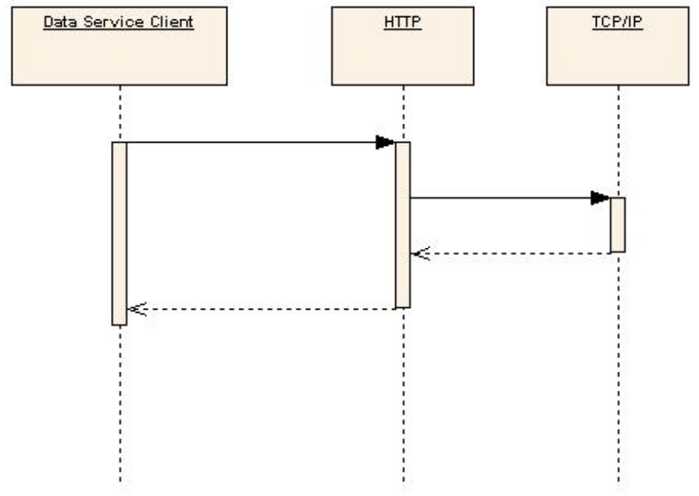

Security and Security Management

Authentication
The first step in the security workflow is authentication, which is the process by which a trusted organization claims a user is who they claim to be. This is implemented using the caGrid AuthenticationService (see the diagram below). The goal is for the user to get a grid user certificate to be used in authorization. The user submits their credentials (user name and password) to the AuthenticationService, which has an institutional IdP plugged in. This component performs the necessary steps to determine that the user credentials are valid. In the case of the Duke IdP plugin, the user name and password are validated against the Duke Domain Controller, which uses NT Security. Once validated, the AuthenticationService returns a SAML Assertion to the user, which asserts that the user is who they claim to be. The SAML Assertion can then be passed off to a Dorian Service to generate a grid user certificate.

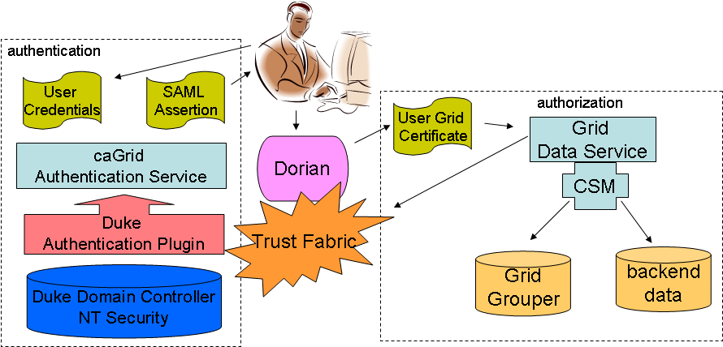

High-level overview of the caTRIP security architecture

Authorization
The second step in the security workflow is authorization, which is the process by which a system grants the user access to specific resources. This is implemented using the CSM plug-in to the grid data service. The grid user is mapped to an application user. When a data field is accessed on behalf of the user, an authorization structure is queried to determine if the user has permission to access it. If not, then a security exception is returned to the client. Authorization is made possible because a trust fabric exists between the service serving the data resource and the AuthenticationService.

Delegation
One twist on the security workflow is delegation, which is the process by which a service acts on behalf of the user. This impacts caTRIP because the DQE service queries domain services using the user’s certificate. The architecture of delegation has not yet been fully described or implemented by the caGrid team. As the delegation architecture is fleshed out, more details will be provided.

Foreign CDEs
Another twist on the security workflow is the use of “foreign CDEs” for the purpose of joining data. It is conceivable that a user does not have permission to view a CDE that is used for joining between two different domain services. The classic example of this is to join patients across services using the MRN. In this case, a special security workflow must be undertaken during authorization. A special trust fabric will be instantiated between the DQE service and the domain service such that foreign CDEs will be returned to the DQE service with the understanding that the delegated user is not authorized to view them but is authorized to join on them. The exact mechanism by which this is accomplished is not yet completely clear.

Information Models
Information models are leveraged to create our domain services, as well as register metadata in the caDSR and EVS. The following information models are used:

- caTissue CORE (Washington University): caTRIP has leveraged this model in its entirety without any modification.
- CAE (Pittsburgh University): caTRIP has modified this model by adding a small number of attributes and classes.
- caTIES (Pittsburgh University): caTRIP has leveraged this model in its entirety without any modification.
- caIntegrator SNP (NCICB): The caTRIP has leveraged this model in its entirety without any modification.
- Tumor Registry (Duke): This model is created from scratch by the caTRIP team.

The information models themselves are UML-based and created using Enterprise Architect (EA). They can be found at:

http://gforge.nci.nih.gov/plugins/scmcvs/cvsweb.php/catrip/documentation/models/?cvsroot=catrip

The Hibernate mappings are generated for the domain services using the caCORE SDK. The caCORE-generated APIs themselves are not used in caTRIP. Grid services are generated from metadata registered in the caDSR using the caGrid Introduce toolkit. An XMI file is generated from the information model (UML), semantically annotated, registered in the caDSR, and the caCORE-like service is generated.

One key facet of the caTRIP information models is that they are loosely coupled using the classes of Participant, Accession, and Biospecimen. Currently, only ParticipantMedicalRecordNumber is used to perform distributed joins across services.

Grid Services
The five grid data services described below were developed for caTRIP: The Introduce toolkit provided by the caGrid 1.0 infrastructure was leveraged extensively for developing these services. The query processor, which converts CQL statements into Hibernate Query Language (HQL) statements and executes them, was extended to support extra features.

caTissue Core Data Service
This data service is based on the caCORE SDK generated API of the caTissue Core 1.01 application.

caTissue Clinical Annotation Engine (CAE) Data Service
This data service is based on the CAE 1.2 domain model. It exposes only a subset of domain objects, specifically relevant to the breast annotations.

Cancer Text Information Extraction System (caTIES) Data Service
This data service is based on the caTIES domain model. It exposes only a subset of domain objects, specifically relevant to the identifiable portion of the model.

Tumor Registry Data Service
This data service is based on the Duke University tumor registry domain model, which was developed as a part of caTRIP phase 1 effort.

CGMES Data Service
This data service is based on the CGEMS domain model, which is a part of the NCICB’s caIntegrator project.

The grid services themselves are designed as an N-tier architecture (see the below Figure). The lowest tier is the underlying RDBMS, which can be provided by any number of vendors. caTRIP has been developed extensively leveraging Oracle and MySQL, but any relational database can be used. The next tier is Hibernate, which provides an object-relational mapping to the domain model. The final tier is the caGrid data service, which maps CQL queries to HQL queries using a CQL processor.

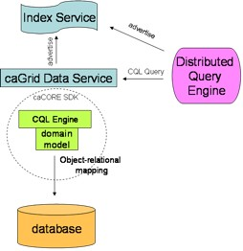

Architecture of a Grid Service

Installing caTRIP

caTRIP Minimal System Requirements
Minimal System Requirements | - Internet connection  - Server specs listed in Table 1

caTRIP has been tested on the platforms shown in Error: Reference source not found .

 | Linux Server | Windows
Model | HP Proliant ML 330 | Dell GX 270
CPU | 1 x Intel® Xeon™ Processor 2.80GHz | 1 x Intel® Pentium™ Processor 2.80GHz
Memory | 4 GB | 1 GB
Local Disk | System 2 x 36GB  (RAID 1)  Data = 2 x 146 (RAID 1) | System 1 x 36GB
OS | Red Hat Linux ES 3 (RPM 2.4.21-20.0.1) | Windows XP/2000 Professional
Table 1 Platform Testing Environment

caTRIP Software and Technology Requirements

Software Requirements
Required Software—Not Included in caTRIP | You must download and install the required software that is not included with caTRIP (listed in Error: Reference source not found.) The software name, version, description, and URL hyperlinks (for download) are indicated in the table. Java is required for running the client, and the rest of the listed software is required for running the services

(Required software that is included with the caTRIP is listed in Appendix I)
Software Name | Version | Description | URL
Java Software Development Kit (SDK):Java 2 Standard Edition (J2SE) | j2sdk1.5.2_06 or higher | The J2SE Software Development Kit (SDK) supports creating J2SE applications | http://java.sun.com/j2se/1.4.2/ download.html
Globus Toolkit | 4.0.3 | An open source software toolkit used for building Grid systems and applications | http://www.globus.org/toolkit/downloads/
Apache Tomcat | 5.0.28 | Apache Tomcat is an open source servlet container. | http://tomcat.apache.org/download-55.cgi
Apache Ant | 1.6 or higher | Apache Ant is a Java-based build tool | http://ant.apache.org/bindownload.cgi
Oracle Database | 9i or 10g | Oracle is a commercially-available, alternative relational database management system (RDBMS) | http://www.oracle.com/technology/products/oracle9i/index.html
MysSQL | 4.1 | Open source relational database | http://dev.mysql.com/downloads/
Table 2 Required software

Preliminary Considerations
 | BEFORE YOU BEGIN | caTRIP has been tested with the operating systems and hardware specified on pages Error: Reference source not found through 3 of this guide. We cannot guarantee caTRIP will work If you are using variations of these operating systems and/or hardware.

Installing Prerequisites
Step | Action
1 | Jakarta Ant - Extract the contents of the Ant zip file, apache-ant-1.6.2-bin.zip and save it to your computer. For example, if your root directory in Windows is C:\, then extract your Ant home directory to C:\apache-ant-1.6.2.
2 | Java JRE - Download version 1.5 or higher and install it to a desired location e.g. C:\jdk1.5.0_06.
3 | Verify that the environment variables ANT_HOME and JAVA_HOME are set and that your PATH statement includes the locations of the Ant and Java binaries. For example, PATH should include C:\apache-ant-1.6.2\bin; C:\ jdk1.5.0_06\bin.  To do this in Windows:  - Select My Computer > Properties (from the shortcut menu) > Advanced tab.  - Click the Environment_Variables... button.  - ANT_HOME and JAVA_HOME must each be listed in one or the other of the panels of the dialog box. To add either, below one of the panels, click the New button.  - In the New User Variable dialog box, add the Variable and Variable Value.  Examples:  Variable = ANT_HOME; Variable Value = C:\apache-ant-1.6.2  Variable = JAVA_HOME; Variable Value = C:\ jdk1.5.0_06  - Verify that the PATH statement listed in the Environment Variables dialog box includes both the ANT_HOME and JAVA_HOME binaries and that they read as follows: C:\ jdk1.5.0_06\bin;C:\apache-ant-1.6.2\bin. (To easily review these, copy them to a text editor.) If necessary, click the Edit button and enter the correct information.
4 | Tomcat Installation – extract the zip file to the c:\ drive. After unzipping add the variable CATALINA_HOME = <your tomcat home> e.g.  CATALINA_HOME = c:\ tomcat_cagrid_5.0.28
- 88  5 | Globus installation – extract the zip file to the c:\ drive.  Add the environment variable GLOBUS_HOME=c:\<globus location> for example:  GLOBUS_LOCATION = c:\ ws-core-4.0.3  Next install the Globus container into Tomcat. Change to the globus directory c:\<globus location>\ . To install the container run the following:  ant -f share\globus_wsrf_common\tomcat\tomcat.xml deployTomcat -Dtomcat.dir="<tomcat location>"  Output of the Globus installation:  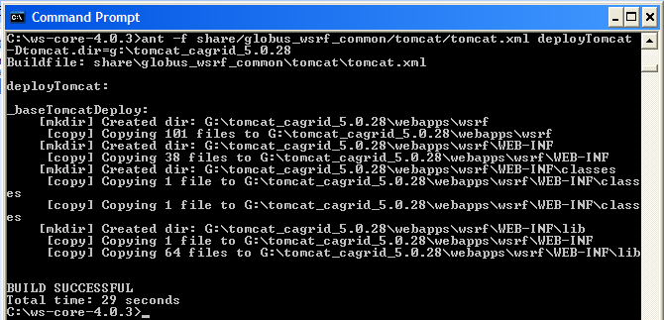  The Globus installation will add a new directory ‘wsrf’ in the Tomcat directory under ‘webapps’  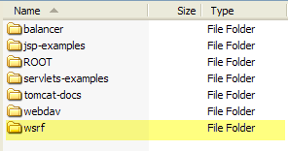
6 | Download and install MySQL 4.1 to a desired location e.g. c:\mysql4.1  http://dev.mysql.com/downloads/
7 | Download and install Oracle 9i or 10g to a desired location e.g. c:\oracle  http://www.oracle.com/technology/products/oracle9i/index.html

Downloading caTRIP
 | SUGGESTION | To best understand the installation and testing procedures for the caTRIP, it is recommended that you follow the procedures described in this section with minimal deviation.
Complete the following steps to download caTRIP;

Step | Action
1 | Go GForge web site to download caTRIP:  https://gforge.nci.nih.gov/frs/?group_id=131
2 | Save it to a directory on your computer (for example, C:\caTRIP in Windows). This may take several minutes.
3 | Extract the contents of the caTRIP distribution zip file to your root directory. For example, if your root directory in Windows is C:\, then your caTRIP home directory is C:\caTRIP.  Note: This directory name cannot contain any spaces or this will cause errors in Windows. For instance, do not place the caTRIP directory in the Program Files directory.

Installing the Components
After downloading and unzipping caTRIP the following components need to be edited or installed:

- Install Oracle and MySQL databases
- Install Web Services
- Edit Hibernate configuration files
- Edit caTRIP Configuration Files

Database setup
Database scripts for both Oracle and MySQL are available to create the user and schemas. All sql scripts can be found in the directory: codebase\projects\db_scripts

File Name | Description
Tumor_registry_oracle_creation.sql | This file contains SQL statements that can be used to create the user and database for the Tumor Registry database in Oracle
CAE_oracle_creation.sql | This file contains SQL statements that can be used to create the user and database for Clinical Annotations Engine (CAE) database in Oracle
CGEMS_oracle_creation.sql | This file contains SQL statements that can be used to create the user and database for Cancer Genetic Markers of Susceptibility (CGEMS) database in Oracle
Query_share_oracle_creation.sql | This file contains SQL statements that can be used to create the user and database for the query sharing database in Oracle
Catissuecore_mysql_creation.sql | This file contains SQL statements that can be used to create the user and database for caTIssueCore database in MySQL
caties_mysql_creation.sql | This file contains SQL statements that can be used to create the user and database for Text Information Extraction System (caTIES) database in MySQL

Database Test Data
Test data for the Oracle databases CAE and Tumor Registry are available in the directory: codebase\projects\db_scripts\sampleData

Web Services

After the databases have been installed it is time to create the caTRIP services. The services will be deployed to Tomcat in the Globus directory wsrf\WEB-INF\etc.

Step | Action
1 | Go to where caTRIP was download and unzipped and change to the codebase directory.  <catrip directory>\codebase
2 | Run the Ant task ‘clean’ to clean appropriate directories. Run the following from the codebase directory:  ant clean
- 3  3 | Run the Ant task ‘all’ to compile all the code. Run the following from the codebase directory:  ant all
4 | Run the Ant task ‘deployTomcat’ to deploy the services to Tomcat. Run the following from the codebase directory:  ant deployTomcat  Note: Each service can be installed separately by running the same ant task within the service’s folder.
5 | After all Ant tasks are complete, you can check if the services got deployed by checking the following directory in Tomcat.  C:\<tomcat install dir>\webapps\wsrf\WEB-INF\etc  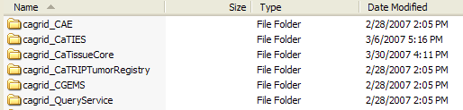

Hibernate Configuration Files

Once the services are installed, the Hibernate configuration files need to be update with your database information. Each service has a jar file which contains the Hibernate file to be updated.

Step | Action
1 | Go to the directory where Tomcat was installed. Change to the directory:  <tomcat dir>\webapps\wsrf\WEB-INF\lib  Here is where you will find the jar files to be updated
2 | Listed here are the services which use an Oracle database. See the next step for what lines to edit inside the hibernate configuration file.  Query service :  jar file: _queryservice.jar. hibernate file : hibernate.cfg.xml  CAE Service:  jar file: cae_domain.jar hibernate file : cae-hibernate.cfg.xml  CGEMS Service:  jar file: cgems-domain.jar hibernate file : cgems-hibernate.cfg.xml  Tumor Registry Service:  jar file: tumor_registry-domain.jar hibernate file : tumor-hibernate.cfg.xml
- 3  3 | Edit the following highlighted areas with your Oracle database information:  Connection URL:  <property name="connection.url">jdbc:oracle:thin:@localhost:1522:{service name}</property>  Connection Username :  <property name="connection.username">username</property>  Connection Password :  <property name="connection.password">password</property>
4 | Listed here are the services which use an MySQL database. See the next step for what lines to edit inside the hibernate configuration file.  caTIES Service:  jar file: caties-domain.jar hibernate file : caties-hibernate.cfg.xml caTissueCore Service:  jar file: catissuecore-domain.jar hibernate file : catissue-hibernate.cfg.xml
- 3  5 | Edit the following highlighted areas with your MySQL database information:  Connection URL :  <property name="connection.url">jdbc:mysql://localhost:3306/caties_ctrm</property>  Connection Username :  <property name="connection.username">username</property>  Connection Password :  <property name="connection.password">password</property>

caTRIP Configuration Files
Now the databases and web service are installed with the Hibernate files up to date, it is time to update some configuration files to point to the newly deployed web services.

Step | Action
1 | Go to where caTRIP was download and unzipped and change to the gui directory.  <catrip directory>\codebase\projects\gui
2 | Edit the build.properties file to set the location of the query service. This will be where your Tomcat is installed  query.sharing.url=http://localhost:8181/wsrf/services/cagrid/QueryService
- 3  3 | Now switch to the conf directory under gui:  <catrip directory>\codebase\projects\gui\conf  Here is where the service-config.xml file is located. The location of each service is set in this file.  The ipaddress of each service location needs to be changed to point to where your service is installed e.g. localhost.  <catripService url="http://152.16.96.114/wsrf/services/cagrid/CaTissueCore" serviceMetadataFileName="CaTissueCore_serviceMetadata.xml" domainModelFileName="caTissueCore_domainModel.xml"/>
- 3  4 | Next the simple gui interface configuration file needs to be update with the location of the services as well. Switch to the directory:  <catrip directory>\codebase\projects\gui\conf\simplegui  Here is where the SimpleGuiObjectGraph.xml file is located. Search for the service tags (<service) and change the location of the services for the simple gui interface.  The ipaddress of each service location needs to be changed to point to where your service is installed e.g. localhost.  <service displayName="Tissue Bank" url=http://152.16.96.114/wsrf-0216/services/cagrid/CaTissueCore …

NOTE:   | For more information on configuration files, refer Configuration files section in Creating new data service

Creating new data service

Domain model setup
First step in creating a data service is to setup the domain model and data model.

Step | Action
1 | Create data model using Enterprise Architect or your favorite data modeling tool. Database scripts can me created manually
2 | Create the data base /schema
- 3  3 | Create object model using Enterprise Architect or your favorite modeling tool
- 3  4 | Generate Java Beans.
5 | Perform Hibernate Mappings  Refer to http://www.hibernate.org
6 | Create hibernate configuration file with the following naming convention.  <<service_name>>_hibernate.cfg.xml  Replace <<service_name>> with the data service name. This name should be unique.  Refer to http://www.hibernate.org
7 | Create castor mapping xml file with the following naming convention.  <<service_name>>-xml-mapping.xml.  Replace <<service_name>> with the data service name. This name should be unique.  Refer to http://www.castor.org
8 | Create domain model jar file which includes domain model class files, hibernate mapping files , castor mapping files. Save this domain model jar file for future use. Here is the directory structure for CAE service  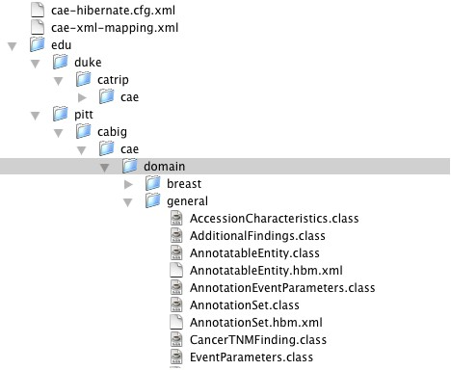

Create data service using Introduce toolkit
Introduce Toolkit is a service creation toolkit built by caGrid team. It supports easy developement and deployment of caBIG compatible grid enabled data and analytical services. Introduce toolkit reduces the service developers needing to manage the low level details of the WSRF specification and integration with the Globus Toolkit.

 | 1 |  | Refer to https://cabig.nci.nih.gov/workspaces/Architecture/caGrid for caGrid documentation.  Download caGrid code base.  Build caGrid code base.  Bring up Intrduce toolkit.  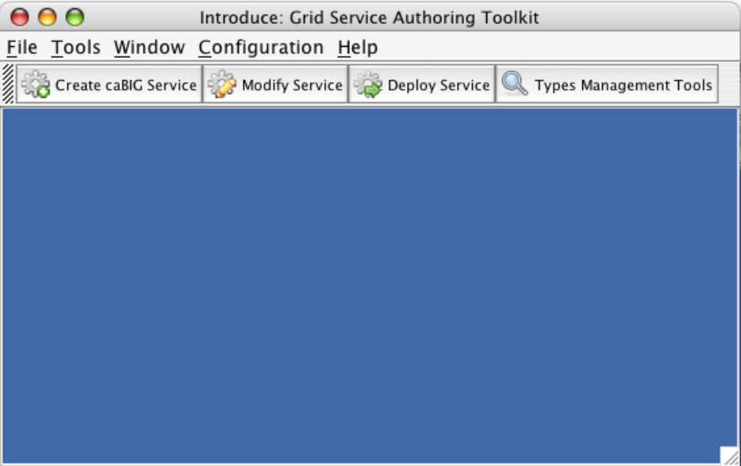  Click on “Create caBIG Service”
 | 2 |  | 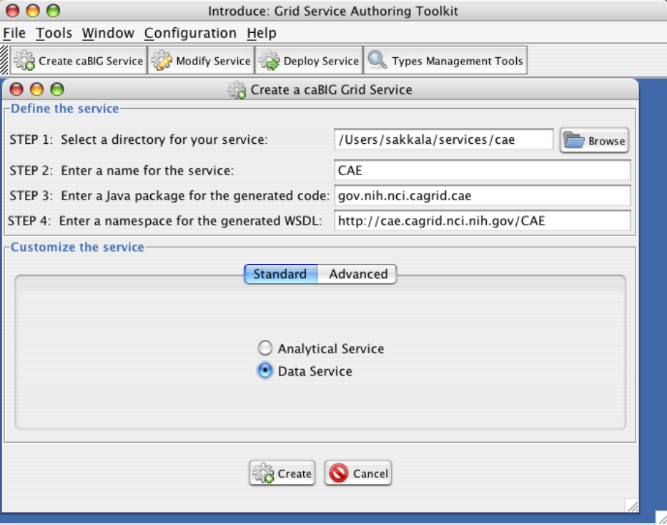  Fill all the four text fields. (CAE is the sample for service used as an example)  Select “Data Service” radio button.  Click “Create”
 | - 3  3 |  | 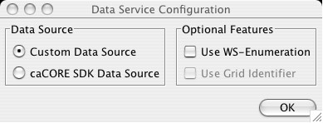  Select “Custom Data Source”  Click “OK”
 | - 3  4 |  | Service Interface  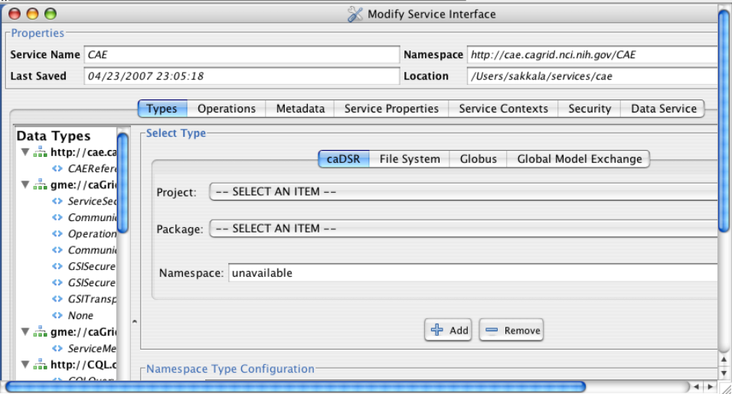  Click on “Data Service” Tab
 | 5 |  | 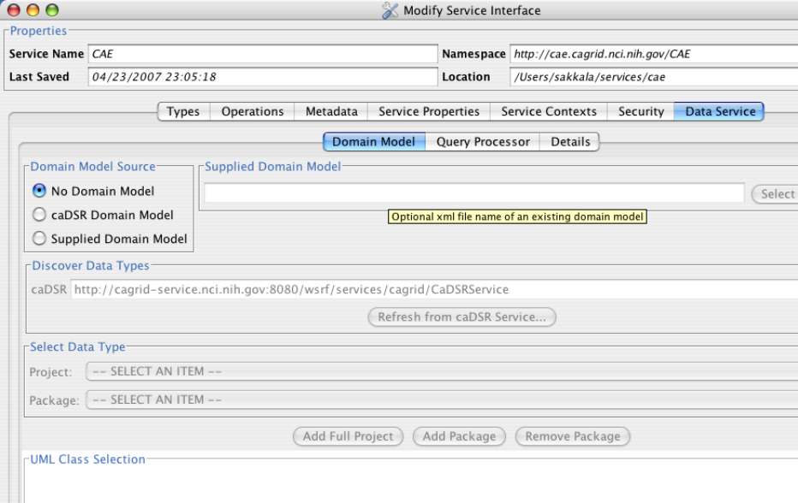  As we created our own domain model jar file we don’t need to select any domain model this screen.  Select “No Domain Model” radio button  Click on “Query Processor” tab
 | 6 |  | Locate the query processor jar file cagrid-caTrip-SdkQuery1.0.jar in  “<<catrip_code_base>>/projects/catrip-custom-jars/lib.  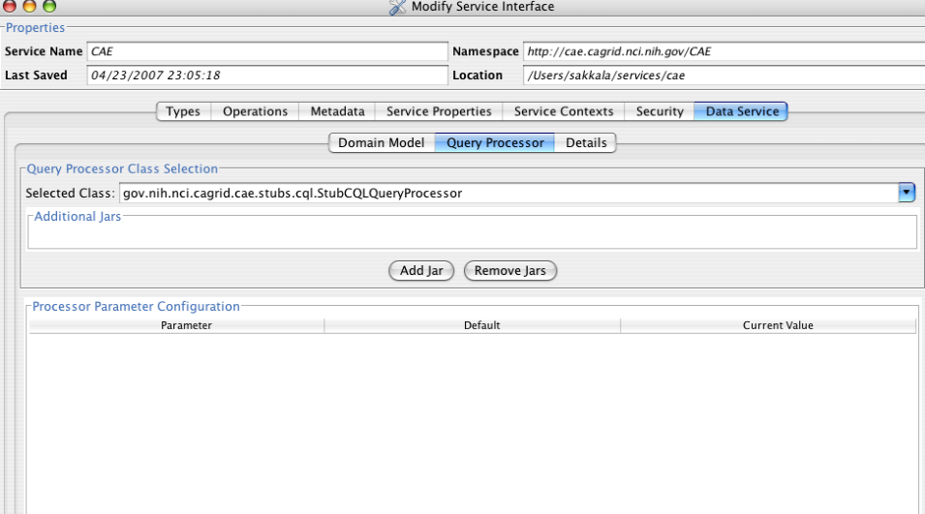  Click “Add Jar” which would open your file system and then select cagrid-caTrip-SdkQuery1.0.jar from caTRIP distribution
 | 7 |  | 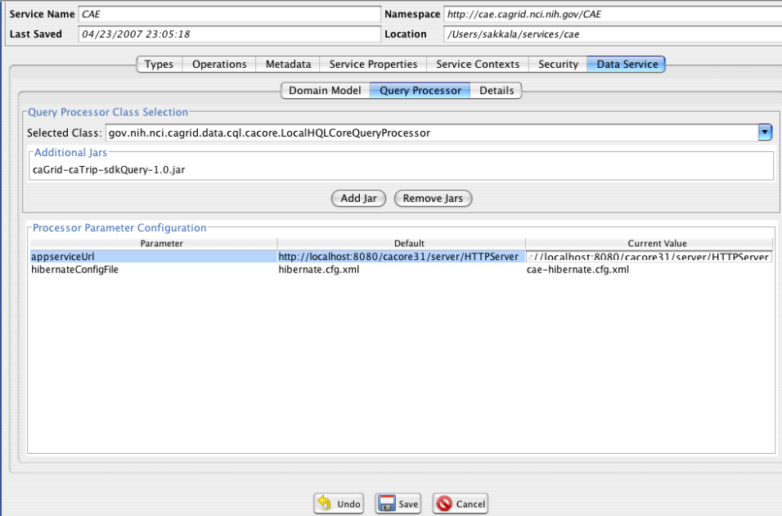  Select “gov.nih.nci.cagrid.data.cql.cacore.LocalHQLCoreQueryProcessor” from “Selected Class” drop down list.  Modify hibernateConfigFile Current Value to ca-hibernate.cfg.xml (this is the file from step # 3.1.3  Click Save to save the data service.
8 |  | Go to the folder where you created the service <<service_location>>.  /Users/sakkala/services/cae in this example  - Copy all the jars from “<<catrip_code_base>>/projects/catrip-custom-jars/lib”  to <<service_location>>/lib . Replace the existing jars.  - Copy 1_gov.nih.nci.cagrid.CQLQuery.xsd from “<<catrip_code_base>>/projects/catrip-custom-jars/schema” to <<service_location>>/schema/<<servce_name>>/schema. Replace existing schema.
9 |  | Add type mappings to all domain model classes to <<service_location>>/server-config.wsdd.  Sample for two objects. Speciman and Participant  <ns3:typeMapping xmlns:ns3=”http://xml.apache.org/axis/wsdd/” xmlns:ns1=”http://xml.apache.org/axis/wsdd/providers/java” xmlns:ns2=”gme://caTissueCAE.caBIG/1.0/edu.duke.catrip.cae.domain.general” encodingStyle=”” serializer=”gov.nih.nci.cagrid.encoding.SDKSerializerFactory” deserializer=”gov.nih.nci.cagrid.encoding.SDKDeserializerFactory” type=”ns1:edu.duke.catrip.cae.domain.general.Specimen” qname=”ns2:Specimen” />  <ns3:typeMapping xmlns:ns3=”http://xml.apache.org/axis/wsdd/” xmlns:ns1=”http://xml.apache.org/axis/wsdd/providers/java” xmlns:ns2=”gme://caTissueCAE.caBIG/1.0/edu.duke.catrip.cae.domain.general” encodingStyle=”” serializer=”gov.nih.nci.cagrid.encoding.SDKSerializerFactory” deserializer=”gov.nih.nci.cagrid.encoding.SDKDeserializerFactory” type=”ns1:edu.duke.catrip.cae.domain.general.Participant” qname=”ns2:Participant” />
10 |  | Build service by executing “ant all” from <<service_location>>
11 |  | Deploy to tomcat by executing “ant deployTomcat” from <<service_location>>
12 |  | Create domain model extract using caCore SDK.  http://ncicb.nci.nih.gov/infrastructure/cacoresdk

Query Builder Configuration Files
Configuration files are located in <<catrip_code_base>>/projects/gui/conf directory of caTRIP distribution.

Most of the complexity of the Advanced Query Builder are hidden in the Basic Query Builder with the help of a configuration file. This configuration file stores the information regarding the pre-defined Backbone Target objects, their association path and role names with other classes in the same service, and the association path through which they can be “joined” with other (foreign) services to make a cross-service DCQL query.

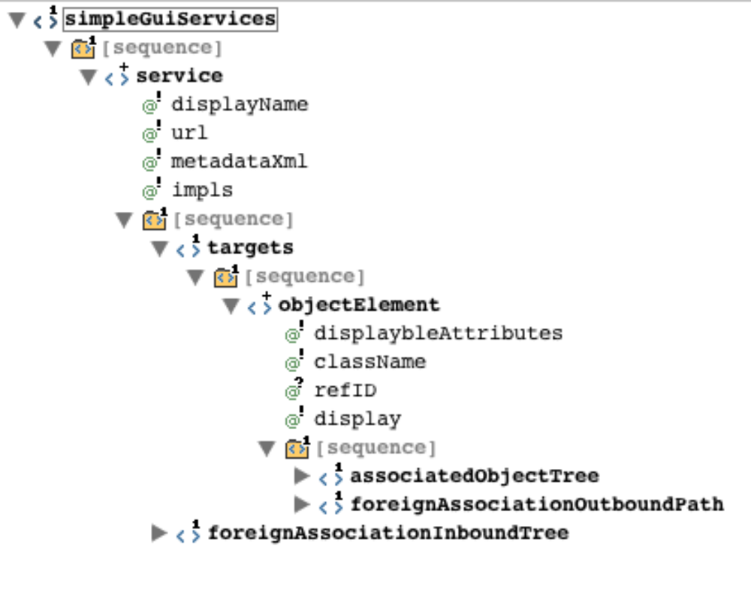
Snapshot of Basic Query Builder Configuration schema

Configuring simple-gui.xml. Let us go through each element on this xml file. Take a look at the above XML schema for reference.

<service> Element (1..*)
Each data service details should be configured in service element.

Let us look at a sample example with TumorRegistry and CGEMS services.

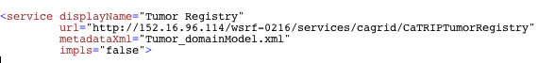

displayName – Name of the service as it appears in Basic Query Builder UI.

url – Data Service EPR

metadataXML – name of domain model extract file.

impls – this flag can have true/false . If Class names ends with Impl this flag should be “true”

<objectElement> Element (1..*)
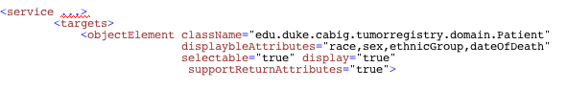
List of back bone objects are listed as objectElements in <targets> container.

className – Fully qualified class name of the back bone object.

supportReturnAttributes – “true” if this service allows selection of return attributes.

Note: All objects may not support return attributes because there should be a bidirectional association between target object and associated object to support this feature

displayableAttributes – List of attributes of back bone object on which user can set filters.

< associatedObjectTree > Element (1)

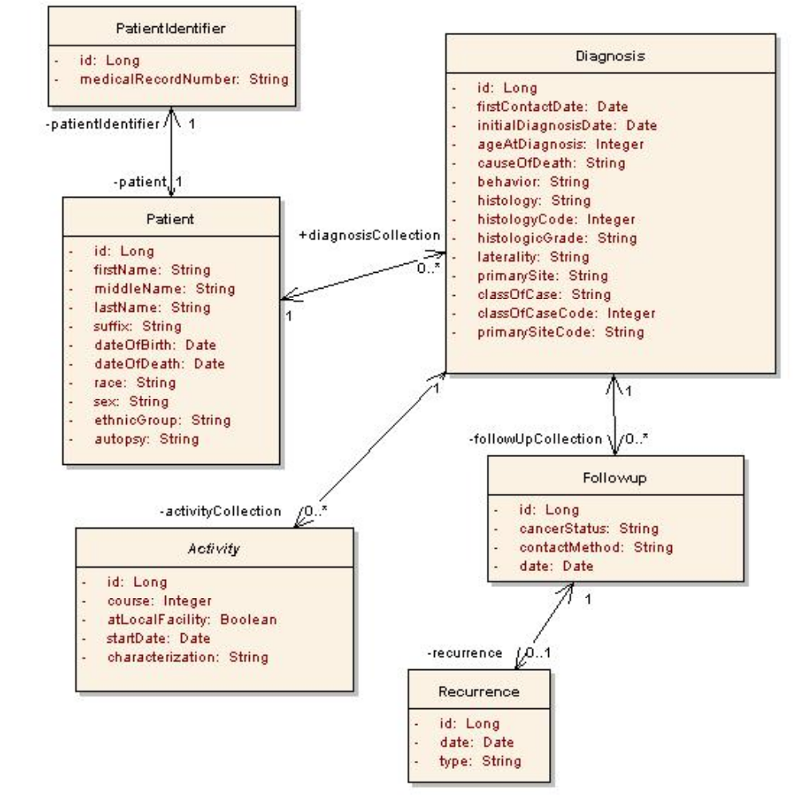
CGEMS Object model snap shot

Above Figure is a snap shot of CGEMS object model with few objects.
Target object Patient is directly associated with Diagnosis.
Patient is associated to Activity via Diagnosis.
Patient is associated to Followup via Diagnosis.
Patient is associated to Recurrence via Diagnosis via Followup

assoiatedObjectTree defines the Association path from the Target class to any other class defined in the association tree, thus eliminating the need for the end user to link the classes like in the Advanced GUI.

Below XML shows how these associations are configured in the configuration file using Association element within associatedObjectTree element.
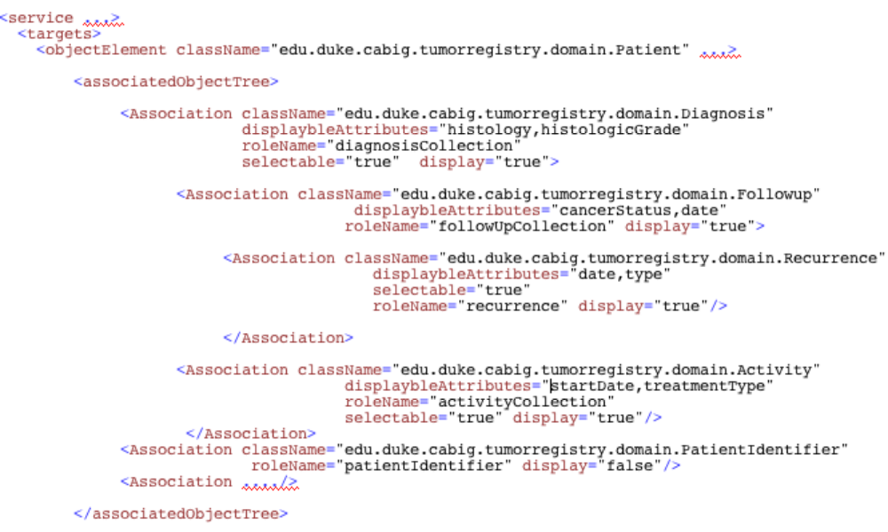

Attributes in Association tag :

ClassName: Fully qualified class name.

displayableAttributes: List of attributes of back bone object on which user can set filters.

roleName: Association role name with high level Association or objectElement in the tree.

display: Some association classes are used to connect the lower associations , not necessarily to set any filters. “false” to not allow any filters on any attributes of this class.

< foreignAssociationOutboundPath > Element (1)

TUMOR REGISTRY DATA SERVICE

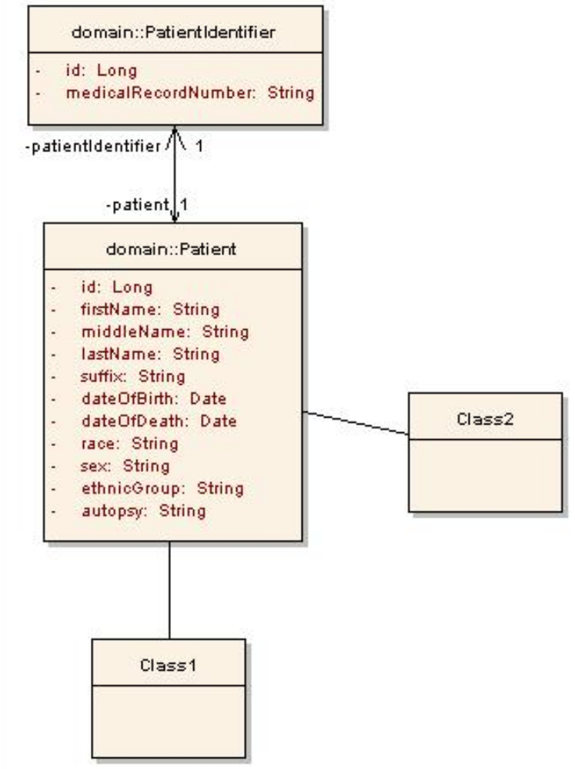
OUT BOUND
CDE
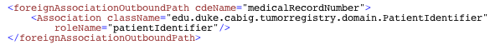

In order to link/join a Target class with other services (a foreign service in this context), it has a predefined association path to a class that has a linking CDE that is common across the services to be joined. Above listing shows a class called ParticipantIdentifier which has a linking CDE called MedicalRecordNumber.

cdeName – name of the common atrribute
className – fully qualified class name
roleName – role name from target object to this class.

< foreignAssociationInboundTree > Element (1…*)

Assume Tumor Registry service metioned above needs to associate with CGEMS service

CGEMS DATA SERVICE
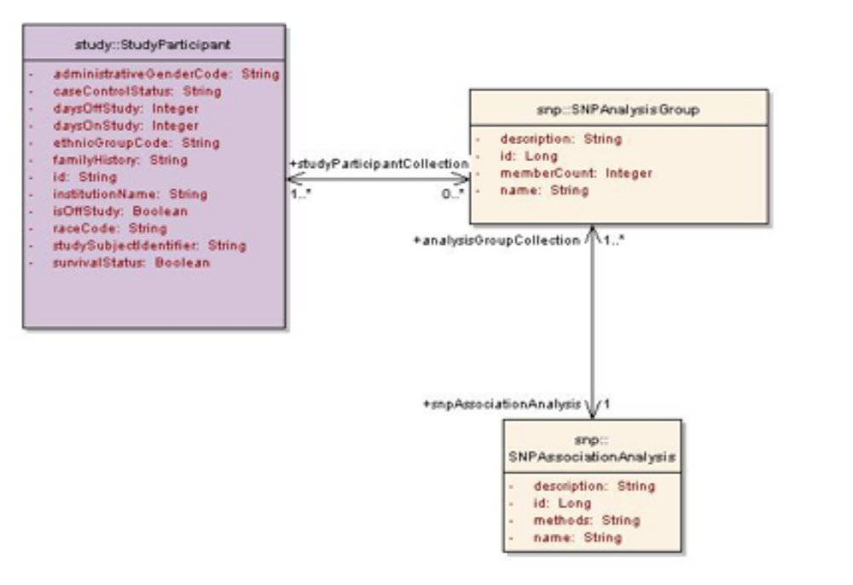
INBOUND
CDE

Similarly, in order to have query filters from foreign services, each such filter class should have a pre-defined association path from the class which has the linking CDE to the filter class. Above listing shows an example a filter class is SNPAnalysisGroup and SNPAssociationAnalysis and the linking class is StudyParticipant and linking CDE is studySubjectIdentifier.

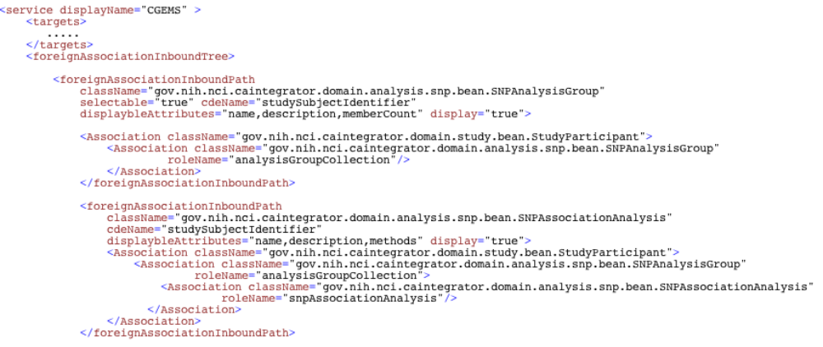

Configure catrip-config.xml.

AdvanceGUI picks up the list of services either from Index service or services-config.xml file based on the configuration in catrip-config.xml file. This file is also located in ..gui/config directory.

Index service URL and available identity providers can be configured in this file.

<indexService use="false" name="Local Index Service" url="<<INDEX SERVICE EPR"/>

Index service information.

use – caTRIP applications works with or withour using index service. If you want the data services to be discovered from an index service value of use should be “true”. If this value is false , the list of services are picked up from services-config.xml

name – name of the index service.

url – End point reference(EPR) of the index service.

<federatedQueryEngineService name="Local" url="http://…”/>

Federated Query Engine name and EPR. This feature is not supported in current release. Don’t make any changes for federatedQueryEngineService

You can configure available Identity providers in <gridIndentityProviders> tag. Refer to the Security Section for more information.

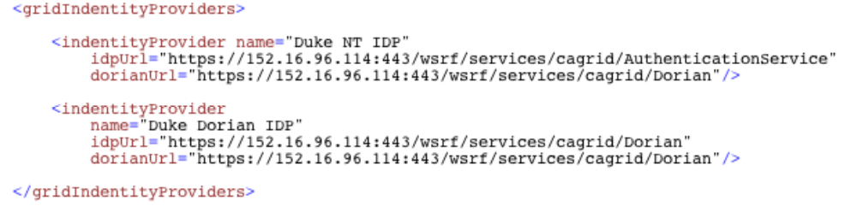

name : Name to appear in caTRIP GUI login screen. Should be unique.
idpUrl : Authentication Service EPR
dorianUrl : Dorian Service EPR.
Configuring services-config.xml.
This file is also located in ..gui/config directory , contains URLS of each data services and filenames of corresponding domain model extract and service meta data . This information is used by Advanced GUI if indexService is use=”false”.

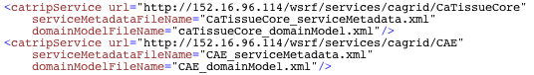

url : Data Service EPR

serviceMetadataFileName : service metadata file name.

domainModelFileName : Domain model extract file name.

Testing the Application
At this point, everything is installed and we can test the application before bundling it into a Webstart application for others to use.

Step | Action
1 | Start Tomcat.  <tomcat directory>/bin/startup.bat
2 | Open a command window and change to the gui directory where caTRIP was installed  <catrip directory>/codebase/projects/gui  Execute the Ant task ‘run’  ant run  This will start the application.  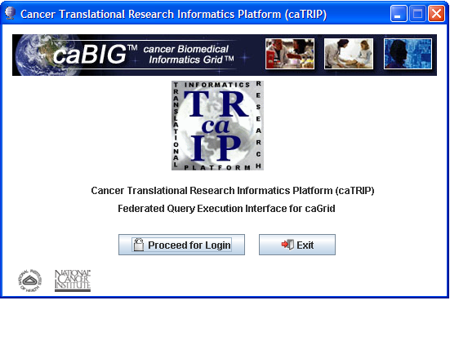
3 | From the splash screen press the ‘Proceed for Login’ button to move to the login screen  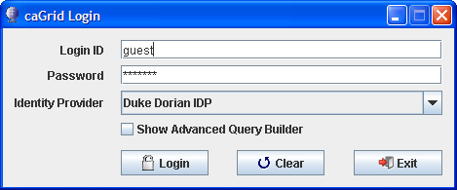
- 3  4 | From the login screen press ‘Login’ to continue to the simple qui interface.
- 3  5 | If you have not loaded the Tumor Registry test data yet load it now. After loading change the Target Data Element and Data Source to the values for the Tumor Registry.  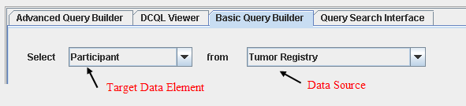
- 3  5 | Press the Execute Query button. You will see all the data from the Tumor Registry data source.  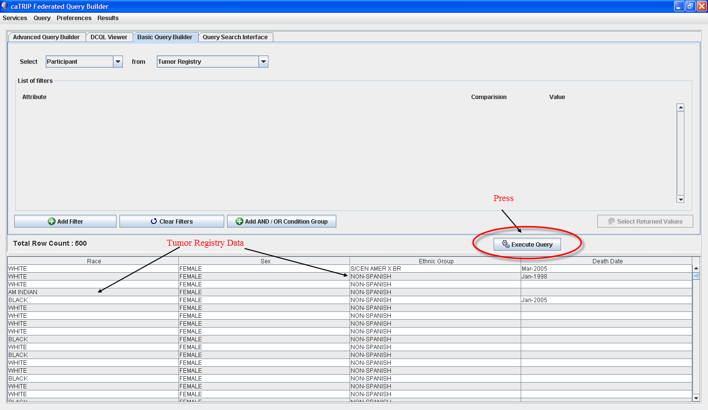
- 3  6 | Test the other services by changing the target data element which will change the initial data source drop down. Change the initial data source drop down to each entry and press the Execute Query button.  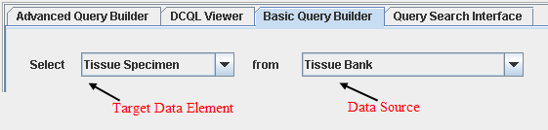  No records will be returned if you have no data for a data source. Look for any service errors regardless if you have data or not. If you have an error, redeploy the services again.
- 3  6 | See the User’s Guide on how to create more complex queries.  User’s Guide can be found at : https://gforge.nci.nih.gov/projects/catrip/

Creating a Webstart Application
Java Web Start is a framework allows application to be started directly from the Internet using a web browser. Unlike Java applets, Web Start applications do not run inside the browser, and the sandbox in which they run does not have to be as restricted, although this can be configured. A JNLP file is hosted on the tomcat, which can be downloaded to clients machine. JNLP file include information such as the location of the jar package file and the name of the main class for the application, in addition to any other parameters for the program. With a properly configured browser, JNLP files are passed to a Java Runtime Environment, which in turn downloads the application onto the user's machine and starts executing it.

Instructions to install caTRIP web start web application on tomcat.

Step | Action
1 | In <catrip-codebase>/projects/gui  ant webstart-build: Build WebStart Version of caTrip Application.  Creates a dir in the gui folder named "gui/webstart-build" which is the final deployment image. then it signs the jars in "webstart-build/lib" directory.
2 | ant webstart-deploy-tomcat: Deploy WebStart Version of caTrip Application on Tomcat.  Prompts for the server URL and will modifies the files in the "webstart-build" dir and copy them to ${env.CATALINA_HOME}/webapps/catrip-webstart folder.
- 3  3 | ant webstart-test: Test WebStart Version of caTrip Application, without deployment on tomcat.

Security
In caTRIP, authentication is implemented using caGrid Authentication framework. We have also implemented Windows NT authentication, and plugged this into caGrid Authentication framework. When security is deployed locally, an administrator will have to plug in an institutional authentication module or use Dorian. In the later, users will get logins from the Dorian system administrator.

NT Authentication
- User should authenticate using his/her Duke NT credentials via caTRIP GUI
- caTRIP first authenticates with local NT credential provider via the Windows NT authentication service and obtains a SAML assertion as proof they authenticated. (Windows NT host and domain information is configurable, so implementation works for any Windows NT system)
- SAML assertion provided by the authentication service to obtain grid credentials from Dorian. (NT authentication service at Duke is registered with Dorian as a trusted identity provider)
- Dorian will issue grid credentials to the caTRIP GUI application.
- Once GUI obtains grid credentials from Dorian GUI allows the user to login. User builds and executes queries on multiple secured data services.
- Upon receiving grid credentials from a user, a secure data service authenticates the user to ensure that the user has presented valid grid credentials.
Windows NT domain and server information can be configured in authentication service configuration file. Authentication service is part of caGrid distribution. caTRIP has extended and incorporated NT authentication functionality with authentication service.
Configuring authentication-config.xml for NT authentication
<bean id=”dukeAuthenticationManager” class=”edu.duke.idp.service.DukeAuthenticationManager”>
<property name=”credentialProviderHost” value=”<<IP ADDRESS OF CREDENTIAL PROVIDER>>”/>
<property name=”domainName” value=”<<WINDOWS NT DOMAIN NAME>>”/></bean>
More information on authentication service can be found in caGrid Documentation
http://gforge.nci.nih.gov/plugins/scmcvs/cvsweb.php/cagrid-1-0/Documentation/docs/security/gaards-security-admin-guide.doc?cvsroot=cagrid-1-0

Default Dorian Authentication
caTRIP has another implementation for non Window NT users. All users may not be part of Dukes Windows NT IdP. caTRIP supports users created using Dorian’s default authentication service.

Dorian is a grid user management service that (1) hides the complexities of creating and managing grid credentials from the users and (2) provides a mechanism for users to authenticate using their institution’s authentication mechanism, assuming a trust agreement is in place between Dorian and the institution.

- Dorian administrator can create User accounts directly on Dorian .
- User should authenticate using his/her Dorian credentials via caTRIP GUI
- As the user was registered directly with Dorian and not through an existing credential provider, caTRIP obtains grid credentials directly from Dorain.
- Once GUI obtains grid credentials from Dorian , GUI allows the user to login. User builds and executes queries on multiple secured data services.
- Upon receiving grid credentials from a user, a secure data service authenticates the user to ensure that the user has presented valid grid credentials.
Create Users in Dorian and configure catrip-config.xml file with Dorian URL and Authentication URL. Authentication URL for default Dorian would be same as Dorian URL, Configuration information can be found in section 3.2.3
Documentation on how to create users can be found in caGrid security documentation
http://gforge.nci.nih.gov/plugins/scmcvs/cvsweb.php/cagrid-1-0/Documentation/docs/security/gaards-security-admin-guide.doc?cvsroot=cagrid-1-0
Read “Grid User Management” section in the above document.

Authorization
Basic Authorization is implemented in this phase of caTRIP. Authorization is implemented using NCICB Common Security Module (CSM). Integration of CSM and grid services is implemented using caGrid Authz component.

- Once the user has been authenticated, a secure data service next determines if a user is authorized to perform what they requested, basically execute query method in this implementation.
- A Grid Grouper service is deployed at duke, which provides a group-based authorization solution for the Grid.
- CSM is used for managing and enforcing access control policy centrally. These access control policies are based on membership to groups in Grid Grouper.
- Grid services ask CSM with a user can perform queries on the service or not.
- Based on the access control policy maintained in CSM, CSM decides whether or not a user is authorized. CSM enforces its group based access control policy by asking Grid Grouper whether the caller is a member of the groups specified in the policy.
- User provisioning Tool (UPT) is also installed at duke . The UPT provides functionality to create authorization data elements like Roles, Protection Elements, Users, etc., and also provides functionality to associate them with each other

Please refer to the following documentation

Topic | URL
CSM / UPT | http://ncicb.nci.nih.gov/infrastructure/cacore_overview/csm
caGrid Authz | http://www.cagrid.org/mwiki/index.php?title=CaGrid:How-To:IntegrateCSMAuthorizationPolicy:
caGrid security: | http://gforge.nci.nih.gov/plugins/scmcvs/cvsweb.php/cagrid-1-0/Documentation/docs/security/gaards-security-admin-guide.doc?cvsroot=cagrid-1-0

Running the Application
After creating the Webstart application enter the URL in the browser. On your first visit the application will download some configuration files to your computer in your home directory

Documents and Settings/<your name>/.catrip
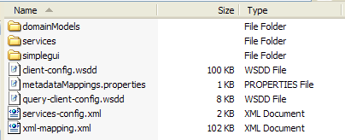
The directory should be as follows:

If for any reason these files become corrupted, simply delete this folder. On the next visit to the URL the application will download the files again.

Appendix I caTRIP Components
The caTRIP includes the following components:
  - Framework packages
- org.hibernate
  - Configuration files to enable you to customize your installation to meet your specific database, server, and other network needs
- deploy.properties
- SimpleGuiObjectGraph.xml
  - Ant buildfile
  - MySQL database creation scripts
  - Oracle database creation scripts

Contacting Technical Support
caTRIP Application Support | For Support post a message at:  catrip-training@gforge.nci.nih.gov

