Software Requirements Specification

Cancer Translational Research Informatics (caTRIP)
Scientific Use Cases
Duke Comprehensive Cancer Center

DOCUMENT REVISION HISTORY
Version Number | Date | Description
1.0 | June 21, 2006 | - Initial Draft

Background/Summary

Table of Content
Requirements Specification 1
Cancer Translational Research Informatics (caTRIP) Scientific Use Cases 1
Background/Summary 1
1 Introduction 4
2 System Use Cases 4
3 High-level Scientific Use Cases 4
3.1 Query Data Types 4
3.1.1 Use Case Model 4
3.1.2 Brief Description 4
3.1.3 Primary Actor 5
3.1.4 Secondary Actors 5
3.1.5 Preconditions 5
3.1.6 Basic Flow of Events 5
3.1.7 Alternative Flows 5
3.1.8 Postconditions 5
3.1.9 Special Requirements 5
3.2 Query Models 5
3.2.1 Use Case Model 5
3.2.2 Brief Description 5
3.2.3 Primary Actor 6
3.2.4 Secondary Actors 6
3.2.5 Preconditions 6
3.2.6 Basic Flow of Events 6
3.2.7 Alternative Flows 6
3.2.8 Postconditions 6
3.2.9 Special Requirements 6
3.3 Query Databases 6
3.3.1 Use Case Model 6
3.3.2 Brief Description 6
3.3.3 Primary Actor 7
3.3.4 Secondary Actors 7
3.3.5 Preconditions 7
3.3.6 Basic Flow of Events 7
3.3.7 Alternative Flows 7
3.3.8 Postconditions 7
3.3.9 Special Requirements 7
3.4 Query Datasets 7
3.4.1 Use Case Model 7
3.4.2 Brief Description 8
3.4.3 Primary Actor 8
3.4.4 Secondary Actors 8
3.4.5 Preconditions 8
3.4.6 Basic Flow of Events 8
3.4.7 Alternative Flows 8
3.4.8 Postconditions 8
3.4.9 Special Requirements 8
4 Specific Scientific Use Cases 8
5 Overall Requirements 9
5.1 System Requirements Prioritization 9
5.2 High-level Scientific Requirements Prioritization 9
5.3 Specific Scientific Requirements Prioritization 9
6 Data Definitions 9
7 Sign Off 10
7.1 Approval 10

Introduction

System Use Cases

High-level Scientific Use Cases
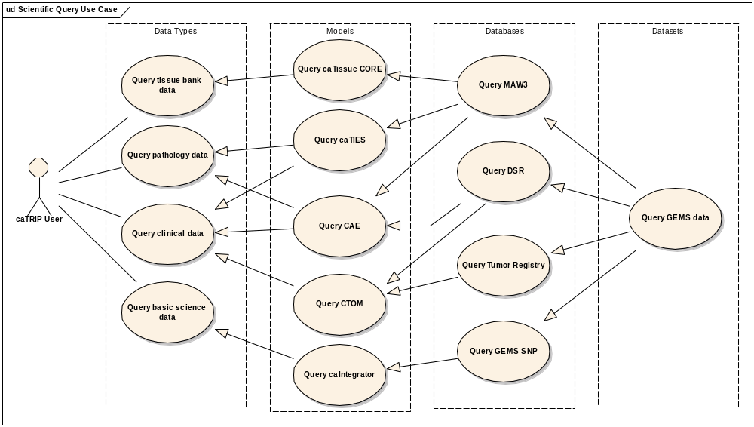

Query Data Types

Use Case Model
See above.

Brief Description
In this use case, a user has the ability to query the spectrum of datatypes exposed in caTRIP.

Primary Actor
caTRIP User

Secondary Actors
None

Preconditions
None

Basic Flow of Events
- The user logs into the caTRIP system.
- The user is presented with a number of services that provide tissue banking, pathology, clinical, and basic science data.
- The user is able to query those services and retrieve data of the particular type he is interested in.

Alternative Flows
None

Postconditions
None

Special Requirements
None

Query Models

Use Case Model
See above.

Brief Description
In this use case, a user has the ability to query a number of caBIG data models exposed in caTRIP.

Primary Actor
caTRIP User

Secondary Actors
None

Preconditions
None

Basic Flow of Events
- The user logs into the caTRIP system.
- The user is presented with a number of services that provide access to the caTissue CORE, caTIES, CAE, CTOM, and caIntegrator data models.
- The user is able to query those services and retrieve CDE-based data of the particular type he is interested in.

Alternative Flows
None

Postconditions
None

Special Requirements
None

Query Databases

Use Case Model
See above.

Brief Description
In this use case, a user has the ability to query a number of Duke databases that are exposed by one or more caBIG data models in caTRIP.

Primary Actor
caTRIP User

Secondary Actors
None

Preconditions
None

Basic Flow of Events
- The user logs into the caTRIP system.
- The user is presented with a number of services that provide access to a variety of caBIG data models that wrap the MAW3, DSR, Tumor Registry, and GEMS SNP databases.
- The user is able to query those services and retrieve CDE-based data that is materialized from the Duke databases.

Alternative Flows
None

Postconditions
None

Special Requirements
None

Query Datasets

Use Case Model
See above.

Brief Description
In this use case, a user has the ability to query a Duke dataset that has data spread across a number of Duke databases that are, in turn, wrapped with caBIG data models.

Primary Actor
caTRIP User

Secondary Actors
None

Preconditions
None

Basic Flow of Events
- The user logs into the caTRIP system.
- The user is presented with a number of services that provide access to a variety of caBIG data models that wrap Duke databases.
- The user is able to query those services and retrieve CDE-based data that is materialized from a dataset with data in the Duke databases.

Alternative Flows
None

Postconditions
None

Special Requirements
None

Specific Scientific Use Cases
This section will be informed by domain experts at Duke. It will be filled in during month 3 for the final requirements and specifications document.

Overall Requirements

System Requirements Prioritization

High-level Scientific Requirements Prioritization
Priority | Use Case Name | Supp Requirement Ref #
1 | Query Data Types
1 | Query Models
2 | Query Databases
3 | Query Datasets

Specific Scientific Requirements Prioritization
This section will be informed by domain experts at Duke. It will be filled in during month 3 for the final requirements and specifications document.

Data Definitions
CDE – Common Data Element.

Sign Off

Approval

Workspace General Contractor Rep Print Name Date
Architecture Workspace Rep Print Name Date
VCDE Workspace Rep Print Name Date
Workspace Working Group Rep Print Name Date
NCICB Rep Print Name Date

