caTRIP
Translational Research Informatics Platform
Title of Publication

Installation Guide

caBIG™ is an initiative of the National Cancer Institute, NIH, DHHS
Table of Contents

Introduction 1
Overview of caTRIP 1
caTRIP Minimal System Requirements 1
Minimal System Requirements 1
caTRIP Software and Technology Requirements 2
Software Requirements 2
Required Software—Not Included in caTRIP 2
Installing caTRIP 4
Preliminary Considerations 4
Installing Prerequisites 4
Downloading caTRIP 6
Installing the Components 6
Database setup 7
Web Services 7
Hibernate Configuration Files 8
caTRIP Configuration Files 10
Testing the Application 10
Creating a Webstart Application 11
Running the Application 11
Executing Tests 13
Appendix I {product} Components 14
Contacting Technical Support 14
caTRIP Application Support 14

Introduction
This manual is intended as a guide for system administrators attempting to install caTRIP at their organization. It describes the installation process, and various configuration options. It assumes prior understanding of what caTRIP is, and what it is trying to do. A brief introduction of caTRIP is included in the following section, however we recommend that you read the Requirements specification and Design specification documents found at the caTRIP website at https://gforge.nci.nih.gov/projects/catrip/

Overview of caTRIP | In order to have an impact in society, discoveries in cancer research need to be translated into knowledge that can be directly applied to treatment and prevention. These discoveries usually start within the basic sciences, from experiments developed at the molecular level, slowly progressing to clinical research. Although this translational process is at the very basis of our ability to generate new biomedical knowledge, to date few tools have been developed to successfully link the basic and clinical science fields in a way so that researchers from both arenas can easily make connections between the two. More specifically, cancer research would benefit from the development of applications that could aggregate clinical and molecular data in a repository that is user-friendly, easily accessible, as well as compliant with regulatory requirements of privacy and security.  In line with the requirements outlined above, the Duke Comprehensive Cancer Center, in collaboration with SemanticBits LLC, has developed the Cancer Translational Research Informatics Platform, a translational research system for the Cancer Biomedical Informatics Grid (caBIG) project. caTRIP allows users to query across a number of caBIG data services, join on common data elements (CDEs), and view their results in a user-friendly interface. Having as its initial focus the enabling of outcomes analysis, caTRIP allows clinicians to query across data from existing patients with similar characteristics to find treatments that were administered with success. In doing so, caTRIP can help inform treatment and improve patient care, as well as enable the searching of available tumor tissue, locating patients for clinical trials, and investigating the association between multiple predictors and their corresponding outcomes such as survival. Of importance, caTRIP relies on the vast array of open source caBIG applications, including (1) Tumor Registry, a clinical system that is used to collect endpoint data; (2) the cancer Text Information Extraction System (caTIES, https://cabig.nci.nih.gov/tools/caties), a locator of tissue resources that works via the extraction of clinical information from free text surgical pathology reports while using controlled terminologies to populate caBIG-compliant data structures; (3) caTissue CORE ( https://cabig.nci.nih.gov/tools/catissuecore), a tissue bank repository tool for biospecimen inventory, tracking, and basic annotation; (4) Cancer Annotation Engine (CAE) ( https://cabig.nci.nih.gov/tools/cae), a system for storing and searching pathology annotations; (5) caIntegrator ( http://gforge.nci.nih.gov/projects/caintegrator/), a tool for storing, querying, and analyzing translational data, including SNP data.

caTRIP Minimal System Requirements

Minimal System Requirements | - Internet connection  - Server specs listed in Table 1
The caTRIP has been tested on the platforms shown in Table 1 .

 | Linux Server | Windows
Model | HP Proliant ML 330 | Dell GX 270
CPU | 1 x Intel® Xeon™ Processor 2.80GHz | 1 x Intel® Pentium™ Processor 2.80GHz
Memory | 4 GB | 1 GB
Local Disk | System 2 x 36GB  (RAID 1)  Data = 2 x 146 (RAID 1) | System 1 x 36GB
OS | Red Hat Linux ES 3 (RPM 2.4.21-20.0.1) | Windows XP/2000 Professional
Table 1 Platform Testing Environment

caTRIP Software and Technology Requirements

Software Requirements
Required Software—Not Included in caTRIP | You must download and install the required software that is not included with caTRIP (listed in Table 2 .) The software name, version, description, and URL hyperlinks (for download) are indicated in the table.

(Required software that is included with the caTRIP is listed in Appendix I on page Error: Reference source not found.)
Software Name | Version | Description | URL
Java Software Development Kit (SDK):Java 2 Standard Edition (J2SE) | j2sdk1.5.2_06 or higher | The J2SE Software Development Kit (SDK) supports creating J2SE applications | http://java.sun.com/j2se/1.4.2/ download.html
Globus Toolkit | 4.0.3 | An open source software toolkit used for building Grid systems and applications | http://www.globus.org/toolkit/downloads/
Apache Tomcat | 5.0.28 | Apache Tomcat is an open source servlet container. | http://tomcat.apache.org/download-55.cgi
Apache Ant | 1.6 or higher | Apache Ant is a Java-based build tool | http://ant.apache.org/bindownload.cgi
Oracle Database | 9i or 10g | Oracle is a commercially-available, alternative relational database management system (RDBMS) | http://www.oracle.com/technology/products/oracle9i/index.html
MysSQL | 4.1 | Open source relational database | http://dev.mysql.com/downloads/
Table 2 Required software

Installing caTRIP

Preliminary Considerations
 | BEFORE YOU BEGIN | caTRIP has been tested with the operating systems and hardware specified on pages 2 through 3 of this guide. We cannot guarantee caTRIP will work If you are using variations of these operating systems and/or hardware.

Installing Prerequisites
Step | Action
1 | Jakarta Ant - Extract the contents of the Ant zip file, apache-ant-1.6.2-bin.zip and save it to your computer. For example, if your root directory in Windows is C:\, then extract your Ant home directory to C:\apache-ant-1.6.2.
2 | Java JRE - Download version 1.5 or higher and install it to a desired location e.g. C:\jdk1.5.0_06.
3 | Verify that the environment variables ANT_HOME and JAVA_HOME are set and that your PATH statement includes the locations of the Ant and Java binaries. For example, PATH should include C:\apache-ant-1.6.2\bin; C:\ jdk1.5.0_06\bin.  To do this in Windows:  - Select My Computer > Properties (from the shortcut menu) > Advanced tab.  - Click the Environment_Variables... button.  - ANT_HOME and JAVA_HOME must each be listed in one or the other of the panels of the dialog box. To add either, below one of the panels, click the New button.  - In the New User Variable dialog box, add the Variable and Variable Value.  Examples:  Variable = ANT_HOME; Variable Value = C:\apache-ant-1.6.2  Variable = JAVA_HOME; Variable Value = C:\ jdk1.5.0_06  - Verify that the PATH statement listed in the Environment Variables dialog box includes both the ANT_HOME and JAVA_HOME binaries and that they read as follows: C:\ jdk1.5.0_06\bin;C:\apache-ant-1.6.2\bin. (To easily review these, copy them to a text editor.) If necessary, click the Edit button and enter the correct information.
4 | Tomcat Installation – extract the zip file to the c:\ drive. After unzipping add the variable CATALINA_HOME = <your tomcat home> e.g.  CATALINA_HOME = c:\ tomcat_cagrid_5.0.28
- 88  5 | Globus installation – extract the zip file to the c:\ drive.  Add the environment variable GLOBUS_HOME=c:\<globus location> for example:  GLOBUS_LOCATION = c:\ ws-core-4.0.3  Next install the Globus container into Tomcat. Change to the globus directory c:\<globus location>\ . To install the container run the following:  ant -f share\globus_wsrf_common\tomcat\tomcat.xml deployTomcat -Dtomcat.dir="<tomcat location>"  Output of the Globus installation:  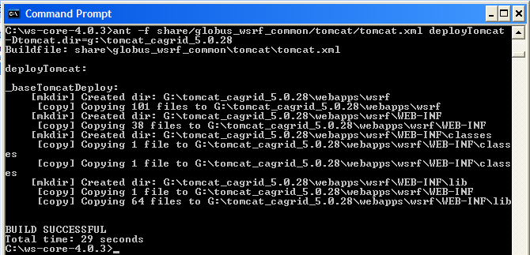  The Globus installation will add a new directory ‘wsrf’ in the Tomcat directory under ‘webapps’  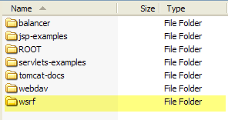
6 | Download and install MySQL 4.1 to a desired location e.g. c:\mysql4.1  http://dev.mysql.com/downloads/
7 | Download and install Oracle 9i or 10g to a desired location e.g. c:\oracle  http://www.oracle.com/technology/products/oracle9i/index.html

Downloading caTRIP
 | SUGGESTION | To best understand the installation and testing procedures for the caTRIP, it is recommended that you follow the procedures described in this section with minimal deviation.
Complete the following steps to download caTRIP;

Step | Action
1 | Go to the {appropriate term} download web site (add URL).
3 | Select caTRIP and agree to the software license by selecting Checking this box indicates that you agree to the above terms.
4 | Under Source Distribution, select the appropriate file for your platform (Windows or Unix/Linux) and save it to a temporary directory on your computer (for example, C:\temp in Windows). This may take several minutes.
5 | Extract the contents of the caTRIP distribution zip file to your root directory. For example, if your root directory in Windows is C:\, then your caTRIP home directory is C:\caTRIP.  Note: This directory name cannot contain any spaces or this will cause errors in Windows. For instance, do not place the caTRIP directory in the Program Files directory.

Installing the Components
After downloading and unzipping caTRIP the following components need to be edited or installed:

- Install Oracle and MySQL databases
- Install Web Services
- Edit Hibernate configuration files
- Edit caTRIP Configuration Files

Database setup
Database scripts for both Oracle and MySQL are available to create the user and schemas. All sql scripts can be found in the directory /sqlscripts.
(NEED TO CREATE THESE SCRIPTS)

File Name | Description
Tumor_registry_oracle_creation.sql | This file contains SQL statements that can be used to create the user and database for the Tumor Registry database in Oracle
CAE_oracle_creation.sql | This file contains SQL statements that can be used to create the user and database for Clinical Annotations Engine (CAE) database in Oracle
CGEMS_oracle_creation.sql | This file contains SQL statements that can be used to create the user and database for Cancer Genetic Markers of Susceptibility (CGEMS) database in Oracle
Query_share_oracle_creation.sql | This file contains SQL statements that can be used to create the user and database for the query sharing database in Oracle
Catissuecore_mysql_creation.sql | This file contains SQL statements that can be used to create the user and database for caTIssueCore database in MySQL
caties_mysql_creation.sql | This file contains SQL statements that can be used to create the user and database for Text Information Extraction System (caTIES) database in MySQL

Web Services

After the databases have been installed it is time to create the caTRIP services. The services will be deployed to Tomcat in the Globus directory wsrf\WEB-INF\etc.

Step | Action
1 | Go to where caTRIP was download and unzipped and change to the codebase directory.  <catrip directory>\codebase
2 | Run the Ant task ‘clean’ to clean appropriate directories. Run the following from the codebase directory:  ant clean
- 3  3 | Run the Ant task ‘all’ to compile all the code. Run the following from the codebase directory:  ant all
4 | Run the Ant task ‘deployTomcat’ to deploy the services to Tomcat. Run the following from the codebase directory:  ant deployTomcat  Note: Each service can be installed separately by running the same ant task within the service’s folder.
5 | After all Ant tasks are complete, you can check if the services got deployed by checking the following directory in Tomcat.  C:\<tomcat install dir>\webapps\wsrf\WEB-INF\etc  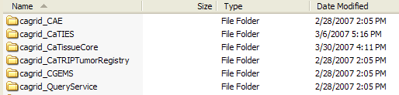

Hibernate Configuration Files

Once the services are installed, the Hibernate configuration files need to be update with your database information. Each service has a jar file which contains the Hibernate file to be updated.

Step | Action
1 | Go to the directory where Tomcat was installed. Change to the directory:  <tomcat dir>\webapps\wsrf\WEB-INF\lib  Here is where you will find the jar files to be updated
2 | Listed here are the services which use an Oracle database. See the next step for what lines to edit inside the hibernate configuration file.  Query service :  jar file: _queryservice.jar. hibernate file : hibernate.cfg.xml  CAE Service:  jar file: cae_domain.jar hibernate file : cae-hibernate.cfg.xml  CGEMS Service:  jar file: cgems-domain.jar hibernate file : cgems-hibernate.cfg.xml  Tumor Registry Service:  jar file: tumor_registry-domain.jar hibernate file : tumor-hibernate.cfg.xml
- 3  3 | Edit the following highlighted areas with your Oracle database information:  Connection URL:  <property name="connection.url">jdbc:oracle:thin:@localhost:1522:{service name}</property>  Connection Username :  <property name="connection.username">username</property>  Connection Password :  <property name="connection.password">password</property>
4 | Listed here are the services which use an MySQL database. See the next step for what lines to edit inside the hibernate configuration file.  caTIES Service:  jar file: caties-domain.jar hibernate file : caties-hibernate.cfg.xml caTissueCore Service:  jar file: catissuecore-domain.jar hibernate file : catissue-hibernate.cfg.xml
- 3  5 | Edit the following highlighted areas with your MySQL database information:  Connection URL :  <property name="connection.url">jdbc:mysql://localhost:3306/caties_ctrm</property>  Connection Username :  <property name="connection.username">username</property>  Connection Password :  <property name="connection.password">password</property>

caTRIP Configuration Files
Now the databases and web service are installed with the Hibernate files up to date, it is time to update some configuration files to point to the newly deployed web services.

Step | Action
1 | Go to where caTRIP was download and unzipped and change to the gui directory.  <catrip directory>\codebase\projects\gui
2 | Edit the build.properties file to set the location of the query service. This will be where your Tomcat is installed  query.sharing.url=http://localhost:8181/wsrf/services/cagrid/QueryService
- 3  3 | Now switch to the conf directory under gui:  <catrip directory>\codebase\projects\gui\conf  Here is where the service-config.xml file is located. The location of each service is set in this file.  The ipaddress of each service location needs to be changed to point to where your service is installed e.g. localhost.  <catripService url="http://152.16.96.114/wsrf/services/cagrid/CaTissueCore" serviceMetadataFileName="CaTissueCore_serviceMetadata.xml" domainModelFileName="caTissueCore_domainModel.xml"/>
- 3  4 | Next the simple gui interface configuration file needs to be update with the location of the services as well. Switch to the directory:  <catrip directory>\codebase\projects\gui\conf\simplegui  Here is where the SimpleGuiObjectGraph.xml file is located. Search for the service tags (<service) and change the location of the services for the simple gui interface.  The ipaddress of each service location needs to be changed to point to where your service is installed e.g. localhost.  <service displayName="Tissue Bank" url=http://152.16.96.114/wsrf-0216/services/cagrid/CaTissueCore …

NOTE:   | See the caTRIP Administration Guide for a detailed explanation of the caTRIP configuration files.  https://gforge.nci.nih.gov/projects/catrip/

Testing the Application
At this point, everything is installed and we can test the application before bundling it into a Webstart application for others to use.

Step | Action
1 | Start Tomcat.  <tomcat directory>/bin/startup.bat
2 | Open a command window and change to the gui directory where caTRIP was installed  <catrip directory>/codebase/projects/gui  Execute the Ant task ‘run’  ant run  This will start the application.  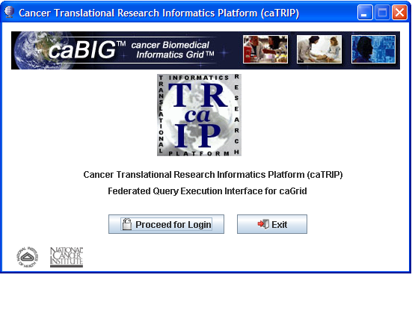
3 | From the splash screen press the ‘Proceed for Login’ button to move to the login screen  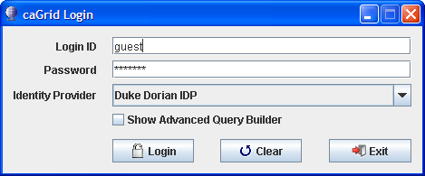
- 3  4 | From the login screen press ‘Login’ to continue to the simple qui interface.
- 3  5 | Press the Execute Query button. You will see all the data from the Tissue Bank data source.  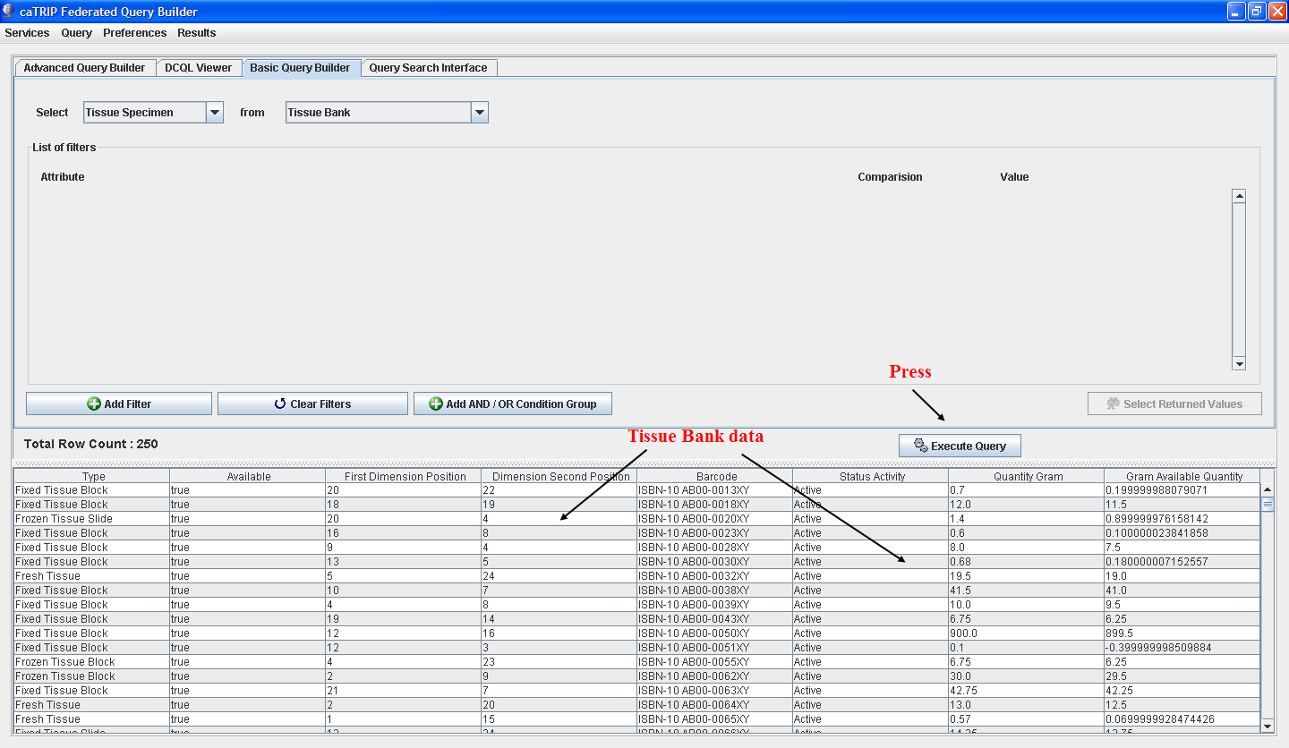
- 3  6 | See the User’s Guide on how to create queries.  User’s Guide can be found at : https://gforge.nci.nih.gov/projects/catrip/

Creating a Webstart Application
TBD

Security

TBD

Running the Application
After creating the Webstart application enter the URL in the browser. On your first visit the application will download some files to your computer in your home directory

Documents and Settings/<your name>/.catrip

If for any reason these files become corrupted, simply delete this folder. On the next visit to the URL the application will download the files again.

Executing Tests
Refer to the users guide for how to use the system
https://gforge.nci.nih.gov/projects/catrip/

Appendix I caTRIP Components
The caTRIP includes the following components:
  - Framework packages
- org.hibernate
  - Configuration files to enable you to customize your installation to meet your specific database, server, and other network needs
- deploy.properties
- SimpleGuiObjectGraph.xml
  - Ant buildfile
  - MySQL database creation scripts
  - Oracle database creation scripts

Contacting Technical Support
caTRIP Application Support | For Support post a message at:  catrip-training@gforge.nci.nih.gov

