caTRIP Alpha Domain Expert Feedback

Raj Dash as transcribed by Patrick McConnell

Alpha feedback
Visual query designer:
- Very flexible and powerful
- Should be able to meet all scientific use cases
- Good for a sophisticated user, but not for a clinician
- Need a simplified GUI with drop-down menus
- Simplified GUI will go through phases of refinement with clinician feedback
Infrastructure
- It seems all the fundamental infrastructure is in place

Recommendations for beta
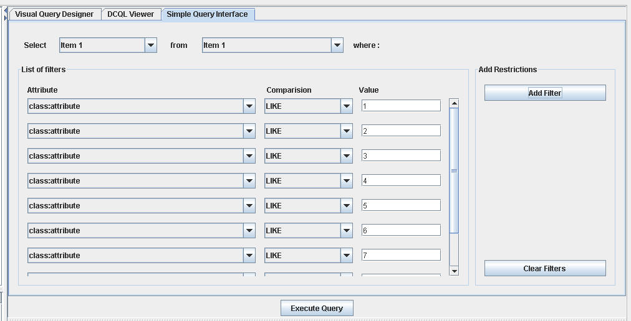
Simplified GUI
- Clinicians will not understand what CDEs are in which services
  - The program should be able to figure out what service to query based on:
    - What they are interested in having returned
    - The filter criteria
  - If the program cannot figure out (because ambiguous) then ask the user
  - The CDEs for filter criteria should be configurable
    - Pre-configured by file
    - File altered by GUI where checkboxes to for which to display
  - Saving queries is a very important use case (phase II is OK to implement)
    - This could be used to combine queries into ANDs and Ors
  - Grouping filters into AND/OR groups will be confusing to clinicians
  - It would be useful to remove the CDEs that a user does not have the permissions to view
  - There should be some audit trail capability, at least at the domain service level
    - This could be implemented at the grid level
    - Who issued the query, the actual query, and whether it returned should be listed in a database
    - Specialized software should not be necessary to view the audit trail (e.g. it could be stored in an Oracle database)
  - An example filter value would be helpful because a clinician will not necessarily know what LIKE means

