Data Description

caTRIP 1.0

Duke Comprehensive Cancer Center

Change log

When | Who | What
6/12/2006 | Patrick | First draft
11/2/2006 | Patrick | Adding details

Contents
1. Contents 3
2. Stakeholders 4
2.1. Duke Bioinformatics 4
2.2. Duke Information Systems 4
2.3. Duke Breast SPORE 4
2.4. Duke Health Technology Systems 4
2.5. Duke Department of Pathology 4
2.6. Semantic Bits 4
2.7. 5AM Solutions 4
3. Databases 5
3.1. MAW3 5
3.2. Tumor Registry 5
3.3. GEMS Illumina 5
3.4. DSR 5
4. Datasets/Studies 6
4.1. Breast SPORE 6
4.2. GEMS 6
5. caBIG Tools 7
5.1. caTissue CORE 7
5.2. CAE 7
5.3. caIntegrator CGEMS 7
5.4. Tumor Registry 8
6. Test datasets 9
6.1. Methodology 9
6.2. Datasets 9
7. Real datasets 10
7.1. caTissue CORE 10
7.2. Tumor Registry map 10
7.3. CAE map 10
7.4. caIntegrator CGEMS map 10
8. Exposure of real datasets 11
8.1. caTissue CORE 11
8.2. Tumor Registry 11
8.3. CAE 11
8.4. caIntegrator CGEMS 11

Stakeholders
This section calls out those involved in the caTRIP project from a data standpoint.

Duke Bioinformatics
A. Jamie Cuticchia: PI of caTRIP
Patrick McConnell: lead architect of caTRIP

Duke Information Systems
Bob Annechiarico: project manager of caTRIP
Mark Peedin: developer and data architect
Wilma Stanley: consultation on tumor registry

Duke Breast SPORE
Joellan Schildkraut: PI of GEMS project
Janet Grubber: statistician on GEMS project

Duke Health Technology Systems
Howard Shang: PI of DSR

Duke Department of Pathology
Raj Dash: pathologist and PI of MAW3
Chris Hubbard: lead architect of MAW3

Semantic Bits
Ram Chilukuri: leader developer of caTRIP
Srini Akkala: caTRIP developer
Sanjeev Agarwal: caTRIP developer

5AM Solutions
Bill Mason: caTRIP developer

Databases
This section describes the databases at Duke that will act as a source of data for the project.

MAW3
The Medical Assistant on the World Wide Web (MAW3) is an entity-centric database that houses tissue banking data, as well as pathology and other data associated with a number of studies at Duke. It has a web front-end that allows data entry and querying. The middle-tier consists of JavaScript services that perform data manipulation and querying. The backend is a SQLServer database.

Tumor Registry
The Tumor Registry is provided by a commercial system by Impac called MRS and stores endpoint data since 1980. It is a relational database housed in SQLServer. The general datatypes include patient information, diagnoses, treatment, follow-up, recurrence, and staging.

GEMS Illumina
SNP data from a custom Illumina array will be collected for the GEMS project. The data will be provided in standard Illumina comma delimited files.

DSR
The Decision Support Repository (DSR) is a relational style data warehouse that houses data collected from a number of different groups across Duke Health Systems. This data consists of clinical, pathology, billing, and financial. It is mined using a number of different commercial tools. The use of the DSR in caTRIP is uncertain.

Datasets/Studies
This sections describes the datasets that will populate the databases.

Breast SPORE
The Duke Breast SPORE consists of five research projects and an ongoing developmental research project representing the translational components of five major research programs within the Duke Breast Cancer Research Program, four cores, a career development and a research development program are proposed to further our translational research in breast cancer. The projects include:

"Hypoxia and Chemoresistance in Breast Cancer"
Project Leader: Mark Dewhirst, DVM, PhD
Co-Project Leader: Lawrence Marks, MD; David Brizel, MD

"T Helper Cell Responses to HER2/neu in Breast Cancer Patients"
Principal Investigator: H. Kim Lyerly, MD
Co-Investigators: Tim Clay, PhD; Michael Morse, MD

"Genetic Modifiers of BRCA1 and BRCA2"
Principle Investigator: Joellen Schildkraut, PhD
Co-Investigator: Edwin Iversen, PhD

"Application of Pharmacogenomics to the Treatment of Breast Cancer"
Principle Investigator: O. Michael Colvin, MD
Co-Investigator: Jeffrey Marks, PhD

Data for caTRIP will be taken from Duke Breast SPORE participants.

GEMS
The goal of the GEMS investigation is to identify factors that influence the incidence of breast cancer in germline BRCA1/2 mutation carriers. The focus of the proposed study is to examine whether genetic factors involved in the DNA damage and repair act as modifiers of BRCA1 and BRCA2. The hypotheses are supported by findings that BRCA1 and BRCA2 are associated with protein complexes involved in various aspects of genome surveillance and repair and two recent studies reporting an interaction between a RAD51 polymorphism and BRCA2. The team hypothesize that variants in the genes that encode proteins involved in DNA repair may interact with mutations in BRCA1 and BRCA2.

caBIG Tools
This sections describes the caBIG tools/databases that will house the datasets.

Tools Summary
caBIG Tool | Database | Dataset
caTissue CORE | MAW3 | Breast SPORE
CAE | MAW3 | Breast SPORE
caIntegrator CGEMS | Illumina SNP | GEMS
Tumor Registry | Tumor Registry | Breast SPORE

caTissue CORE
caTISSUE Core (Tissue Bank Repository Tool) is a common infrastructure intended to accelerate all aspects of cancer research, care and prevention that provides access to information about available tissues using a platform independent, simple UI (User Interface). This application is capable of detailed biospecimen tracking and will allow for the aggregation of data from all three Tissue Banks & Pathology Tools (TBPT) applications (caTIES, caTISSUE Core, and caTISSUE Clinical Annotation) in a future release. caTissue CORE will house the tissue banking data found in MAW3.

CAE
caTissue CORE (Tissue Bank Repository Tool) is a common infrastructure intended to accelerate all aspects of cancer research, care and prevention that provides access to information about available tissues using a platform independent, simple UI (User Interface). This application is capable of detailed biospecimen tracking and will allow for the aggregation of data from all three Tissue Banks & Pathology Tools (TBPT) applications (caTIES, caTISSUE Core, and caTISSUE Clinical Annotation) in a future release. caTissue CORE will house the tissue banking data found in MAW3.

caIntegrator CGEMS
Cancer Genetic Markers of Susceptibility (CGEMS) is a three-year initiative that will identify genetic alterations that make people susceptible to prostate and breast cancer. Scientists involved will use DNA available from five large studies of prostate cancer and five large studies of breast cancer to “scan” the genome for common genetic variations between patients who have these cancers and controls that do not have cancer. NCICB in collaboration with Division of Cancer Epidemiology and Genetics (DCEG), the NCI Core Genotyping Facility (CGF), and the NCI Office of Cancer Genomics (OCG) is helping develop the CGEMS data repository.

The caIntegrator version 1.0 addressed Rembrandt 1.0 and I-SPY portal version 0.5 use cases and was release in Jan 2006. The caIntegrator version 2.0 expands and updates the CG-OM to address Rembrandt version 1.5, I-SPY version 1.0 and CGEMS use cases as well as provides a caBIG compatible API. The framework leverages Java 2 Enterprise Edition, a hybrid star schema, caCORE SDK and various open source technologies.

Tumor Registry
The Tumor Registry database was modeled based upon the MRS database by Impac. Classes and attributes were gleaned from the handful of tables that store the underlying data. The Tumor Registry database is implemented in Oracle, with Hibernate APIs, as well as a grid service. Routines for extracting data from MRS and for loading the extract into the database are available.

Test datasets
This section describes the methodology for generating test datasets, as well as the volume and structure of the data. The datasets can be found at:

http://gforge.nci.nih.gov/plugins/scmcvs/cvsweb.php/catrip/documentation/data/phase1_test_data/?cvsroot=catrip

Methodology
Two types of test data were employed: fabricated data and real deidentified data. We “forced” the individual datasets to “match up” by synchronizing patient/participant medical record numbers across all the datasets. Because of this, even the real deidentified data should be considered test data when taken in context with the other datasets.

The fabricated data was constructed in three steps:

- Identify sample data

Various databases at Duke, on the internet, and at cancer center websites were inspected to find characteristic data for each CDE.

- Build input files

Input files for each CDE were constructed from the sample data. These files consisted of a variety of realistic values.

- Load data

Data from each file is randomly selected and assigned to the domain Java objects. Those objects are then loaded into the database using Hibernate APIs.

Datasets
The following table summarizes the test datasets created and employed for caTRIP 1.0 beta:
Test Dataset Summary
Database | Type | Platform | Patient Count
caTissue CORE | Fabricated | MySQL | 250
CAE | Fabricated | Oracle | 500
caIntegrator CGEMS | Partially Real | Oracle | 321
Tumor Registry | Real | Oracle | 5509
caTissue CORE | Real | Oracle | 853

The caTissue CORE and CAE datasets were fabricated using the methodology described above. The caIntegrator CGEMS data comes from the CGEMS project. It is partially real because it is real data, though the actual patients are fabricated with fabricated BRCA1/2 status. The Tumor Registry data is a subset of the real data found in the Tumor Registry database.

Real datasets
This section describes the real datasets exposed in the caTRIP system. They are deidentified and can be found at:

http://gforge.nci.nih.gov/plugins/scmcvs/cvsweb.php/catrip/documentation/data/phase1_real_data/?cvsroot=catrip

caTissue CORE
The Duke MAW3 database was mapped to a set of relational tables, which was then mapped to the caBIG caTissue CORE database. The mapping table can be found at:

http://gforge.nci.nih.gov/plugins/scmcvs/cvsweb.php/catrip/documentation/data/phase1_real_data/caTissueCORE_map.xls?cvsroot=catrip

Tumor Registry map
The Duke Tumor Registry database was mapped to a set of flat files, which was then mapped into the caBIG Tumor Registry database. The mapping table can be found at:

http://gforge.nci.nih.gov/plugins/scmcvs/cvsweb.php/catrip/documentation/data/phase1_real_data/TR_map.xls?cvsroot=catrip

CAE map
Not yet mapped

caIntegrator CGEMS map
Not yet mapped

Exposure of real datasets

caTissue CORE
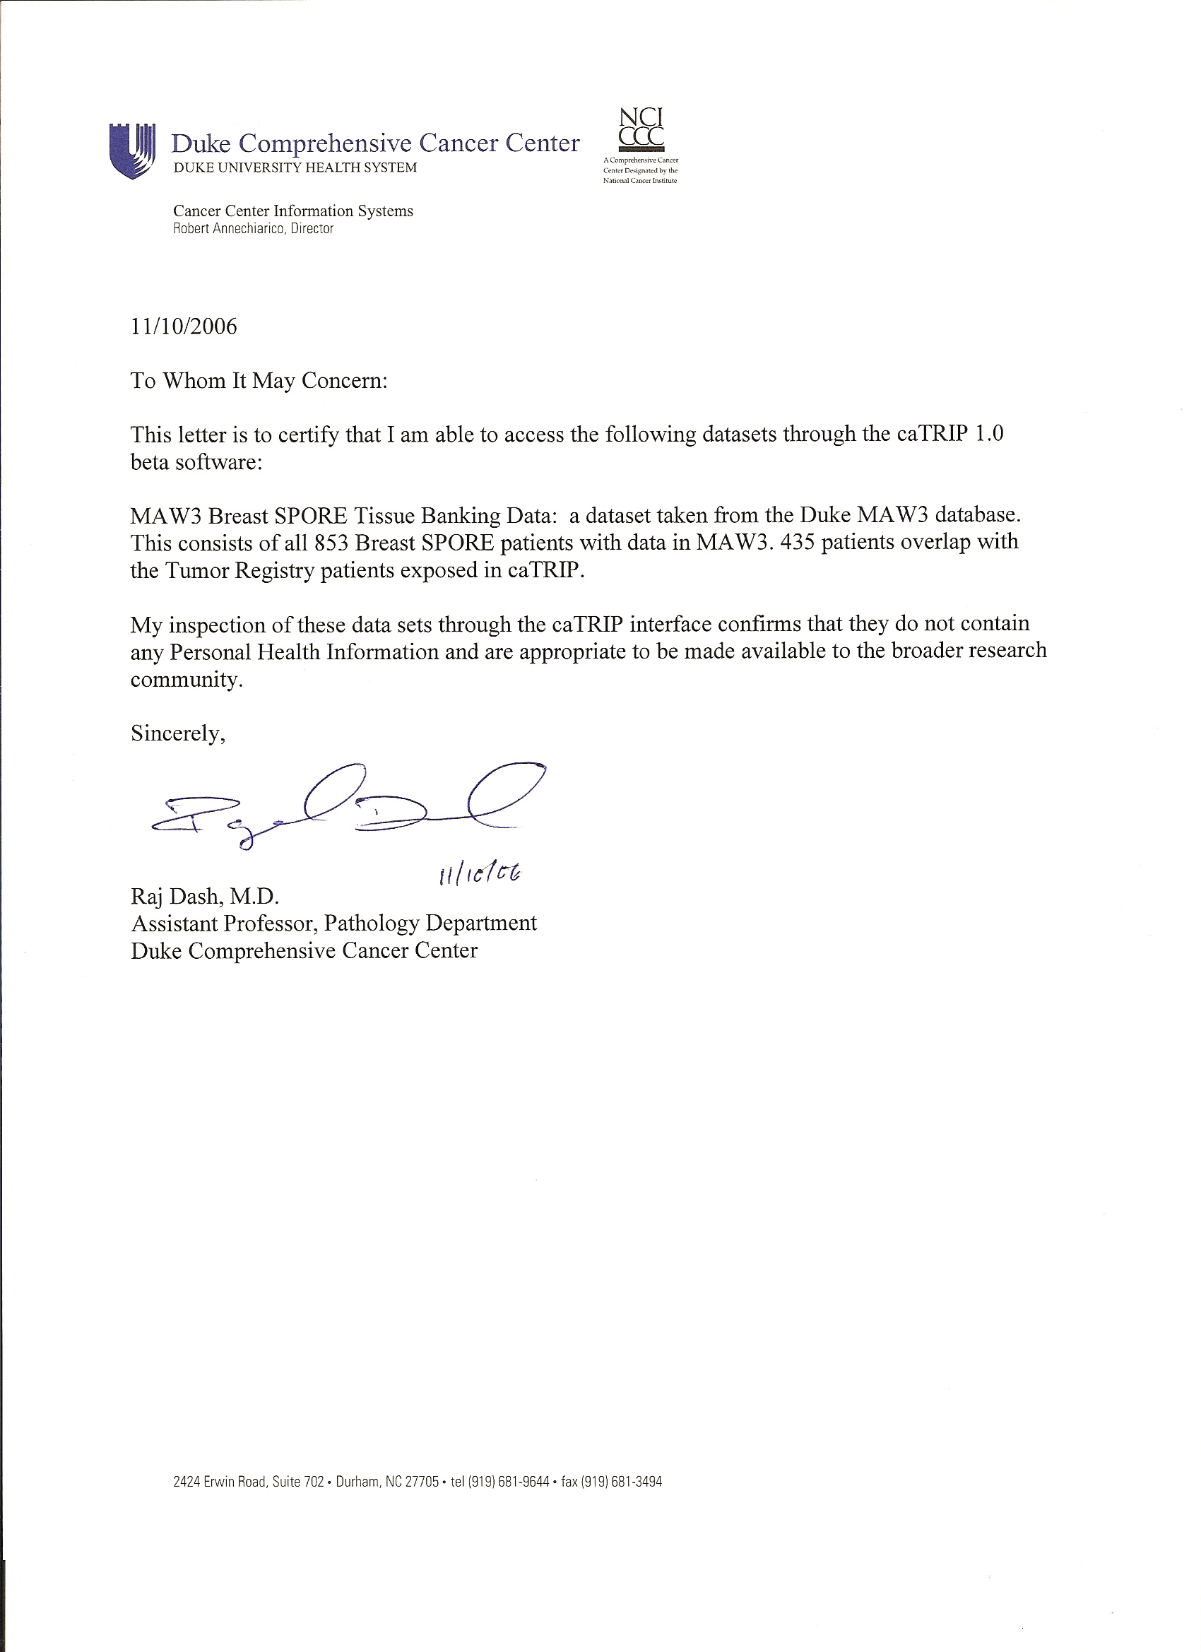

Tumor Registry

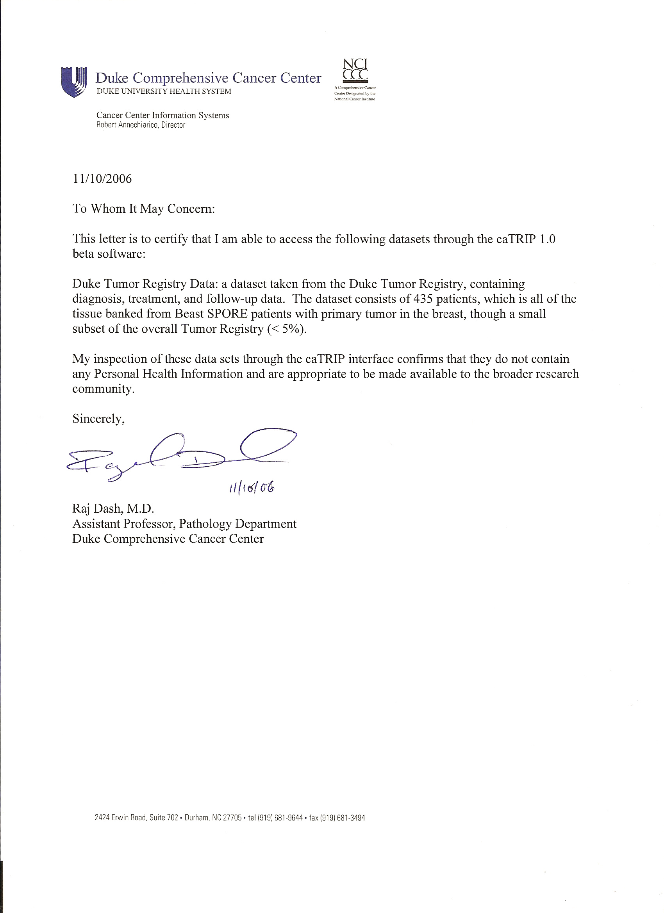

CAE
CAE data has been extracted from MAW3. Access in caTRIP is pending final review by Raj Dash.
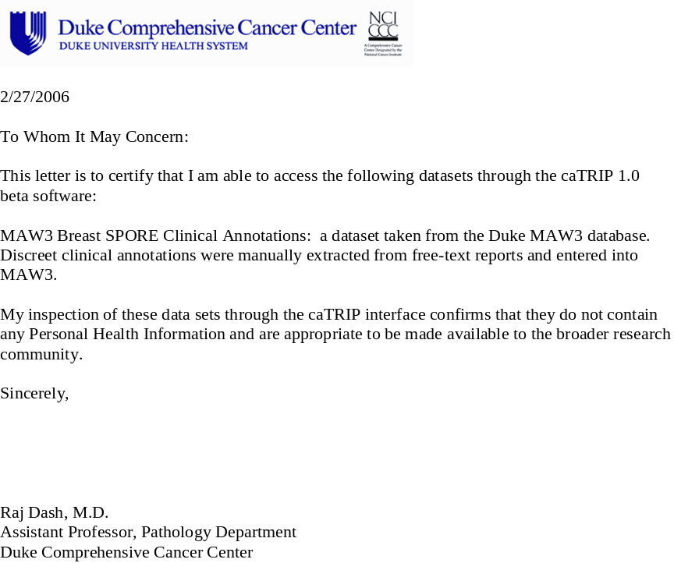

caIntegrator CGEMS
caIntegrator data has been extracted from the GEMS study. Access in caTRIP is pending final review by Raj Dash.

