caTRIP
End User Manual

Duke Comprehensive Cancer Center

Document Change History
Version Number | Date | Contributor | Description
0.1 | 4/2/2007 | Bill Mason | First Draft
0.2 | 5/4/2007 | Bill Mason | Final Draft
1.0 | 5/23/2007 | Patrick McConnell | Final Release


Updated August 1, 2006

Copyright and License page

Copyright Notice. Copyright 2006 Duke Comprehensive Cancer Center (“caBIG™ Participant”). caTRIP was created with NCI funding and is part of the caBIG™ initiative. The software subject to this notice and license includes both human readable source code form and machine readable, binary, object code form (the “caBIG™ Software”).
This caBIG™ Software License (the “License”) is between caBIG™ Participant and You. “You (or “Your”) shall mean a person or an entity, and all other entities that control, are controlled by, or are under common control with the entity. “Control” for purposes of this definition means (i) the direct or indirect power to cause the direction or management of such entity, whether by contract or otherwise, or (ii) ownership of fifty percent (50%) or more of the outstanding shares, or (iii) beneficial ownership of such entity.
License. Provided that You agree to the conditions described below, caBIG™ Participant grants You a non-exclusive, worldwide, perpetual, fully-paid-up, no-charge, irrevocable, transferable and royalty-free right and license in its rights in the caBIG™ Software, including any copyright or patent rights therein that may be infringed by the making, using, selling, offering for sale, or importing of caBIG™ Software, to (i) use, install, access, operate, execute, reproduce, copy, modify, translate, market, publicly display, publicly perform, and prepare derivative works of the caBIG™ Software; (ii) make, have made, use, practice, sell, and offer for sale, and/or otherwise dispose of caBIG™ Software (or portions thereof); (iii) distribute and have distributed to and by third parties the caBIG™ Software and any modifications and derivative works thereof; and (iv) sublicense the foregoing rights set out in (i), (ii) and (iii) to third parties, including the right to license such rights to further third parties. For sake of clarity, and not by way of limitation, caBIG™ Participant shall have no right of accounting or right of payment from You or Your sublicensees for the rights granted under this License. This License is granted at no charge to You. Your downloading, copying, modifying, displaying, distributing or use of caBIG™ Software constitutes acceptance of all of the terms and conditions of this Agreement. If you do not agree to such terms and conditions, you have no right to download, copy, modify, display, distribute or use the caBIG™ Software.
- Your redistributions of the source code for the caBIG™ Software must retain the above copyright notice, this list of conditions and the disclaimer and limitation of liability of Article 6 below. Your redistributions in object code form must reproduce the above copyright notice, this list of conditions and the disclaimer of Article 6 in the documentation and/or other materials provided with the distribution, if any.
- Your end-user documentation included with the redistribution, if any, must include the following acknowledgment: “This product includes software developed by Duke Comprehensive Cancer Center.” If You do not include such end-user documentation, You shall include this acknowledgment in the caBIG™ Software itself, wherever such third-party acknowledgments normally appear.
- You may not use the names “Duke Comprehensive Cancer Center”, “The National Cancer Institute”, “NCI”, “Cancer Bioinformatics Grid” or “caBIG™” to endorse or promote products derived from this caBIG™ Software. This License does not authorize You to use any trademarks, service marks, trade names, logos or product names of either caBIG™ Participant, NCI or caBIG™, except as required to comply with the terms of this License.
- For sake of clarity, and not by way of limitation, You may incorporate this caBIG™ Software into Your proprietary programs and into any third party proprietary programs. However, if You incorporate the caBIG™ Software into third party proprietary programs, You agree that You are solely responsible for obtaining any permission from such third parties required to incorporate the caBIG™ Software into such third party proprietary programs and for informing Your sublicensees, including without limitation Your end-users, of their obligation to secure any required permissions from such third parties before incorporating the caBIG™ Software into such third party proprietary software programs. In the event that You fail to obtain such permissions, You agree to indemnify caBIG™ Participant for any claims against caBIG™ Participant by such third parties, except to the extent prohibited by law, resulting from Your failure to obtain such permissions.
- For sake of clarity, and not by way of limitation, You may add Your own copyright statement to Your modifications and to the derivative works, and You may provide additional or different license terms and conditions in Your sublicenses of modifications of the caBIG™ Software, or any derivative works of the caBIG™ Software as a whole, provided Your use, reproduction, and distribution of the Work otherwise complies with the conditions stated in this License.
- THIS caBIG™ SOFTWARE IS PROVIDED "AS IS" AND ANY EXPRESSED OR IMPLIED WARRANTIES (INCLUDING, BUT NOT LIMITED TO, THE IMPLIED WARRANTIES OF MERCHANTABILITY, NON-INFRINGEMENT AND FITNESS FOR A PARTICULAR PURPOSE) ARE DISCLAIMED. IN NO EVENT SHALL THE DUKE COMPREHENSIVE CANCER CENTER OR ITS AFFILIATES BE LIABLE FOR ANY DIRECT, INDIRECT, INCIDENTAL, SPECIAL, EXEMPLARY, OR CONSEQUENTIAL DAMAGES (INCLUDING, BUT NOT LIMITED TO, PROCUREMENT OF SUBSTITUTE GOODS OR SERVICES; LOSS OF USE, DATA, OR PROFITS; OR BUSINESS INTERRUPTION) HOWEVER CAUSED AND ON ANY THEORY OF LIABILITY, WHETHER IN CONTRACT, STRICT LIABILITY, OR TORT (INCLUDING NEGLIGENCE OR OTHERWISE) ARISING IN ANY WAY OUT OF THE USE OF THIS caBIG™ SOFTWARE, EVEN IF ADVISED OF THE POSSIBILITY OF SUCH DAMAGE.

Development Team
Development | User’s Guide | Program Management
Patrick McConnell¹ | Patrick McConnell¹ | Jamie Cuticchia¹
Ram Chilukuri² |  | Bob Annechiarico¹
Srini Akkala² |  | Patrick McConnell¹
Bill Mason³ |  | Ram Chilukuri²
Sanjeev Agarwal²
Mark Peedin¹
Christopher Hubbard¹
¹Duke Comprehensive Cancer Center
²Semantic Bits
³5AM Solutions

Contacts and Support
Enter training contact | catrip-training@gforge.nci.nih.gov

LISTSERV Facilities Pertinent to software teams
LISTSERV | URL | Name
catrip-users | catrip-users@gforge.nci.nih.gov | caTRIP Users Forum
catrip-general | catrip-general@gforge.nci.nih.gov | caTRIP General Forum
catrip-developers | catrip-developers@gforge.nci.nih.gov | caTRIP Developers Forum

Table of Contents

Chapter 1 Introduction to the Manual 3
Overview of caTRIP Functionality 3
Users of caTRIP 4
Organization of the User Guide 4
Document Text Conventions 5
Chapter 2 Logging in 9
Security 9
Launching caTRIP 9
Logging into caTRIP 9
Chapter 3 Using the Basic Query Builder 11
Introduction to the Basic Query Builder 11
Creating a Query in the Basic Query Builder 12
Problem Statement 12
Select Target Data Element and Initial Data Source 12
Adding Filters 13
Run the Query 14
Using AND/OR Grouping 14
Problem Statement 14
Adding Return values to the Query 16
Return Value Dialog 16
Adding Return Values 16
Query Results 16
Chapter 4 Using the Advanced Query Builder 18
Building queries in the Advanced Query Builder 18
Login 18
Selecting Your Data Sourcess 18
Problem Statement: 19
The Canvas 20
Linking Objects 20
Adding Filters 21
Multiple Data Sources 22
Problem Statement: 22
Chapter 5 Using the Query Search Interface 26
Finding queries with the query search interface 26
Problem Statement 26
Saving a Query 27
Executing the Query 28
Searching for queries using filters 28
Adding Query Filters 28
Chapter 6 Export Query Results 30
Chapter 7 DCQL Viewer 32
What is it? 32
What can I do with it? 32
Chapter 8 Example Queries 35
Find available tumor tissue 35
Find factors of survival 37
Find patients for trials 38
Chapter 9 Error Messages/Indicators and Problem Resolutions 41
Description and interpretation of error messages 41
Chapter 10 Limitations 43
Joins 43
Grouping Filters of Foreign Data Sources 43
Query views 43
Query Search View Button 43
Appendix A Overview of the Software 44
Software Overview 44
Components of the Software 45
Appendix B References 48
Technical Manuals/Articles 48
Scientific Publications 48
caBIG Material 48
caCORE Material 48
Appendix C Glossary 49
Index 51

Introduction to the Manual
This User Manual was created to provide users of the cancer Translational Research Informatics Platform (caTRIP) with information on how to create, save, and run queries to perform outcome analysis against clinical, pathology and basic science data across the cancer Biomedical Informatics Grid (caBIG).
Topics in this chapter include:
- Overview of caTRIP Functionality
- Users of caTRIP
- Organization of the User's Manual
- Document Text Conventions

Overview of caTRIP Functionality

In order to have an impact in society, discoveries in cancer research need to be translated into knowledge that can be directly applied to treatment and prevention. These discoveries usually start within the basic sciences, from experiments developed at the molecular level, slowly progressing to clinical research. Although this translational process is at the very basis of our ability to generate new biomedical knowledge, to date few tools have been developed to successfully link the basic and clinical science fields in a way so that researchers from both arenas can easily make connections between the two. More specifically, cancer research would benefit from the development of applications that could aggregate clinical and molecular data in a repository that is user-friendly, easily accessible, as well as compliant with regulatory requirements of privacy and security.
In line with the requirements outlined above, the Duke Comprehensive Cancer Center, in collaboration with SemanticBits LLC, has developed the Cancer Translational Research Informatics Platform, a translational research system for the Cancer Biomedical Informatics Grid (caBIG) project. caTRIP allows users to query across a number of caBIG data services, join on common data elements (CDEs), and view their results in a user-friendly interface. Having as its initial focus the enabling of outcomes analysis, caTRIP allows clinicians to query across data from existing patients with similar characteristics to find treatments that were administered with success. In doing so, caTRIP can help inform treatment and improve patient care, as well as enable the searching of available tumor tissue, locating patients for clinical trials, and investigating the association between multiple predictors and their corresponding outcomes such as survival. Of importance, caTRIP relies on the vast array of open source caBIG applications, including (1) Tumor Registry, a clinical system that is used to collect endpoint data; (2) the cancer Text Information Extraction System (caTIES, https://cabig.nci.nih.gov/tools/caties), a locator of tissue resources that works via the extraction of clinical information from free text surgical pathology reports while using controlled terminologies to populate caBIG-compliant data structures; (3) caTissue CORE ( https://cabig.nci.nih.gov/tools/catissuecore), a tissue bank repository tool for biospecimen inventory, tracking, and basic annotation; (4) Cancer Annotation Engine (CAE) ( https://cabig.nci.nih.gov/tools/cae), a system for storing and searching pathology annotations; (5) caIntegrator ( http://gforge.nci.nih.gov/projects/caintegrator/), a tool for storing, querying, and analyzing translational data, including SNP data.
More information about caTRIP can be found at:
- The caTRIP GForge site: http://gforge.nci.nih.gov/projects/catrip/
- The caTRIP Wiki: http://gforge.nci.nih.gov/plugins/wiki/index.php?id=131&type=g
caTRIP is aiming for caBIG silver-level compatibility, as well as caBIG grid compatibility. Currently, the guidelines and review process for gold-level compatibility are not defined well enough to claim gold-level compliance.

Users of caTRIP
Medical doctors and clinicians that need to access data records pertaining to information on patients on clinical trials and their survival, surgery and treatment, to help them make treatment decisions for their patients. Helpful if the caTRIP user has a basic understanding of querying relational databases but not necessary.

Organization of the User Guide
Chapter in caTRIP User Manual | Chapter Contents
Chapter 1 | Introduction to the User Manual: This chapter orients the first time user to what is contained within the manual as well as provides a brief background of the software.
Chapter 2 | Overview of the Software: This chapter gives a fairly high level overview of the application. It gives context for the problem that the application has been created to solve; components of the software, the features and functions of the application itself. Also a general orientation to the look and feel of the application's user interface (UI). Included are overviews Advanced Query Builder, the Query Search Interface and the Query Search interface as well as how to navigate through the UI.
Chapter 3 | Logging In: This chapter gives an explanation of how to launch the application as well as how to log in.
Chapter 4 | Using the Basic Query Builder: This chapter gives a detailed orientation to the look and feel and describes how to use the interface by building an example query.
Chapter 5 | Using the Advanced Query Builder: This chapter gives a detailed orientation to the look and feel and describes how to use this drag and drop interface by building an example query.
Chapter 6 | Using the Query Search Interface: This chapter gives a detailed orientation to the look and feel and describes how to find queries stored by other users.
Chapter 7 | Export Query Results: This chapter describes how to export your search results to Excel, HTML and Comma Separated Values (CSV) formats.
Chapter 8 | DCQL Viewer: This chapter takes a look at the what caTRIP is building behind the scenes as a query is constructed from the GUI.
Chapter 9 | Example Queries: This chapter describes example queries a user would create. Each example is described with detailed step by step instructions.
Chapter 10 | Error Messages/Indicators and Problem Resolutions: This chapter addresses the common error messages a typical user might encounter and how to resolve the problem underlying the message.
Chapter 11 | Unsupported Features: This chapter details the features not mplemented in the release.
Chapter 12 | Glossary/Acronyms/Abbreviations: This appendix lists terms along with their definitions.
Appendix A | References: This appendix lists documents that were referred to in order to create this manual.
Appendix B | caTRIP: How to Search: This appendix provides techniques for effectively searching when using caTRIP.
Index | Full Index

Document Text Conventions
The following table shows various typefaces to differentiate between regular text and menu commands, keyboard keys, and text that you type. This illustrates how conventions are represented in this guide.
Convention | Description | Example
Bold & Capitalized Command  Capitalized command > Capitalized command | Indicates a Menu command  Indicates Sequential Menu commands | Admin > Refresh
text in small caps | Keyboard key that you press | Press enter.
text in small caps + text in small caps | Keyboard keys that you press simultaneously | Press shift + ctrl and then release both.
Boldface type | Options that you select in dialog boxes or drop-down menus. Buttons or icons that you click. | In the Open dialog box, select the file and click the Open button.
Italics | Used to reference other documents, sections, figures, and tables. | caCORE Software Development Kit 1.0 Programmer’s Guide
Italic boldface type | Text that you type | In the New Subset text box, enter Proprietary Proteins.
Courier typestyle | Used for filenames, directory names, commands, file listings, source code examples and anything that would appear in a Java program, such as methods, variables, and classes. | URL_definition ::= url_string
Note: | Highlights a concept of particular interest | Note: This concept is used throughout the installation manual.
Table 1. 1 Document Conventions
Warning! | Highlights information of which you should be particularly aware. | Warning! Deleting an object will permanently delete it from the database.
{} | Curly brackets are used for replaceable items. | Replace {root directory} with its proper value such as c:\cabio

Logging in
Topics in this chapter include:
- Security
- Launching caTRIP
- Logging into caTRIP

Security
caTRIP supports NT authentication which is built on top of windows NT 4.0 authentication. Users can login with their NT user id and password.

Launching caTRIP
An administrator must have already installed caTRIP on the server before it can be accessed. You can get the link from your administrator. If there one is not setup you can access a full demo application here.
http://152.16.96.114/catrip-webstart/
Once you have the link, enter it into a browser to see the caTRIP webpage. Click the launch link to start the application. The first time you run the application it will have to download the required libraries and resources. Launching the application in subsequent sessions should load much more quickly.

Logging into caTRIP
When starting caTRIP the splash screen is displayed:
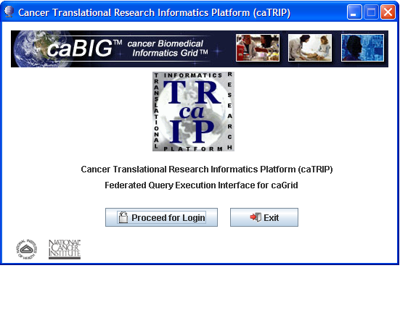
Click “Proceed for Login” and the login screen is displayed:

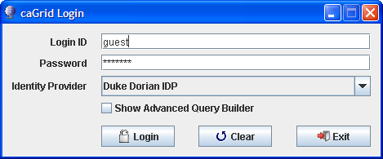
Do not select Show Visual Query Designer yet, it will be discussed in Using the Advanced Query Builder. Click Login to proceed to the Basic Query Builder which is described next. For the Duke training site you can use the guest login. If you have it installed at your institution then you will need to get a login from your Administrator.

Using the Basic Query Builder
Topics in this chapter include:
- Introduction to the Basic Query Builder
- Building an Example Query
- Using AND/OR Grouping
- Adding Return Values

Introduction to the Basic Query Builder
This interface allows you to build queries using drop-down menus. Data Sources, target data elements, and CDEs are pre-selected in a configuration file to simplify the interface. After logging in (see Chapter 3) this interface is displayed. Below is a quick summary of the interface elements.

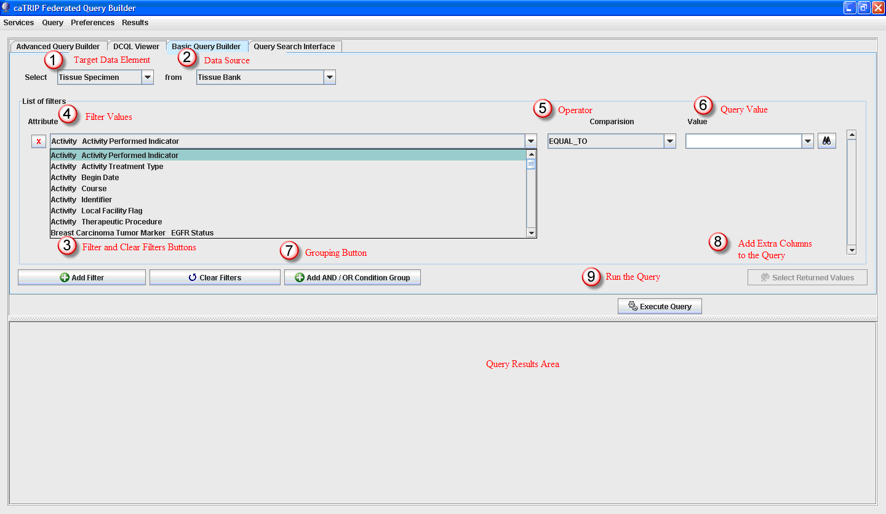
1. Target Data Elements– this will be the root of your query. At a minimum the results will contain all the attributes from this object.
2. Data Source– determines which database will be queried
3. Add Filter – use this button to add filter criteria
4,5,6 Create a filter by selecting a column, operator and value e.g. “course = 1” in caTRIP will be “Activity course EQUAL_TO 1”
7. Add AND/OR Condition Group – allows the user to group the filters using AND/OR conditions
8. Select Return Values – adds extra columns to the result list
9. Execute Query – runs the created query

Creating a Query in the Basic Query Builder
In this section we will create a query using the Basic Query Builder.
Problem Statement:
What are all the tissue specimens from patients that have a her2/new status of positive?
Make sure you are on the tab marked “Basic Query Builder” which is the default view when the application is opened.

Select Target Data Element and Initial Data Source
The first step is to select a “target data element” from the first drop-down menu. This will be the root of your query and will determine which initial service to query. Select “Tissue Specimen” as the target data element and “Tissue Bank” as the service.
Note: Adding a filter is optional. Running this query will return all the records in the Tissue Bank.
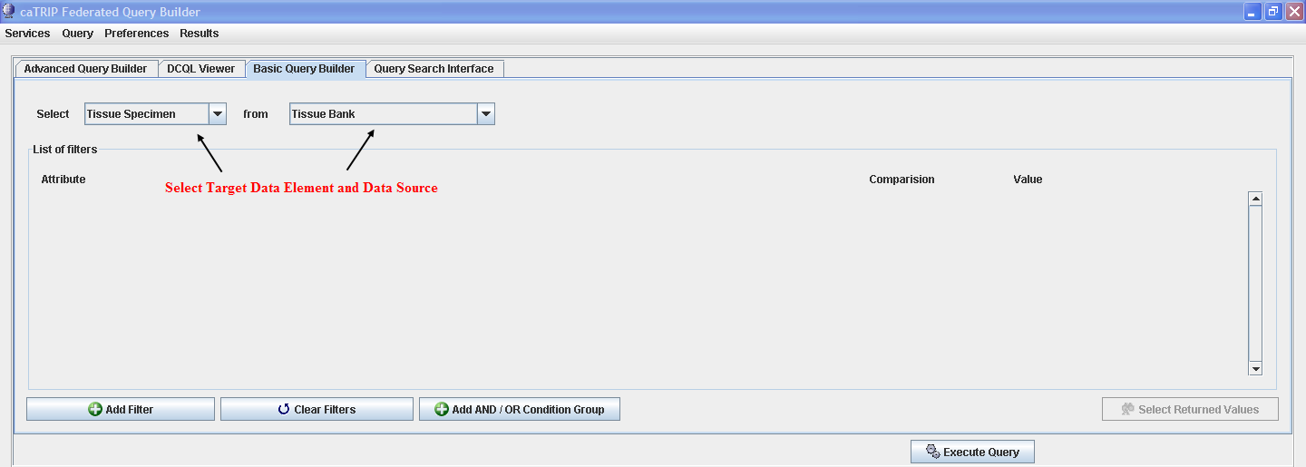

Adding Filters
The next step is to add a filter to the query. Filters focus the query to return only data you are interested in viewing. The problem statement is asking about Her2/Neu Status so click the Add Filter button and choose “Breast Carcinoma Tumor Marker Her2/Neu Status” from the Attribute list.
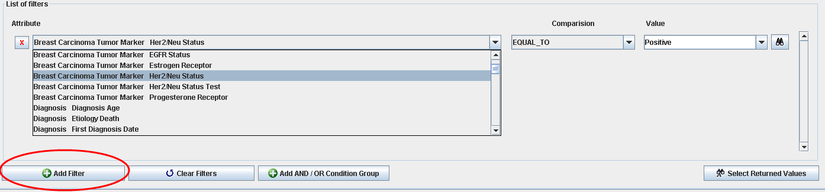
One row is displayed along with 2 other fields; Comparison and Value. The comparison box allows you to select what sort of comparison to make with the inputted value. The comparison is EQUAL_TO and the value is “Positive”.
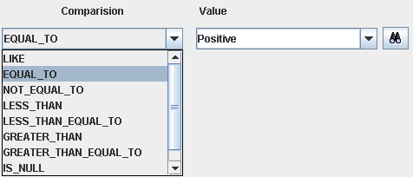

The binoculars button next to the value box will query the database for all the valid values and populate the value drop down.
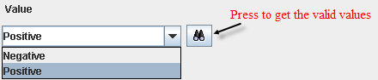
Grouping button allows the user to perform AND/OR groupings with the current filters. We will not be using it in this example but see Using AND/OR Grouping section for a detailed explanation.
Select Returned Values button is used to add columns to the query to be returned and displayed in the results. Each target data element has a default set of columns to be returned and this button adds to that list. We will not be using it in this example but see Adding Return Values to the Query for a detailed explanation .

Run the Query
The final step is to run the query by clicking the Execute Query button.
Results will be shown in the table at the bottom of the screen.
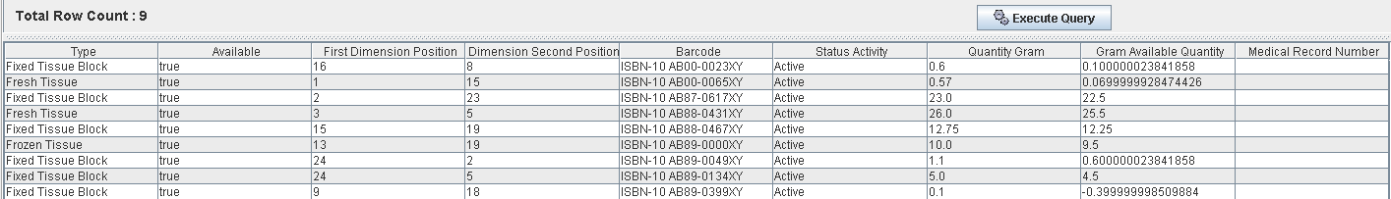

Using AND/OR Grouping
When adding filters to your query an implicit “AND” is placed between each filter automatically. The AND/OR grouping button allows you to group filters together and place an AND or OR condition between them.
Creating an OR condition:
Problem Statement:
What are all the tissue specimens from patients that have a tissue dimension of 3 OR 4 mm.
Add 2 filters to the query by pressing the Add Filter button twice. Select the same Attribute, “Three Dimensional Tumor Size Largest Dimension” and set the Comparison to EQUAL_TO for both and a value of 3 for one filter and 4 for the other filter.
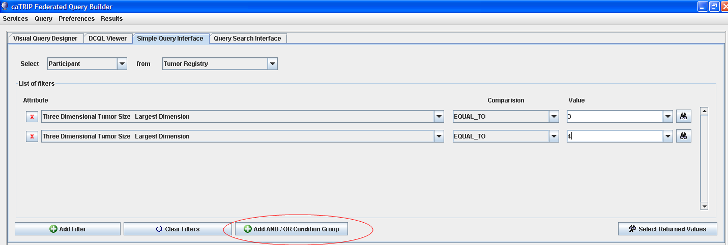
Press the Add AND/OR Condition Group button and the following dialog is displayed:
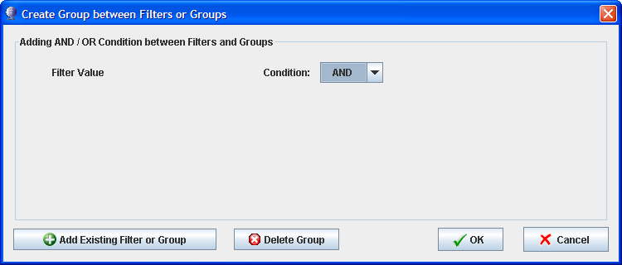
To create the OR condition, you will add the two filters by pressing Add Existing Filter or Group button twice.
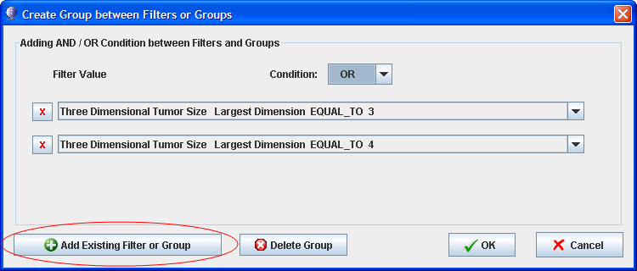
Once the filters are added, to put an OR condition between them, select “OR” from the Condition drop down and press the OK button. The filters are now grouped together with an OR condition.
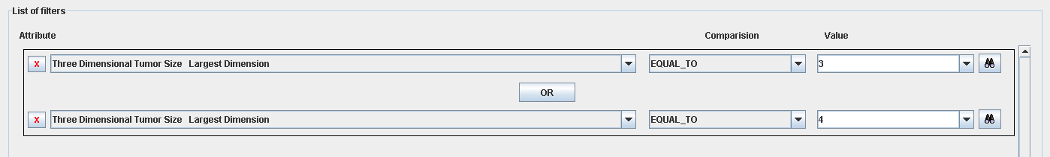

Adding Return values to the Query
Select Returned Values button is used to add extra columns to the query which will be displayed in the query results. Each target data element has a default set of columns which will make up the contents of the query results. If there are other columns you want to see in the results, click this button to find a list of columns to choose to add to the default list.
Note: Some services do not support returning extra columns so the button is disable in these situations.

Return Value Dialog
The following dialog is displayed after clicking the button:
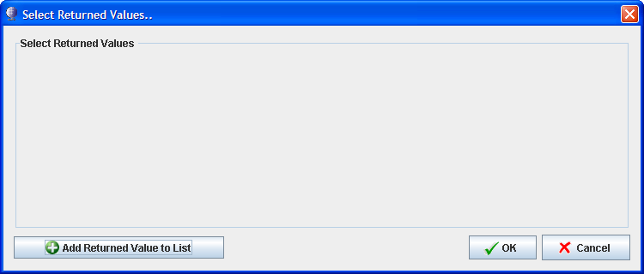

Adding Return Values
Press Add Returned Value to List and select a column from the drop down list to be added to the query. Add as many as you like by pressing the button once for each additional column. To remove a column, press the button on the row to be removed.
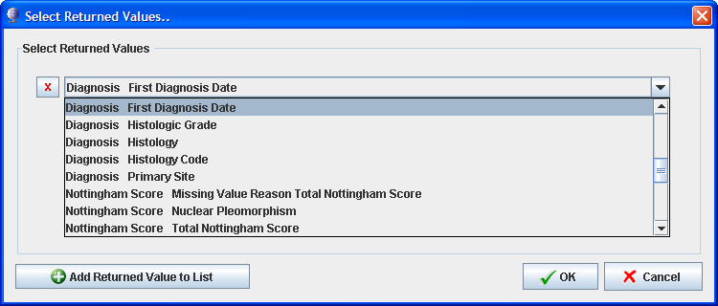

Query Results
Press Ok when done. When you return to the query screen run the query and your extra columns will be displayed in the results.
Note: You will not see a list of extra columns listed on the Basic Query Builder screen itself. Open the dialog box again to see the list of selected columns.
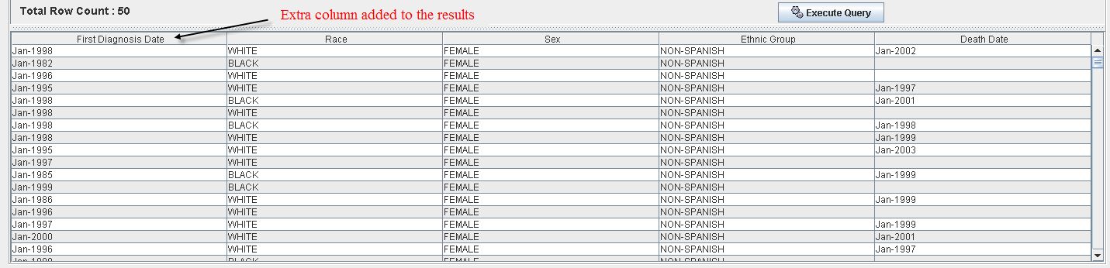

Using the Advanced Query Builder
Topics in this chapter include:
- Login – an extra step
- Introduction to the Advanced Query Builder
- Building an Example Query

Building queries in the Advanced Query Builder
The Advanced Query Builder is designed for the user who has in-depth knowledge of the domain models associated with each service. All the objects and attributes for each service are available here as opposed to the simple interface where many of the objects have been removed to simplify the query building process.

Login
To get to this query builder you will need to check “Show Advanced Query Builder” from the login page.

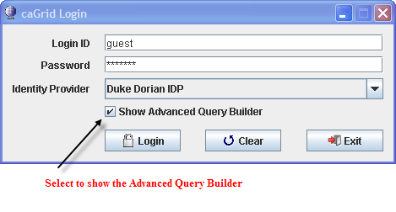

Selecting Your Data Sourcess
Next, you need to select the services you want to use in your query.
Click the button Show All, this will find all available services. Next check the services you want to use in your queries then click the Select button to confirm your choices. This will take you to the Advanced Query Builder.

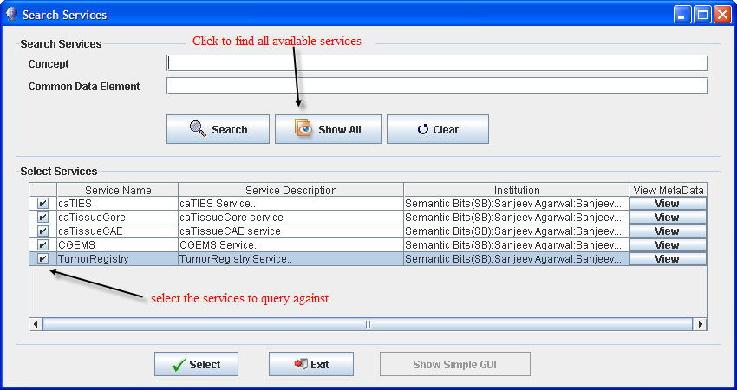
Note: Search and Clear functionality are not implemented yet.
Below the Advanced Query Builder is displayed highlighting the different areas of the interface.
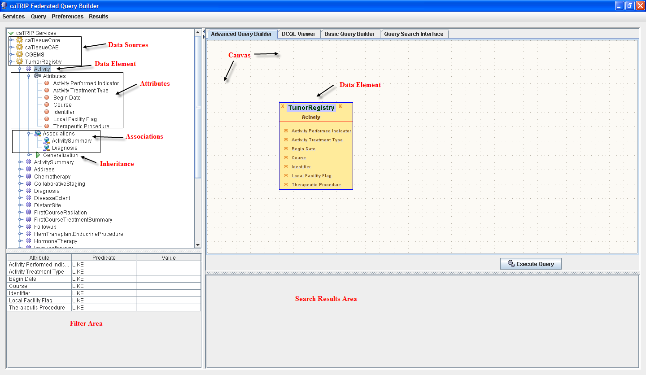
Now we will create a query using the Advanced Query Builder.

Problem Statement:
What are all the tissue specimens from patients whose tissue site is breast?
For this query we will need to put two data elements on the canvas; TissueSpecimen and SpecimenCharacteristics. We will place a connection between them then put a filter on the SpecimenCharacteristics element and set the tissue site equal to breast.

The Canvas
Start by expanding the caTissueCore node then drag TissueSpecimen and SpecimenCharacteristics objects on to the canvas. The target data element is shown in a different color and will be the root of your query which means these are the attributes which will comprise the query results. Any object can be designated as the target data element by right clicking it and selecting from the menu “Set object as Target Object”.
Important: The first object dragged on to the canvas is defaulted to be the target data element.
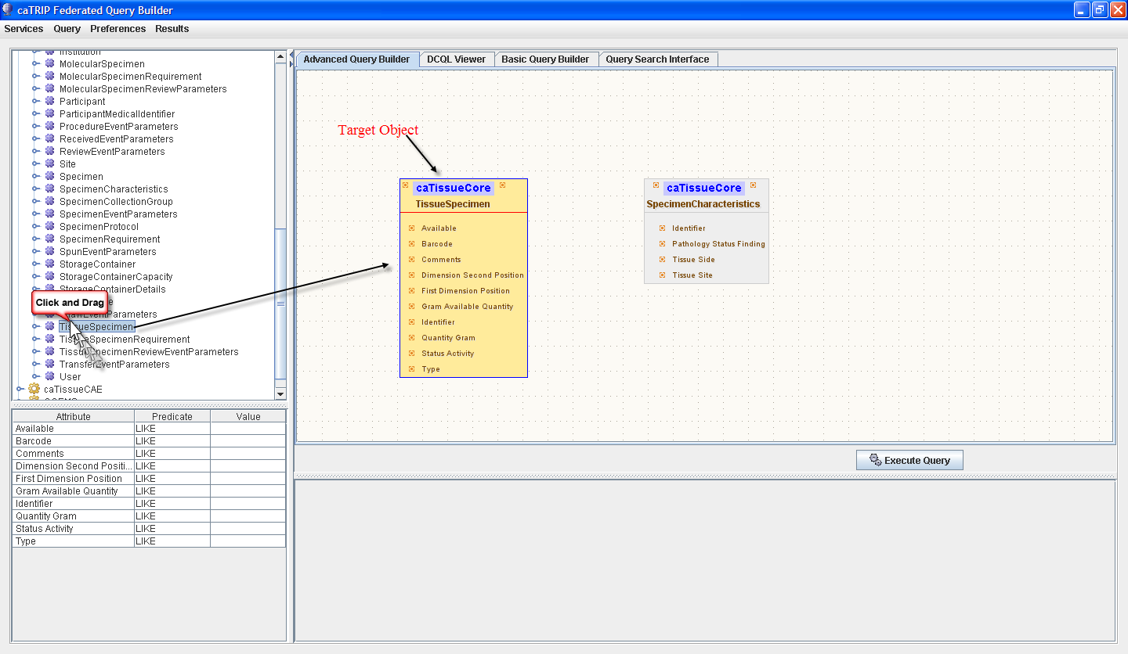

Linking Objects
Next, the two objects need to be linked together by drawing a line between the objects. Click on the small x on the right side of the TissueSpecimen, hold the mouse down, drag the mouse to the small x on the left side of SpecimenCharacteristics and release the mouse. We link these objects because they represent tables in the database which relate to each other thru database keys. By linking them we can match and return all the tissue specimens keys in Specimen Characteristics which match for our filter of tissue site being breast.
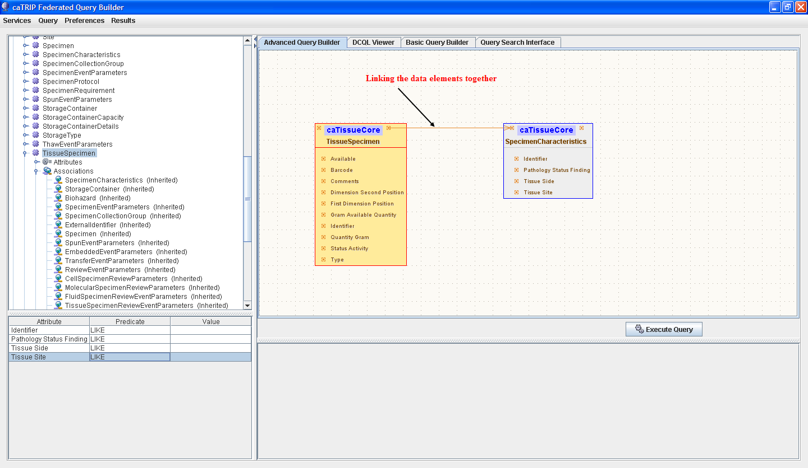
Note: Expand the TissueSpecimen data element and you will see Attributes, Associations and Generalization nodes. A convenient way to know what TissueSpecimen can be linked with is by expanding the Associations node. Here you see SpecimenCharacteristics, among others, is associated so this lets us know that we can draw the association between these two data elements. You can drag data element on to the canvas right from the Associations tree.

Adding Filters
Finally, in the filter area, we need to filter the results by setting tissue site to breast on SpecimenCharacteristics. Clicking on SpecimenCharacteristics will display all the attributes of the object in the filter area. Set the predicate to EQUAL_TO and the value to “breast” (without the quotes). Then press the Execute Query button to run the query.
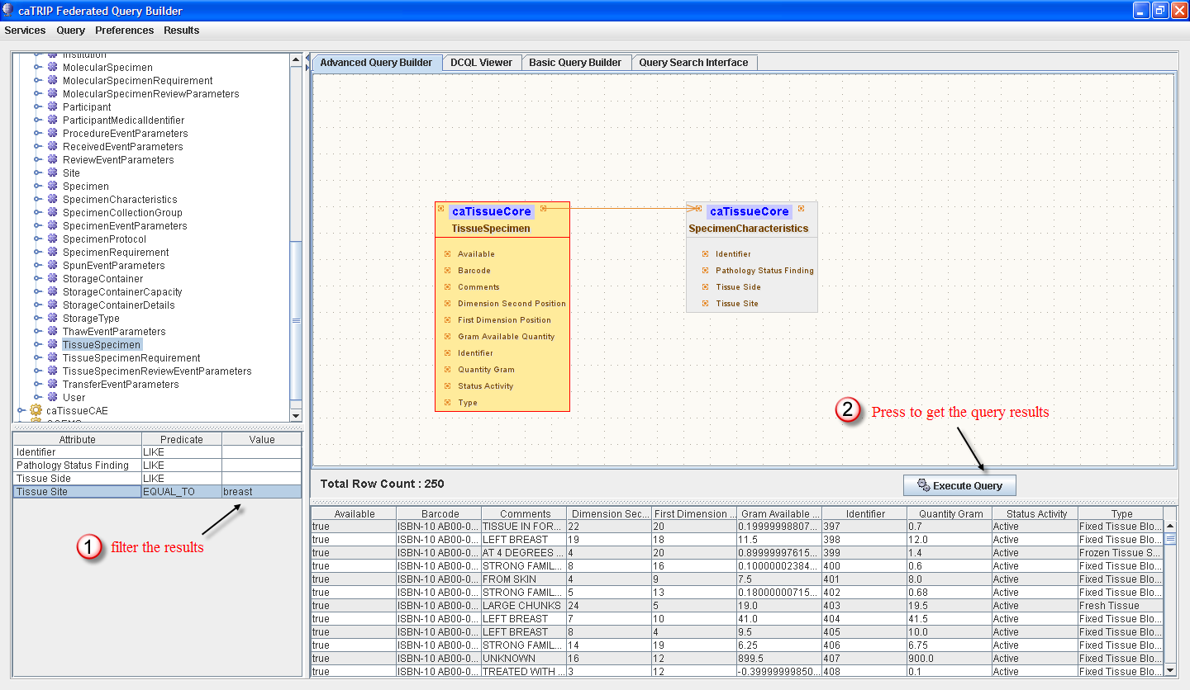

Multiple Data Sources
Up to now, we have only linked data elements together at the data element level within one data source. Queries can cross multiple data sources by linking together data elements of different data sources at the attribute level.

Problem Statement:
A patient enters the clinic and is diagnosed with a lobular carcinoma. The Her2/Neu status comes back positive. A Clinician is interested in retrieving all the participants with this criteria.
For this query, we need to link together two datasources; Clinical Annotation Engine (CAE) and the Tumor Registry (TR). From the Tumor Registry, the Patient data element will be our target data element as those are the attributes we want to see in our query results. Then we need to link in the CAE data source to filter on the Her2/Neu Status attribute.
We will create the query in three stages:
- Create Tumor Registry query
- Create the CAE query
- Link them together
Expand the Tumor Registry data source and locate the Patient data element. Drag it on to the canvas first to designate it as our target data source. Next, expand the Association node within the Patient data element and drag on the Diagnosis and PatientIdentifier data elements. Draw the associations and arrange them as shown in the picture below. Click on the Diagnosis data element and add the Histology filter shown below.
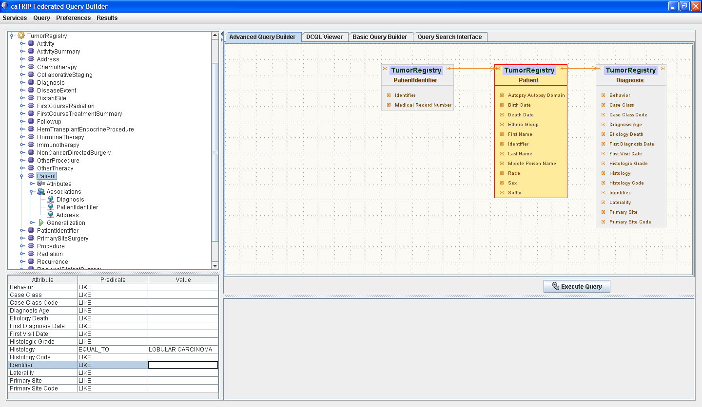
We have the Tumor Registry data source setup, now to setup the CAE data source on the same pallet. Expand the caTissueCAE data source, find Participant data element and drag it on to the canvas. Expand the Associations node and drag on the ParticipantMedicalIdentifier data element. These data elements will be used to link with the patient data of the Tumor Registry to find matching patients from each data source. To complete the CAE side we need to add X, X,BreastCancerBioMarker to the canvas and arrange them as shown below. Select BreastCancerBioMarker and add the filter Her2/Neu status filter.
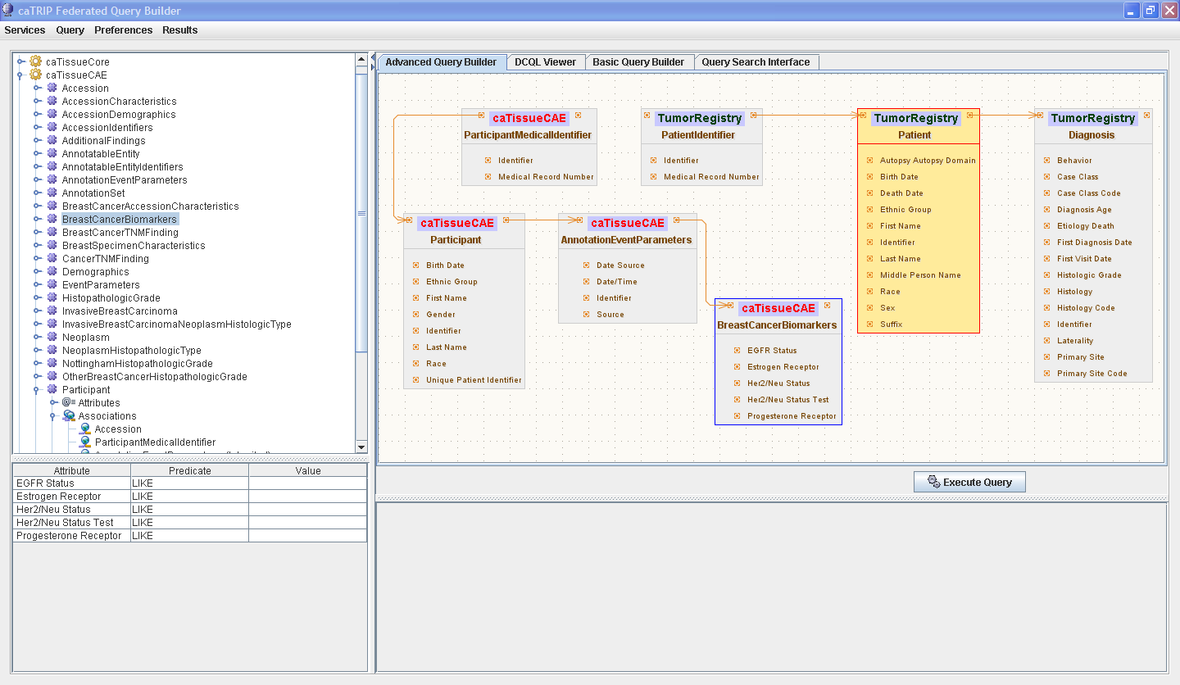
Both data sources are now complete. Next, we hook them together at the attribute level. We do this so we can match the patient keys from both data sources. Draw an association from TumorRegistry.PatientIdentifier.Medical Record Number to caTissueCAE. ParticipantMedicalIdentifier.Medical Record Number in the direction shown.
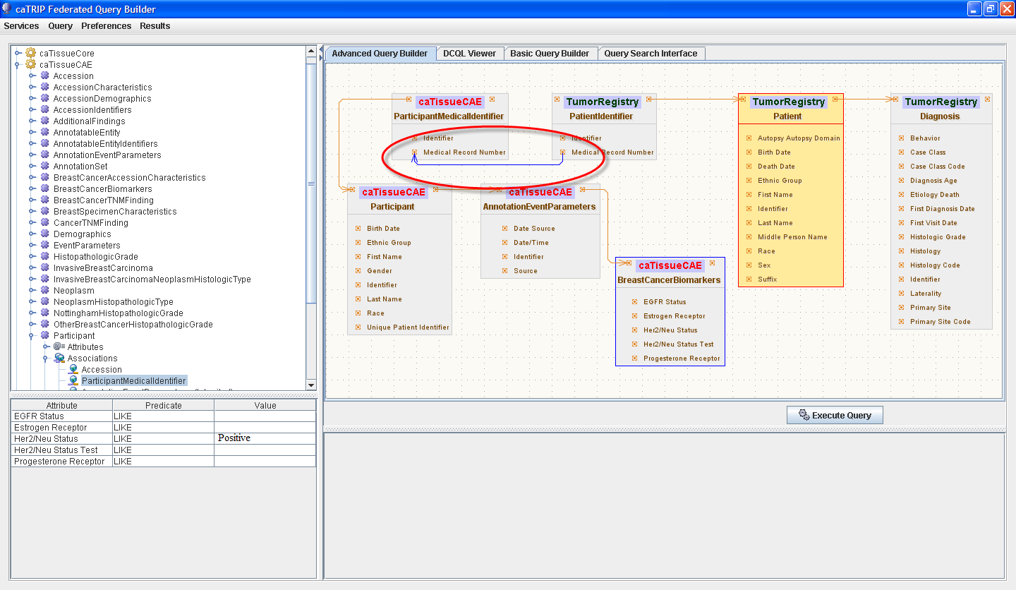
We have crossed data sources in this example asking to get all the Tumor Registry patients who have a Histology of “Lobular Carcinoma” and Her2/Neu status of Positive. The Her2/Neu status is not stored in the Tumor Registry but in the CAE data source. So by linking them together we can find the patients that exists in both data sources matching the criteria.

Using the Query Search Interface
Topics in this chapter include:
- Saving a Query
- Introduction to the Query Search Interface
- Retrieving Stored Queries
- Searching using Filters

Finding queries with the query search interface
The Query Search Interface is used to find and run queries saved by you and other authorized users. Finding queries can be accomplished by entering user name, description or query name and by filtering on variables used within the query.
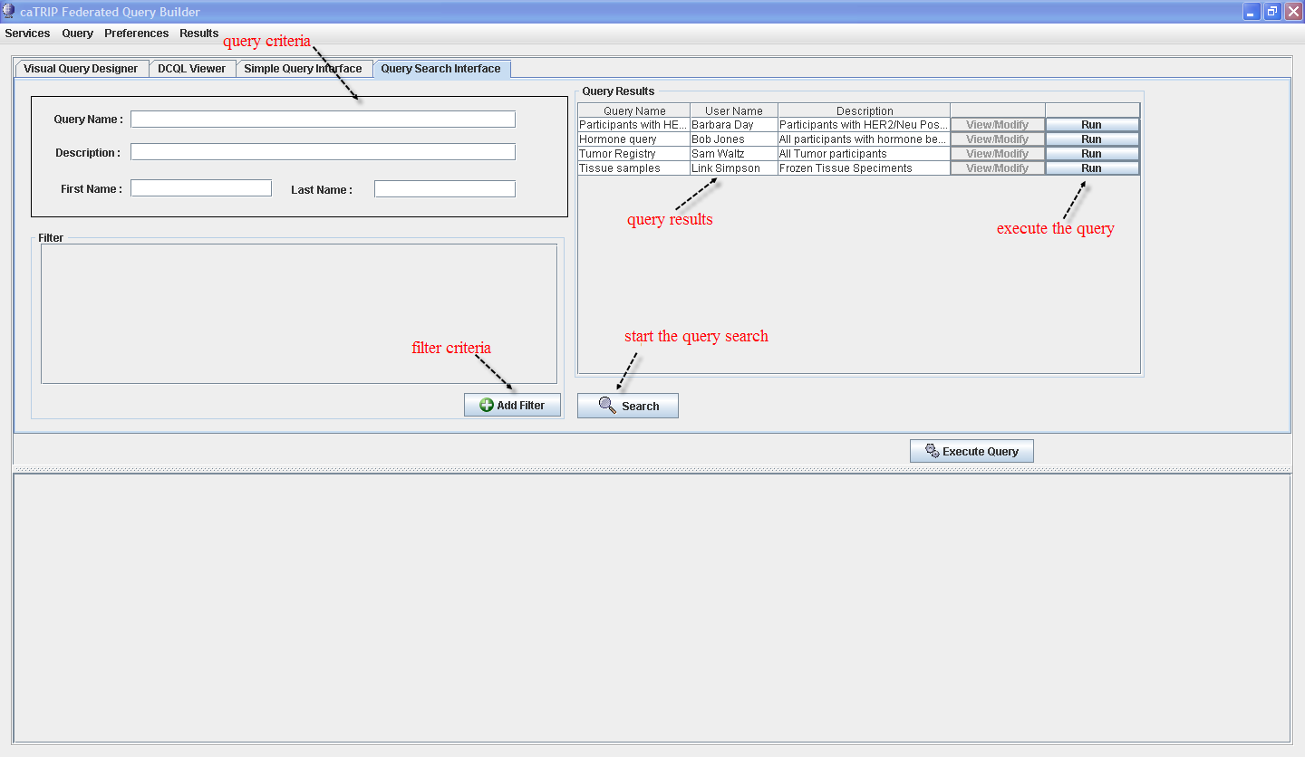
To find all the saved queries you have permission to view and run simply press the Search button without entering any criteria. Use caution when executing this query because response time could be slow if there are a lot of saved queries.

Before we can find a query we need to save one first. Let’s create a simple query and save it.
Problem Statement:
Find all the patients who were diagnosed at an age greater than 50.

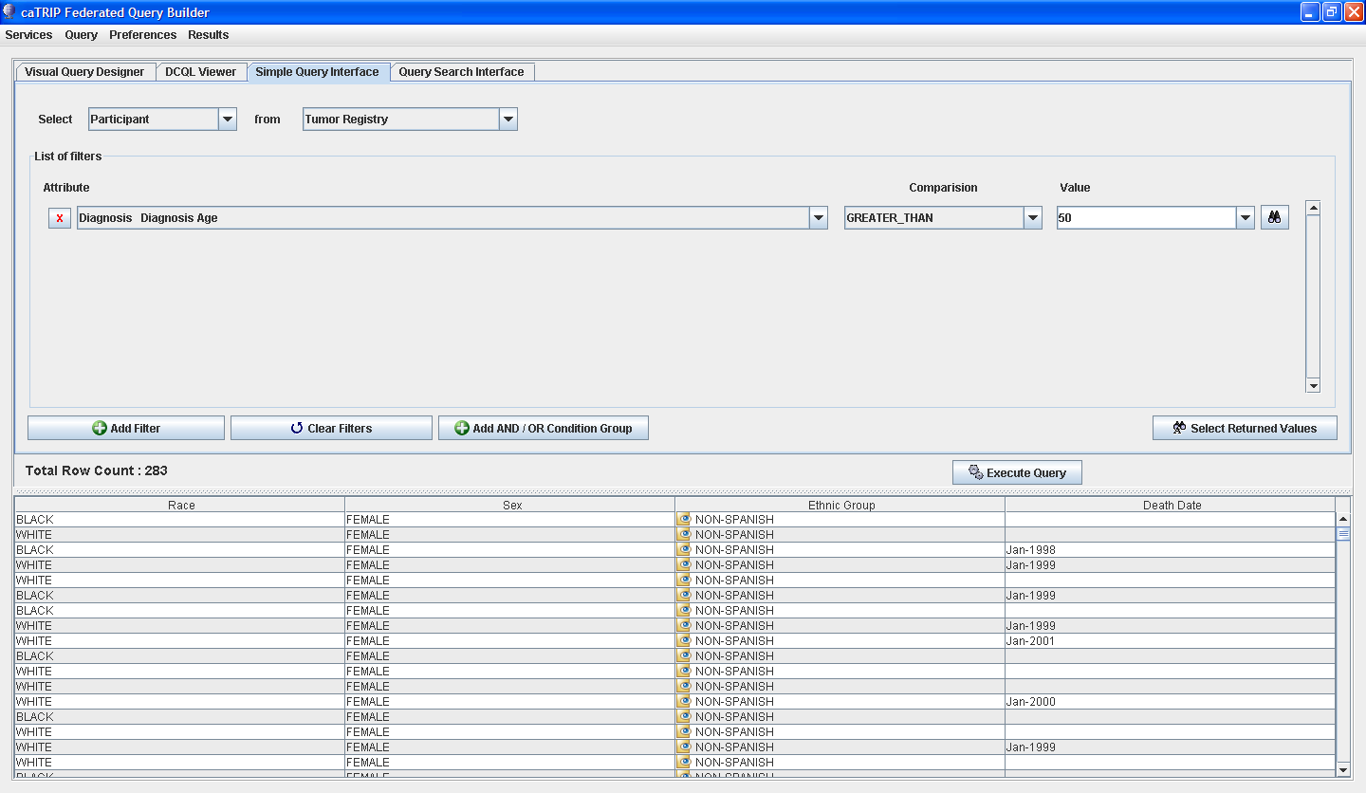.

Saving a Query
To save the query, select the menu item Query->Save Query
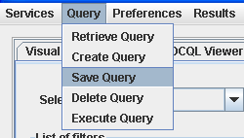

The following dialog is displayed for you to enter in information about the query. Name the query and give it a description so others will know what your query does. You can enter in your name to show ownership and others can find your queries by your name. Once done press the Save button and your query is stored in the database.
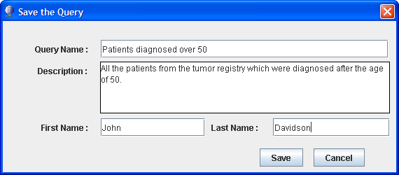

Executing the Query
Now move to the query tab and search for the query you just saved by entering in the query name. You can enter in part of the query name and the system will perform a wild card search to find all queries starting with the partial query name .

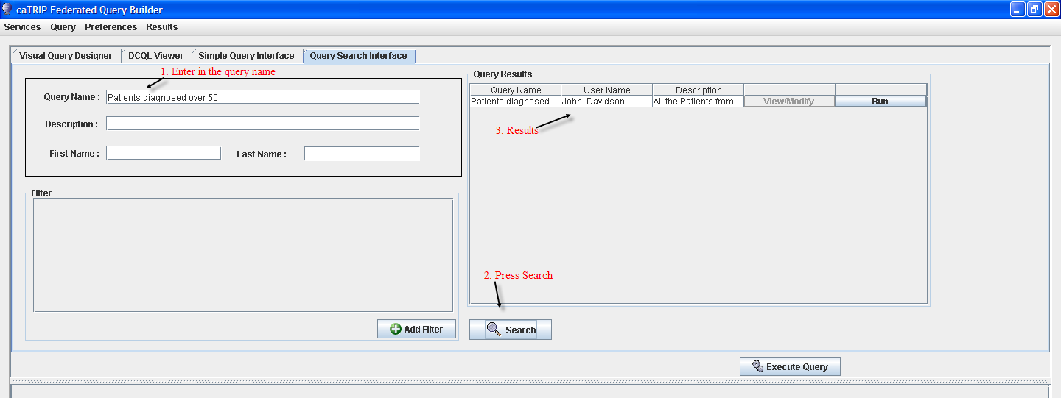
Press the Run button in the table to execute the query.
Note: The View/Modify button is disabled for all queries. It will be implement in a later release which will allow the user to see the query graphically in the Query Search Interface.

Searching for queries using filters
In addition to using the attributes to find queries; filters can be used to find ones which use specific query criteria. For example, the query we just saved uses the criteria Diagnosis – Diagnosis Age. Filters allow you to find all queries which deal with diagnosis age.

Adding Query Filters
Press the Add filter button and select “Diagnosis Diagnosis Age” from the filter dropdown and press the Search button.
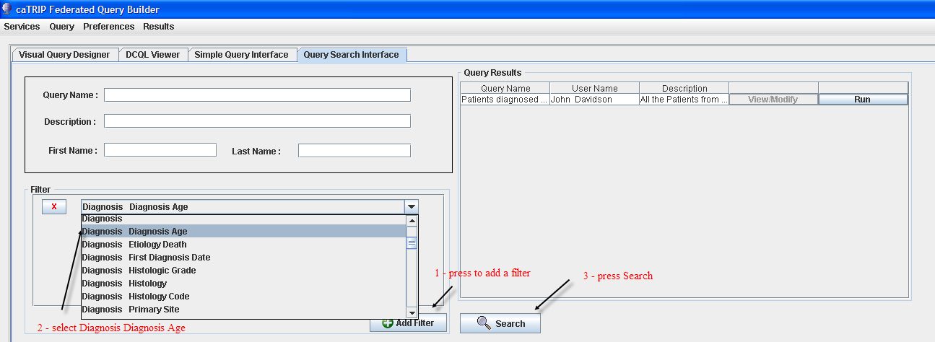

Export Query Results
Topics in this chapter include:
- Exporting Query Results

Performing outcome analysis can entail further analysis of the data. For these cases the results can be exported to the following formats:
- HTML
- Excel
- Comma Separated Values (CSV)
After the query has been run, to export to Excel select from the menu
Results->Export Results to Excel .
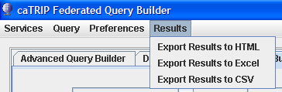
The file will be exported to your home directory located at:
C:\documents and settings\<your name>\.catrip\caTRIP_Query_Results.xls
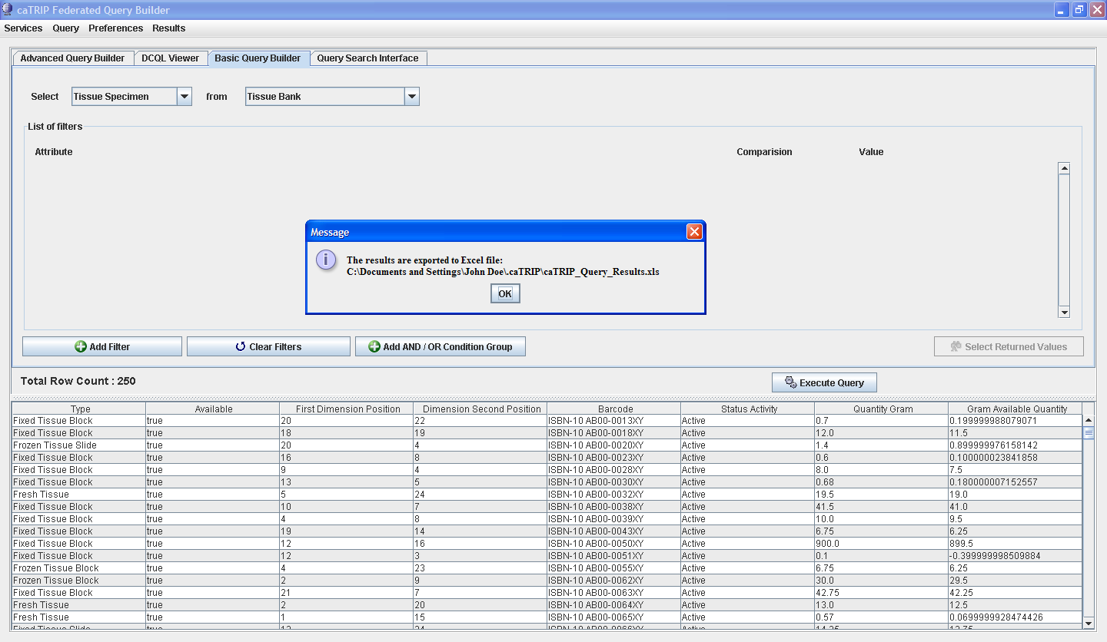
When exporting to Excel, all exports are directed to the same Excel file but stored to a new Excel Sheet each time.
Note: The application will not warn you when you are about to overwrite an existing file. In the case of Excel, it will use a different Excel Sheet. HTML and CSV exports will be overwritten. Before exporting again, be sure to save any exported results to a different directory or filename to prevent overwriting.

DCQL Viewer
Topics in this chapter include:
- What is the DCQL Viewer?
- Components of the DCQL Viewer

What is it?
The Distributed Common Query Language (DCQL) Viewer displays what the user is building as he clicks or drags objects and filters on the GUI to build his query. This query language is used to distribute queries to the services selected in the user built query.

What can I do with it?
Not much. You cannot edit the text on this tab and really only the administrator should be concerned with this page. There are some thing a user can see as he builds his query as depicted below:
- The target data element is one of the first things listed. This is a query against the Tissue Specimen service
- Return Values – this shows all the attributes of the target data element being returned in the result list.
- Filter – Any query restrictions are listed here
- Data Source Location – where the service that is being queried is located
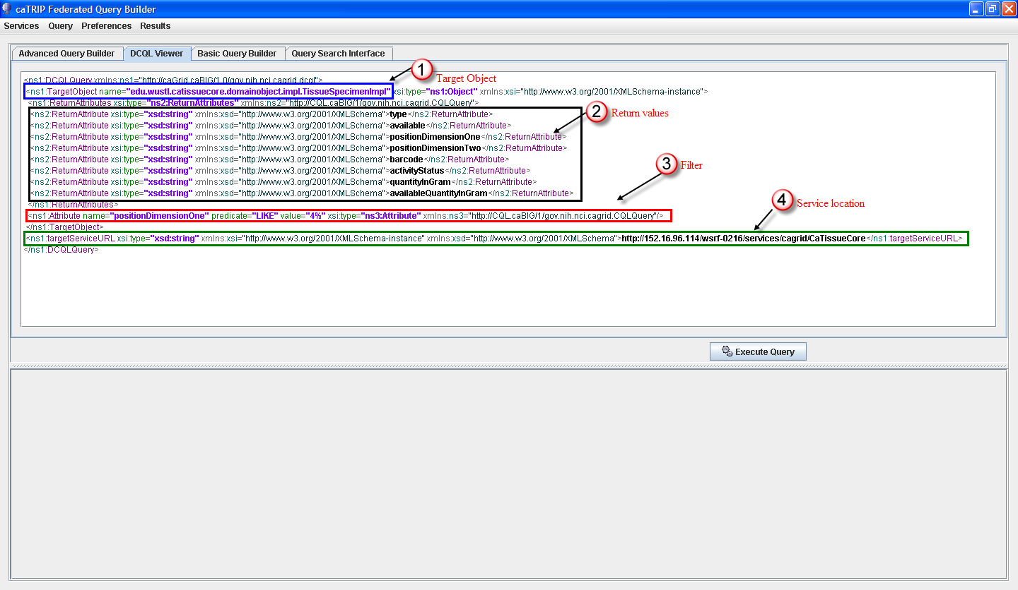

Example Queries
This chapter describes some sample queries to get you started. These fall into the categories of:
- Find available tumor tissue
- Find factors of survival
- Determine the distribution of disease factors over time
- Find patients for trials
- Determine correlation of factors pre and post surgery

Find available tumor tissue
- What are all the available tissue specimens from the breast?
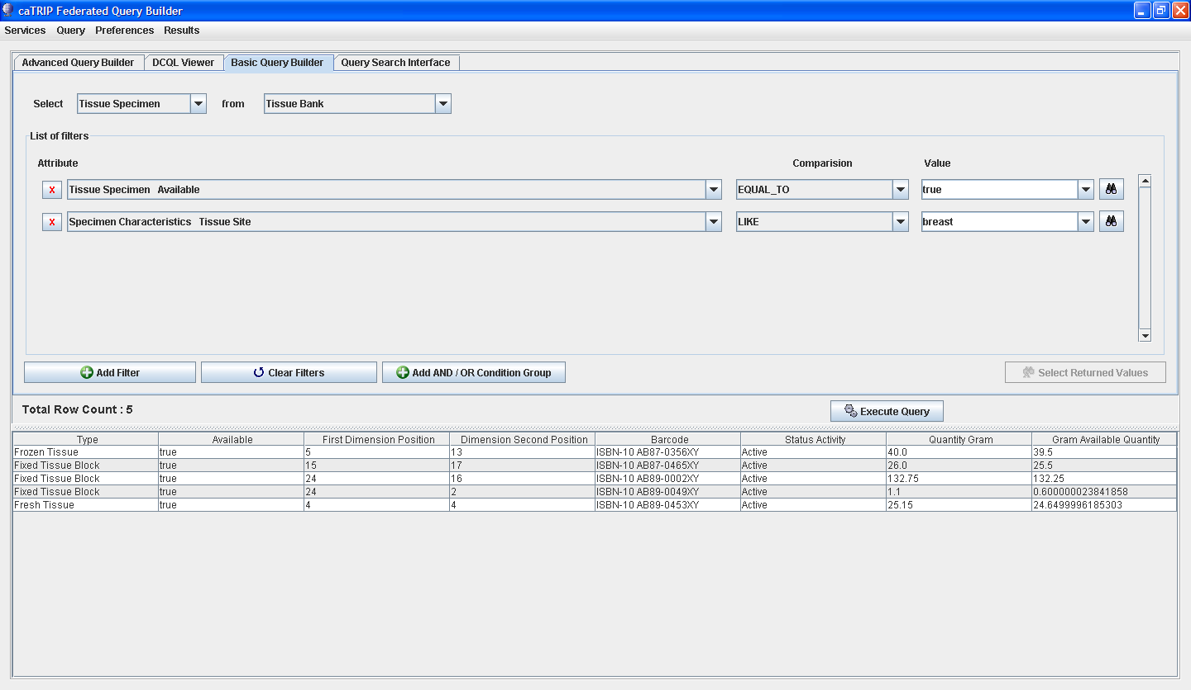
- What are all the tissue specimens from patients that have a her2/new status of positive?
- What are all the tissue specimens from her2/neu positive patients that have a primary tumor in the breast?
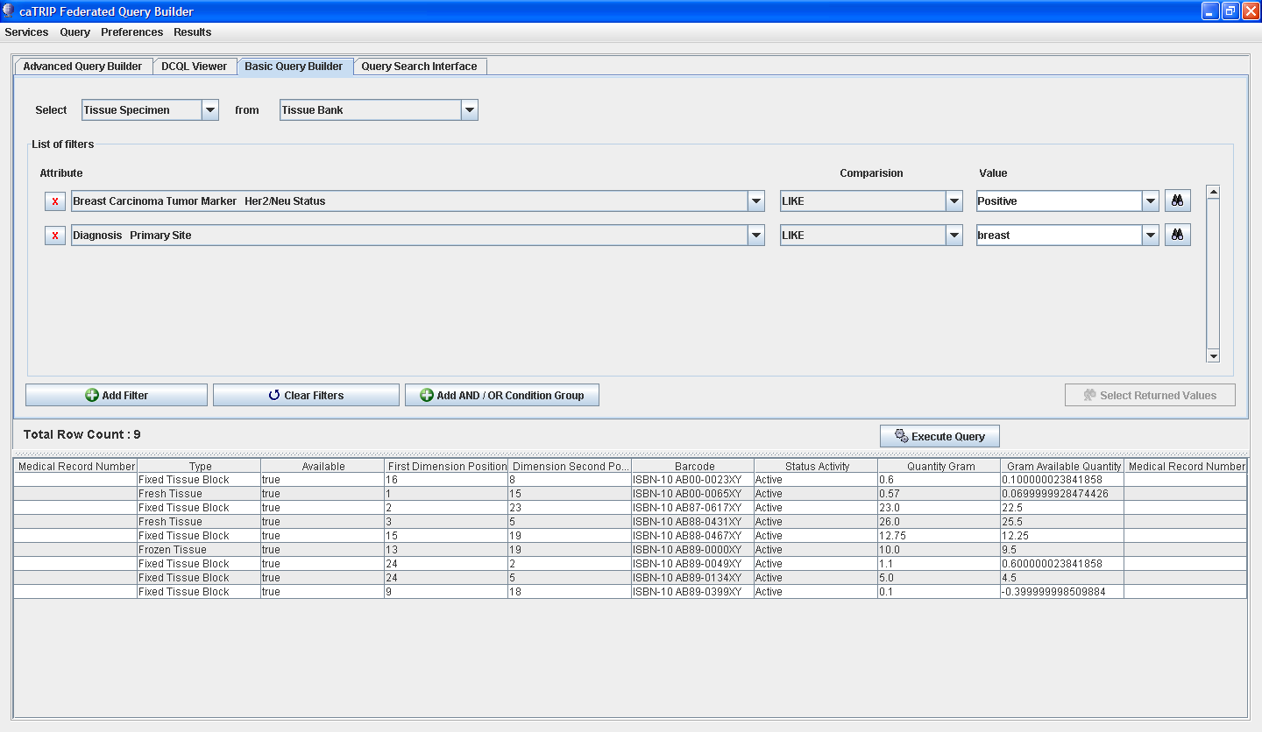
- What are all the tissue specimens from her2/neu positive patients that have a primary tumor in the breast and are BRCA1 positive?
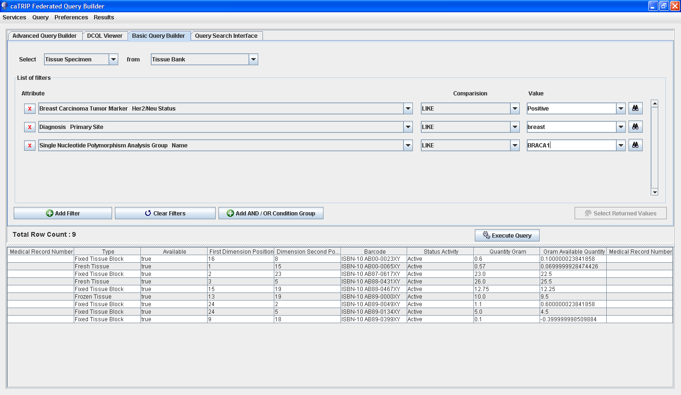

Find factors of survival
- What are all the ER positive patients that have survived breast cancer after radiation treatment?
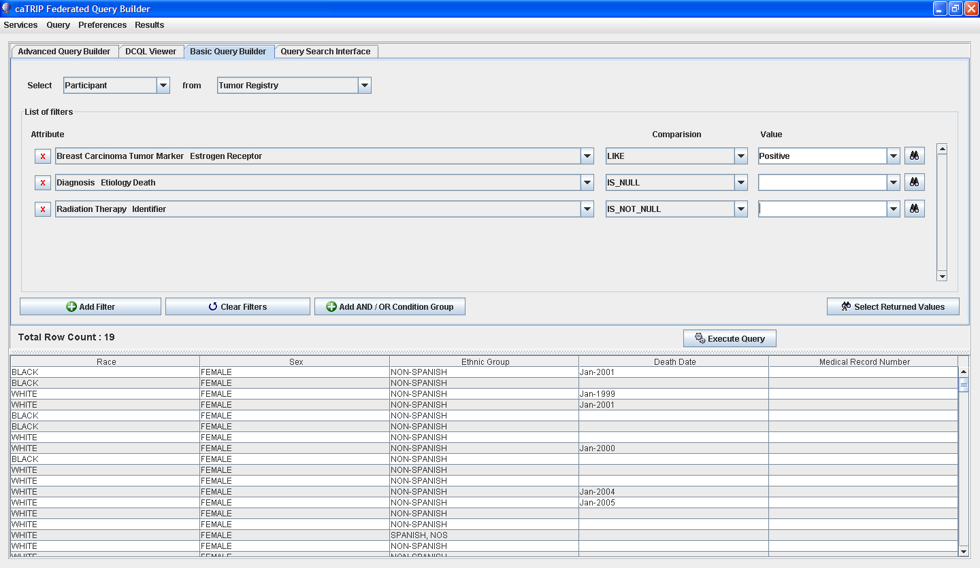
- What are all the BRCA1 positive patients over the age of 50 that have survived breast cancer after surgery?
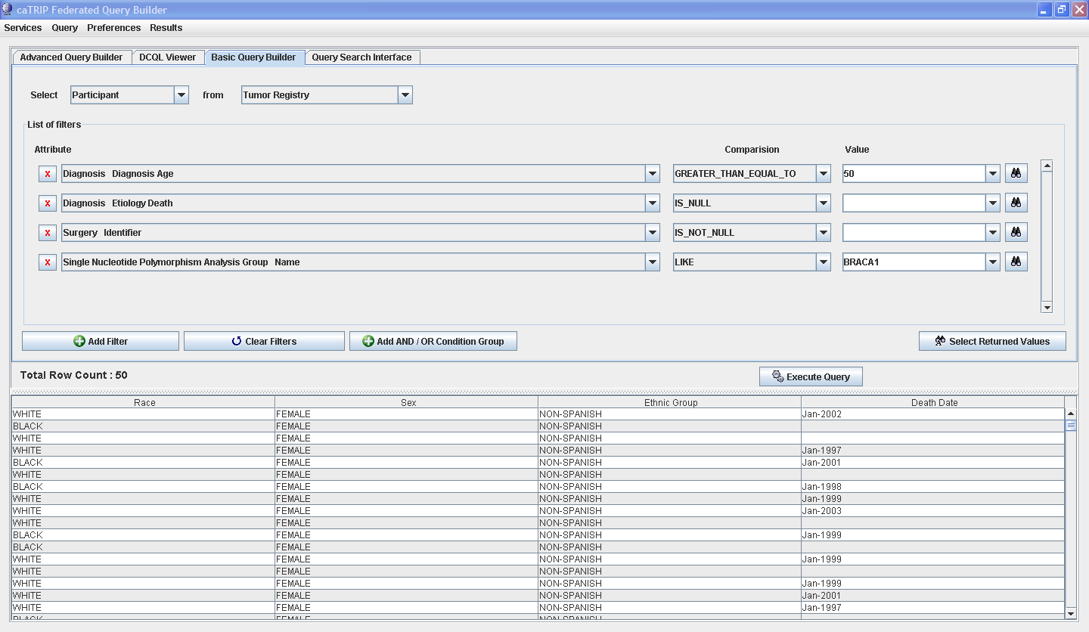

Find patients for trials
- What are all the patients that are triple negative (ER, PR, and HER2/NEU negative)?
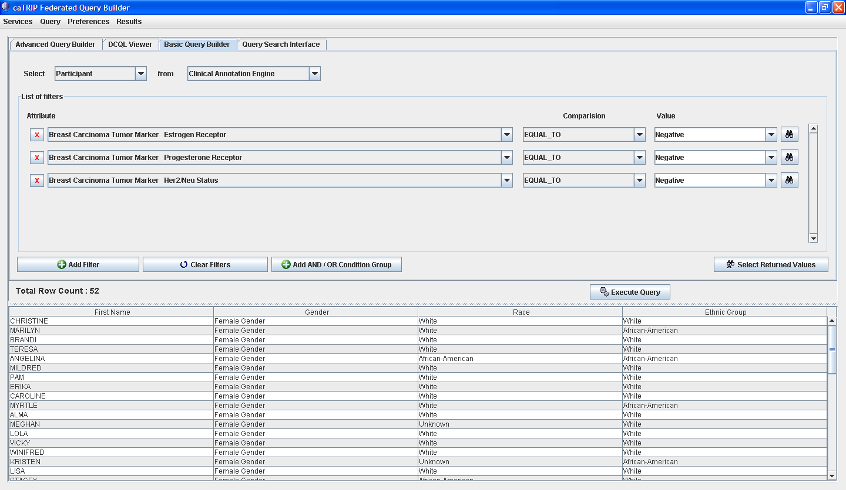

Error Messages/Indicators and Problem Resolutions
This chapter includes:
- Description and interpretation of error messages

Description and interpretation of error messages
Error messages will appear in popup windows like this:
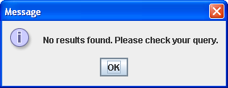
Here are some common messages and their interpretation:
Message | Interpretation
No results found. Please check your query. | Your query resulted in no results because of some limiting filter criteria.
Cannot add filter from foreign service to an OR group | Selecting foreign services for filter criteria is allowed but placing an OR condition is not implemented yet.

Limitations
This chapter describes the features of caTRIP that are not supported in the current release.

Joins
Only foreign joins of equality are currently supported. For example, you could not join between services using one date being greater than another.

Grouping Filters of Foreign Data Sources
Cannot add a filter from a foreign service to an OR group. This feature is not implemented yet.

Query views
Queries are synchronized between the Simple Interface and the DCQL view, as well as the Query Builder and the DCQL view. However, there is no synchronization from DCQL (e.g. no editing of DCQL) and no synchronization between the Simple Interface and Query Builder. In fact, the Simple Interface is disabled in Query Builder mode and vice versa.

Query Search View Button
The View/Modify button is disable and will be implemented in the next version. This button will synchronize with the Query Builder to graphically display the saved query.

- Overview of the Software

Software Overview
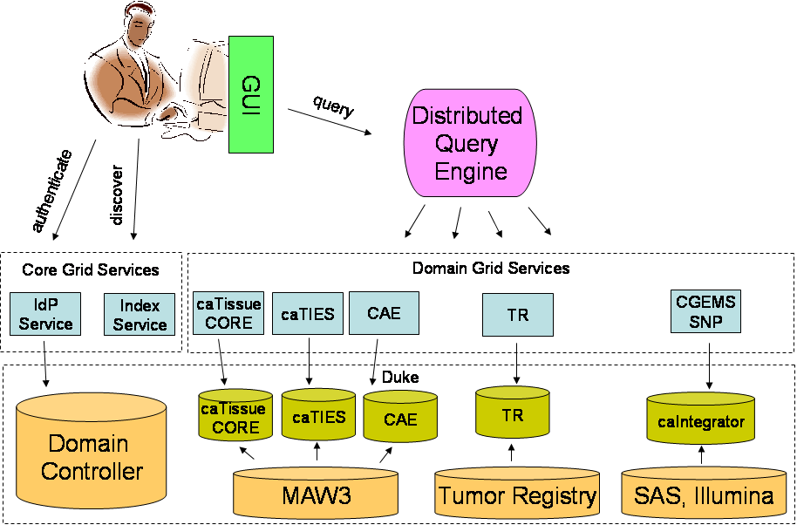
The caTRIP application is divided into three major components: domain services, the distributed query engine, and the graphical user interface. The domain services are grid services that expose information models that encapsulates the translational data. The distributed query engine (DQE) takes in distributed common query language (DCQL) queries, decomposes the query into individual common query language queries (CQL), issues those queries to the domain services, aggregates the results, and returns it to the caller. The graphical user interface (GUI) provides a metadata driven interface for building DCQL to be issued against the DQE, as well as reporting utilities for data visualization.

Figure 1 High-level overview of the caTRIP system/architecture

Components of the Software
A number of caGrid, NCICB, and third-party components are leveraged in the caTRIP architecture. These include:
- AuthenticationService (IdP Service): allows the GUI to perform user authentication based on an institutional identity provider (IdP)
- IndexService: domain services advertise metadata to the IndexService, which can then be discovered by the GUI
- Common Security Module (CSM): provides coarse-grained and fine grained authorization within the domain services
- caDSRData Source: provides the metadata necessary for the GUI to provide an interface based upon concepts and CDEs for query building
- Hibernate: provides a mapping between the underlying database and the objects that are returned from queries
- Oracle and MySQL: provides the underlying database

- References

Technical Manuals/Articles
- National Cancer Institute. "caCORE 2.0 Technical Guide", ftp://ftp1.nci.nih.gov/pub/cacore/caCORE2.0_Tech_Guide.pdf
- Java Bean Specification: http://java.sun.com/products/javabeans/docs/spec.html
- Foundations of Object-Relational Mapping: http://www.chimu.com/publications/objectRelational/
- Object-Relational Mapping articles and products: http://www.service-architecture.com/object-relational-mapping/
- Hibernate Reference Documentation: http://www.hibernate.org/hib_docs/reference/en/html/
- Basic O/R Mapping: http://www.hibernate.org/hib_docs/reference/en/html/mapping.html
- Java Programming: http://java.sun.com/learning/new2java/index.html
- Javadoc tool: http://java.sun.com/j2se/javadoc/
- JUnit: http://junit.sourceforge.net/
- Extensible Markup Language: http://www.w3.org/TR/REC-xml/
- XML Metadata Interchange: http://www.omg.org/technology/documents/formal/xmi.htm

Scientific Publications

caBIG Material
- caBIG: http://cabig.nci.nih.gov/
- caBIG Compatibility Guidelines: http://cabig.nci.nih.gov/guidelines_documentation

caCORE Material
- caCORE: http://ncicb.nci.nih.gov/core
- caBIO: http://ncicb.nci.nih.gov/core/caBIO
- caDSR: http://ncicb.nci.nih.gov/core/caDSR
- EVS: http://ncicb.nci.nih.gov/core/EVS
- CSM: http://ncicb.nci.nih.gov/core/CSM
- Glossary
Term | Definition
API | Application Programming Interface
caArray | cancer Array Informatics
caBIG | cancer Biomedical Informatics Grid
caBIO | Cancer Bioinformatics Infrastructure Objects
caCORE | cancer Common Ontologic Representation Environment
caDSR | Cancer Data Standards Repository
CAE | Clinical Annotation Engine
caTRIP | Cancer Translational Research Informatics Platform
CDE | Common Data Element
CSM | Common Security Module
CSV | Comma Delimited
DCQL, | Distributed Common Query Language
EA | Enterprise Architect
EVS | Enterprise Vocabulary Services
GUI | Graphical User Interface
HTTP | Hypertext Transfer Protocol
JAR | Java Archive
Javadoc | Tool for generating API documentation in HTML format from doc comments in source code (http://java.sun.com/j2se/javadoc/)
JDBC | Java Database Connectivity
JUnit | A simple framework to write repeatable tests (http://junit.sourceforge.net/)
metadata | Definitional data that provides information about or documentation of other data.
NCI | National Cancer Institute
NCICB | National Cancer Institute Center for Bioinformatics
ORM | Object Relational Mapping
RDBMS | Relational Database Management System
SDK | Software Development Kit
Semantic connector | A development kit to link model elements to NCICB EVS concepts.
SQL | Structured Query Language
UI | User Interface
UML | Unified Modeling Language
URL | Uniform Resource Locators
VD | Value Domain
WAR | Web Application Archive
WSDL | Web Services Description Language
XMI | XML Metadata Interchange (http://www.omg.org/technology/documents/formal/xmi.htm) - The main purpose of XMI is to enable easy interchange of metadata between modeling tools (based on the OMG-UML) and metadata repositories (OMG-MOF) in distributed heterogeneous environments

Index

AND/OR grouping, 15
binoculars, 14
caTRIP Wiki, 4
Common Security Module, 8
Examples
BRACA1 Positive, 36
BRACA1 Positive over 50, 37
breast tissue, 35
Factors of Survival, 37
her2/neu positive, 36
Triple Negative patients, 38
Exporting to Excel, 31
Link two datasources, 23
Login
Advanced Query Builder, 19
Basic Query Builder, 10
Organization of the User's Manual, 3
Query Search
Filters, 29
Finding, 27
saving, 28
References
caBIG materials, 44
caCORE material, 44
scientific publications, 44
technical manuals, guides, 44
Selecting Return Values, 17
Service
Authentication, 7
caDSR, 8
Index, 8
Text Conventions
keyboard keys, 5
menu commands, 5
Text conventions, Supplement, 5
The caTRIP GForge site, 4

