Cancer Translational Research Informatics Platform (caTRIP) Use Cases

DOCUMENT REVISION HISTORY
Version Number | Date | Description
1.0 | May 31, 2006 | - Initial Draft
2.0 | June 16, 2006 | - Added more use cases
3.0 | 7/5/2006 | - Added high-level scientific use cases
4.0 | 8/2/2006 | - Updated with detailed scientific use cases
5.0 | 8/8/2006 | - Added path report detailed scientific use case

Background/Summary
This document presents use cases for the Cancer Translational Research Informatics (caTRIP) system developed by Duke University. Principle features of that system will provide the following functionality:
- Ability to build queries graphically
- Issue one query to many services
- Save, edit and delete queries
- Export query results
- Automatically locate classes across services which are semantically equivalent
- Automatically locate all classes which have direct links to a selected class

We also define high-level scientific use cases that describe the types of data that the user will be accessing, which includes:
- Tissue Bank
- Pathology
- Clinical
- Basic science

Finally, we define specific scientific use cases that describe the actual scientific problems that the system will address. These will be added in the final use case document.

Table of Content
Cancer Translational Research Informatics Platform (caTRIP) Use Cases 1
Background/Summary 1
1 Introduction 4
1.1 Overview 4
1.2 Related Documents 4
2 Actors and Goals 4
3 System Use Cases 5
3.1 Login 5
3.2 Manage Query 7
3.3 Locate Equivalent Classes 9
3.4 Find Associated Classes 10
3.5 Manage Search Engine Service 11
3.6 Manage User Preferences 13
3.7 Manage Query Results 14
3.8 Manage Multiple Queries 15
4 High-level Scientific Use Cases 17
4.1 Query tissue bank data 17
4.2 Query pathology data 18
4.3 Query clinical data 20
4.4 Query basic science data 21
5 Detailed Scientific Use Cases 22
5.1 Find available tumor tissue 22
5.2 Find factors of survival 25
5.3 Determine the distribution of disease factors over time 28
5.4 Discover patterns of recurrence Error! Bookmark not defined.
5.5 Find patients for trials 30
5.6 Determine correlation of factors pre and post surgery 32
5.7 Find pathology reports of interest 34
6 Overall Requirements 36
6.1 System Requirements Prioritization 36
6.2 High-level Scientific Requirements Prioritization 36
6.3 Detailed Scientific Requirements Prioritization 37
7 Data Definitions 37
8 Sign Off 38
8.1 Approval 38

Introduction

Overview
The Duke Comprehensive Cancer Center, in collaboration with SemanticBits LLC, has been tasked with developing a translational research system for the Cancer Biomedical Informatics Grid (caBIG) project. The project, which is slated to last for one year, will be divided into two phases. In phase one, Duke will be developing a pilot infrastructure to tackle the difficult problem of outcomes analysis, where a clinician can access clinical, pathology, and basic science data from a cohort of patients to help guide the clinician in determining the best diagnostic and/or treatment modality for new patients. The infrastructure will be composed of a set of caBIG systems, some of which are already deployed at Duke and include C3D, caTIES, caTissue CORE, caArray, and RProteomics. These distributed data systems will be tied together using the caGrid technology developed as part of the caBIG project, leveraging open standards such as the WS-RF and Globus Toolkit 4.0, XML, and data standards. The project will use existing datasets at the CALGB, Breast SPORE, and others within the Duke research community stored in the eBrowser, Decision Support Repository (DSR), and Medical Assistant on the World Wide Web (MAW3). Phase two of the contract will involve moving the pilot system to a production system that can be deployed and used at other cancer centers.

Related Documents
All project documents are at http://cabigcvs.nci.nih.gov/viewcvs/viewcvs.cgi/catrip/

Actors and Goals
The likely users of the Cancer Translational Research Informatics Platform (caTRIP) system are people with the job responsibilities listed below.
- Registered User – These individuals play the central role in the system. Data access for all user roles will be read only deidentified data. This indicates that a clinician, basic researcher and data tech. (from SRS) have the same access and privileges. All user have access to query other applications but is the target application which controls what type of data each user can view. Each user must have an account in the Duke Identity Provider.

System Use Cases
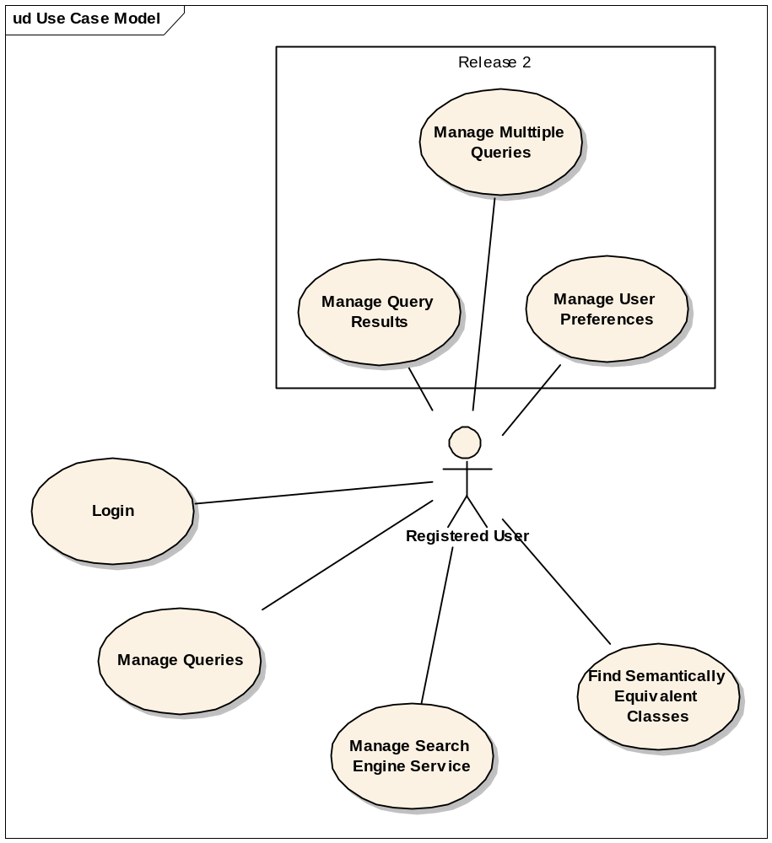

Login

Use Case Model
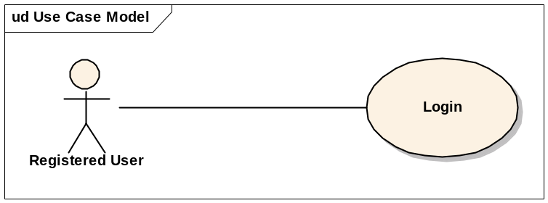

Brief Description
In this use case a user logs into the system

Primary Actor
Registered User

Secondary Actors
None

Preconditions
The application is pre-loaded with the correct URL to the IdP service.

Basic Flow of Events
- The system presents a login screen that includes fields for username, password and for selecting an Identify Provider (IDP).
- The User provides his username, password and IDP
- caTRIP successfully authenticates the user with the provided credentials.
- caTRIP grants access to the system.

Alternative Flows

No index service configured
- Before presenting the login screen, the system detects no index service configured
- The system will present an Index Service screen with one field for the index service URL
- The user enters the index service URL (a default value is provided by the system)
- The system presents the login screen
- Continue from step 2 of the basic flow

No IDP configured
- Before presenting the login screen, the system detects that there is no IDP configured.
- The system will present an IDP screen with one field for the IDP URL.
- The user enters the IDP URL (a default value is provided by the system)
- The system presents the login screen
- Continue from step 2 of the basic flow

Invalid Credentials
- This use case flow of events starts at Step 3 of the Basic Flow if the system indicates that the login or password provided is invalid.
- caTRIP presents the login screen again and displays a message that the login credentials were invalid. caTRIP directs the user to contact the system administrator for support if he has problems connecting to caTRIP.

Postconditions
None

Special Requirements
None

Manage Query

Use Case Model
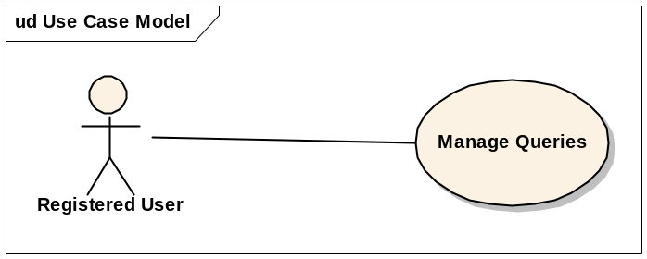

Brief Description
In this use case, a user has the ability to run, create, edit, delete and save queries.

Primary Actor
Registered User

Secondary Actors
None

Preconditions
User is logged in

Basic Flow of Events
- The user creates a query.
- The user selects to submit the query.
- The system will query the available systems
- The system returns the data in a tabular format.

Alternative Flows

Save a Query
- This use case flow of events starts at Step 4 of the Basic Flow when the user wants to save the query
- The system will prompt the user to save a new query or perform a Save As on an existing query.
- The user is prompted to enter the following:
  - author
  - description
  - query name
- The system will add the following meta data:
  - date
  - caTRIP version
  - source (basic/advanced)
- The system will save the query.

Open a Saved Query
User navigates to select a query screen
User selects a query
The system opens the query

Delete a Query
- User navigates to the delete query screen
- The system displays a list of saved queries
- The user selects the query to be deleted
- The system prompts for confirmation
- The user accepts and the query is removed from the system.

Share a Query
1. The user creates a query
2. The user elects to save this query to a shared area.
3. The user is prompted to enter the following metadata
  - author
  - description
  - query name
4. The system will automatically store the following
  - caTRIP version
  - date
  - source (basic/advanced)
5. The query is saved to a shared area.

Update a Query
- The system presents the user with a query selection screen
- The user selects a query to update.
- The system load the query into the query editing screen displaying the query and the services it will query against.
- The user makes a change
- See alternate flow Save a Query

Postconditions
None

Special Requirements
None

Locate Equivalent Classes

Use Case Model
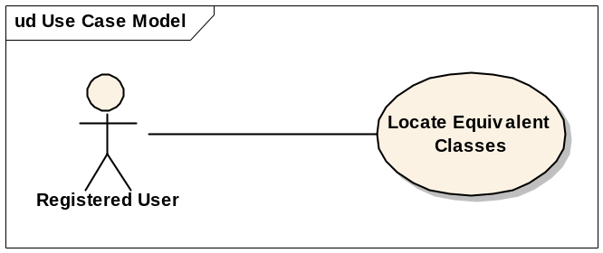

Brief Description
In this use case, a user selects to find all the semantically equivalent classes across services. A user would execute this use case to have the system find equivalent classed in other services. For example, one service may have a patient class and another has a participant class. The two are named differently but they are semantically equivalent.

Primary Actor
Registered User

Secondary Actors
None

Preconditions
User is logged in.

Basic Flow of Events
- User selects a source class for which to find all of its semantically equivalent classes
- The System will display a list of matching classes
- User selects one of the semantically equivalent classes
- The system will display the CDEs for the selected class
- The user will select one CDE from the source class and one CDE from the semantically equivalent class.
- The user accepts the selections.
- The system displays a graphical representation of the classes and link.

Alternative Flows

Postconditions
None

Special Requirements
None

Find Associated Classes

Use Case Model
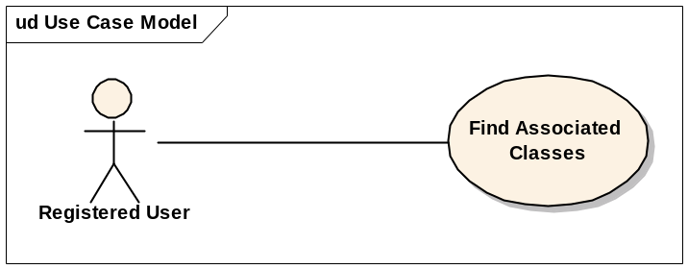

Brief Description
In this use case, a user selects to find all associated domain classes within a selected service. A user would execute this use case to find all the classes which have a direct relationship with a selected class.

Primary Actor
Registered User

Secondary Actors
None

Preconditions
User is logged in.

Basic Flow of Events
- User chooses to find all the domain classes for a selected class.
- The system display a list of matching classes
- The user chooses one or more of the classes and selects ok.
- The system displays the selected domain model class(es) together with the links to the source class.

Alternative Flows

Postconditions
None

Special Requirements
None

Manage Search Engine Service

Use Case Model
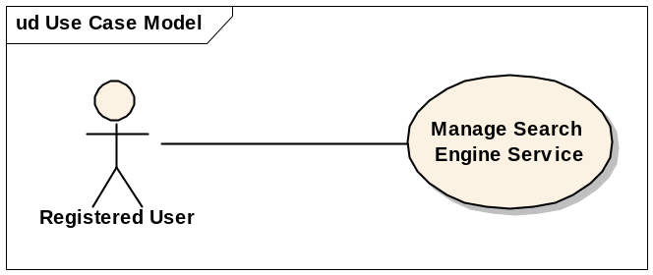

Brief Description
In this use case, a user can view, add and remove a distributed query engine services.

Primary Actor
Registered User

Secondary Actors
None

Preconditions
User is logged in.

Basic Flow of Events
- The user chooses to view the list of search engine services.
- The system displays the services

Alternative Flows

Manually add a search engine service
- User selects to add a service
- User enters the URL of the service and a unique service name
- User selects save.
- The system will locate the new service and add it to the list of search engine services.

Remove a search engine service
- This use case flow of events starts at Step 2 of the Basic Flow
- User selects a service(s) to remove and saves
- The system deletes the service(s).

Indicate a default search service
- This use case flow of events starts at Step 2 of the Basic Flow
- The user indicates the default service and presses save.
- The system saves the information.
- This use case flow of events starts at Step 2 of the Basic Flow

Postconditions
None

Special Requirements
None

Manage User Preferences

Use Case Model
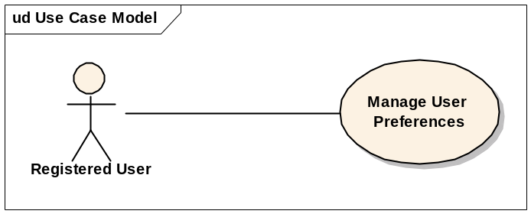

Brief Description
In this use case, a user can view and edit user preferences.

Primary Actor
Registered User

Secondary Actors
None

Preconditions
User is logged in.

Basic Flow of Events
- The user chooses to view his current user preferences.
- The system displays the user preferences
- The user edits the preferences and presses save
- The system stores the changes

Postconditions
None

Special Requirements
The user will have the ability to edit the following:
- Reuse a set of services upon login
- Specify Default Search engine
- Specify folder for query download
- Remember user id and password

Manage Query Results

Use Case Model
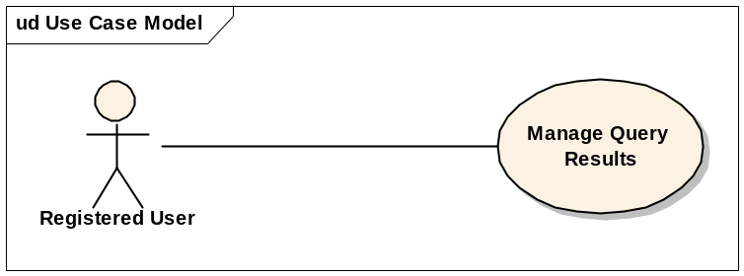

Brief Description
In this use case, a user can choose to send the query results via alternate methods.

Primary Actor
Registered User

Secondary Actors
None

Preconditions
  - User is logged in.
  - Has results from a submitted query
  - Has a valid email

Basic Flow of Events
- The user selects to email the query results.
- The user enters the email address and presses send.
- The system exports the results (see 3.3.7.1 Export Query Result).
- The system opens the client’s email program and enters the email address and attaches the results

Alternate Flow

Download query results
- The user selects to download the results in a CSV (comma delimited) format.
- The system will prompt the user to begin the download.
- The user accepts the download process and saves the file to the computer.

Postconditions
None

Special Requirements
None

Manage Multiple Queries

Use Case Model
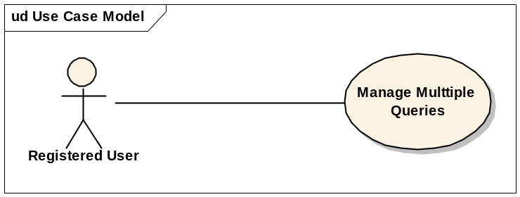

Brief Description
In this use case, a user can open and execute more that one query simultaneous – to be implemented in phase II.

Primary Actor
Registered User

Secondary Actors
None

Preconditions
User is logged.
User already has one query running

Basic Flow of Events
- The user selects to open a second query.
- The user submits the query
- The user selects to view the progress of each query.
- The system displays the current query statuses.
- The system notifies the user when each query completes
- Each query result is opened in a separate area.

Alternate Flow
None

Postconditions
None

Special Requirements
None

High-level Scientific Use Cases
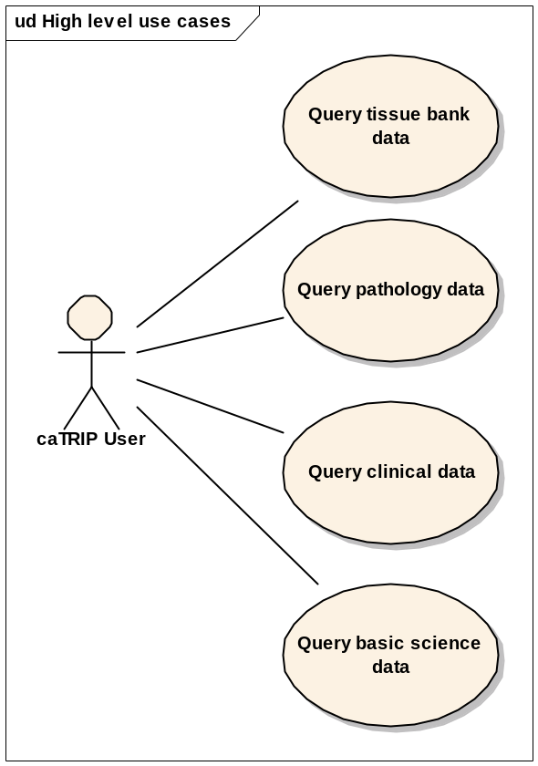

Query tissue bank data

Use Case Model
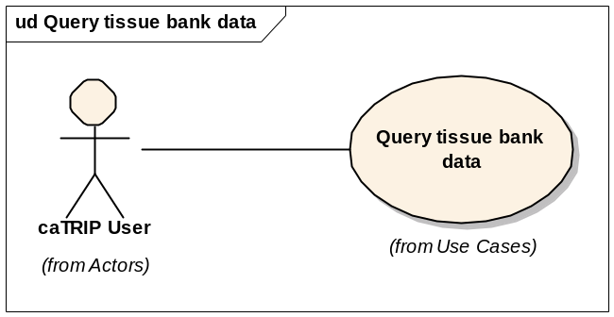

Brief Description
In this use case, a user can query tissue banking data. This will access one or more caTissue CORE grid services.

Primary Actor
Registered User

Secondary Actors
None

Preconditions
User is logged.

Basic Flow of Events
  - The user discovers a grid service that exposes tissue banking data
  - The user constructs a query
  - The user submits the query
  - The user gets tissue banking data back in the form of a report

Alternate Flow
None

Postconditions
None

Special Requirements
None

Query pathology data

Use Case Model
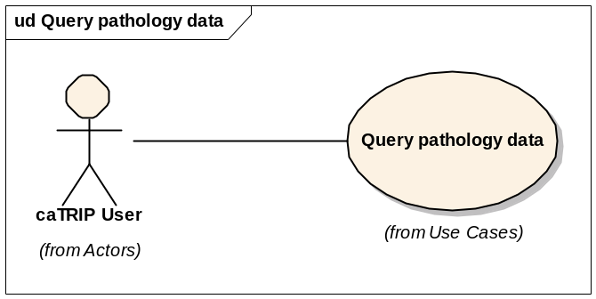

Brief Description
In this use case, a user can query pathology data. This will access one or more caTIES and CAE grid services.

Primary Actor
Registered User

Secondary Actors
None

Preconditions
User is logged.

Basic Flow of Events
  - The user discovers a grid service that exposes pathology data
  - The user constructs a query
  - The user submits the query
  - The user gets pathology data back in the form of a report

Alternate Flow
None

Postconditions
None

Special Requirements
None

Query clinical data

Use Case Model
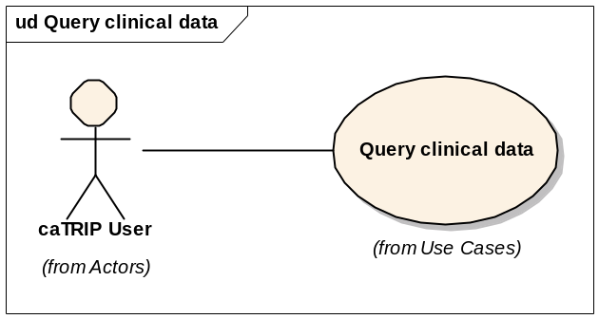

Brief Description
In this use case, a user can query clinical data. This will access one or more CTOM grid services

Primary Actor
Registered User

Secondary Actors
None

Preconditions
User is logged.

Basic Flow of Events
  - The user discovers a grid service that exposes clinical data
  - The user constructs a query
  - The user submits the query
  - The user gets clinical data back in the form of a report

Alternate Flow
None

Postconditions
None

Special Requirements
None

Query basic science data

Use Case Model
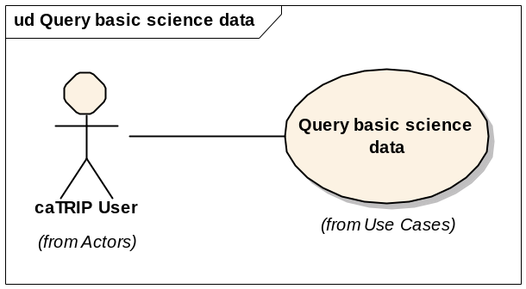

Brief Description
In this use case, a user can query basic science data. This will access one or more caIntegrator grid services.

Primary Actor
Registered User

Secondary Actors
None

Preconditions
User is logged.

Basic Flow of Events
  - The user discovers a grid service that exposes basic science data
  - The user constructs a query
  - The user submits the query
  - The user gets basic science data back in the form of a report

Alternate Flow
None

Postconditions
None

Special Requirements
None

Detailed Scientific Use Cases

Find available tumor tissue

Use Case Model

Scientific Description
The overall goal of this use case is for a user to determine if there is any tumor tissue available for the patients in a given protocol or study. The patients are identified as being on a study by their MRN on a list provided by the user. The result is a list of specimen identifiers and locations that can be requested from a specified banking center.

Technical Description
The overall goal of this use case is for a user to determine if there is any tumor tissue available for the patients in a given protocol or study. The patients are identified as being on a study by have their MRN on a list provided by the user. The query starts with the TissueSpecimen class in caTissue CORE, and various filters on MRN, date of treatment, tumor site, and pathology biomarkers can be applied. The result is a list of specimen objects that could be explored further.

Primary Actor
Registered User

Secondary Actors
None

Preconditions
The user has a list of patient identifiers, such as MRNs.

Basic Flow of Events
  - The user loads their patient identifiers into caTRIP
  - The user constructs a query based on the following services and fields:
    - caTissue CORE
      - TissueSpecimen
        - available=true
      - SpecimenCharacteristics
        - tissueSite=breast
      - CollectionEventParameters
        - timestamp (foreign key)
      - SpecimenCollectionGroup
      - ClinicalReport
      - ParticipantMedicalIdentifier
        - medicalRecordNumber (foreign key)
  - The user submits the query
  - The user gets back a list of banked tissue samples

Alternate Flow
- The user adds a query filter on pre-treatment
  - Tumor Registry
    - Patient
      - mrn=ParticipantMedicalIdentifier.medicalRecordNumber
    - Diagnosis
    - Activity
      - dateOfFirstTreatment>CollectionEventParameters.timestamp
- The user adds a query filter on post-treatment
  - Tumor Registry
    - Patient
      - mrn=ParticipantMedicalIdentifier.medicalRecordNumber
    - Diagnosis
    - Activity
      - dateOfFirstTreatment<CollectionEventParameters.timestamp
- The user adds a query filter on tumor location
  - Tumor Registry
    - Patient
      - mrn=ParticipantMedicalIdentifier.medicalRecordNumber
    - Diagnosis
      - primarySite=[user value]
- The user adds a query filter on pre-surgery
  - Tumor Registry
    - Patient
      - mrn=ParticipantMedicalIdentifier.medicalRecordNumber
    - Diagnosis
    - Surgery
      - dateOfFirstTreatment<CollectionEventParameters.timestamp
- The user adds a query filter on post-surgery
  - Tumor Registry
    - Patient
      - mrn=ParticipantMedicalIdentifier.medicalRecordNumber
    - Diagnosis
    - Surgery
      - dateOfFirstTreatment>CollectionEventParameters.timestamp
- The user adds a query filter on pathology biomarker
  - CAE
    - AnnotatableEntity
    - AnnotationEventParameters
    - ParticipantIdentifiers
      - mrn=ParticipantMedicalIdentifier.medicalRecordNumber
    - BreastCancerBiomarkers
      - estrogenReceptor=[user value] or
      - HER2Status=[user value] or
      - HER2TestType=[user value] or
      - progesteroneReceptor=[user value] or
      - EGFRStatus=[user value]

Postconditions
None

Special Requirements
None

Find factors of survival

Use Case Model

Scientific Description
The overall goal of this use case is for a user to determine factors of survival for individuals with breast cancer. The query permits identification of cohorts of patients who have survived a certain number of years following their diagnosis of breast cancer based on other search parameters specified (BRCA1/2 results, pathology biomarkers, etc.).

Technical Description
The overall goal of this use case is for a user to determine factors of survival for individuals with breast cancer. The query is across all available patients in the database as identified by MRN. The query starts with the Patient class in the Tumor Registry, and various filters on BRCA1/2 results, pathology biomarkers, vital status, and epidemiological can be applied. These could either be query filters or part of the resulting report for further interrogation by a researcher. A unique aspect of this use case is that a report that spans multiple objects should be generated for the researcher.

Primary Actor
Registered User

Secondary Actors
None

Preconditions
None

Basic Flow of Events
- The user constructs a query based on the following services and fields:
    - Tumor Registry
      - Patient
        - mrn (foreign key)
    - caIntegrator SNP
      - StudyParticipant
        - studySubjectIdentifier=Patient.mrn
        - SNPAnalysisGroup,name=brca1 and/or
        - SNPAnalysisGroup,name=brca2
- The user submits the query
- The user gets back a list of patients and potential confounding factors
    - Tumor Registry
      - Diagnosis.causeOfDeath
      - Patient.race
      - Patient.sex
      - Patient.dateOfBirth
      - DiseaseExtent.clinicalNodeState
      - DiseaseExtent.tumorSize
      - DiseaseExtent.clinicalMetStage
      - Diagnosis.histologicGrade
      - Diagnosis.histology
      - Radiation
      - Chemotherapy
      - Surgery
    - caIntegrator SNP
      - SNPAnalysisGroup
      - SNPAssociationAnalysis
      - SNPAssociationFinding
      - SNPAnnotation
      - GeneBiomarker
    - CAE
      - BreastCancerBiomarkers.estrogenReceptor
      - BreastCancerBiomarkers.HER2Status
      - BreastCancerBiomarkers.HER2TestType
      - BreastCancerBiomarkers.progesteroneReceptor
      - BreastCancerBiomarkers.EGRFStatus

Alternate Flow
- The user adds a query filter on pathology biomarker
    - CAE
      - AnnotatableEntity
      - AnnotationEventParameters
      - ParticipantIdentifiers
        - mrn=Patient.mrn
      - BreastCancerBiomarkers
        - estrogenReceptor=[user value]
        - HER2Status=[user value]
        - HER2TestType=[user value]
        - progesteroneReceptor=[user value]
        - EGFRStatus=[user value]
- The user adds a query filter on clinical information
    - Tumor Registry
      - Patient
        - race=[user input]
        - sex=[user input]
        - dateOfBirth<[user input]
- The user adds a query filter on diagnosis
    - Tumor Registry
      - Diagnosis
        - exists(causeOfDeath) or not(exists(causeOfDeath))
- The user adds a query filter on type of treatment
    - Tumor Registry
      - exists(Radiation)
      - exists(Chemotherapy)
      - exists(Surgery)
- The user adds a query filter on type of surgery
    - Tumor Registry
      - exists(RegionalLymphNodeSurgery)
      - exists(PrimerySiteSurgery)
      - exists(NonCancerDirectedSurgery)
      - exists(RegionalDistantSurgery)

Postconditions
None

Special Requirements
None

Determine the distribution of disease factors over time

Use Case Model

Scientific Description
The overall goal of this use case is to determine the distribution over time of a number of factors that may contribute to or reflect progression of a disease state (such as recurrence or metastasis or death). These factors could be laboratory values, social stressors, serum tumor markers, change in expression of pathology biomarkers, etc. The result is aggregated data, such as counts over time or trend data for numerical data elements.

Technical Description
The overall goal of this use case is to determine the distribution over time of a number of factors that contribute to disease state. These factors could be pathology biomarkers. The result is aggregate data, such as counts over time.

Primary Actor
Registered User

Secondary Actors
None

Preconditions
None

Basic Flow of Events
- The user constructs a query based on the following services and fields:
- CAE
- Participant
- AnnotatableEntity
- AnnotationEventParameters
- BreastCancerBiomarkers
        - estrogenReceptor=[user value]
        - HER2Status=[user value]
        - HER2TestType=[user value]
        - progesteroneReceptor=[user value]
        - EGRFStatus=[user value]
        - timestamp>=[user value] and timestamp<[user value]
- TumorRegistry
- DiseaseExtent.clinicalNodeState
- DiseaseExtent.tumorSize
- DiseaseExtent.clinicalMetStage
- Diagnosis.histologicGrade
- Diagnosis.histology
- The user submits the query
- The user gets back a count of patients
- CAE
- count(Patient)

Alternate Flow
None

Postconditions
None

Special Requirements
None

Find patients for trials

Use Case Model

Scientific Description
The overall goal of this use case is to find patients that may be eligible for a particular clinical trial. The example used in this use case is that of the triple negative hormone and her-2/neu overexpression status (ER-negative, PR-negative, HER2 /neu-negative).

Technical Description
The overall goal of this use case is to find patients that may be eligible for a particular clinical trial. The example used in this use case is that of the triple negative (ER-negative, PR-negative, HER2 /neu-negative). The query starts with a patient in CAE and filters on the biomarkers, returning a list of patients. One way in which this use case is unique is that patient identifiable data must be returned to the user.

Primary Actor
Registered User

Secondary Actors
None

Preconditions
The user is authorized to see patient identifiable data.

Basic Flow of Events
- The user constructs a query based on the following services and fields:
- CAE
- AnnotatableEntity
- AnnotationEventParameters
- BreastCancerBiomarkers
- estrogenReceptor=negative
- HER2Status=negative
- progesteroneReceptor=negative
- The user submits the query
- The user gets back a list of patients
- CAE
- Patient
- AnnotationEventParameters
- ParticipantIdentifiers
- mrn

Alternate Flow
None

Postconditions
None

Special Requirements
None

Determine correlation of factors pre and post surgery

Use Case Model

Scientific Description
The overall goal of this use case is to find patients that have particular factors change before and after surgery. The factors of interest are primarily laboratory values but also other repeated data points such as drug levels, etc. The result is patient data that can be further explored to find correlating factors.

Technical Description
The overall goal of this use case is to find patients that have particular factors change before and after surgery. The factors of interest are pathology biomarkers. The result is patient data that can be further explored to find correlating factors. One way in which this use case is unique is the way that dates are filtered and then there is a “foreign” join on the same object type.

Primary Actor
Registered User

Secondary Actors
None

Preconditions
None

Basic Flow of Events
- The user constructs a query based on the following services and fields:
- Tumor Registry
- Patient
- mrn (foreign key)
- Diagnosis
- Surgery
- dateOfFirstTreatment (foreign key)
- CAE (before surgery)
- AnnotatableEntity
- AnnotationEventParameters
- ParticipantIdentifiers
- mrn=Patient.mrn
- AnnotatableEntity
- AnnotationEventParameters
- timestamp<Surgery.dateOfFirstTreatment
- BreastCancerBiomarkers
- estrogenReceptor (foreign key)
- HER2Status (foreign key)
- progesteroneReceptor (foreign key)
- CAE (after surgery)
- AnnotatableEntity
- AnnotationEventParameters
- ParticipantIdentifiers
- mrn=Patient.mrn
- AnnotatableEntity
- AnnotationEventParameters
- timestamp>Surgery.dateOfFirstTreatment
- BreastCancerBiomarkers
- estrogenReceptor != estrogenReceptor (from before surgery) or
- HER2Status != HER2Status (from before surgery) or
- progesteroneReceptor != progesteroneReceptor (from before surgery)
- The user submits the query
- The user gets back a list of patients
- Tumor Registry
- CAE

Alternate Flow
None

Postconditions
None

Special Requirements
None

Find pathology reports of interest

Use Case Model

Scientific Description
The overall goal of this use case is to find patients that have particular factors of interest and then retrieve associated pathology reports. The factors of interest are either consistently reported keywords within pathology reports or a set of manually abstracted granular pathology data or clinical data elements. The result is pathology reports

Technical Description
The overall goal of this use case is to find patients that have particular coarse grain factors and then retrieve pathology reports. The factors of interest are pathology biomarkers. The result is pathology reports. One way in which this use case is unique is that is returns a large blob of text that can be viewed by the user.

Primary Actor
Registered User

Secondary Actors
None

Preconditions
None

Basic Flow of Events
- The user constructs a query based on the following services and fields:
- CAE
- AnnotatableEntity
- AnnotationEventParameters
- AccessionIdentifiers
- surgicalPathologyNumber (foreign key)
- AnnotatableEntity
- AnnotationEventParameters
- BreastCancerBiomarkers
- estrogenReceptor=[user value]
- HER2Status=[user value]
- progesteroneReceptor=[user value]
- caTIES
- PathologyReport
- uuid= AccessionIdentifiers.surgicalPathologyNumber
- The user submits the query
- The user gets back a list of patients and their pathology reports
- caTIES
- PathologyReport
- uuid= AccessionIdentifiers.surgicalPathologyNumber
- Patient

Alternate Flow
- The user adds a query filter on factors
    - Tumor Registry
      - DiseaseExtent.clinicalNodeState
      - DiseaseExtent.tumorSize
      - DiseaseExtent.clinicalMetStage
      - Diagnosis.histologicGrade
      - Diagnosis.histology

Postconditions
None

Special Requirements
None

Overall Requirements

System Requirements Prioritization

Priority | Use Case Name | Supp Requirement Ref #
1 | Login
1 | Manage Query
1 | Find Semantically Equivalent Classes
1 | Find Associated Domain Classes
1 | Manage Search Engine Service
2 | Manage User Preferences
2 | Manage Query Results
2 | Manage Multiple Queries

High-level Scientific Requirements Prioritization

Priority | Use Case Name | Supp Requirement Ref #
1 | Query tissue bank data
1 | Query pathology data
1 | Query clinical data
1 | Query basic science data

Detailed Scientific Requirements Prioritization

Priority | Use Case Name | Supp Requirement Ref #
1 | Find available tumor tissue
1 | Find factors of survival
2 | Determine the distribution of disease factors over time
1 | Find patients for trials
2 | Determine correlation of factors pre and post surgery
3 | Find pathology reports of interest

Data Definitions
CDE – Common Data Element.
IDP – Identity Provider

Sign Off

Approval

Workspace General Contractor Rep Print Name Date
Architecture Workspace Rep Print Name Date
VCDE Workspace Rep Print Name Date
Workspace Working Group Rep Print Name Date
NCICB Rep Print Name Date

