Cancer Translational Research Informatics Platform(caTRIP)
Software Requirements Specification
Version 1.0

Document Change Record
Version Number | Date | Description
1.0 | June 16, 2006 | Initial Draft
2.0 | June 26, 2006 | Added Help requirements: Sanjeev
3.0 | 7/5/3006 | Modified query use cases, added scientific use cases: Patrick

TABLE OF CONTENTS
1. Introduction 6
1.1 Project Perspective 6
1.2 caTRIP System Diagram 7
1.2.1 Users and Characteristics 7
1.3 Release Overview 8
1.3.1 System scope 8
1.3.2 Out of scope for caTRIP 1.0 8
1.4 Document Overview 8
1.5 Reference Documents 8
1.6 Definitions 9
2. SYSTEM requirements 10
2.1 caBIG compatibility 10
2.1.1 Vocabularies and Data Elements 10
2.1.2 Application Programmatic Interface (API) 10
2.2 SYSTEM Environment 10
2.3 SECURITY Environment 12
3. caTRIP requirements 13
3.1 General requirements 13
3.2 FUNCTIONAL REQUIREMENTS 13
3.3 Scientific Data requirements 14
3.3.1 Data Types 14
3.3.2 caBIG Applications 14
3.3.3 Duke databases 14
3.3.4 Duke datasets 14
3.3.5 caBIG Application mappings 14
3.4 Scientific requirements 15
3.5 Online User Documentation and Help System Requirements 15
3.6 End User Account Management and Login 15
3.7 Auditing 16
3.8 Logging 16
3.9 Exceptional flow 16
3.10 Reliability 16
3.11 Maintainability 16
3.12 Portability 16
3.13 Version control 16
3.14 Software generation and integration 16
4. CATRIP ARCHITECTURE 17
4.1 LOGICAL VIEW 17
4.2 COmponent VIEW 18
4.3 DEployment view 19
4.4 CATRIP DESIGN 20
4.4.1 FEDERATED QUERY ENGINE 20
Class Diagram: Federated Query Engine 21
Sequence Diagram: Federated Query Engine 22
4.4.2 GRAPHICAL USER INTERFACE 23
Class Diagram: Authentication infrastructure. 25
Class Diagram: Service and Domain Model Discovery infrastructure. 26
Sequence Diagram: Query Execution. 27
4.4.3 DOMAIN SERVICES 28
4.4.4 EXCEPTIONS 28
5. Assumptions AND Dependencies 29
5.1 Assumptions about system users 29
6. Usability 29
6.1 Design for ease of use 29
6.2 Number of records 29
6.3 Sortable Columns 29
6.4 ACcessibility 29
6.5 USER PREFERENCES 29
7. General Assumptions 30
8. Dependencies 31
9. RISKS 32
APPENDIX A. ACRONYMS and abbreviations 33

Introduction
This document captures the complete software requirements for the caTRIP functional prototype to be developed under Statement of Work caBIG-ICR-00-21-20051219 as part of the caBIG™ project.

Project Perspective
The Duke Comprehensive Cancer Center, in collaboration with SemanticBits LLC, has been tasked with developing a translational research system for the Cancer Biomedical Informatics Grid (caBIG) project. The project, which is slated to last for one year, will be divided into two phases. In phase one, Duke will be developing a pilot infrastructure to tackle the difficult problem of outcomes analysis, where a clinician can access clinical, pathology, and basic science data from a cohort of patients to help guide the clinician in determining the best diagnostic and/or treatment modality for new patients. The infrastructure will be composed of a set of caBIG systems, some of which are already deployed at Duke and include C3D, caTIES, caTissue CORE, caArray, and RProteomics. These distributed data systems will be tied together using the caGrid technology developed as part of the caBIG project, leveraging open standards such as the WS-RF and the Globus Toolkit 4.0, XML, and data standards. The project will use existing datasets at the CALGB, Breast SPORE, and others within the Duke research community stored in the eBrowser, Decision Support Repository (DSR), and Medical Assistant on the World Wide Web (MAW3). Phase two of the contract will involve moving the pilot system to a production system that can be deployed and used at other cancer centers.

caTRIP System Diagram


MAW3
DSR
Tumor
Registry
caIntegrator
caTIES
CAE
CTOM
caTissue
Core
CAE
CTOM
CGEMS
SNP
Duke Databases
Domain Grid Services
Distributed
Query
Engine
query
Index Service
G
U
I

Users and Characteristics
The likely users of caTRIP are people with the job responsibilities listed below. The role(s) granted to each user in the application will depend on the specific responsibilities of the person’s job and other institutional rules under which they execute their responsibilities.
Registered User – These individuals manage query creation and execution. These users have access to de-identified data only. This use can be broken into three basic subcategories of users that may be using the system:
Clinician: a medical doctor that performs patient care and likely will have little technical knowledge of grid and other related concepts
Basic science researcher: a researcher in the biological or chemical sciences that performs experiments to validate scientific hypothesis and will likely have little technical knowledge of the grid and other related concepts
Data technician: a specialist that assists clinicians and basic science researchers in performing queries, manipulating datasets, and generating reports and will likely have some technical knowledge of the grid and other related concepts

Release Overview

System scope
The primary features that will be developed as part of the caTRIP project include the following:
- Ability to discover services that are registered with a particular index service
- Display services and their semantic/domain model metadata including the associated CDEs
- Graphically creating queries using semantic/domain model metadata
- Store, retrieve and edit queries
- Ability to graphically link classes together to build a query
- Ability to easily locate semantically equivalent classes within a service and also across services
- Ability to easily locate all classes directly associated with a selected class
- Submit a query to one or more caBIG systems that are deployed as data services on the caGrid 1.0
- Display de-identified data in the query results
- Download the results of a query to local file system

Out of scope for caTRIP 1.0
The following will be implemented in subsequent release(s):
- Management of multiple query submissions
  - Ability to create more than one query at a time.
  - Opening more than one query at a time
  - Executing more than one at a time
  - Display the status of all running queries

Document Overview
This SRS captures all the software requirements for the caTRIP project. The remaining SRS sections are organized as follows:
- Section 2, System Requirements Specification: Describes the requirements specific to ensuring that caTRIP conforms to the caBIG guidelines and requirements.
- Section 3, caTRIP requirements: Describes the functionality of caTRIP

Reference Documents
- Statement of Work caBIG-ICR-00-21-20051219
- caTRIP Use Case Document,
http://cabigcvs.nci.nih.gov/viewcvs/viewcvs.cgi/catrip/documentation/use_cases/caTRIP_Use_Cases.doc
- caTRIP Risk Matrix,
http://cabigcvs.nci.nih.gov/viewcvs/viewcvs.cgi/catrip/documentation/risks/caTRIP_Risk_Matrix.doc

Definitions
MUST - This word means that the definition is an absolute requirement of the specification.
MUST NOT - This phrase means that the definition is an absolute prohibition of the specification.
WILL - This word means that the definition is an absolute future requirement of the specification.
WILL NOT - This phrase mean that the definition is an absolute future prohibition of the specification.
SHOULD - This word means that there may exist valid reasons in particular circumstances to ignore a particular item, but the full implications must be understood and carefully weighed before choosing a different course.
SHOULD NOT - This phrase means that there may exist valid reasons in particular circumstances when the particular behavior is acceptable or even useful, but the full implications should be understood and the case carefully weighed before implementing any behavior described with this label.
MAY - This word means that a requirement is truly optional. The developer may choose to include the item based on the needs of their design.

SYSTEM requirements

caBIG compatibility

Vocabularies and Data Elements
One of the main goals of caBIG is to ensure that all applications use the same vocabulary and data elements for similar concepts across the grid. This will eliminate any inconsistency in data descriptors (metadata) and make it possible to pass semantically equivalent data with confidence across various applications within the grid
Req. ID | Requirement
VCDE-1 | caTRIP must use Enterprise Vocabulary Services (EVS) and Cancer Data Standards Repository (caDSR) for each and every data element and concept which will be exposed to the grid.

Application Programmatic Interface (API)

The main goal of caBIG is to create a network or grid of applications, which have the ability to share de-identified data and tools, thereby creating a World Wide Web of cancer research. In order to achieve this, all caBIG applications must provide an Application Program Interface (API) so that other applications can retrieve meaningful data for correlation with other applications or create new applications
Req. ID | Requirement
ARCH-1 | caTRIP system will expose well-defined API’s that could be invoked in a distributed environment.

SYSTEM Environment
caTRIP system will be developed on open source Java/J2EE platform using JDK 1.5.
The caBIG compatibility guidelines do not address the issue of the number of platforms and databases on which caBIG applications must run. Because caBIG is an open source project, it is desirable that testing be performed on the Linux platform.
Req. ID | Requirement
ENV-1 | The client software will be tested locally with the following operating systems:  - Windows XP  - Linux
ENV-5 | The client software will be tested locally with the following browsers:  - Internet Explorer 5.0x, 6.0x  - Mozilla Firefox  There will be no IE specifc code used for caTRIP. This includes technologies like DHTML and IE Specific JavaScripts.
ENV-9 | The system where caTRIP GUI will be installed will have an Internet Browser (Netscape or Internet Explorer etc) and Java Web Start installed.
ENV-10 | The application server will require at least the following:  - 1 GHz CPU  - 1 GB RAM  - 2 GB hard disk
ENV-15 | The client computer will require at least the following:  - 1 GHz CPU  - 512 MB RAM

System Requirements for the caBIG domain systems that are going to be integrated in the caTRIP system are:
caTissue Core system:
Req. ID | Requirement
ENV- 100 | Application Server: Jboss 4.0.0
ENV- 105 | Database : MySQL 4.1.10 OR Oracle
ENV- 110 | Java version 1.4.2 or higher
ENV- 115 | Apache Ant version 1.6.5
ENV- 120 | Mail server access (SMTP)

CAE system:
Req. ID | Requirement
ENV- 200 | Database: Oracle 9.2.0.6
ENV- 205 | Java Version: JDK 1.5
ENV- 210 | Java App Server: Jboss 4.0.0
ENV- 215 | Security: CSM User Provisioning Tool
ENV- 220 | Browser: Internet Explorer 5.x or later Mozilla Firefox 1.x
ENV- 225 | Apache Ant version 1.6.5
ENV- 230 | Database Server: Min. Disk Space = 8 GB, Min RAM = 1 GB
ENV- 235 | Application Server: Min. Disk Space = 2 GB, Min RAM = 1 GB

caTIES system:
Req. ID | Requirement
ENV- 300 | Java Version: 1.4.2_04
ENV- 305 | Database: MySQL 5.0
ENV- 310 | Application Server: Tomcat 5.0.28
ENV- 315 | Apache Ant 1.6.2
ENV- 320 | DeID 6.12

CTOM system:
Req. ID | Requirement
ENV- 400 | Application Server: Jboss 4.0.0
ENV- 405 | Database : MySQL 4.1.10 OR Oracle 9.x
ENV- 410 | Java version 1.4.2 or higher
ENV- 415 | Apache Ant version 1.6.5
ENV- 420 | Mail server access (SMTP)

caTRIP system:
Req. ID | Requirement
ENV- 500 | Application Server: Tomcat 5.0.28
ENV- 505 | Database : MySQL 4.1.10 OR Oracle 10.x
ENV- 510 | Java Version 1.5 or higher
ENV- 515 | Apache Ant version 1.6.5
ENV- 520 | Mail server access (SMTP)

SECURITY Environment
caGrid
Authentication Service
SAML
Assertion
User
Credentials
Dorian
Duke
Authentication Plugin
Duke Domain Controller
NT Security
Grid
Data Service
User Grid
Certificate
CSM
database
App User
Grid User
authentication
authorization
existing
application security
new
security model

Req. ID | Requirement
SEC-5 | caTRIP will use CSM APIs for user authentication; that is, to verify a user’s credentials and allow access to the application and authorization services.
SEC-10 | A Java Key Store will be needed at the caTRIP client side
SEC-15 | CA Certificate Chain to certify the caTRIP query engine service and the caTRIP user.
SEC-20 | User’s private key management system.
SEC-25 | Each caTRIP user shall be authenticated against a specific trusted Identity Provider (IDP) registered with Dorian in the caGrid in order to execute the Federated Query. The caTRIP GUI should provide a means for users to login.
SEC-30 | In Phase one of the caTRIP project, the login will be based on two fields; username and password.
SEC-35 | The login infrastructure may provide “Remember Me” feature in which the username and password are stored on the user’s client machine.
.

caTRIP requirements

Non Functional requirements
Req. ID | Requirement
GEN-5 | The use cases for the caTRIP system call for grid-enablement. Therefore, the caTRIP system will be deployable as a service on the caGrid. This would entail developing an analytical service and deploying it on caGrid.
GEN-10 | The caTRIP system should serve as a framework for translational research informatics and should support plug-in-ability of collaborating systems. This will make the caTRIP system highly reusable. Cancer centers that are engaged in translational research will be able to adopt the proposed system.
GEN-15 | The caTRIP system should completely be driven by metadata registered in the caDSR. Such metadata is taken from the UML domain models of the collaborating systems, as well as the proposed system. Queries should be formulated using metadata, and all GUI elements will need to be based on metadata.
GEN-20 | The caTRIP system should be able to interact with data services deployed on caGrid 1.0.
GEN-25 | An intuitive user friendly graphical user interface for building complex queries that can span across multiple collaborating systems and viewing result sets should be developed as a part of the proposed system. Queries should be built using the metadata that collaborating systems register in caDSR.
GEN-30 | Performance is a major consideration in a distributed system, especially a distributed query system. Queries must resolve in a timely fashion for the system to be usable. Thus, distributed joins should resolve in a timely manner. We define a timely manner on the order of minutes rather than hours.

FUNCTIONAL REQUIREMENTS
Req. ID | Requirement
UC-1 | A user logs into the system by entering his username, password and selecting the proper Identity Provider (IDP). The IDP is the mechanism to validate the user’s login credentials. When no IDP has been configured, the user is prompted to enter an IDP.
UC-5 | Query management includes the ability to edit, delete, create and run queries. Each query is submitted to other caBIG systems thru a federated query engine. The results are combined and returned in a tabular format.
UC-10 | A user can easily find all the semantically equivalent classes across caBIG applications. For example, one application may have a patient object and another has a participant object. The two are named differently but they are semantically equivalent thus can be linked together by the system.
UC-15 | A user can easily find all associated domain classes within a selected application. The associated classes are ones which have a direct relationship with the selected class. Once the associated class is selected, the system will automatically link them together.
UC-20 | Manage search engine services allows the user to add, remove and designate a default search engine service. The user can add a service if the system does not find an appropriate one. In order to reuse a service each time a query is issued, the user can designate one to the default service.
UC-25 | The system will provide the user with a set of user preferences. Each user can personalize the system with these settings. For example, a user can specify a default search engine to use each time he logs into the system.
UC-30 | A user can save or email the query results outside the system. When saving the results, the system will download a comma separated file. When emailing the results, the system will create the same comma separated file and use the client’s email system to complete the transfer.

Scientific Data requirements

Data Types
Req. ID | Requirement
SCD-1-1 | The system will allow the querying of tissue banking data
SCD-1-2 | The system will allow the querying of pathology data
SCD-1-3 | The system will allow the querying of clinical data
SCD-1-4 | The system will allow the querying of basic science data

caBIG Applications
Req. ID | Requirement
SCD-2-1 | The system will allow the querying of caTissue CORE
SCD-2-2 | The system will allow the querying of caTIES
SCD-2-3 | The system will allow the querying of CAE
SCD-2-4 | The system will allow the querying of CTOM
SCD-2-5 | The system will allow the querying of caIntegrator

Duke databases
Req. ID | Requirement
SCD-3-1 | The system will allow the querying of MAW3
SCD-3-2 | The system will allow the querying of Tumor Registry
SCD-3-3 | The system will allow the querying of GEMS SNP

Duke datasets
Req. ID | Requirement
SCD-4-1 | The system will allow the querying of GEMS dataset

caBIG Application mappings
Req. ID | Requirement
SCD-5-1 | The system will expose MAW3 data via the caTissue CORE object model
SCD-5-2 | The system will expose MAW3 data via the CAE object model
SCD-5-3 | The system will expose MAW3 data via the caTIES object model
SCD-5-4 | The system will expose DSR data via the CAE object model
SCD-5-5 | The system will expose DSR data via the CTOM object model
SCD-5-6 | The system will expose Tumor Registry data via the CTOM object model
SCD-5-7 | The system will expose GEMS SNP data via the caIntegrator object model

Scientific requirements

Query
Req. ID | Requirement
SC-1-1 | Filter values can be loaded from a file.
SC-1-2 | Filter criteria must support =, !=, <, <=, >, >=
SC-1-3 | Filter criteria must support strings, booleans, dates, floats, and integers
SC-1-4 | Joins must be allowed across systems (e.g. by mrn)
SC-1-5 | Filters must support AND/OR between filters
SC-1-6 | Filters must support the existence and non-existence of a class or attribute
SC-1-7 | Filters must support comparison between attributes (i.e. filter value is taken from an attribute instead of user input)

Reporting
Req. ID | Requirement
SC-2-1 | Values from the primary query must be viewable
SC-2-2 | Values from filter criteria must be viewable
SC-2-3 | Values from arbitrarily associated classes must be viewable in an interactive way
SC-2-4 | Large text objects must be viewable (e.g. pathology reports)
SC-2-5 | Counts of results must be viewable
SC-2-6 | Records must be exportable/copiable from the user interface
SC-2-7 | Aggregate data must be reportable and viewable (e.g. counts over time or trend data for numerical data elements) – this may leverage external tools for visualization

Security
Req. ID | Requirement
SC-3-1 | Deidentified data must be queriable and accessible
SC-3-2 | Identifiable data must be queriable and accessible by authorized users

Online User Documentation and Help System Requirements
Req. ID | Requirement
HLP-5 | The Online Help will be accessible via a keyboard shortcut (Ex F1).
HLP-10 | Help includes URLs pointing to external web sites, and the system will launch the browser with the target URL.
HLP-15 | There shall be a variety of help levels and documentation formats accessible from the UI. Ex. user cookbooks with examples, FAQ, email contacts etc.
HLP-20 | The Help System may allow user to store his/her own FAQ into the Help System for later use.
HLP-30 | The user shall be able to print the Help documentation from the UI directly.
HLP-35 | Help shall be context-sensitive (relevance based view of the contents) where relevant. In GUI, mouse-over banners will indicate use of buttons and fields.
HLP-40 | The help infrastructure shall allow user to search within the help content based on keywords.
HLP-45 | The Java Help system will leverage JavaHelp APIs.

End User Account Management and Login
A potential user who wants to have access to the caTRIP system must have a login to the Duke IT infrastructure in the form of a cancer center domain login. All existing staff and faculty have domain logins. Users outside of Duke must submit an application to Duke IT to get a login to the Duke system. This is typically only done when a formal collaboration or business association is formed.

Req. ID | Requirement
UACCT-1 | The system shall allow anyone who can navigate to the caTRIP URL, has a valid account and using the browser listed in requirement ENV_5 to have access to the system.
UACCT-5 | The system shall provide a mechanism to specify a designated email for the system administrator.
UACCT-10 | The application’s help page shall provide access to the following information:  - Name of the System Administrator  - Email address of the System Administrator  - Phone or pager number of the System Administrator  - Instructions for contacting Application Support  - Log in functionality
UACCT-15 | The system shall allow a user to log out of the application.

Auditing
caTRIP will not provide any auditing. Each caBIG system will be responsible for implementing basic auditing.

Logging
Logging must be implemented in the GUI and Federated Query Engine (FQE) components of the caTRIP system. In the case of the GUI, logs will be written to a file that will be stored on the users file system. Log file for the FQE will be stored on the application server, which is Tomcat, file system. This will greatly facilitate de-bugging problems that arise during the use of the caTRIP system.

Exceptional flow
Any runtime exceptions or errors must be reported to the user in a graphical window containing the probable cause of the problem and how to rectify that.
The exceptions and errors shall be divided into two groups:
- User errors
- OS and System/Application errors.

Reliability
The developers will do their best, within the time-limits imposed on them, to deliver a perfectly working product. No actual guarantees to the amount of software faults (bugs) in the finished product will be made, other than the fact that the product must pass a previously created set of tests. The details of this test bench are beyond the scope of this document, and will be specified in a separate document.

Portability
Since Java is platform-independent, the only portability requirement is to stay well clear of using native libraries and platform dependent 3rd party tools and java libraries.
All the paths for the local file system must not be hard coded. Example C:\myDir etc.

Version control
The source code generated will be kept in CVS on gforge site.

Software generation and integration
All code produced must be commented and documented. The process for building the finished product and all its sub-components from source code must be documented.

CATRIP ARCHITECTURE

LOGICAL VIEW
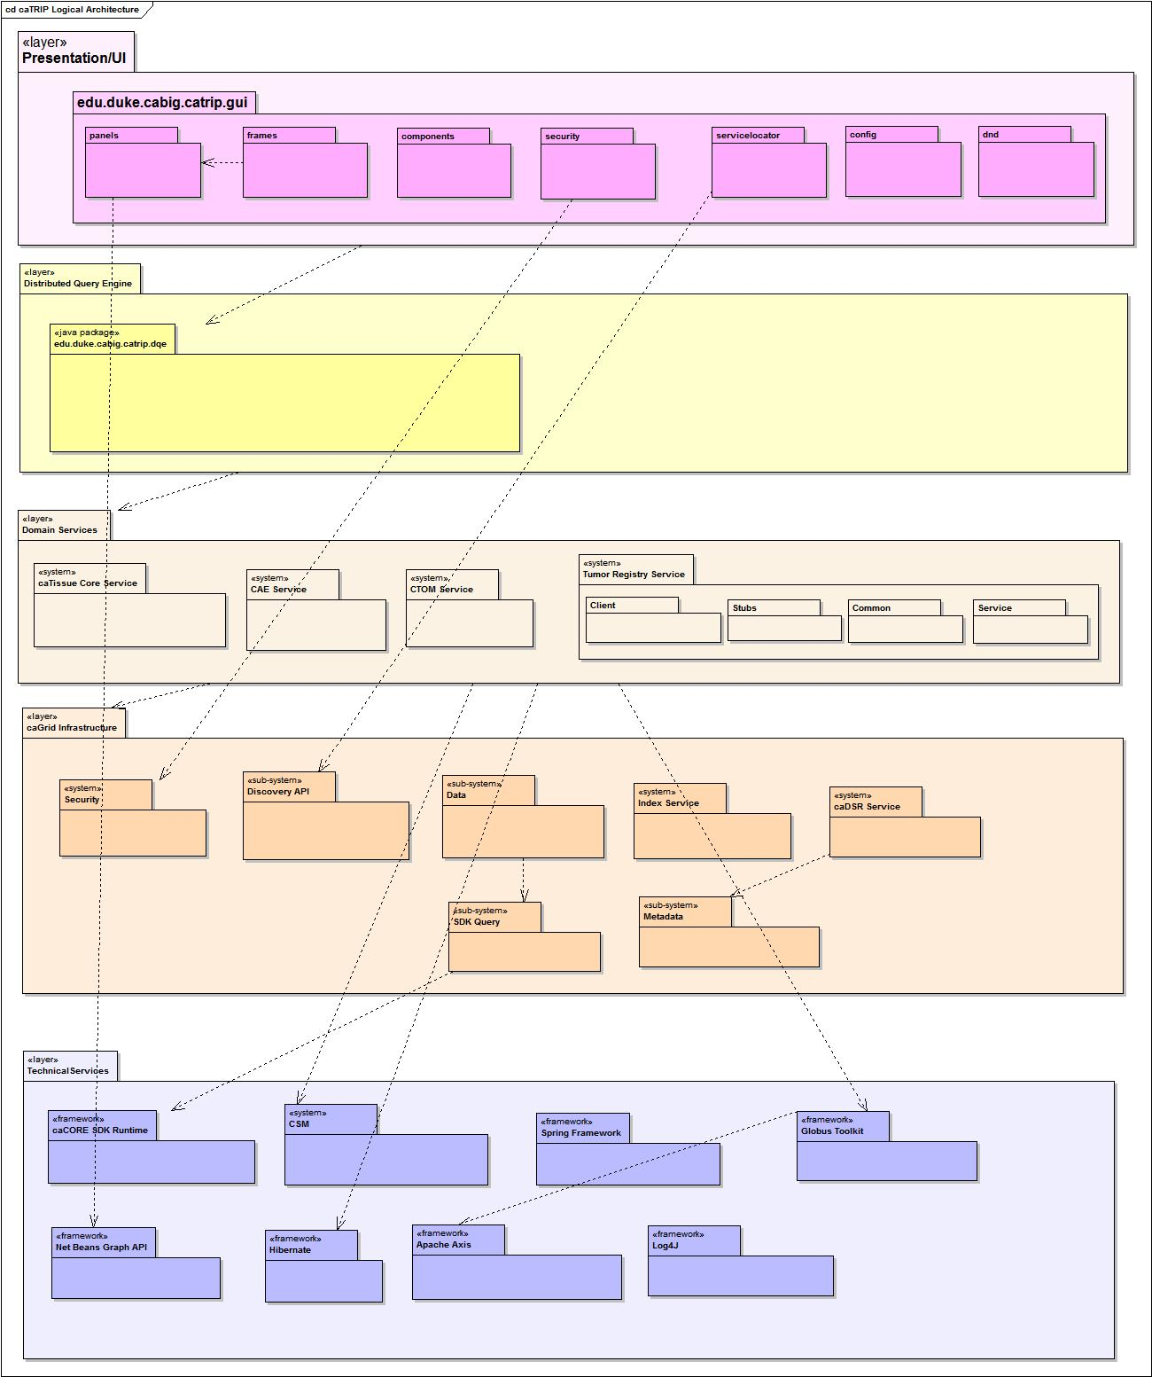

COmponent VIEW
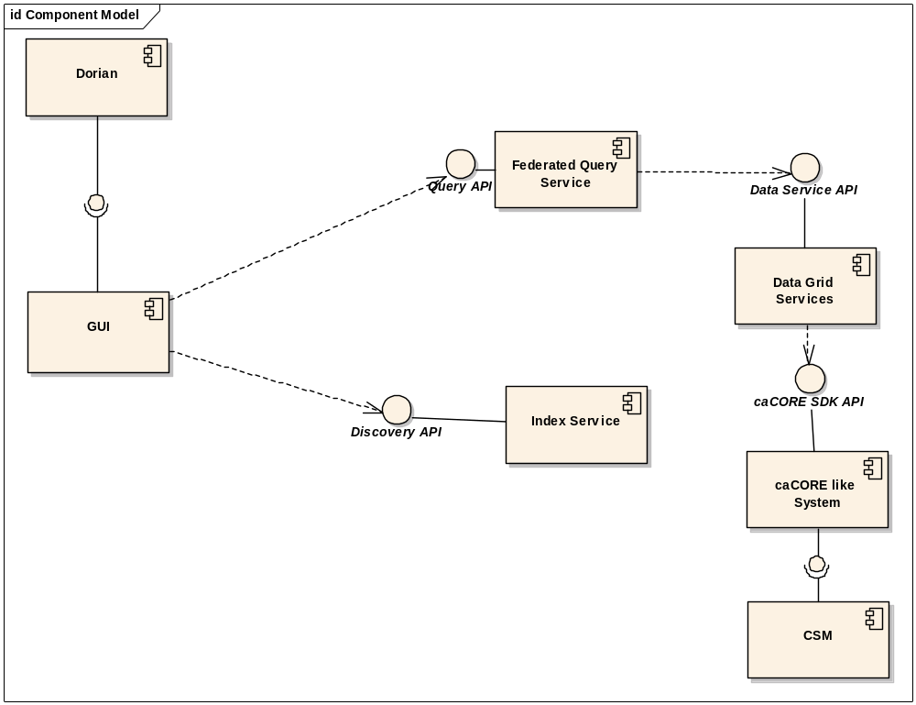

DEployment view
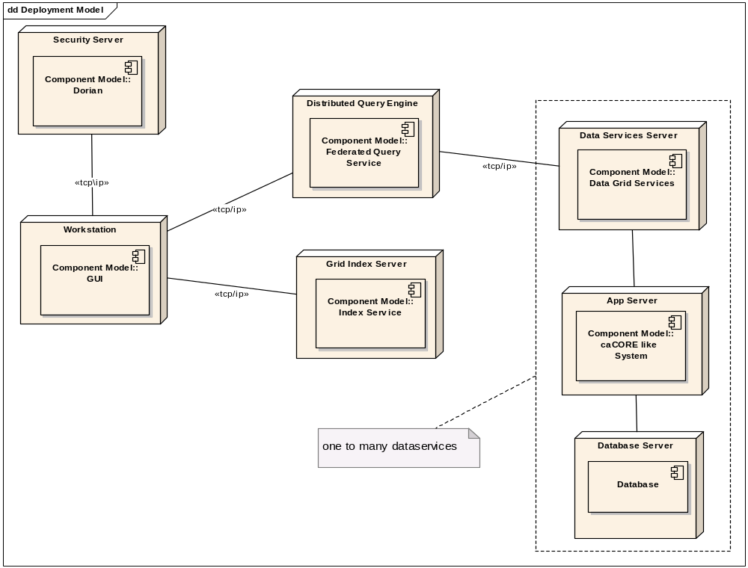

CATRIP DESIGN

FEDERATED QUERY ENGINE
The primary responsibility of federated query engine is to execute federated queries across the chosen caGRID data services. Queries written in the DCQL (distributed caBIG query language CQL) are the primary input to the engine. Main classes of federated query engine are described below.

FederatedQueryEngine

Federated Query Engine class is the entry point to the system. caTRIP GUI provides DCQL Query Object to this class. Federated Query engine calls Federated Query Processor to process the query and obtains resolved CQL query. The resolved CQL query is passed to federated query executor which executes the query and returns CQL Query Result Set. The Result Set would be handed over to caTRIP GUI which would display in tabular format.

FederatedQueryProcessor
The Federated Query Processor decomposes the DCQL query into individual data service queries. After decomposing the query, federated query processor passes each CQL query and service URL of the data service to Federated Query Executor. After processing all the federated queries, federated query processor builds a final CQL query and returns to Federated Query Engine.

FederatedQueryExecutor
Using CQL query federated query processor generates, the federated query executor issues a data source specific query to corresponding data source. It uses the Service Client Factory to obtain a reference to an appropriate data source query handler that actually executes the query. Results Obtained from a foreign data service are passed Result Aggregator for processing. Criteria group Result Aggregator generates is used as where clause to higher level Query.

ServiceClientFactory
Using service URL received from federated query executor, Service Client Factory instantiates appropriate Data Service and returns the instance to Federated Query Executor.

ResultAggregator
Result sets obtained by executing data source specific queries are processed by the Result Aggregator. Result Aggregator performs right and left joins on CDEs and builds criteria and returns the criteria as Group.

Class Diagram: Federated Query Engine

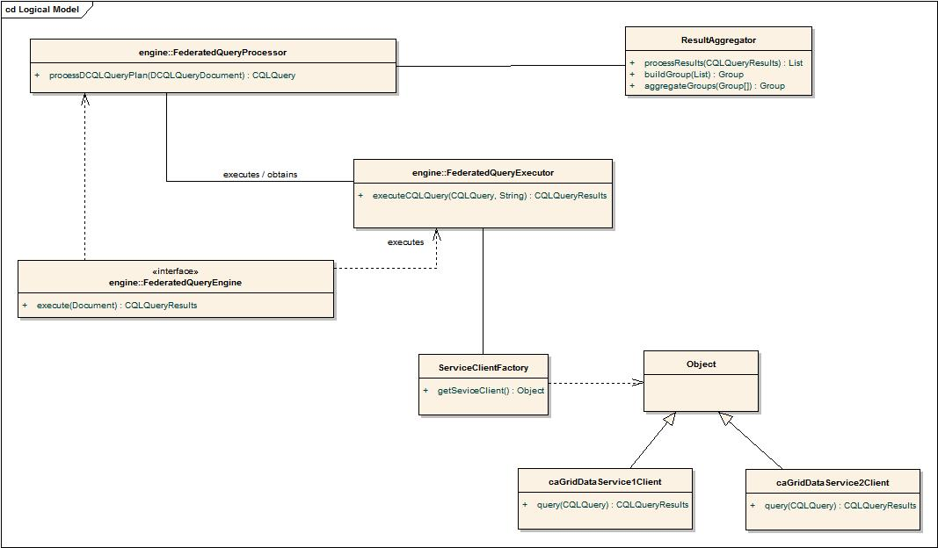

Sequence Diagram: Federated Query Engine
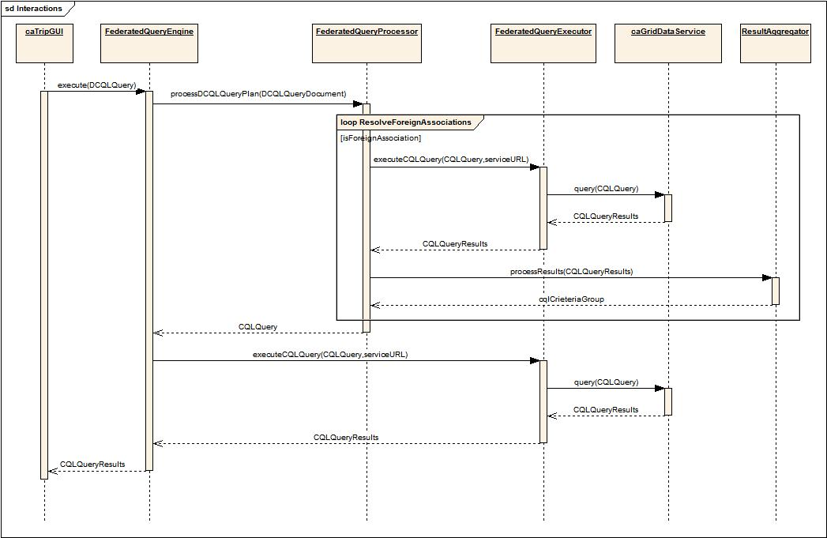

GRAPHICAL USER INTERFACE
The primary purpose of the caTRIP GUI is to enable user to create the Federated query in a Visual way. The queries then converted into the DCQL (distributed caBIG query language CQL) and sent to the Federated Query Engine for processing and the result is shown to the user in a tabular fashion. Some of main components/classes of caTRIP GUI are described below.
AuthenticationManager:
This class is responsible for authentication of the GUI user. The method "authenticate(String, String, String)" takes in the username, password and the idpProviderUrl.
GUIConfigurationLoader:
This class loads the configuration file for the GUI, like list of IDPs, directory location, login configuration and other settings.
LoginProviderLocatorFactory:
This factory class gets the appropriate LoginProviderLocator to get the list of IDPs.
DorianLoginProviderLocator:
This class connects to Dorian Server and get the list of Trusted IDPs for that caGrid infrastructure.
ServiceLocaterFactory:
This factory class gets the appropriate ServiceLocator to discover services.
DiscoveryClientServiceLocator:
This class is a ServiceLocator which uses Discovery APIs to talk to Index Service and get the list of Published Grid Services.
XMLFileServiceLocator:
This class is a ServiceLocator which gets the list of Grid Services from already downloaded serviceMetadata XML files.
ServiceMetaDataRegistry:
This class acts as a Registry for the Discovered Grid Services. The class provides the mechanism to mark the Discovered Services as selected Services for the purpose of GUI Domain Model tree building.
DomainModelMetaDataRegistry:
This class acts as a Registry for the classes from the Discovered Services. It has methods to bind and lookup the classes based on the unique class RefIds.
DomainModelRetrievalFactory:
This factory class gets a DomainModelRetrievalStrategy implementation for retrieval of the Domain Model for a given service.

DiscoveryClientDomainModelRetrievalStrategy:
This DomainModelRetrievalStrategy implementation uses Discovery APIs to get the Domain Model from the Index service.
JavaObjectDeSerializationDomainModelRetrievalStrategy:
This DomainModelRetrievalStrategy implementation uses locally serialized Java Objects to get the Domain Model using Java De serialization approach.
XMLDomainModelRetrievalStrategy:
This DomainModelRetrievalStrategy implementation uses Domain Model extracts from the caDSR, stored locally in the form of XML files.
DCQLBuilder:
This class creates DCQL out of the Visual Query.
DCQLExecutor:
This class executes the DCQL by sending the generated DCQL to the Federated Query Engine and gets the results back.

Class Diagram: Authentication infrastructure.

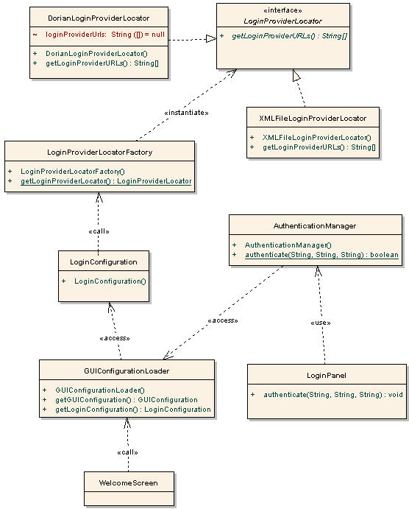

Class Diagram: Service and Domain Model Discovery infrastructure.
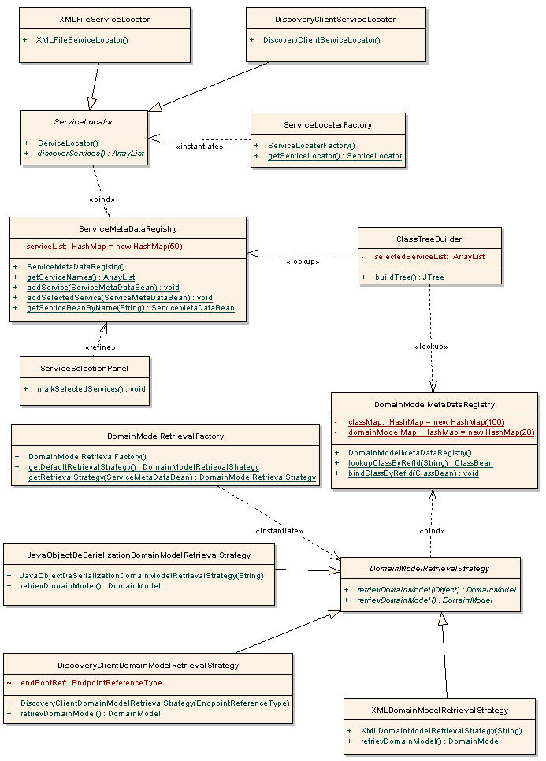

Sequence Diagram: Query Execution.
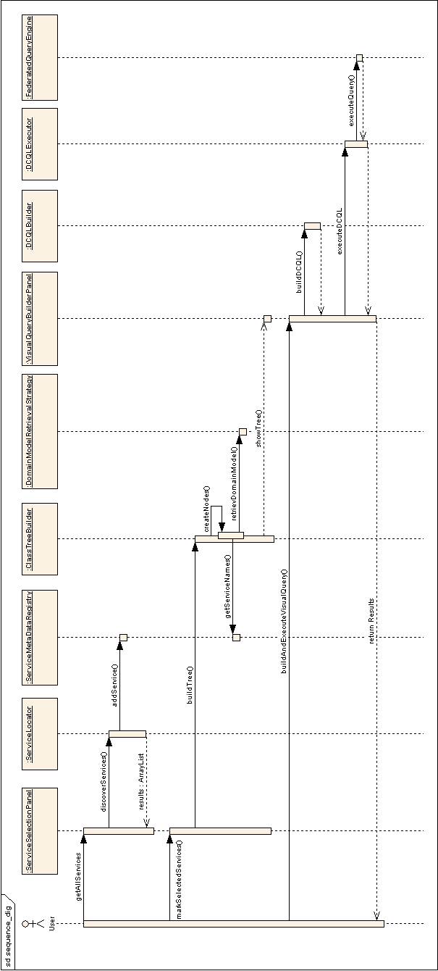

EXCEPTIONS
Some high level exceptions in caTRIP system are described below. We will ensure that a meaningful error message is associated with each of these exceptions.
AuthenticationFailedException
AuthenticationFailedException if user provides incorrect credentials.
IndexServiceNotAvialableException
IndexServiceNotAvialableException would be thrown if GUI could not able to locate index service.
MalformedQueryException
MalformedQueryException would be thrown if the generated DCQL from GUI doesn’t validate against DCQL xml schema. This exception also can be thrown if CQL generated by federated query engine doesn’t validate against CQL xml schema.
QueryProcessingException
QueryProcessingExcetion would be thrown if FederatedQueryProcessesor could not able to decompose DCQL or perform join conditions with federated query results etc.
DomainServiceNotAvialableException
DomainServiceException would be thrown if the target domain service is down, or if FederatedQueryExecutor could not able to connect to the provided domain service url.

Assumptions AND Dependencies

Assumptions about system users
AS-USER-1: All users are familiar with the basic conventions of graphical user interfaces, including dialog boxes to find files, clicking on a ‘+’ sign to expand a list and on a ‘-‘ sign to contract it, and the drag and drop concept. If they are not familiar with these conventions, they will be trained independently of the caTRIP project.
AS-USER-5: All users are familiar with medical terminology to the extent required to do their jobs. The definitions provided as system metadata are not intended to provide comprehensive understanding of the concepts in the domain, but rather to unambiguously identify them to a knowledgeable user.

Usability

Design for ease of use
The user interface shall be designed for ease-of-use by the designated end-users, shall use terms common to the user’s normal business environment, and shall require little to no additional training on the system.

Sortable Columns
The results from the query execution will be shown in a tabular fashion and the user will be able to sort based on any column's data.

ACcessibility
The caTRIP GUI application should be easy to launch preferably via double click on an icon.

USER PREFERENCES
The caTRIP GUI application should allow specifying user preferences to enable customization.

General Assumptions
Following is a list of assumptions
- The user is connected to the Internet continuously during the execution of the query.
- The services based on which the DCQL/CQL was created are published on the Index Service known to the FQE.
- The caBIG systems (services) used in the caTRIP project are up and running so that the FQE can communicate with them
- caTRIP doesn’t support any service level auditing; it is assumed that the auditing is taken care at the individual service level.
- Every caTRIP user has username, password and email id stored in an identity provider.
- The caTRIP user has permission to access at least one of the caBIG services that is part of the caTRIP system.

Dependencies
Dep. ID | Dependency Description
DEP-# | Since caTRIP system will be based on the infrastructure provided caGrid 1.0, there is a very strong dependency on it. We anticipate working very closely with the caGrid 1.0 development team. We will be using the interim stable builds of caGrid 1.0 during our development cycle.
DEP-# | caTRIP will be using a variety of caBIG and NCICB applications such as caTissue Core, CAE, CTOM and caIntegrator. This will create a strong dependency on the individual domain applications we end up using in the caTRIP project. We also plan to interact with the respective domain application development teams during the caTRIP development cycle.

RISKS
All recognized risks for caTRIP development project are listed in the document caTRIP Risk Matrix (listed in the Reference Documents section). To facilitate maintenance of the risk matrix, we do not reproduce it here.

APPENDIX A. ACRONYMS and abbreviations
Acronym | Stands for
API | Application Programming Interface
caBIG | Cancer Biomedical Informatics Grid
caDSR | Cancer Data Standards Repository
CAE | Clinical Annotation Engine
caTRIP | Cancer Translational Research Informatics Platform
CAP | College of American Pathologists
CDE | Common Data Element
EVS | Enterprise Vocabulary System
HIPAA | Health Insurance Portability and Accountability Act
NCI | National Cancer Institute
SOW | Statement of Work
SQL | Structured Query Language
UML | Unified Modeling Language
V/CDE | Vocabulary and Common Data Elements (Workspace)
FQE | Federated Query Engine

