Introduction
In order to have an impact in society, discoveries in cancer research need to be translated into knowledge that can be directly applied to treatment and prevention. These discoveries usually start within the basic sciences, from experiments developed at the molecular level, slowly progressing to clinical research or the research involving human subjects. Although this translational process is at the very basis of our ability to generate new knowledge, to date few tools have been developed to successfully link the basic and clinical science fields in an easy way so that researchers from both arenas can easily make connections between the two. More specifically, cancer research would benefit from the development of applications that could aggregate clinical and molecular data in repository that is easily accessible as well as compliant with regulatory requirements of privacy and security.

In line with the requirements outlined above, the Duke Comprehensive Cancer Center, in collaboration with SemanticBits LLC, has been tasked with developing the Cancer Translational Research Informatics Platform (caTRIP, https://cabig.nci.nih.gov/tools/caTRIP, this and all caBIG links last accessed on Feb/21/2007), a translational research system for the Cancer Biomedical Informatics Grid (caBIG) project. caTRIP allows users to query across a number of caBIG data services, join on common data elements (CDEs), and view their results in a user-friendly interface. Having as its initial focus the enabling of outcomes analysis, caTRIP allows clinicians to query across data from existing patients with similar characteristics to find treatments that were administered with success. In doing so, caTRIP can help inform treatment and improve patient care, but also allowing for search of available tumor tissue, locating patients for clinical trials, investigating the association between multiple predictors and their corresponding outcomes such as survival. Of importance, caTRIP relies on the vast array of open source caBIG applications, including (1) Cancer Central Clinical Database (C3D, https://cabig.nci.nih.gov/tools/c3d) a clinical trials data management system that is used to collect clinical trial data using standard case report forms (CRFs) based on common data elements (CDEs); (2) the cancer Text Information Extraction System (caTIES, https://cabig.nci.nih.gov/tools/caties), a locator of tissue resources that works via the extraction of clinical information from free text surgical pathology reports while using controlled terminologies to populate caBIG-compliant data structures; (3) caTissue CORE (https://cabig.nci.nih.gov/tools/catissuecore), a tissue bank repository tool for biospecimen inventory, tracking, and basic annotation; (4) caArray (https://cabig.nci.nih.gov/tools/caArray), a microarray data management system for submission, annotation and download of microarray data; (5) RProteomics (https://cabig.nci.nih.gov/tools/RProteomics), a tool for analysis of mass spectrometry proteomics data.
The objective of this article is to describe the caTRIP system in relation to its objectives, overall software architecture, security, implementation, usability, and future development plans.

Case Study: Outcomes Analysis
A motivating use case for the development of caTRIP is that of outcomes analysis, whereby a clinican can query data from a cohort of preexisting patients to inform treatment of another patient. An oncologist should be able to ask "what are the treatments and outcomes of other patients that have similar characteristics to my patient." Describe a case study scenario here. This could be the Her2/Neu positive lobular carcinoma use case, or some other.http://gforge.nci.nih.gov/plugins/scmcvs/cvsweb.php/catrip/documentation/use_cases/caTRIP_Use_Cases.doc?cvsroot=catrip

Design Objectives
Having its focus on outcomes analysis, we initially gathered the ideal objectives that should be met by caTRIP, illustrated by typical questions that should be answered by clinicians and researchers using the system. These objectives and example questions include:
- Allow for the search of available tumor tissue for patients with predicting factors of interest. A typical question to be answered by caTRIP would thus be would be "What are all the tissue specimens from her2/neu positive patients that have a primary tumor in the breast and are BRCA1 positive?"
- Identify predictors contributing to increased or decreased survival among a subset of cancer patients. It should answers questions such as "What are all the ER positive patients that have survived breast cancer after radiation treatment?"
- Determine the distribution over time of a number of factors that may contribute to or reflect progression of a disease state: Does a change in pathology biomarkers over time contribute to recurrence or death?
- Determine the association between a multitude of clinical predictors and their respective post-operative outcomes, such as "Does a change in ER or PR status before and after surgery correlate with other factors?"
- Identify patients eligible for participation in clinical trials who meet a pre-defined set of inclusion and exclusion criteria such as "List all patients that are triple negative (ER, PR, and HER2/NEU negative)?
- Identify pathology reports of interest, such as "Show me all pathology reports for Her2/Neu positive patients with a lobular carcinoma."
http://gforge.nci.nih.gov/plugins/scmcvs/cvsweb.php/catrip/documentation/use_cases/caTRIP_Use_Cases.doc?cvsroot=catrip

Technical Requirements
The technical requirements are used to inform the design of the system. They fall into the following broad categories:

- Scientific: requirements related to meeting specific scientific use cases
- System:requirements related to the functioning of the system
- Application: requirements related to running the application from an end-user perspective
- Non-functional: requirements that do not inform the functional features

The scientific requirements motivate the development of the project and provide scope for features. Our high level scientific use cases relate to accessing a variety of data types stored in a number of data systems at Duke. The Medical Assistant on the World Wide Web (MAW3), Genetic Modifiers of BRCA 1/2 (GEMS), and Tumor Registry data sources feed caTRIP pathology, clinical, tissue banking, single nucleotide polymorphism (SNP), and treatment/endpoint data. From this baseline, we defined the use cases described in section #, which feed into the system and application requirements that define the overall set of features that caTRIP implements.

The system requirements primarily relate development in the Cancer Biomedical Informatics Grid (caBIG) initiative. caBIG has outlined a rigorous set of requirements related to interoperability that span the categories of legacy, bronze, silver, and gold compatibility. Silver compatibility involves places requirements on both the data elements that are exposed to/by caTRIP, as well as the application programming interfaces (APIs). Data elements leveraged in caTRIP must be defined as common data elements (CDEs) registered in the Cancer Data Standards Repository (caDSR). Each CDE must have one or more concepts registered in the Enterprise Vocabulary Service (EVS). This comdination of defining the structure of the data, as well as the underlying concepts describing the provide caTRIP with a semantically rich information model to query upon. Comptability of the APIs in caTRIP falls more towards gold compatibility, which has not fully been defined yet. All data that is accessible to caTRIP must be exposed via caGrid data services. This means that the data is queriable via a well-defined interface that accepts queries via the caGrid Common Query Language (CQL), which defines the query in object-oriented terms corresponding to the registered CDEs. Finally, there are also system requirements related to security, which includes authenticating users based on credentials, as well as authorizing users to access data.

The application requirements relate to the features that directly impact the end-user. A scoping use case for caTRIP is that the user need not have any technical background or understand the backend data in order to use the application. For example, clinicians tend to prefer drop-down menu driven user interfaces rather than complex drag-and-drop interfaces. The data sources themselves should be dynamically discoverable such that the data items displayed should be metadata driven. Finally, the user should be able to save and share queries with others. While non-functional requirements do not impact end-user features, meeting them is important for any application to be successful. These include logging, auditing, exception handling, reliability, portability, scalability, and version control. caTRIP strives to meet these goals at varying levels, often leveraging underlying technology stacks (such as the relational databases).

More detailed about the system and scientific requirements can be found in the caTRIP SRS found at:
http://gforge.nci.nih.gov/plugins/scmcvs/cvsweb.php/catrip/documentation/requirements/caTRIP_Req_Spec.doc?cvsroot=catrip
In addition, readers may find useful the caTRIP Use Case Document, which can be found at:
http://gforge.nci.nih.gov/plugins/scmcvs/cvsweb.php/catrip/documentation/use_cases/caTRIP_Use_Cases.doc?cvsroot=catrip

Software architecture
caTRIP is developed as an N-tier architecture, with three primary tiers: domain services, the distributed query engine (DQE), and the graphical user interface (see Figure #). The domain services are grid service that expose information models that encapsule the underlying data. The distributed query engine takes as input a distributed common query language (DCQL) query, decomposes it into individual common query language (CQL) queries, issues those queries to the domain services, joins/aggregates the results, and returns the final results to the caller. The graphical user interface (GUI) provides a metadata-driven interface for building and running DCQL. It also provides and interface for saving and searching for queries.

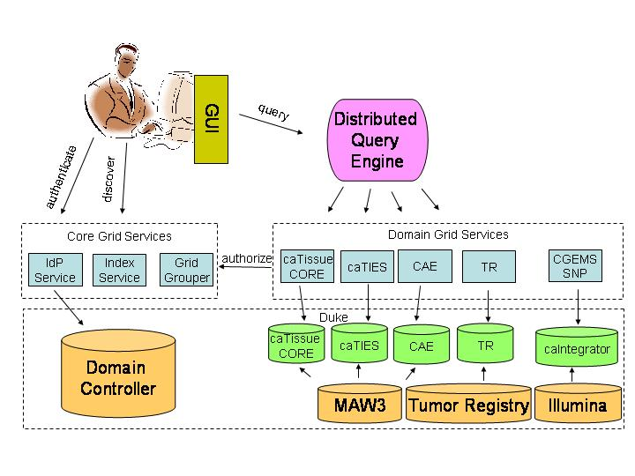
Figure #. High-level view of the caTRIP architecture, including Domain Services, Distributed Query Engine, and Graphical User Interface.
Patrick may need to replace this with a better architectural diagram.

A primary goal for caTRIP is to leverage existing technologies wherever possible. These include:

- Globus 4.1 for the underlying messaging stack
- caGrid 1.0 for the underlying service infrastructure
  - Introduce for service creation
  - Index Service for descovering services on the grid
  - Authentication Service to authenticate users using their instituational credentials
  - Dorian to obtain a grid user proxy
  - Grid Grouper to authorize users to access data based on groups
- Common Security Module (CSM) for plugging authorization into the data service
- Cancer Data Standards Repository (caDSR) for storing common data elements (CDEs)
- Enterprise Vocabulary Services (EVS) for storing semantic concepts
- Hibernate for an object-relational mapping
- Oracle and MySQL for backend relational databases

The following sections describe some of the caTRIP architectural components in more detail. More information can be found in the caTRIP architecture document and UML models:
Add links here

Graphical User Interface
The Graphical User Interface (GUI) is a Java Swing-based thick client that can be accessed via Java WebStart (URL). It provides the user with the ability to construct, execute, and share distributed queries in a graphical fashion. There are two primary ways to construct queries: the Simple Interface is a more limited, yet powerful way to build queries using drop-down menus, and the Advanced Interface is a flexible way to build queries using drag-and-drop.

Simple Interface
The Simple Interface was developed to target the clinician as an end user. Queries are constructured using drop-down menus to add filters, AND/OR groups, and return attributes (see Figure #). Available services are selected via a configuration file as are the CDEs that make up the drop-down menu items for filters and return attributes. Joins across these services are performed using common identifiers. Specifically, in caTRIP, we use the Medical Record Number (MRN) of patients to join and aggregate data. However, the data models of the underlying services are composed of potentially complex classes, attributes, and associations between the classes (see Figure #). To construct queries that span multipled classes and association, drilling into this information space, the configuration file describes the paths from the outbound path from each class to the class contain MRN, as well as the inbound path to each filterable/returnable CDE. This configuration file enables the logic to perform the work that would normally be performed by the user dragging classes onto a canvas and drawing associations between them.
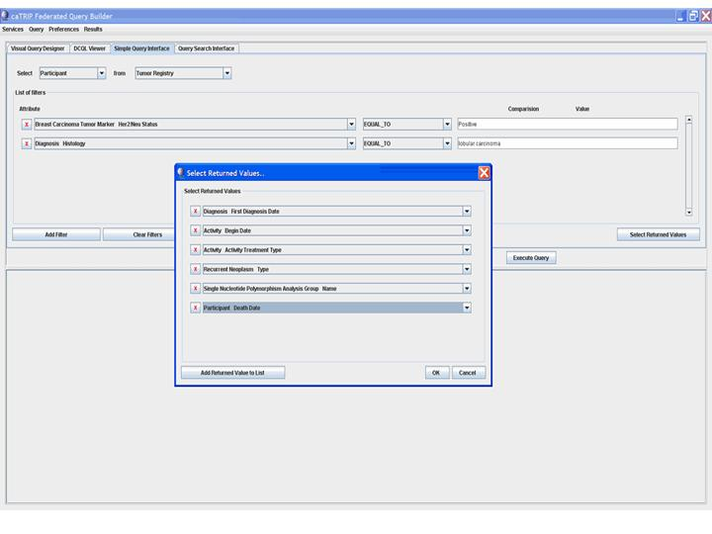
Figure #. Screenshot of the Simple Interface depicting a outcomes analysis translational query. This query is searching for all patients with a lobular carcinoma and a Her2/Neu status of positive. The return attributes are diagnosis date, treatment date, treatment type, recurrance, BRCA 1/2 status, and date of death.
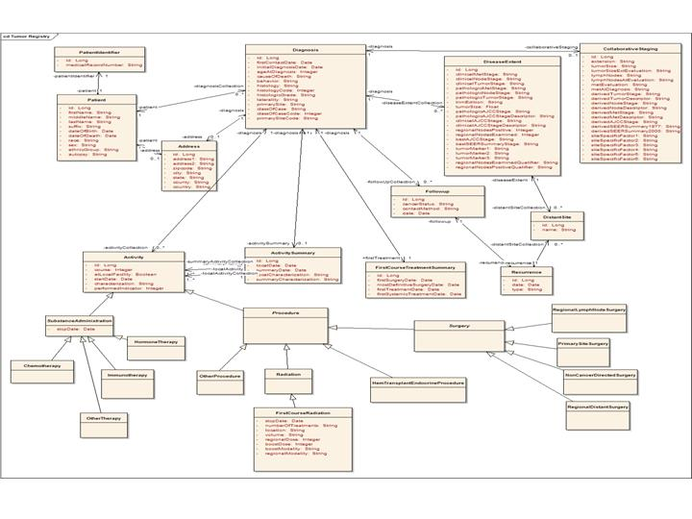
Figure #. Example domain model (Tumor Registry) depicting the relative complexity of an information model.

Advanced Interface
The Advanced Interface was developed to target a data technician. Queries are constructed by dragging classes onto a canvas, drawing associations between them, and adding filters along the way (see Figure #). Because the logic of how to traverse the information space is not built in like it is with the Simple Interface, the users must manually create the association paths to the classes/attributes that they would like to filter, as well as those they would like to perform cross-service foreign joins with. However, with this comes the flexibility to perform queries not supported by the Simple Interface. For example, the user can perform foreign joins using CDEs other than the MRN.
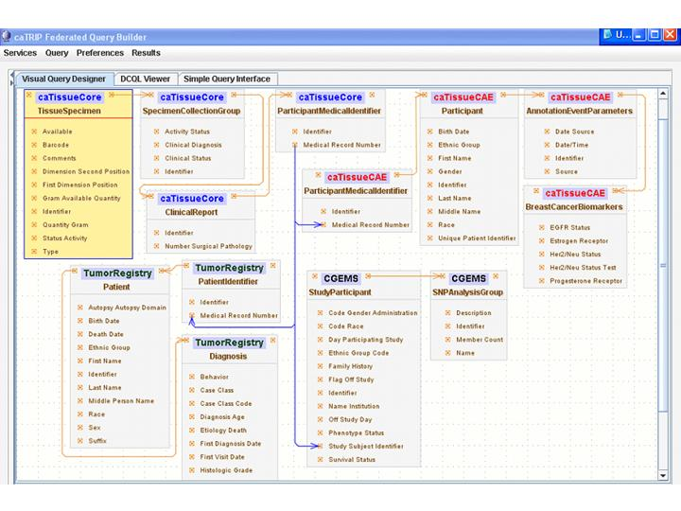
Figure #. Example Advanced Interfacing, depicting the potential complexity of distributed queries. The query addresses the question "what are all the tissue specimens from her2/neu positive patients that have a primary tumor in the breast and are BRCA1 positive?"

Distributed Query Engine
The Distributed Query Engine (DQE) provides the logic to perform a query across different caGrid data services. It takes as input a Distributed Common Query Language (DCQL) query, breaks it into separate Common Query Language (CQL) queries, issues those queries to the appropriate underlying data services, receives the results, performs joins, aggregates data, and returns the results. The DQE is built as a Java service and can be deployed as a grid service.

Domain Services
The domain services themselves can be further divided into a number tiers, including the relational database management system (RDBMS), Hibernate, CQL processor, and grid service (see Figure #). Hibernate provides an object abstraction of the underlying relational database, exposing tables and columns as classes and attributes in a flexible, configurable manner (reference). The CQL processor translates a CQL query based upon common data elements and their associations into a Hibernate Query Language (HQL) query. This is a relatively complex mapping because CQL and HQL have much different syntaxes. Finally, the grid service provides a standards-based entry point to issue a CQL query. caGrid provides the underlying technology stack for the grid service, which itself is based upon Globus 4.1 (caGrid reference, Globus reference).

Need to add some more text here?

Security
caTRIP leverages the caGrid 1.0 infrastructure, which provides robust security for a distributed, grid environment (see Figure #). This will be incorporated into the caTRIP application in the second quarter of 2007.
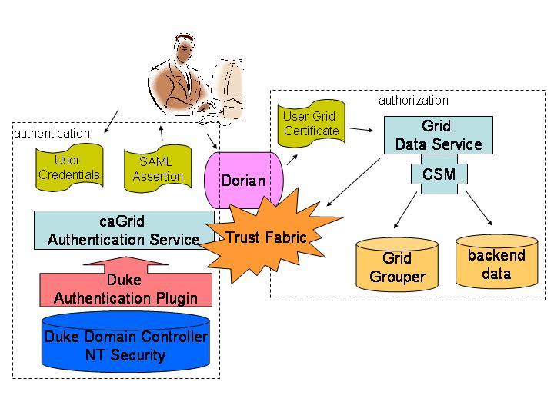

Authentication
The first step in the security workflow is authentication, which is the process by which a trusted organization claims a user is who they claim to be. This is implemented using the caGrid Authentication Service. The goal is for the user to obtain a grid user certificate to be used in authorization. The user submits their credentials (user name and password) to the AuthenticationService, which has an institutional identity provider (IdP) plug-in. This component performs the necessary steps to determine that the user credentials are valid. In the case of the Duke IdP plugin, the user name and password are validated against the Duke Domain Controller, which uses NT Security. This means that a user can log in with the same Cancer Center credentials they use to log in to their workstation. Once validated, the AuthenticationService returns a SAML Assertion to the user, which asserts that the user is who they claim to be. The SAML Assertion can then be passed off to a Dorian Service to generate a grid user certificate. All of these interactions are handled for the user by the caTRIP application.
Figure 2 High-level overview of the caTRIP security architecture

Authorization
The second step in the security workflow is authorization, which is the process by which a system grants the user access to specific resources. This is implemented using the Common Security Module (CSM) plug-in to the grid data service. The CSM is an open source toolkit that provides a flexible way to provision users and perform authorization. The grid user is mapped to an application user. When a data field is accessed on behalf of the user, an authorization structure is queried to determine if the user has permission to access it. If not, then a security exception is returned to the client. Authorization is made possible because a trust fabric exists between the service serving the data resource and the AuthenticationService.

Delegation and Foreign CDEs
One twist on the security workflow is delegation, which is the process by which a service acts on behalf of the user. This impacts caTRIP because the distributed query engine can be run as a service, so it must query the domain services using the user’s certificate. The architecture of delegation has not yet been fully described or implemented by the caGrid team. The final implementation will likely leverage the DelegationService from the Globus project. The user will signal the DelegationService that it is permissible for a collocated service to act on the user’s behalf. In the meantime, the distributed query engine simply passes the user's credentials to the data services identified in the distributed query. This bypasses some of the business rules encoded in the user certificate, such as number of delegation hops, but it is sufficient to meet caTRIP user cases.

Another twist on the security workflow is the use of “foreign CDEs” for the purpose of joining data. It is conceivable that a user does not have permission to view a CDE that is used for joining between two different domain services. The classic example of this is to join patients across services using the MRN. In this case, a special security workflow must be undertaken during authorization. A trust fabric will be instantiated between the distributed query engine service and the domain service such that foreign CDEs will be returned to the DQE service with the understanding that the delegated user is not authorized to view them but is authorized to join on them.

Customized Tools and Features
Note: extensibility of caTRIP will be implemented in phase 2.
The caTRIP application is a flexible, extensible system for querying and mining distributed data services on the grid. One way it can be extended by adding more data services for querying. The first step is for your data service to advertise itself with an IndexService so that the GUI is able to discover it. The GUI provides two different ways to build queries: the simple interface and the advanced interface. At this point, nothing more than advertisement is required to make the data service available to the advanced interface. To make the service available to the simple interface, a configuration file that is bundled with the Java Webstart application must be modified. Paths to and from foreign CDEs within the information model must be defined. The exact syntax and method of modifying this file is defined in the Administration Manual (not yet written).

Software testing

-Mccon012 2/20/07 3:08 PM
The testing approach for caTRIP is to convert the use cases into a number of automated unit, integration and system tests to ensure the software conforms to the requirements. Test cases are derived from updated functional specifications of all relevant use cases. Unit tests and testing scenarios were constructed in parallel with core development efforts, while validating the specifications against the relevant use cases. The use of diagrammatic representations of use cases in the form of task-based flow-charts, state diagrams, or UML sequence diagrams facilitated the creation of test cases and monitoring outcomes. Automated test execution using Ant and unit testing supported rapid testing, capturing issues eary in the development lifecycle, and provided detailed logs of frequent test results (through nightly builds). An automated test environment was setup based upon CruiseControl to ensure accurate and consistent testing outcomes. Usability testing was performed to ensure that the overall user experience is intuitive, while all interfaces and features both appear consistent and function as expected. Comprehensive usability testing is currently underway by clinicians at Duke using realistic scenarios.

More information about software testing can be found in the caTRIP test approach document found at:
URL

Installation requirements
The system requirements can be found in the caTRIP SRS found at:
http://gforge.nci.nih.gov/plugins/scmcvs/cvsweb.php/catrip/documentation/requirements/caTRIP_Req_Spec.doc?cvsroot=catrip

Implementation and end-user training
caTRIP is currently in its second phase of development. Phase 1 concluded the pilot development activities of caTRIP, providing a baseline architecture and proof-of-concept user interface. caTRIP is currently half way through development of a six month second phase aimed at providing a production-level software that could be deployed at individual cancer centers. Training documentation, including a user guide, installation guide, and technical guide will be available in May, 2007.

Usability
-Mccon012 2/20/07 3:13 PM

Formal Usability

Field Usability

Current Utilization
caTRIP is currently deployed at the Duke Comprehensive Cancer Center and is available to clinicians and researchers. A planned phase three of caTRIP development will involve the deployment and utilization of caTRIP to a broader community.

Future Plans
In phase one and two of caTRIP, use cases focused on intra-institutional problems, tearing down the silos of data-oriented systems in a single cancer center. In future iterations we plan to extend caTRIP to tackle cross-institutional use cases. This involves extending the caTRIP interface and distributed query engine to support aggregation of data from services that expose common data elements. For example, a motivating use case amongst prospective adopters is to aggregate treatment, endpoint, pathology, and tissue banking data from a number of different cancer centers. This will allow researchers and clinicians to expand their queries and answer questions that they previously could not at their own institution. Furthermore, we planto integrate caTRIP with analytics, specifically focusing on microarray analysis. The caBIG gene expression database, caArray, is a rich source of central or distributed gene expression data, which itself can be tied to clinical data, such as pathology biomarkers. This microarray data can be analyzed and visualized dynamically using services provided by other caBIG applications, such as geWorkbench, GenePattern, and Bioconductor. This notion of building workflows based upon queries designed using caTRIP’s simple interface can provide a powerful tool for both researchers and clinicians. Finally, we also planto enhance the user interface, providing more sophisticated reporting and data mining functionality. All of these features will be driven by end-user requirements of the adopter sites, which is a critical facet to the caBIG initiative.

Acknowledgements
The authors would like to acknowledge the contributions of the developers, database administrators, and system administrators at Duke, including Mark Peedin, Christopher Hubbard, Wilma Stanley, Farid Mohammad, and William Banks. We would also like to thank the development efforts of Srini Akkala and Sanjeev Agarwal from Semantic Bits, LLC, as well as Bill Mason from at 5AM Solutions. We would like to thank the contributions of the subject matter experts at Duke, including Drs. Kelley Marcom, Gretchen Kimmick, Kimberly Blackwell , and Lee Wilke. Finally, we would also like to thank our liaison to NCI, Juli Klemm, for her support and intellectual contributions.

The authors would additionally like to acknowledge NCI for funding the project under the 1435-04-04-CT-73980 grant, and the Breast SPORE under the 5P50 CA068438-09 grant.

