caTRIP GUI
Technical Guide

caTRIP Design and Architecture (Ram)
This chapter could include the following topics:
- Design is how the requirements of the software are implemented in the product
- Include links to developer design documents such as use case documents and to the latest UML models for the software

GUI design:
The primary purpose of the caTRIP GUI is to enable user to create the Federated query in a Visual way. The queries then converted into the DCQL (distributed caBIG query language: CQL) and sent to the Federated Query Engine for processing and the result is shown to the user in a tabular fashion.
caTRIP has two kinds of GUIs:
Visual Query designer : Trageted for advanced users who are familiar with UML domain model and technologies like Drag-n-Drop etc. Data Managers and developers would be the primary users of this interface.
Simple Query Interface : (aka Simple GUI) Targeted towards non technical users, who are not familiar with UML models . Cliniacians would be the primary users of this interface.

Simple GUI:
Simple GUI or “Simple Query Interface” is aimed for end users like Clinicians and Doctors.

Loading of the Configuration and Domain Model Metadata Extract:
The diagram below explains the process of loading the configuration file and Domain model Metadata extract that is being bundled with the caTRIP user interface.
Currently 4 Grid Data services are integrated with Simple GUI and the configuration files includes the configuration for the same. Along with the simple GUI configuration file the GUI also ships with the Domain Model metadata extract for 4 services so that the relevant Semantic information is shown in the GUI.
When a user launches the GUI, he or she is given a choice to go to default (Simple GUI) or Visual Query Designer which is explained in next section.
When the user choose default option, the class SimpleSearchPanel which is responsible for generating the Simple Query Interface, loads all the Metadata and simple GUI configuration during the Initialization process.

Diagram 1: Simple GUI: Loading of the configuration and metadata extract
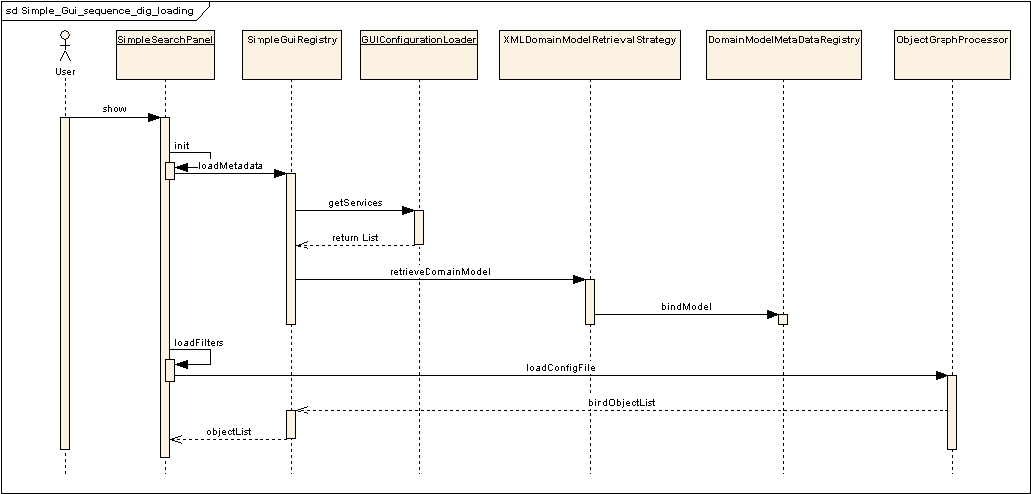
The SimpleSearchPanel class calls methods on SimpleGuiRegistry class which is basically a storage of information about the Domain model and the simple gui configuration.
The SimpleGuiRegistry class than get’s the list of Domain models for the services configured in the configuration file and load the metadata using utility class(ex. XMLDomainModelRetrievalStrategy) and binds the model and semantic information with a Domain Model Metadata registry. Domain Model Metadata registry has methods to bind and lookup the classes based on the unique class RefIds and fully classified class names.
After loading of Domain model extract is done, the filters and other information about the services is loaded from the Simple GUI configuration file with the help of class ObjectGraphProcessor and the information is again get’s bind to the Simple GUI Registry.

Execution of the Query:
The Diagran-2 explains the event flow for the query execution from the Simple GUI.
As soon as a user adds a filter to the query the filter information gets added to the Simple GUI registry as well. The Registry has information about the filters, their respective classes and the service URLs and other semantic information.
Once the user click the Execute button, the Simple GUI Registry is asked to prepare for the DCQL generation. This is an important step in the Simple GUI as the associations and linking between the various filters across services is done in this step. As per the CQL design a CQL query should have a Target Object and than an association structure specifying the filters in the form of attribute in other classes. The same association tree is being build in this step of the query execution from Simple GUI. As oppose to the Advance GUI where the user who is building the query associates the object on the graph manually.

Diagram 2: Simple GUI: Execution of the query.
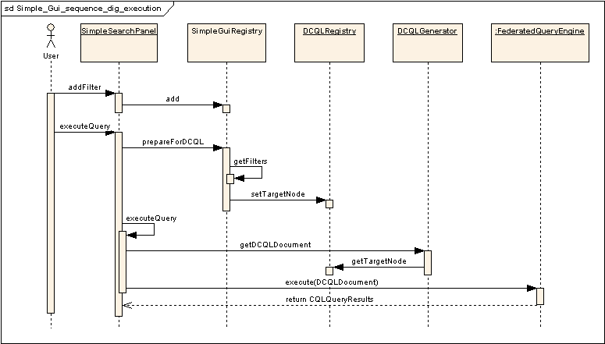

Once the association tree is generated and a target not is assigned and bind to the DCQL Registry, the DCQL generator just picks up the Target Node reference and than traverse through the association tree and create appropriate DCQL with Associations and Foreign association spanned across multiple Grid services.
Once the DCQL generator generate a DCQL document (a XMLBeans generated object representing xml form of DCQL), it is being passed to the Federated Query Engine (FQE) for execution.
The CQL Results returned from the FQE are than parser via java Reflection and than displayed on the Output panel of the GUI.

Simple GUI configuration file structure:
Most of the complexities of the Advance GUI are hidden in the Simple GUI with the help of a configuration file. This configuration file and stores the information regarding the pre-defined Backbone Target objects, their association path and role names with other classes in the same service and the association path through which it can be “Joined” with other (foreign) service to make a cross-service DCQL query.
Diagram-3 shows a typical example of Association path within a service. Each service can have multiple Target object element and each Target class has a Association tree. Any class can appear only once in the Association tree. This basically define the Association path from the Target class to any other class defined in the association tree thus user doesn’t have to link the classes like in the Advance GUI.
Each class definition has properties like it the displayable attributes and the display property. These property define the number of the CDE that will appear in the Filter list of the Simple GUI and if the class shall be mask or not.

Diagram-3: Simple GUI configuration file: Association path
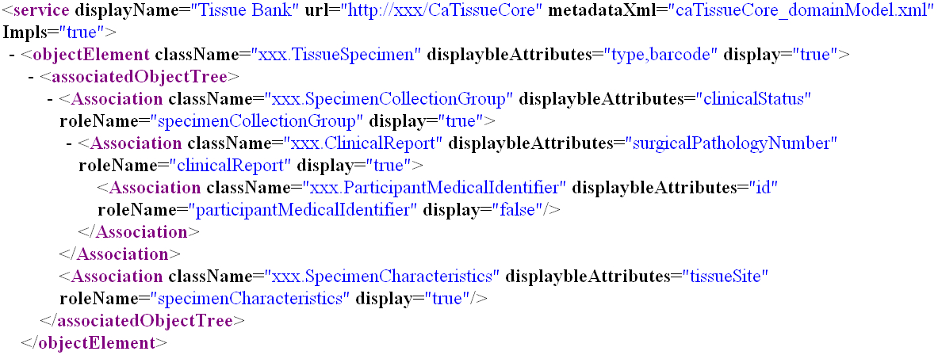

In order to link/join the Target class with other services (foreign service in this context), each target class has a predefined association path to a class which will have a linking CDE which is common across services to be joined. In Diagram-4 such a class is Participant Medical Identifier and the linking CDE is Medical Record Number.

Diagram-4: Simple GUI configuration file: Foreign Association outbound path.
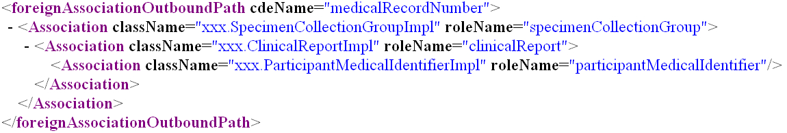

Similarly in order to have filters from foreign services, each such filter class should have an pre-defined association path from a class which has the linking CDE to the filter class.
In Diagram-5 such a filter class is Breast Cancer Biomarkers and the linking class is Participant Medical Identifier and linking CDE is Medical Record Number.

Diagram-5: Simple GUI configuration file: Foreign Association inbound path.
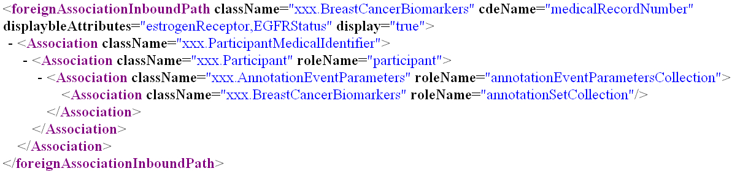

In general every service element can have multiple Target element with a foreign association outbound path element and multiple foreign association Inbound paths. In the configuration file there can me multiple services defined and for each service the service display name, service url and the location of Domain Model Metadata extract xml is defined. The Diagram-6 shows a part of the Simple GUI configuration xml schema.

Diagram-6: Simple GUI configuration file xml schema: simpleQueryInterface-config.xsd
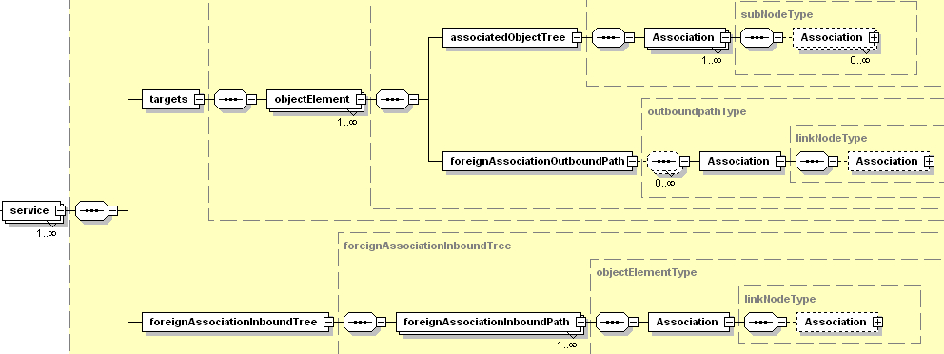

Visual Query Designer:
The Visual Query designer is targeted towards tech savvy users who are aware of the UML domain models of the Grid services being used and other technology stuff.

Loading of the Configuration and Domain Model Metadata Extract:
The diagram below explains the process of loading the configuration file and Domain model Metadata and building the class/CDE tree.
In case of Advance GUI, there are basically two options to load the services. The GUI can point to a Index service and can discover the services at the run time or it can point to the locally cached service for which the Domain Model metadata xml is locally stored. This is controlled by a configuration parameter in the GUI configuration file “catrip-config.xml”.
For both the options, the user is asked to search the services based on some parameters or user can perform a “Search All” operation.
If the Index service discovery option was selected, there is a Service locator which uses Discovery APIs to locate all the published service in the configured Index service. The list is than shown to the user for selection. Once the user selects the services to be shown in the Advance GUI, for each service there is a Domain Model Retrieval Strategy class which also uses Discovery APIs to get the Domain Model metadata extract at the client machine. Once the Domain model is downloaded, it is parsed and the Domain Model Metadata Registry is populated with class and other metadata information, which is being used to build the class Tree.

Diagram 7: Advance GUI: Loading of the configuration and metadata extract and Tree building
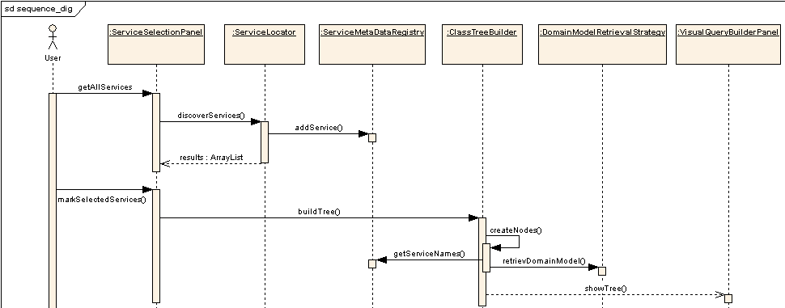

Execution of the Query:
The Query Execution process for the Advance GUI is similar to the Simple GUI, except the fact that the user link the class nodes on the Graph panel and creates a Association tree. The user can select any class node as the Target Node by the context menu options and thus bind it to the DCQLRegistry. Once there is a Target Node and the Association tree is defined on the Graph panel, the execution process follow the same path as of Simple GUI.

