Federated Query Engine Architecture

Federated Query Engine design:
The primary responsibility of federated query engine is to execute federated queries across the chosen caGRID data services. Queries written in the DCQL (distributed caBIG query language CQL) are the primary input to the engine. Federated Query Engine decomposes DCQL queries into individual CQL queries . These CQL queries are passed to individual data services where they get executed and results are passed back to federated query engine . Federated query engine aggregates the results from multiple services and sends back the result to client .

DCQL:
DCQL is designed on top of CQL query language . DCQL is defined in an XML document conforming to a well defined schema which is extended from CQL schema.

This DCQL schema can be graphically represented by the following diagram:

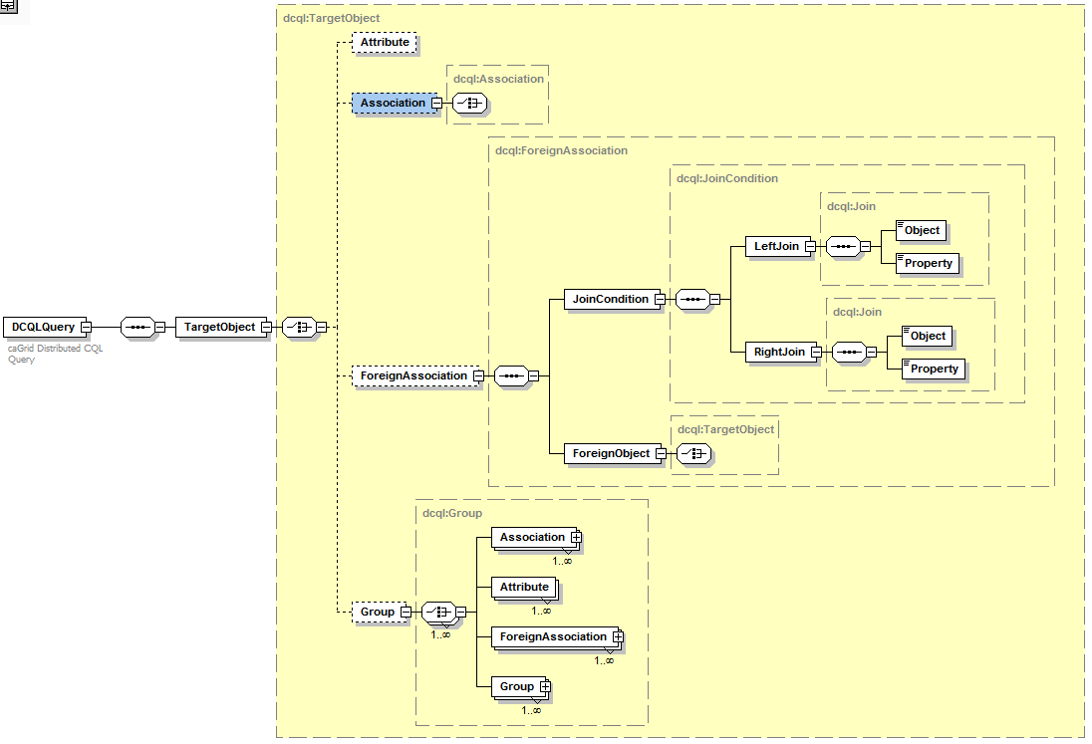

Parts of the DCQL schema:

DCQLQuery: DCQLQuery is a simple wrapper element at the head of every DCQL query document. It contains the target element.

TargetObject: The TargetObject element is of the type Object, and describes the data type which the query will return from a data service specified in serviceURL property.

Object: The Object element contains the required attribute ‘name.’ This attribute’s value defines the caDSR class of the object. When the Object is the top level of a DCQL query, it identifies the target data type that will be returned by the caGrid Data Service. The Object allows for a choice between four child elements. The possible child elements are Attribute, Association, ForeignAssociation and Group. Objects may have at most one of these child elements.

Attribute: Extended from CQL Attribute. An Attribute type in DCQL describes a restriction on an attribute of an Object. The Attribute contains three XML attributes, which define the restriction. The attribute ‘name’ defines the name of the attribute to be restricted. The attribute ‘value’ defines the restriction on the attribute. The attribute ‘predicate’ describes what type of restriction the attribute defines. Allowable predicates are defined by the schema’s simple type ‘Predicate’, which defines an enumeration of allowable values. The predicate values are generally self-descriptive: “EQUAL_TO", “NOT_EQUAL_TO", “LIKE", "LESS_THAN", "LESS_THAN_EQUAL_TO", “GREATER_THAN", and “GREATER_THAN_EQUAL_TO." Two additional predicates, "IS_NULL", and “IS_NOT_NULL" check only for the presence or absence, respectively, of an attribute, and do not restrict its value at all. Therefore, any ‘value’ attribute will be ignored when using these predicates.

Association: An association describes a related Object, which defines the associated object’s restrictions for the query, as well as the relationship from one object to another. Specifically, it defines the relationship down the object model tree. The Association complex type is an extension of Object. The Association has a single, optional attribute named ‘roleName.’ This attribute identifies which associated object field the Association is defining.
Group: Groups define logical joints of two or more conditions, and operate against the Object to which they are attached. Groups must have two or more children, which may be a mixture of type Attribute, Association, or Group. Groups also have an attribute named ‘logicOperator,’ whose type is defined in the schema’s simple type LogicalOperator. This type is an enumeration of the values “AND” and “OR.” The operator is applied to all children in the group. The “AND” operator requires that all conditions in the group be true for the group to evaluate as true. The “OR” operator requires that any condition in the group evaluate as true.

ForeignAssociation: A ForeignAssociation describes the relationship between data services.
JoinCondition defines the touch points between the services.
LeftJoin defines Object name and property name of local object
RightJoin defines Object name and property name of remote object.
ForeignObject in ForeignAssociation becomes a “TargetObject” on the foreign service.

Federated Query Engine Execution :

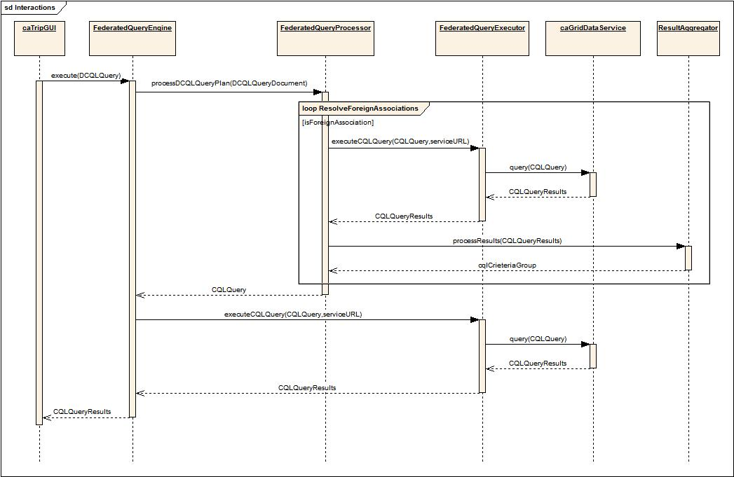

FederatedQueryProcessor
The Federated Query Processor decomposes the DCQL query into individual data service queries. After decomposing the query, federated query processor passes each CQL query and service URL of the data service to Federated Query Executor. After processing all the federated queries, federated query processor builds a final CQL query and returns to Federated Query Engine.

FederatedQueryExecutor
Using CQL query federated query processor generates, the federated query executor issues a data source specific query to corresponding data source. It uses the Service Client Factory to obtain a reference to an appropriate data source query handler that actually executes the query. Results Obtained from a foreign data service are passed Result Aggregator for processing. Criteria group Result Aggregator generates is used as where clause to higher level Query.

ServiceClientFactory
Using service URL received from federated query executor, Service Client Factory instantiates appropriate Data Service and returns the instance to Federated Query Executor.

ResultAggregator
Result sets obtained by executing data source specific queries are processed by the Result Aggregator. Result Aggregator performs right and left joins on CDEs and builds criteria and returns the criteria as Group.

