caTRIP
Technical Guide

Duke Comprehensive Cancer Center


Updated June 22, 2006
Copyright and License page

Copyright Notice. Copyright 2006 Duke Comprehensive Cancer Center (“caBIG™ Participant”). caTRIP was created with NCI funding and is part of the caBIG™ initiative. The software subject to this notice and license includes both human readable source code form and machine readable, binary, object code form (the “caBIG™ Software”).
This caBIG™ Software License (the “License”) is between caBIG™ Participant and You. “You (or “Your”) shall mean a person or an entity, and all other entities that control, are controlled by, or are under common control with the entity. “Control” for purposes of this definition means (i) the direct or indirect power to cause the direction or management of such entity, whether by contract or otherwise, or (ii) ownership of fifty percent (50%) or more of the outstanding shares, or (iii) beneficial ownership of such entity.
License. Provided that You agree to the conditions described below, caBIG™ Participant grants You a non-exclusive, worldwide, perpetual, fully-paid-up, no-charge, irrevocable, transferable and royalty-free right and license in its rights in the caBIG™ Software, including any copyright or patent rights therein that may be infringed by the making, using, selling, offering for sale, or importing of caBIG™ Software, to (i) use, install, access, operate, execute, reproduce, copy, modify, translate, market, publicly display, publicly perform, and prepare derivative works of the caBIG™ Software; (ii) make, have made, use, practice, sell, and offer for sale, and/or otherwise dispose of caBIG™ Software (or portions thereof); (iii) distribute and have distributed to and by third parties the caBIG™ Software and any modifications and derivative works thereof; and (iv) sublicense the foregoing rights set out in (i), (ii) and (iii) to third parties, including the right to license such rights to further third parties. For sake of clarity, and not by way of limitation, caBIG™ Participant shall have no right of accounting or right of payment from You or Your sublicensees for the rights granted under this License. This License is granted at no charge to You. Your downloading, copying, modifying, displaying, distributing or use of caBIG™ Software constitutes acceptance of all of the terms and conditions of this Agreement. If you do not agree to such terms and conditions, you have no right to download, copy, modify, display, distribute or use the caBIG™ Software.
- Your redistributions of the source code for the caBIG™ Software must retain the above copyright notice, this list of conditions and the disclaimer and limitation of liability of Article 6 below. Your redistributions in object code form must reproduce the above copyright notice, this list of conditions and the disclaimer of Article 6 in the documentation and/or other materials provided with the distribution, if any.
- Your end-user documentation included with the redistribution, if any, must include the following acknowledgment: “This product includes software developed by Duke Comprehensive Cancer Center.” If You do not include such end-user documentation, You shall include this acknowledgment in the caBIG™ Software itself, wherever such third-party acknowledgments normally appear.
- You may not use the names “Duke Comprehensive Cancer Center”, “The National Cancer Institute”, “NCI”, “Cancer Bioinformatics Grid” or “caBIG™” to endorse or promote products derived from this caBIG™ Software. This License does not authorize You to use any trademarks, service marks, trade names, logos or product names of either caBIG™ Participant, NCI or caBIG™, except as required to comply with the terms of this License.
- For sake of clarity, and not by way of limitation, You may incorporate this caBIG™ Software into Your proprietary programs and into any third party proprietary programs. However, if You incorporate the caBIG™ Software into third party proprietary programs, You agree that You are solely responsible for obtaining any permission from such third parties required to incorporate the caBIG™ Software into such third party proprietary programs and for informing Your sublicensees, including without limitation Your end-users, of their obligation to secure any required permissions from such third parties before incorporating the caBIG™ Software into such third party proprietary software programs. In the event that You fail to obtain such permissions, You agree to indemnify caBIG™ Participant for any claims against caBIG™ Participant by such third parties, except to the extent prohibited by law, resulting from Your failure to obtain such permissions.
- For sake of clarity, and not by way of limitation, You may add Your own copyright statement to Your modifications and to the derivative works, and You may provide additional or different license terms and conditions in Your sublicenses of modifications of the caBIG™ Software, or any derivative works of the caBIG™ Software as a whole, provided Your use, reproduction, and distribution of the Work otherwise complies with the conditions stated in this License.
- THIS caBIG™ SOFTWARE IS PROVIDED "AS IS" AND ANY EXPRESSED OR IMPLIED WARRANTIES (INCLUDING, BUT NOT LIMITED TO, THE IMPLIED WARRANTIES OF MERCHANTABILITY, NON-INFRINGEMENT AND FITNESS FOR A PARTICULAR PURPOSE) ARE DISCLAIMED. IN NO EVENT SHALL THE DUKE COMPREHENSIVE CANCER CENTER OR ITS AFFILIATES BE LIABLE FOR ANY DIRECT, INDIRECT, INCIDENTAL, SPECIAL, EXEMPLARY, OR CONSEQUENTIAL DAMAGES (INCLUDING, BUT NOT LIMITED TO, PROCUREMENT OF SUBSTITUTE GOODS OR SERVICES; LOSS OF USE, DATA, OR PROFITS; OR BUSINESS INTERRUPTION) HOWEVER CAUSED AND ON ANY THEORY OF LIABILITY, WHETHER IN CONTRACT, STRICT LIABILITY, OR TORT (INCLUDING NEGLIGENCE OR OTHERWISE) ARISING IN ANY WAY OUT OF THE USE OF THIS caBIG™ SOFTWARE, EVEN IF ADVISED OF THE POSSIBILITY OF SUCH DAMAGE.

Insert Names of Development Team(s) here
Development | Programmer’s guide | Program Management
Patrick McConnell¹ |  | Jamie Cuticchia¹
Ram Chilukuri² |  | Bob Annechiarico¹
Srini Akkala² |  | Patrick McConnell¹
Bill Mason³ |  | Ram Chilukuri²
Sanjeev Agarwal²
Mark Peedin¹
Christopher Hubbard¹
¹Duke Comprehensive Cancer Center
²SemanticBits
³5AM Solutions

Contacts and Support
Enter training contact | Patrick McConnell  (patrick.mcconnell@duke.edu)
Enter customer support contact | NA

LISTSERV Facilities Pertinent to software teams
LISTSERV | URL | Name
catrip-users | catrip-users@gforge.nci.nih.gov | caTRIP Users Forum
catrip-general | catrip-general@gforge.nci.nih.gov | caTRIP General Forum
catrip-developers | catrip-developers@gforge.nci.nih.gov | caTRIP Developers Forum

Table of Contents

Chapter 1 Overview of the Software 3
Software Overview 3
System Requirements 3
Design and Architecture 3
Chapter 2 caTRIP Requirements 5
Chapter 3 caTRIP Design and Architecture 5
Architecture 5
GUI Design 6
Federated Query Engine 12
DCQL 12
Federated Query Engine Execution 14
Data Services Design 15
Chapter 4 Security and Security Management 18
Authentication 18
Authorization 19
Delegation 19
Foreign CDEs 20
Configuring Security 20
Chapter 5 Information Models 20
Chapter 6 Grid Services 21
caTissue Core Data Service 21
caTissue Clinical Annotation Engine (CAE) Data Service 21
Tumor Registry Data Service 21
CGMES Data Service 21
Chapter 7 Customized Tools and Features 22
Appendix A References 22
Technical Manuals/Articles 22
Scientific Publications 23
Appendix B Glossary 23

Overview of the Software

Software Overview
The Duke Comprehensive Cancer Center, in collaboration with SemanticBits LLC, has been tasked with developing a translational research system for the Cancer Biomedical Informatics Grid (caBIG) project. The project, which is slated to last for one year, will be divided into two phases. In phase one, Duke will be developing a pilot infrastructure to tackle the difficult problem of outcomes analysis, where a clinician can access clinical, pathology, and basic science data from a cohort of patients to help guide the clinician in determining the best diagnostic and/or treatment modality for new patients. The infrastructure will be composed of a set of caBIG systems, some of which are already deployed at Duke and include C3D, caTIES, caTissue CORE, caArray, and RProteomics. These distributed data systems will be tied together using the caGrid technology developed as part of the caBIG project, leveraging open standards such as the Open Grid Services Infrastructure (OGSI), Globus, XML, and data standards. The project will use existing datasets at the CALGB, Breast SPORE, and others within the Duke research community stored in Medical Assistant on the World Wide Web (MAW3), GEMS SNP, and the Duke Tumor Registry. Phase two of the contract will involve moving the pilot system to a production system that can be deployed and used at other cancer centers.
This document describes the architecture for phase 1, as well as some of the proposed architecture for phase 2.
More information about caTRIP can be found at:
- The caTRIP GForge site: http://gforge.nci.nih.gov/projects/catrip/
- The caTRIP Wiki: http://gforge.nci.nih.gov/plugins/wiki/index.php?id=131&type=g
caTRIP is aiming for caBIG silver-level compatibility, as well as caBIG grid compatibility. Currently, the guidelines and review process for gold-level compatibility are not defined well enough to claim gold-level compliance.

System Requirements
The system requirements can be found in the caTRIP SRS found at:
http://gforge.nci.nih.gov/plugins/scmcvs/cvsweb.php/catrip/documentation/requirements/caTRIP_Req_Spec.doc?cvsroot=catrip

Design and Architecture
The caTRIP application is divided into three major components: domain services, the distributed query engine, and the graphical user interface (see Figure 1). The domain services are grid services that expose information models that encapsulates the translational data. The distributed query engine (DQE) takes in distributed common query language (DCQL) queries, decomposes the query into individual common query language queries (CQL), issues those queries to the domain services, aggregates the results, and returns it to the caller. The graphical user interface (GUI) provides a metadata driven interface for building DCQL to be issued against the DQE, as well as reporting utilities for data visualization.

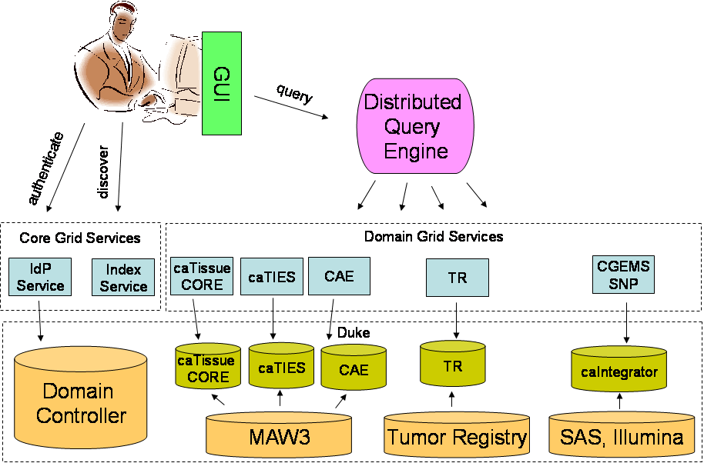

Figure 1 High-level overview of the caTRIP system/architecture

A number of caGrid, NCICB, and third-party components are leveraged in the caTRIP architecture. These include:
- AuthenticationService (IdP Service): allows the GUI to perform user authentication based on an institutional identity provider (IdP)
- IndexService: domain services advertise metadata to the IndexService, which can then be discovered by the GUI
- Common Security Module (CSM): provides both coarse-grained and fine grained authorization within the domain services
- caDSR Service: provides the metadata necessary for the GUI to provide an interface based upon concepts and CDEs for query building
- Hibernate: provides a mapping between the underlying database and the objects that are returned from queries
- Oracle/MySQL: provides the underlying database

caTRIP Requirements
The requirements call into the following broad categories:
- System Requirements
caBIG compatibility, APIs, environment (web browser, databases, etc.), security, and grid enablement
- Application Requirements
GUI, querying, metadata, query sharing
- Non-functionality requirements
Logging, auditing, exceptional flow, reliability, portability, version control
- Scientific Requirements
Data types, data systems, datasets, querying reporting, and security
More detailed about the system and scientific requirements can be found in the caTRIP SRS found at:
http://gforge.nci.nih.gov/plugins/scmcvs/cvsweb.php/catrip/documentation/requirements/caTRIP_Req_Spec.doc?cvsroot=catrip
In addition, readers may find useful the caTRIP Use Case Document, which can be found at:
http://gforge.nci.nih.gov/plugins/scmcvs/cvsweb.php/catrip/documentation/use_cases/caTRIP_Use_Cases.doc?cvsroot=catrip

caTRIP Design and Architecture
This chapter could include the following topics:
- Design is how the requirements of the software are implemented in the product
- Include links to developer design documents such as use case documents and to the latest UML models for the software

Architecture

As described in the Chapter 1, caTRIP has three main components: a graphical user interface through which the end users design and execute queries, a federated query engine that decomposes the queries that span multiple systems into system specific queries, execute, and aggregate the results, and the domain services that wrap the various caBIG systems. The following sections cover details on the design and architecture of these components

GUI Design
The primary purpose of the caTRIP GUI is to enable users to create federated queries in a visual manner. The queries are converted into DCQL (distributed common query language), sent to the Federated Query Engine for processing, and the result is shown to the user in a tabular fashion.

caTRIP has two flavors of GUIs

- Visual Query designer : Targeted towards advanced users who are familiar with the UML domain model and technologies like drag-and-drop. Data Managers and developers would be the primary users of this interface.

- Simple Query Interface (Simple GUI): Targeted towards non technical users, who are not familiar with UML models . Clinicians would be the primary users of this interface.

Simple GUI
Simple GUI or “Simple Query Interface” is aimed for end users like Clinicians.

Loading of the Configuration and Domain Model Metadata Extract
The diagram below explains the process of loading the configuration file and Domain model Metadata extract that is being bundled with the caTRIP user interface.

Currently, four Grid Data services are integrated with the Simple GUI, which are included out-of-the-box in the configuration files. Along with the simple GUI configuration file, the GUI also ships with the Domain Model metadata extract for 4 services so that the relevant Semantic information can be shown in the GUI.

When a user launches the GUI, he or she is given a choice to use the default (Simple GUI) or Visual Query Designer, which is explained in next section.

When the user chooses the default option, the class SimpleSearchPanel, which is responsible for generating the Simple Query Interface, loads all the Metadata and simple GUI configuration during the Initialization process.

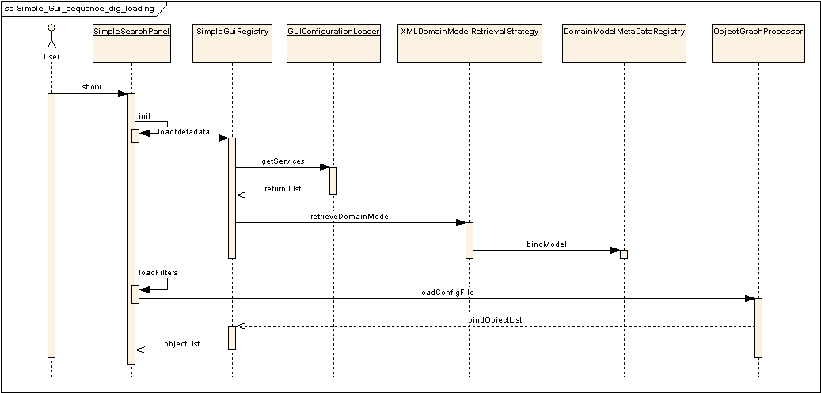
Figure 2 Simple GUI: Loading of the configuration and metadata extract
The SimpleSearchPanel class calls methods on SimpleGuiRegistry class, which is a storage of information about the Domain model and the simple GUI configuration.

The SimpleGuiRegistry class than gets the list of Domain models for the services configured in the configuration file and load the metadata using utility classes (eg. XMLDomainModelRetrievalStrategy) and binds the model and semantic information with a Domain Model Metadata registry. The Domain Model Metadata registry has methods to bind and lookup the classes based on the unique class RefIds and fully classified class names.

After the domain model metadata extract is loaded, the filters and other information about the services are loaded from the Simple GUI configuration file with the help of the class ObjectGraphProcessor and the information is bound to the Simple GUI Registry.

Execution of the Query
The UML sequence diagram below explains the event flow for the query execution in the Simple GUI.

As soon as the user adds a filter to the query, the filter information gets added to the Simple GUI registry as well. The Registry has information about the filters, their respective classes and the service URLs, and other semantic information. Once the user clicks the Execute button, the Simple GUI Registry is asked to prepare for DCQL generation. This is an important step in the Simple GUI, as the associations and linking between the various filters across services is performed here. As per the CQL design, a CQL query has a Target Object and then an association structure specifying the filters in the form of attributes of other classes. The same association tree is built in this step of the query execution in the Simple GUI as opposed to the Advanced GUI where the user who is building the query associates the object on the graph manually.
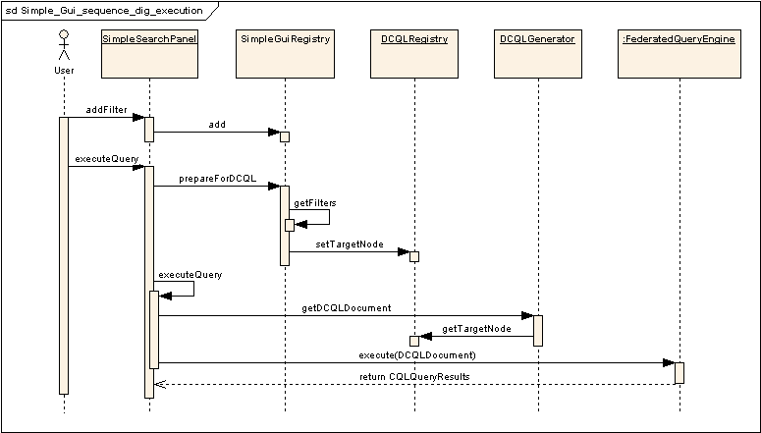
Figure 3 Simple GUI: Execution of the query.
Once the association tree is generated and a target node is assigned and bound to the DCQL Registry, the DCQL generator just picks up the Target Node reference and then traverses through the association tree to create appropriate DCQL with associations and foreign associations spanning across multiple Grid services.

After the DCQL generator generates a DCQL document (an XMLBeans generated object representing xml form of DCQL), it is passed to the Federated Query Engine (FQE) for execution.

The CQL Results returned from the FQE are then parsed via java Reflection and displayed on the output panel of the GUI.

Simple GUI configuration file structure
Most of the complexities of the Advanced GUI are hidden in the Simple GUI with the help of a configuration file. This configuration file stores the information regarding the pre-defined Backbone Target objects, their association path and role names with other classes in the same service, and the association path through which it can be “joined” with other (foreign) services to make a cross-service DCQL query.

Figure 4 shows a typical example of Association path within a service. Each service can have multiple Target object elements and each Target class has a Association tree. Any class can appear only once in the Association tree. This defines the Association path from the Target class to any other class defined in the association tree, thus eliminating the need for the end user to link the classes like in the Advanced GUI.

Each class definition has properties like the displayable attributes and the display. These properties define the CDEs that will appear in the Filter list of the Simple GUI and if the class will be displayed or not.

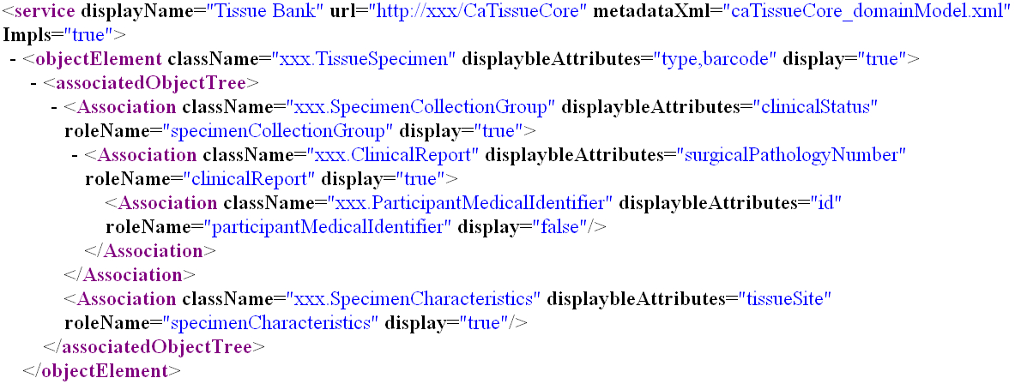
Figure 4 Simple GUI configuration file: Association path

In order to link/join a Target class with other services (a foreign service in this context), it has a predefined association path to a class that has a linking CDE that is common across the services to be joined. Diagram-4 shows a class called ParticipantMedicalIdentifier which has a linking CDE called Medical Record Number.

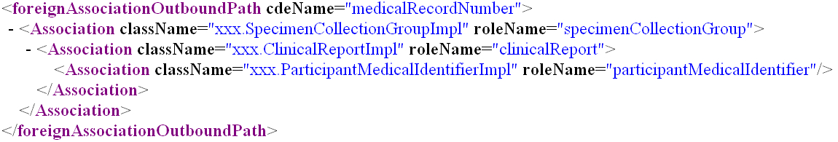
Figure 5 Simple GUI configuration file: Foreign Association outbound path.
Similarly, in order to have query filters from foreign services, each such filter class should have a pre-defined association path from the class which has the linking CDE to the filter class. Figure 6 shows an example a filter class is Breast Cancer Biomarkers, and the linking class is Participant Medical Identifier and linking CDE is Medical Record Number.
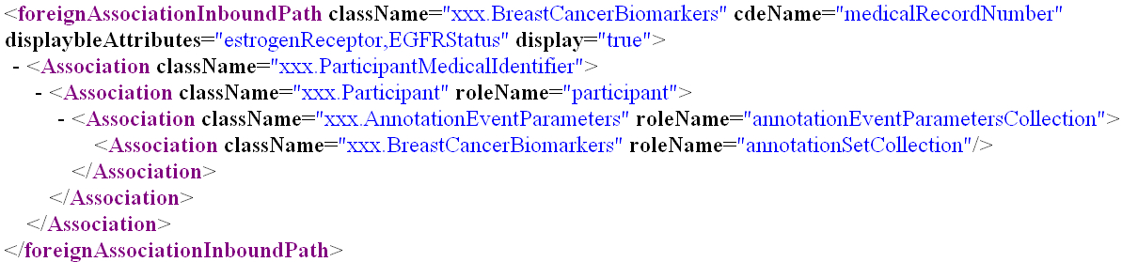
Figure 6 Simple GUI configuration file: Foreign Association inbound path.

In general every service element can have multiple Target elements with a foreign association outbound path element and multiple foreign association inbound paths. In the configuration file there can me multiple services defined, and for each service the service display name, service URL and the location of Domain Model Metadata extract xml are defined. Figure 7 shows a part of the Simple GUI configuration xml schema.

Diagram-6:
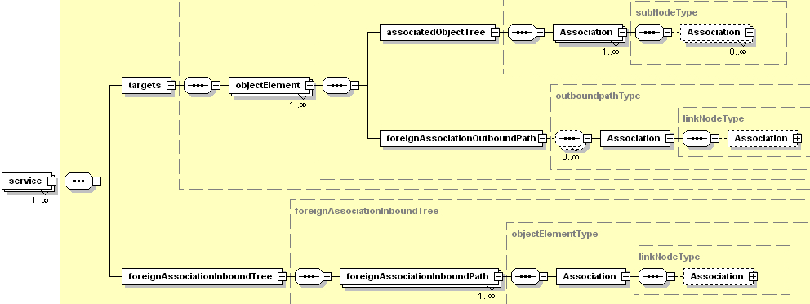
Figure 7 Simple GUI configuration file xml schema: simpleQueryInterface-config.xsd.

Visual Query Designer (Advanced GUI)
The Visual Query designer is targeted towards more technically savvy users who are aware of the UML domain models of the Grid services being used in the caTRIP, as well as other technologies such as drag-and-drop and tree traversal.

Loading of the Configuration and Domain Model Metadata
The figure below explains the process of loading the caTRIP configuration file, the service specific domain model metadata, and building the class/CDE tree.

In the case of Advanced GUI, there are two options to load the services. The GUI can be configured to point to an Index service, which can then be used to discover services at run-time using the caGrid discovery API. It can also retrieve the list of services from a configuration file. In the first case, domain model metadata is accessed using the discovery API, but the in the later case it is stored locally on the file system as an XML extract. This is controlled by a configuration parameter in the GUI configuration file “catrip-config.xml”.

For both the options, the user is asked to search the services based on some parameters, or the user can perform a “Search All” operation.

If the discovery option using an Index service is selected, there is a Service locator that uses Discovery APIs to locate all the published services in the selected Index Service. The list is then shown to the user for selection. A Domain Model Retrieval Strategy class iterates over each selected service and also uses Discovery APIs to retrieve the Domain Model metadata extract to the client machine. Once the Domain model is downloaded, it is parsed, and the Domain Model Metadata Registry is populated with metadata information, which is then used to build the class tree.

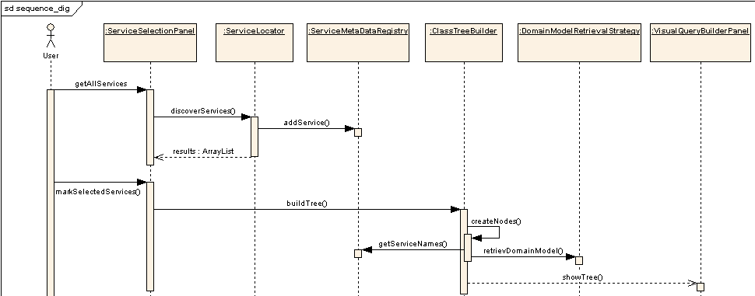
Figure 8 Advanced GUI: Loading of the configuration and metadata extract and Tree building

Execution of the Query
The Query Execution process for the Advanced GUI is similar to the Simple GUI, except for the fact that the user links the class nodes on the Graph panel and creates an Association Tree. The user can select any class node as the Target Node by using the context menu option and thus bind it to the DCQLRegistry. Once there is a Target Node selected and the Association tree is defined on the Graph panel, the execution process follows the same path as in Simple GUI.

Federated Query Engine
The primary responsibility of federated query engine is to execute federated queries across the chosen caGRID data services. Queries written in the DCQL (distributed caBIG query language CQL) are the primary input to the engine. Federated Query Engine decomposes DCQL queries into individual CQL queries . These CQL queries are passed to individual data services where they get executed and results are passed back to federated query engine . The federated query engine aggregates the results from multiple services and sends back the result to client.

DCQL
DCQL is designed on top of the CQL query language . DCQL is defined in an XML document conforming to a well defined schema, which is extended from CQL schema (see Figure 9).

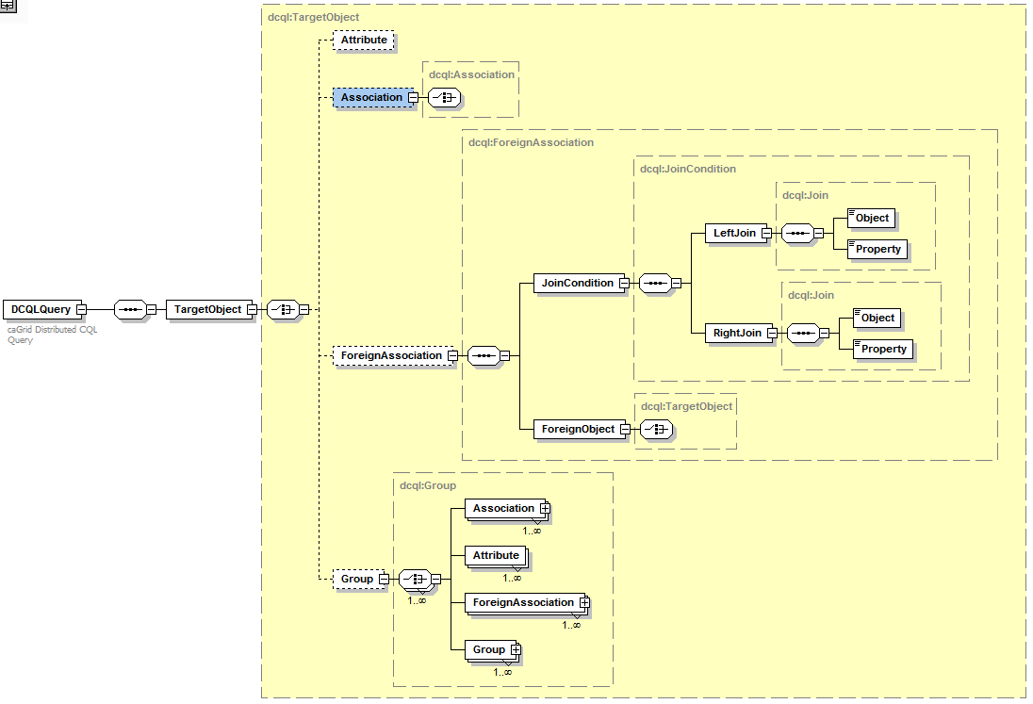
Figure 9 DCQL schema

DCQLQuery: DCQLQuery is a simple wrapper element at the head of every DCQL query document. It contains the target element.

TargetObject: The TargetObject element is of the type Object, and describes the data type that the query will return from a data service specified in the serviceURL property.

Object: The Object element contains the required attribute ‘name.’ This attribute’s value defines the caDSR class of the object. When the Object is the top level of a DCQL query, it identifies the target data type that will be returned by the caGrid Data Service. The Object allows for a choice between four child elements. The possible child elements are Attribute, Association, ForeignAssociation, and Group. Objects may have at most one of these child elements.

Attribute: Extended from CQL Attribute. An Attribute type in DCQL describes a restriction on an attribute of an Object. The Attribute contains three XML attributes, which define the restriction. The attribute ‘name’ defines the name of the attribute to be restricted. The attribute ‘value’ defines the restriction on the attribute. The attribute ‘predicate’ describes what type of restriction the attribute defines. Allowable predicates are defined by the schema’s simple type ‘Predicate’, which defines an enumeration of allowable values. The predicate values are generally self-descriptive: “EQUAL_TO", “NOT_EQUAL_TO", “LIKE", "LESS_THAN", "LESS_THAN_EQUAL_TO", “GREATER_THAN", and “GREATER_THAN_EQUAL_TO." Two additional predicates, "IS_NULL", and “IS_NOT_NULL" check only for the presence or absence, respectively, of an attribute, and do not restrict its value at all. Therefore, any ‘value’ attribute will be ignored when using these predicates.

Association: An association describes a related Object, which defines the associated object’s restrictions for the query, as well as the relationship from one object to another. Specifically, it defines the relationship down the object model tree. The Association complex type is an extension of Object. The Association has a single, optional attribute named ‘roleName.’ This attribute identifies which associated object field the Association is defining.

Group: Groups define logical joints of two or more conditions, and operate against the Object to which they are attached. Groups must have two or more children, which may be a mixture of type Attribute, Association, or Group. Groups also have an attribute named ‘logicOperator,’ whose type is defined in the schema’s simple type LogicalOperator. This type is an enumeration of the values “AND” and “OR.” The operator is applied to all children in the group. The “AND” operator requires that all conditions in the group be true for the group to evaluate as true. The “OR” operator requires that any condition in the group evaluate as true.

ForeignAssociation: A ForeignAssociation describes the relationship between data services.
JoinCondition defines the touch points between the services.
LeftJoin defines Object name and property name of local object
RightJoin defines Object name and property name of remote object.

The ForeignObject in ForeignAssociation becomes a “TargetObject” on the foreign service.

Federated Query Engine Execution

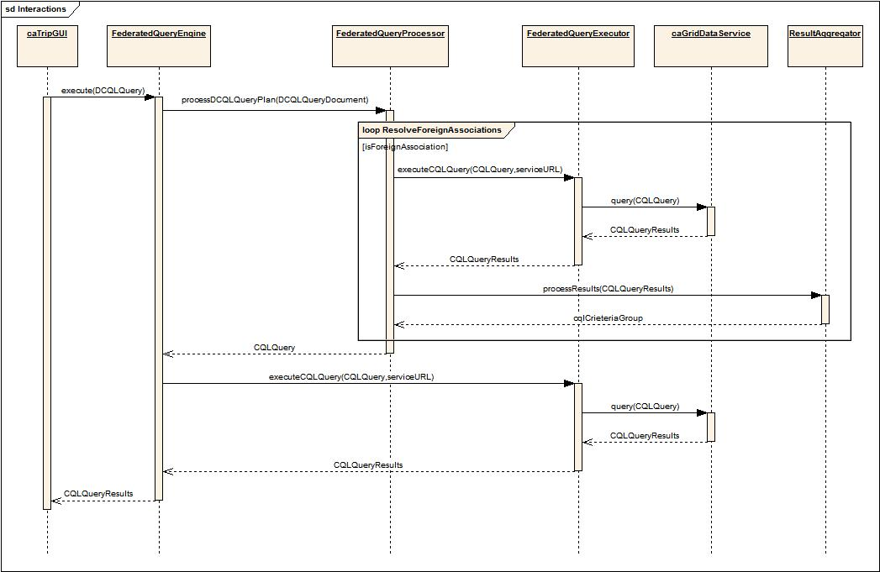

FederatedQueryProcessor
The Federated Query Processor decomposes the DCQL query into individual data service queries. After decomposing the query, federated query processor passes each CQL query and service URL of the data service to Federated Query Executor. After processing all the federated queries, the federated query processor builds a final CQL query and returns to Federated Query Engine.

FederatedQueryExecutor
Using a CQL query, the federated query processor generates, the federated query executor issues a data source specific query to corresponding data source. It uses the Service Client Factory to obtain a reference to an appropriate data source query handler that actually executes the query. Results obtained from a foreign data service are passed to the Result Aggregator for processing. Criteria group Result Aggregator is used as a ‘where’ clause to the higher level Query.

ResultAggregator
Result sets obtained by executing data source specific queries are processed by the Result Aggregator. The Result Aggregator performs right and left joins on CDEs and builds criteria and returns the criteria as Group.

Data Services Design
caTRIP heavily relies on the caGrid 1.0 data services infrastructure. The domain systems such as caTissue Core and caTissue CAE are wrapped as data services and exposed to the FQE. Diagram below illustrates the steps involved in executing a query represented in CQL using a caGrid data service.
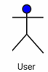
caGrid
Data Service

query(CQL Query)
Query Processor

processQuery(CQLQuery)
Data Source
createQuery(HQL Query)
ResultSet
CQLQueryResults
Serialized to XML
CQLQueryResults
Builds XML CQL query
Deserialized Data Objects
Data
Service
Client
- Client builds a CQL Query
- CQL query is submitted as part of request to the query() method of the caGrid data service via standard grid protocol
- Data service deserializes an XML representation of the CQL query into a CQLQuery object and then passes it to the configured CQL Query Processor implementation class
- CQL query processor converts CQL into HQL and queries the underlying data source to generate the result set.
- Results are serialized as XML and returned to the client as a single CQLQueryResults object.
- Introduce generated data service client iterates thru the result set and deserializes the XML into java objects if desired.
In caTRIP, we have two types of data services: caCORE SDK based and non caCORE SDK based. The following sequence diagram illustrates the various classes and interactions between them for a data service that is based on caCORE SDK generated data access API. The HQLCoreQueryProcessor (provided by the caGrid 1.0 infrastructure) translates the CQL query into an HQL query and uses the caCORE SDK’s application service class to execute it. This results in an additional network call, as the caCORE SDK’s application service is deployed in a different JVM.

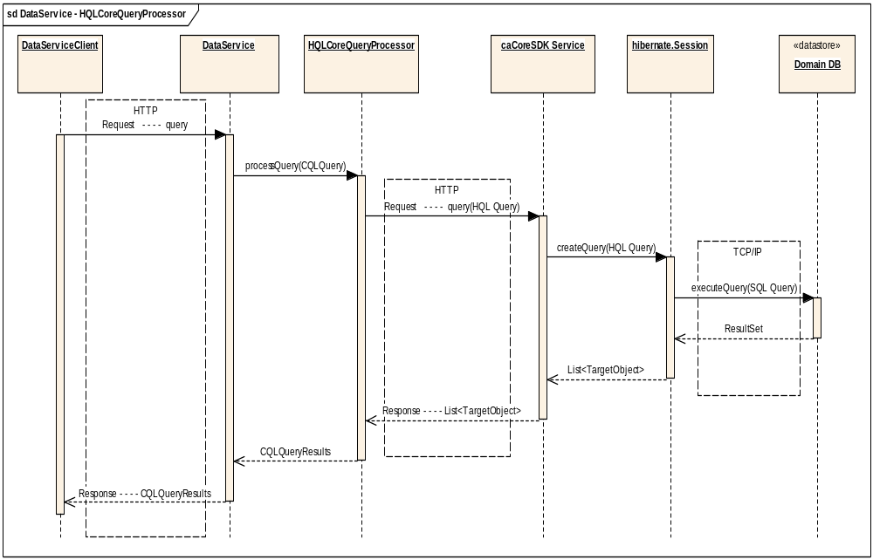

The following sequence diagram illustrates the various classes and the interactions for a data service that is not based on caCORE SDK generated data access API. The LocalHQLCoreQueryProcessor, which is an extension of HQLCoreQueryProcessor, translates the CQL query into an HQL query and uses the Hibernate query API to execute it. This eliminates an additional network call as the data access layer is packaged with the data service itself resulting in significant performance improvements.

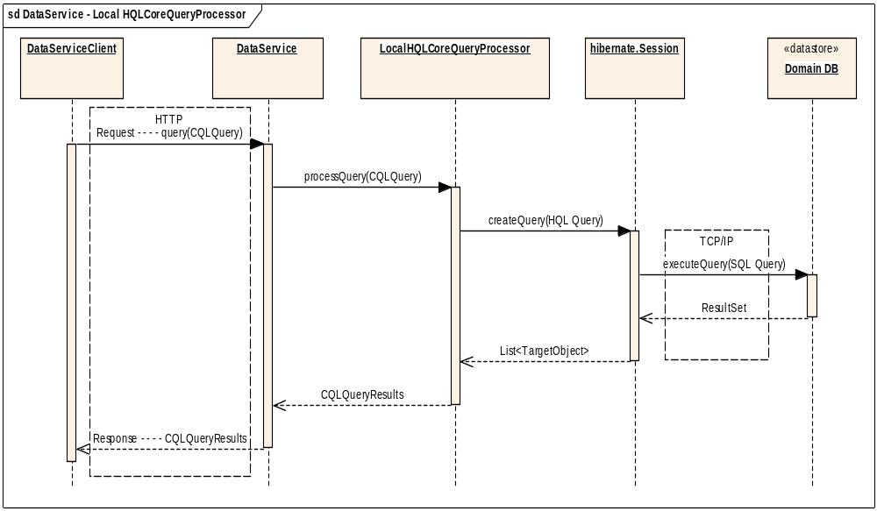

Security and Security Management
Security is currently not implemented in phase 1. However, we provide details on the proposed security architecture in phase 2. It is important to note that caTRIP will be among the first applications to leverage caGrid security in a production, PHI-related environment.

Authentication

The first step in the security workflow is authentication, which is the process by which a trusted organization claims a user is who they claim to be. This is implemented using the caGrid AuthenticationService (see Figure 10). The goal is for the user to get a grid user certificate to be used in authorization. The user submits their credentials (user name and password) to the AuthenticationService, which has an institutional IdP plugged in. This component performs the necessary steps to determine that the user credentials are valid. In the case of the Duke IdP plugin, the user name and password are validated against the Duke Domain Controller, which uses NT Security. Once validated, the AuthenticationService returns a SAML Assertion to the user, which asserts that the user is who they claim to be. The SAML Assertion can then be passed off to a Dorian Service to generate a grid user certificate.
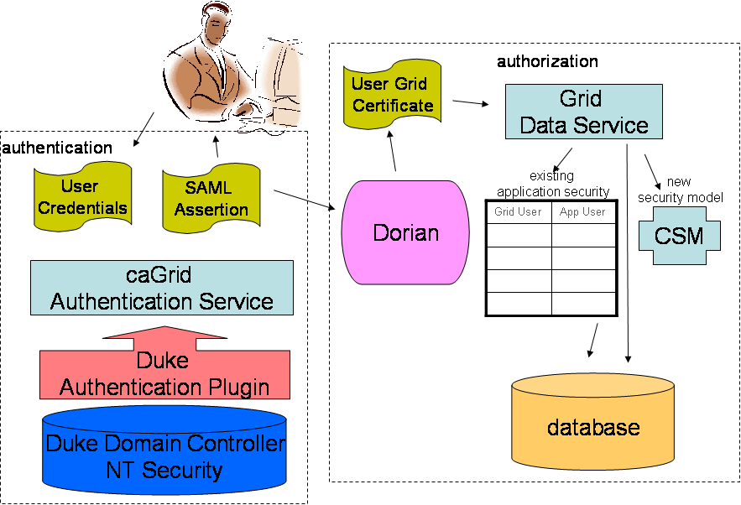
Figure 10 High-level overview of the caTRIP security architecture

Authorization

The second step in the security workflow is authorization, which is the process by which a system grants the user access to specific resources. This is implemented using the CSM plug-in to the grid data service. The grid user is mapped to an application user. When a data field is accessed on behalf of the user, an authorization structure is queried to determine if the user has permission to access it. If not, then a security exception is returned to the client. Authorization is made possible because a trust fabric exists between the service serving the data resource and the AuthenticationService.

Delegation

One twist on the security workflow is delegation, which is the process by which a service acts on behalf of the user. This impacts caTRIP because the DQE service queries domain services using the user’s certificate. The architecture of delegation has not yet been fully described or implemented by the caGrid team. However, it appears that he DelegationService from the Globus project will be leveraged. The user will signal the DelegationService that it is permissible for a collocated service to act on the user’s behalf. As the delegation architecture is fleshed out, more details will be provided.

Foreign CDEs

Another twist on the security workflow is the use of “foreign CDEs” for the purpose of joining data. It is conceivable that a user does not have permission to view a CDE that is used for joining between two different domain services. The classic example of this is to join patients across services using the MRN. In this case, a special security workflow must be undertaken during authorization. A special trust fabric will be instantiated between the DQE service and the domain service such that foreign CDEs will be returned to the DQE service with the understanding that the delegated user is not authorized to view them but is authorized to join on them. The exact mechanism by which this is accomplished is not yet completely clear.

Configuring Security

This is covered in the caTRIP administration guide and the caTRIP installation guide (not yet released).

Information Models
Information models are leveraged to create our domain services, as well as register metadata in the caDSR and EVS. The following information models are used:
- caTissue CORE (Washington University)
The caTRIP will be leveraging this model in its entirety without any modification.
- CAE (Pittsburgh University)
The caTRIP will be modifying this model by adding a small number of attributes and classes.
- caIntegrator SNP (NCICB)
The caTRIP will be leveraging this model in its entirety without any modification.
- Tumor Registry (Duke)
This model is created from scratch by the caTRIP team.
The information models themselves are UML-based and created using EnterpriseArchitect (EA). They can be found at:
http://gforge.nci.nih.gov/plugins/scmcvs/cvsweb.php/catrip/documentation/models/?cvsroot=catrip
The Hibernate mappings are generated for the domain services using the caCORE SDK. The caCORE-generated APIs themselves are not used in caTRIP. Grid services are generated from metadata registered in the caDSR using the caGrid Introduce toolkit. An XMI file is generated from the information model (UML), semantically annotated, registered in the caDSR, and the caCORE-like service is generated.
One key facet of the caTRIP information models is that they are loosely coupled using the classes of Participant, Accession, and Biospecimen. Currently, only ParticipantMedicalRecordNumber is used to perform distributed joins across services. The caTRIP team will work to harmonize the CDEs for these “backbone objects”.

Grid Services
The four grid data services described below were developed in the phase 1 of caTRIP: The Introduce toolkit provided by the caGrid 1.0 infrastructure was leveraged extensively for developing these services. The query processor – which converts CQL statements into Hibernate Query Language (HQL) statements and executes them – provided by the Introduce toolkit was extended to support non caCORE SDK generated systems.

caTissue Core Data Service
This data service is based on the caCORE SDK generated API of the caTissue Core 1.01 application.

caTissue Clinical Annotation Engine (CAE) Data Service
This data service is based on the CAE 1.2 domain model. It exposes only a subset of domain objects, specifically relevant to the breast annotations.

Tumor Registry Data Service
This data service is based on the Duke University tumor registry domain model, which was developed as a part of caTRIP phase 1 effort.

CGMES Data Service
This data service is based on the CGEMS domain model, which is a part of the NCICB’s caIntegrator project.

The grid services themselves are designed as an N-tier architecture (see Figure 11). The lowest tier is the underlying RDBMS, which can be provided by any number of vendors. caTRIP has been developed extensively leveraging Oracle, but any relational database can be used. The next tier is Hibernate, which provides an object-relational mapping to the domain model. The final tier is the caGrid data service, which maps CQL queries to HQL queries using a CQL processor.
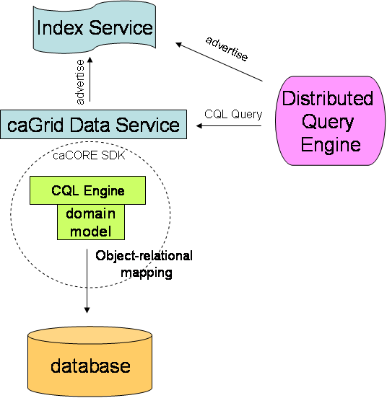
Figure 11 Architecture of a Grid Service

Customized Tools and Features
The caTRIP application is a flexible, extensible system for querying and mining distributed data services on the grid. One way it can be extended by adding more data services for querying. The first step is for your data service to advertise itself with an IndexService so that the GUI is able to discover it. The GUI provides two different ways to build queries: the simple interface and the advanced interface. At this point, nothing more than advertisement is required to make the data service available to the advanced interface. To make the service available to the simple interface, a configuration file that is bundled with the Java Webstart application must be modified. Paths to and from foreign CDEs within the information model must be defined. The exact syntax and method of modifying this file is defined in the Administration Manual (not yet written).
- References

Technical Manuals/Articles
- caTRIP information models: http://gforge.nci.nih.gov/plugins/scmcvs/cvsweb.php/catrip/documentation/models/?cvsroot=catrip
- caTRIP use cases: http://gforge.nci.nih.gov/plugins/scmcvs/cvsweb.php/catrip/documentation/use_cases/caTRIP_Use_Cases.doc?cvsroot=catrip
- caTRIP requirements: http://gforge.nci.nih.gov/plugins/scmcvs/cvsweb.php/catrip/documentation/requirements/caTRIP_Req_Spec.doc?cvsroot=catrip
- caTRIP GForge site: http://gforge.nci.nih.gov/projects/catrip/
- caTRIP Wiki: http://gforge.nci.nih.gov/plugins/wiki/index.php?id=131&type=g

Scientific Publications
http://gforge.nci.nih.gov/plugins/scmcvs/cvsweb.php/catrip/documentation/publications/?cvsroot=catrip
- Glossary
Term | Definition
DQE | Distributed Query Engine
CSM | Common Security Module
IdP | Identity Provider
caTRIP | Cancer Translational Research Informatics Platform
SNP | Single Nucleotide Polymorphism
CAE | Clinical Annotation Engine
API | Application Programming Interface
CDE | Common Data Element
CQL | Common Query Language
DCQL | Distributed Common Query Language
GUI | Graphical User Interface
UML | Unified Modeling Language

