- Login Screen on Application Launch:
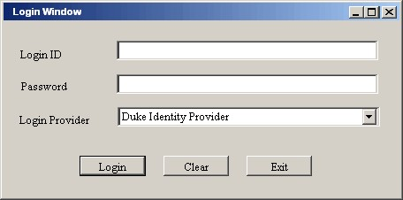

Since IdP will be provided via grid service, we should have a button for discovery. Implemented in Phase II.

- Search Services screen
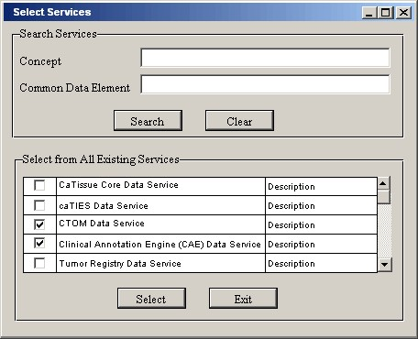

There has to be a column for institution and column with a button to view all service-level metadata.

Will Concept and CDE fields be free-text?

- Select Services from the search result.
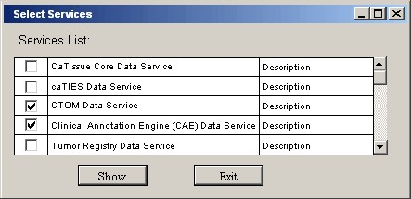

See comments from above about columns to add.

- Main Screen: Visual Query Designer/Builder
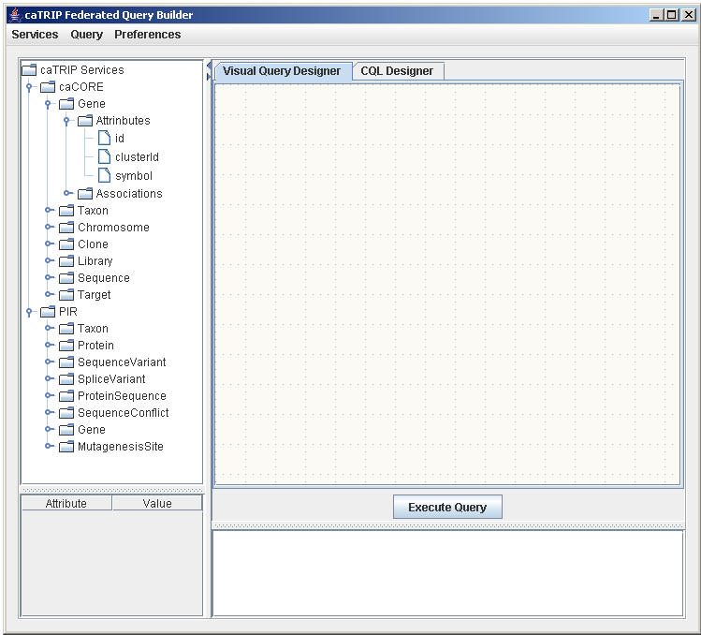

The icons in the tree should be more meaningful than folders and files.

We could have a higher set of tabs that represents any number of open queries.

- Service Domain Model Classes showing CDEs and associated classes.
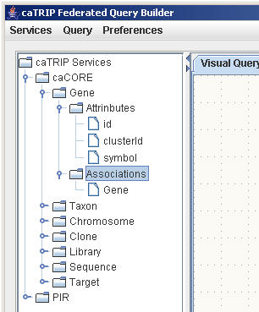

- Visual Query Designer
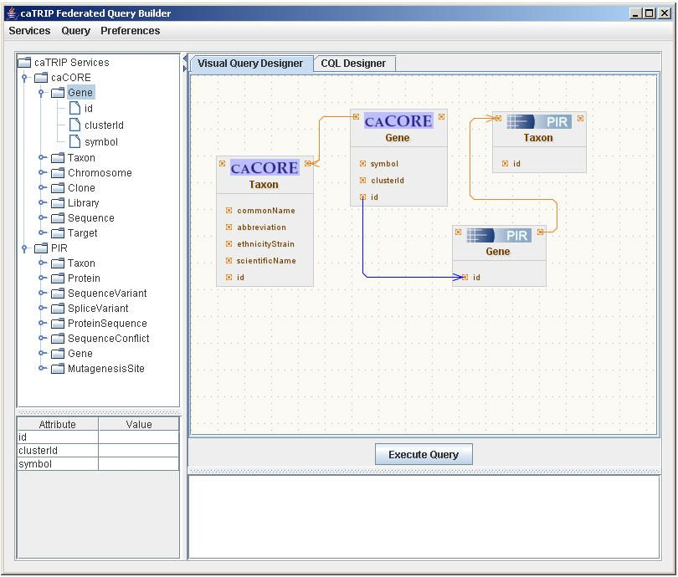

Associations should probably be listed in some fashion similar to attributes with their role names. Otherwise, it is a little hard to see from just the design area what could be linked.

A datatype field might be nice for the attribute filter table. Maybe too crowded though. Also, we should discuss how to implement AND/OR and >/<

- Services Menu: Add Services
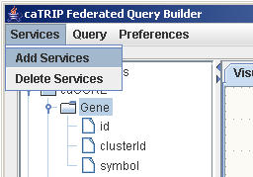

- Add Services Wizard.

See comments from same window in beginning.

- Get All Semantically Equivalent Classes from Domain Models of Selected Services.
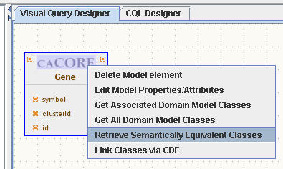

- List of Semantically Equivalent Classes from Domain Models.
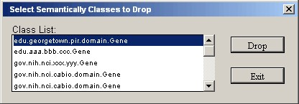

You could have some description here (from EVS concept or something), but not strictly necessary.

- Link CDE between selected class.
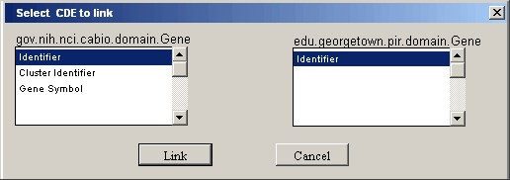

It would be better to have this as part of the class selection dialog. Too many nested dialogs can be confusing to users.

- Link classes from Different Domain Model via Common CDEs. Manual Linking is also Possible.
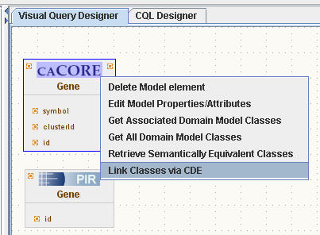

This will require two classes to be selected? If not, the next dialog assumes that there is only one class that is semantically equivalent available in the editor.

- Select the CDEs to link.

- Action of clicking: “Add Search Engine” Menu item under Preferences Menu.
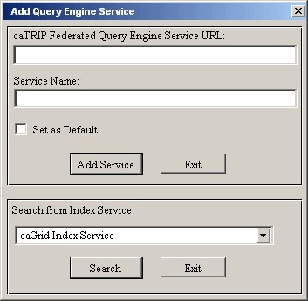

I think it would be more clear if the search section was above the URL section. Also, the service name is the search criteria – that needs to be better laid out.

- Select Search services.
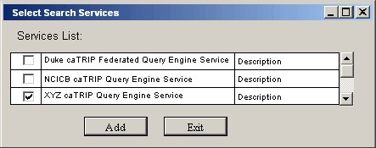

Add an institution column. Also button to see entire service-level metadata.

- Action of clicking: “Choose Search Engine” Menu item under Preferences Menu
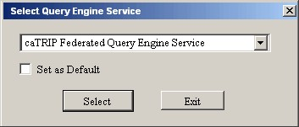

- Other PopUp Menu Actions available for any Class.
