Architecture Diagram

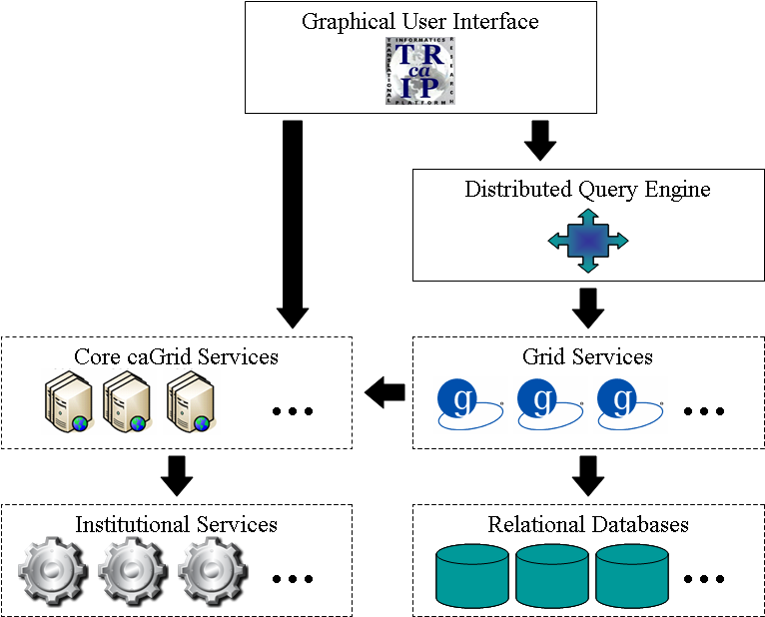

Intended Audience: Clinicians, Cancer Researchers, Data Technicians

Product Description: caTRIP allows users to query across a number of caBIG data services, join on common data elements (CDEs), and view their results in a user-friendly interface. Having as its initial focus the enabling of outcomes analysis, caTRIP allows clinicians to query across data from existing patients with similar characteristics to find treatments that were administered with success. In doing so, caTRIP can help inform treatment and improve patient care, as well as enable the searching of available tumor tissue, locating patients for clinical trials, and investigating the association between multiple predictors and their corresponding outcomes such as survival. Of importance, caTRIP relies on the vast array of open source caBIG applications, including (1) Tumor Registry, a clinical system that is used to collect endpoint data; (2) the cancer Text Information Extraction System (caTIES, https://cabig.nci.nih.gov/tools/caties), a locator of tissue resources that works via the extraction of clinical information from free text surgical pathology reports while using controlled terminologies to populate caBIG-compliant data structures; (3) caTissue CORE ( https://cabig.nci.nih.gov/tools/catissuecore), a tissue bank repository tool for biospecimen inventory, tracking, and basic annotation; (4) Cancer Annotation Engine (CAE) ( https://cabig.nci.nih.gov/tools/cae), a system for storing and searching pathology annotations; (5) caIntegrator ( http://gforge.nci.nih.gov/projects/caintegrator/), a tool for storing, querying, and analyzing translational data, including SNP data.

Tool at a Glance Presentation: http://gforge.nci.nih.gov/docman/view.php/131/6486/caTRIP_icr_2007_05_09.ppt

Demo Files and Exercises:

- caTRIP Project Summary Presentation: http://gforge.nci.nih.gov/docman/view.php/131/6486/caTRIP_icr_2007_05_09.ppt

Documentation and Training

- End User Manual: http://gforge.nci.nih.gov/docman/view.php/131/6482/caTRIP_End_User_Manual.doc
- Training Module: http://gforge.nci.nih.gov/docman/view.php/131/6483/caTRIP_Training_Module.ppt
- Technical Guide/Install Guide/Administration Guide: http://gforge.nci.nih.gov/docman/view.php/131/6484/caTRIP_Technical_Guide.doc

Related caBIG Tools:

- caTissue CORE
- CAE
- caTIES
- caIntegrator
- caGrid

