caTRIP QA Testing Questionnaire

12/26/2006

Raj Dash, M.D.

Purpose
The purpose of this questionnaire is to provide feedback to the development team on your use of the software system. The background section provides an introduction to the system, as well as instructions on how to run the software. The testing section provides some detailed and general questions related to the system, as well as an opportunity to provide unstructured comments. The usability section will grade system usability in a quantitative fashion.

Background
The Cancer Translational Research Informatics Platform (caTRIP) aims to solve the difficult translational research problem of outcomes analysis. When a patient enters the clinic, the oncologist should be able to look across a cohort of patients with similar characteristics to help inform treatment. We solve this problem by leveraging caGrid to perform distributed queries across caTissue CORE, CAE, the Duke Tumor Registry, and the caIntegrator SNP database. The user interface is metadata driven, providing a flexible way to build queries and mine results.

The system as it stands now has real deidentified patient data from the Duke tissue bank, as well as the Duke Tumor Registry. There is also a test version that includes clinical annotations and SNP data. The application can be accessed at:

http://cagrid2.duhs.duke.edu/catrip_webstart/

Testing

Background
Which of the following most accurately describes you?

X Duke clinician (domain expert)
__ Non-Duke clinician
__ Other domain expert
__ Developer
__ Other – Please specify: _________________

Overall, how useful do you find the caTRIP application to your work?

Very useless __ __ __ X __ Very useful

Please provide any comments that you think could improve the caTRIP application:

See comments in Simple GUI – this is the interface that clinicians would actually use. The advanced GUI is way too complex for them.

User interface
How useful did you find the advanced interface?

Very useless __ __ X __ __ Very useful

How could we improve the advanced interface?

I found it difficult to determine which classes are associated and how to navigate between different classes that have one or more other classes between them. Right-click menus may help with this.

How useful did you find the simple interface?

Very useless __ __ __ __ X Very useful

How useful easy to use did you find the simple interface?

Very difficult __ __ __ __ X Very easy

How could we improve the simple interface?

There needs to be drop-down lists of allowable or available values in the input box. There is no way to add ANDs and ORs between the fields – everything filter has an implicit AND. There is no way to save queries and then build upon retrieved queries. There is no way to select which fields are displayed in the results. It is not obvious what some of the filter criteria means – there needs to be definitions somewhere for these. There is no apparent filter for “is alive” or “is dead” – apparently you have to use an IS_NULL filter on date of death. This is not obvious, so there needs to be a way to define custom filters based on other filters. IS_NULL and IS_NOT_NULL is very confusing – use “exists”/“doesn’t exist” or something similar.

Use cases
caTRIP has been developed to meet a specific set of use cases. Please provide feedback on how well you think the use cases were met, as well as what other use cases you think caTRIP could be used to meet or extended to meet.

Find available tumor tissue

The overall goal of this use case is for a user to determine if there is any tumor tissue available for the patients in a given protocol or study. The patients are identified as being on a study by their MRN on a list provided by the user. The result is a list of specimen identifiers and locations that can be requested from a specified banking center.

How well do you think caTRIP meets this use case?

Poorly __ __ __ X __ Completely

Comments on how caTRIP addresses this use case:

There is no way to identify a participant as being on a particular study. However, you are able to find tumor tissue and add filter criteria, such as alive/dead or pathology biomarkers.

Find factors of survival

The overall goal of this use case is for a user to determine factors of survival for individuals with breast cancer. The query permits identification of cohorts of patients who have survived a certain number of years following their diagnosis of breast cancer based on other search parameters specified (BRCA1/2 results, pathology biomarkers, etc.).

How well do you think caTRIP meets this use case?

Poorly __ __ __ __ X Completely

Comments on how caTRIP addresses this use case:

I can select patients, perform greater-than or less-than filters on dates (such as date of diagnosis), filter on BRCA 1/2 status, and pathology biomarkers. One note is that BRCA status filter is not obvious – see comments for simple GUI in 3.2.

Determine the distribution of disease factors over time

The overall goal of this use case is to determine the distribution over time of a number of factors that may contribute to or reflect progression of a disease state (such as recurrence or metastasis or death). These factors could be laboratory values, social stressors, serum tumor markers, change in expression of pathology biomarkers, etc. The result is aggregated data, such as counts over time or trend data for numerical data elements.

How well do you think caTRIP meets this use case?

Poorly X __ __ __ __ Completely

Comments on how caTRIP addresses this use case:

I can’t do trend data – phase 2?

Find patients for trials

The overall goal of this use case is to find patients that may be eligible for a particular clinical trial. The example used in this use case is that of the triple negative hormone and her-2/neu overexpression status (ER-negative, PR-negative, HER2 /neu-negative).

How well do you think caTRIP meets this use case?

Poorly __ __ __ __ X Completely

Comments on how caTRIP addresses this use case:

I can find a list of patients that are triple-negative.

Determine correlation of factors pre and post surgery

The overall goal of this use case is to find patients that have particular factors change before and after surgery. The factors of interest are primarily laboratory values but also other repeated data points such as drug levels, etc. The result is patient data that can be further explored to find correlating factors.

How well do you think caTRIP meets this use case?

Poorly X __ __ __ __ Completely

Comments on how caTRIP addresses this use case:

I can’t do correlations – phase 2?

Find pathology reports of interest

The overall goal of this use case is to find patients that have particular factors of interest and then retrieve associated pathology reports. The factors of interest are either consistently reported keywords within pathology reports or a set of manually abstracted granular pathology data or clinical data elements. The result is pathology reports.

How well do you think caTRIP meets this use case?

Poorly X __ __ __ __ Completely

Comments on how caTRIP addresses this use case:

I don’t see a field for pathology reports – phase 2?

Others

What other use cases important to your work do you think caTRIP could be used to meet or extended to meet?

The possibilities are certainly not limited to the few use cases that are highlighted in caTRIP documentation. caTRIP facilitates data re-use and data aggregation to minimize barriers for research and promote evidence-based clinical care. Virtually any research protocol and/or clinical care scenario can potentially be augmented or improved by the resources that caTRIP provides. caTRIP has the potential to be the “Google” of caBIG!

Usability
Strongly Strongly
disagree agree
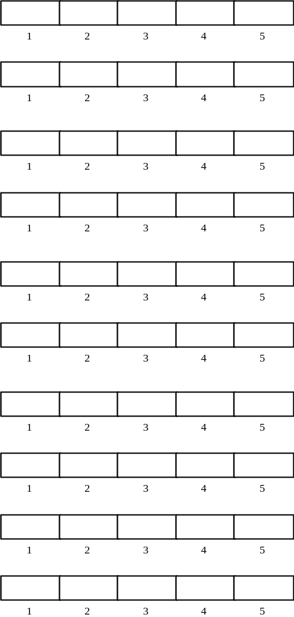
1. I think that I would like to
use this system frequently

2. I found the system unnecessarily
complex

3. I thought the system was easy
to use

4. I think that I would need the
support of a technical person to
be able to use this system

5. I found the various functions in
this system were well integrated

6. I thought there was too much
inconsistency in this system

7. I would imagine that most people
would learn to use this system
very quickly

8. I found the system very
cumbersome to use

9. I felt very confident using the
system

10. I needed to learn a lot of
things before I could get going
with this system

