caTRIP
End User Manual

Duke Comprehensive Cancer Center

Document Change History
Version Number | Date | Contributor | Description
V1.0 | 10/24/2006 | Patrick | First Draft


Updated August 1, 2006

Copyright and License page

Copyright Notice. Copyright 2006 Duke Comprehensive Cancer Center (“caBIG™ Participant”). caTRIP was created with NCI funding and is part of the caBIG™ initiative. The software subject to this notice and license includes both human readable source code form and machine readable, binary, object code form (the “caBIG™ Software”).
This caBIG™ Software License (the “License”) is between caBIG™ Participant and You. “You (or “Your”) shall mean a person or an entity, and all other entities that control, are controlled by, or are under common control with the entity. “Control” for purposes of this definition means (i) the direct or indirect power to cause the direction or management of such entity, whether by contract or otherwise, or (ii) ownership of fifty percent (50%) or more of the outstanding shares, or (iii) beneficial ownership of such entity.
License. Provided that You agree to the conditions described below, caBIG™ Participant grants You a non-exclusive, worldwide, perpetual, fully-paid-up, no-charge, irrevocable, transferable and royalty-free right and license in its rights in the caBIG™ Software, including any copyright or patent rights therein that may be infringed by the making, using, selling, offering for sale, or importing of caBIG™ Software, to (i) use, install, access, operate, execute, reproduce, copy, modify, translate, market, publicly display, publicly perform, and prepare derivative works of the caBIG™ Software; (ii) make, have made, use, practice, sell, and offer for sale, and/or otherwise dispose of caBIG™ Software (or portions thereof); (iii) distribute and have distributed to and by third parties the caBIG™ Software and any modifications and derivative works thereof; and (iv) sublicense the foregoing rights set out in (i), (ii) and (iii) to third parties, including the right to license such rights to further third parties. For sake of clarity, and not by way of limitation, caBIG™ Participant shall have no right of accounting or right of payment from You or Your sublicensees for the rights granted under this License. This License is granted at no charge to You. Your downloading, copying, modifying, displaying, distributing or use of caBIG™ Software constitutes acceptance of all of the terms and conditions of this Agreement. If you do not agree to such terms and conditions, you have no right to download, copy, modify, display, distribute or use the caBIG™ Software.
- Your redistributions of the source code for the caBIG™ Software must retain the above copyright notice, this list of conditions and the disclaimer and limitation of liability of Article 6 below. Your redistributions in object code form must reproduce the above copyright notice, this list of conditions and the disclaimer of Article 6 in the documentation and/or other materials provided with the distribution, if any.
- Your end-user documentation included with the redistribution, if any, must include the following acknowledgment: “This product includes software developed by Duke Comprehensive Cancer Center.” If You do not include such end-user documentation, You shall include this acknowledgment in the caBIG™ Software itself, wherever such third-party acknowledgments normally appear.
- You may not use the names “Duke Comprehensive Cancer Center”, “The National Cancer Institute”, “NCI”, “Cancer Bioinformatics Grid” or “caBIG™” to endorse or promote products derived from this caBIG™ Software. This License does not authorize You to use any trademarks, service marks, trade names, logos or product names of either caBIG™ Participant, NCI or caBIG™, except as required to comply with the terms of this License.
- For sake of clarity, and not by way of limitation, You may incorporate this caBIG™ Software into Your proprietary programs and into any third party proprietary programs. However, if You incorporate the caBIG™ Software into third party proprietary programs, You agree that You are solely responsible for obtaining any permission from such third parties required to incorporate the caBIG™ Software into such third party proprietary programs and for informing Your sublicensees, including without limitation Your end-users, of their obligation to secure any required permissions from such third parties before incorporating the caBIG™ Software into such third party proprietary software programs. In the event that You fail to obtain such permissions, You agree to indemnify caBIG™ Participant for any claims against caBIG™ Participant by such third parties, except to the extent prohibited by law, resulting from Your failure to obtain such permissions.
- For sake of clarity, and not by way of limitation, You may add Your own copyright statement to Your modifications and to the derivative works, and You may provide additional or different license terms and conditions in Your sublicenses of modifications of the caBIG™ Software, or any derivative works of the caBIG™ Software as a whole, provided Your use, reproduction, and distribution of the Work otherwise complies with the conditions stated in this License.
- THIS caBIG™ SOFTWARE IS PROVIDED "AS IS" AND ANY EXPRESSED OR IMPLIED WARRANTIES (INCLUDING, BUT NOT LIMITED TO, THE IMPLIED WARRANTIES OF MERCHANTABILITY, NON-INFRINGEMENT AND FITNESS FOR A PARTICULAR PURPOSE) ARE DISCLAIMED. IN NO EVENT SHALL THE DUKE COMPREHENSIVE CANCER CENTER OR ITS AFFILIATES BE LIABLE FOR ANY DIRECT, INDIRECT, INCIDENTAL, SPECIAL, EXEMPLARY, OR CONSEQUENTIAL DAMAGES (INCLUDING, BUT NOT LIMITED TO, PROCUREMENT OF SUBSTITUTE GOODS OR SERVICES; LOSS OF USE, DATA, OR PROFITS; OR BUSINESS INTERRUPTION) HOWEVER CAUSED AND ON ANY THEORY OF LIABILITY, WHETHER IN CONTRACT, STRICT LIABILITY, OR TORT (INCLUDING NEGLIGENCE OR OTHERWISE) ARISING IN ANY WAY OUT OF THE USE OF THIS caBIG™ SOFTWARE, EVEN IF ADVISED OF THE POSSIBILITY OF SUCH DAMAGE.

Insert Names of Development Team(s) here
Development | User’s Guide | Program Management
Patrick McConnell¹ | Patrick McConnell¹ | Jamie Cuticchia¹
Ram Chilukuri² |  | Bob Annechiarico¹
Srini Akkala² |  | Patrick McConnell¹
Bill Mason³ |  | Ram Chilukuri²
Sanjeev Agarwal²
Mark Peedin¹
Christopher Hubbard¹
¹Duke Comprehensive Cancer Center
²Semantic Bits
³5AM Solutions

Contacts and Support
Enter training contact | Patrick McConnell  (patrick.mcconnell@duke.edu)
Enter customer support contact | NA

LISTSERV Facilities Pertinent to software teams
LISTSERV | URL | Name
catrip-users | catrip-users@gforge.nci.nih.gov | caTRIP Users Forum
catrip-general | catrip-general@gforge.nci.nih.gov | caTRIP General Forum
catrip-developers | catrip-developers@gforge.nci.nih.gov | caTRIP Developers Forum

Table of Contents

Chapter 1 Introduction to the Manual 1
Chapter Organization and Content 1
Overview of the Guide 1
Getting Started with caTRIP 1
Organization of the User Guide 1
Document Text Conventions 1
Chapter 2 Overview of the Software 3
Software Overview 3
Components of the Software 3
Features and Functions of the Software 3
Description of the User Interface 4
Chapter 3 User Interface 7
Launching caTRIP 7
Logging into caTRIP 7
Building queries in the simple interface 8
Building queries in the query builder interface 9
Mining results 9
Chapter 4 Example Queries 11
Find available tumor tissue 11
Find factors of survival 13
Determine the distribution of disease factors over time 14
Find patients for trials 14
Determine correlation of factors pre and post surgery 15
Chapter 5 Error Messages/Indicators and Problem Resolutions 17
Description and interpretation of error messages 17
Chapter 6 Unsupported Features 19
Security 19
Joins 19
Query views 19
Case sensitivity 19
Reporting 19
Chapter 7 Glossary/Acronyms/ Abbreviations 20
Appendix A References 22
Technical Manuals/Articles 22
Scientific Publications 22
caBIG Material 22
caCORE Material 22
Appendix B Glossary 25
Index 28

Introduction to the Manual
Topics in this chapter include:
- Chapter organization and content
- Overview of the guide
- Getting started
- Organization of the user’s guide
- Document text convenstions

Chapter Organization and Content
Chapter content: For this chapter, write a brief paragraph introducing the software for which this manual is written. Then tie that into the purpose of this chapter which is to describe the purpose, objectives, and brief directions for using this manual.

Overview of the Guide
Brief overview of this user’s guide.

Getting Started with caTRIP
You can access the caTRIP application at:
- http://cagrid2.duhs.duke.edu/catrip-webstart/
Click on the link to launch the application. The first time you run launch the application it will have to download the required libraries and resources. Launching the application in subsequent sessions should load much more quickly.

Organization of the User Guide
Summarize each chapter in the table.
Chapter | Contents

Document Text Conventions
Chapter 1 | Description of Chapter 1
Etc.
Apply table text style to text
The following table shows various typefaces to differentiate between regular text and menu commands, keyboard keys, and text that you type. This illustrates how conventions are represented in this guide.
Convention | Description | Example
Bold & Capitalized Command  Capitalized command > Capitalized command | Indicates a Menu command  Indicates Sequential Menu commands | Admin > Refresh
text in small caps | Keyboard key that you press | Press enter.
text in small caps + text in small caps | Keyboard keys that you press simultaneously | Press shift + ctrl and then release both.
Boldface type | Options that you select in dialog boxes or drop-down menus. Buttons or icons that you click. | In the Open dialog box, select the file and click the Open button.
Italics | Used to reference other documents, sections, figures, and tables. | caCORE Software Development Kit 1.0 Programmer’s Guide
Italic boldface type | Text that you type | In the New Subset text box, enter Proprietary Proteins.
Courier typestyle | Used for filenames, directory names, commands, file listings, source code examples and anything that would appear in a Java program, such as methods, variables, and classes. | URL_definition ::= url_string
Note: | Highlights a concept of particular interest | Note: This concept is used throughout the installation manual.
Table 1. 1 Document Conventions
Warning! | Highlights information of which you should be particularly aware. | Warning! Deleting an object will permanently delete it from the database.
{} | Curly brackets are used for replaceable items. | Replace {root directory} with its proper value such as c:\cabio

Overview of the Software
This chapter provides an overview of the software.
Topics in this chapter include: (bullet list and cross reference to sections in chapter).
- Software Overview on this page
- Component of software and functions on page sss
- Etc.

Software Overview
Background of the software, if appropriate. Include pertinent website links, if appropriate. General description and scope of the system.
caBIG compatibility level
Images can be inserted where appropriate. Figure 1 is an example of an image copied and pasted in metafile format.
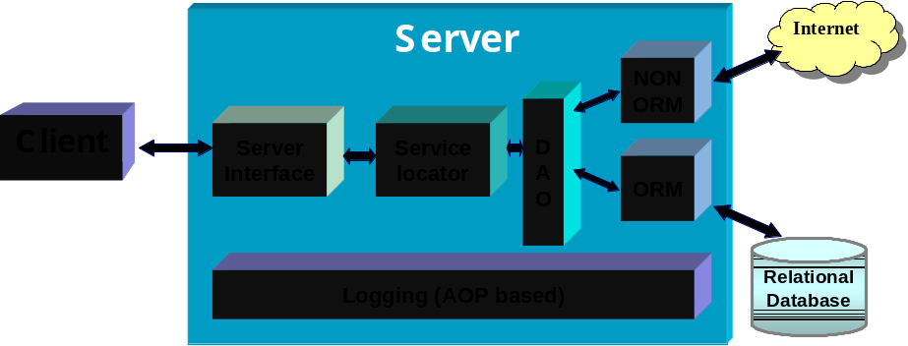

Figure 1 If captions are inserted automatically, when you update the book, captions also update automatically..

Sections of this chapter could also include:

Components of the Software

Features and Functions of the Software

Description of the User Interface

User Interface
Topics in this chapter include:
- Launching caTRIP
- Logging into caTRIP
- Building queries in the simple interface
- Building queries in the query builder interface
- Mining results

Launching caTRIP
You can access the caTRIP application at:
- http://152.16.96.114/catrip-webstart/
Click on the link to launch the application. The first time you run launch the application it will have to download the required libraries and resources. Launching the application in subsequent sessions should load much more quickly.

Logging into caTRIP
Click “Proceed to Login” on the splash screen:
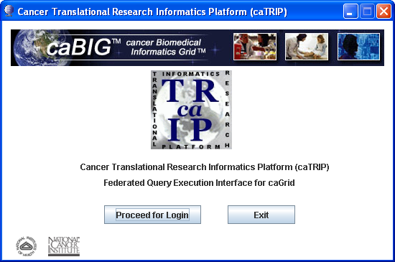
Security is currently not implemented, so you will not have to enter a user name or password. However, you should select “Show Visual Query Designer” if you want to use the advanced features. Otherwise, leave it unselected and click Login.
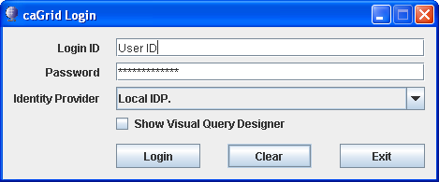
If you choose to use the visual query designer, you will need to select services to run on. You can either enter query criteria or simply click “Show All”. Select the service you’d like to use by clicking their check boxes in the table, and then click “Select” to open the query designer window.
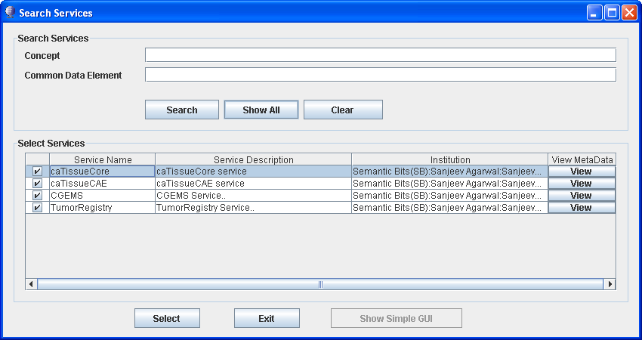

Building queries in the simple interface
The simple interface allows you to build queries using drop-down menus. Services, target objects, and CDEs are pre-selected in a configuration file to simplify the interface.
The first step is to select a “target object” from the first drop-down menu. This will be the root of your query and will determine which initial services to query.
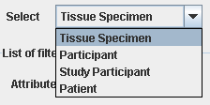
The second step is to select a service to query from. This will determine how the query is formulated and from which service data elements are returned.

The third step is to add filters to the query. This is accomplished by clicking the “Add Filter” button.
You can then select the specific data element you would like to filter on. Data elements from all the services will be available.
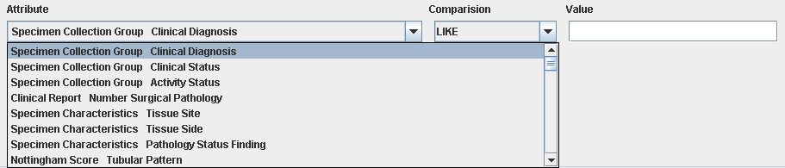
The comparison box allows you to select what sort of comparison to make with the value you input and the data element. For example, you can select greater than for numeric and date fields. Like is an operation that performs a text search.
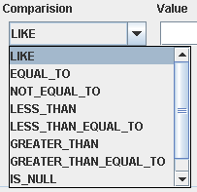
You can add as many filters as you would like. There is an implicit AND between the filters.
The final step is to run the query by clicking the “Execute” button.

Results will be shown in the results table at the bottom of the screen.
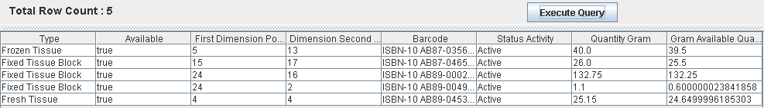

Building queries in the query builder interface
Describe that here

Mining results
Mining results is not supported in this release.

Example Queries
This chapter describes some sample queries to get you started. These fall into the categories of:
- Find available tumor tissue
- Find factors of survival
- Determine the distribution of disease factors over time
- Find patients for trials
- Determine correlation of factors pre and post surgery

Find available tumor tissue
- What are all the available tissue specimens from the breast?
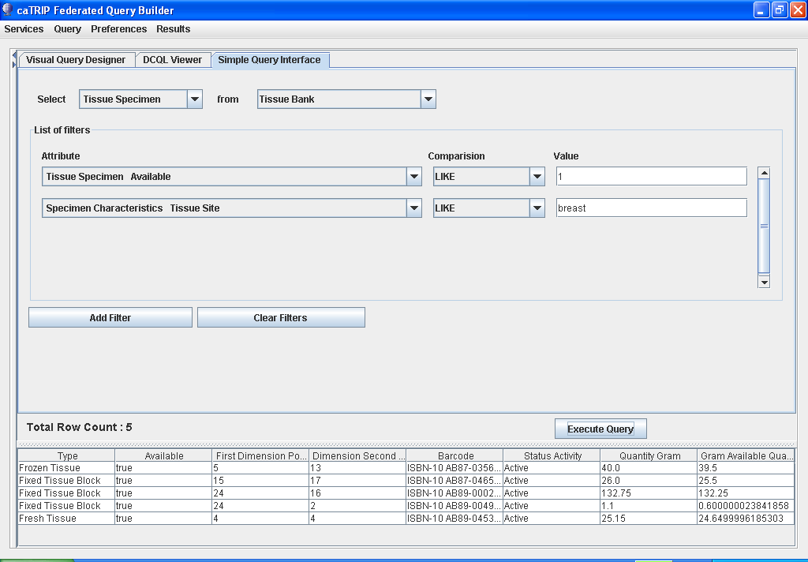
- What are all the tissue specimens from patients that have a her2/new status of positive?
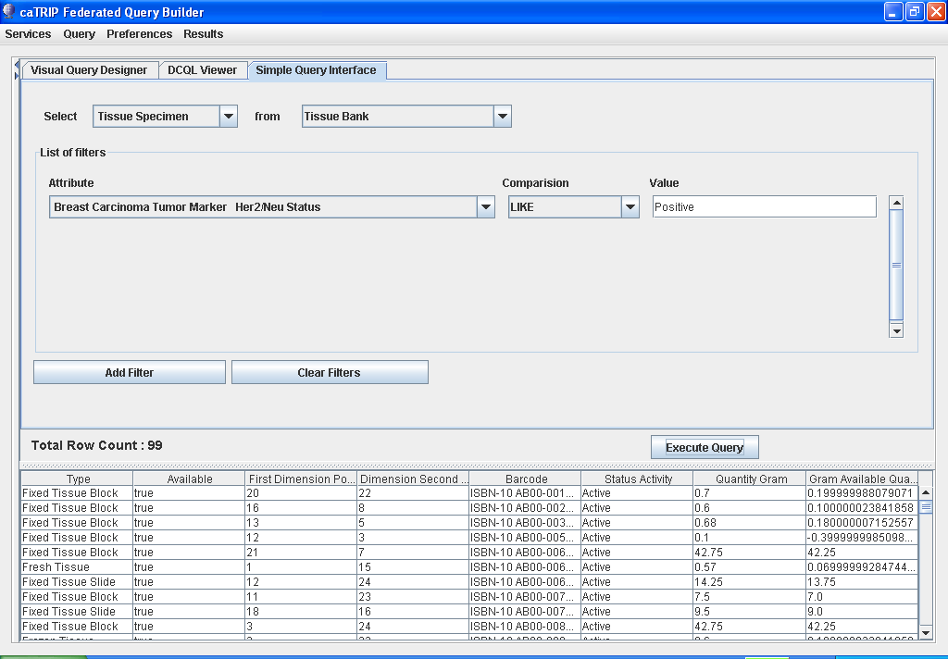
- What are all the tissue specimens from her2/neu positive patients that have a primary tumor in the breast?
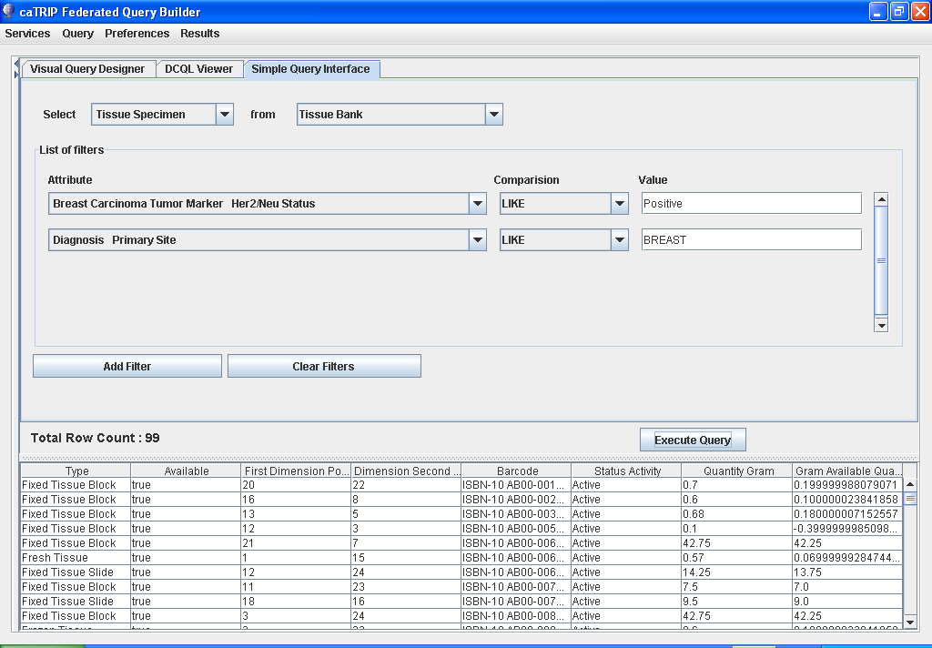
- What are all the tissue specimens from her2/neu positive patients that have a primary tumor in the breast and are BRCA1 positive?
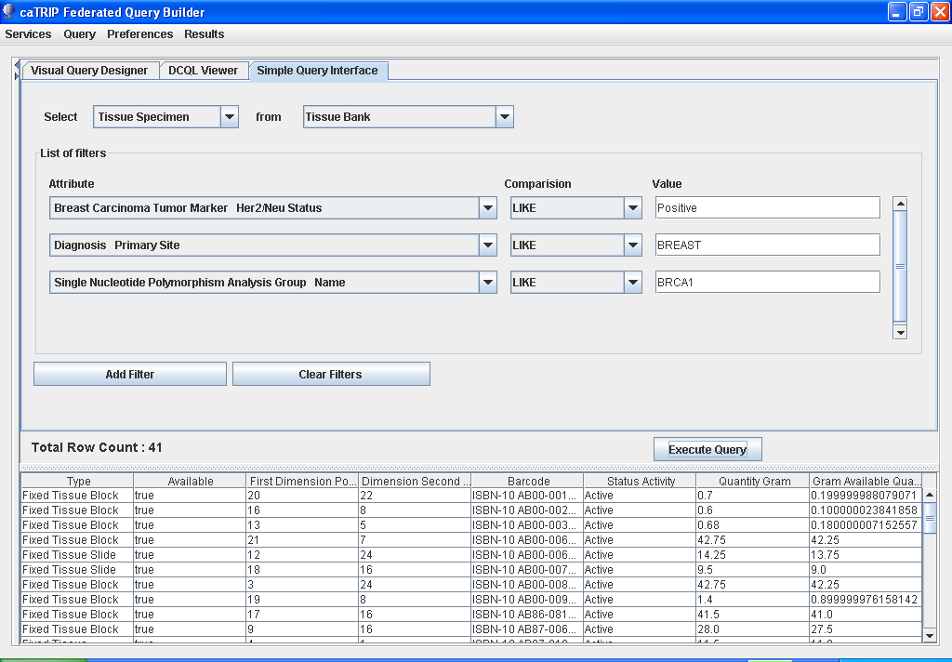

Find factors of survival
- What are all the ER positive patients that have survived breast cancer after radiation treatment?
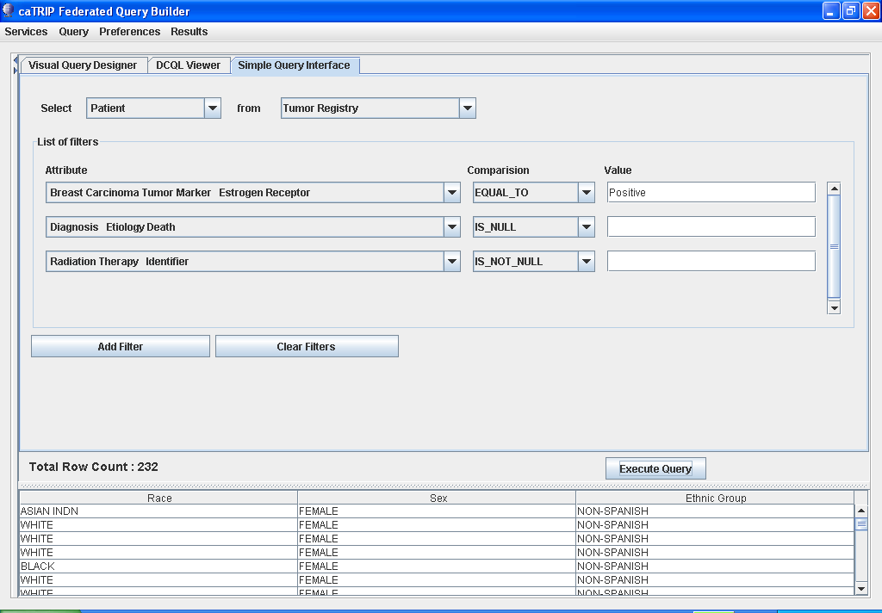
- What are all the BRCA1 positive patients over the age of 50 that have survived breast cancer after surgery?
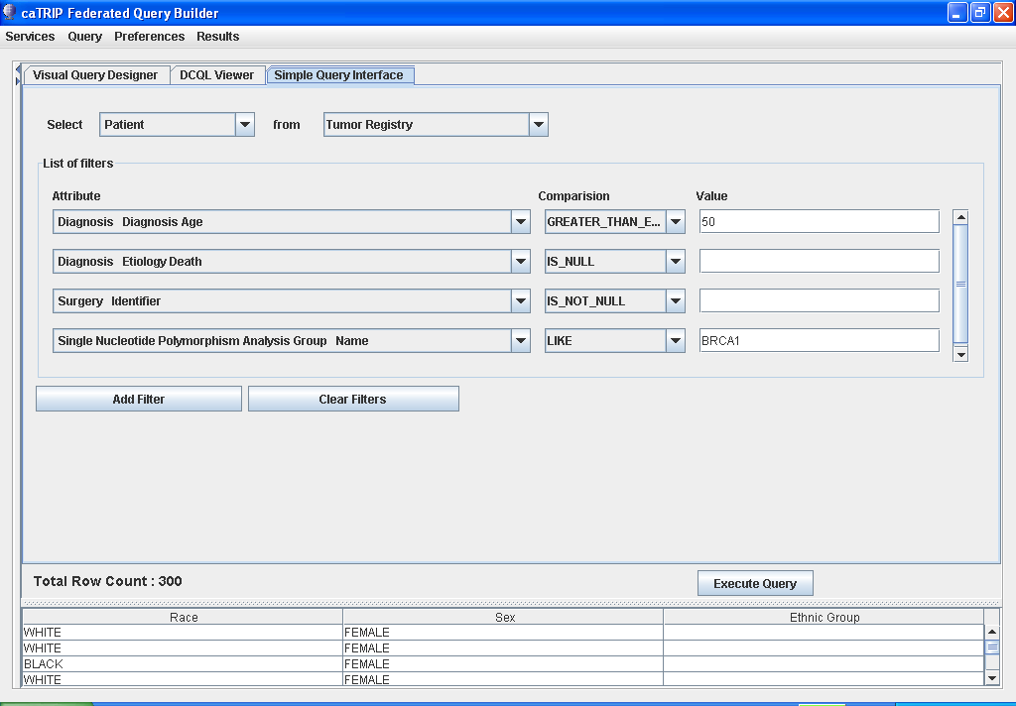

Determine the distribution of disease factors over time
There are no queries in this category

Find patients for trials
- What are all the patients that are triple negative (ER, PR, and HER2/NEU negative)?
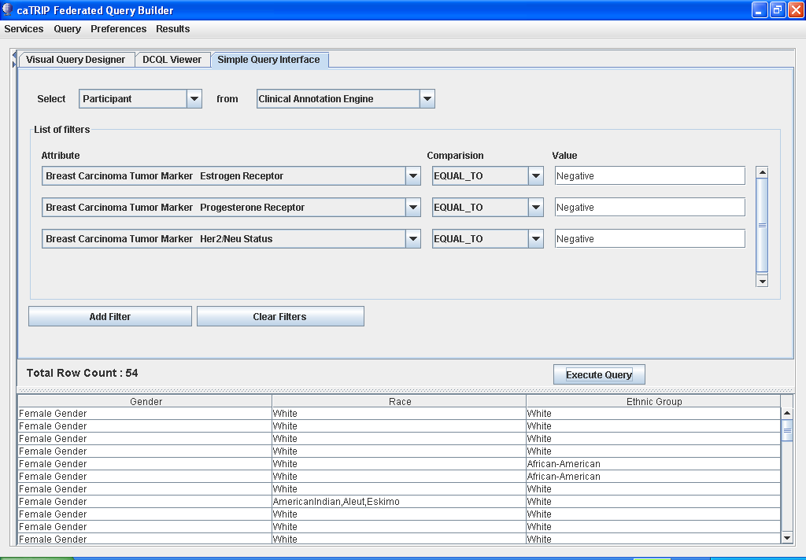

Determine correlation of factors pre and post surgery
There are no queries in this category

Error Messages/Indicators and Problem Resolutions
This chapter includes:
- Description and interpretation of error messages

Description and interpretation of error messages
Error messages will appear in popup windows like this:
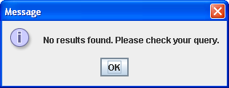
Here are some common messages and their interpretation:
Message | Interpretation
No results found. Please check your query. | Your query resulted in no results because of some limiting filter criteria.

Unsupported Features
This chapter describes the features of caTRIP that are not supported in the current release.

Update in WebStart
In order to get the latest configuration changes in the GUI, you will have to delete the .caTRIP folder in your home directory before running the GUI. For me, I would delete C:\Documents and Settings\MCCON012\.caTRIP. This will be changed in phase 2.

Security
No security has been implemented for caTRIP. This includes authentication and authorization. All data is deidentified or fake.

Joins
Only foreign joins of equality are currently supported. For example, you could not join between services using one date being greater than another.

Query views
Queries are synchronized between the Simple Interface and the DCQL view, as well as the Query Builder and the DCQL view. However, there is no synchronization from DCQL (e.g. no editing of DCQL) and no synchronization between the Simple Interface and Query Builder. In fact, the Simple Interface is disabled in Query Builder mode and vice versa.

Case sensitivity
Queries for caTissue CORE are case-insensitive. However, queries to all other services are case sensitive.

Reporting
Only the target object is displayed in the output table. A future release will allow for the selection of output fields, as well as mining into objects.

Glossary/Acronyms/ Abbreviations
You could divide this into separate chapters, depending on the number of entries here. You could also make this an appendix.
For an examples, see Appendix B

- References
This appendix could include lists and hypertext links, where appropriate, to technical manuals, articles, scientific publications, etc. Examples are shown:

Technical Manuals/Articles
- National Cancer Institute. "caCORE 2.0 Technical Guide", ftp://ftp1.nci.nih.gov/pub/cacore/caCORE2.0_Tech_Guide.pdf
- Java Bean Specification: http://java.sun.com/products/javabeans/docs/spec.html
- Foundations of Object-Relational Mapping: http://www.chimu.com/publications/objectRelational/
- Object-Relational Mapping articles and products: http://www.service-architecture.com/object-relational-mapping/
- Hibernate Reference Documentation: http://www.hibernate.org/hib_docs/reference/en/html/
- Basic O/R Mapping: http://www.hibernate.org/hib_docs/reference/en/html/mapping.html
- Java Programming: http://java.sun.com/learning/new2java/index.html
- Javadoc tool: http://java.sun.com/j2se/javadoc/
- JUnit: http://junit.sourceforge.net/
- Extensible Markup Language: http://www.w3.org/TR/REC-xml/
- XML Metadata Interchange: http://www.omg.org/technology/documents/formal/xmi.htm

Scientific Publications

caBIG Material
- caBIG: http://cabig.nci.nih.gov/
- caBIG Compatibility Guidelines: http://cabig.nci.nih.gov/guidelines_documentation

caCORE Material
- caCORE: http://ncicb.nci.nih.gov/core
- caBIO: http://ncicb.nci.nih.gov/core/caBIO
- caDSR: http://ncicb.nci.nih.gov/core/caDSR
- EVS: http://ncicb.nci.nih.gov/core/EVS
- CSM: http://ncicb.nci.nih.gov/core/CSM
- Glossary
Following is an example list of terms and their definitions. You may use any of these you consider appropriate for your glossary.
Term | Definition
API | Application Programming Interface
caArray | cancer Array Informatics
caBIG | cancer Biomedical Informatics Grid
caBIO | Cancer Bioinformatics Infrastructure Objects
caCORE | cancer Common Ontologic Representation Environment
caDSR | Cancer Data Standards Repository
caMOD | Cancer Models Database
cardinality | Cardinality describes the minimum and maximum number of associated objects within a set
CDE | Common Data Element
CGAP | Cancer Genome Anatomy Project
CMAP | Cancer Molecular Analysis Project
CN | Common Name
CS | Classification Scheme
CSI | Classification Scheme Item
CSM | Common Security Module
CTEP | Cancer Therapy Evaluation Program
CUI | Concept Unique Identifier
CVS | Concurrent Versions System
DAML | DARPA Agent Markup Language
DAO | Data Access Objects
DARPA | Defense Advanced Research Projects Agency
DAS | Distributed Annotation System
DL | Description Logic
EA | Enterprise Architect
EBI | European Bioinformatics Institute
EVS | Enterprise Vocabulary Services
GAI | CGAP Genetic Annotation Initiative
GEDP | Gene Expression Data Portal
HIPPA | Health Insurance Portability and Accountability Act
HLGT | High Level Group Term
HLT | High Level Term
HTTP | Hypertext Transfer Protocol
ISO | International Organization for Standardization
JAAS | Java Authentication and Authorization Service
JAR | Java Archive
Javadoc | Tool for generating API documentation in HTML format from doc comments in source code (http://java.sun.com/j2se/javadoc/)
JDBC | Java Database Connectivity
JET | Java Emitter Templates
JMI | Java Metadata Interface
JSP | JavaServer Pages
JUnit | A simple framework to write repeatable tests (http://junit.sourceforge.net/)
LDAP | Lightweight Directory Access Protocol
LLT | Lowest Level Term
LOINC | Logical Observation Identifier Names and Codes
MAGE | MicroArray and Gene Expression
MAGE-OM | MicroArray Gene Expression - Object Model
MedDRA | Medical Dictionary for Regulatory Activities
metadata | Definitional data that provides information about or documentation of other data.
MGED | Microarray Gene Expression Data
MMHCC | Mouse Models of Human Cancers Consortium
MO | MGED Ontology
multiplicity | Multiplicity of an association end indicates the number of objects of the class on that end may be associated with a single object of the class on the other end
NCI | National Cancer Institute
NCICB | National Cancer Institute Center for Bioinformatics
OIL | Ontology Inference Layer
OilEd | Ontology editor allowing you to build ontologies using DAML+OIL
OLLT | Obsolete Lower Level Terms
OMG | Object Management Group
ORM | Object Relational Mapping
PT | Preferred Term
RDBMS | Relational Database Management System
SDK | Software Development Kit
Semantic connector | A development kit to link model elements to NCICB EVS concepts.
SOC | System Organ Class
SPORE | Specialized Programs of Research
SQL | Structured Query Language
SSC | Special Search Categories
UI | User Interface
UID | User Identification
UML | Unified Modeling Language
UMLS | Unified Medical Language System
UPT | User Provisioning Tool
URL | Uniform Resource Locators
VD | Value Domain
WAR | Web Application Archive
WSDL | Web Services Description Language
XMI | XML Metadata Interchange (http://www.omg.org/technology/documents/formal/xmi.htm) - The main purpose of XMI is to enable easy interchange of metadata between modeling tools (based on the OMG-UML) and metadata repositories (OMG-MOF) in distributed heterogeneous environments

Index
It is very easy to generate an index and extremely helpful to the manual user. See the Style Guide (https://cabig.nci.nih.gov/working_groups/Training_SLWG/Documents/Technical_Pubs_Style_Guide_021405_jbh.pdf) for suggestions for inserting index markers and generating an index.

Note: You may need to check the font size of your index text. The index font in the template has been configured as Times New Roman, size 10, but MS Word is subject to some bugs. While size 10 font is configured, some text may display as size 9 (as you can see in the following index). To manually correct the font size, select the entire index and select Format > Font, and choose Font Size 10. Each time you update your index, however, you will need to re-verify the font size.

Glossary, 17
References
caBIG materials, 15
caCORE material, 15
scientific publications, 15
technical manuals, guides, 15
Text conventions, Supplement, 3

