caTRIP
Translational Research Informatics Platform
Title of Publication

Installation Guide

caBIG™ is an initiative of the National Cancer Institute, NIH, DHHS
Table of Contents

Introduction 1
Overview of caTRIP 2
caTRIP Minimal System Requirements 2
Minimal System Requirements 3
caTRIP Software and Technology Requirements 3
Software Requirements 3
Required Software—Not Included in caTRIP 3
Installing caTRIP 4
Preliminary Considerations 4
Installing Prerequisites 5
Downloading caTRIP 7
Installing the Components 7
Database setup 7
Database Test Data 8
Web Services 8
Hibernate Configuration Files 9
caTRIP Configuration Files 10
Creating new data service 11
Domain model setup 11
Create data service using Introduce toolkit 13
Query Builder Configuration Files 18
Testing the Application 25
Creating a Webstart Application 27
Security 28
NT Authentication 28
Default Dorian Authentication 29
Authorization 29
Running the Application 30
Appendix I caTRIP Components 31
Contacting Technical Support 31
caTRIP Application Support 31

Introduction
This manual is intended as a guide for system administrators attempting to install caTRIP at their organization. It describes the installation process, and various configuration options. It assumes prior understanding of what caTRIP is, and what it is trying to do. A brief introduction of caTRIP is included in the following section, however we recommend that you read the Requirements specification and Design specification documents found at the caTRIP website at https://gforge.nci.nih.gov/projects/catrip/

Overview of caTRIP | In order to have an impact in society, discoveries in cancer research need to be translated into knowledge that can be directly applied to treatment and prevention. These discoveries usually start within the basic sciences, from experiments developed at the molecular level, slowly progressing to clinical research. Although this translational process is at the very basis of our ability to generate new biomedical knowledge, to date few tools have been developed to successfully link the basic and clinical science fields in a way so that researchers from both arenas can easily make connections between the two. More specifically, cancer research would benefit from the development of applications that could aggregate clinical and molecular data in a repository that is user-friendly, easily accessible, as well as compliant with regulatory requirements of privacy and security.  In line with the requirements outlined above, the Duke Comprehensive Cancer Center, in collaboration with SemanticBits LLC, has developed the Cancer Translational Research Informatics Platform, a translational research system for the Cancer Biomedical Informatics Grid (caBIG) project. caTRIP allows users to query across a number of caBIG data services, join on common data elements (CDEs), and view their results in a user-friendly interface. Having as its initial focus the enabling of outcomes analysis, caTRIP allows clinicians to query across data from existing patients with similar characteristics to find treatments that were administered with success. In doing so, caTRIP can help inform treatment and improve patient care, as well as enable the searching of available tumor tissue, locating patients for clinical trials, and investigating the association between multiple predictors and their corresponding outcomes such as survival. Of importance, caTRIP relies on the vast array of open source caBIG applications, including (1) Tumor Registry, a clinical system that is used to collect endpoint data; (2) the cancer Text Information Extraction System (caTIES, https://cabig.nci.nih.gov/tools/caties), a locator of tissue resources that works via the extraction of clinical information from free text surgical pathology reports while using controlled terminologies to populate caBIG-compliant data structures; (3) caTissue CORE ( https://cabig.nci.nih.gov/tools/catissuecore), a tissue bank repository tool for biospecimen inventory, tracking, and basic annotation; (4) Cancer Annotation Engine (CAE) ( https://cabig.nci.nih.gov/tools/cae), a system for storing and searching pathology annotations; (5) caIntegrator ( http://gforge.nci.nih.gov/projects/caintegrator/), a tool for storing, querying, and analyzing translational data, including SNP data.

caTRIP Minimal System Requirements

Minimal System Requirements | - Internet connection  - Server specs listed in Table 1
The caTRIP has been tested on the platforms shown in Table 1 .

 | Linux Server | Windows
Model | HP Proliant ML 330 | Dell GX 270
CPU | 1 x Intel® Xeon™ Processor 2.80GHz | 1 x Intel® Pentium™ Processor 2.80GHz
Memory | 4 GB | 1 GB
Local Disk | System 2 x 36GB  (RAID 1)  Data = 2 x 146 (RAID 1) | System 1 x 36GB
OS | Red Hat Linux ES 3 (RPM 2.4.21-20.0.1) | Windows XP/2000 Professional
Table 1 Platform Testing Environment

caTRIP Software and Technology Requirements

Software Requirements
Required Software—Not Included in caTRIP | You must download and install the required software that is not included with caTRIP (listed in Table 2 .) The software name, version, description, and URL hyperlinks (for download) are indicated in the table.

(Required software that is included with the caTRIP is listed in Appendix I on page Error: Reference source not found.)
Software Name | Version | Description | URL
Java Software Development Kit (SDK):Java 2 Standard Edition (J2SE) | j2sdk1.5.2_06 or higher | The J2SE Software Development Kit (SDK) supports creating J2SE applications | http://java.sun.com/j2se/1.4.2/ download.html
Globus Toolkit | 4.0.3 | An open source software toolkit used for building Grid systems and applications | http://www.globus.org/toolkit/downloads/
Apache Tomcat | 5.0.28 | Apache Tomcat is an open source servlet container. | http://tomcat.apache.org/download-55.cgi
Apache Ant | 1.6 or higher | Apache Ant is a Java-based build tool | http://ant.apache.org/bindownload.cgi
Oracle Database | 9i or 10g | Oracle is a commercially-available, alternative relational database management system (RDBMS) | http://www.oracle.com/technology/products/oracle9i/index.html
MysSQL | 4.1 | Open source relational database | http://dev.mysql.com/downloads/
Table 2 Required software

Installing caTRIP

Preliminary Considerations
 | BEFORE YOU BEGIN | caTRIP has been tested with the operating systems and hardware specified on pages 2 through 3 of this guide. We cannot guarantee caTRIP will work If you are using variations of these operating systems and/or hardware.

Installing Prerequisites
Step | Action
1 | Jakarta Ant - Extract the contents of the Ant zip file, apache-ant-1.6.2-bin.zip and save it to your computer. For example, if your root directory in Windows is C:\, then extract your Ant home directory to C:\apache-ant-1.6.2.
2 | Java JRE - Download version 1.5 or higher and install it to a desired location e.g. C:\jdk1.5.0_06.
3 | Verify that the environment variables ANT_HOME and JAVA_HOME are set and that your PATH statement includes the locations of the Ant and Java binaries. For example, PATH should include C:\apache-ant-1.6.2\bin; C:\ jdk1.5.0_06\bin.  To do this in Windows:  - Select My Computer > Properties (from the shortcut menu) > Advanced tab.  - Click the Environment_Variables... button.  - ANT_HOME and JAVA_HOME must each be listed in one or the other of the panels of the dialog box. To add either, below one of the panels, click the New button.  - In the New User Variable dialog box, add the Variable and Variable Value.  Examples:  Variable = ANT_HOME; Variable Value = C:\apache-ant-1.6.2  Variable = JAVA_HOME; Variable Value = C:\ jdk1.5.0_06  - Verify that the PATH statement listed in the Environment Variables dialog box includes both the ANT_HOME and JAVA_HOME binaries and that they read as follows: C:\ jdk1.5.0_06\bin;C:\apache-ant-1.6.2\bin. (To easily review these, copy them to a text editor.) If necessary, click the Edit button and enter the correct information.
4 | Tomcat Installation – extract the zip file to the c:\ drive. After unzipping add the variable CATALINA_HOME = <your tomcat home> e.g.  CATALINA_HOME = c:\ tomcat_cagrid_5.0.28
- 88  5 | Globus installation – extract the zip file to the c:\ drive.  Add the environment variable GLOBUS_HOME=c:\<globus location> for example:  GLOBUS_LOCATION = c:\ ws-core-4.0.3  Next install the Globus container into Tomcat. Change to the globus directory c:\<globus location>\ . To install the container run the following:  ant -f share\globus_wsrf_common\tomcat\tomcat.xml deployTomcat -Dtomcat.dir="<tomcat location>"  Output of the Globus installation:  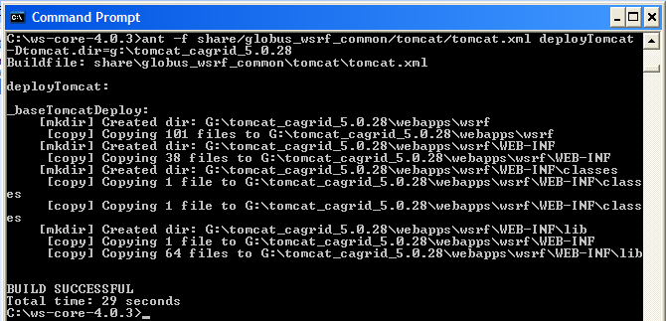  The Globus installation will add a new directory ‘wsrf’ in the Tomcat directory under ‘webapps’  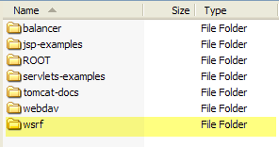
6 | Download and install MySQL 4.1 to a desired location e.g. c:\mysql4.1  http://dev.mysql.com/downloads/
7 | Download and install Oracle 9i or 10g to a desired location e.g. c:\oracle  http://www.oracle.com/technology/products/oracle9i/index.html

Downloading caTRIP
 | SUGGESTION | To best understand the installation and testing procedures for the caTRIP, it is recommended that you follow the procedures described in this section with minimal deviation.
Complete the following steps to download caTRIP;

Step | Action
1 | Go GForge web site to download caTRIP:  https://gforge.nci.nih.gov/frs/?group_id=131
2 | Save it to a directory on your computer (for example, C:\caTRIP in Windows). This may take several minutes.
3 | Extract the contents of the caTRIP distribution zip file to your root directory. For example, if your root directory in Windows is C:\, then your caTRIP home directory is C:\caTRIP.  Note: This directory name cannot contain any spaces or this will cause errors in Windows. For instance, do not place the caTRIP directory in the Program Files directory.

Installing the Components
After downloading and unzipping caTRIP the following components need to be edited or installed:

- Install Oracle and MySQL databases
- Install Web Services
- Edit Hibernate configuration files
- Edit caTRIP Configuration Files

Database setup
Database scripts for both Oracle and MySQL are available to create the user and schemas. All sql scripts can be found in the directory: codebase\projects\db_scripts

File Name | Description
Tumor_registry_oracle_creation.sql | This file contains SQL statements that can be used to create the user and database for the Tumor Registry database in Oracle
CAE_oracle_creation.sql | This file contains SQL statements that can be used to create the user and database for Clinical Annotations Engine (CAE) database in Oracle
CGEMS_oracle_creation.sql | This file contains SQL statements that can be used to create the user and database for Cancer Genetic Markers of Susceptibility (CGEMS) database in Oracle
Query_share_oracle_creation.sql | This file contains SQL statements that can be used to create the user and database for the query sharing database in Oracle
Catissuecore_mysql_creation.sql | This file contains SQL statements that can be used to create the user and database for caTIssueCore database in MySQL
caties_mysql_creation.sql | This file contains SQL statements that can be used to create the user and database for Text Information Extraction System (caTIES) database in MySQL

Database Test Data
Test data for the Oracle databases CAE and Tumor Registry are available in the directory: codebase\projects\db_scripts\sampleData

Web Services

After the databases have been installed it is time to create the caTRIP services. The services will be deployed to Tomcat in the Globus directory wsrf\WEB-INF\etc.

Step | Action
1 | Go to where caTRIP was download and unzipped and change to the codebase directory.  <catrip directory>\codebase
2 | Run the Ant task ‘clean’ to clean appropriate directories. Run the following from the codebase directory:  ant clean
- 3  3 | Run the Ant task ‘all’ to compile all the code. Run the following from the codebase directory:  ant all
4 | Run the Ant task ‘deployTomcat’ to deploy the services to Tomcat. Run the following from the codebase directory:  ant deployTomcat  Note: Each service can be installed separately by running the same ant task within the service’s folder.
5 | After all Ant tasks are complete, you can check if the services got deployed by checking the following directory in Tomcat.  C:\<tomcat install dir>\webapps\wsrf\WEB-INF\etc  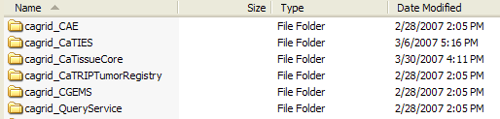

Hibernate Configuration Files

Once the services are installed, the Hibernate configuration files need to be update with your database information. Each service has a jar file which contains the Hibernate file to be updated.

Step | Action
1 | Go to the directory where Tomcat was installed. Change to the directory:  <tomcat dir>\webapps\wsrf\WEB-INF\lib  Here is where you will find the jar files to be updated
2 | Listed here are the services which use an Oracle database. See the next step for what lines to edit inside the hibernate configuration file.  Query service :  jar file: _queryservice.jar. hibernate file : hibernate.cfg.xml  CAE Service:  jar file: cae_domain.jar hibernate file : cae-hibernate.cfg.xml  CGEMS Service:  jar file: cgems-domain.jar hibernate file : cgems-hibernate.cfg.xml  Tumor Registry Service:  jar file: tumor_registry-domain.jar hibernate file : tumor-hibernate.cfg.xml
- 3  3 | Edit the following highlighted areas with your Oracle database information:  Connection URL:  <property name="connection.url">jdbc:oracle:thin:@localhost:1522:{service name}</property>  Connection Username :  <property name="connection.username">username</property>  Connection Password :  <property name="connection.password">password</property>
4 | Listed here are the services which use an MySQL database. See the next step for what lines to edit inside the hibernate configuration file.  caTIES Service:  jar file: caties-domain.jar hibernate file : caties-hibernate.cfg.xml caTissueCore Service:  jar file: catissuecore-domain.jar hibernate file : catissue-hibernate.cfg.xml
- 3  5 | Edit the following highlighted areas with your MySQL database information:  Connection URL :  <property name="connection.url">jdbc:mysql://localhost:3306/caties_ctrm</property>  Connection Username :  <property name="connection.username">username</property>  Connection Password :  <property name="connection.password">password</property>

caTRIP Configuration Files
Now the databases and web service are installed with the Hibernate files up to date, it is time to update some configuration files to point to the newly deployed web services.

Step | Action
1 | Go to where caTRIP was download and unzipped and change to the gui directory.  <catrip directory>\codebase\projects\gui
2 | Edit the build.properties file to set the location of the query service. This will be where your Tomcat is installed  query.sharing.url=http://localhost:8181/wsrf/services/cagrid/QueryService
- 3  3 | Now switch to the conf directory under gui:  <catrip directory>\codebase\projects\gui\conf  Here is where the service-config.xml file is located. The location of each service is set in this file.  The ipaddress of each service location needs to be changed to point to where your service is installed e.g. localhost.  <catripService url="http://152.16.96.114/wsrf/services/cagrid/CaTissueCore" serviceMetadataFileName="CaTissueCore_serviceMetadata.xml" domainModelFileName="caTissueCore_domainModel.xml"/>
- 3  4 | Next the simple gui interface configuration file needs to be update with the location of the services as well. Switch to the directory:  <catrip directory>\codebase\projects\gui\conf\simplegui  Here is where the SimpleGuiObjectGraph.xml file is located. Search for the service tags (<service) and change the location of the services for the simple gui interface.  The ipaddress of each service location needs to be changed to point to where your service is installed e.g. localhost.  <service displayName="Tissue Bank" url=http://152.16.96.114/wsrf-0216/services/cagrid/CaTissueCore …

NOTE: | For more information on configuration files, refer Configuration files section in Creating new data service

Creating new data service

Domain model setup
First step in creating a data service is to setup the domain model and data model.

Step | Action
1 | Create data model using Enterprise Architect or your favorite data modeling tool. Database scripts can me created manually
2 | Create the data base /schema
- 3  3 | Create object model using Enterprise Architect or your favorite modeling tool
- 3  4 | Generate Java Beans.
5 | Perform Hibernate Mappings  Refer to http://www.hibernate.org
6 | Create hibernate configuration file with the following naming convention.  <<service_name>>_hibernate.cfg.xml  Replace <<service_name>> with the data service name. This name should be unique.  Refer to http://www.hibernate.org
7 | Create castor mapping xml file with the following naming convention.  <<service_name>>-xml-mapping.xml.  Replace <<service_name>> with the data service name. This name should be unique.  Refer to http://www.castor.org
8 | Create domain model jar file which includes domain model class files, hibernate mapping files , castor mapping files. Save this domain model jar file for future use. Here is the directory structure for CAE service  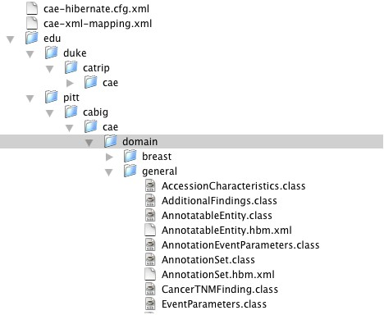

Create data service using Introduce toolkit
Introduce Toolkit is a service creation toolkit built by caGrid team. It supports easy developement and deployment of caBIG compatible grid enabled data and analytical services. Introduce toolkit reduces the service developers needing to manage the low level details of the WSRF specification and integration with the Globus Toolkit.

 | 1 |  | Refer to https://cabig.nci.nih.gov/workspaces/Architecture/caGrid for caGrid documentation.  Download caGrid code base.  Build caGrid code base.  Bring up Intrduce toolkit.  Click on “Create caBIG Service”
 | 2 |  | Fill all the four text fields. (CAE is the sample for service used as an example)  Select “Data Service” radio button.  Click “Create”
 | - 3  3 |  | 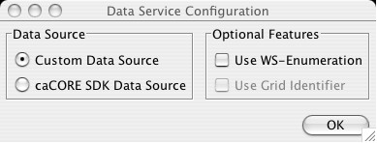  Select “Custom Data Source”  Click “OK”
 | - 3  4 |  | Service Interface  Click on “Data Service” Tab
 | 5 |  | As we created our own domain model jar file we don’t need to select any domain model this screen.  Select “No Domain Model” radio button  Click on “Query Processor” tab
 | 6 |  | Locate the query processor jar file cagrid-caTrip-SdkQuery1.0.jar in  “<<catrip_code_base>>/projects/catrip-custom-jars/lib.  Click “Add Jar” which would open your file system and then select cagrid-caTrip-SdkQuery1.0.jar from caTRIP distribution
 | 7 |  | Select “gov.nih.nci.cagrid.data.cql.cacore.LocalHQLCoreQueryProcessor” from “Selected Class” drop down list.  Modify hibernateConfigFile Current Value to ca-hibernate.cfg.xml (this is the file from step # 3.1.3  Click Save to save the data service.
8 |  | Go to the folder where you created the service <<service_location>>.  /Users/sakkala/services/cae in this example  - Copy all the jars from “<<catrip_code_base>>/projects/catrip-custom-jars/lib”  to <<service_location>>/lib . Replace the existing jars.  - Copy 1_gov.nih.nci.cagrid.CQLQuery.xsd from “<<catrip_code_base>>/projects/catrip-custom-jars/schema” to <<service_location>>/schema/<<servce_name>>/schema. Replace existing schema.
9 |  | Add type mappings to all domain model classes to <<service_location>>/server-config.wsdd.  Sample for two objects. Speciman and Participant  <ns3:typeMapping xmlns:ns3=”http://xml.apache.org/axis/wsdd/” xmlns:ns1=”http://xml.apache.org/axis/wsdd/providers/java” xmlns:ns2=”gme://caTissueCAE.caBIG/1.0/edu.duke.catrip.cae.domain.general” encodingStyle=”” serializer=”gov.nih.nci.cagrid.encoding.SDKSerializerFactory” deserializer=”gov.nih.nci.cagrid.encoding.SDKDeserializerFactory” type=”ns1:edu.duke.catrip.cae.domain.general.Specimen” qname=”ns2:Specimen” />  <ns3:typeMapping xmlns:ns3=”http://xml.apache.org/axis/wsdd/” xmlns:ns1=”http://xml.apache.org/axis/wsdd/providers/java” xmlns:ns2=”gme://caTissueCAE.caBIG/1.0/edu.duke.catrip.cae.domain.general” encodingStyle=”” serializer=”gov.nih.nci.cagrid.encoding.SDKSerializerFactory” deserializer=”gov.nih.nci.cagrid.encoding.SDKDeserializerFactory” type=”ns1:edu.duke.catrip.cae.domain.general.Participant” qname=”ns2:Participant” />
10 |  | Build service by executing “ant all” from <<service_location>>
11 |  | Deploy to tomcat by executing “ant deployTomcat” from <<service_location>>
12 |  | Create domain model extract using caCore SDK.  http://ncicb.nci.nih.gov/infrastructure/cacoresdk

Query Builder Configuration Files
Configuration files are located in <<catrip_code_base>>/projects/gui/conf directory of caTRIP distribution.
Most of the complexities of the Advanced Query Builder are hidden in the Basic Query Builder with the help of a configuration file.
This configuration file stores the information regarding the pre-defined Backbone Target objects, their association path and role names with other classes in the same service, and the association path through which it can be “joined” with other (foreign) services to make a cross-service DCQL query.

Snapshot of Basic Query Builder Configuration schema

Configuring simple-gui.xml. Let us go through each element on this xml file. Take a look at the above XML schema for reference.

<service> Element (1..*)
Each data service details should be configured in service element.

Let us look at a sample example with TumorRegistry and CGEMS services.

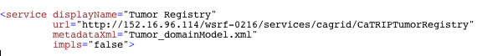

displayName – Name of the service as it appears in Basic Query Builder UI.
url – Data Service EPR
metadataXML – name of domain model extract file.
impls – this flag can have true/false . If Class names ends with Impl this flag should be “true”

<objectElement> Element (1..*)
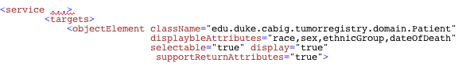
List of back bone objects are listed as objectElements in <targets> container.

className – Fully qualified class name of the back bone object.
supportReturnAttributes – “true” if this service allows selection of return attributes.
Note: All objects may not support return attributes because there should be a bidirectional association between target object and associated object to support this feature
displayableAttributes – List of attributes of back bone object on which user can set filters.

< associatedObjectTree > Element (1)

CGEMS Object model snap shot

Above Figure is a snap shot of CGEMS object model with few objects.
Target object Patient is directly associated with Diagnosis.
Patient is associated to Activity via Diagnosis.
Patient is associated to Followup via Diagnosis.
Patient is associated to Recurrence via Diagnosis via Followup

assoiatedObjectTree defines the Association path from the Target class to any other class defined in the association tree, thus eliminating the need for the end user to link the classes like in the Advanced GUI.

Below XML shows how these associations are configured in the configuration file using Association element within associatedObjectTree element..

Attributes in Association tag :

ClassName : Fully qualified class name.
displayableAttributes – List of attributes of back bone object on which user can set filters.
roleName : Association role name with high level Association or objectElement in the tree.
selectable :??
display : Some association classes are used to connect the lower associations , not necessarily to set any filters. “false” to not allow any filters on any attributes of this class.

< foreignAssociationOutboundPath > Element (1)

TUMOR REGISTRY DATA SERVICE

OUT BOUND
CDE
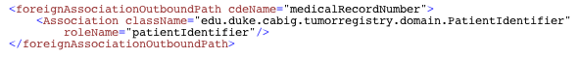

In order to link/join a Target class with other services (a foreign service in this context), it has a predefined association path to a class that has a linking CDE that is common across the services to be joined. Above listing shows a class called ParticipantIdentifier which has a linking CDE called MedicalRecordNumber.

cdeName – name of the common atrribute
className – fully qualified class name
roleName – role name from target object to this class.

< foreignAssociationInboundTree > Element (1…*)

Assume Tumor Registry service metioned above needs to associate with CGEMS service

CGEMS DATA SERVICE
INBOUND
CDE

Similarly, in order to have query filters from foreign services, each such filter class should have a pre-defined association path from the class which has the linking CDE to the filter class. Above listing shows an example a filter class is SNPAnalysisGroup and SNPAssociationAnalysis and the linking class is StudyParticipant and linking CDE is studySubjectIdentifier.

Configure catrip-config.xml.

AdvanceGUI picks up the list of services either from Index service or services-config.xml file based on the configuration in catrip-config.xml file. This file is also located in ..gui/config directory.
Index service URL and available identity providers can be configured in this file.
<indexService use="false" name="Local Index Service" url="<<INDEX SERVICE EPR"/>
Index service information.
use – caTRIP applications works with or withour using index service. If you want the data services to be discovered from an index service value of use should be “true”. If this value is false , the list of services are picked up from services-config.xml
name – name of the index service.
url – End point reference(EPR) of the index service.

<federatedQueryEngineService name="Local" url="http://…”/>
Federated Query Engine name and EPR. This feature is not supported in current release. Don’t make any changes for federatedQueryEngineService

You can configure available Identity providers in <gridIndentityProviders> tag. Refer to Section 3.3 for more information on security.

name : Name to appear in caTRIP GUI login screen. Should be unique.
idpUrl : Authentication Service EPR
dorianUrl : Dorian Service EPR.
Configuring services-config.xml.
This file is also located in ..gui/config directory , contains URLS of each data services and filenames of corresponding domain model extract and service meta data . This information is used by Advanced GUI if indexService is use=”false” in step 3.2.3
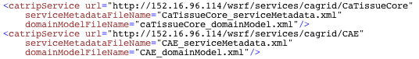

url : Data Service EPR
serviceMetadataFileName : service metadata file name.
domainModelFileName : Domain model extract file name.

Testing the Application
At this point, everything is installed and we can test the application before bundling it into a Webstart application for others to use.

Step | Action
1 | Start Tomcat.  <tomcat directory>/bin/startup.bat
2 | Open a command window and change to the gui directory where caTRIP was installed  <catrip directory>/codebase/projects/gui  Execute the Ant task ‘run’  ant run  This will start the application.  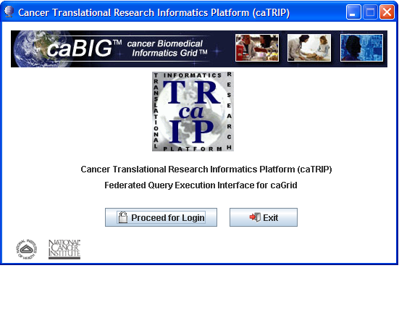
3 | From the splash screen press the ‘Proceed for Login’ button to move to the login screen  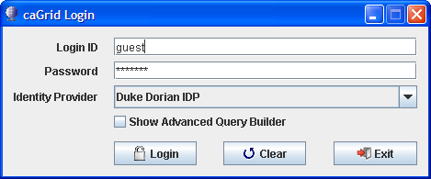
- 3  4 | From the login screen press ‘Login’ to continue to the simple qui interface.
- 3  5 | If you have not loaded the Tumor Registry test data yet load it now. After loading change the Target Data Element and Data Source to the values for the Tumor Registry.  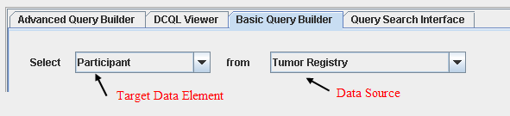
- 3  5 | Press the Execute Query button. You will see all the data from the Tumor Registry data source.  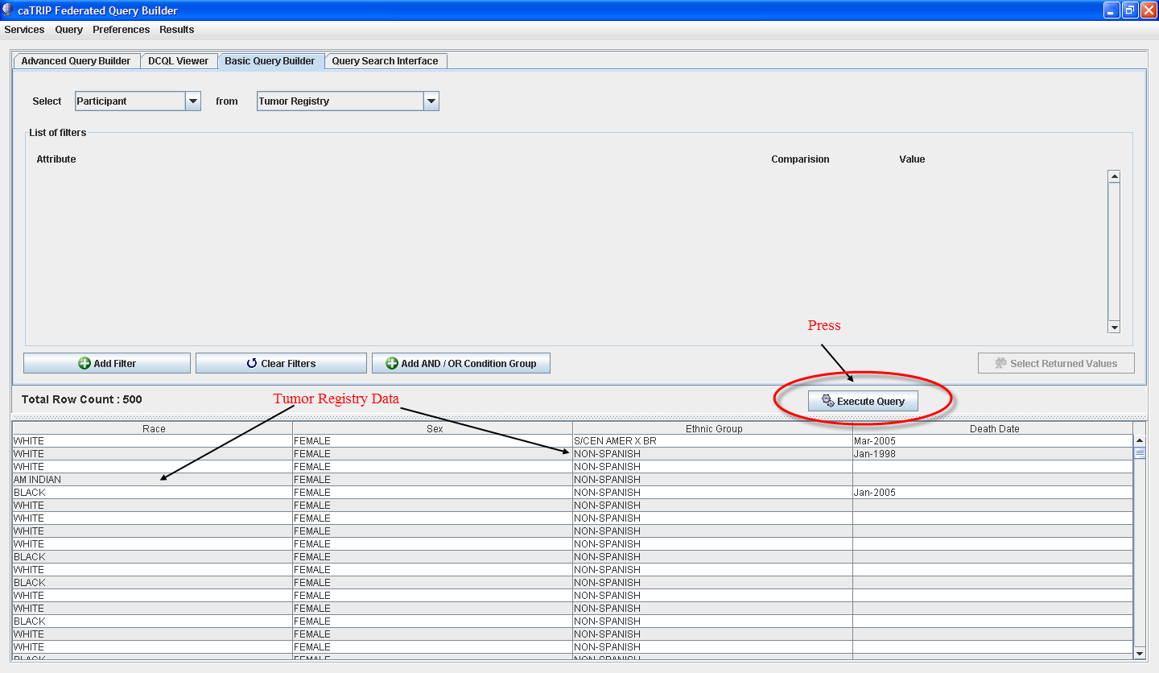
- 3  6 | Test the other services by changing the target data element which will change the initial data source drop down. Change the initial data source drop down to each entry and press the Execute Query button.  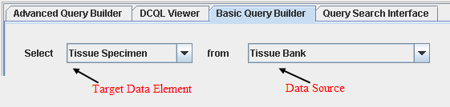  No records will be returned if you have no data for a data source. Look for any service errors regardless if you have data or not. If you have an error, redeploy the services again.
- 3  6 | See the User’s Guide on how to create more complex queries.  User’s Guide can be found at : https://gforge.nci.nih.gov/projects/catrip/

Creating a Webstart Application
Java Web Start is a framework allows application to be started directly from the Internet using a web browser. Unlike Java applets, Web Start applications do not run inside the browser, and the sandbox in which they run does not have to be as restricted, although this can be configured. A JNLP file is hosted on the tomcat, which can be downloaded to clients machine. JNLP file include information such as the location of the jar package file and the name of the main class for the application, in addition to any other parameters for the program. With a properly configured browser, JNLP files are passed to a Java Runtime Environment, which in turn downloads the application onto the user's machine and starts executing it.
Instructions to install caTRIP web start web application on tomcat.

Step | Action
1 | In <catrip-codebase>/projects/gui  ant webstart-build: Build WebStart Version of caTrip Application.  Creates a dir in the gui folder named "gui/webstart-build" which is the final deployment image. then it signs the jars in "webstart-build/lib" directory.
2 | ant webstart-deploy-tomcat: Deploy WebStart Version of caTrip Application on Tomcat.  Prompts for the server URL and will modifies the files in the "webstart-build" dir and copy them to ${env.CATALINA_HOME}/webapps/catrip-webstart folder.
- 3  3 | ant webstart-test: Test WebStart Version of caTrip Application, without deployment on tomcat.

Security
In current caTRIP, authentication is implemented using caGrid Authentication framework. Implemented Windows NT authentication, and plugged into caGrid Authentication framework.

NT Authentication
- User should authenticate using his/her duke NT credentials via caTRIP GUI
- caTRIP first authenticates with local NT credential provider via the Windows NT authentication service and obtains a SAML assertion as proof they authenticated. (Windows NT host and domain information is configurable, so implementation works for any Windows NT system)
- SAML assertion provided by the authentication service to obtain grid credentials from Dorian. (NT authentication service at Duke is registered with Dorian as a trusted identity provider)
- Dorian will issue grid credentials to the caTRIP GUI application.
- Once GUI obtains grid credentials from Dorian GUI allows the user to login. User builds and executes queries on multiple secured data services.
- Upon receiving grid credentials from a user, a secure data service authenticates the user to ensure that the user has presented valid grid credentials.
Windows NT domain and server information can be configured in authentication service configuration file. Authentication service is part of caGrid distribution. caTRIP has extended and incorporated NT authentication functionality with authentication service.
Configuring <<need to give full path >> authentication-config.xml for NT authentication
<bean id=”dukeAuthenticationManager” class=”edu.duke.idp.service.DukeAuthenticationManager”>
<property name=”credentialProviderHost” value=”<<IP ADDRESS OF CREDENTIAL PROVIDER>>”/>
<property name=”domainName” value=”<<WINDOWS NT DOMAIN NAME>>”/></bean>
More information on authentication service can be found in caGrid Documentation
http://gforge.nci.nih.gov/plugins/scmcvs/cvsweb.php/cagrid-1-0/Documentation/docs/security/gaards-security-admin-guide.doc?cvsroot=cagrid-1-0

Default Dorian Authentication
caTRIP has another implementation for non Window NT users. All users may not be part of Dukes Windows NT Idp. caTRIP supports users created using Dorian’s default authentication service.

Dorian is a grid user management service that (1) hides the complexities of creating and managing grid credentials from the users and (2) provides a mechanism for users to authenticate using their institution’s authentication mechanism, assuming a trust agreement is in place between Dorian and the institution.

- Dorian administrator can create User accounts directly on Dorian .
- User should authenticate using his/her Dorian credentials via caTRIP GUI
- As the user was registered directly with Dorian and not through an existing credential provider, caTRIP obtains grid credentials directly from Dorain.
- Once GUI obtains grid credentials from Dorian , GUI allows the user to login. User builds and executes queries on multiple secured data services.
- Upon receiving grid credentials from a user, a secure data service authenticates the user to ensure that the user has presented valid grid credentials.

Create Users in Dorian and configure catrip-config.xml file with Dorian URL and Authentication URL. Authentication URL for default Dorian would be same as Dorian URL, Configuration information can be found in section 3.2.3
Documentation on how to create users can be found in caGrid security documentation
http://gforge.nci.nih.gov/plugins/scmcvs/cvsweb.php/cagrid-1-0/Documentation/docs/security/gaards-security-admin-guide.doc?cvsroot=cagrid-1-0
Read “Grid User Management” section in the above document.

Authorization
Basic Authorization is implemented in this phase of caTRIP.
Authorization is implemented using NCICB Common Security Module (CSM).
Integration of CSM and grid services is implemented using caGrid Authz component.

- Once the user has been authenticated, a secure data service next determines if a user is authorized to perform what they requested, basically execute query method in this implementation.
- A Grid Grouper service is deployed at duke, which provides a group-based authorization solution for the Grid.
- CSM is used for managing and enforcing access control policy centrally. These access control policies are based on membership to groups in Grid Grouper.
- Grid services ask CSM with a user can perform queries on the service or not.
- Based on the access control policy maintained in CSM, CSM decides whether or not a user is authorized. CSM enforces its group based access control policy by asking Grid Grouper whether the caller is a member of the groups specified in the policy.
- User provisioning Tool (UPT) is also installed at duke . The UPT provides functionality to create authorization data elements like Roles, Protection Elements, Users, etc., and also provides functionality to associate them with each other

Please refer to the following documentation

Topic | URL
CSM / UPT | http://ncicb.nci.nih.gov/infrastructure/cacore_overview/csm
caGrid Authz | http://www.cagrid.org/mwiki/index.php?title=CaGrid:How-To:IntegrateCSMAuthorizationPolicy:
caGrid security: | http://gforge.nci.nih.gov/plugins/scmcvs/cvsweb.php/cagrid-1-0/Documentation/docs/security/gaards-security-admin-guide.doc?cvsroot=cagrid-1-0

Running the Application
After creating the Webstart application enter the URL in the browser. On your first visit the application will download some configuration files to your computer in your home directory

Documents and Settings/<your name>/.catrip
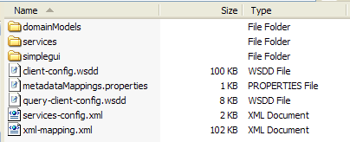
The directory should be as follows:

If for any reason these files become corrupted, simply delete this folder. On the next visit to the URL the application will download the files again.

Appendix I caTRIP Components
The caTRIP includes the following components:
  - Framework packages
- org.hibernate
  - Configuration files to enable you to customize your installation to meet your specific database, server, and other network needs
- deploy.properties
- SimpleGuiObjectGraph.xml
  - Ant buildfile
  - MySQL database creation scripts
  - Oracle database creation scripts

Contacting Technical Support
caTRIP Application Support | For Support post a message at:  catrip-training@gforge.nci.nih.gov

