Page | Topic Alias | FrameMaker Topic | Help File (.html)
Opens by default when no context-sensitive link is specified  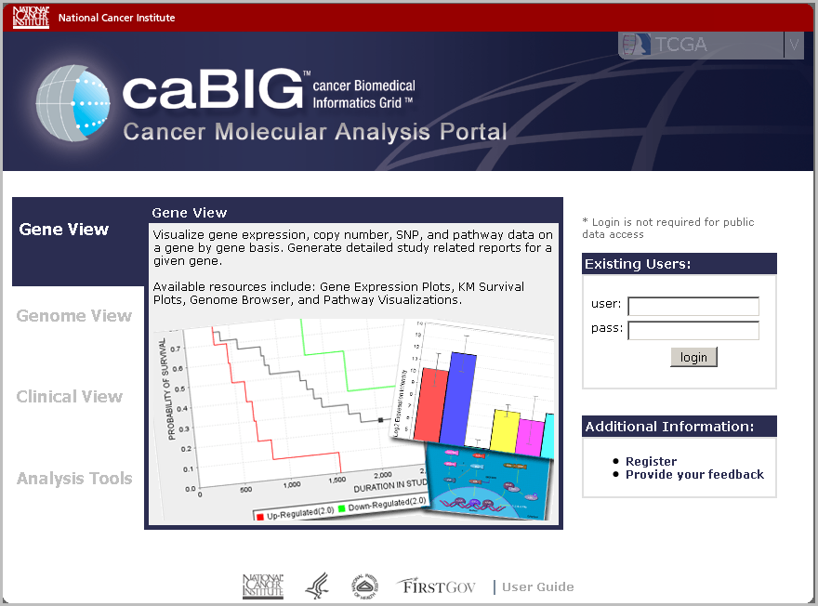 | welcome | Welcome to the CMA Portal Online Help | Welcome.1.1
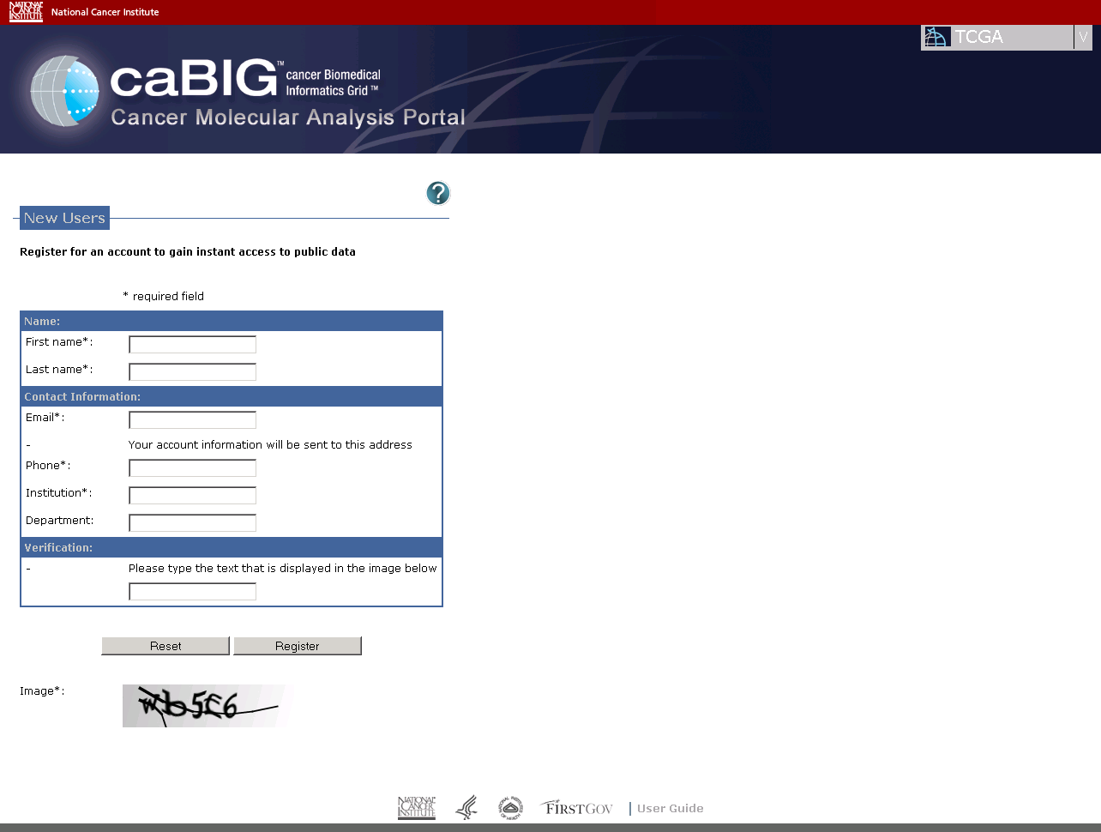 | register | Requesting a Username and Password | cmapGetStartedRegister.2.3
 | logging_in | Logging In to the Cancer Molecular Analysis Portal | cmapGetStartedRegister.2.4
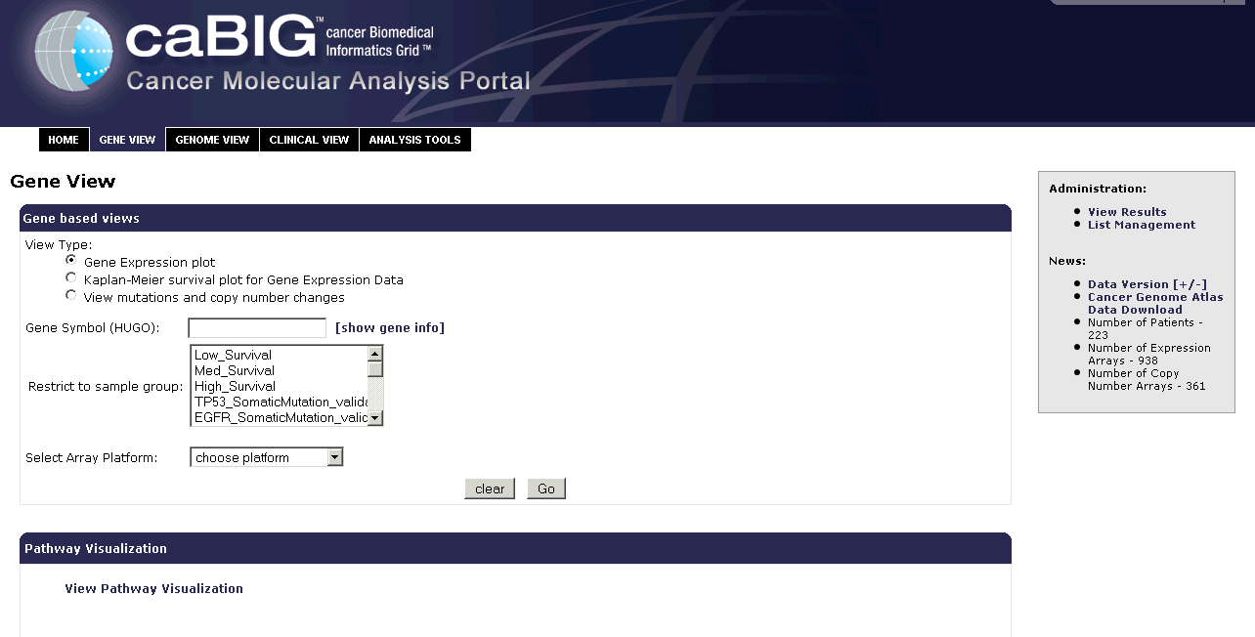 | gene_view | Working With Gene-Based Views | cmapGeneView3.1
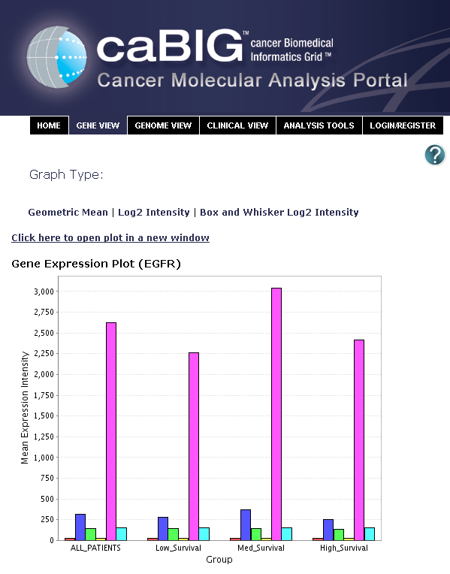 | gene_expression_plot | Understanding Geometric Mean Gene Expression Plots |  | cmapGeneView3.4
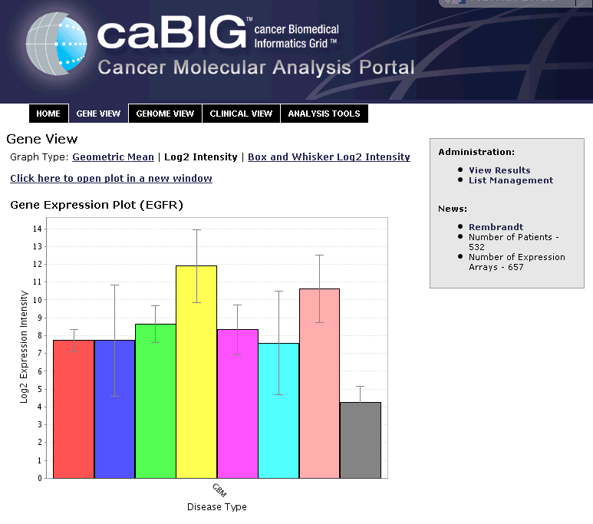 | log2_intensity | Box and Whisker Log2 Intensity Gene Expression Plot Details |  | CmapGeneView3.6
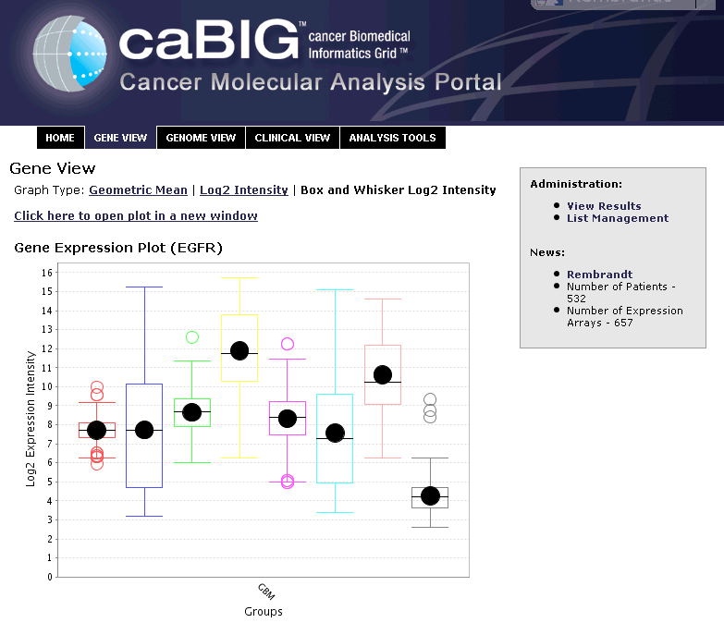 | log2_whisker_plot | Box and Whisker Log2 Intensity Gene Expression Plot Details |  | CmapGeneView3.7
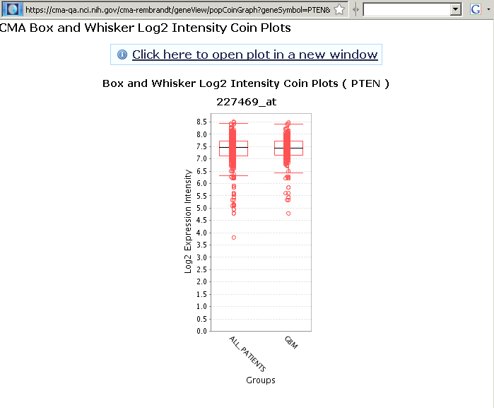 | coin_plot  (if you have control of this) | Displaying Coin Plots |  | CmapGeneView3.8
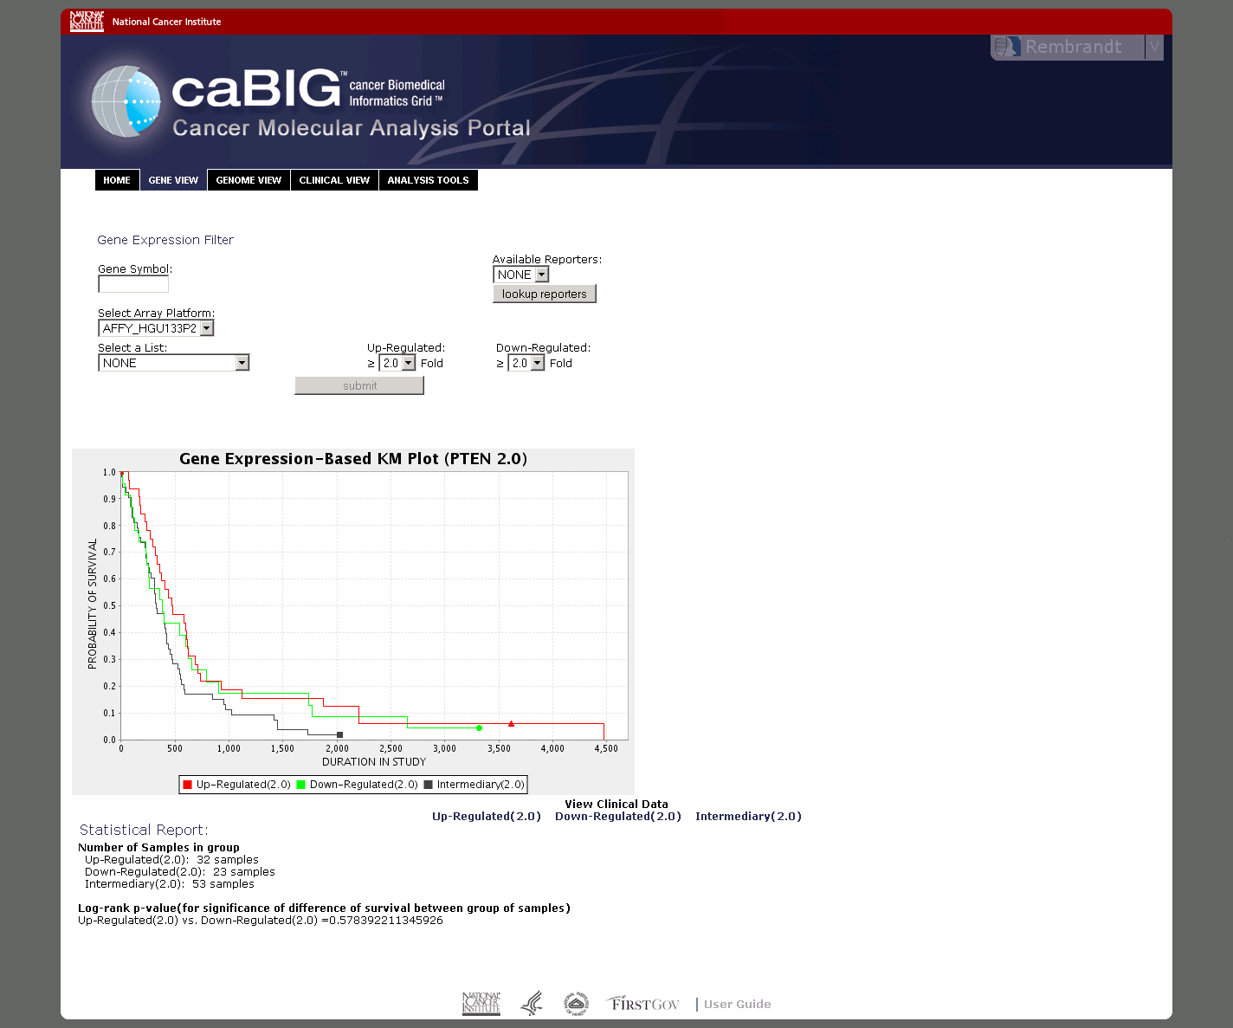 | expression_based_km | Understanding Gene Expression-Based KM Plots |  | CmapGeneView3.10
 | clinical_report | Viewing Clinical Reports |  | CmapGeneView3.12
 | pathway_overview | Pathway Visualization Overview |  | CmapPWanom4.2
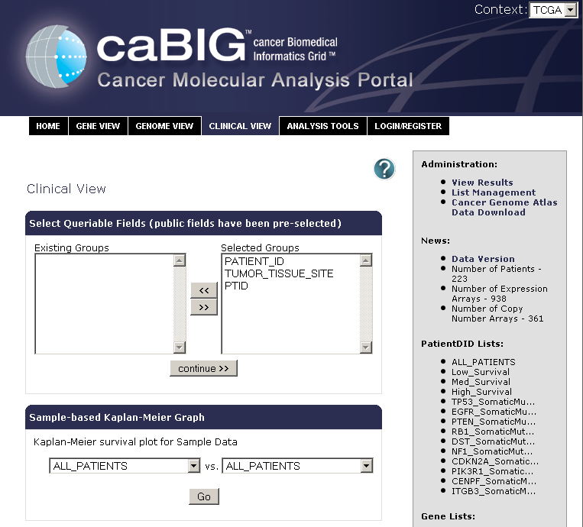 | clinical_search_criteria | Specifying Clinical Data Search Criteria |  | CmapClinicalView6.2
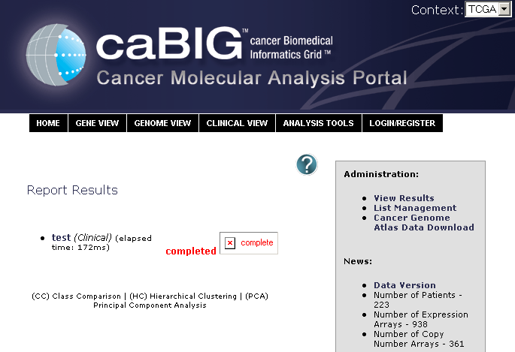 | view_results_overview | Navigating to the Report Results Page |  | cmapClinicalView6.8
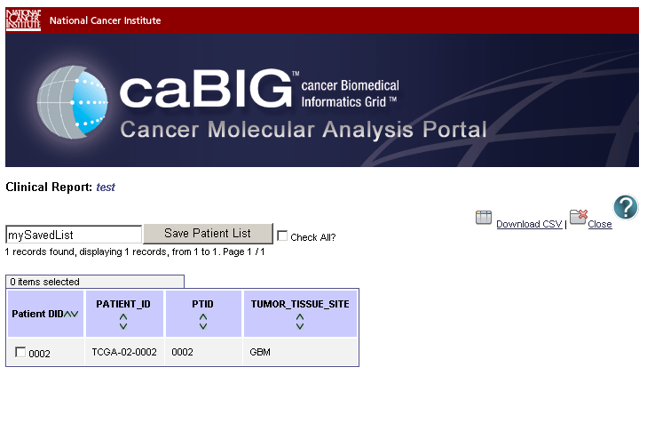 | clinical_report_table | Working With Clinical Report Results |  | cmapClinicalView6.9
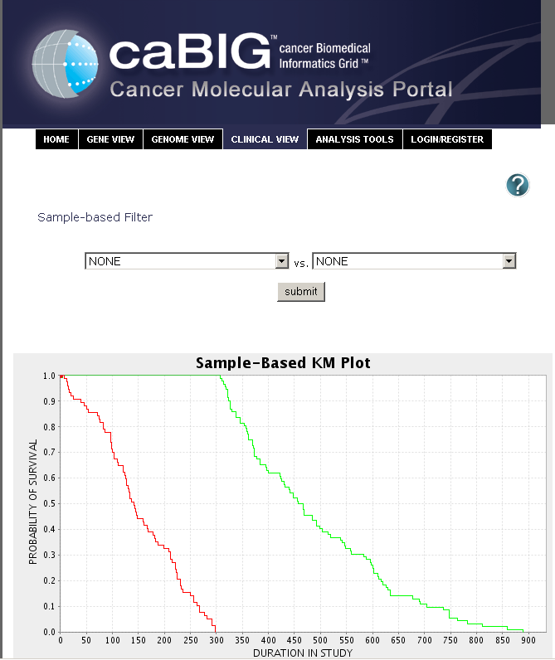 | km_plots_overview | Creating Sample-Based KM Plots |  | cmapClinicalView6.11

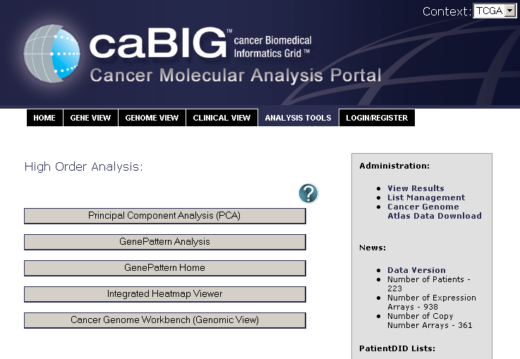 | analysis_tools | Accessing Analysis Tools | cmapAnalysisTools7.1
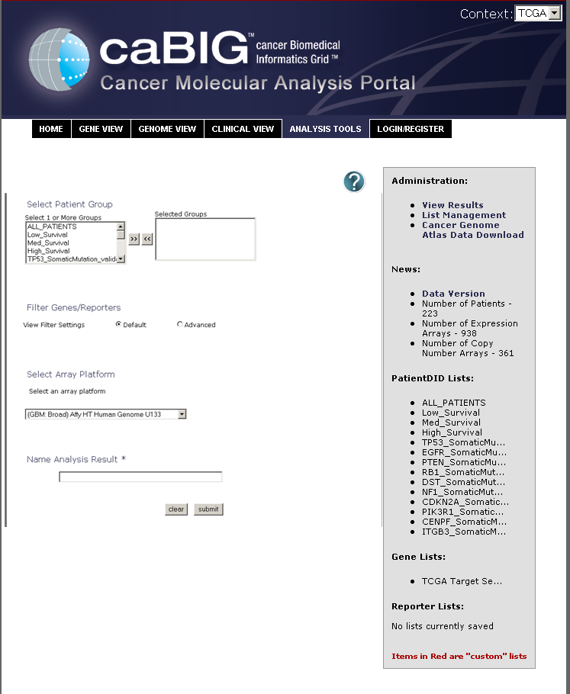 | principal_analysis | Principal Component Analysis | cmapAnalysisTools7.3
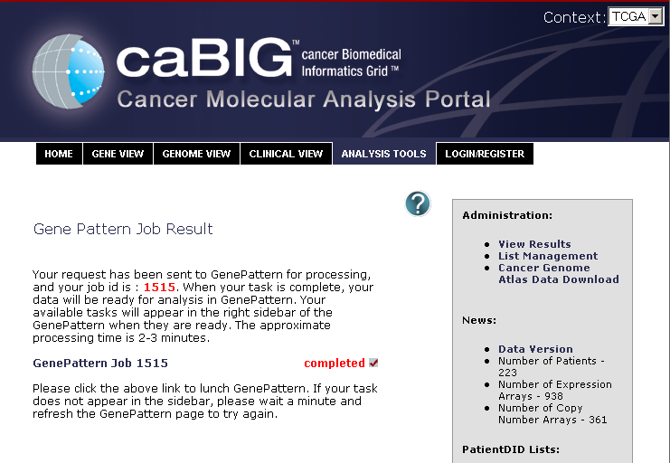 | gene_pattern_analysis | Gene Pattern Analysis | cmapAnalysisTools7.8
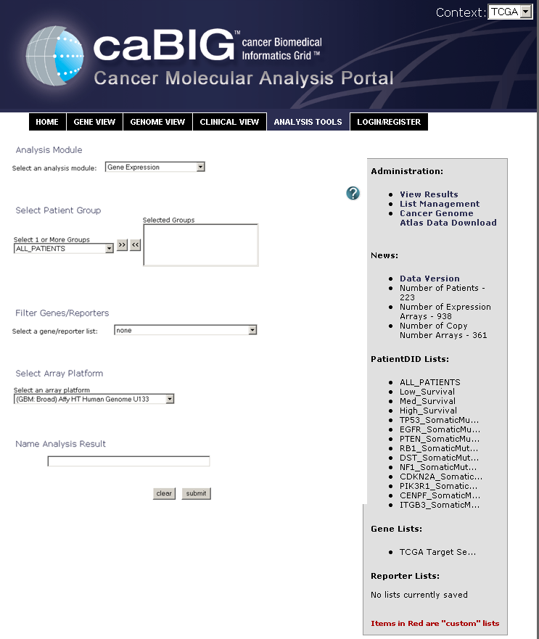 | gene_pattern_criteria | Selecting Criteria for Gene Pattern Analysis | cmapAnalysisTools7.9
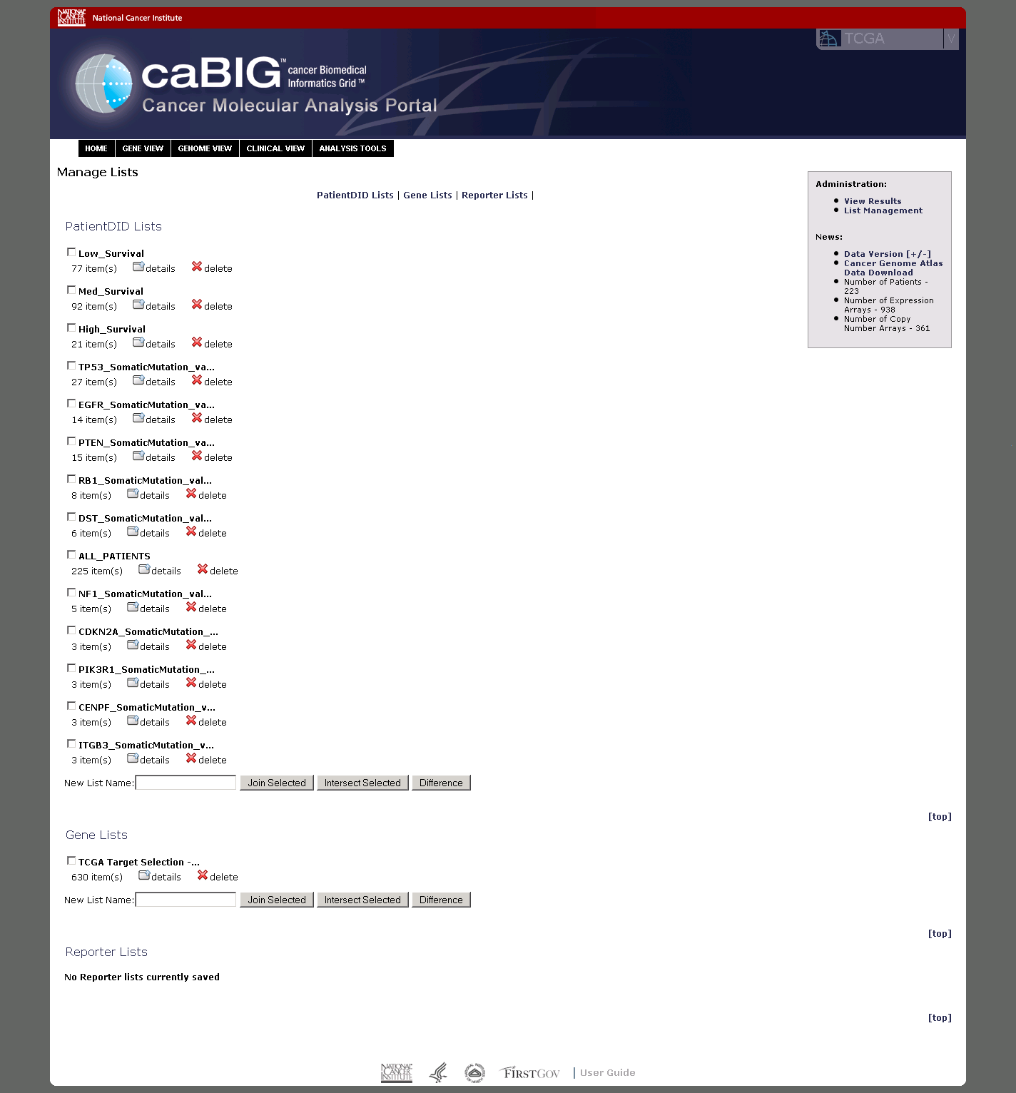 | manage_lists_overview | List Management Overview | cmaplists8.2

NOTES:
- Help icons on these images are meant only as a guide.
- All aliases are lower case, no matter what Microsoft thinks they should be.
- Some pages may not be in CMA Portal development realm.

