Advanced JDBC Logging Architecture

Prepared by:

Brian Husted
Ekagra Software Technologies
August 21, 2004

Draft

Table of Contents

Advanced JDBC Logging Architecture 1
1. BUSINESS REQUIREMENTS 2
2. FUNCTIONAL OVERVIEW 3
2.1 Custom Log4J Appender 3
2.2 Front end Web Application (Log Tracker) 3
3. TECHNICAL OVERVIEW 5
3.1 Architecture 5
3.2 JDBCAppender 6
3.3 Database Modifications 7
3.4 Configuration and Deployment 8
3.4.1 JDBCAppender 8
3.4.2 Web Front End 8

BUSINESS REQUIREMENTS
The ability to rapidly identify and resolve production support issues is critical to almost every J2EE application. In many cases, production support teams and developers must traverse through several log files and thousands of debug messages. Furthermore, with the popularity of clustered environments it is usually necessary to review logs from many different servers. This process has proved to be both time consuming and counter productive. As a result, a more powerful architecture for logging and querying application messages has surfaced.

FUNCTIONAL OVERVIEW
The solution proposed to solve the business requirements consists of a custom Log4J Appender and a Struts web application. Together these components provide a powerful and efficient capability to search across clustered servers and applications.

Custom Log4J Appender
A custom Apache Log4J Appender will be responsible for formatting and inserting Log4J messages into the configurable RDBMS.

The table will provide useful columns for querying:

- Date – The date and time when the message was logged (i.e. 04/12/2004)
- Log Level – The severity of the message (i.e. DEBUG, INFO, ERROR)
- Server – The host that the message was logged from (i.e. myhost1,myhost2)
- Application – The application that logged the message (i.e. MyApplication)
- Message – The actual log message
- Thread – The name of the execute thread that logged the message
- Category – The Log4J category which the message was logged
- Throwable – The associated stack trace messages logged with Throwable objects
- NDC – The Nested Diagnostic Context of the message

2.1.1 JDBC Appender
This approach utilizes a custom Apache Log4J Appender that persists the messages (via JDBC) in the RDBMS.

Front end Web Application (Log Tracker)
The log tracker front-end application provides the query capabilities for log messages. In addition, the application provides a simple user name/password authentication.

Below is the authentication screen for controlling access.

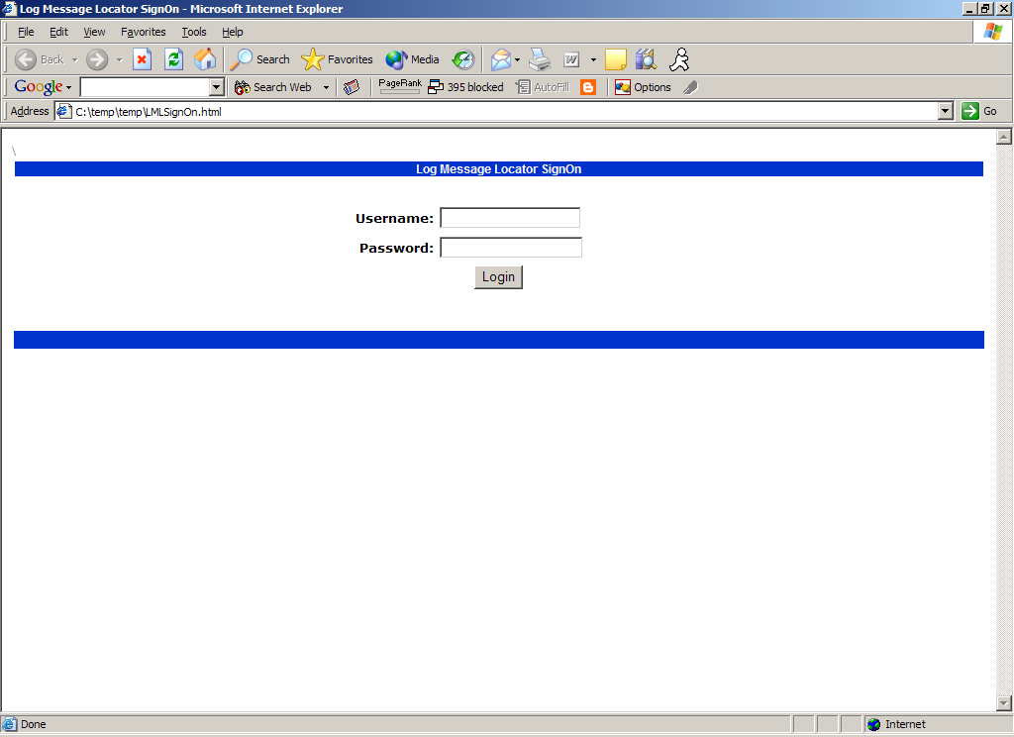

Below is a screen shot of the query page

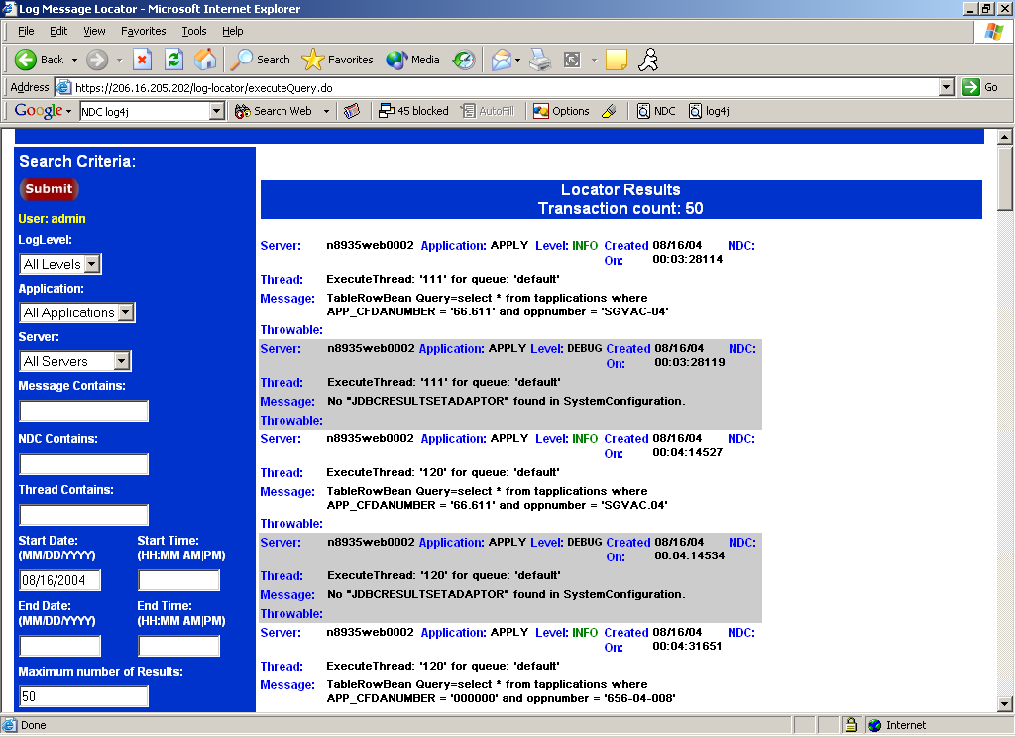

TECHNICAL OVERVIEW

Architecture
The JDBC logging solution will contain the following components:

RDBMS (Non-Transaction Database Recommended)
- Used to store all log messages
- Totally separate from transaction database cluster
- Oracle users should consider mysql for better performance

JDBCAppender
- Contained within a reusable Jar file that is appended to the target application’s classpath
- Inserts the SQL statements into the database in near real time
- Using a configurable buffer to perform batch processing
- Spawns threads to execute the batch inserts to maximize performance

J2EE Server
- Used to host front end query application
- Located on the Logging Server

Log Tracker
- Struts based front-end application deployed on a J2EE application container such as Tomcat
- Provides access to query log messages from J2EE applications

Architecture Diagram
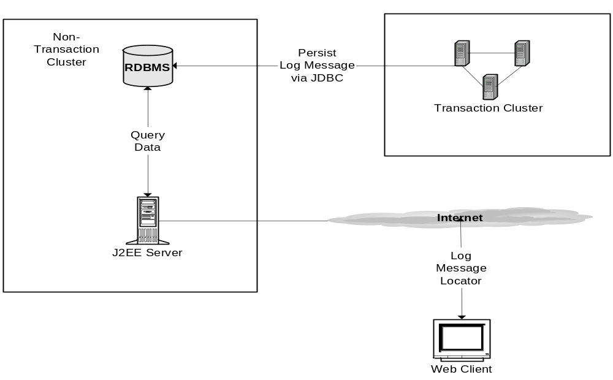

JDBCAppender
The JDBCAppender is responsible for logging all data encapsulated within a Log4J LoggingEvent object. Upon invocation of the append method, the appender extracts the data from the logging event, creates the SQL insert statement and stores it in a StringBuffer. Once the buffer reaches the configurable threshold, the appender spawns a thread to execute a batch insert.

For optimal performance the following best practices will be employed:
- Buffering and batch inserting into the RDBMS

Sequence diagram

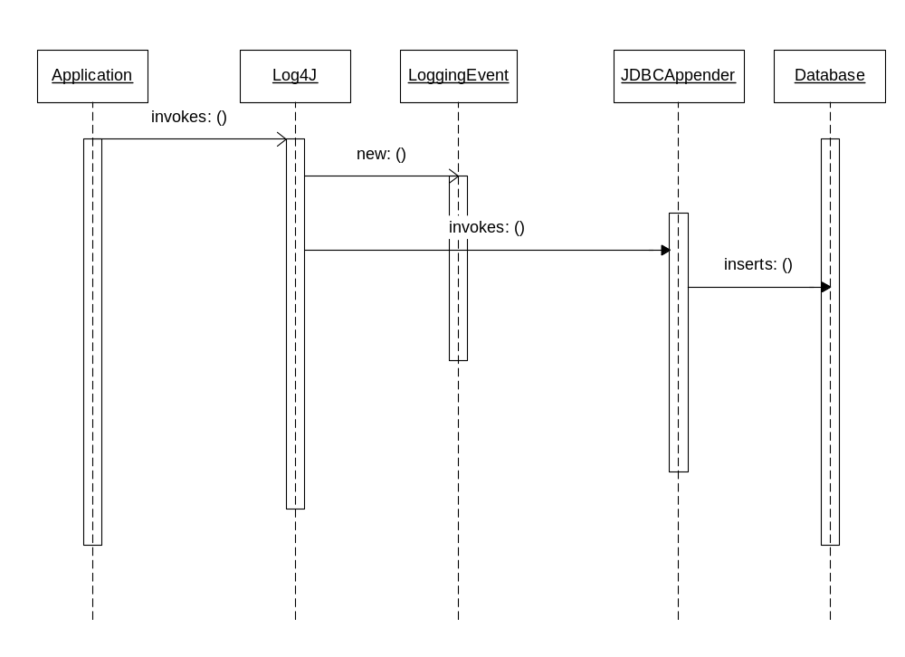

Database Modifications
Required Database Objects:

- LOGTAB Table – Table will persist the information encapsulated in LoggingEvent objects. The table is structured to support generating XML that conforms to the log4J.dtd. Scripts for Oracle and MySql are provided.
- SIGNIN_USERS Table – Table will persist the user credentials to authenticate user’s for the logging application front-end. Note: passwords MUST be SHA-1 encoded BEFORE they are inserted into the RDBMS.

Configuration and Deployment

JDBCAppender

The following two steps will configure and deploy the JDBCAppender within an application:

- Add the jdbc_appender.jar to the applications classpath

- Configure the JDBCAppender in the applications log4J config file. Parameters include:

  - application – the name of the application using this appender
  - dbDriverClass – the JDBC Driver class
  - dbURL – the URL to the RDBMS that will host the Log table for persisting log messages
  - dbUser – the RDBMS user name
  - dbPwd – the RDBMS password
  - maxBufferSize – the threshold for the size of the SQL insert buffer. For example, if set to 500 then the JDBCAppender will wait until 500 messages have been collected and then issue a batch insert.

Sample Log4J XML Appender configuration below:

<appender name="JDBC" class="gov.grants.appender.JDBCAppender">
<param name="application" value=”MyApplication” />
<param name=”dbDriverClass” value=” org.gjt.mm.mysql.Driver” />
<param name=”dbUrl” value=” jdbc:mysql://[HOST]:[PORT]/[DB_NAME]” />
<param name=” dbUser” value=”admin” />
<param name=” dbPwd” value=”password” />
<param name="maxBufferSize" value="500" />

<layout class="org.apache.log4j.PatternLayout">
<param name="ConversionPattern"
value=":: [%d{ISO8601}] %-5p %c{1}.%M() %x - %m%n" />
</layout>
</appender>

<logger name="gov.grants.appender ">
<level value="debug" />
<appender-ref ref="JDBC" />
</logger>

Web Front End
The front end web application is an Apache Struts based MVC implementation. The application is provided as a war (web application resource) file. The following steps below provide instructions for deploying and configuring the front end web application.

- Edit the connection.properties file located in the src/resources directory. This property file defines the RBDMS parameters.
- Generated the war file by running the included ant script.
- Deploy the war file on the J2EE container.

