
Common Security Module
Auditing and Logging Design

Version No: 1.0
Last Modified: 07/27/06

Author : Vijay Parmar
Team : Common Logging Module (CLM)
Client : National Cancer Institute - Center for Bioinformatics,
National Institutes of Health,
US Department of Health and Human Services

Document History

Document Location
The most current version of this document is located in CVS under security/docs.

Revision History
Version Number | Revision Date | Author | Summary of Changes
0.1 | 07/27/06 | Vijay Parmar | Initial Draft

Review
Name | Team/Role | Version | Date Reviewed | Reviewer Comments

Related Documents
More information can be found in the following related CLM documents:

Document Name

Table of Contents
1. Introduction 4
2. Problem Statement 4
3. Audit and Logging Requirements 4
4. Analysis 4
5. Use Cases 4
5.1 Actors 4
6. Design 6
7. Consumer View 9
8. Manager View 10
8.1 Auditing and Logging API implementation summary 10
8.2 ObjectStateLogger implementation summary 10
8.3 ObjectStateLogger transaction behavrior 11
8.4 Property files 12

Common Logging Module Design for 3.2 Release

Introduction
In an effort to make CSM compliant with CRF 21 / part 11, CSM will provide auditing and logging functionality. This document describes the associated problem statement, requirements, analysis, and usecases, and explains the design.

Problem Statement
Currently CSM is using log4j for logging for application logs. But for CRF21 / part 11 some specific messages are to be logged in a specific way. All the objects should be logged in a manner so that they can be audited at later stage.

Audit and Logging Requirements
The CSM APIs will log certain events including:
- Login
- Log out
- Login attempt
- Login failure
- User lock out

For object auditing the following should be logged:
- Object state at the time of insertion
- Object state before update
- Object state after update
- Object state before deletion
- Mark the state of the object as deleted when the object is deleted.

All the above object state logging should be done with the user’s information and the time stamp.

Analysis
CSM is capable of logging events with log4j. The only required change is to log specific events. For that the logger has to be called at specific points in the application.
CSM does not currently provide functionality for auditing of objects. For persistence CSM uses MySql 4.11, which does not currently support the concept of triggers. So there is no way to store the states of the objects in a database during transactions. Only through the application layer can this be accomplished.

Use Cases
This section describes the use cases that have emerged from the requirements.

Actors
- CSMEventLogger
  - CSMEventLogger will log the events in the way specified by CRF21/Part 11.
- ObjectStateLogger
  - ObjectStateLogger will log the state of the object during the transaction.

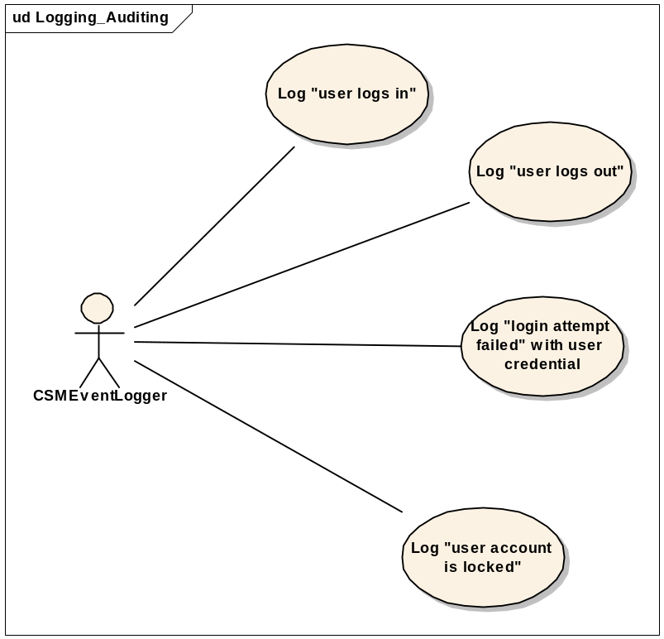
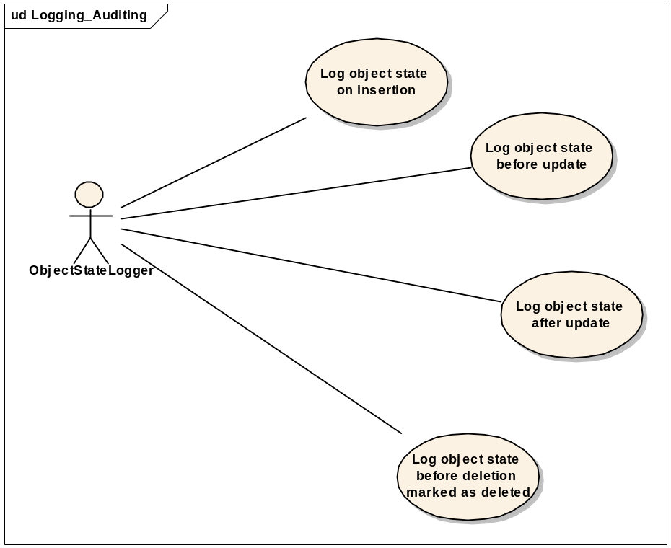

Design
CSM uses hibernate for persisting objects. The architecture of the Hibernate is based on AOP and event model. There are some standard transaction events defined in hibernate, namely preInsert, postInsert, preUpdate, postUpdate etc… These events are thrown at the time of the respective action. Being an open architecture, hibernate provides a transaction interceptor interface, which is defined in “org.hibernate.Interceptor”. This allows applications designers to implement this interceptor if needed. This implemented interceptor intercepts all these events and gives the designers the opportunity to access the objects at this juncture. For logging the object state, this is perfect place to plug in the logic. This interceptor provides all the necessary methods of the transaction. These methods can be implemented to address our requirements.
Please see the class diagram below:
cd Logical Model
«interface»
hibernate::Interceptor
+
onLoad(Object, Serializable, Object[], String[], Type[]) : boolean
+
onFlushDirty(Object, Serializable, Object[], Object[], String[], Type[]) : boolean
+
onSave(Object, Serializable, Object[], String[], Type[]) : boolean
+
onDelete(Object, Serializable, Object[], String[], Type[]) : void
+
preFlush(Iterator) : void
+
postFlush(Iterator) : void
+
isTransient(Object) : Boolean
+
findDirty(Object, Serializable, Object[], Object[], String[], Type[]) : int[]
+
instantiate(String, EntityMode, Serializable) : Object
+
getEntityName(Object) : String
+
getEntity(String, Serializable) : Object
+
afterTransactionBegin(Transaction) : void
+
beforeTransactionCompletion(Transaction) : void
+
afterTransactionCompletion(Transaction) : void
hibernate::ObjectStateInterceptor
+
onLoad(Object, Serializable, Object[], String[], Type[]) : boolean
+
onFlushDirty(Object, Serializable, Object[], Object[], String[], Type[]) : boolean
+
onSave(Object, Serializable, Object[], String[], Type[]) : boolean
+
onDelete(Object, Serializable, Object[], String[], Type[]) : void
+
preFlush(Iterator) : void
+
postFlush(Iterator) : void
+
isTransient(Object) : Boolean
+
findDirty(Object, Serializable, Object[], Object[], String[], Type[]) : int[]
+
instantiate(String, EntityMode, Serializable) : Object
+
getEntityName(Object) : String
+
getEntity(String, Serializable) : Object
+
afterTransactionBegin(Transaction) : void
+
beforeTransactionCompletion(Transaction) : void
+
afterTransactionCompletion(Transaction) : void
hibernate::ObjectStateLogger
+
insert_Operation: String
+
delete_Operation: String
+
update_Operation: String
-
logger: Logger
+
logMessage(Object, Serializable, Object [], Object [], String [], Type [], String) : void
+
configureLogger(String) : void
Appender
OptionHandler
log4j::AppenderSkeleton
#
layout: Layout
#
name: String
#
threshold: Priority
#
errorHandler: ErrorHandler = new OnlyOnceErr...
#
headFilter: Filter
#
tailFilter: Filter
#
closed: boolean = false
~
activateOptions() : int
~
addFilter(Filter) : int
~
append(LoggingEvent) : void
~
clearFilters() : int
~
finalize() : int
~
getErrorHandler() : int
~
getFilter() : int
~
getFirstFilter() : Filter
~
getLayout() : int
~
getName() : String
~
getThreshold() : int
~
isAsSevereAsThreshold(Priority) : int
~
doAppend(LoggingEvent) : void
~
setErrorHandler(ErrorHandler) : void
~
setLayout(Layout) : int
~
setName(String) : int
~
setThreshold(Priority) : int
Constants
appender::JDBCAppender
-
application: String = null
-
server: String = null
-
dbUrl: String = null
-
dbDriverClass: String = null
-
dbUser: String = null
-
dbPwd: String = null
-
useFilter: String = null
-
recordCtr: int = 0
-
maxBufferSize: int = 0
-
buff: List = new ArrayList()
+
JDBCAppender()
+
JDBCAppender(Layout)
+
setLayout(Layout) : void
-
clean(String) : String
#
replace(String, String, String) : String
#
replace(String, int, int, String) : String
+
append(LoggingEvent) : void
-
addRowToBuffer(String) : void
-
useFilter() : boolean
-
execute() : void
#
getThrowable(LoggingEvent) : String
+
requiresLayout() : boolean
+
close() : void
+
getApplication() : String
+
setApplication(String) : void
+
getServer() : String
+
setServer(String) : void
+
getBuff() : List
+
setBuff(List) : void
+
getDbDriverClass() : String
+
setDbDriverClass(String) : void
+
getDbPwd() : String
+
setDbPwd(String) : void
+
getDbUrl() : String
+
setDbUrl(String) : void
+
getDbUser() : String
+
setDbUser(String) : void
+
getMaxBufferSize() : int
+
setMaxBufferSize(int) : void
+
getRecordCtr() : int
+
setRecordCtr(int) : void
+
getUseFilter() : String
+
setUseFilter(String) : void
appender::JDBCAppenderFilter
-
filterList: List = new ArrayList()
+
isMatch(LoggingEvent) : boolean
-
init() : void
+
getFilterList() : List
+
setFilterList(List) : void
utils::ObjectStateMessageGenerator
+
stringMessageGenerator(Object, Serializable, Object [], Object [], String [], Type [], String) : String
+
xmlMessageGenerator(Object, Serializable, Object [], Object [], String [], Type [], String, String) : String
hibernate::SessionFactory
-
sessionFactory: SessionFactory
-
objectStateInterceptor: ObjectStateInterceptor
+
getAuditSession() : Session
utils::ApplicationProperty
-
messageLoggingXMLFormat: String
-
messageLoggingStringFormat: String
+
isObjectStateLoggingEnable(Object) : boolean
+
getInstance() : Object
+
getMessageLoggingFormat() : String
+
getConfigFile() : String
«use»
«use»
«instantiate»
«use»
«use»
«realize»

The ObjectStateLogger is the class that provides the logic to obtain a configurable logger as well as filter out unregistered fully qualified domain objects for logging. It also provides the capability to generate the auditing message in the format of XML file or to the configured logger based upon the property file. The interface interceptor is from Hibernate and can be found at “org.hibernate.Interceptor”. The ObjectStateIneterceptor is the actual implementation of the interceptor interface. This is where all the logic will go. ObjectStateMessageGenerator is a utility class, which will convert an object state to the string or to an xml document. This class will be used in the ObjectStateLogger for logging purposes. The SessionFactory is the only API for the client application that intends to use the framework. It provides a method called getAuditSession() for an application to obtain a Hibernate session with an Interceptor object passed in.
The object state will have two components:
- The object itself (called inherent state)
- The children (dependent objects)

When an object is transformed to a state, it will log the actual state of the object (no IDs). The dependent objects will be logged with their IDs only.
For your reference, see the reference implementation of this interceptor at this address: http://www.hibernate.org/318.html. Our design will vary from this implementation. There is no need for domain objects to implement the Auditable interface, and dependent objects do not have to implement the Component interface. At the same time it is worth mentioning that the reference implementation of this interface has been documented in the hibernate docs at www.hibernate.org. ObjectStateLogger can log with the JDBCAppender that has been designed by Ekagra Software Technologies or a regular log4j Appender depending on the configuration file.
The user name has to be propagated to the interceptor for logging purposes. For this, ThreadLocal should be used. The username can be attached as an attribute and then cleared after use.
In the above diagram AppenderSkeleton is an abstract class from log4j, which allows us to write custom appenders. In our case we will use this class to write one JDBC Appender for the CSMEventLogger which can be used directly from the client application for specific events logging.
Sequence diagram for the ObjectStateLogger:
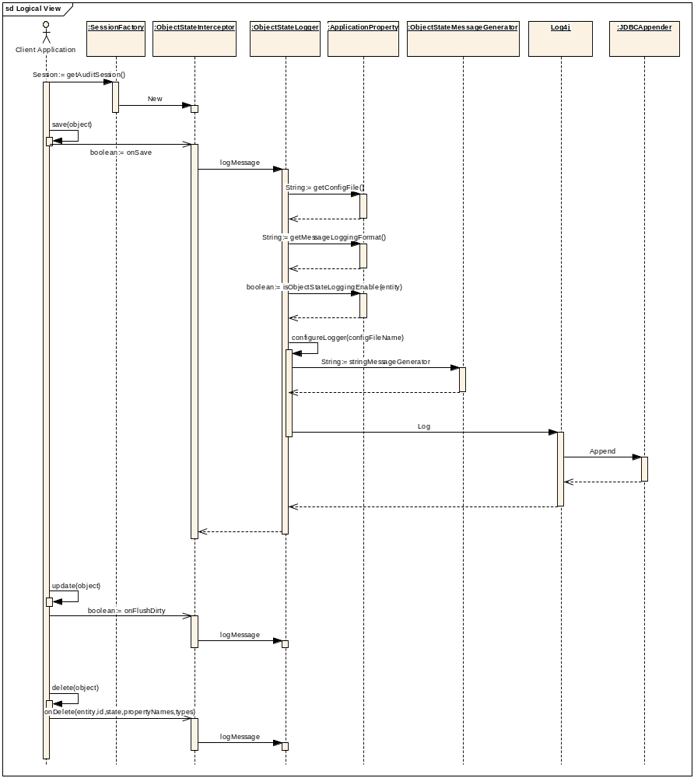
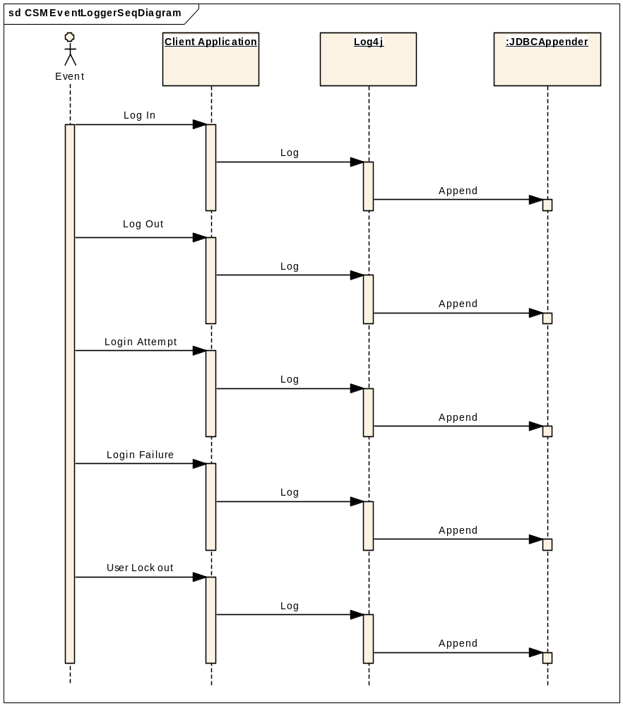

Consumer View
This section talks about how to plug the Auditing and Logging framework into the application as well as how to set up the necessary configuration files.
The Auditing and Logging will be provided as a framework that is pluggable and the application will use it by calling a particular CMS API. With the Hibernate 3.0 persistence technology, the application performs persistence via a regular Hibernate session. To audit and log object state changes during the persistence that is executed with a session, the session will need to be created with a Hibernate Interceptor object being the parameter. The Auditing and Logging framework will provide the API for obtaining such a session so that the object state auditing can be achieved.
The Auditing and Logging framework has the capability to provide configurable loggers through the property file. Within the property file, the application can define the log configuration file for the logger.
The Auditing and Logging framework also has the capability to provide a mechanism to configure classes to audit object states. The fully qualified domain object names are required so that in run time the Auditing and Logging framework can filter out those domain objects that are not configured for auditing and only audit those that are configured in the configuration file.
In summary, to use the Auditing and Logging framework, three things need to be done by the application developer. First is to obtain a Hibernate session through the framework API; Secondly, provide a property file to define the logger configuration file; Lastly in the property file also provide a list of fully qualified domain object names that need to audit.

Manager View

Auditing and Logging API implementation summary
As described above, the application needs to obtain a Hibernate session with an Interceptor object to conduct auditing. The framework provide a class SessionFactory that implement a method called getAuditSession(). Within this method, an Interceptor object gets instantiated and passed into the openSession method of the sessionFactory object. In summary, in the application code, a Hibernate session for auditing can be obtained through the following: Session session = AuditSessionService.getAuditSession();

ObjectStateLogger implementation summary
Auditing and Logging framework provides the flexibility to configure different loggers as well configure the fully qualified domain object names for auditing. All these functionalities are implemented in ObjectStateLogger class by reading the property file. The property file contains the following information: logger configuration file, a list of fully qualified domain object names for auditing. Upon reading the property file, the Auditing and Logging framework decides what logger will be used and what domain objects will be audited. In addition, the property file can contain information about what type of output will be generated, for example XML file. In the case of XML, the object states audit trail information will be generated in a XML file.

ObjectStateLogger transaction behavrior
According to Hibernate document, Hibernate itself does not support nested transactions. There should be at most one uncommitted transaction associated with a particular Hibernate session. This is the assumption for the design of ObjectStateLogger in terms of transaction behavior. The overall design guideline is that if a transaction gets rolled back, any log messages generated by the ObjectStateInterceptor within that particular transaction span will not be persisted in to the database. On the other hand, if the transaction is committed successfully, the log messages will be persisted to the database. To achieve this effect, a Boolean variable isIntransaction is maintained in the ThreadLocal variable. Upon beginning of a transaction, this variable is set to TRUE and it is set to FALSE upon completion of the transaction. This is done in the AfterTransactionBegin method and AfterTransactionCompletion method respectively in the ObjectStateInterceptor class. In the ObjectStateInterceptor class’ callback methods onSave, onDelete and onDirtyFlush, a check on the isIntransaction will be performed to determine whether to save the log messages to a buffer or to persist to the log database. If the value is TRUE, then store the log messages to the buffer which is maintained in the ThreadLocal, otherwise persist the log messages to the log database. After the transaction ends, the AfterTransactionCompletion gets called. This method allows for checking if this transaction is committed or rolled back. This is the place to implement the log which clears the log buffer if the transaction fails or persist the log buffer to the database if the transaction is successful.
Pease refer to the following sequence diagram for the transaction behavior:
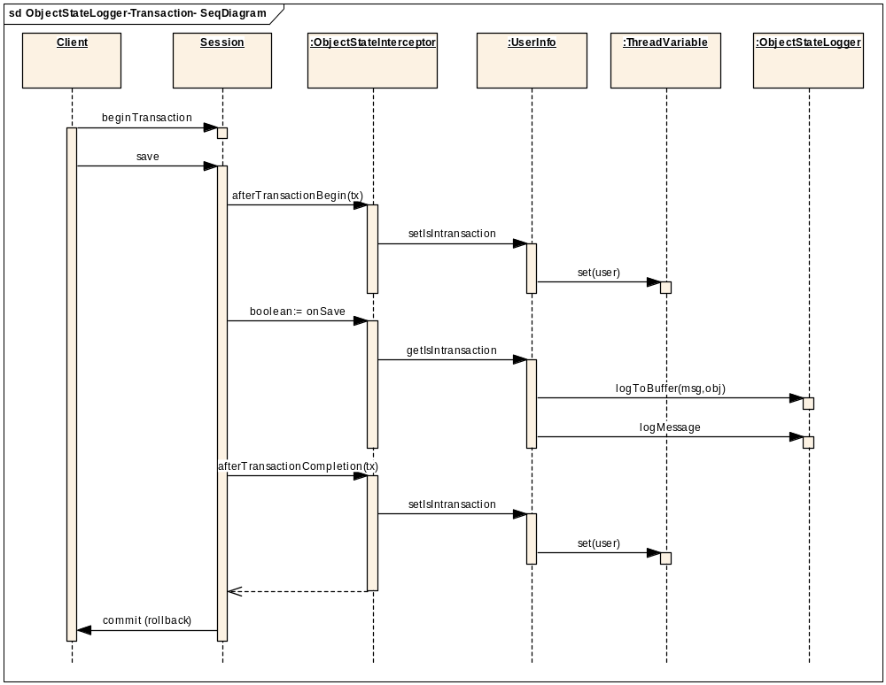

Property files
The property file will be a xml file and contains particular information about the logger configuration file name and a list of fully qualified domain object names, etc. To use the Auditing and Logging framework, a property file named ObjectStateLogger.xml must be provided in the classpath. The following is a sample property file:
<auditing-config>
<logger-config>
Log4jConfig.xml
</logger-config>
<object-state-logger>
TEST
</ object-state-logger>
<message-type>
string
</message-type>
<audited-object-list>
<object>
<name>
Client.gov.nih.nci.domainObject.Customer
</name>
</object>
<object>
<name>
Client.gov.nih.nci.domainObject.Item
</name>
</object>
</ audited-object-list >
</auditing-config>
If the audited-object-list tag is not present, then all the domain object states will be audited.

