UNC - DWD
Draft Requirements and Specification Document (Task 2.6.1)
Software Requirements Specification

Version 1.0

Document Change Record
Version Number | Date | Description
1.0 | 2/23/2005 | Initial document
1.1 | 3/23/2005 | Added Introduction
1.2 | 3/28/2005 | Project Description
1.3 | 4/1/2005 | Requirements
1.4 | 4/6/2005 | System Architecture and Appendix

TABLE OF CONTENTS
HST SE Software Requirements Specification Template
1. Introduction 1
1.1 Scope 1
1.1.1 Identification 2
1.1.2 System Overview 2
1.1.3 Document Overview 2
1.2 Reference Documents 3
2. Project Description 4
2.1 Project Perspective 4
2.2 Project Functions 4
2.3 User Characteristics 4
2.4 Constraints 4
2.5 Qualification Provisions 4
2.6 Assumptions and Dependencies 5
3. Requirements 6
3.1 Java GUI for dwd adjustment 6
3.2 Matlab Code For DWD Conversion 6
3.3. java visualization 7
4. System architecture 8
Appendix A – Acronym List 9

Introduction
This SRS captures the complete software requirements for the Distance Weighted Discrimination software for combining microarray data sets, release version 1.
UNC Lineberger Comprehensive Cancer Center (Lineberger) has performed research on the meta-analysis of different microarray data sets. All large microarray datasets contain systematic biases that are due to different sources of RNA, different batches of microarrays and especially different microarray platforms. To address this challenge, individuals at Lineberger have developed a tool called Distance Weighted Discrimination (DWD) that makes statistical corrections to reduce these biases. The approach is based on modern statistical discrimination methods and was shown to be better than Support Vector Machines and Singular Value Decomposition for the adjustment of systematic biases.
Many institutions maintain archives of microarray data; however, data sets coming from different institutions and different microarray platforms are largely not directly comparable. Implementation of DWD may allow the merging of datasets which would allow, for example, the evaluation of all breast tumor microarray experiments (which individually total 500-600 experiments across 6 labs) as a single dataset that contains many common clinical parameters. A larger dataset such as this will allow subset analysis that is currently not possible due to small sample sizes.
To date, the method has been developed, evaluated and applied by one research group at UNC Chapel Hill. The current implementation uses MatLab for statistical calculations. For this project, DWD will 1) Be deployed to the Adopter site(s) for analysis; 2) Be adapted to the caBIG architecture; 3) Read in data from in MAGE-ML format or from the caArray MAGE-OM API; and 4) Enhanced with visual diagnostics to improve usability.

Scope
Distance Weighted Discrimination (DWD) can perform systematic bias adjustment in microarray data (http://genome.med.unc.edu:8080/caBIG/DWDindex.htm). The original version of DWD was written in Matlab, which requires the installation of expensive software: Matlab. In Matlab, the BatchAdjustSM.m file is executed and the centered data are written to a file. But BatchAdjustSM.m only takes a file that is combined from two separated files based on the common keys. The centered output file from BatchAdjustSM.m will be processed again by putting back the keys. The pre- and post- processing work is done by two Perl scripts.
The main objective of this project is to convert the existing Matlab code into an executable that can be called by Java. All pre- and post- processing work is also done in Java.
There are three main parts of the programming components of this project:
- Design Java GUI for entering all input and output parameters.
- Convert DWD Matlab codes for adjustment into c executable.
- Implement Java visualization, including Java GUI, principal component analysis (PCA), and the conversion of the Matlab codes into c executables

Identification
DWD 1.0

System Overview
Distance Weighted Discrimination (DWD) can perform systematic bias adjustment in microarray data (http://genome.med.unc.edu:8080/caBIG/DWDindex.htm). Inputs are two microarray data files (currently Stanford text format, but eventually MAGE-ML), with no missing values, and common gene identifiers. Output is a single merged data file (in the same format).
The original version of DWD for microarrray data combination was written in Matlab, by J. S. Marron. A key component was the Matlab implementation of DWD for general purpose discrimination (i.e. classification), written by M. J. Todd. This was based on the SDPT3 optimization package of Toh, Tutuncu, and Todd, see http://www.math.nus.edu.sg/~mattohkc/sdpt3.html.
All of this software is currently internet available for free use. The research of J. S. Marron was supported by Cornell University's College of Engineering Mary Upson Fund and NSF Grants DMS-9971649 and DMS-0308331. M. J. Todd was supported in part by NSF Grants DMS-9805602 and DMS-0209457 and ONR Grant N00014-02-1-0057. SDPT3 was supported in part by National University of Singapore, Singapore-MIT Alliance, NSF through grant DMS-9805602 and ONR through grant N00014-96-1-0050, and NSF through grant CCR-9875559.
The Matlab version of DWD for microarray bias adjustment is internet available at https://genome.unc.edu/pubsup/dwd/.

Document Overview
This SRS captures the complete software requirements for the Distance Weighted Discrimination software for combining microarray data sets, Release 1, as part of the Integrative Cancer Research Workspace of the caBIG™ program. Requirements and procedural instructions are included in the Standard Operating Procedures (SOPs).
All software will be completely open source, as outlined under the GNU General Public License. There are no additional security or privacy considerations.
The remaining SRS sections are organized as follows:
- Section 2. Project Description: Describes the general factors that affect the Distance Weighted Discrimination software for combining microarray data sets.
- Section 3. Requirements: Describes all the software requirements to a level of detail sufficient to enable designers to design a system to satisfy those requirements, and testers to test that the system satisfies those requirements.
- Section 4. System Architecture: Illustrates the relationships between the requirement categories described in Section 3 in a flow chart.
- Appendix A. Acronym List: Defines the abbreviations used on the project.

Reference Documents
For additional project and requirement specific information, refer to the following documents:
Marron JS, Todd, MJ: Distance Weighted Discrimination, [http://www.optimization-online.org/DB_HTML/2002/07/513.html]: 2002.
Benito M, Parker J, Du Q, Wu J, Xiang D, Perou CM, Marron JS: Adjustment of systematic microarray data biases. Bioinformatics 2004, 20: 105-114.
Liu X, Parker, J., Fan, C., Perou, C. M., Marron, J. S. (2005) Visualization of Cross Platform Microarray Normalization, http://genome.med.unc.edu:8080/caBIG/paper1.pdf
DWD graphics site: http://genome.med.unc.edu:8080/caBIG/DWDindex.htm
DWD software download site: https://genome.unc.edu/pubsup/dwd/
SDPT3 download site: http://www.math.nus.edu.sg/~mattohkc/sdpt3.html

Project Description

Project Perspective
Current implementations of DWD require machines using Windows 2000 and XP. The DWD application runs under Java,

Project FunctionS
DWD performs systematic bias adjustment in microarray data. Inputs are two microarray data files (currently Stanford text format, but eventually MAGE-ML), with no missing values, and common gene identifiers. Output is a single merged data file (in the same format).

User Characteristics
Users will be bioinformatics researchers, who want to combine microarray data sets. The typical purpose of combining data sets is to increase statistical power. The goal could be to combine data within the same lab, that was gathered under different conditions (RNA sources, fabrication batch, protocol, etc.), or to combine data from different labs but the same platform, or even across different microarray platforms.

Constraints
DWD requires:
- Two input data files in Stanford text format (currently, and eventually in MAGE-ML, when conversion modules become available). More than two data sets are currently handled by pair-wise merging.
- Common gene identifiers in the two input files.
- No missing data. Missing values should first be imputed. see http://bioinformatics.oupjournals.org/cgi/reprint/17/6/520.pdf for a good introduction to the main ideas of, and methods typically used for, imputation, and see http://www.scripps.edu/researchservices/dna_array/new/Data_Analysis_SAM.htm for imputation software.

Qualification Provisions
- Testing
Qualification of the operation of the system and its components will be done through unit testing and system testing.
This will be done for all of the Requirement IDs (defined in Section 3): 1.1, 1.2, 1.3, 1.4, 1.5, 1.6, 1.7, 1.8, 1.9, 2.1, 2.2, 2.3, 2.4, 2.5, 3.1, 3.2, 3.3, 3.4, 3.5.
- Visual Inspection
Additional qualification through visual inspection, will be done for the GUI layout.
In section 3, the GUI layout appears in requirement IDs: 1.1, 3.1, 3.4.
- Statistical Analysis
Additional qualification through statistical analysis will be done for the PCA, indexed in Section3, as Requirement ID: 3.2.

Assumptions and Dependencies
DWD requires:
- Windows 2000/XP operating system.
- Java JRE, 1.4.2 or higher.
- A compiled version of the SDPT3 optimization package.
Upgrading DWD to allow MAGE-ML input and output is dependent on the development of a MAGE-ML conversion module.
This project is completely open source, according to the GNU General Product License.

Requirements
The requirements are divided into 3 categories. The first category consists of the requirements for the Java GUI user interface. The second category is the set of requirements for the conversion from Matlab into c executables, which can be called by Java. The third category contains the Java diagnostic visualizations.
For discussion of the relationships between these categories, see Section 4.

Java GUI For DWD Adjustment

Table 3.1-1: Java GUI for DWD Adjustment Requirements
Req ID | Requirement Type | Requirement Description | CCR # (Optional) | Trace from User Requirement/  Trace to System Requirement (Optional)
1.1 | System | Design GUI and retrieve parameters
1.2 | System | Preprocess two input files
1.3 | System | Post-process results generated by C executable.
1.4 | System | Add column standardization
1.5 | System | Add popup window showing progress
1.6 | System | Add in popup window, to confirm overwrite of existing files
1.7 | System | Create DWD.jar,
1.8 | System | Create DWD bat file.
1.9 | System | Installation of DWD

Matlab Code For DWD Conversion

Table 3.1-2: Matlab Code for DWD conversion Requirements
Req ID | Requirement Type | Requirement Description | CCR # (Optional) | Trace from User Requirement/  Trace to System Requirement (Optional)
2.1 | System | Modify original DWD Matlab code
2.2 | System | Convert from Matlab to C executable
2.3 | System | Extract libraries, and place as appropriate
2.4 | System | Call C executable in Java environment
2.5 | System | Add in mean adjustment type

Java Visualization

Table 3.1-3: Java visualization Requirements
Req ID | Requirement Type | Requirement Description | CCR # (Optional) | Trace from User Requirement/  Trace to System Requirement (Optional)
3.1 | System | Design GUI and retrieve parameters
3.2 | System | Compute PCA
3.3 | System | Convert KDE Matlab code into C executable
3.4 | System | Design GUI for visual plot
3.5 | System | Display different plots

System architecture
The relationships between the requirement categories described in Section 3, are illustrated in this flow chart, which shows the logical function of the software. Requirement Categories 1 and 2 refer to the top and lower left part of the chart. Requirement Category 3 is about the lower right part.
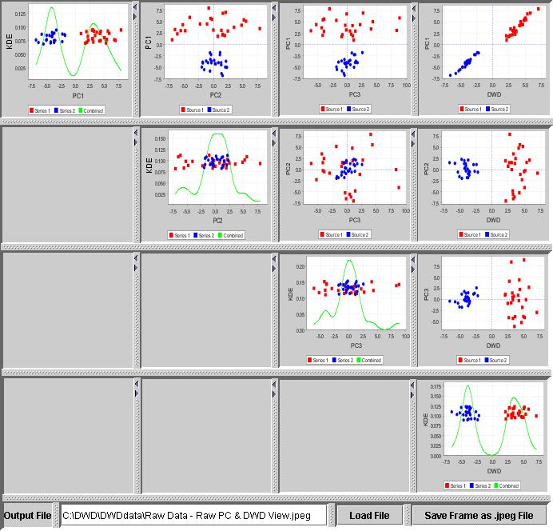
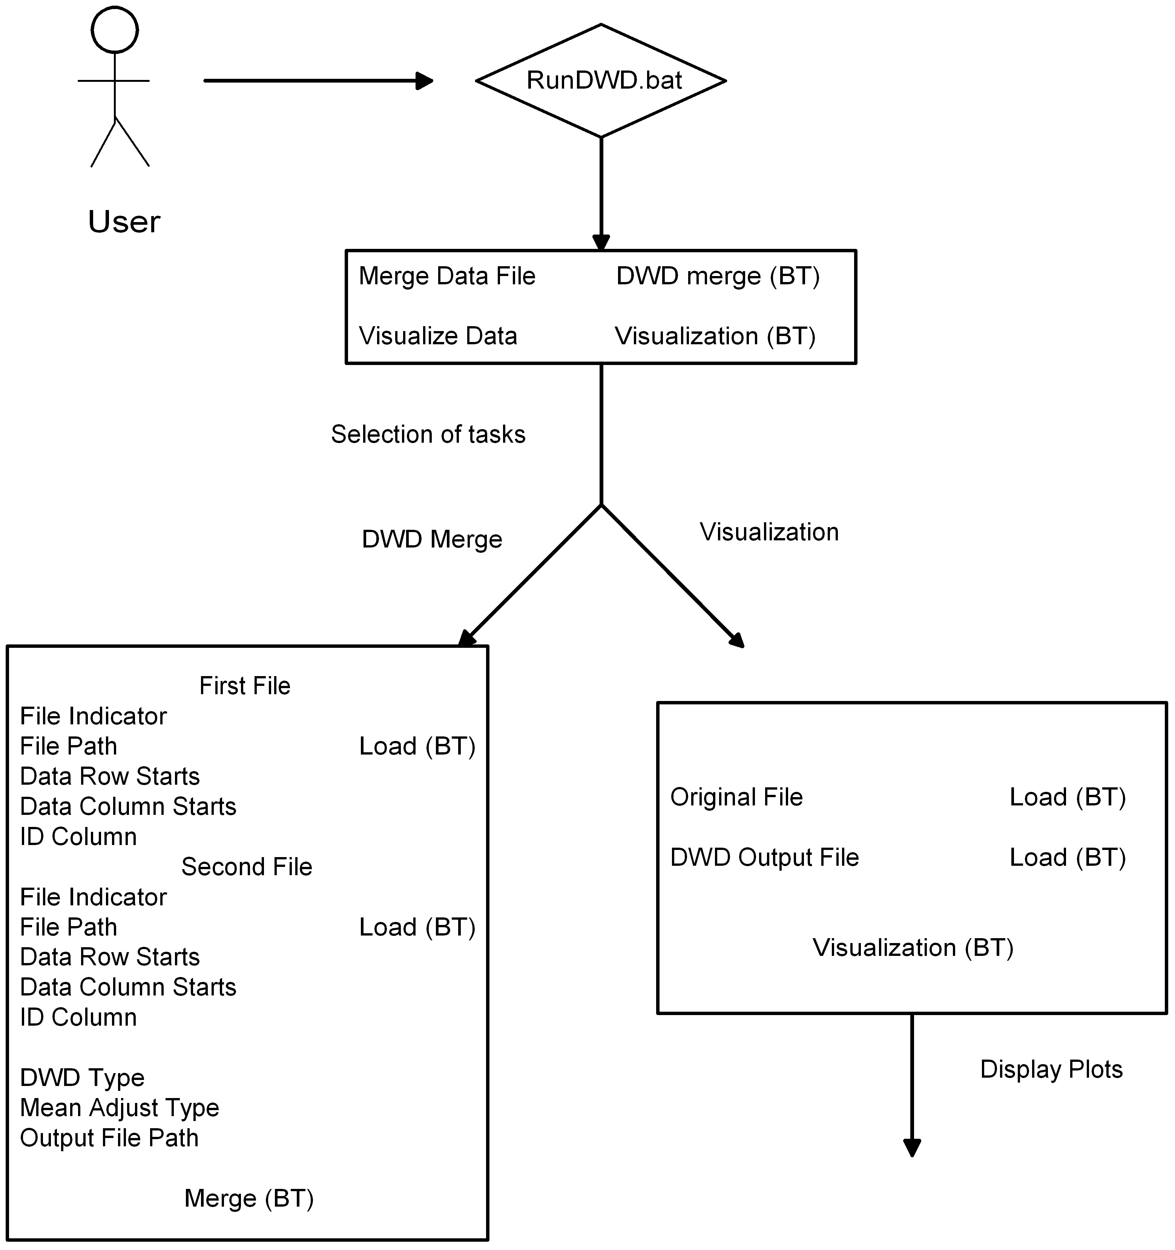

Appendix A – Acronym List

Term/  Abbreviation | Description
DWD | Distance Weighted Discrimination
SDPT3 | Semi-Definite Programming Package
GNU GPL | GNU's not Unix, General Public License
DBA | Database Administrator
PM | Project Manager
RM | Requirements Manager
RTM | Requirements Traceability Matrix
SCM | Software Configuration Management
SDLC | Software Development Lifecycle
SDP | Software Development Plan
SE | Software Engineering
SEPG | Software Engineering Process Group
SM | Software Manager
SOP | Standard Operating Procedure
SPI | Software Process Improvement
SQA | Software Quality Assurance
SW | Software
TBD | To Be Determined
TM | Test Manager

