caBIG™ Documentation and Training

DWD
Technical, Installation and User Guide

caBIG™ is an initiative of the National Cancer Institute, NIH, DHHS

Copyright and License

This project is completely open source and complies with the caBIG™ Open Source Software (OSS) Licensing agreement.

- Redistributions of source code must retain the following notice “ The DWD software is a product of the Lineberger Comprehensive Cancer Center and the Department of Statistics and Operations Research, The University of North Carolina. Initial development was done under the caBIG Subcontract 79184CBS36.

- This license does not authorize the incorporation of this software into any proprietary programs. This license does not authorize the recipient to use any trademarks owned by either NCI or The University of North Carolina.

- THIS SOFTWARE IS PROVIDED "AS IS," AND ANY EXPRESSED OR IMPLIED WARRANTIES, (INCLUDING, BUT NOT LIMITED TO, THE IMPLIED WARRANTIES OF MERCHANTABILITY AND FITNESS FOR A PARTICULAR PURPOSE) ARE DISCLAIMED. IN NO EVENT SHALL THE NATIONAL CANCER INSTITUTE, SAIC, OR THEIR AFFILIATES BE LIABLE FOR ANY DIRECT, INDIRECT, INCIDENTAL, SPECIAL, EXEMPLARY, OR CONSEQUENTIAL DAMAGES (INCLUDING, BUT NOT LIMITED TO, PROCUREMENT OF SUBSTITUTE GOODS OR SERVICES; LOSS OF USE, DATA, OR PROFITS; OR BUSINESS INTERRUPTION) HOWEVER CAUSED AND ON ANY THEORY OF LIABILITY, WHETHER IN CONTRACT, STRICT LIABILITY, OR TORT (INCLUDING NEGLIGENCE OR OTHERWISE) ARISING IN ANY WAY OUT OF THE USE OF THIS SOFTWARE, EVEN IF ADVISED OF THE POSSIBILITY OF SUCH DAMAGE.

DWD of Development Team(s)
Development | Programmer’s guide | Program Management
Names of developers | Names of technical writers and reviewers | Names of program managers
J. S. Marron^{1,2} | J. S. Marron | J. S. Marron
Xingliang ‘Everett’ Zhou² | Xingliang ‘Everett’ Zhou
¹ Statistics and Operations Research, The University of North Carolina
² Lineberger Comprehensive Cancer Center, The University of North Carolina

Contacts and Support
Enter training contact | J. S. Marron (marron@email.unc.edu)
Enter customer support contact  Xingliang ‘Everett’ Zhou (xlzhou@email.unc.edu) | https://genome.unc.edu/pubsup/dwd/  Telephone: 919-962-2188

LISTSERV Facilities Pertinent to software teams
LISTSERV | URL | Name
caBIO_Users | https://list.nih.gov/archives/cabio_users.html | caBIO Users Discussion Forum
caBIO_Developers | https://list.nih.gov/archives/cabio_developers.html | caBIO Developers Discussion Forum
caDSR_Users | https://list.nih.gov/archives/cadsr_users.html | Cancer Data Standards Repository
NCIEVS-L Listserv | https://list.nih.gov/archives/ncievs-l.html | NCI Vocabulary Services Information
caArray_Users

Table of Contents

Chapter 1 Introduction to the Manual 1
1.1. Chapter Organization and Content 1
1.1.1 Getting Started with this programmer’s guide……………………………………1
1.1.2 Document Text Conventions 1
Chapter 2 Overview of the Software 3
2.1 Software Overview 3
2.2 Components of the Software 4
2.3 System Requirements 4
2.4 Architecture 5
2.5 Software and Hardware Dependencies 5
Chapter 3 Systems and Architecture 6
3.1 Flow chart of components 6
3.2 Architectural Diagram 7
3.3 Event flow chart and data transfers 7
Chapter 4 DWD Security and Security Management 9
4.1 Security Architecture 9
4.2 Software Authorization 9
4.3 Configuring Software Authorizations 9
Chapter 5 Installation 11
5.1 Installation 11
5.2 Uninstallation 11
Chapter 6 User Guide 13
6.1 How to run DWD 13
6.2 Data set format 14
6.3 Parameter selection 15
6.4 Output 16
Chapter 7 Information Models 17
7.1 Modeling Constraints 17
7.2 Naming Best Practices 17
7.3 Use-Case Diagrams 17
Chapter 8 DWD APIs 19
8.1 DWD Java API doc 19
Chapter 9 DWD Web Services 21
Appendix A References 23
Technical Manuals/Articles 23
Scientific Publications 23
caBIG Material 24
Appendix B Acronym List 27
Index 30

List of Illustrations

Fig. 3.1: Logical Flow Chart of Components
Fig. 3.2: Architectural Diagram
Fig. 3.3: Event flow chart and data transfers
Fig. 7.1 User case diagram

Chapter 1 Introduction to the Manual

Chapter Organization and Content

Distance Weighted Discrimination (DWD) can perform systematic bias adjustment in microarray data. Inputs are two microarray data files, with no missing values, and common gene identifiers.
The purposes of the technical manual are:
- Illustrate the function of DWD;
- Display the architecture design, major components and their relationships;
- Describe the installation of software and requirements of hardware and software;
- Give instructions to run the software

Getting Started with this programmer’s guide

- Review Chapter 1 to learn about the manual structure.
- Review Chapter 2 for a brief overview of the software DWD, including functions of DWD, components of software, architecture, and system requirements.
- Review Chapter 3 to learn about the system and architecture, including flow charts of components and data and an architecture diagram.
- Review Chapter 4 for discussion of security management.
- Review Chapter 5 for details about installation.
- Review Chapter 6 to learn steps for running the software.
- Review Chapter 7 for an overview of the use case.
- Review Chapter 8 for details about the Java API document.

To install and run the software, refer to Chapters 5 and 6.

Document Text Conventions

The following table (Table 1-1) shows various typefaces to differentiate between regular text and menu commands, keyboard keys, and text that you type. This illustrates how conventions are represented in this guide.

Convention | Description | Example
Bold & Capitalized Command  Capitalized command > Capitalized command | Indicates a Menu command  Indicates Sequential Menu commands | Admin > Refresh
text in small caps | Keyboard key that you press | Press enter
text in small caps + text in small caps | Keyboard keys that you press simultaneously | Press shift + ctrl and then release both.
Special typestyle | Used for filenames, directory names, commands, file listings, source code examples and anything that would appear in a Java program, such as methods, variables, and classes. | URL_definition ::= url_string
Boldface type | Options that you select in dialog boxes or drop-down menus. Buttons or icons that you click. | In the Open dialog box, select the file and click the Open button.
Italics | Used to reference other documents, sections, figures, and tables. | caCORE Software Development Kit 1.0 Programmer’s Guide
Italic boldface type | Text that you type | In the New Subset text box, enter Proprietary Proteins.
Note: | Highlights a concept of particular interest | Note: This concept is used throughout the installation manual.
Warning! | Highlights information of which you should be particularly aware. | Warning! Deleting an object will permanently delete it from the database.
{} | Curly brackets are used for replaceable items. | Replace {root directory} with its proper value such as c:\cabio
Table 1-1 Document Conventions

Chapter 2 Overview of the Software
This chapter provides an overview of the software.
Topics in this chapter include: (cross reference to sections in chapter).
- Software Overview on this page
- Components of Software and Functions on page
- System Requirements
- Architecture
- Software and Hardware Dependencies

Software Overview

Many institutions maintain archives of microarray data; however, data sets coming from different institutions and different microarray platforms are largely not directly comparable due to the systematic biases that are caused by different sources of RNA, different batches of microarrays and especially different microarray platforms. To address this challenge, individuals at Lineberger have developed a tool called Distance Weighted Discrimination (DWD) that makes statistical corrections to reduce these biases.
Distance Weighted Discrimination (DWD) can perform systematic bias adjustment in microarray data (http://genome.med.unc.edu:8080/caBIG/DWDindex.htm). Inputs are two microarray data files (allowable formats include both Stanford text format and MAGE-ML standard microarray data files), with no missing values, and common gene identifiers. The gene identifiers can be any from the approved list that the ICR Genome Annotation SIG has compiled (or may compile in the future). Access to these can be found at: http://cdebrowser.nci.nih.gov/CDEBrowser/. Output is a single merged data file (in either Stanford Text or MAGE-ML format).
DWD has been very successful at merging disparate microarray data sets, even across platforms. However, there are some important points to keep in mind. First, when there are multiple biological subtypes present, they need to be represented in each of the two files to be merged. E.g. if one file contains all of one type, and the other file contains all of the other, DWD might eliminate important biological differences. If the data come from different platforms, then pre-transformation can be useful. E.g. for combining cDNA and Affymetrix data, it can be helpful to take the log of the Affymetrix data before inputting to DWD.
The original version of DWD was written in Matlab, which requires the installation of that expensive, and proprietary software package. A key component was the Matlab implementation of DWD for general purpose discrimination (i.e. classification), written by M. J. Todd. This was based on the SDPT3 optimization package of Toh, Tutuncu, and Todd, see http://www.math.nus.edu.sg/~mattohkc/sdpt3.html. To use the Matlab DWD package, two files must be combined first based on the common gene identifiers. The combined file will be fed into Matlab DWD for data adjustment. The result will be processed again by putting back the gene identifiers. The pre- and post- processing work is done by two Perl scripts.
An important contribution of this project was to convert the Matlab code into an executable that can be called by Java. All pre- and post- processing work, and the visual diagnostics, are also done in Java.
An important feature of the software is that input and output data, can be either in Stanford text format, or in MAGE-ML.
All of this software is currently internet available for free use. The research of J. S. Marron was supported by Cornell University's College of Engineering Mary Upson Fund and NSF Grants DMS-9971649 and DMS-0308331. M. J. Todd was supported in part by NSF Grants DMS-9805602 and DMS-0209457 and ONR Grant N00014-02-1-0057. SDPT3 was supported in part by National University of Singapore, Singapore-MIT Alliance, NSF through grant DMS-9805602 and ONR through grant N00014-96-1-0050, and NSF through grant CCR-9875559.
The Matlab version of DWD for microarray bias adjustment is internet available at https://genome.unc.edu/pubsup/dwd/.

Components of the Software
There are three main components of this software:
- Java GUI for entering all input and output parameters.
- Two c executable programs, converted from the original DWD Matlab code.
- Java visualization, including Java GUI, Java principal component analysis (PCA), and kernel density estimation.

System Requirements

The Java version of DWD has been extensively tested in Windows environments. Future work is anticipated to include a Linux version of DWD.
Disk space requirement of the software is about 25 MB.
During execution, there must be at least enough RAM available to hold both data sets, together with the merged data simultaneously. For the merging of currently considered data sets (number of arrays around 100, number of genes around 5 to 20 thousand), 128 Mb is adequate. But for larger data sets, such as 600 cases and 10 to 20 thousand genes, 1G RAM is needed. For MAGE-ML data sets, even larger memory is needed.
DWD also requires a running version of Java JRE 1.4 or above. You can download JRE at http://java.sun.com/j2se/1.4.2/download.html.

It is absolutely necessary to verify that the default JRE is the one you downloaded, rather than something else, such as from Oracle (1.3.1 or older version).

You can start DOS and type java -version to verify it.

Architecture

The caBIG DWD software is organized into three major components. The first component is the Java GUI user interface. The second component does the actual data adjustment, using c executables converted from the original Matlab code, which are called by Java. The third component does the Java diagnostic visualization, for assessing the quality of the result. For discussion of the relationships between these components, see Chapter 3.

Software and Hardware Dependencies

The Java version of DWD that was developed in the first year is classified as a caBIG analytical tool, i.e. it is publicly available for download from the website https://genome.unc.edu/pubsup/dwd/, and can be run on the user’s machine, using Java. The DWD caBIG analytical tool has been extensively tested in Windows environments.
The DWD software itself requires approximately 25 MB of disk space.
During execution, there must be at least enough RAM available to hold both data sets, together with the merged data simultaneously. For the merging of currently considered data sets (number of arrays around 100, number of genes around 5 to 20 thousand), 128 Mb is adequate. But for large data sets, such as 600 cases and 10 to 20 thousand genes, 1G RAM is needed. For MAGE-ML data sets, large memory is also needed.

Chapter 3 Systems and Architecture

Flow chart of components

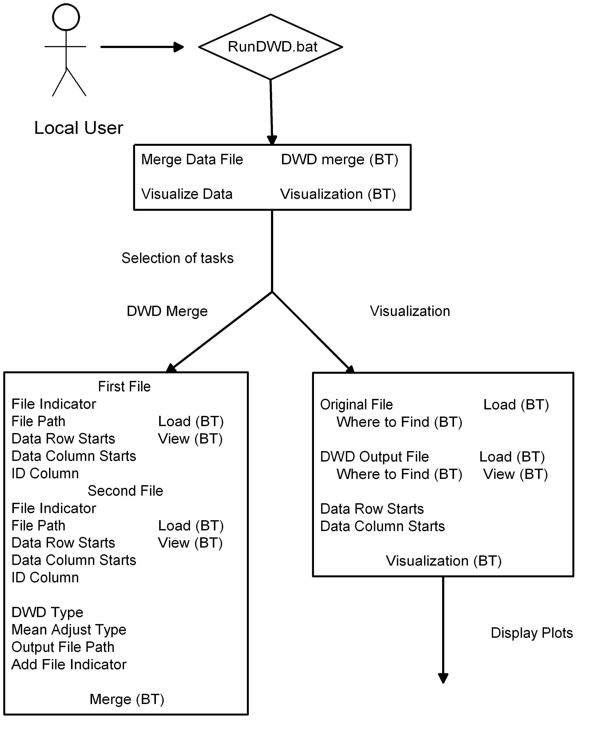
The relationships among the components of the DWD software, are illustrated in this process flow chart, which shows the logical function of the software (Fig. 3.1). Rectangles represent menus visible to the user, and the text inside represents tasks, with (BT) representing buttons. Requirement components 1 and 2 refer to the top and lower left part of the chart. Requirement component 3 is about the lower right part.

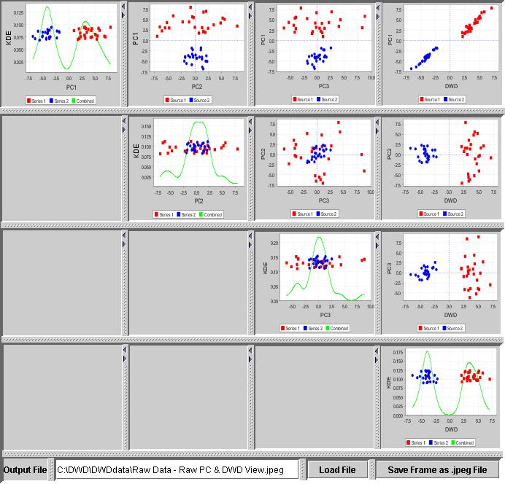

Fig. 3.1: Logical Flow Chart of Components

Architectural Diagram

The main components, together with their interactions are illustrated in the following Architectural Diagram (Fig. 3.2). The GUI is the main command and control module, and all data flows through it.

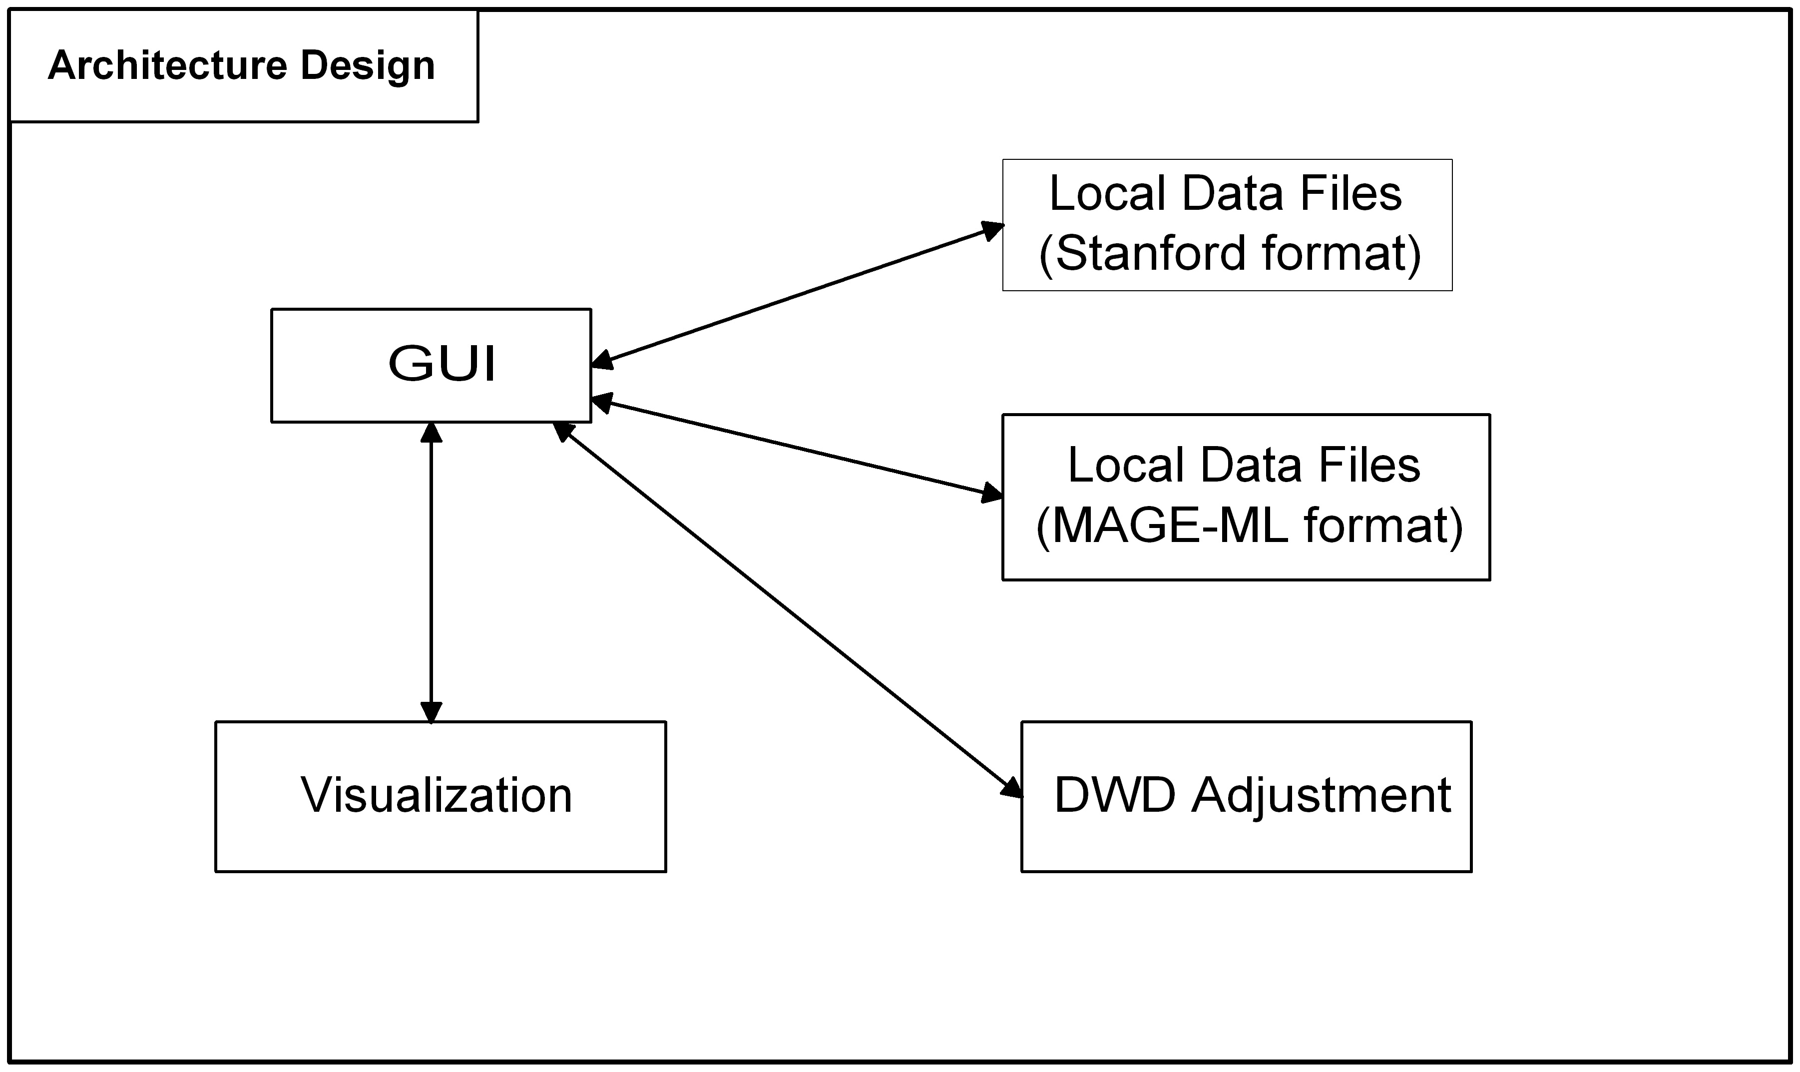

Fig. 3.2: Architectural Diagram

Event flow chart and data transfers

Illustration of the time sequence of events, and data transfers, are illustrated in this Sequence Diagram (Fig. 3.3). The user initiates the merge process by pushing the DWD merge button on the GUI (after inputting appropriate parameters, such as names of the data files to be merged). The GUI requests the data from the file system. The GUI requests the merge from the DWD Merging Module. The module gets the data file from the file system, and perfoms the merge. A “merge finished” message is sent back to the GUI, and the merged data file is stored. The user initiates the diagnostic visualization, by pushing the visualization button. The GUI sends a request to the visualization module, which requests the data from the file system, performs the needed computations, and sends the graphics back to the GUI. The user can request that the graphics be saved on the file system.

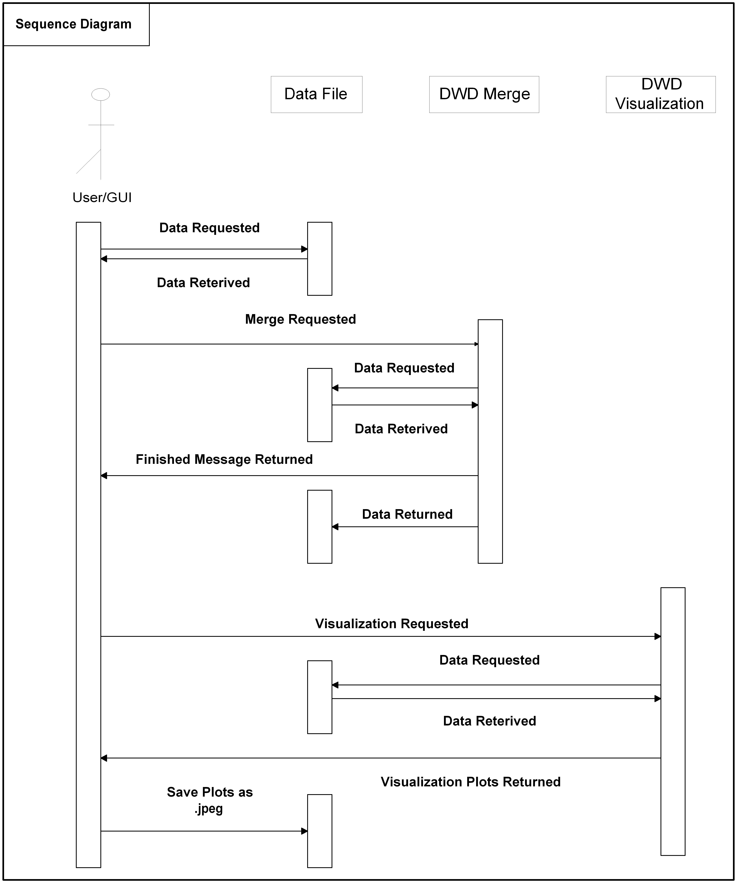

Fig. 3.3: Event flow chart and data transfers

Chapter 4 DWD Security and Security Management
Typical security topics include:

Security Architecture
This is not an issue for the DWD software package, because it only uses data that are currently available to the user, and only gives the result back to the user.

Software Authorization
All users who can log onto the computer with the data can use the software.

Configuring Software Authorizations
First time users must have installation rights to download and install DWD.

Chapter 5 Installation and Uninstallation

Installation

The current version of DWD has been tested on Win XP and 2000. The software should be directly installed onto the c: drive, or else some configuration work is needed. There are three subdirectories under the DWD directory: bin, lib and DWDdata. There are also eight important files in the DWD directory:
README.txt, RunDWD.bat, DWD.jar and other five jar files.
The lib subdirectory contains all libraries and converted c executables.
The DWDdata subdirectory can house all data files, including your original ones and output from DWD. There are two test files: Example1.txt and Example2.txt. You can use these two files to test the installation. Please see Section 6.1 on how to run DWD.
Note: You do not have to put your input and output files in this directory, but this folder is critical. If you delete this folder, an error will pop up to remind you of this.
DWD also requires a running version of Java JRE 1.4 or above. You can download JRE at http://java.sun.com/j2se/1.4.2/download.html.
It is absolutely necessary to verify that the default JRE is the one you downloaded, rather than something else, such as from Oracle (1.3.1 or older version).
You can start DOS and type java -version to verify it.

Uninstallation

Uninstallation is done by simply deleting the DWD directory and all its contents, since DWD makes no use of the Windows Registry, and does not change the system path.

Chapter 6 User Guide
Currently, the input data for DWD adjustment reside on the end user’s machine. In year 2, input data from caArray will also be available.

How to run DWD
There are two methods to run DWD.

Method 1: Start a DOS command line window, cd to DWD, type RunDWD.bat.
Method 2: In Windows Explorer, double click RunDWD.bat.
Method 1 is recommended, because this retains the window, with any error messages, after closing DWD.

After DWD is started, the task selection window pops up as follows.

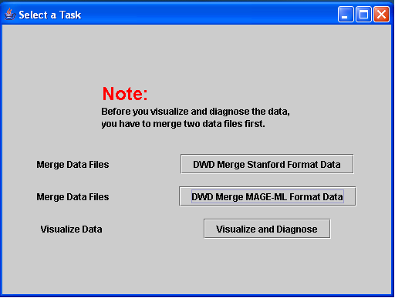

There are two choices for data adjustment corresponding to the two different kinds of data sets (see Section 6.2). If you select the button to merge MAGE-ML format files, the following window pops up (a similar window appears if merge Stanford Format is selected).

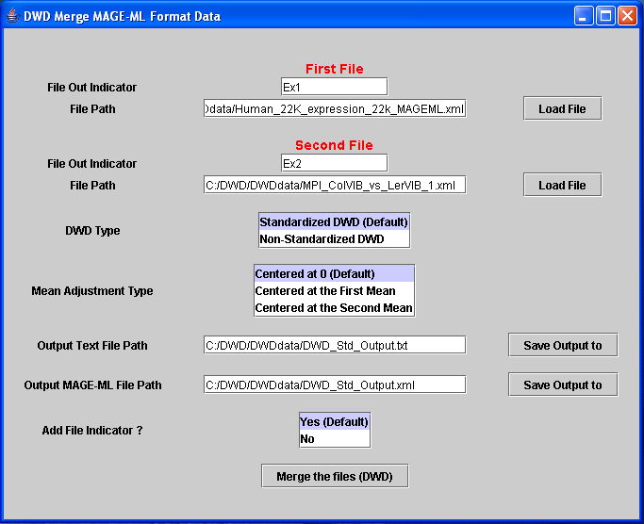

For details of parameter selection, see Section 6.3.

Data set format

The current version of DWD can take either Stanford-like text delimited files, or else MAGE-ML format files, as input.

For Stanford-like text delimited files
The first column of the Stanford-like text delimited file is gene identification, the second column contains some gene annotation, and the data start from the third column. The gene identification must be unique (duplicates are not allowed right now). The first row contains the information of samples. Such data sets have been extensively tested. Two sample files are also included in the DWDdata subdirectory.
The software can also detect missing elements and non-digit values where a digit value is supposed to be and report each error one by one each time. Missing values should first be imputed. see http://bioinformatics.oupjournals.org/cgi/reprint/17/6/520.pdf for a good introduction to the main ideas of, and methods typically used for, imputation of missing values, and see http://www.scripps.edu/researchservices/dna_array/new/Data_Analysis_SAM.htm for imputation software. When you edit the file with MS Excel, please delete any blank lines. We recommend using the TextPad editor to modify your data files (because it highlights “end of line” characters in a way which avoids problems). Here is the website to download TextPad: http://www.textpad.com/download/

For MAGE-ML format files
We have tested files generated from Agilent and Affymetrix, with both internal and external data files. At this time, validation with MAGE-ML.dtd does not work. Validation itself works, but errors occur while reading the internal data generated with Agilent software. The work-around is to delete those lines related to MAGE-ML.dtd in the .xml input files. This is very important.

Parameter selection
In this section, each parameter field in the GUI is discussed, together with typical uses of the allowed values.

For Stanford-like text delimited files.
DWD Type:
Standardized DWD: This option should be selected when the two data sets are not comparable in terms of scale (i.e. range of the expression values), such as occurs when merging data from different platforms, such as Affymetrix and Agilent.
Non-Standardized DWD: This option is useful when the scale (of the expression values) of both data sets are similar, e.g. for merging two data sets within the same lab, but from two fabrication batches.
Mean Adjust Type:
Center at 0: Adjust the data so that both data sets have mean 0, when projected onto the DWD direction vector. This should be selected when both data sets measure differential expression (e.g. Agilent or cDNA), or when the resulting merged data will be thought of as differential (e.g. an Agilent and an Affymetrix data set are being merged).
Center at the First Mean: Adjust data to have the same mean as the first data set, when projected onto the DWD direction vector. This should be used for platforms involving absolute expression values, such as Affymetrix, and when the first data file has more samples or is considered as the “standard” one.
Center at the Second Mean: Adjust data to have the same mean as the first data set, when projected onto the DWD direction vector. Conditions for use of this are the same as above, expect the second data set is considered to be the “standard” one.

Other parameters are straight forward as displayed on the GUI.

For MAGE-ML format files.
In addition to selection of the same parameters as for the Stanford-like text delimited files, some additional rules have proven to be useful, when MAGE-ML format files are used as input:
(1). If there are both raw data (MeasuredBioAssayData) and derived data (DerivedBioAssayData), only the derived data will be retrieved for data adjustment.
(2). If there are more than one raw data/derived data in the one MAGE-ML file, they must be adjusted (i.e. merged) first.
(3). If you want to re-run the data adjustment, you have to restart DWD. The button "Reset" is not adequate for this purpose, because it will only reset the BioAssayData selection and the Quantitation selection.

Output
For Stanford-like text delimited files.
The output files include: DWD_input.txt, DWD_Vec.txt, and DWD_Non_Std_Output.txt/ DWD_Std_Output.txt (if you use the default output). DWD_Non_Std_Output.txt/ DWD_Std_Output.txt is the final output corresponding to the two DWD types. But other files (DWD_input.txt and DWD_Vec.txt) will also be used in the visual diagnostics analysis. Please do not delete them. They are automatically overwritten from one run of DWD to another.
For MAGE-ML format files.
In addition to the same files generated as above, there are two extra output files, when MAGE-ML format files are used as input. They are ExternalAdjustedDataFile.txt and DWD_Non_Std_Output.xml/ DWD_Std_Output.xml (if you use default output). The adjusted data will be stored in an external text file named ExternalAdjustedDataFile.txt. The text file, DWD_Non_Std_Output.txt/ DWD_Std_Output.txt (if you use default output) will be used for the visualization.

Chapter 7 Information Models
This chapter contains necessary information about creating object models and the UML Class Diagram.

Modeling Constraints
The DWD UML class diagram was created using the Enterprise Architecture Package. It includes only the logical model, not the data model, because DWD is currently only an analytical tool, and does not need a data base. This class diagram can be found at http://cabigcvs.nci.nih.gov/viewcvs/viewcvs.cgi/distanceweighteddiscrimination/DWD_UNC/Month_7/DWD_UNC_UML_Class_Digram_Final.EAP

Naming Best Practices
The DWD Java classes are named according to the conventions suggested at http://www.nbirn.net/Resources/Developers/Conventions/Style/Java_Naming.htm. Basically, there are two rules: Package names start with lower case letters and class names start with upper case letters.

Use-Case Diagrams
The DWD Use-Case Diagram is in Fig. 7.1.

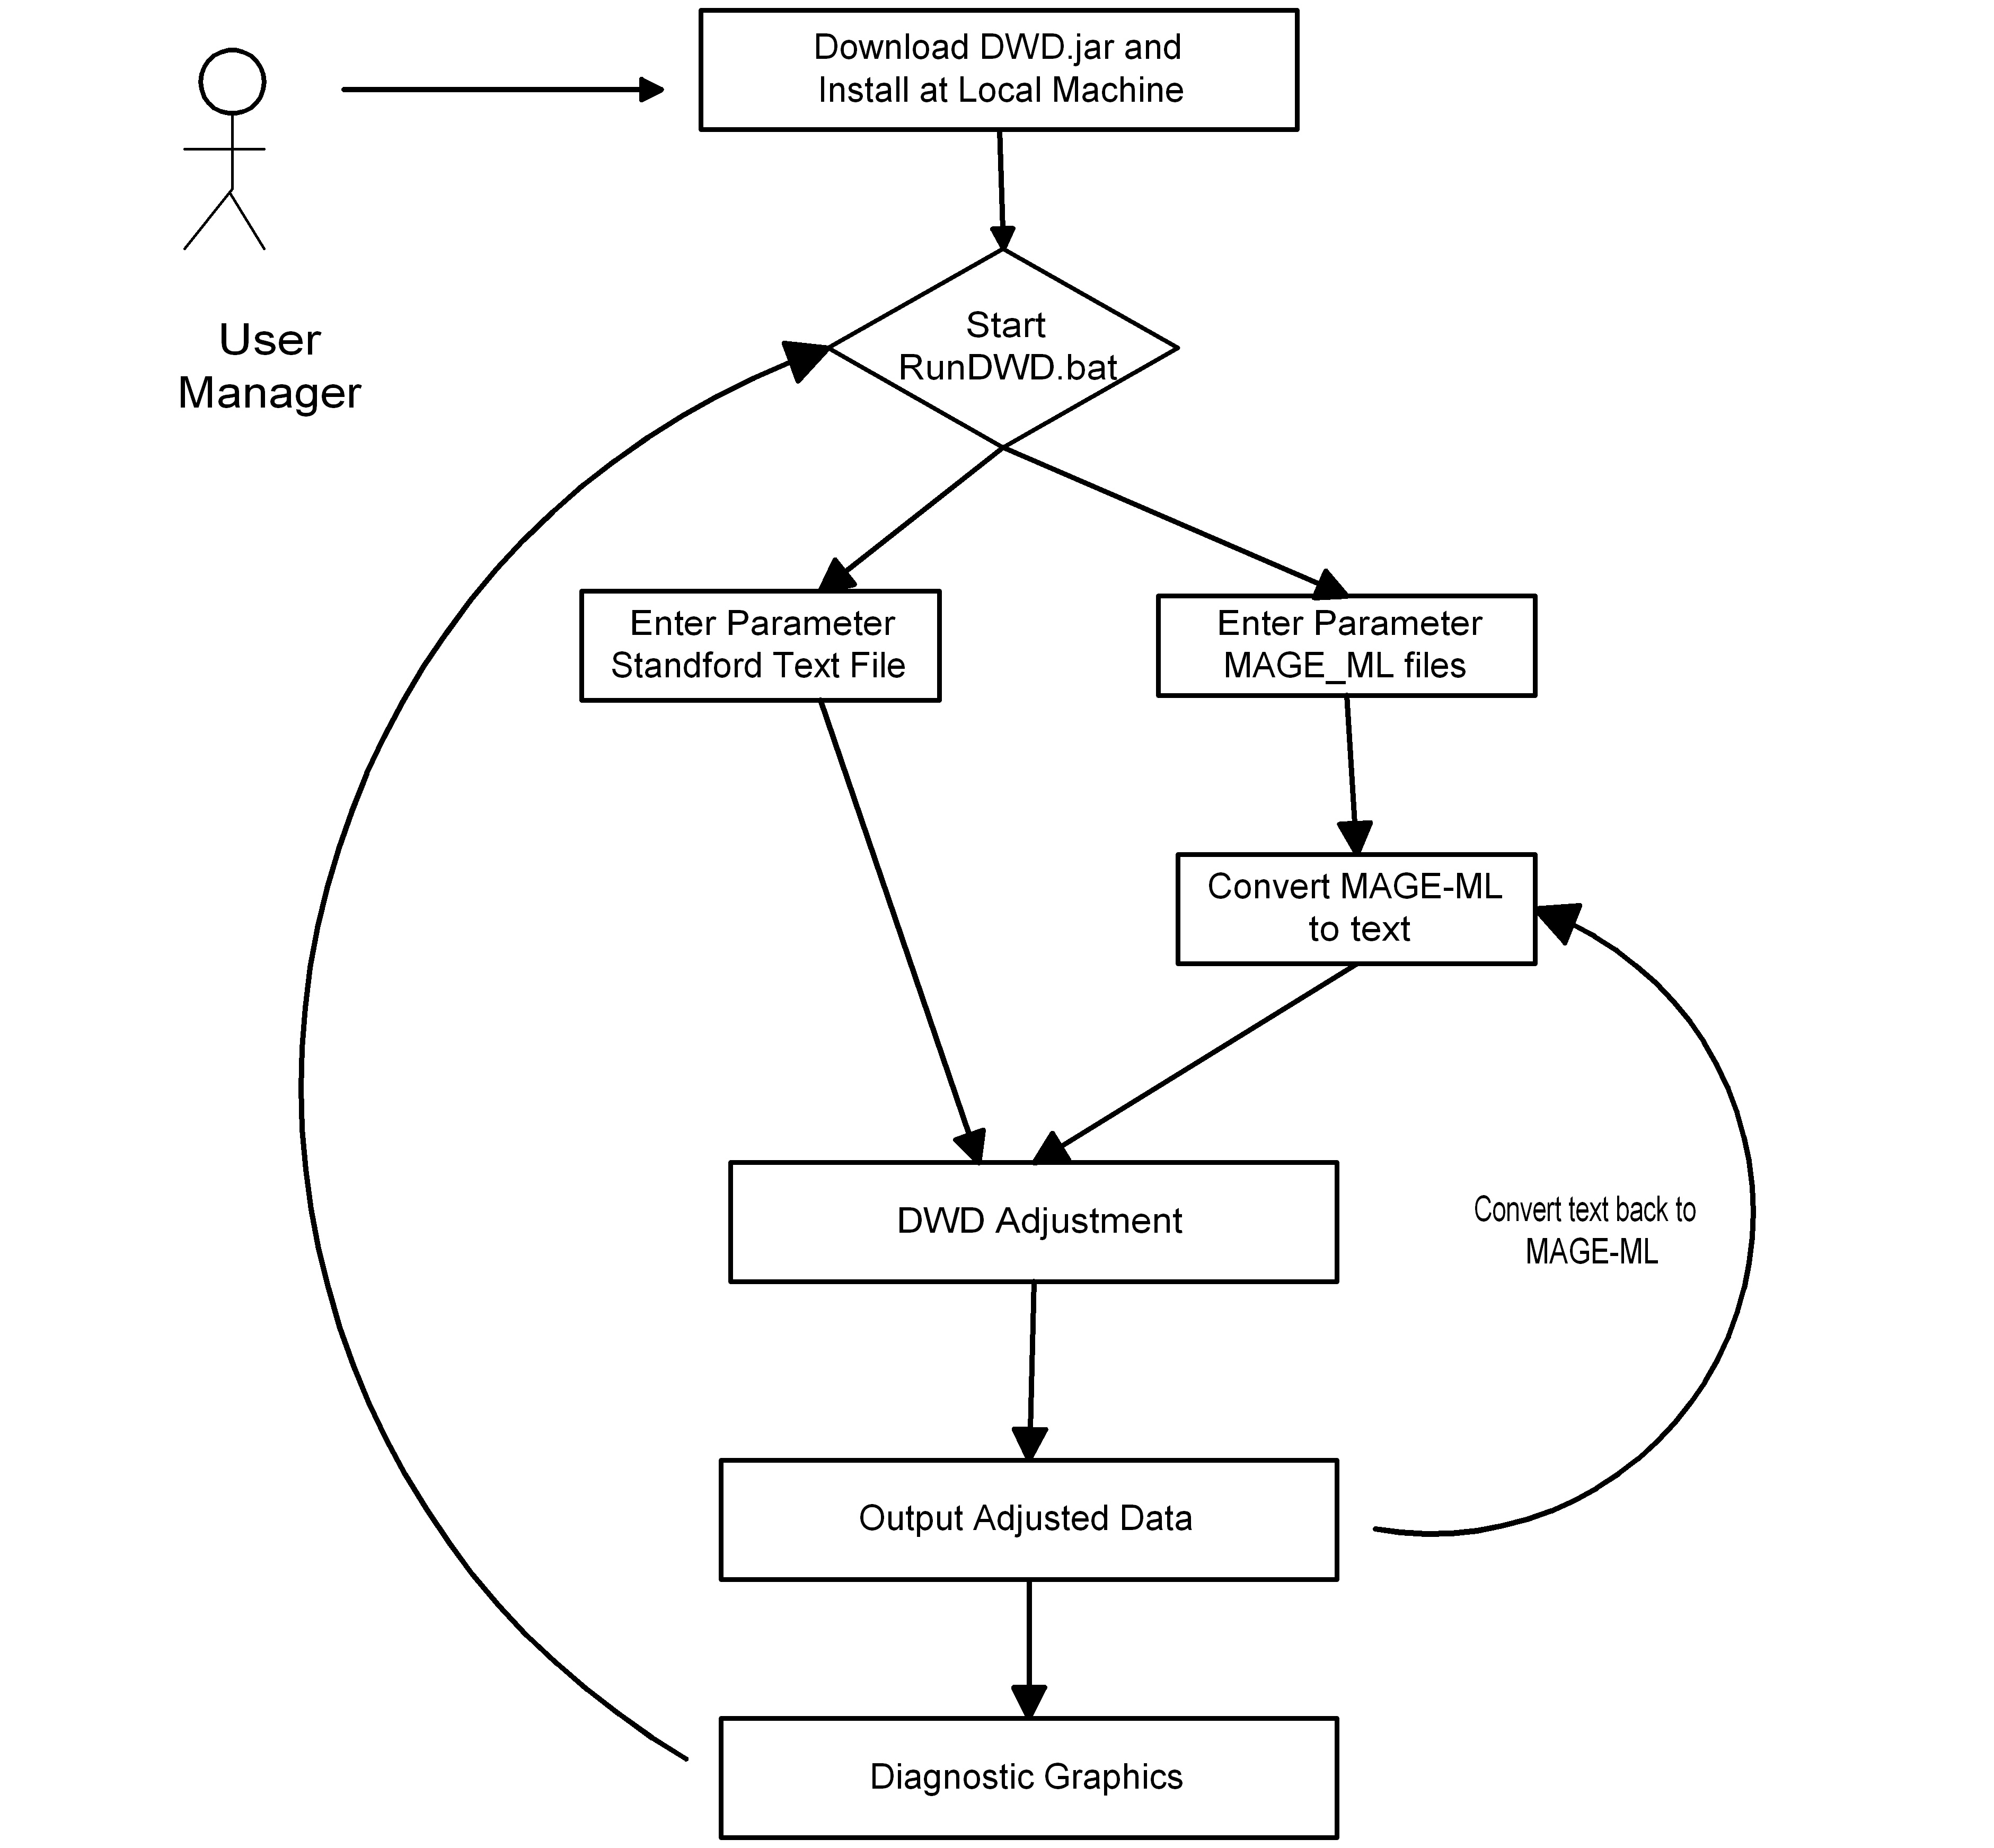

Fig. 7.1 Use-case diagram for DWD

Chapter 8 DWD APIs
This chapter covers summaries of APIs that are covered with more details in Javadocs.

DWD Java API doc

You can find the DWD Java API doc at:
http://cabigcvs.nci.nih.gov/viewcvs/viewcvs.cgi/distanceweighteddiscrimination/DWD_UNC/Month_2_06/JavaDoc/

Some details are summarized below.
There are six packages:
- The package “edu.unc.LCCC.caBIG.DWD.javaCode” includes one class with the main function.
- The package “edu.unc.LCCC.caBIG.DWD.javaCode.ImportMAGEMLFiles” includes six classes, which handle the input and output MAGE-ML files.
- The package “edu.unc.LCCC.caBIG.DWD.javaCode.processfile” includes eight classes, which start the GUI for uploading files, for processing text files, and for calling the c executable.
- The package “edu.unc.LCCC.caBIG.DWD.javaCode.SVD” includes five classes, which compute the singular value decomposition that underlies principal component analysis.
- The package “edu.unc.LCCC.caBIG.DWD.javaCode.util” includes three classes, which contains the help functions for the GUI design, the quick sorting and the binary searching.
- The package “edu.unc.LCCC.caBIG.DWD.javaCode.visualization” includes four classes for the visual diagnostics.

Chapter 9 DWD Web Services
DWD will become a web service in its second year of development.

- References

Technical Manuals/Articles

For additional project requirement and specific information, refer to the following documents:

DWD requirements and function specifications: http://cabigcvs.nci.nih.gov/viewcvs/viewcvs.cgi/distanceweighteddiscrimination/DWD_UNC/Month_10/DWD_UNC_Req_Spec_With%20Visualization_Final.doc

DWD use case:
http://cabigcvs.nci.nih.gov/viewcvs/viewcvs.cgi/distanceweighteddiscrimination/DWD_UNC/Month_6/DWD_UNC_ICR_caBIG_Use_Case_FINAL.doc

DWD UML class diagram:
http://cabigcvs.nci.nih.gov/viewcvs/viewcvs.cgi/distanceweighteddiscrimination/DWD_UNC/Month_10/DWD_UNC_UML_Class_Digram_Final.EAP

DWD Java API documentation:
http://cabigcvs.nci.nih.gov/viewcvs/viewcvs.cgi/distanceweighteddiscrimination/DWD_UNC/Month_2_06/JavaDoc/

DWD graphics site: http://genome.med.unc.edu:8080/caBIG/DWDindex.htm
DWD software download site: https://genome.unc.edu/pubsup/dwd/
SDPT3 download site: http://www.math.nus.edu.sg/~mattohkc/sdpt3.html

Scientific Publications

Marron JS, Todd, MJ: Distance Weighted Discrimination, [http://www.optimization-online.org/DB_HTML/2002/07/513.html]: 2002.
Benito M, Parker J, Du Q, Wu J, Xiang D, Perou CM, Marron JS: Adjustment of systematic microarray data biases. Bioinformatics 2004, 20: 105-114.
Liu X, Parker, J., Fan, C., Perou, C. M., Marron, J. S. (2005) Visualization of Cross Platform Microarray Normalization, http://genome.med.unc.edu:8080/caBIG/paper1.pdf

caBIG Material
- caBIG: http://cabig.nci.nih.gov/
- caBIG Compatibility Guidelines: http://cabig.nci.nih.gov/guidelines_documentation

- Acronym List

Term | Definition
API | Application Programming Interface
caArray | cancer Array Informatics
caBIG | cancer Biomedical Informatics Grid
caBIO | Cancer Bioinformatics Infrastructure Objects
caCORE | cancer Common Ontologic Representation Environment
caDSR | Cancer Data Standards Repository
caMOD | Cancer Models Database
Cardinality | Cardinality describes the minimum and maximum number of associated objects within a set
CDE | Common Data Element
CGAP | Cancer Genome Anatomy Project
CMAP | Cancer Molecular Analysis Project
CN | Common Name
CS | Classification Scheme
CSI | Classification Scheme Item
CSM | Common Security Module
CTEP | Cancer Therapy Evaluation Program
CUI | Concept Unique Identifier
CVS | Concurrent Versions System
DAML | DARPA Agent Markup Language
DAO | Data Access Objects
DARPA | Defense Advanced Research Projects Agency
DAS | Distributed Annotation System
DL | Description Logic
DWD | Distance Weighted Discrimination
EA | Enterprise Architect
EBI | European Bioinformatics Institute
EVS | Enterprise Vocabulary Services
GAI | CGAP Genetic Annotation Initiative
GEDP | Gene Expression Data Portal
HIPPA | Health Insurance Portability and Accountability Act
HLGT | High Level Group Term
HLT | High Level Term
HTTP | Hypertext Transfer Protocol
ISO | International Organization for Standardization
JAAS | Java Authentication and Authorization Service
JAR | Java Archive
Javadoc | Tool for generating API documentation in HTML format from doc comments in source code (http://java.sun.com/j2se/javadoc/)
JDBC | Java Database Connectivity
JET | Java Emitter Templates
JMI | Java Metadata Interface
JSP | JavaServer Pages
JUnit | A simple framework to write repeatable tests (http://junit.sourceforge.net/)
LDAP | Lightweight Directory Access Protocol
LLT | Lowest Level Term
LOINC | Logical Observation Identifier Names and Codes
MAGE | MicroArray and Gene Expression
MAGE-ML | MicroArray and Gene Expression – Markup Language
MAGE-OM | MicroArray Gene Expression - Object Model
MedDRA | Medical Dictionary for Regulatory Activities
metadata | Definitional data that provides information about or documentation of other data.
MGED | Microarray Gene Expression Data
MMHCC | Mouse Models of Human Cancers Consortium
MO | MGED Ontology
multiplicity | Multiplicity of an association end indicates the number of objects of the class on that end may be associated with a single object of the class on the other end
NCI | National Cancer Institute
NCICB | National Cancer Institute Center for Bioinformatics
OIL | Ontology Inference Layer
OilEd | Ontology editor allowing you to build ontologies using DAML+OIL
OLLT | Obsolete Lower Level Terms
OMG | Object Management Group
ORM | Object Relational Mapping
PT | Preferred Term
RDBMS | Relational Database Management System
SDK | Software Development Kit
Semantic connector | A development kit to link model elements to NCICB EVS concepts.
SOC | System Organ Class
SPORE | Specialized Programs of Research
SQL | Structured Query Language
SSC | Special Search Categories
UI | User Interface
UID | User Identification
UML | Unified Modeling Language
UMLS | Unified Medical Language System
UPT | User Provisioning Tool
URL | Uniform Resource Locators
VD | Value Domain
WAR | Web Application Archive
WSDL | Web Services Description Language
XMI | XML Metadata Interchange (http://www.omg.org/technology/documents/formal/xmi.htm) - The main purpose of XMI is to enable easy interchange of metadata between modeling tools (based on the OMG-UML) and metadata repositories (OMG-MOF) in distributed heterogeneous environments
XML | Extensible Markup Language (http://www.w3.org/TR/REC-xml/) - XML is a subset of Standard Generalized Markup Language (SGML). Its goal is to enable generic SGML to be served, received, and processed on the Web in the way that is now possible with HTML. XML has been designed for ease of implementation and for interoperability with both SGML and HTML

Index

A
Affymetrix data 7
analytical tool 9
Architectural Diagram 11
Architecture 9
B
bias adjustment 7
C
caArray 17
Center at 0 19
Center at the First Mean 19
Center at the Second Mean 20
Components of the Software 8
Contacts iv
Conventions 5
D
data transfers 11
Development Team iii
Disk space requirement 8
Distance Weighted Discrimination 7
Document conventions, Supplement 6
DWD Java API 23
DWD Type 19
F
Flow chart of components 10
G
gene identifiers 7
Getting Started 5
I
imputation of missing values 19
Inputs 7
Installation 15
J
Java JRE 1.4 8
L
Licensing ii
M
MAGE-ML 7
MAGE-ML format files 18
Mean Adjust Type 19
microarray data 7
N
Naming Best Practices 21
Non-Standardized DWD 19
O
Open Source Software ii
Output 20
R
RAM available 8
S
Scientific Publications 27
SDPT3 optimization package 7
Security Management 13
Sequence Diagram 11
Software and Hardware Dependencies 9
Software Overview 7
Standardized DWD 19
Stanford text format 7
Stanford-like text delimited files 18
System Requirements 8
T
TextPad editor 19
time sequence of events 11
U
UML class diagram 21
Use-Case Diagrams 21
User Guide 17
V
validation 19
visualization button 11
W
web service 8

