National Cancer Institute Center for Bioinformatics (NCICB)

caBIG™ DWD System Installation / Administration Reference Manual

12/10/2005
Document version 1.0
DWD version 1.1

2
TABLE OF CONTENTS

1. Project title 1
2. Related documents table of contents 2
3. Purpose and objectives of the manual 3
3.1 How to use the manual 3
4. Introduction and overview of software 4
4.1 Background of the application 4
4.2 Brief introduction to the software architecture and major components 4
4.3 caBIGTM compatibility level 5
4.4 Software and hardware dependencies 6
5. list of illustrations 7
5.1 THE INITIALIZATION OF DWD GUI 7
5.2 The gui for data adjustment 8
5.3 The gui for visual diagonostic 9
6. instllation and initialization 10
6.1 system preparation and set up 10
6.2 installing the software 10
6.3 initilization / configuration of files, variables, and data 10
6.4 initial software startup 10
6.5 Interrupt / recovery /restart 11
6.6 tailoring reconfiguration, adaptation 11
6.7 re-initialization after failure 11
6.8 some notes about data files 11
7. installation test suite or test plan 13
8. related documents 14
9. startup and termination 15
10 standard operating procedures 16
11. Sign off 17
Appendix A – Acronym List 18

3 Purpose and objectives of the manual

This document was created to provide sites adopting the DWD system with information on installation, configuration, and system administration instructions.

How to use the manual

This manual is divided into several sections. Section 6 provides a background and brief overview of the purpose and features of DWD (actually list subsections). Section 7 is the main part of this document. It contains detailed instructions on how to install, to configure, and to run a functional system from a distribution. Section 7 also discusses allowable data formats, and control options that are available. A test suite is outlined in Section 8 for verification of an installation.

4 Introduction and overview of software

  - Background of the application

UNC Lineberger Comprehensive Cancer Center (Lineberger) has performed research on the meta-analysis of different microarray data sets. All large microarray datasets contain systematic biases that are due to different sources of RNA, different batches of microarrays and especially different microarray platforms. To address this challenge, individuals at Lineberger have developed a tool called Distance Weighted Discrimination (DWD) that makes statistical corrections to reduce these biases. The approach is based on modern statistical discrimination methods and was shown to be better than Support Vector Machines and Singular Value Decomposition for the adjustment of systematic biases.

The full Year 1 caBIG DWD project includes the following major tasks.
- Convert the Matlab functions into c executable;
- Design the GUI to input the parameters for both Stanford text files and MAGE-ML files, and call the c executable to do the data adjustment;
- Design GUI to do visual diagnostic.

The full Year 1 caBIG DWD Package, for combining microarray data sets, and for monitoring the effectiveness of the process through visual diagnostics, has been successfully deployed several times, at a variety of locations. These include by the Development Team, and others, at the UNC Lineberger Center, and by the Adopter Team at the Wistar Institute.

  - Brief introduction to the software architecture and major components

There are three major components for Java version DWD. They are:

- Java GUI Component for Data Adjustment;
- DWD Adjustment Component;
- Java GUI Component for Data Visualization.

The relationships between there major components described above, are illustrated in the following process flow chart, which shows the logical function of the software. Rectangles represent menus visible to the user, and the text inside represents tasks, with (BT) representing buttons.

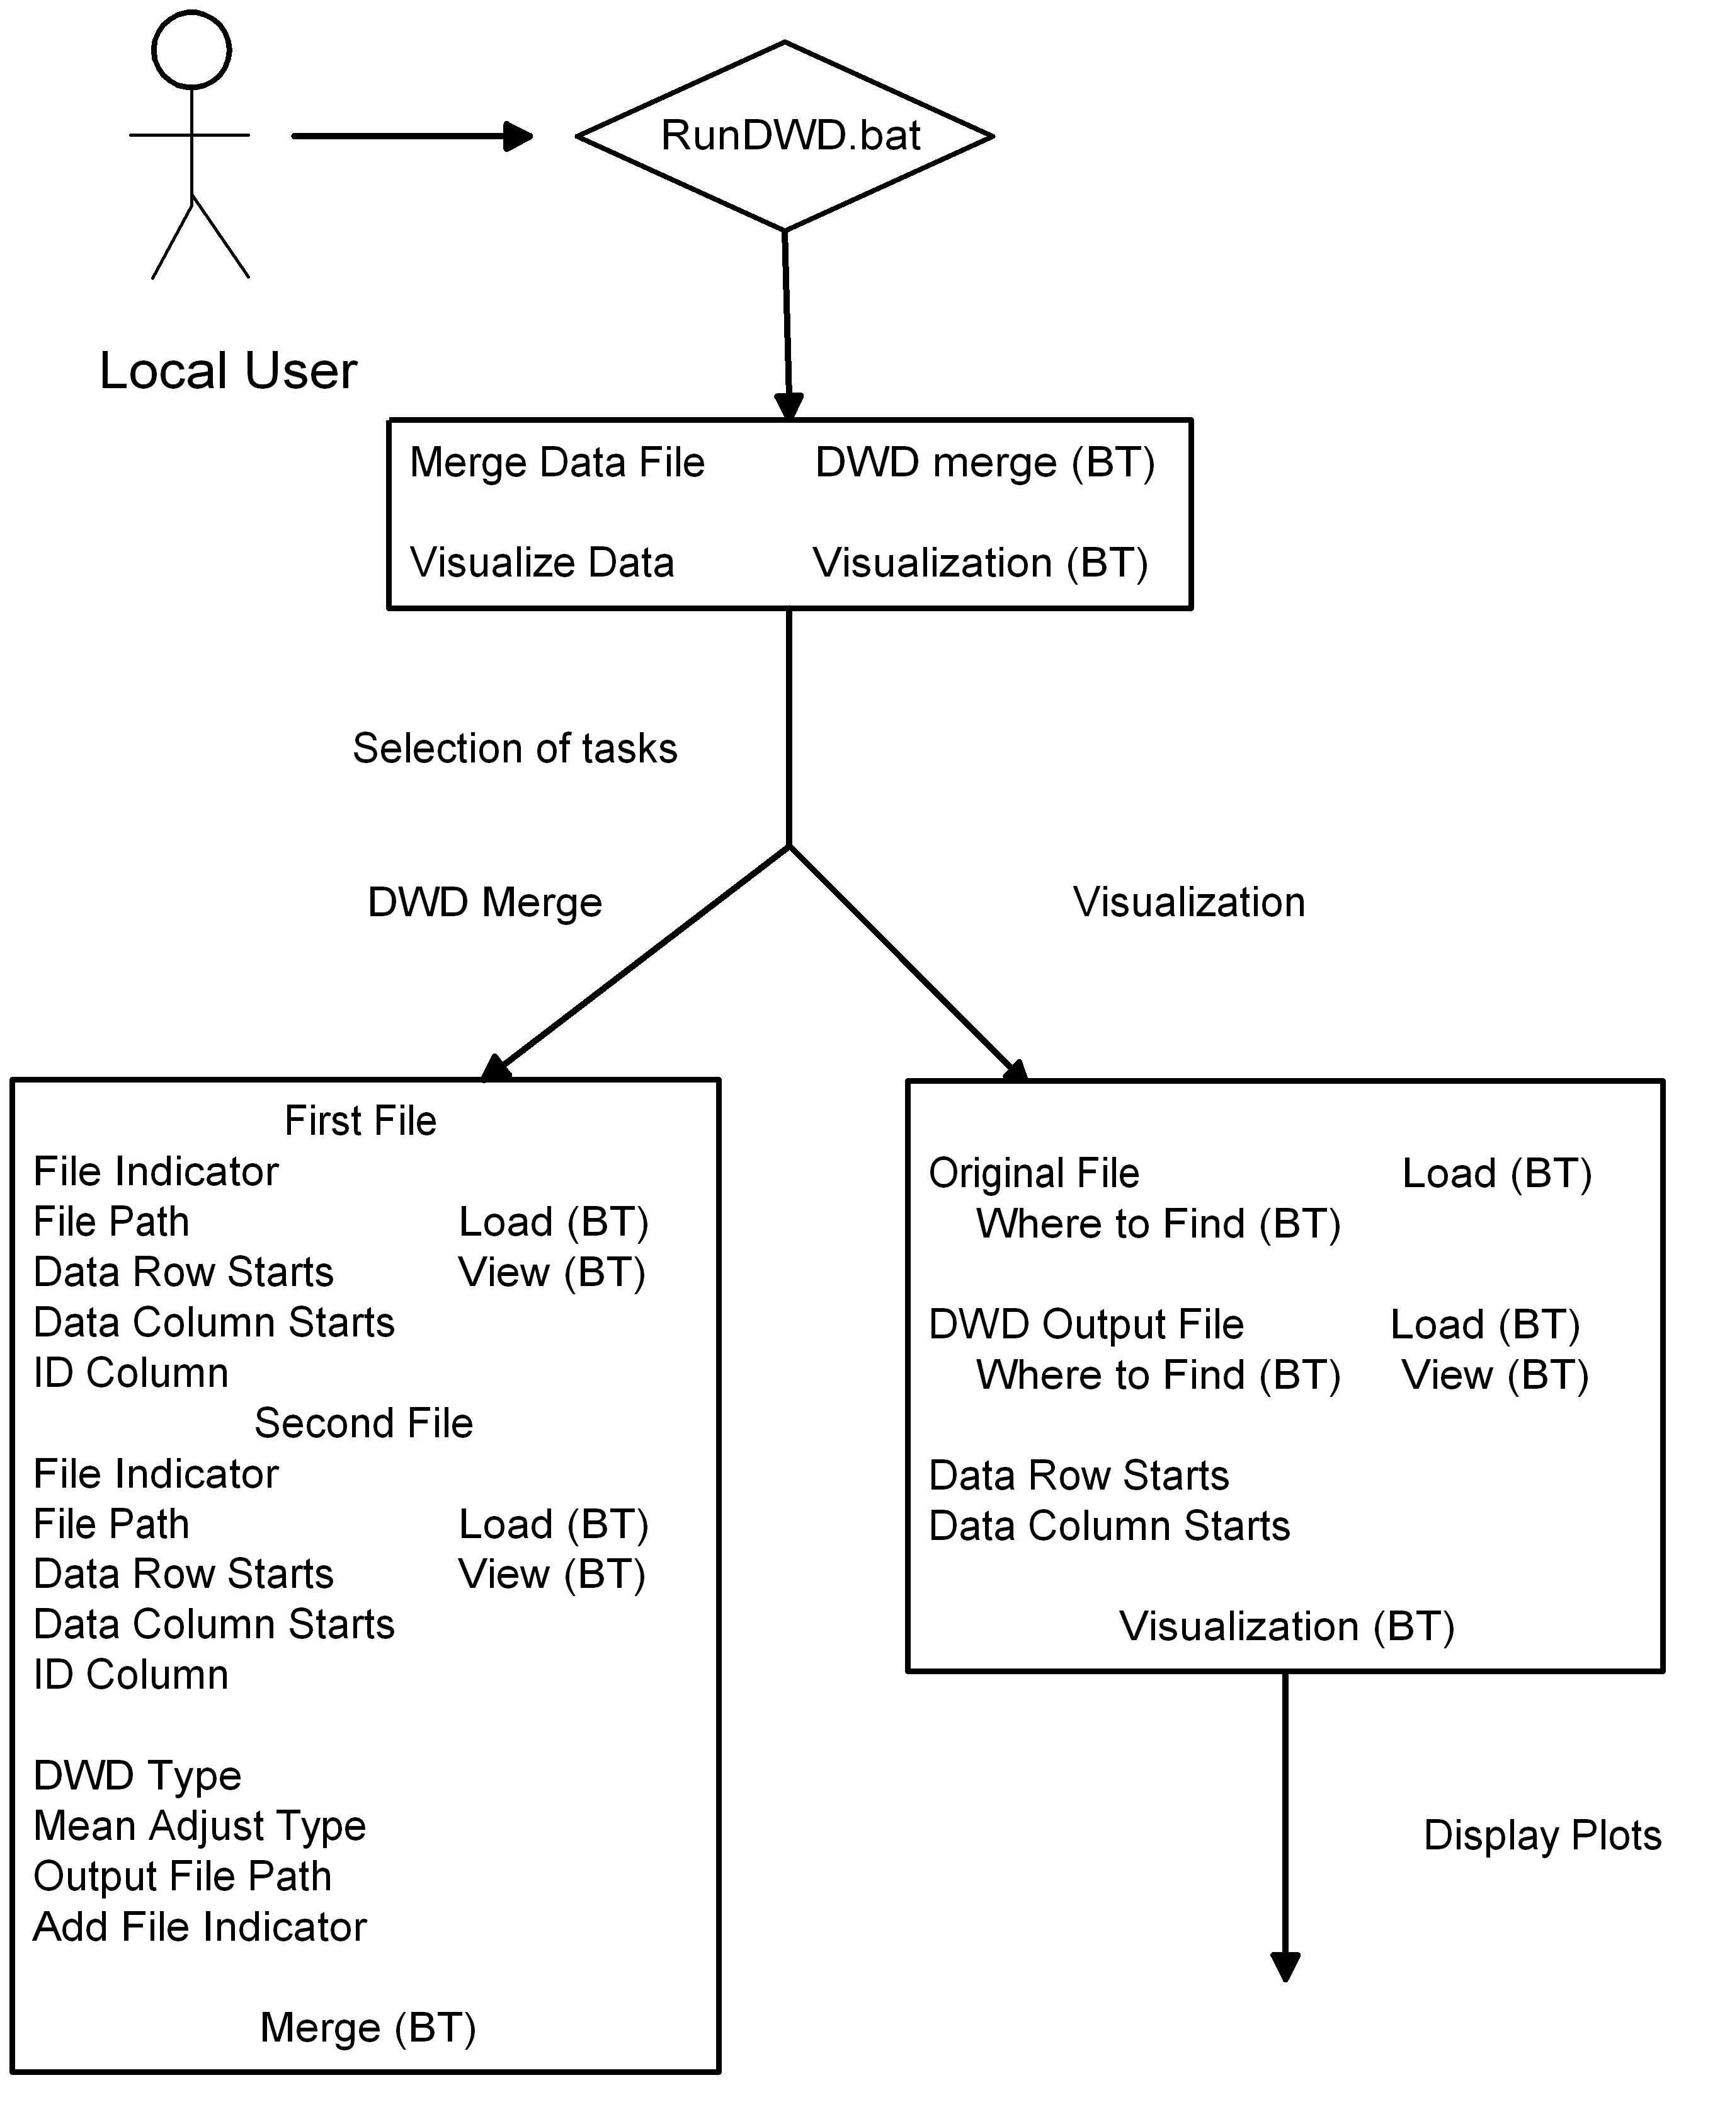

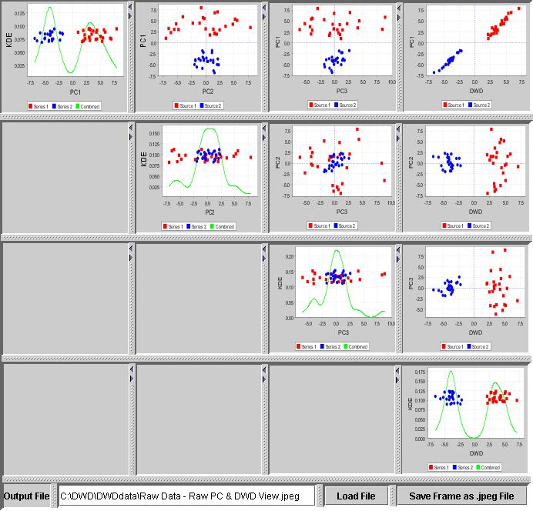

  - caBIG™ compatibility level

The current implementation of the DWD system meets the silver level of caBIG™ compatibility. The current DWD can import MAGE-ML files and do adjustment, then output the adjusted data as MAGE-ML file.

  - Software and hardware dependencies

The current DWD only runs on Window OS machine. The Java jre 1.4 or above is needed.

If the input files are not very big, say 10,000 genes and 300 samples, then a regular PC runs fine. However, when the sample size reaches >600, the visualization may take long time. This will be improved in the Year 2 project.

When the input files are MAGE-ML and the files have many derived BioAssayData, a regular PC is not enough.

5 List of Illustrations

The initialization of DWD GUI.

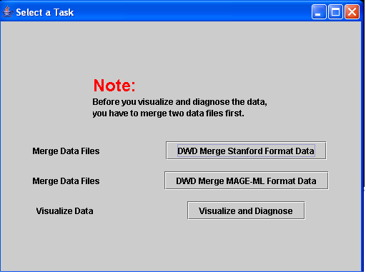

  - The GUI for Data Adjustment

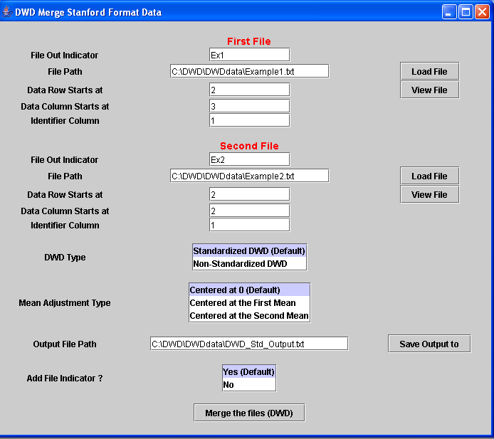

5.3 The GUI for Visual Diagnostic

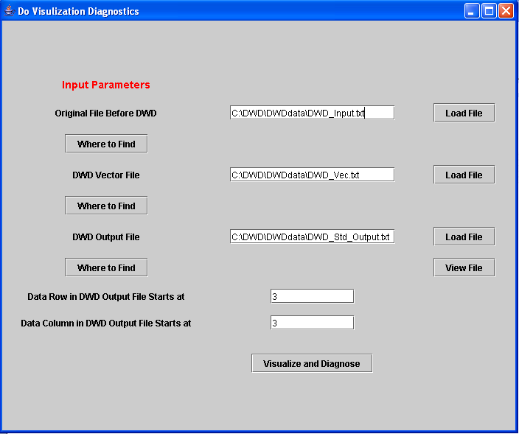

6 Installation and initialization

  - System preparation and set-up

    - System preparation

No special system set-up is needed, except installation of Java jre. You can download jre at http://java.sun.com/j2se/1.4.2/download.html.

  - Installing the software

You can download DWD at : https://genome.unc.edu/pubsup/dwd/.

The current version of DWD is only tested in Win XP and 2000. The software should be directly installed under c: drive, or else you would have some configuration work to do. There are two subdirectories under the DWD directory: lib and DWDdata. There are also eight important files in the DWD directory: README.txt, RunDWD.bat, DWD.jar and other five jar files.

The lib subdirectory contains all libraries and converted c executable.

The DWDdata subdirectory can house all data files, including your original ones and output from DWD.

Note: You do not have to put your input and output files in this directory, but this folder is critical. If you delete this folder, an error message window will pop up to remind you of this.

  - Initialization/configuration of files, variables, data

If DWD is installed as above, no initialization/configuration is needed. All the variables and data will be provided during the running of software.

  - Initial software startup

There are two methods running of DWD

Method 1: Start DOS command line window, change current directory to DWD, type RunDWD.bat.
Method 2: In windows explorer, double click RunDWD.bat.

I tend to use the method 1, because an error can be retained after you close DWD.

  - Interrupt/recovery/restart

If you want to interrupt the application, just close the GUI window or close DOS window. When you are ready to re-run the application, follow the same step list in 7.4.

  - Tailoring, reconfiguration, adaptation

N/A.

  - Re-initialization after failure

Same as interruption of application.

  - Some Notes Related to Data Files:

    - Data set format

The current version of DWD can take Stanford-like text delimited file and MAGE-ML format file as input.

A. For Stanford-like text delimited file.
The first column of the Stanford-like text delimited file is gene identification, the second column contains some gene annotation, and the values for the measured gene expression data start in the third column. The gene identification must be unique (duplicates are not allowed right now). The first row contains information about the samples. This kind of input format has been extensively tested. Two sample files are also included in the DWDdata subdirectory. The software can also detect the missing elements and non-digit values where a digit value is supposed to be and report each error one by one each time.

Missing values should first be imputed. see http://bioinformatics.oupjournals.org/cgi/reprint/17/6/520.pdf for a good introduction to the main ideas of, and methods typically used for, imputation, and see http://www.scripps.edu/researchservices/dna_array/new/Data_Analysis_SAM.htm for imputation software. When you edit the file with MS Excel, please delete any blank lines. We suggest using the TextPad editor to modify your files. Here is the website to download TextPad: http://www.textpad.com/download/

B. For MAGE-ML format file.
We have tested files generated from Agilent and Affymetrix, either with internal data or external data files. At this time, validation with MAGE-ML.dtd does not work. In fact, validation itself works, but it either generated errors, or hung, while reading internal data generated by Agilent software. The work-around is to delete those lines related to MAGE-ML.dtd in the .xml input files. This is very important.

Parameter selection

A. For Stanford-like text delimited file.
Options are clear, as displayed on the GUI.

B. For MAGE-ML format file.
When MAGE-ML format files are used as input, there are a few criteria we adopt.
(1). If there are both raw data (MeasuredBioAssayData) and derived data (DerivedBioAssayData), only derived data will be retrieved for data adjustment.
(2). If there are more than one raw data/derived data sets in the one MAGE-ML file, they must be adjusted first.
(3). If you want to re-run the data adjustment, you have to restart DWD. The button "Reset" in both the BioAssayData selection menu and the Quantitation selection menu will only reset those two parameters.

6.8.3 Output

A. For Stanford-like text delimited file.
The output files include: DWD_input.txt, DWD_Vec.txt, and DWD_Non_Std_Output.txt/ DWD_Std_Output.txt (if you use default output). DWD_Non_Std_Output.txt/ DWD_Std_Output.txt is the final output corresponding to the two DWD types. Note that the order of genes in the output files is different from that of input files. The rows in the output files are sorted based on the gene identification column in the ascending order. But other files (DWD_input.txt and DWD_Vec.txt) will also be used in the visual diagnostics analysis. Please do not delete them. They are automatically overwritten from one run of DWD to another.

B. For MAGE-ML format file.
In addition to the same files generated as above, there are two extra output files, when MAGE-ML format files are used as input. They are ExternalAdjustedDataFile.txt and DWD_Non_Std_Output.xml/ DWD_Std_Output.xml (if you use default output). The adjusted data will be stored in an external text file named ExternalAdjustedDataFile.txt. The text file, DWD_Non_Std_Output.txt/ DWD_Std_Output.txt (if you use default output) will be used for the visualization. MAGE-ML output can only be generated when both input files are MAGE-ML formatted.

7. Installation test suite or test plan

The test suite related to installation is documented in the DWD_UNC_Test_Activity_Log_Complete.doc and they are listed below. You can download this file at: http://cabigcvs.nci.nih.gov/viewcvs/viewcvs.cgi/distanceweighteddiscrimination/DWD_UNC/Month_11/DWD_UNC_Test_Activity_Log_Complete.doc.

Put the compiled and source files online and test accessibility from website. | 1.11 | Pass | Everett Zhou,  Xuxin Liu,  Michael Nebozhyn
Test installation, starting from .zip files. Includes assessment of clarity and relevance of the file ReadME.txt | 1.9 | Pass | Xuxin Liu,  Michael Nebozhyn

8 Related documents

Other documentation is available for the DWD project, including both on-line documentation and text-based documentation. A current list of user documentation follows.

  - DWD Software Requirements and Specification at http://cabigcvs.nci.nih.gov/viewcvs/viewcvs.cgi/distanceweighteddiscrimination/DWD_UNC/Month_10/DWD_UNC_Req_Spec_For%20Visualization_Final.doc

DWD Administration Manual (this document)

  - DWD User Guide (README.txt) at https://genome.unc.edu/pubsup/dwd/README.txt

  - DWD test activity log at http://cabigcvs.nci.nih.gov/viewcvs/viewcvs.cgi/distanceweighteddiscrimination/DWD_UNC/Month_11/DWD_UNC_Test_Activity_Log_Complete.doc

  - For earlier Matlab versions of DWD: https://genome.unc.edu/pubsup/dwd/

  - The original DWD paper: Marron, J. S. and Todd, M. J. (2002) , Distance Weighted Discrimination, http://www.optimization-online.org/DB_HTML/2002/07/513.html

  - First application of DWD to microarray data Benito M, Parker J, Du Q, Wu J, Xian D, Perou CM, Marron JS. (2004) Adjustment of systematic microarray data biases, Bioinformatics 20:105-144.
9. Startup and termination

This section is intended to describe the procedures for safely starting and shutting down a running application server. But DWD is currently a tool, not a service, so this is not applicable. The section has not been deleted, because it will be useful when DWD becomes a caBIG Analytic Service.

10. Standard operating procedures

This section is intended to describe the procedures for system maintenance. But DWD is currently a tool, not a service, so this is not applicable. The section has not been deleted, because it will be useful when DWD becomes a caBIG Analytic Service.

11. Sign off

Louise Showe 1/5/2006
Adopter Rep Louise Showe Date

Appendix A. Abbreviations and acronyms

Acronym | Description
DWD | Distance Weighted Discrimination
SDPT3 | Semi-Definite Programming Package
MAGE-ML | Micro Array Gene Expression- Markup Language
SRS | Software Requirements and Specifications
CCR | Change control request
DBA | Database Administrator
HSTOMP | Health Services Team Organizational Management Portal
MS | Microsoft
PAL | Process Asses Library
PM | Project Manager
RM | Requirements Manager
RTM | Requirements Traceability Matrix
SCM | Software Configuration Management
SDLC | Software Development Lifecycle
SE | Software Engineering
SEPG | Software Engineering Process Group
SM | Software Manager
SOP | Standard Operating Procedure
SPI | Software Process Improvement
SQA | Software Quality Assurance
SW | Software
TM | Test Manager
VM | Version Manager

