Use Case Document

DWD
UNC Lineberger Comprehensive Cancer Center

DOCUMENT REVISION HISTORY
Version Number | Date | Description
1.0 | March 30 2005 | - Initial Draft
1.1 | May 5, 2005 | - Added in Use Case 1 and 2
1.2 | May 30, 2005 | - Finished Use Case 1 and deleted Use Case 2
1.3 | May 31,2005 | - Overall Requirements and Data Definitions
1.4 | July 7, 2005 | - Incorporated adopter’s comments

Background/Summary
The DWD project in the Integrative Cancer Research Workspace of caBIG™, aims to provide a tool for effective combination of differing microarray data sets. The method has been successful for the mitigation of batch effects that may arise from experimental differences such as sample collection, RNA preparation, and any differences in the experimental manipulations, also for the more challenging problem of combining data sets across platforms and laboratories. The caBIG™ implementation of DWD is intended to put this tool in the hands of cancer researchers, as part of the caBIG™ environment. An additional important goal is the development of visual diagnostics, to ensure that DWD is working properly.

Table of Content
Requirements Specification 1
Module Name 1
Background/Summary 1
1 Introduction 3
1.1 Overview 3
1.2 Related Documents 3
2 Actors and Goals 4
2.1 User Manager 4
3 Use Cases 4
3.1 Standalone Java Version of DWD—Stanford Data Format 4
3.1.1 Use Case Model 4
3.1.2 Brief Description 5
3.1.3 Primary Actor 6
3.1.4 Secondary Actors 6
3.1.5 Preconditions 6
3.1.5.1 Stanford Text Input Files 6
3.1.5.2 Some Common Gene Identifiers … ………………………………………...6
No Missing data………………………………………………………………6
3.1.6 Basic Flow of Events………………………………………………………………...7

3.1.7 Postconditions 8
3.1.7.1 Successful merging and visualization 9
3.1.7.2 Successful merging of data, but failed visualization 9
3.1.7.3 Unsuccessful merging of data 10
3.1.8 Special Requirements 10
3.1.8.1 Windows 2000/XP operating system 10
3.1.8.2 Java JRE, 1.4.2 or higher 10
3.1.8.3 A compiled version of the SDPT3 optimization package 10
4 Overall Requirements 11
4.1 Requirements Prioritization 11
5 Data Definitions 11
6 Sign Off 12
6.1 Approval 12

Introduction

Overview
UNC Lineberger Comprehensive Cancer Center (Lineberger) has performed research on the meta-analysis of different microarray data sets. All large microarray datasets contain systematic biases that are due to many experimental parameters, including different sources of RNA, different batches of microarrays, different analysis programs and, in particular, different microarray platforms. To address this challenge, individuals at Lineberger have developed a tool called Distance Weighted Discrimination (DWD) that makes statistical corrections to reduce these biases. The approach is based on modern statistical discrimination methods and was shown to be better than Support Vector Machines and Singular Value Decomposition for the adjustment of systematic biases.
Many institutions maintain archives of microarray data; however, datasets coming from different institutions and different microarray platforms are, for the most part, not directly comparable. Implementation of DWD would allow investigators to merge multiple datasets and allow the evaluation of many more samples than any one lab could process. For example, if all breast tumor microarray experiments (which individually total 500-600 experiments across six labs) could be combined as a single dataset that contains many common clinical parameters, this would allow subset analysis that is currently not possible due to small sample sizes.
To date, the method has been developed, evaluated, and applied by one research group at UNC Chapel Hill. The current implementation uses MatLab for statistical calculations. For this project, DWD will: 1) Be deployed to the Adopter site(s) for testing; 2) Be adapted to the caBIG architecture; 3) Accept data in both Stanford tab delimited text file and MAGE-ML format; and 4) Be enhanced with visual diagnostics to improve usability.

Related Documents
The original DWD paper was:
Marron JS, Todd, MJ: Distance Weighted Discrimination, [http://www.optimization-online.org/DB_HTML/2002/07/513.html]: 2002.
The first paper proposing the application of DWD to batch and source adjustment for microarrays was:
Benito M, Parker J, Du Q, Wu J, Xiang D, Perou CM, and Marron JS: Adjustment of systematic microarray data biases. Bioinformatics 2004, 20: 105-114.
A paper which further validated the use of DWD for cross platform data was:
Liu X, Parker, J., Fan, C., Perou, C. M., Marron, J. S. (2005) Visualization of Cross Platform Microarray Normalization, http://genome.med.unc.edu:8080/caBIG/paper1.pdf
This use case is based on the DWD Requirements and Specification Document, which can be viewed at: http://cabigcvs.nci.nih.gov/viewcvs/viewcvs.cgi/distanceweighteddiscrimination/DWD_UNC/Month_3/DWD_UNC_Req_Spec.doc

Actors and Goals
DWD is intended to be used by any single researcher, who wants to combine disparate data sets, with the goals of increasing statistical power, of identifying important new subclasses and identifying genes that define these new classes.

User Manager
The researcher is called the User Manager. The User Manager is responsible for studying and interpreting the diagnostic graphics, which are the visual output representing the merged micro-array data set, to ensure that a useful data merging has occurred.

Other Actors
No other actors are needed for DWD.

Use Cases

Stand alone Java version of DWD – Stanford data format and MAGE-ML data format

Use Case Model

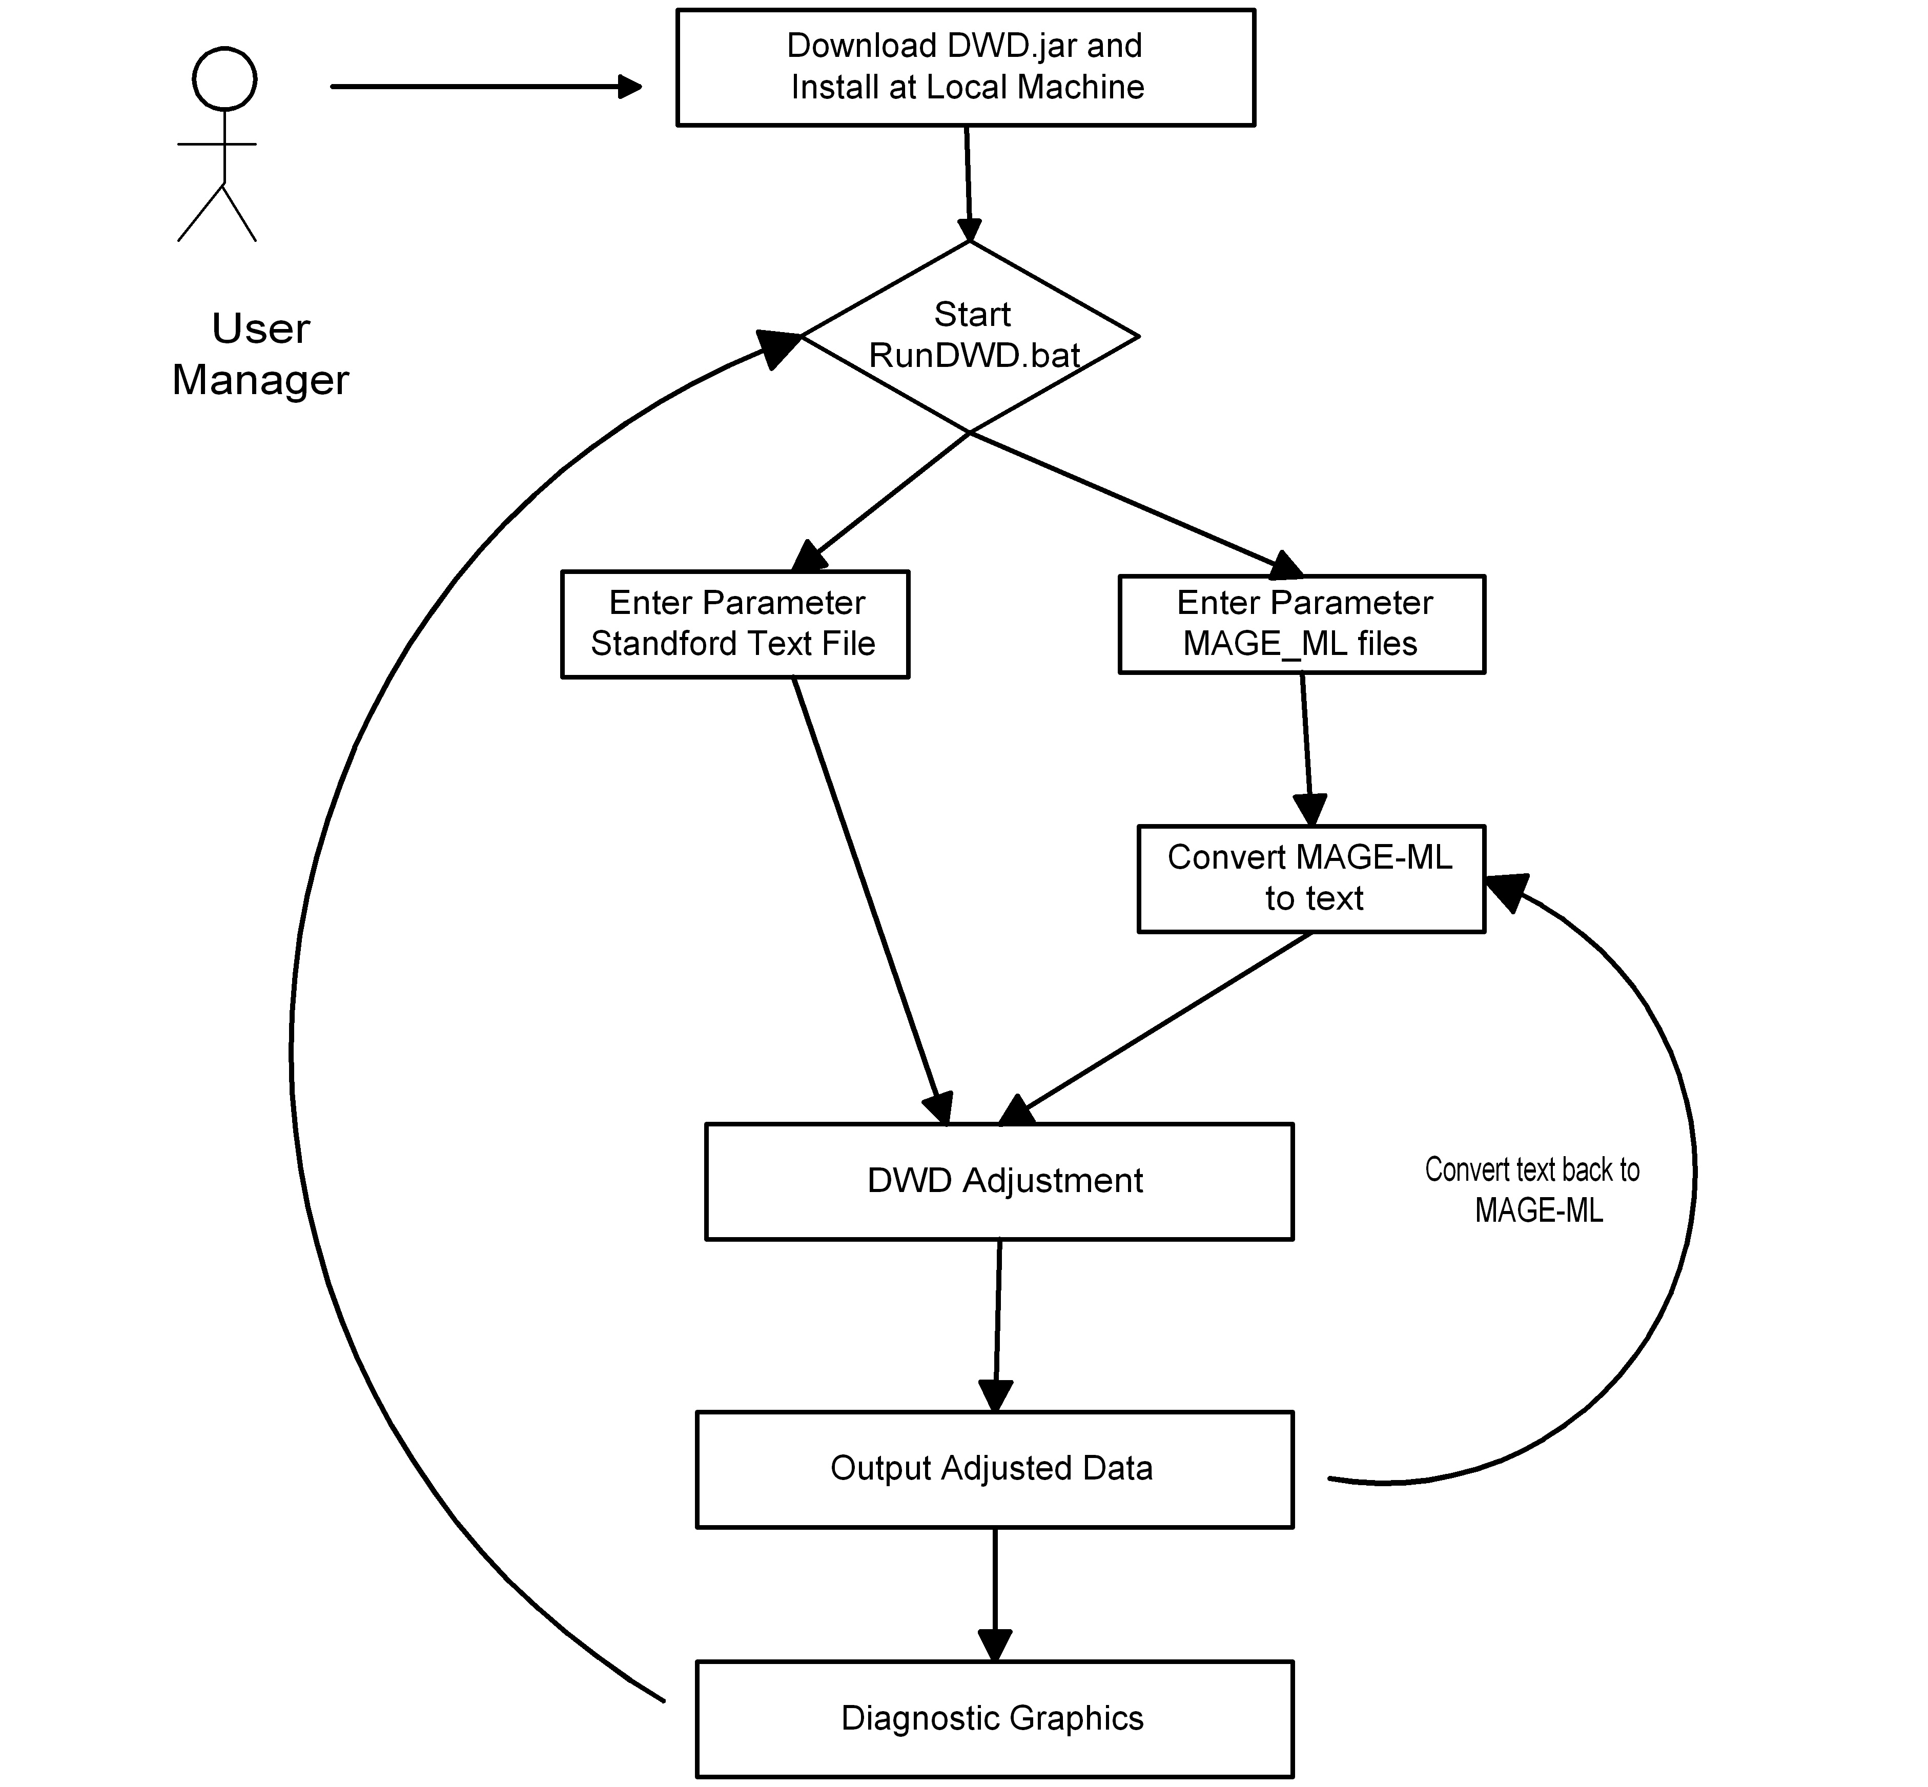

Brief Description
Researcher X launches the DWD client. He loads in the two datasets to be combined, in the Stanford text format or MAGE-ML format. The DWD client generates the adjusted data, and graphics that indicate how successful the DWD process has been at normalization. If the graphic suggests that a further column standardization step will be useful, the client allows this step as well and studies the quality of the result with a further graphical display. The final combined dataset is output as a new combined Stanford text format file or MAGE-ML format.

Primary Actor
The primary Actor is the User Manager, i.e. the researcher who wants to merge the microarray data.

Secondary Actors
There are no secondary actors.

Preconditions
DWD requires:

Text Input Files
Two input data files in Stanford text format on the user’s machine (eventually MAGE-ML format will be accepted). Merging more than two data sets is currently handled pair-wise, sequentially merging the datasets.

Some Common Gene Identifiers
Merging two datasets requires some intersection of common gene identifiers in the two input files. Other gene identifiers can be present in the dataset, but will be ignored if they are not common in the two datasets to be merged. Gene ordering in the two files can be arbitrary.

No Missing Data
No missing data is allowed. Missing values in the arrays should first be imputed, as described at http://bioinformatics.oupjournals.org/cgi/reprint/17/6/520.pdf. This site provides a good introduction to the methods typically used for, imputation.

http://www.scripps.edu/researchservices/dna_array/new/Data_Analysis_SAM.htm
for imputation software. (A goal of the year two development is to combine DWD with other tools for automatic imputation of missing data.)

Preprocessing of input files
It is especially important, when merging datasets obtained on different platforms, to keep in mind that different normalization techniques used in the context of different platforms must be taken into account before the data may be successfully merged. For example, both affymetrix, and single channel cDNA chips provide measurements of expression level of multiple genes in a particular sample, whereas the dual color cDNA arrays quantify the gene expression levels relative to that of the reference mRNA. Ignoring this fact and applying DWD correction on the two datasets directly would lead to incorrect results. Therefore, it is the responsibility of the user to ensure that gene expression measurements, though done on different platforms, are describing common gene expression in a consistent manner. For single channel vs. dual channel data combination, this can be done, for example, by dividing the single channel expression values by that of the sample comparable to the reference mRNA used in the second channel.

Another important issue to keep in mind, is that DWD is designed to correct for a systematic bias, and as such, may be expected to be useful only in the cases where the systematic bias due to either experimental or collection conditions is not confounded by important biological factors. For example, DWD would not be useful for merging two sets, where the first set is composed of control samples, and the second set is mostly patient samples. In this case, the systematic bias due to two different batches is confounded with sample phenotype distribution (patient vs. control), and application of DWD would eliminate biological systematic differences between two sets of samples distinguishing patient vs. controls.

In order for a DWD correction to be accurate, a minimum sample size is required. Currently, the successful performance of the DWD algorithm has been established in cases when individual sample set size exceeds approximately ten samples. The lower minimum on the appropriate number of samples is being established; however, as of now, it can be confidently stated that if sample size falls below three, DWD adjustment should not be expected to be accurate.

Basic Flow of Events

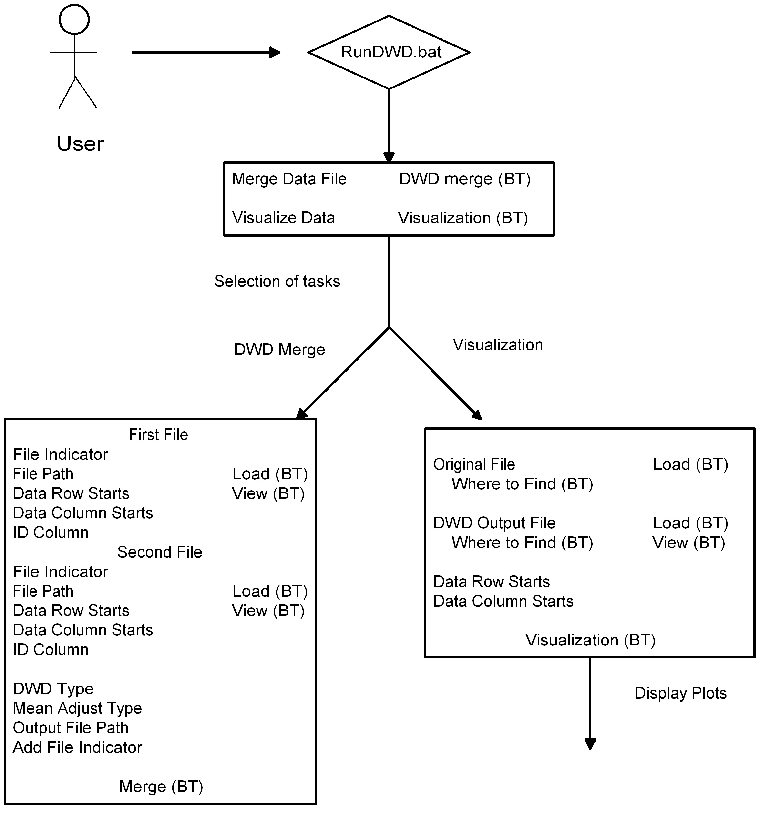

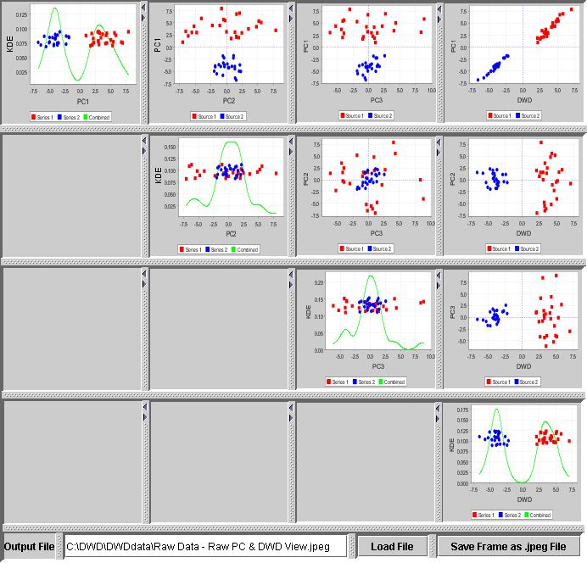

Post-conditions
An example of the main diagnostic plot is shown below. This is the Principal Component Analysis (PCA) view of two example datasets, before DWD merging, with one indicated in blue, and the other in red. Note the large gap in the first principal component between data sets.
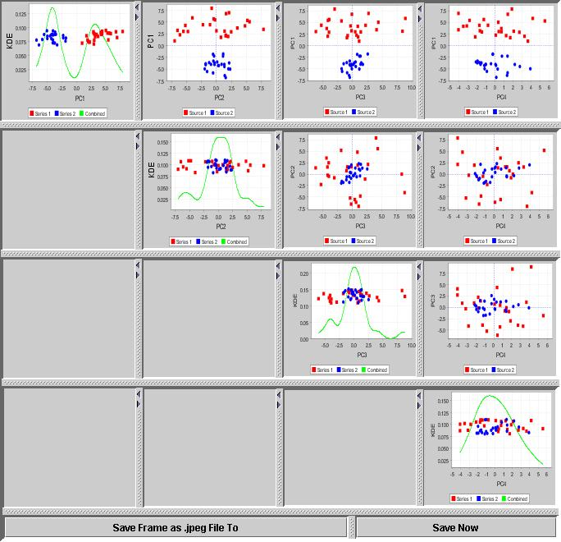

Successful merging and visualization
The data has been successfully merged, so the user has a new data set, which is output. The dataset contains the original gene labels and annotation, as well as the original sample names. According to the chosen value of the Add File Indicator, a row may be added, which indicates the original source of each sample. Also output is another file, with the DWD direction vector that was used in the adjustment. In addition, five graphics windows will be displayed, which will allow careful inspection of the results of the DWD adjustment. One of these is the raw data PCA plot, an example of which is shown above. The corresponding PCA plot after DWD merging is shown below. Note that the data sets have now been very effectively merged, in the sense that the red and blue data points are now well mixed.
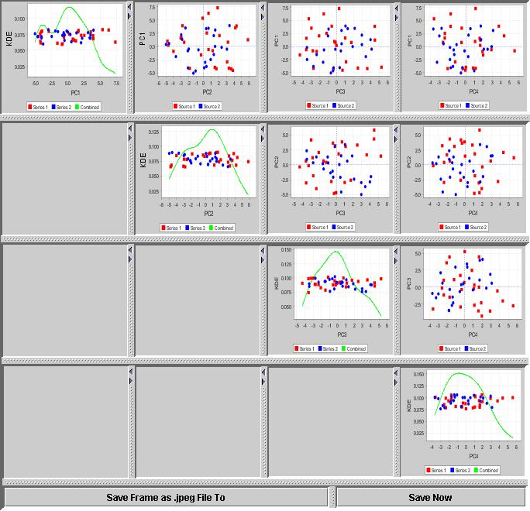

Successful merging of data, but failed visualization
In the very unlikely event that the combined data lie in a subspace of dimension less than four (e.g. if there are less than four common gene identifiers between the merged datasets), the merge operation will still provide a merged dataset, but instead of the usual graphics window, an error window will be displayed. Text in the window will indicate the problem.

Unsuccessful merging of data
This can happen in three cases: (1) there are no common gene identifiers; (2) there are missing values in the data; (3) some data inputs are not numerical. In these cases, execution will terminate, before any merging is done. The only output will be a graphics window, with text that describes the nature of the error.

Special Requirements
DWD requires:

Windows 2000/XP operating system

Java JRE, 1.4.2 or higher

A compiled version of the SDPT3 optimization package

Overall Requirements

Requirements Prioritization

Priority | Use Case Name | Supp Requirement Ref #
1 | Standalone DWD with Stanford format text data sets | DWD_UNC_Req_Spe.doc
2 | Standalone DWD with MAGE-ML format data sets | DWD_UNC_Req_Spe.doc

Data Definitions
Standalone DWD: This version of DWD can be downloaded and installed on a local machine. It is silver level compatible.
Stanford Format Text File: The first row of this type of file is for samples or cases. The first column is the gene identifier and the second column is for any annotation. The rest of rows and columns are the expression value sets.
Gene Identifier: A set of unique IDs, which will be used to combine two files before data adjustment.

Sign Off

Approval
Louise C. Showe Louise C.Showe 7/7/05
Wistar Adopter Rep Louise Showe Date

