Part A: ispyportal.properties

- In windows, it is located at :C:/local/content/ispyportal/config
- In unix, it is located at: /local/content/ispyportal/config
- This is what needs be changed for this file in unin env:
  - gov.nih.nci.ispyportal.data_directory =C:/local/content/ispyportal/data
  - gov.nih.nci.caintegrator.gp.server=http://caintegrator-dev.nci.nih.gov/
  - gov.nih.nci.ispyportal.data_updates= Clinical Data 11/06/08,Agilent 5/22/07,cDNA 5/17/07 : needs to modify the dates if new data has been received
  - gov.nih.nci.caintegrator.gpvisualizer.supportFileURL=http://caintegrator-dev.nci.nih.gov/gp/getFile.jsp?task=<lsid>&file=<supportFileNamegov.nih.nci.ispyportal.jms.jboss_url=localhost:1099

- This line should be added to: ${JBOSS_HOME}\ server\default\deploy\properties-service.xml file:
<attribute name="Properties">
gov.nih.nci.ispyportal.propertiesFile=C:/local/content/ispyportal/config/ispyportal.properties
</attribute>

in the <mbean code="org.jboss.varia.property.SystemPropertiesService"
name="jboss:type=Service,name=SystemProperties">
</mbean>

Section.

Part B: ispy data files location
- In windows, they are located at :C:/local/content/ispyportal/data
- In unix, they are located at /local/content/ispyportal/data

Part C: ispy dev server info

- ispy application’s dev machine uses dbiodev5024, the war file should be deployed to: /usr/local/jboss-4.0.4.GA/server/ncicb-app/deploy
- Login info: Shuang has the info
- startup and stop command for cbiovdev5024: /usr/local/jboss-4.0.4.GA/server/ncicb-app/bin: /start_jboss.sh, and ./stop_jboss.sh

Part D: Gene Pattern info
cbiovdev5010 is the machine that hosts Genepattern for the dev tier

Location to upload new binary files for gene pattern analysis:
/usr/local/genepattern/resources

Part E: ispy data refresh info

- Every time when we receive new data, we usually upload them to the ispy ftp
Server (Shuang should have the login info, please don’t distribute the list outside of ispy team, if anybody from the ispy community asks for the login, refer them to the ispy investigators).

Part F: ispy application data files

There are 6 files in ispy that should not be checked into svn since they are clinical
data, they need to be kept local:

a) ACRIN6657_Mammo_08-01-15.xls
b) DataDictionarySept08.doc
c) Integrated_Clin_Path_MR_Labtrak_fish_09_18_2008.xls
d) I-SPY.BAC.CGH.Baseline.N59.xls
e) ISPY_BAC_CBS_N59.xls
f) Path Variables 10_18_7.doc

They need to be copied to: ..\ispy\WebRoot\docs folder
Before building ispy.war file

Where to find the jar containing the above 6 files: ISPYPortalDataFile_01-06-09_QA.jar in the folder of “ISPY-ANALYSIS-PORTAL”on the ftp://ncicbftp2.nci.nih.gov server

When to update these file:

Evert time when the above files get an update.

Integrated_Clin_Path_MR_Labtrak_fish_09_18_2008.xls: this file needs be update when there is a new data type or existing data have updates.

We usually receive new clinical data every quauter from Gloria Broadwater (broad005@mc.duke.edu)

Part G: ispy release note:

Shine suggested that we need to add new feature info to this file:
https://caintegrator-stage.nci.nih.gov/ispy/docs/ReleaseNote_1.5.1.doc

Part H: ispy user guide and help docs:

We need to update the user guide and help docs when ispy releases new features, the person working on them is: Jill Hadfield, she is in the global list.

Part I: ispy investigators contact info:

- Sarah Davis: kconway@med.unc.edu

- Meredith Buxton: Meredith.Buxton@ucsfmedctr.org

Part J: how to tag in svn:

- from myeclipse, highlight project you are about to tag, then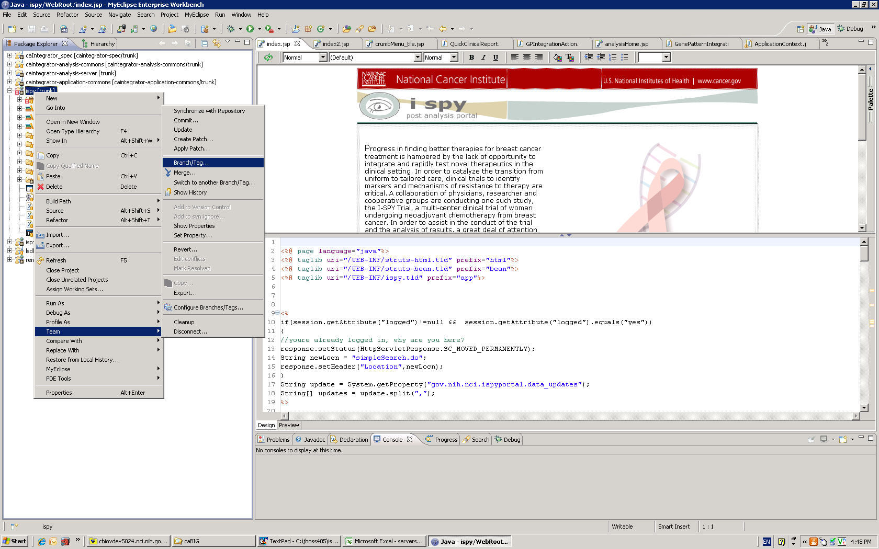

- This screen will show up: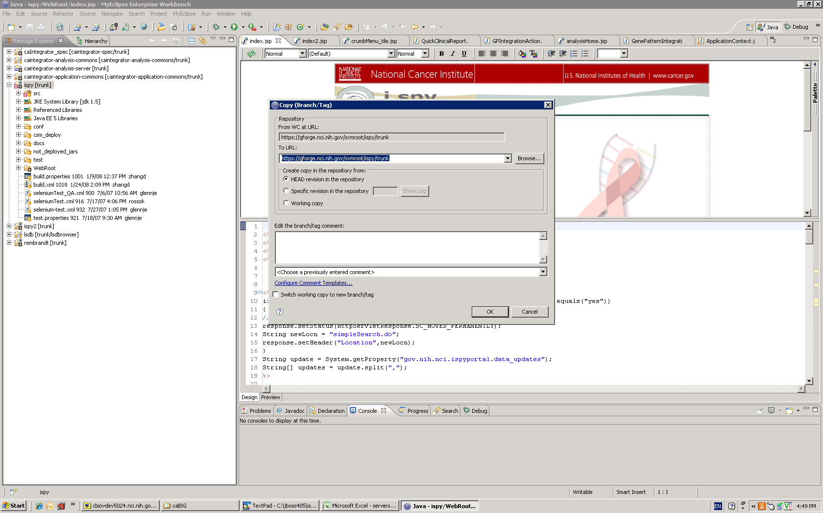

- click on “Browse” to come to :

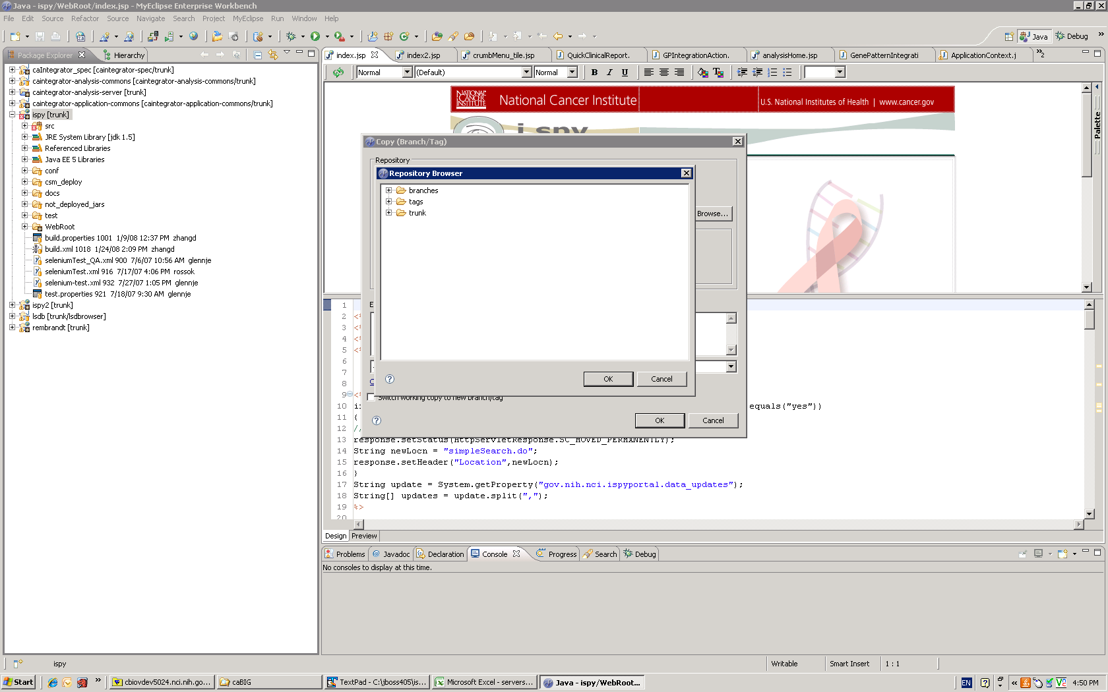

- Highlight “tags”, then click on “OK” button:
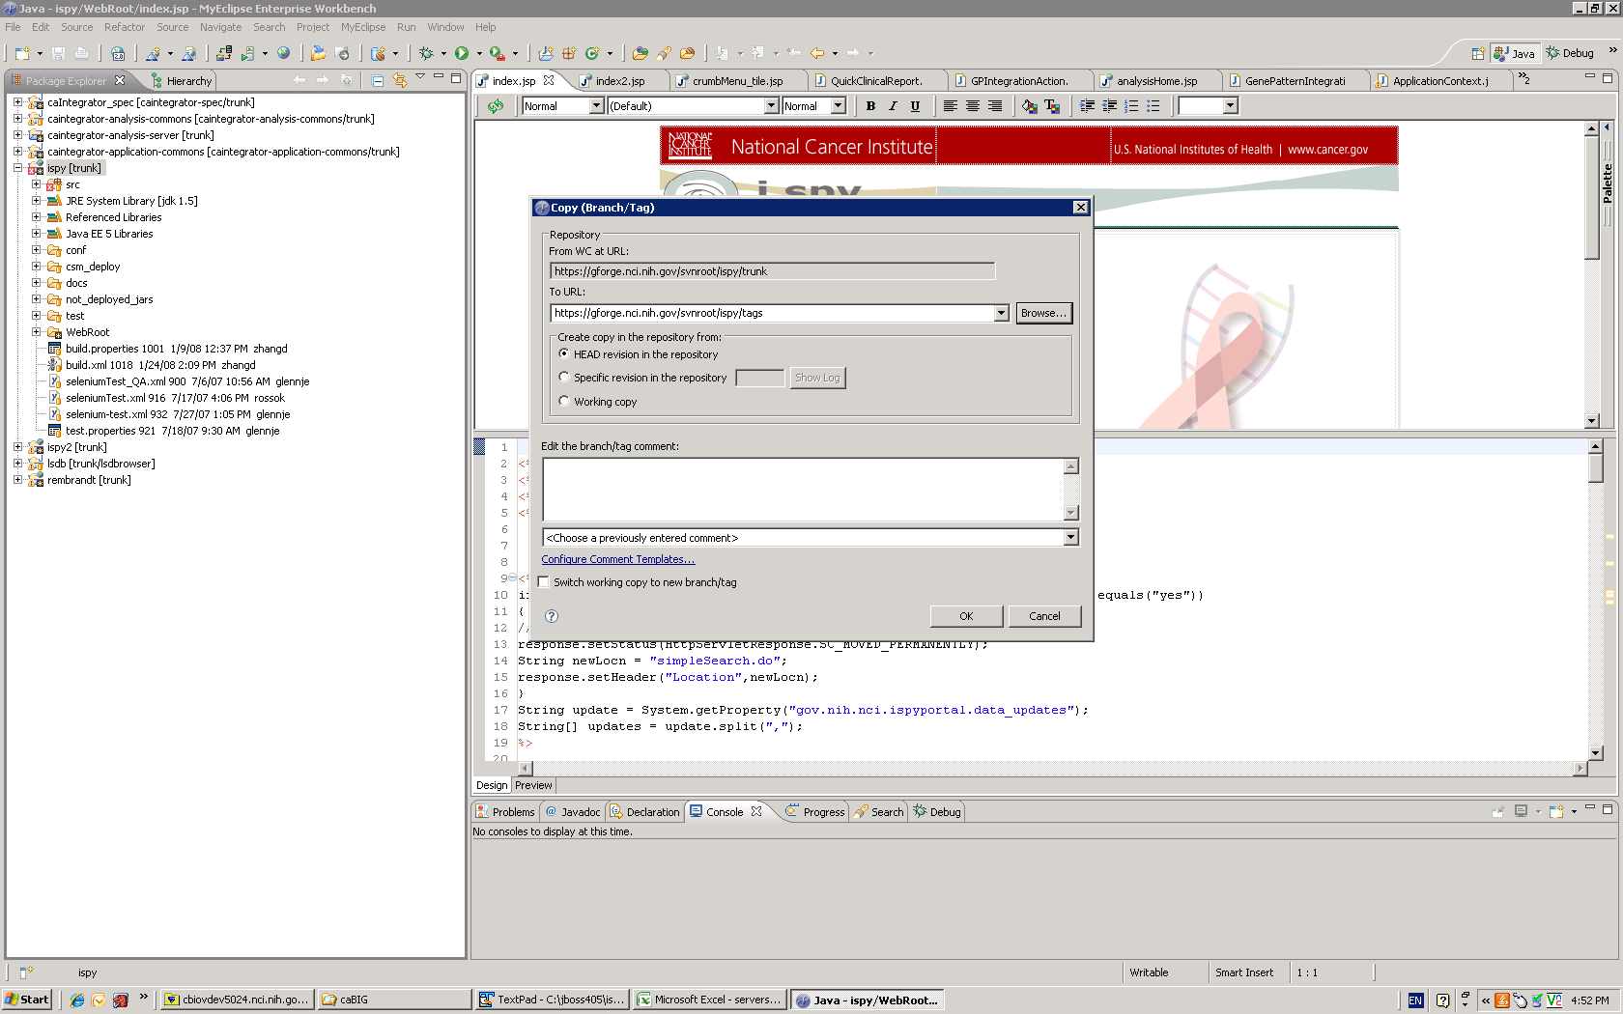

5. Enter a tag name after https://gforge.nci.nih.gov/svnroot/ispy/tags/, click on “OK”

Part K: analysis server info:

Locally in order to access to the analysis server, you must :

- add an exception to your systems’ firewall:
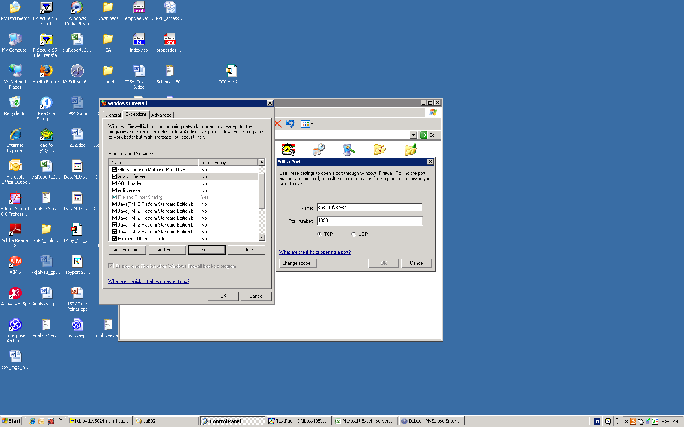

- Analysis servers for dev and local pcs:
a)cbiovdev5024 is served by: cbiovdev5007 and cbiovdev5008.
b) The developer pcs use cbiovdev5009
3. Currently analysis server and gene pattern servers are using the same binary files, this is the location to upload the binary files for analysis server: /local/content/caintegrator/RdataFiles

4. Shuang should be have the logging info and start up scripts
5. Before being able to access the analysis server locally, one needs to create a properties file on the dev 5009 machine, in the /local/content/caintegrator/bin directory, for example: analysisServerDana.properties, with the following information:

# This properties file is to be deployed on the analysis server machine.
###########################################################################
# The location of the jboss instance running JBossMQ
###########################################################################
#jmsmq_location=156.40.128.136:1099

#Dana
jmsmq_location=NCI-zhangd-1.nci.nih.gov:1099

###########################################################################
# The location of the Rembrandt R data file and R function definitions
###########################################################################
RinitializationFile=/local/content/caintegrator/RdataFiles/RFunctions.R

RdataFileDirectory=/local/content/caintegrator/RdataFiles/
################################################################
# Set the request and response queue names

############################################################
analysis_request_queue=queue/SharedAnalysisRequest

#analysis_response_queue=@ANALYSIS_RESPONSE_QUEUE@ (no longer requered since we are now using the JMS replyTo field)

###########################################################################
# Number of Compute Threads - Each compute thread will

# have an initialized Rconnection
###########################################################################
num_compute_threads=1

###########################################################################
# set to TRUE to turn R to echo R statement execution
###########################################################################
debugRcommands=TRUE

###########################################################################
# Number of milliseconds to wait before attempting to re-establish the
# JMS queue connection
###########################################################################
reconnectWaitTimeMS=5000

###########################################################################
# The location of the Rserve instance
###########################################################################
rserve_location=localhost

###########################################################################
# LOG4J Properties
###########################################################################
# Set root logger level to DEBUG and its only appender to A1.
log4j.rootLogger=OFF

log4j.logger.gov.nih.nci.caintegrator=DEBUG,A1

log4j.appender.A1=org.apache.log4j.RollingFileAppender

#log4j.appender.A1.File=analysisServer.log4j
log4j.appender.A1.File=/local/content/caintegrator/log/analysisServerDana.log

log4j.appender.A1.MaxFileSize=1MB
log4j.appender.A1.MaxBackupIndex=5

# A1 uses PatternLayout.
log4j.appender.A1.layout=org.apache.log4j.PatternLayout
#log4j.appender.A1.layout.ConversionPattern=%-4r [%t] %-5p %c %x - %m%n
log4j.appender.A1.layout.ConversionPattern=%d [%t] %-5p %c %x - %m%n

- Check individual analysis server log file: dev 5009’s /local/content/caintegrator/log folder, each person who has the above properties file should have a log file, for example: analysisServerDana.log

Part L: ispy deployement:

jms.jar can’t be included in ispy war file, other wise the application can’t access to the anaylysis server.
Use jbossmq.jar instead in the ${JBOSS_HOME}\server\default\lib

Part M: ispy datasource file:

The data source file is located at: ${JBOSS_HOME}\server\default\deploy\oracle-ds.xml:

With the following information needed to make db connections:

<local-tx-datasource>
<jndi-name>ispycsm</jndi-name>
<connection-url>jdbc:oracle:thin:@cbiodb540.nci.nih.gov:1550:INTM1DEV</connection-url>
<user-name>ispydev</user-name>
<password>ispy2983</password>
<driver-class>oracle.jdbc.driver.OracleDriver</driver-class>
<exception-sorter-class-name>org.jboss.resource.adapter.jdbc.vendor.OracleExceptionSorter</exception-sorter-class-name>
</local-tx-datasource>
<local-tx-datasource>
<jndi-name>ispy</jndi-name>
<connection-url>jdbc:oracle:thin:@cbiodb540.nci.nih.gov:1550:INTM1DEV</connection-url>
<user-name>ispydev</user-name>
<password>ispy2983</password>
<driver-class>oracle.jdbc.driver.OracleDriver</driver-class>
<exception-sorter-class-name>org.jboss.resource.adapter.jdbc.vendor.OracleExceptionSorter</exception-sorter-class-name>
</local-tx-datasource>

Part N: Deployment instructions:

The deployment instructions are located at:

https://gforge.nci.nih.gov/docman/index.php?group_id=203&selected_doc_group_id=1096&language_id=1

Part P: setting up ispy project:

Ispy module is dependent on:

  - caintegrator-analysis-commons
  - caintegrator-spec
  - caintegrator-application-commons
The above 3 are located at:
https://gforge.nci.nih.gov/svnroot/caintegrator

  - ispy: located at : https://gforge.nci.nih.gov/svnroot/ispy

If building ispy using ant scripts, one needs to build them in the order of 1) to 4)

If building ispy using myEclipse, one needs to build 1), then set 2)’s dependency on 1), then build 3) , set 3)’s dependency on 1) & 2)
When building ispy, set 4)’s dependency on 1), 2), & 3)

Clinic Data Update (April 21, 2010)

Data Preparation
- Move the following files to the directory:
[jboss44@cbiovdev5024 qa_2010]$
/local/home/jboss-cgems/temp/qa_2010/

ACRIN6657_Mammo_08-01-15.xls
IntegratedClinicData_Feb_2010.xls
I-SPY.BAC.CGH.Baseline.N59.xls
DataDictionaryIntegratedDataJan2010.doc
ISPY_BAC_CBS_N59.xls
Path_Variables_10_18_7.doc

- Create jar file:
$ jar -cf ISPYPortalDataFile_04-20-2010.jar *

- Move the following files to the directory,
/local/home/jboss-cgems/temp/qa_2010/property_files/

ispy_patient_data_02-2010.txt
ispyportal.properties

- Modify the file, ispyportal.properties
gov.nih.nci.ispyportal.patient_data=ispy_patient_data_02-2010.txt

gov.nih.nci.ispyportal.data_updates=Clinical Data Feb. 2010,Agilent 5/22/07,cDNA 5/17/07

- Create a jar file in the dir: /local/home/jboss-cgems/temp/qa_2010/property_files/

jar –cf ISPYPortalPropertiesFile_04-20-2010_QA.jar *

- Move ISPYPortalDataFile_04-20-2010.jar and ISPYPortalPropertiesFile_04-20-2010_QA.jar to the “ftp_auth/ISPY-ANALYSIS-PORTAL” directory of the ftp site:

ftp://ncicbftp2.nci.nih.gov
login: caintegratorftp

- Update data links in crumbMenu_tile.jsp
- Update column names and column token order in ClinicFileBasedQueryService.jar and PatientData.java

