Use Cases Document

I-SPY Analysis Portal

caIntegrator Project

July 21, 2006

Software Requirements Specification

I-SPY Analysis Portal
NCICB

DOCUMENT REVISION HISTORY
Version Number | Date | Contributor | Description
1.0 | 07/21/2006 | Michael Harris | Draft

Background/Summary
The objective of the I-SPY portal project is to give the I-SPY investigators a web-based portal to access and perform statistical analysis on the experimental data generated by the I-SPY clinical trial. I-SPY is a breast cancer clinical trial that is investigating the efficacy of neoadjuvant chemotherapy prior to surgery. The I-SPY portal project will provide the study researchers with a platform to visualize and explore the study data. The ultimate goal of the project is to identify a set of biomarkers that will predict response to therapy.

Table of Contents

Software Requirements Specification 2
I-SPY Analysis Portal 2
Background/Summary 2
1 Introduction 4
1.1 Overview 4
1.2 Related Documents 4
2 Actors 4
3 Use Cases 5
1.1.1 Clinical Query Use Case 6
1.1.2 Clinical Query Wireframe 7
1.2 View Images in NCIA System Use Case 8
1.3.1 Query FISH Data Use Case 9
1.3.2 FISH Query Wireframe 9
1.4.1 Query IHC Data Use Case 10
1.4.2 IHC Wireframe 11
1.5.1 P53 Data Query Use Case 12
1.5.2 P53 Wireframe 13
1.6.1 Correlative Graphs Use Case 14
1.6.2 Correlative Graph Wireframes 15
4 Approval 16

Introduction

Overview
This document serves as a requirements document for the I-SPY Analysis Portal Project. Requirements are listed in the form of Use Cases which are widely used and a useful mechanism to discover and record functional requirements. The system is intended to be a platform for researchers to query the clinical and genomic data associated with the project and to be able to perform on-the-fly statistical analysis to identify novel biomarkers.

Related Documents

Document Name | Version | Location
I-SPY Analysis Portal Project Plan | 1.1 | L:\caIntegrator\Project Plan\ISPY.mpp

2 Actors
An actor is a person, organization or external system that plays ac role in one or more interaction with the I2 imaging system. The following is a list of Actors that interact with the system:
Researcher This is the end user that will be using the I-SPY Analysis Portal to explore and perform analysis on the study data.
AnalysisServer The AnalysisServer is a software system used to perform on-the-fly statistical calculations on the study data.

3 Use Cases

The use cases for the I-SPY analysis portal can be organized as shown in the following diagram. Once a researcher logs into the system, he/she is able to perform queries on the study data, save custom lists, and perform statistical analysis on data using the custom lists. To avoid clutter in the diagram, associations between the list management use case and the query and analysis use case are omitted. Every query use case allows the user to save custom lists of patients or genes via the list management module. The all of statistical analysis use cases can utilize these custom lists to create input to the statistical methods. The NCIA Image View use case extends the clinical query use case and will be described in more detail below.

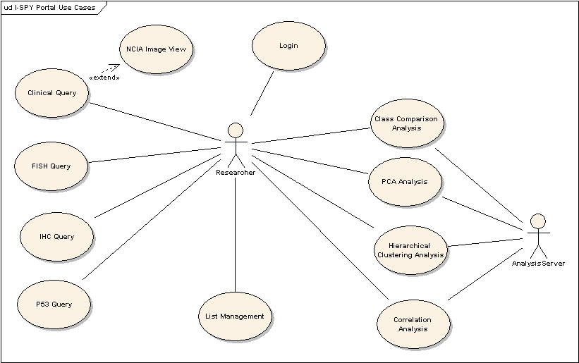
1.1.1 Clinical Query Use Case
Use Case Name | Perform Clinical Query
Use Case ID | 1.1
Primary Actor | Researcher
Trigger | Researcher wants to define a custom list of patients based on one or more clinical parameters.
Pre-conditions | Researcher is logged into the system.
Flow of Events | 1) The researcher selects a specific group of patients or selects all patients  2) The researcher selects query parameters for one or more of: disease stage, histology type, nuclear grade, treatment agents, clinical response, tumor diameter, MRI % change, ER status, PR status, and HER2 status  3) The researcher submits the query.  4) The researcher views the clinical report.  5) The researcher saves a subset of patients in the report as a list for use in subsequent queries.
Post-Conditions | Any patient lists saved are available for use in subsequent queries.
Extension | Researcher views image data corresponding to a specific patient in the NCIA system by clicking the view image link on the clinical report.
Related Use Case | User Login, View images in NCIA system.

1.1.2 Clinical Query Wireframe
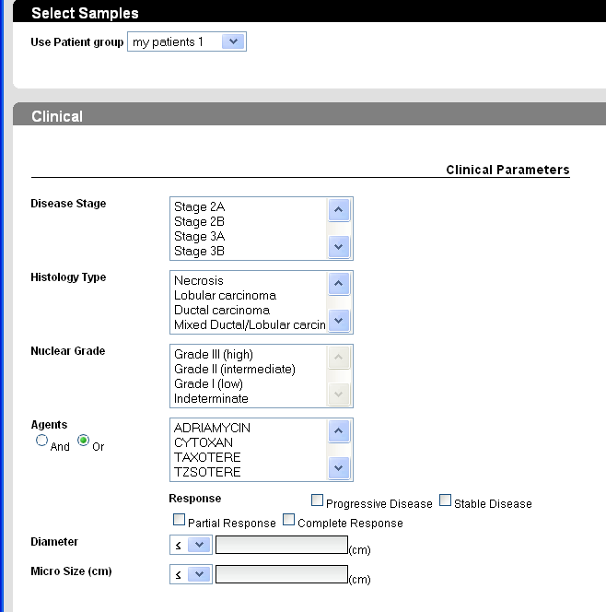
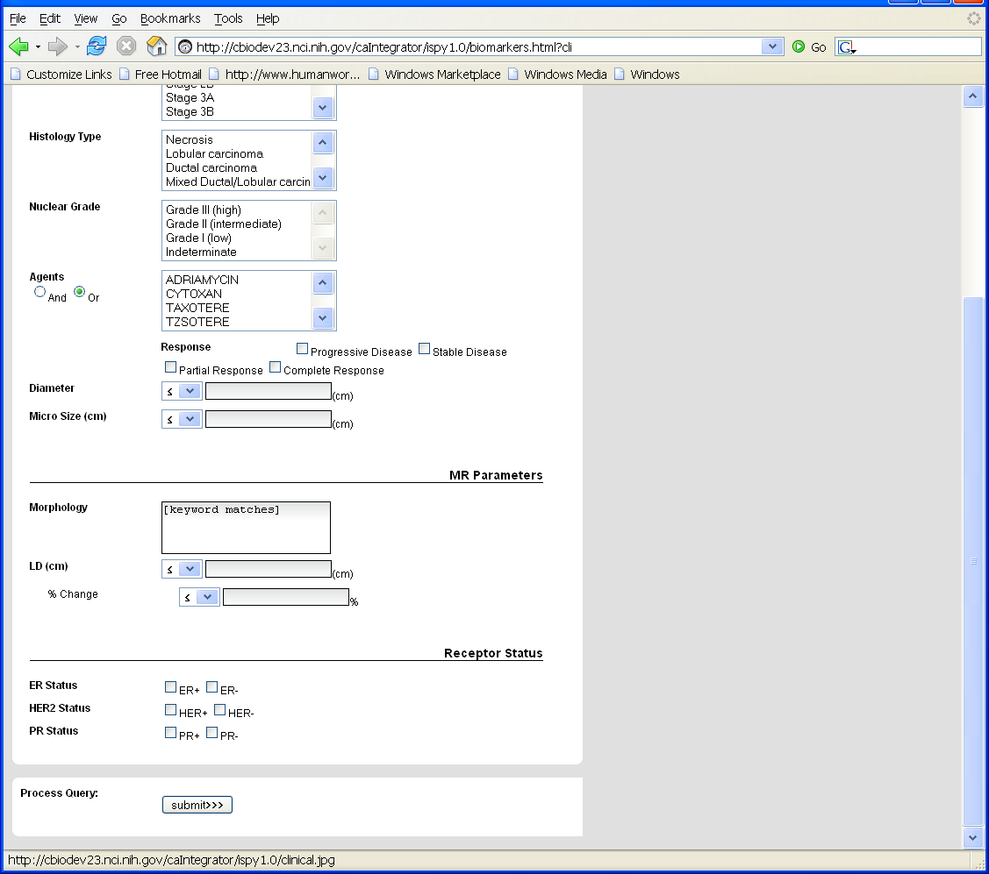

View Images in NCIA System Use Case

Use Case Name | View Images in NCIA System
Use Case ID | 1.2
Primary Actor | Researcher
Trigger | Researcher is viewing a clinical report and wants to investigate image data for a particular patient.
Pre-conditions | Researcher is logged into the system.  Researcher has produced a clinical report either as the result of a clinical query or from the PCA or Hierarchal Clustering HOA reports.
Flow of Events | - Researcher selects the image link from the clinical report for the patient of interest.  - The researcher is directed to the NCIA page which will display pre and post treatment images for the patient of interest along with clinical information such as longest diameter percent change.
Post-Conditions | Any patient lists saved are available for use in subsequent queries.
Alternate Flow of Events | If the researcher is viewing images for the first time in the NCIA system then the researcher must log in to the NCIA system. The researcher will only be required to login to the NICA system once for a given session.
Related Use Case | Login, See the view ISPY images use case for the NCIA system.

1.3.1 Query FISH Data Use Case

Use Case Name | Query FISH Data
Use Case ID | 1.3
Primary Actor | Researcher
Trigger | Researcher wants to investigate FISH data or define a custom list of patients based on FISH data.
Pre-conditions | Researcher is logged into the system.
Flow of Events | 1. Researcher navigates to the FISH query page  - Researcher specifies a group of patients to use for the query and selects an available biomarker (TOPO2 and/or ERBB2) and selects one or more CNA status values (amplified, deleted, or unchanged)  - Researcher selects a time point of interest  - Researcher executes the query and views the returned FISH report  - Researcher selects patients of interest from the report and saves them as a custom list to be used in subsequent queries.
Post-Conditions | Any patient lists saved are available for use in subsequent queries.
Related Use Case | Login

1.3.2 FISH Query Wireframe
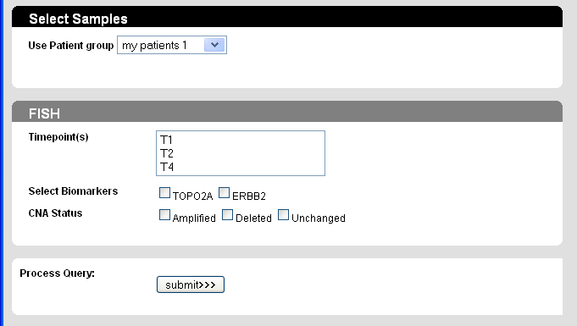

1.4.1 Query IHC Data Use Case

Use Case Name | Query IHC Data
Use Case ID | 1.4
Primary Actor | Researcher
Trigger | Researcher wants to investigate IHC data
Pre-conditions | Researcher is logged into the system.
Flow of Events | 1.Researcher navigates to the IHC query page  2. Researcher selects a custom patient list or selects all samples.  3. Researcher selects a specific time point or all time points.  4. Researcher selects biomarker(s) of interest.  5. Researcher selects specific values for: Intensity of Stain, Localization of Stain, Percent Positive, Distribution of Stain, and Result Code  6. Researcher runs the query and views the resulting report.  7. Researcher selects patients of interest from the report and saves them as a custom list to be used in subsequent queries.
Post-Conditions | Any patient lists saved are available for use in subsequent queries.
Related Use Case | Login

1.4.2 IHC Wireframe
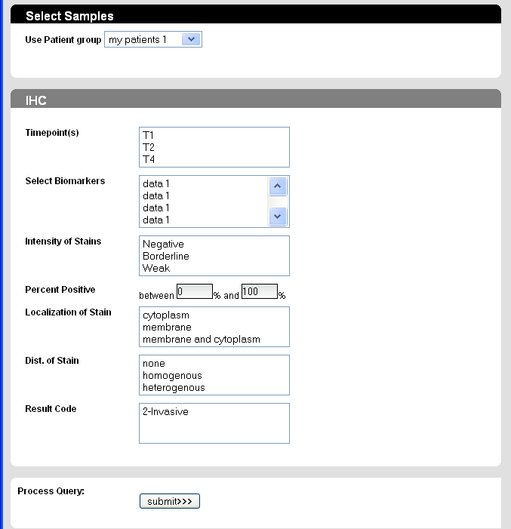

1.5.1 P53 Data Query Use Case

Use Case Name | Query P53 Data
Use Case ID | 1.5
Primary Actor | Researcher
Trigger | Researcher wants to investigate P53 data or define a custom list of patients based on P53 data.
Pre-conditions | Researcher is logged into the system.
Flow of Events | 1. The researcher navigates to the P53 data query page.  - The researcher chooses a custom patient list or decides to use all patients.  - The researcher specifies mutation status, location, functional effect, functional domain, and amino acid change.  - The researcher submits the query and views the report.  - The researcher saves the patients listed in the report as a custom list for use in subsequent queries.
Post-Conditions | Any patient lists saved are available for use in subsequent queries.
Related Use Case | Login

1.5.2 P53 Wireframe

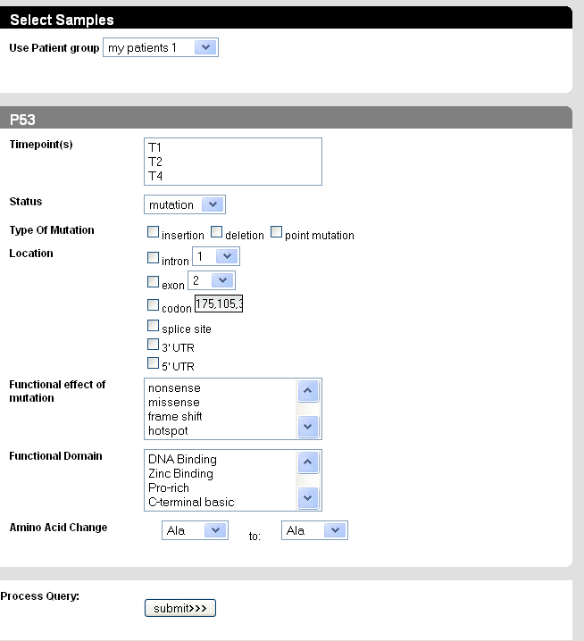

1.6.1 Correlative Graphs Use Case
Use Case Name | View Correlative Graphs
Use Case ID | 1.6
Primary Actor | Researcher
Trigger | Researcher wants to investigate the relationship between two continuous valued clinical or genomic variables.
Pre-conditions | Researcher is logged into the system.
Flow of Events | 1. The researcher navigates to the High Order Analysis Page and selects correlation.  - The researcher selects two continuous valued variables.  - A graph is drawn representing the correlation between the two variables.  - The researcher can save patients from the report (for example, interesting outliers) in a custom list for further investigation.
Post-Conditions | Any patient lists saved are available for use in subsequent queries.
Related Use Case | Login

1.6.2 Correlative Graph Wireframes

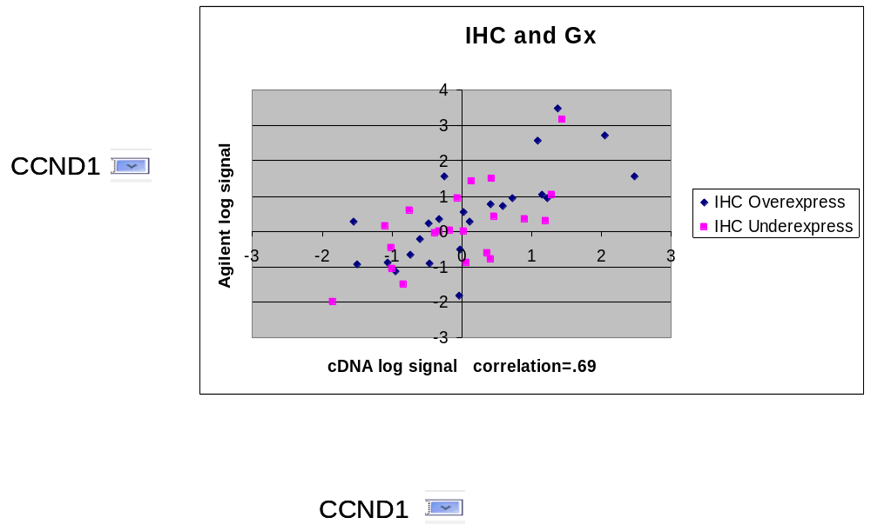

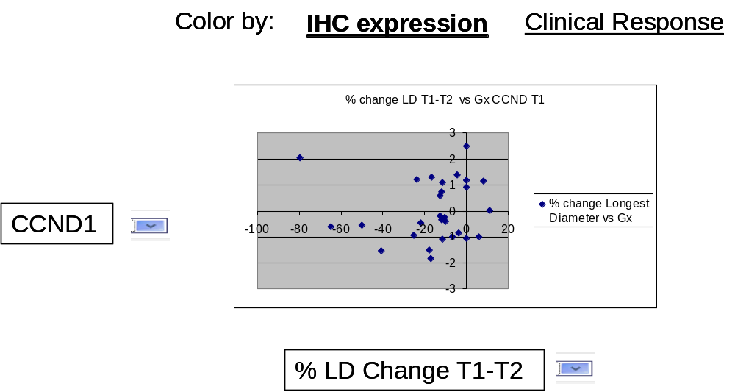

1.6.3 GenePattern Analysis Use Case
Use Case Name | View Correlative Graphs
Use Case ID | 1.6
Primary Actor | Researcher
Trigger | Researcher wants to analyze their data through GenePattern Integration
Pre-conditions | Researcher is logged into the system.
Flow of Events | - The researcher navigates to the High Order Analysis Page and selects GenePattern Analysis.  - The researcher selects  a). Group and Time Points.  b). Filtering Genes/Reporters.  c). Array Platform.  - Click GenePattern Job XXX (when it’s completed) to launch GenePattern.  - Two files (.gct and .cls) will show in Recent Jobs.  - Impute missing values using ImputeMissingValues.KNN  - Run CMS.pipeline, HC.pipeline and KNN.pipeline using imputed .gct +/- .cls file
Post-Conditions | Any results are available for user to download or visualize using GenePattern visualizer modules
Related Use Case | Login

4 Approval

Workspace General Contractor Rep Print Name Date
Architecture Workspace Rep Print Name Date
VCDE Workspace Rep Print Name Date
Workspace Working Group Rep Print Name Date
NCICB Rep Print Name Date

