Application and Submitter Information
Submitted by  (name & phone #) |  |  | Shuang Cia  301-594-0901 | Date | 07/29/2009
Application name |  |  | ispy | Version number | 1.5.1
Government sponsor  (name & phone #) |  |  | Shine Jacobs  301.443.6135 | QA approval  (name & phone #) | Ujala Kapoor  301-443-6253
NCICB Build and Deployment Policies |  |  | Policy Documents https://gforge.nci.nih.gov/docman/index.php?group_id=27&selected_doc_group_id=84&language_id=1  Forms and Templates  https://gforge.nci.nih.gov/docman/index.php?group_id=27&selected_doc_group_id=317&language_id=1  Submitter has read all relevant policy and procedures documents available via the links above, and affirms that this deployment request and all supporting documentation and scripts is in conformance with them.  __No  _X_Yes
Build Information
Subversion module | Module : caintegrator-analysis-commons  Module : caintegrator-spec  Module : caintegrator-application-commons  Module : ispy |  |  | Tag to build | ISPY_RC2_11JUNE2009
Associated change request(s)
Changes to build instructions | __ No  _X_ Yes [updated build instructions must be provided; please note that if these changes have not been previously discussed there may be a delay in performing this deployment.]
Link to build instructions
Changes to deployment instructions | __ No  _X_ Yes [updated deployment instructions must be provided; please note that if these changes have not been previously discussed there may be a delay in performing this deployment.]
Link to deployment instructions
Database update necessary | _X_ No  __ Yes [database deployment request form is required]
Link to database deployment supporting materials
Step 1. ispyportal.properties file and new clinical and pathological data file

Go to the directory.. /local/content/ispyportal/config of the stage server, rename the existing ispyportal.properties to ispyportal.properties_old.
Next, transfer the file: ISPYPortalPropertiesFile_07282009_stage.jar
from the ISPY-ANALYSIS-PORTAL directory of the ftp site:
ftp://ncicbftp2.nci.nih.gov
login: caintegratorftp
into the directory ../local/content/ispyportal/config and extract it using the command: jar –xvf ISPYPortalPropertiesFile_07282009_stage.jar

There should be 2 files extracted from the ISPYPortalPropertiesFile_07282009_stage.jar
- ispyportal.properties
- ispy_patient_data_04-2009.txt

Next, move the file, ispy_patient_data_04-2009.txt , to the directory, /local/content/ispyportal/data/.

Remove the file ISPYPortalPropertiesFile_07282009_stage.jar from the ../local/content/ispyportal/config directory.

You may need to set the server name and the port number marked in yellow to the correct value for the JNDI port in the new /local/content/ispyportal/config/ispyportal.properties file.

gov.nih.nci.ispyportal.jms.jboss_url=localhost:1099
gov.nih.nci.caintegrator.gp.server=http://cbiovdev5010.nci.nih.gov:58080/

Additional deployment instructions |  | Step 2. ispy.war deployment  1) Deploy the ispy.war file to the stage server.  2) Before restarting the jboss, do the following:  go to ${jboss_home} /server/default/deploy directory, modify the following lines for ispycsm and ispy datasource like indicated below in the oracle-ds.xml file:  <local-tx-datasource>  <jndi-name>ispycsm</jndi-name>  <connection-url>jdbc:oracle:thin:@cbdb-s1001.nci.nih.gov:1550:INTM1STG</connection-url>  <user-name>ispystg</user-name>  <password>wer32kd#9</password>  <driver-class>oracle.jdbc.driver.OracleDriver</driver-class>  <exception-sorter-class-name>org.jboss.resource.adapter.jdbc.vendor.OracleExceptionSorter</exception-sorter-class-name>  </local-tx-datasource>  <local-tx-datasource>  <jndi-name>ispy</jndi-name>  <connection-url>jdbc:oracle:thin:@cbdb-s1001.nci.nih.gov:1550:INTM1STG</connection-url>  <user-name>ispystg</user-name>  <password>wer32kd#9</password>  <driver-class>oracle.jdbc.driver.OracleDriver</driver-class>  <exception-sorter-class-name>org.jboss.resource.adapter.jdbc.vendor.OracleExceptionSorter</exception-sorter-class-name>  </local-tx-datasource>  Step 3. Testing the application  The following will test the new p53 query.  Step 1) Use your LDAP login and password to log in for testing of the application by logging to: https://caintegrator-stage.nci.nih.gov/ispy/  Step 2) Click “Search” tab  Step 3) Click on the “p53 Query” button. Under the Name Analysis Result section, type: p53. Now click on the Submit button  Step 4) You should now be taken to the View Results page.
Click on the underlined p53 once the status is set to complete. You should now see a report page.

The following will test the gene pattern functionality.
Step 1) Use your LDAP login and password to log in for testing of the application by logging to: https://caintegrator-stage.nci.nih.gov/ispy/
Step 2) Click “High Order Analysis” tab
Step 3) Click on the “Send the Data to Gene Pattern” button. Select T1 and T2 under “Select 1 or More Time Points”, the move both T1, T2 to the “Selected Groups” box using the arrows on the page with following 2 things in it:

a) Complete ResponseT1_T2---T1
b) Complete ResponseT1_T2---T2

Under the Name Analysis Result section, type: gp. Now click on the Submit button
Step 4) You should now be taken to the View Results page. Click on the underlined gp once the status is set to complete. You should now see a report page.

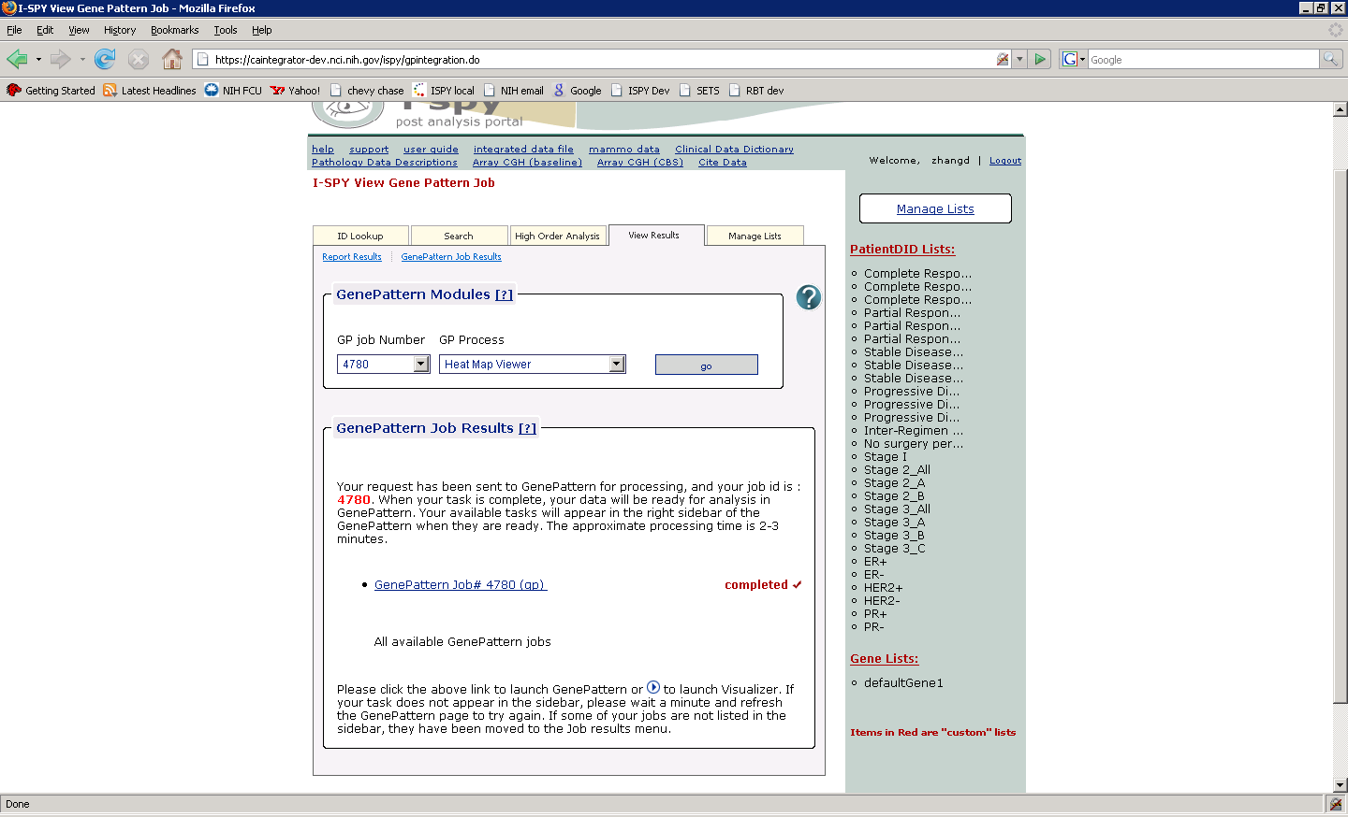

Click on the button “go”, following the instructions, then wait for a few seconds, you should see a heap map displayed.

Proposed deployment
to staging
Requested Date |  | July 27th, 2009
Approval For Promotion to Production
Approved by
Proposed deployment to production
Requested Date

