Deployment specific instructions to accompany every deployment request.
Application and Submitter Information
Author Name & Phone # |  | Shuang Cai  301 594 0901 | Date | 06/03/2010
Application / Product Name |  | ISPYPORTAL | Version Number | 1.5.2
Government Sponsor Name & Phone # |  | Anand Basu | QA Sponsor Name & Phone # | Madhavi Kambampati  301-443-6254
General Information (all information beyond this point is optional unless noted “Required”, leave the field blank if it does not apply to the product)
Background | References for additional information if needed by the deployment team. For example, Gforge documentation URL, Design Document URL, etc.
Hardware | Operating System: (select one)  Solaris  x Linux  Minimum Required dedicated RAM: 2 GB  This allows the Systems Group to maximize hardware use while achieving application performance goal
JBoss | (select one)  JBoss 4.0.2 / Tomcat -5.5.9 / JDK 1.5.0_04  X JBoss 4.0.4 / Tomcat -5.5.17 / JDK 1.5.0_06  __ JBoss 4.0.5 / Tomcat -5.5.20 / JDK 1.5.0_10 (Future Stack)  Other: (please specify)
CaGRID | (select one)  caGRID 1.0 Security Enable (Globus 4.0.3/Tomcat-5.0.28)  caGRID 1.0 (Globus 4.0.3/Tomcat-5.0.28)  Other: (please specify)
Database | (select one)  Oracle 9.2.0.6 (on Solaris) X Oracle 10.x (on Linux)  MySQL 4.1.19 MySQL 5.0.27 (Future)  PostgreSQL 8.1.3 PostgreSQL 8.2.1 (Future)  Other: (please specify)
External Dependencies | caIntegrator Analysis Server  Gene Pattern Server  caArray Java API
FTP | Explain the FTP environment needed. Include secure/non-secure requirements, space allocation, estimated growth rate and file retention period.
Deployment Units
Archive files |  | ispy.war
JBoss Property File Updates
Other Configuration Files |  | Gene pattern server URL  Please see Setup & Configure Externalized Properties section
Configuration Directives
Container Configuration |  | JAVA_OPTS="-server -Xms2048m -Xmx2048m -XX:ThreadStackSize=128 -XX:SurvivorRatio=10 -XX:PermSize=128m -XX:MaxPermSize=128m -Dsun.rmi.dgc.client.gcInterval=3600000 -Dsun.rmi.dgc.server.gcInterval=3600000 -Djava.awt.headless=true"
Logging
External Datasource |  | Configure oracle-ds.xml for ispy and ispycsm.  Note the jdbc:url, user name and password should be same as in the externalized properties section below  Copy the following contents in to ${JBOSS_INSTANCE}/deploy/oracle-ds.xml  <local-tx-datasource>  <jndi-name>ispycsm</jndi-name>  <connection-url>jdbc:oracle:thin:@cbdb-s1001.nci.nih.gov:1550:INTM1STG</connection-url>  <user-name>ispystg</user-name>  <password>wer32kd#9</password>  <driver-class>oracle.jdbc.driver.OracleDriver</driver-class>  <exception-sorter-class-name>org.jboss.resource.adapter.jdbc.vendor.OracleExceptionSorter</exception-sorter-class-name>  </local-tx-datasource>  <local-tx-datasource>  <jndi-name>ispy</jndi-name>  <connection-url>jdbc:oracle:thin:@cbdb-s1001.nci.nih.gov:1550:INTM1STG</connection-url>  <user-name>ispystg</user-name>  <password>wer32kd#9</password>  <driver-class>oracle.jdbc.driver.OracleDriver</driver-class>  <exception-sorter-class-name>org.jboss.resource.adapter.jdbc.vendor.OracleExceptionSorter</exception-sorter-class-name>  </local-tx-datasource>
Authentication Module (e.g. JAAS) |  | See section JBoss Property File Updates
Java Message Service (JMS)
Properties-services
Setup & Configure Externalized Properties |  | Step 1. ispyportal.properties file and new clinical and pathological data file  Go to the directory.. /local/content/ispyportal/config of the stage server, rename the existing ispyportal.properties to ispyportal.properties_old.  Next, transfer the file: ISPYPortalPropertiesFile_04-20-2010_QA.jar  from the ISPY-ANALYSIS-PORTAL directory of the ftp site:  ftp://ncicbftp2.nci.nih.gov  login: caintegratorftp  into the directory ../local/content/ispyportal/config and extract it using the command: jar –xvf ISPYPortalPropertiesFile_04-20-2010_QA.jar  There should be 2 files extracted from the ISPYPortalPropertiesFile_04-20-2010_QA.jar  - ispyportal.properties  - ispy_patient_data_02-2010.txt  Next, move the file, ispy_patient_data_02-2010.txt, to the directory, /local/content/ispyportal/data/.  Remove the file ISPYPortalPropertiesFile_04-20-2010_QA.jar from the /local/content/ispyportal/config directory.  You may need to set the server name and the port number marked in yellow to the correct value for the JNDI port in the new /local/content/ispyportal/config/ispyportal.properties file.  gov.nih.nci.ispyportal.jms.jboss_url=localhost:1099  gov.nih.nci.caintegrator.gp.server=http://caintegrator-stage.nci.nih.gov/  Step 2. ispy.war deployment  1) Deploy the ispy.war file to the stage server.
CSM Configuration
CSM Configuration
UPT Configuration
Standalone modules or scripts
Automated Scripts |  | Identify automated scripts needed to process external tasks. Include frequency to be run, intended location, script dependencies, output files, temporary directory locations, etc.
Manual Scripts |  | Identify manual scripts needed to process any TAR or ZIP file included in the “Deployment Units” section above.
Dependencies and Children
Database Dependency |  | Is there a database component for this deployment?  Yes  x No  If Yes, provide instructions in the sections below.
APIs and Services |  | CBIIT Services required for this application: (select all that apply).  x version 4.0 CSM (specify version)  RMI (explain)  caCORE API (specify version)caBIO 3.1  EVS Services (explain)  x Analysis Services (explain) caintegrator analysis server  caGRID Framework (explain)  x Other (please specify) cArray Java API , Gene Pattern Server
Child services |  | Identify other applications or services dependant on this deployment. This exposes the deployment environment and potential impact of restarts. Identify static connection dependencies which may require child services restart, for example, RMI server and webServices, or R servers and Portal.
System Interaction Details
Cache |  | Any caching mechanism used, the directory required for cache, if this directory must exist in advance or if application creates it, expiration details of cache mechanism and cleaning strategy for cache, e.g. EHCache.  Ehcache  Please see Setup & Configure Externalized Properties section
Hibernate ( ORM ) |  | Please see External Datasource section for oracle-ds.
File System
Mail Forwarding
Grid Services
Grid Details |  | Service offered, grid version, grid dependencies.
Detailed Instructions
EAR, WAR, JAR, TAR and ZIP Deployment |  | ispy.war
RMI |  | Detailed procedure for deployment of RMI services.
Database Interaction |  | Please coordinate with DB team to deploy the ISPY DB with the application.
File Copy
Web Server Configuration
DNS Entries |  | Dev, QA, Stage, and Production host names to be registered in DNS.
Apache |  | Apache configuration or redirection, e.g. options, aliases, mime-types, logs, reports, HTML file types, Index files, etc.
SSL |  | Encrypting session data is strongly encouraged when using authentication mechanisms with real user credentials.
Single Sign On |  | Provide details when using NIH Single Sign On services.
Test Cases
Pre Deployment Tests |  | Tests to perform before deployment to assure normal application/product operations. These tests are used in the event a deployment roll-back is necessary. Also strongly encouraged when different than the post-deployment tests.  The tests may be written in a separate document provided it is placed in a location accessible to the deployment team, preferably on GForge.
Post Deployment Tests  Required |  | The following will test the new p53 query.  Step 1) Use your LDAP login and password to log in for testing of the application by logging to: https://caintegrator-stage.nci.nih.gov/ispy/  Step 2) Click “Search” tab  Step 3) Click on the “p53 Query” button. Under the Name Analysis Result section, type: p53. Now click on the Submit button  Step 4) You should now be taken to the View Results page.  Step 5) Click on the underlined p53 once the status is set to complete. You should now see a report page.  The following will test the new gene pattern functionality.  Step 1) Use your LDAP login and password to log in for testing of the application by logging to: https://caintegrator-stage.nci.nih.gov/ispy/  Step 2) Click “High Order Analysis” tab  Step 3) Click on the “Send the Data to Gene Pattern” button. Select T1 and T2 under “Select 1 or More Time Points”, the move both T1, T2 to the “Selected Groups” box using the arrows on the page with following 2 things in it:  a) Complete ResponseT1_T2---T1  b) Complete ResponseT1_T2---T2  Under the Name Analysis Result section, type: gp. Now click on the Submit button  Step 4) You should now be taken to the View Results page. Click on the underlined gp once the status is set to complete. You should now see a report page.  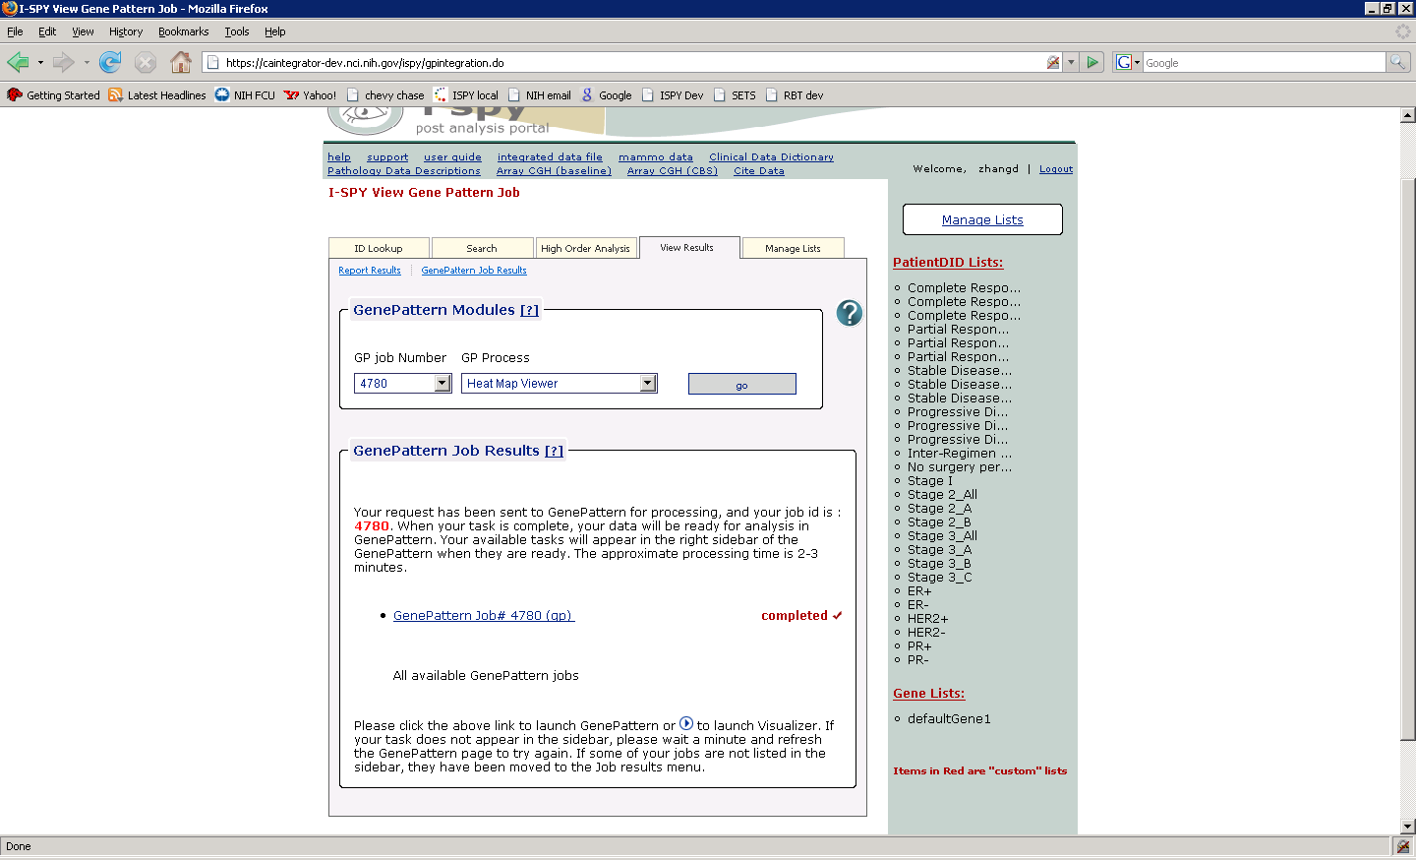  Click on the button “go”, following the instructions, then wait for a few seconds, you should see a heap map displayed.

