The current SuiteBroadcaster channel implementation has the following problems:
- Nearly all of the broadcasting, aggregation, and transaction/rollback code is contained in the JavaScript MirthConnect scripts. This makes it difficult to test.
- The InvocationStrategy code has dependencies on caGrid. We cannot have any caGrid depenencies in our implementation.
- The MirthConnection channel has destinations that are not relevant to the TRANSCEND integration.

To address these problems we will:
- Implement broadcasting, aggregation, and transaction logic as testable Java components.
- Re-implement the InvocationStrategy code to remove caGrid dependencies.
- Implement a new MirthConnect channel that has only TRANSCEND-related channels.

The MirthConnect channel will be called MessageBroadcasterChannel. Figure 1 depicts its structure.

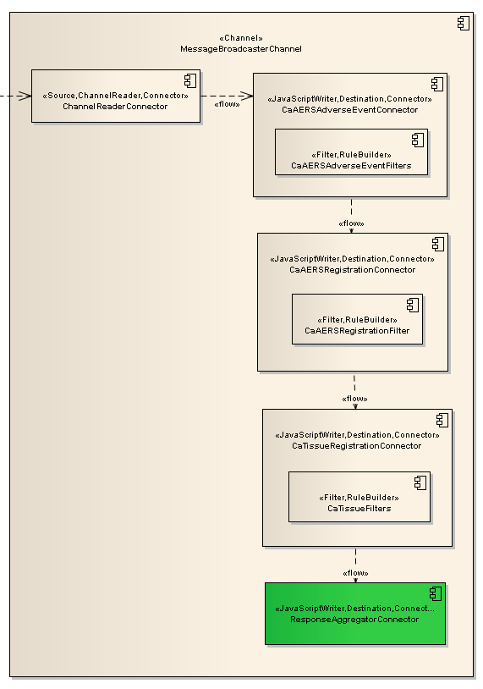
Figure 1: MessageBroadcasterChannel components.

The MessageBroadcasterChannel components include:
- ChannelReaderConnector: Receives iHub messages from MirthConnect. The current Suite iHub message format will be used.
- CaAERSAdverseEventConnector: Responsible for sending adverse event messages to caAERS. <Will be elaborated later.>
- CaAERSRegistrationConnector: Responsible for sending registration messages to caAERS. The CaAERSRegistrationFilters will be used to select only registration messages.
- CaTissueRegisrationConnector: Responsible for sending registration messages to caTissue. The CaTissueFilters will be used to select only registration messages.
- ResponseAggregatorConnector: Responsible for aggregating responses from the caAERS and caTissue connector components and implementing transactions/rollback.
The MirthConnect channels will delegate most of the work to Java components. The primary purpose of the channels will to be support configuration and message routing.

Figure 2 depicts the Java components that will be used by the channels.

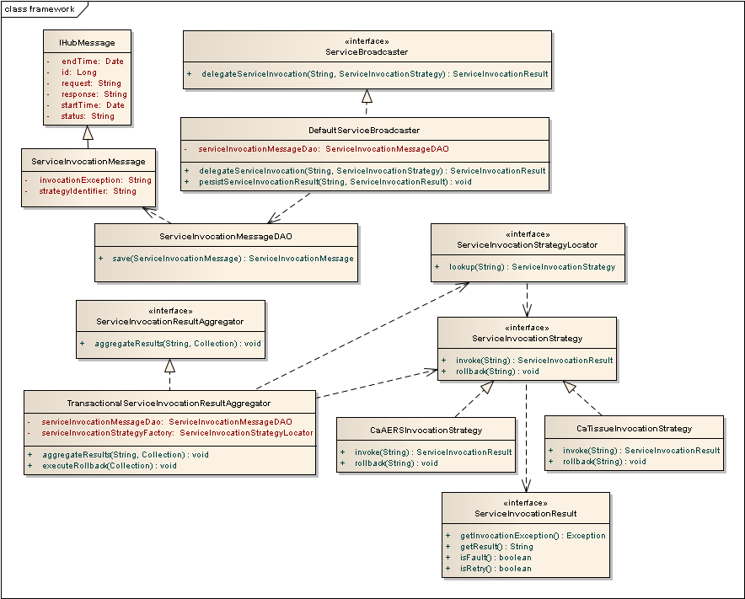
Figure 2: Java components used by MessageBroadcasterChannel.

- IHubMessage: Represents the message that is sent to iHub. This will be persisted (using Hibernate) and used to pass back the ultimate response to the caller. The current iHub implementation saves messages to the MESSAGE table, but includes additional information (e.g. SCHEMA_DEFINITION) that is not needed for the TRANSCEND integration (which doesn’t use caGrid technologies).
- ServiceInvocationMessage: Represents the message that is sent to a target service. This will also be persisted and used in the response aggregation component.
- IHubMessageDAO (not shown): Responsible for persistence of IHubMessage objects.
- ServiceInvocationMessageDAO: Responsible for persistence of ServiceInvocationMessage objects.
- ServiceInvocationStrategy: Represents the logic necessary to invoke a single operation of a service AND also rollback the effects of that operation. Implementations of this interface may contain logic to invoke more than one operation. The invoke and rollback operations both take the XML request message.
- ServiceInvocationStrategyLocator: Responsible for locating a ServiceInvocationStrategy, given a strategy identifier.
- DefaultServiceInvocationStrategyLocator: Implementation of ServiceInvocationStrategyLocator that uses Spring to locate singleton-scoped implementations of ServiceInvocationStrategy by bean name, where bean name is the strategy identifier.
- ServiceBroadcaster: Responsible for doing iHub work that must be done prior to and post calling the invoke operation of the given ServiceInvocationStrategy.
- DefaultServiceBroadcaster (not shown): Implementation of ServiceBroadcaster that uses ServiceInvocationResultDAO to persist the result of the service invocation to the ServiceInvocationMessage that is associated with the given messageID, which identifies the IHubMessage object. The “retry” logic in this component should be the same as the current delegateSingleTargetRequest global template operation – the number of retries should be configurable per strategy identifier.
- ServiceInvocationResultAggregator: Responsible for aggregating the results of a service broadcast. The aggregate operation takes the IHubMessage messageID and a collection of strategy identifiers.
- TransactionalServiceInvocationResultAggregator: An implementation of ServiceInvocationResultAggregator that will aggregate responses by periodically querying the database until it finds either all service invocation responses or some (configurable) timeout period has elapsed. If any service invocation response is an error or timeout, it will initiate a rollback – calling the rollback operation each ServiceInvocationStrategy. It will obtain references to ServiceInvocationStrategies using the ServiceInvocationStrategyLocator.

Figure 3 depicts the sequence of operations involved in propagating a registration message to caAERS and caTissue, and then rolling back that operation.

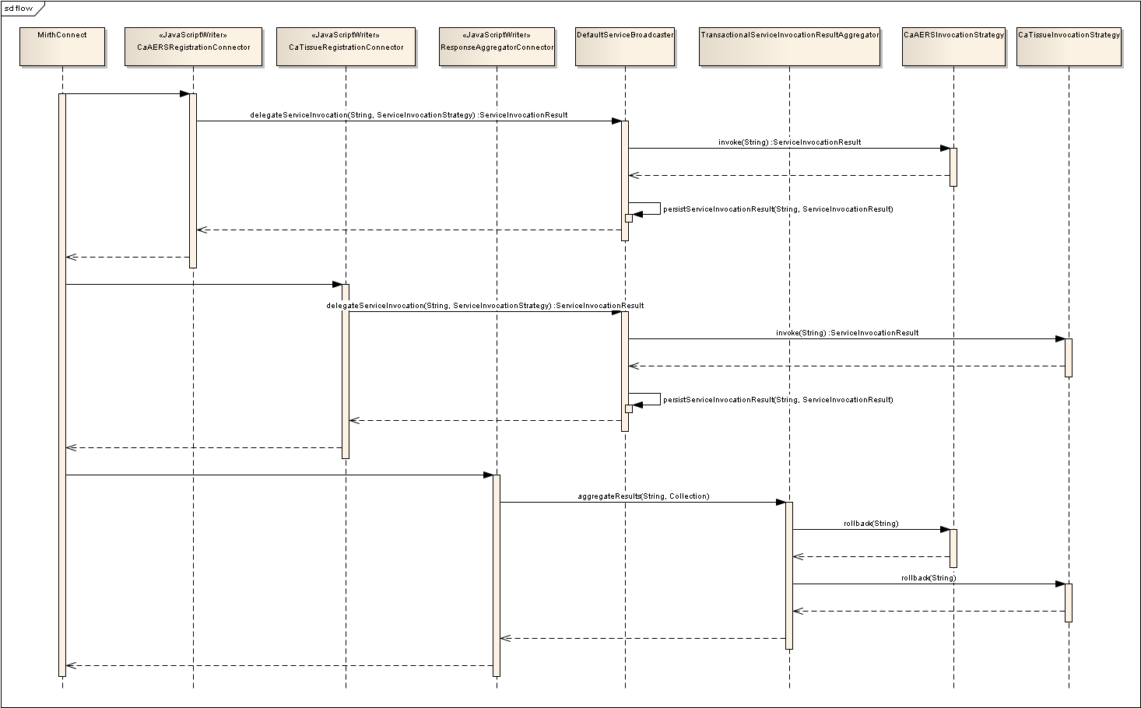

- MirthConnect passes control to CaAERSRegistrationConnector.
- CaAERSRegistrationConnector uses Spring to obtain a reference to a singleton-scoped instances of DefaultServiceBroadcaster and DefaultServiceInvocationStrategyFactory (e.g. by pulling them from the global map). It uses DefaultInvocationStrategyFactory to obtains reference to the CaAERSInvocationStrategy. It passes the messageID and invocation strategy to invoke DefaultServiceBroadcaster.delegateServiceInvocation.
- DefaultServiceBroadcaster calls the invoke operation of the CaAERSInvocationStrategy and persists the results using ServiceInvocationStrategyDAO.
- CaTissueRegistrationConnector uses a process similar to step 2 to invoke delegateServiceInvocation, passing the CaTissueInvocationStrategy.
- DefaultServiceBroadcaster calls the invoke operation of the CaTissueInvocationStrategy and persists the results using ServiceInvocationStrategyDAO.
- MirthConnect passes control to ResponseAggregatorConnector.
- ResponseAggregatorConnector invokes TransactionalServiceInvocationResultAggregator.aggregateResults, passing the messageID and collection of strategy identifiers.
- TransactionalServiceInvocationResultAggregator (TSIRA) kicks off a thread to periodically check if all the results have been retrieved. We should use Spring notification listeners, schedulers, and thread pooling to manage the aggregator threads. There should be one aggregator thread per IHubMessage. When the aggregation is complete, if a rollback is required, the executeRollback operation should iterate through invocation strategy objects invoking the rollback operation on each.

