iHub TRANSCEND Integration Software Architecture Document

Purpose

This document describes the detailed software architecture of the following iHub TRANSCEND Integration sub project of the caBIG Clinical Trials Suite project (the Suite). The goals of this sub project are to 1) migrate the existing, ServiceMix-based iHub implementation to the MirthConnect platform; 2) support additional integration scenarios with caAERS and caTissue.

Use Case View

Functional Requirements

Functional requirements were gathered from the following sources:
- TRANSCEND Architecture Team
  - https://ncisvn.nci.nih.gov/svn/essrt/trunk/Projects/TRANSCEND/Analysis/2TRANSCEND_AE_SR_SM_UseCases.doc
- Suite Business Analysis Team
  - https://wiki.nci.nih.gov/display/caAERS/TRANSCEND+Use+Case+-+Integrate+Study+Participant+Registrations+between+Tolven+and+caAERS

The TRANSCEND Architecture Team use cases that are in-scope for implementation by the Suite project team include the following:
- Adverse Events Package
  - Create/Update Adverse Event (System)
  - Transform AE Data
  - Transmit Adverse Event
- Biospecimen Management Package
  - Create/Update Specimen
  - Register Consent
  - Register Consent Withdrawal
  - Transform Consent Data and Send to caTissue
  - Transform Consent Withdrawal Data and Send to caTissue
  - Transform Specimen Data and Send to caTissue
  - Transmit Biospecimen Data
  - Transmit Consent Data
  - Transmit Consent Withdrawal Data
- Subject Registration Package
  - Create/Update Participant
  - Create/Update Study Subject
  - Transform Data
  - Transmit Data

The entire Suite Business Analysis Team use case is in-scope.

Non-Functional Requirements

Non-functional requirements have been associated with use cases in the TRANSCEND Architecture Team’s use cases. All requirements which are associated with the in-scope use cases are also in-scope for development.

In addition, the following non-functional requirements have been identified.

ReqID | Description
NF0001 | The system MUST be deployed on MirthConnect 2.1.1.
NF0002 | The system MUST be deployable to the same MirthConnect instance as caCIS.
NF0003 | The system MUST not use caGrid technology, or introduce any caGrid technology dependencies.
NF0004 | The system SHOULD reuse caCIS and iHub (MirthConnect) components, where doing so is aligned with the project’s goals.
NF0005 | The system MUST prevent associated systems (caTissue and caAERS) from becoming out-of-sync with Tolven.
NF0006 | The system MUST utilize the caTissue 2.0 remote Java API for all caTissue integration scenarios.
NF0007 | The system MUST utilize the caAERS <version?> SOAP-web service for all caAERS integration scenarios.
NF0008 | Communication between Tolven and caTissue must be synchronous.
NF0009 | Communication between Tolven and caAERS must be synchronous.
NF0010 | The system should support transmission of 200 participant registrations per year, and several hundred adverse event messages per participant.
NF0011 | Any error that occurs during transmission must be reported to the Tolven application in a synchronous fashion, using an appropriate error code and message.
NF0012 | The system MUST align with the larger TRANSCEND architecture as documented in the TRANSCEND architecture document.

Error conditions (as defined in the use cases) will be mapped to error codes according to the following mapping document:
- https://ncisvn.nci.nih.gov/svn/iHub/trunk/docs/design/ErrorHandlingDesign.doc

The following items are explicitly not requirements:
- Migration of all existing iHub components that do not support the in-scope TRANSCEND integration requirements to the MirthConnect platform.
- Use of SSO for authentication between iHub and the target services – caTissue and caAERS.

Logical View

iHub will act as a mediator between Tolven and the target systems – caTissue and caAERS. iHub will be responsible for message transformation, routing, and transmission, and transaction management.

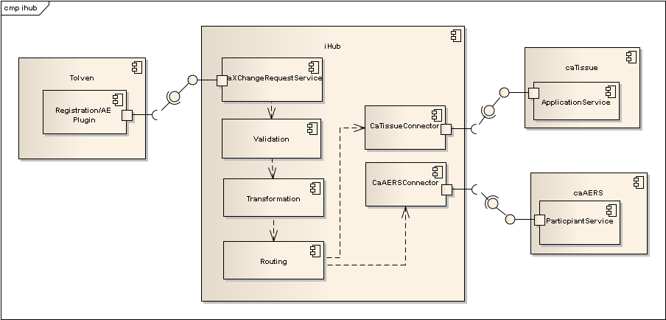

iHub Operations

Tolven will transmit messages to iHub using the existing caXchange request message format. From the perspective of Tolven, iHub will be a service that supports the following operations:
- Create Participant Registration
- Update Participant Registration
- Create Biospecimen
- Update Biospecimen
- Create Consent
- Update Consent
- Create Adverse Event
- Update Adverse Event

The operationName element of the caXchange request’s metadata element, will indicate which operation is being invoked. The serviceType will always be “IHUB”. For example, the metadata element for the Create Participant Registration operation will be as follows.
<metadata>
<transactionControl>PROCESS</transactionControl>
<serviceType>IHUB</serviceType>
<operationName>Create Participant Registration</operationName>
<externalIdentifier>12345</externalIdentifier>
</metadata>

The detailed behavioral semantics of these operations are described in the following sub sections.

Create Participant Registration

This operation enables the creation of a new registration for a participant.

Pre-conditions
- The client is successfully authenticated to iHub.
- The study exists.
- The study site exists.

Inputs
- A caXchange request message, whose message payload contains a Participant Registration TRIM.

Outputs
- A caXchange response message containing either a Success Message, or an Error Message.

Post-conditions
- If the Participant did not exist, it is created.
- Participant is registered to the Study at the Site.

Data Model

Participant Registration TRIM

The following set of data elements will be included in the TRIM:
- First Name [1..1]
- Last Name [1..1]
- Middle Name [0..1]
- Date of Birth [1..1]
- Race [1..*]
- Ethnicity [1..1]
- Gender [1..1]
- MRN [1..1]: Identifier of the participant at the site.
- SSN [1..1]: Unique identifier for the participant across all studies.
- Subject Identifier [1..1]: Unique identifier of the participant on the study.
- Study Identifier [1..1]: Unique identifier of the study.
- Site Identifier [1..1]: Unique identifier of the site.
- Random Patient ID
- Activity Status [1..1]: Status of the participant’s registration.

The following controlled vocabularies are used:
- Race
  - American Indian or Alaskan Native
  - Asian
  - Black or African American
  - Native Hawaiian or Other Pacific Islander
  - White
  - Not Reported
  - Unknown
- Ethnicity
  - Hispanic or Latino
  - Not Hispanic or Latino
  - Not Reported
  - Unknown
- Gender
  - Male
  - Female
  - Not Reported
  - Unknown
- Activity Status
  - active: The participant is registered to the study.
  - inactive: The participant is off the study.

Tolven will send registration data in the form of TRIM messages.

We are using the following TRIM as a template for defining mapping Tolven data to the caTissue and caAERS data models: https://ncisvn.nci.nih.gov/svn/iHub/trunk/docs/transcend/sampleTrims/Patient%20Registration-KL%20TRIM.xml

A mapping of TRIM XML elements to the caTissue and caAERS models has been defined here:
https://ncisvn.nci.nih.gov/svn/iHub/trunk/docs/transcend_data_mapping.xls

Success Message

A successful response will always contain a status of SUCCESS.

<caXchangeResponseMessage
xmlns=”http://caXchange.nci.nih.gov/messaging”>
<responseMetadata>
<!-- The same as given in the request. -->
<externalIdentifier>12345<externalIdentifier>
<caXchangeIdentifier>56789</caXchangeIdentifier>
</responseMetadata>
<response>
<responseStatus>SUCCESS</responseStatus>
<targetResponse>
<targetServiceIdentifier>IHUB</targetServiceIdentifier>
<targetServiceOperation>
Create Participant Registration
</targetServiceOperation>
<targetMessageStatus>RESPONSE</targetMessageStatus>
<targetBusinessMessage>
<xmlSchemaDefinition
type=”http://caXchange.nci.nih.gov/messaging”/>
</targetBusinessMessage>
</targetResponse>
</response>
</caXchangeResponseMessage>

Error Message

Error messages will always contain a status of FAILURE.

<caXchangeResponseMessage
xmlns=”http://caXchange.nci.nih.gov/messaging”>
<responseMetadata>
<!-- The same as given in the request. -->
<externalIdentifier>12345<externalIdentifier>
<caXchangeIdentifier>56789</caXchangeIdentifier>
</responseMetadata>
<response>
<responseStatus>FAILURE</responseStatus>
<caXchangeError>
<errorCode>${errorCode}</errorCode>
<errorDescription>${errorMessage}</errorDescription>
</caXchangeError>
</response>
</caXchangeResponseMessage>

The set of error codes that may be returned for this operation is documented in the error code mapping document.

Business Rules

- If no participant exists with the given SSN, create the participant.
- If a participant exists with the given SSN, associate the participant with this new registration.
- Validation rules as defined in the error code mapping document.

Update Participant Registration

This operation enables 1) attributes of the participant and/or registration to be updated; and 2) the registration to be inactivated or activated. A registration will be inactivated when the participant is taken off the study.

Pre-conditions
- The client is successfully authenticated to iHub.
- The study exists.
- The study site exists.
- The participant exists.
- The registration exists.

Inputs
- A caXchange request message, whose message payload contains a Participant Registration TRIM.

Outputs
- A caXchange response message containing either a Success Message, or an Error Message.

Post-conditions
- Participant and registration attributes are updated according to the provided Participant Registration TRIM.

Data Model

Participant Registration TRIM

This is the same TRIM as for the Create Participant Registration operation.

Success Message

<caXchangeResponseMessage
xmlns=”http://caXchange.nci.nih.gov/messaging”>
<responseMetadata>
<!-- The same as given in the request. -->
<externalIdentifier>12345<externalIdentifier>
<caXchangeIdentifier>56789</caXchangeIdentifier>
</responseMetadata>
<response>
<responseStatus>SUCCESS</responseStatus>
<targetResponse>
<targetServiceIdentifier>IHUB</targetServiceIdentifier>
<targetServiceOperation>
Update Participant Registration
</targetServiceOperation>
<targetMessageStatus>RESPONSE</targetMessageStatus>
<targetBusinessMessage>
<xmlSchemaDefinition
type=”http://caXchange.nci.nih.gov/messaging”/>
</targetBusinessMessage>
</targetResponse>
</response>
</caXchangeResponseMessage>

Error Message

Same as for the Create Participant Registration operation.

Business Rules

- The Subject Identifier and Study Identifier will be used to locate the registration.
- The SSN of the existing Participant should match the SSN in the registration TRIM.
- The data elements in the given registration TRIM will overwrite all existing data elements.
- All data elements except SSN, Subject Identifier, and Study Identifier may be updated.
- Validation rules as defined in the error code mapping document.

Create Biospecimen

This operation enables the creation of one or more biospecimens for a given participant.

Pre-conditions
The client is successfully authenticated to iHub
The participant exists
The study (collection protocol) exists and the participant is registered to it.
The given collection protocol event exists in a specimen collection group on the given collection protocol.

Inputs
- A caXchange request message whose message payload contains a Biospecimen TRIM.

Outputs
- A caXchange response message containing either a Success Message, or an Error Message

Post-conditions
- The given biospecimens are associated with a specific event on the collection protocol to which the participant is registered.

Update Biospecimen

Create Consent

Update Consent

Create Adverse Event

Update Adverse Event

iHub TRANSCEND Integration Components

The TRANSCEND integration components include the following MirthConnect channels:
- CaXChangeRequestServiceChannel: responsible for receiving requests from Tolven.
- CaCISChannel: responsible for validation, transformation, and routing
- MessageBroadcasterChannel: responsible for broadcasting messages to target systems and implementing transactions

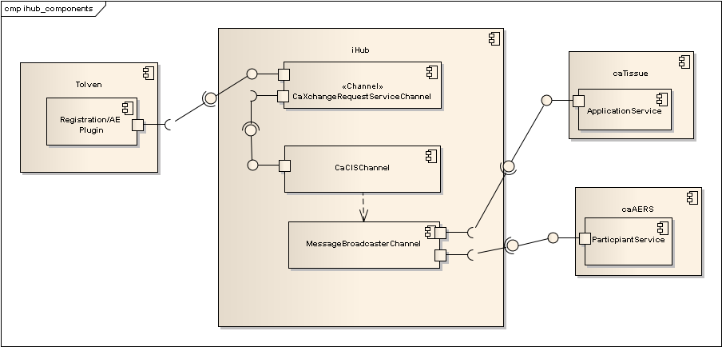

CaXChangeRequestServiceChannel

This channel is responsible for receiving requests from the Tolven plugin and transmitting them to the CaCISChannel.

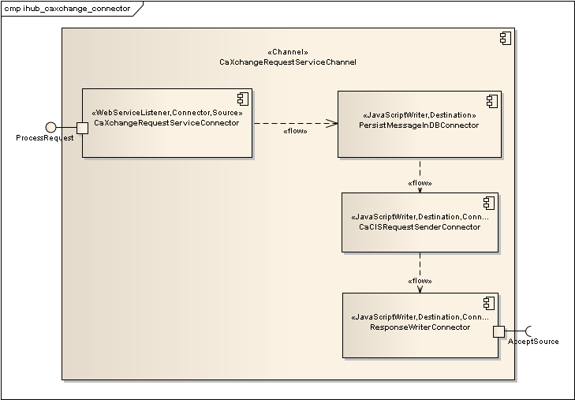

The channel contains the following connectors

- CaXchangeRequestServiceConnector: Supports the caXchange SOAP Web Service interface.
- PersistMessageInDBConnector: Stores incoming messages to a relational database so that they may be correlated to multiple target service responses.
- CaCISRequestSenderConnector: Transforms the CaXchange message format to a CaCIS message format and then invokes the CaCIS Semantic Adapter’s AcceptSource operation.
- ResponseWriterConnector: Translates CaCIS response to a CaXchange response.

CaCISChannel

The CaCIS platform is responsible for validation, transformation, and routing. The TRANSCEND integration will eventually use CaCIS for these purposes. However, since CaCIS is currently still under development, our approach utilizes a separate channel, which implements that CaCIS Semantic Adapter interface.

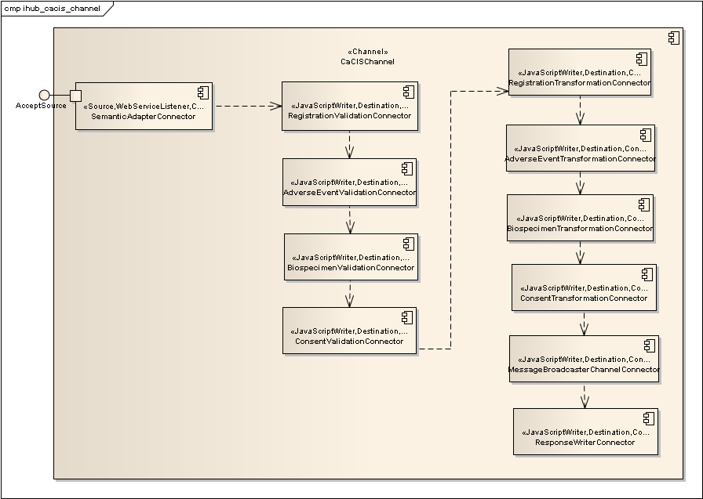

This channel consists of the following connectors
- SemanticAdapterConnector: Exposes the Semantic Adapter SOAP Web Service interface.
- RegistrationValidationConnector: Implements registration-related validations.
- AdverseEventValidationConnector
- BiospecimenValidationConnector
- ConsentValidationConnector
- RegistrationTransformationConnector: Implements the TRIM to canonical format transformation for registration messages.
- AdverseEventTransformationConnector
- BiospecimenTransformationConnector
- ConsentTransformationConnector
- MessageBroadcasterConnector: Formulates a CaXchange message and sends it to the MessageBroadcasterChannel.
- ResponseWriterConnector: Translates error messages from the target services to CaCIS error messages.

Each of the validation and transformation channels has filters on it to select relevant messages – for example, the RegistrationValidationConnector and RegistrationTransformationConnector will select only registration messages.

MessageBroadcasterChannel

This channel is responsible for broadcasting messages to target systems and implementing distributed transactions.

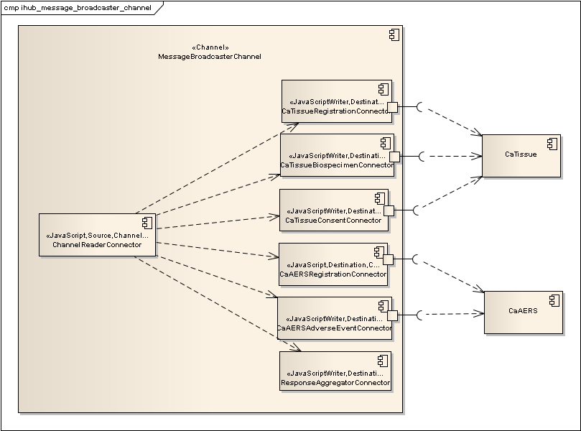

- CaTissueRegistrationConnector: Responsible for translating create and update registration messages into operations on the caTissue remote Java API.
- CaTissueBiospecimenConnector: Responsible for translating create and update biospecimen messages into operations on the caTissue remote Java API.
- CaTissueConsentConnector: Responsible for translating create and update consent messages into operations on the caTissue remote Java API.
- CaAERSRegistrationConnector: Responsible for translating create and update registration messages into operations on the caAERS Participant SOAP Web Service.
- CaAERSAdverseEventConnector: Responsible for translating create and update adverse event messages into operations on the caAERS Adverse Event SOAP Web Service.
- ResponseAggregatorConnector: Responsible for aggregating responses from all target services and unifying them into a single response.

All destination connectors are executed in parallel. Each of the CaTissue*Connector and CaAERS*Connector connectors has a filter that selects only relevant messages – for example, CaTissueRegistrationConnector processes only registration messages. The ResponseAggregatorConnector blocks until all other connectors complete and then either aggregates the response or executes a rollback.

Transaction Framework

The MessageBroadcasterChannel connectors delegate to a framework of Java components to implement distributed transactions.

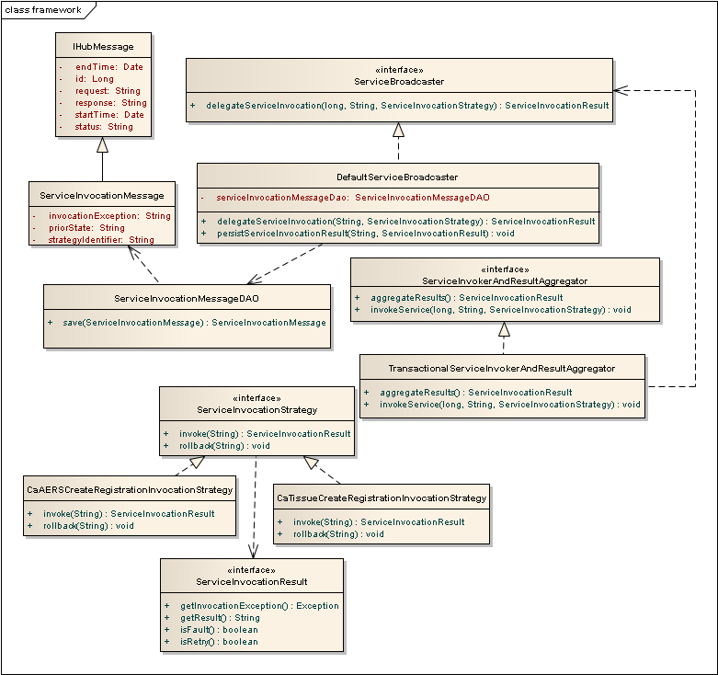

IHubMessage

Represents the message sent to iHub and its ultimate response. It is used to correlated target service responses.

ServiceInvocationMessage

Represents 1) the prior state of an entity; 2) a message sent to a target service; and 3) the service’s response. The priorState data is used to restore the service (or an entity) to its prior state.

IHubMessageDAO and ServiceInvocationMessageDAO

Responsible for persistence of IHubMessage and ServiceInvocationMessage objects, respectively.

ServiceInvocationStrategy

Represents the logic necessary to invoke a single operation of a service AND also rollback the effects of that operation. Implementations of this interface may contain logic to invoke more than one operation. The invoke and rollback operations both take the XML request message.

There are implementations of this for each TRANSCEND operation:
- CaTissueCreateRegistrationInvocationStrategy
- CaTissueUpdateRegistrationInvocationStrategy
- CaAERSCreateRegistrationInvocationStrategy
- CaAERSUpdateRegistrationInvocationStrategy
- CaAERSCreateAdverseEventInvocationStrategy
- CaAERSUpdateAdverseEventInvocationStrategy
- CaTissueCreateBiospecimenInvocationStrategy
- CaTissueUpdateBiospecimenInvocationStrategy
- CaTissueCreateConsentInvocationStrategy
- CaTissueUpdateConsentInvocationStrategy

The connectors locate the appropriate implementation using Spring.

ServiceBroadcaster

Implementations of this interface are responsible for doing the work that must be done prior to invoking a target service – e.g. persisting a message.

DefaultServiceBroadcaster

An implementation of ServiceBroadcaster that uses the DAOs to persist ServiceInvocationMessage objects and invoke ServiceInvocationStrategy implementations. This includes multiple executions (i.e. retry logic) according to the configuration of the ServiceInvocationStrategy.

ServiceInvokerAndResultAggregator

Implementations of this interface are responsible for invoking all target services within a single thread of execution of the MessageBroadcasterChannel channel, and then aggregating the results of those invocations. Each target service connector (e.g. CaTissueRegistrationConnector) is passed the same instance of this object, which is instantiated in the Preprocessor script of the MessageBroadcasterChannel channel. The connector calls the invokeService operation, passing in the appropriate implementation of ServiceInvocationStrategy. The results are aggregated within the ResponseAggregatorConnector connector.

TransactionalServiceInvokerAndResultAggregator

This implementation of ServiceInvokerAndResultAggregator is responsible for implementing a distributed transaction roll back, if any of the results are errors. It uses an internal instance of java.util.concurrent.ExecutorCompletionService to start service invocation threads in one connector and then aggregate them in another connector.

Spring

Like CaCIS, the TRANSCEND integration uses Spring to initialize various components. The Deploy script of the Mirth Connect global scripts is used to load the Spring application context that initializes components which are used by multiple channels. This application context is put into the globalMap under the “commonctx” key.

Application contexts that initialize components that are used by a single channel are loaded by the Deploy script of that channel.

Application contexts are configured using Java properties files that are located in the user’s home directory. If a channel initializes its own application context, it will have its own properties file.

Transformations

All TRANSCEND integration transformations are implemented as XSL transformations. Each transformation is executed by an instance of gov.nih.nci.integration.transformer.XSLTTransformer. An instance of this class must be constructed for each transformation, since transformers are not threadsafe. The Spring application context for each channel initializes a pool of transformers. The channel retrieves instances from that pool.

Transformations are configured through the channel’s property file.

Persistence

Process View

Message Broadcaster Channel

This channel is responsible for 1) sending messages to multiple target services in parallel; 2) aggregating the responses; and 3) executing rollback logic, if required. Messages will be either Create or Update operations. In the case of Update operations, the prior state of the entity to updated must be retrieved so that in the case of a rollback, the prior state can be restored.

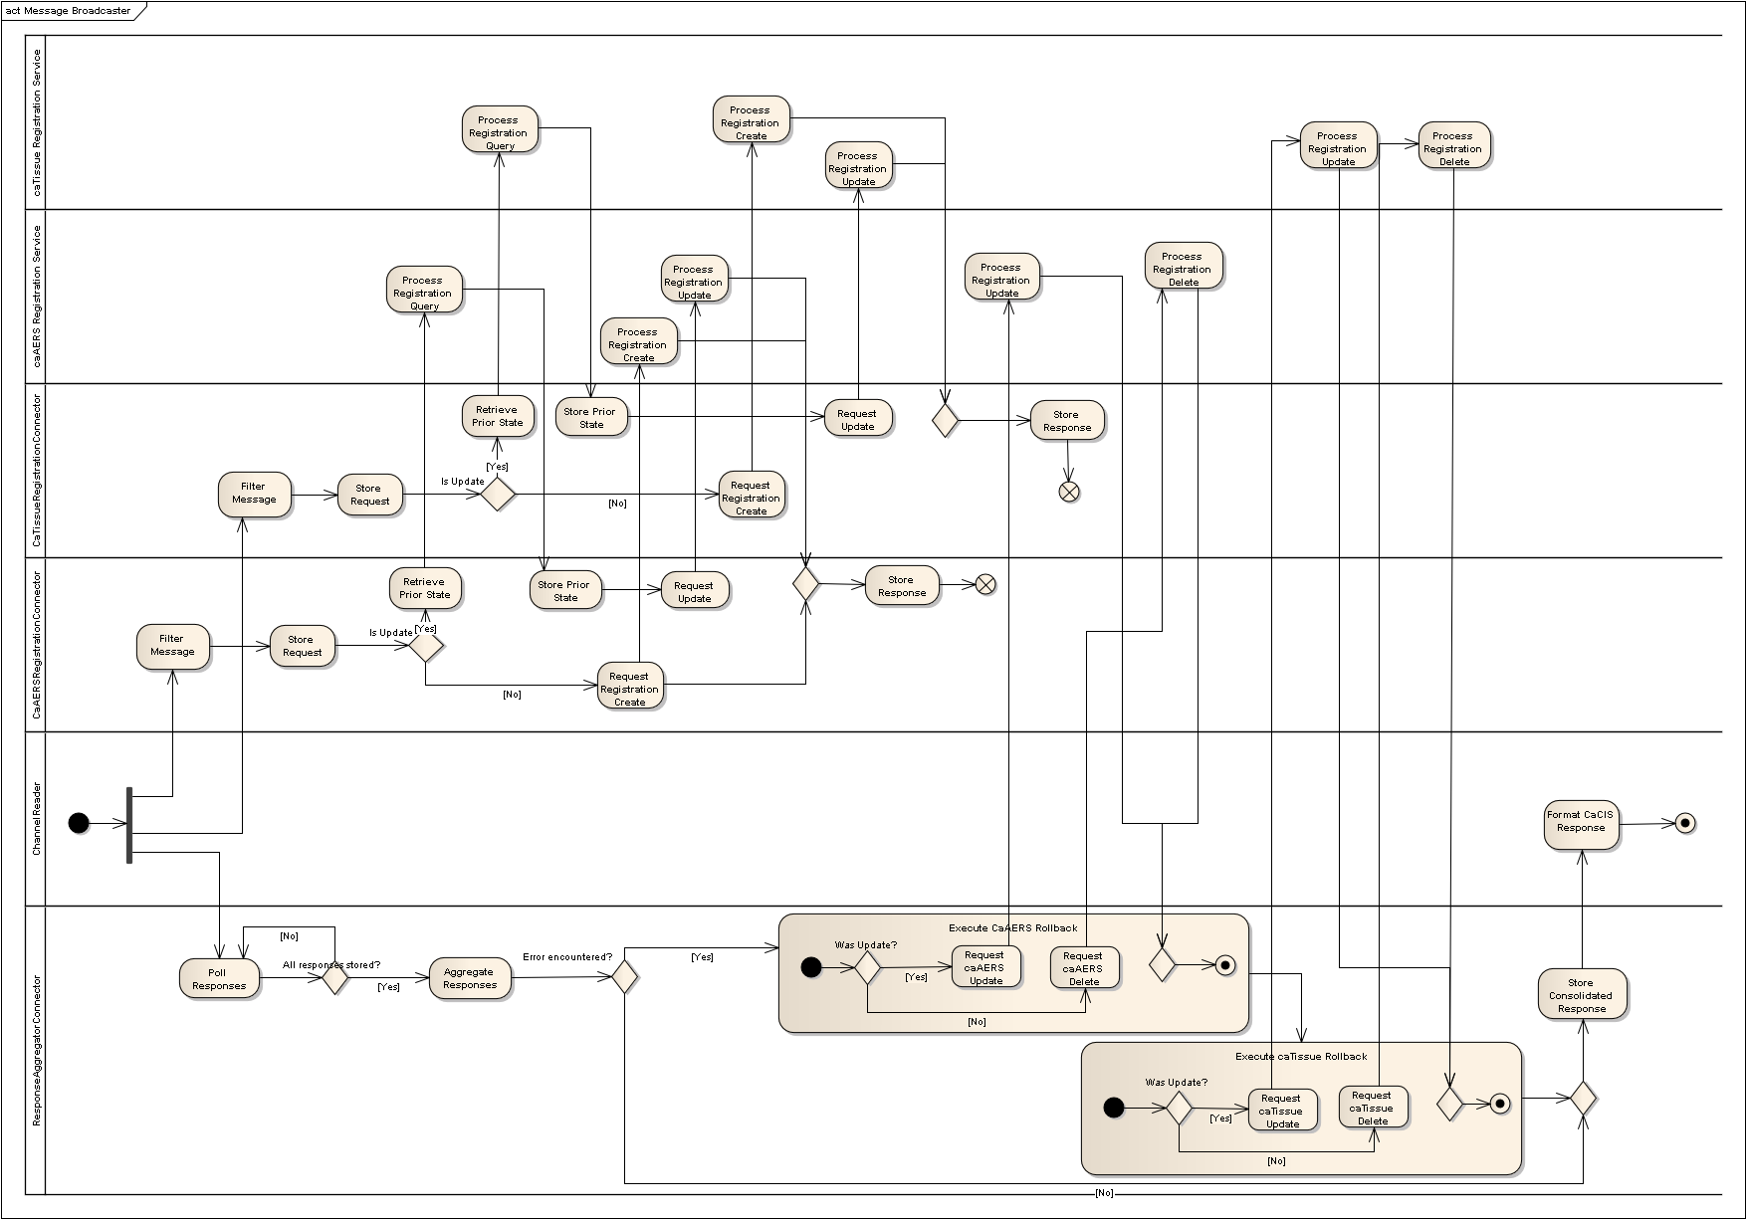

Rollback Algorithm

Each instance of ServiceInvocationStrategy (SIS) is responsible for the entity on which the operation

One SIS does not need to know what happened in another SIS. Each needs to know only 1) the request; 2) the previous state of the object; 3) the result of its own operation.

When the TransactionalServiceInvokerAndResultAggregator (TSIARA) calls rollback on a SIS, that SIS needs to execute the following logic
- If the operation was Create XYZ
  - if that operation failed
    - then do nothing – because the operation had no effect
  - else if the operation was successful
    - then delete the newly created object
- If the operation was Update XYZ
  - if that operation failed
    - then do nothing – because the operation had no effect
  - else if the operation was successful
    - then restore XYZ to its previous state

Development View

Physical View

As the following deployment diagram shows, the iHub TRANSCEND integration components are deployed in the same MirthConnect container as caCIS.

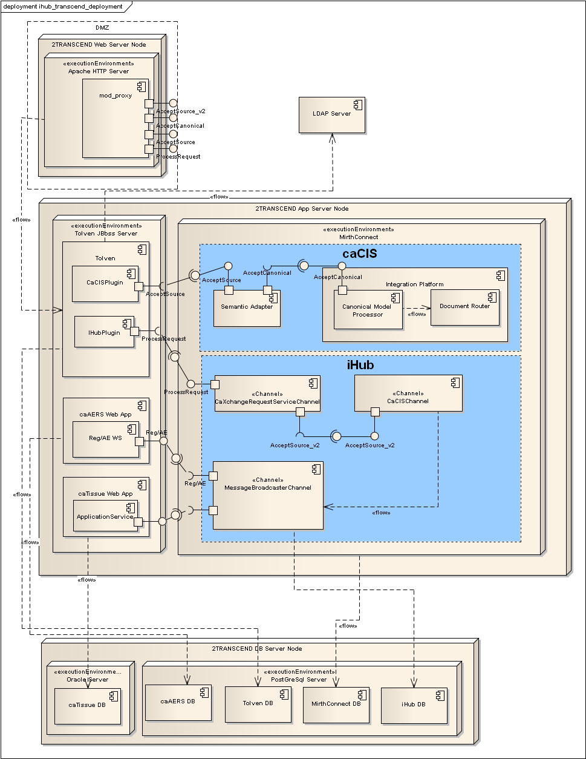

Two additional proxies are configured on the Apache HTTP server:
- AcceptSource_v2: This allows communication between the iHub CaXchangeRequestServiceChannel and the CaCISChannel according to the CaCIS Semantic Adapter service contract.
- ProcessRequest: This is required to enable secure communication between the Tolven iHub plugin, and the iHub CaXchangeRequestServiceChannel, which is a SOAP web service. Security will be configured in the same manner as CaCIS.

The TRANSCEND architecture document (https://ncisvn.nci.nih.gov/svn/essrt/trunk/Projects/TRANSCEND/2TRANSCEND_Integration_Architecture.doc).
The caXchange message format (https://ncisvn.nci.nih.gov/svn/cabigintegrationhub/trunk/software/caXchangeInboundService/schema/CaXchangeRequestProcessor/caXchange.xsd).
The caTissue UML model (https://ncisvn.nci.nih.gov/svn/catissue/catissuecore/trunk/docs/UMLModel/catissuecore_2.0.EAP).
The caAERS participant XML schema, as defined in the ParticipantService WSDL (https://ncisvn.nci.nih.gov/svn/iHub/trunk/software/projects/transcend-caaers/src/main/resources/wsdl/ParticipantService.wsdl).

