TRANSCEND-iHub Service Contract

Version 0.1
May 01, 2012

Authors: | Joshua Phillips  Paul Baumgartner
Reviewers: | Sarah Davis  Ashwin Koleth

Document History

Version | Date | Author | Changes
0.1 | 05/01/2012 | Joshua Phillips | Initial Draft – only the Registration contract is complete
0.2 | 5/2/2012 | Joshua Phillips | Updated biospecimen, consent, and adverse event sections of logical contract.
0.3 | 5/24/2012 | Joshua Phillips | Elaborated the physical contract for biospecimen and consent.
1.0 | 6/11/2012 | Joshua Phillips | Updated biospecimen and consent sections.
1.1 | 6/9/2012 | Joshua Phillips | Added physical contract section for adverse events.
1.2 | 8/15/2012 | Joshua Phillips | Updated for CDA.

1 Purpose 4
2 Logical Contract 4
2.1 Registration 4
2.1.1 Create Registration 4
2.1.2 Update Registration 7
2.1.3 Randomize/Go Off Study 7
2.1.4 Error Handling 8
2.2 Biospecimen Management 8
2.2.1 Create Biospecimen 8
2.2.2 Update Biospecimen 10
2.2.3 Register Consent 10
2.2.4 Register Consent Withdrawal 12
2.3 Adverse Events 12
2.3.1 Create Adverse Event 12
2.3.2 Update Adverse Event 15
3 Physical Contract 16
3.1 Related Documents 16
3.2 iHub Operations 17
3.3 Registration 17
3.3.1 iHub Operations to Use Case Mappings 17
3.3.2 Create Participant Registration 18
3.3.3 Update Participant Registration 19
3.4 Biospecimen 21
3.4.1 iHub Operations to Use Case Mappings 21
3.4.2 Create Biospecimen 21
3.4.3 Register Consent 23
3.5 Adverse Events 25
3.5.1 iHub Operations to Use Case Mappings 25
3.5.2 Create Or Update Adverse Events 25

Purpose

The purpose of this document is to capture a common understanding of the logical and physical contracts between the TRANSCEND CDMS and iHub in support of the TRANSCEND integration of caTissue and caAERS.

The Logical Contract section should be read by SMEs to ensure that the logical integration is correct. The Physical Contract section should be read by implementers of the CDMS iHub plugin to determine how to interact with the iHub service interface to support the TRANSCEND integration use cases.

Logical Contract

Registration

Registration scenarios include:
- Create Registration
- Update Registration
- Randomize/Go Off-Study

Details of each scenario are described below.

Create Registration

The CRA fills out a patient registration form in the CDMS. When all the information has been entered, the CRA submits the form. The CDMS iHub plugin then sends the following data elements to iHub, which in turn sends to caTissue and caAERS.

- Study Subject Identifier: Unique identifier for the participant on the study.
- Study Identifier: Unique identifier for the study.
- Site Identifier: Unique identifier for the study site.
- Subject Identifier: Unique identifier for the participant at the study site.
- Activity Status: Status of the participant’s registration.
- Date of Birth
- Race
- Ethnicity
- Gender

caTissue Mapping

The Study Subject Identifier will be used to search for participants in caTissue using the Participant Last Name field.

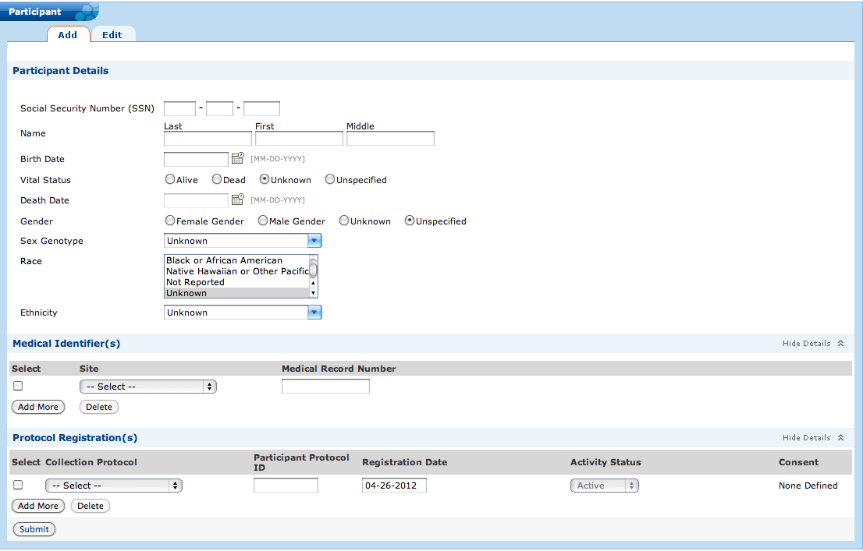
Figure 1: caTissue Participant Registration Form

The following mappings are described in terms of the Add Participant form in caTissue.

- Study Subject Identifier:
  - Participant Details > Last Name
  - Protocol Registrations > Participant Protocol ID
- Study Identifier: Protocol Registrations > Collection Protocol Short Title
- Site Identifier: Medical Identifiers > Site Name
- Subject Identifier: Medical Identifiers > Medical Record Number
- Activity Status: Protocol Registrations > Activity Status
- Data of Birth: Participant Details > Birth Date
- Race: Participant Details > Race
- Ethnicity: Participant Details > Ethnicity
- Gender: Participant Details > Gender

In caTissue, the Collection Protocol (Study) and Site must already exist.

caAERS Mapping

The following mappings are described in terms of the Enter Subject flow in caAERS.

- Subject Identifier:
  - Demographic Information > Subject Identifier
- Name:
  - Demographic Information > First name (or initial)
  - Demographic Information > Last name (or initial)
  - Demographic Information > Maiden name (or initial)
  - Demographic Information > Middle name (or initial)
- Site Identifier: Site > Organization
- Date of Birth: Demographic Information > Date of birth
- Race: Demographic Information > Race
- Ethnicity: Demographic Information > Ethnicity
- Gender: Demographic Information > Gender

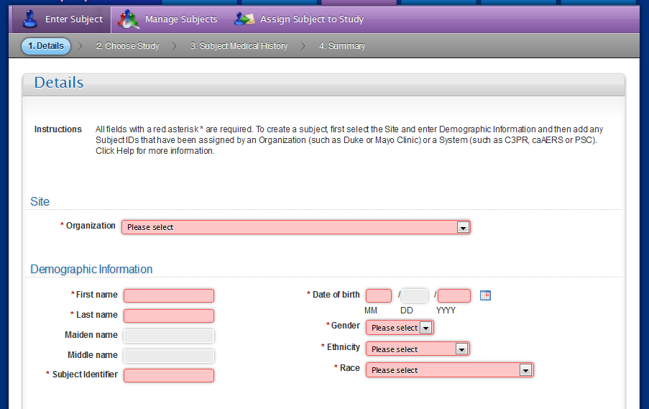
Figure 2: Enter Subject form in caAERS.

The following mappings are described in terms of the Assign Subject to Study flow in caAERS.

- Study Identifier: Study ID
- Study Subject Identifier: Study Subject Identifier
- Activity Status: no mapping; always considered “Active”

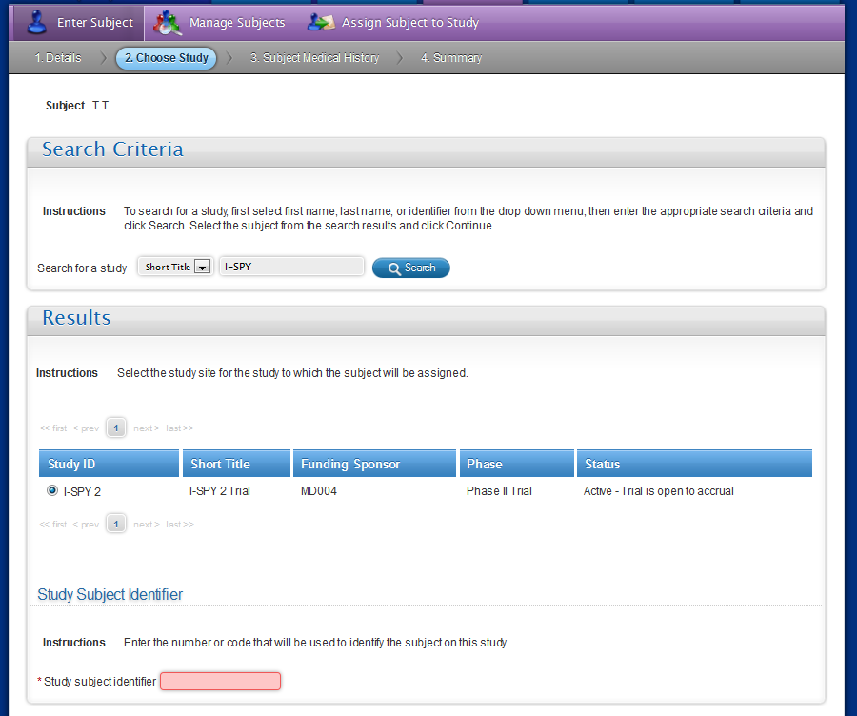
Figure 3: Assign Subject to Study form in caAERS.

In caAERS, the Study and Site must already exist.

Update Registration

The CRA is making some change to the participant registration, but is not deleting the registration or registering the participant for a different study. Only the following data elements can change: Site Identifier, Subject Identifier, Race, Ethnicity, Gender, Date of Birth.

Randomize/Go Off Study

Either through randomization or explicitly through the Off-Study form, the CRA indicates that the participant should go off study, but the registration should not be deleted. The only data elements that are necessary are Study Subject Identifier and Study Identifier. This integration scenario is not applicable to caAERS.

Error Handling

If errors occur in during the transmission of data to caTissue or caAERS, data will not be saved to either application’s database. Instead, the user will receive an appropriate error message, and the iHub administrator will have the information necessary to determine what went wrong.

Biospecimen Management

The biospecimen management scenarios include
- Create Biospecimen
- Update Biospecimen
- Register Consent
- Register Consent Withdrawal

Create Biospecimen

The CRA uses the CDMS biospecimen form to log collection of one or more biospecimens. When the CRA clicks submit, the following data elements are sent to caTissue.

- Participant Info:
  - Study Subject Identifier: Unique identifier for the participant on the study.
- Specimen Info (for each specimen):
  - CDMS Specimen ID: Unique identifier for this sample, assigned by the TRANSCEND CDMS.
  - Study Identifier: The unique identifier for the study.
  - Study Calendar Event Point: The study calendar event point at which the specimen is collected.
  - Barcode
  - Specimen Class
  - Specimen Type
  - Pathological Status
  - Initial Quantity
  - Available Quantity
  - Tissue Site
  - Tissue Side

caTissue Mapping

The Study Subject Identifier will be used to locate the participant by Last Name.

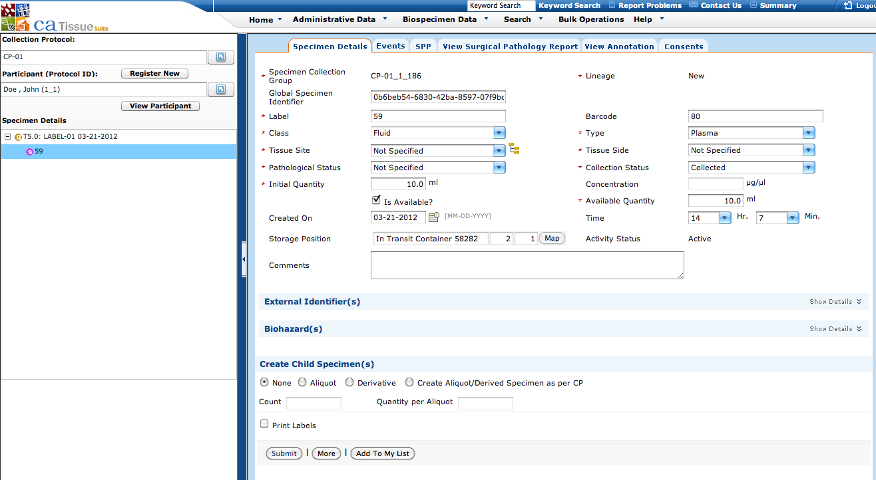
Figure 4: caTissue Add/Edit Specimen Form

The following mappings are described in terms of the Add/Edit Specimen form in caTissue.

- CDMS Specimen ID: Specimen Label
- Barcode: Barcode
- Specimen Class: Class
- Specimen Type: Type
- Pathological Status: Pathological Status
- Initial Quantity: Initial Quantity
- Available Quantity: Available Quantity
- Tissue Site: Tissue Site
- Tissue Side: Tissue Side
- Activity Status: Activity Status
- Study Calendar Event Point: In Add/Edit Specimen form, the event point is the node on the tree in the left panel with the name “T5.0: LABEL-O1 03-21-2012”. However, the event point’s actual “identifier” is “LABEL-01” as shown in the Collection Point Label field in the Add/Edit Study Calendar Event Point form.
- Study Identifier: This will map to the Collection Protocol Title, not shown in the form.

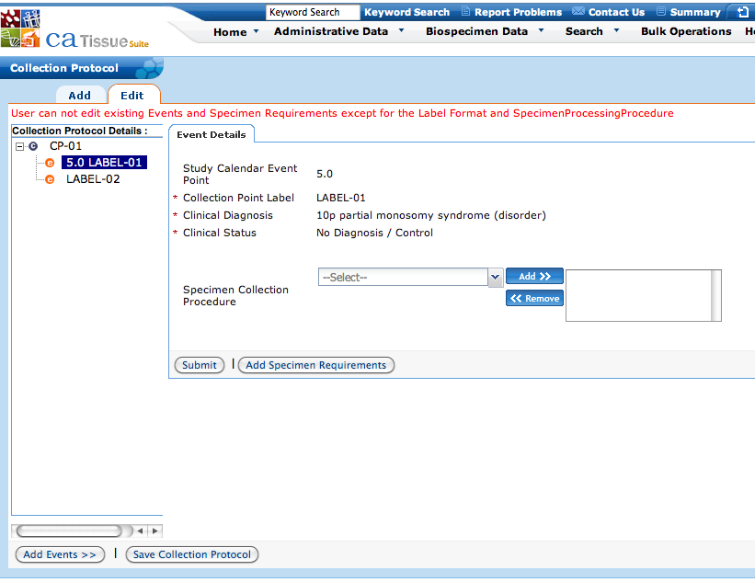
Figure 5: caTissue Add/Edit Study Calendar Event Point Form

Update Biospecimen

The CRA uses the CDMS biospecimen form to change some attribute of the biospecimen. When the CRA clicks submit, the data elements are sent to caTissue.

The same data elements as in the Create Biospecimen scenario are sent. The CDMS Specimen ID, Study Identifier, and Study Calendar Event Point must not be changed.

Register Consent

At various points throughout a participant’s involvement with a study, consent information will be registered. Consent will be registered at the study calendar event point level. That means it will be registered for all specimens that are collected at that event point.

The following consent tiers will be defined in caTissue on all collection protocols to which patients will be registered.
- Consent Tier 1: Patient consented to use specimen for this study?
- Consent Tier 2: Patient consented to use specimen for research outside of this study?

The following data elements will be passed to iHub when consent is registered.
- Study Subject Identifier: Unique identifier for the participant on the study.
- CDMS Specimen ID: Unique identifier for this sample, assigned by the TRANSCEND CDMS.
- Study Identifier: Unique identifier for the study
- Study Calendar Event Point: The study calendar event point at which consent is managed. Consent applies to all specimens that are collected at this point.
- Consent Tier 1 Response: Yes, No, Not Specified, Withdrawn
- Consent Tier 2 Response: Yes, No, Not Specified, Withdrawn

Consent tiers will be defined at the Collection Protocol level in caTissue.

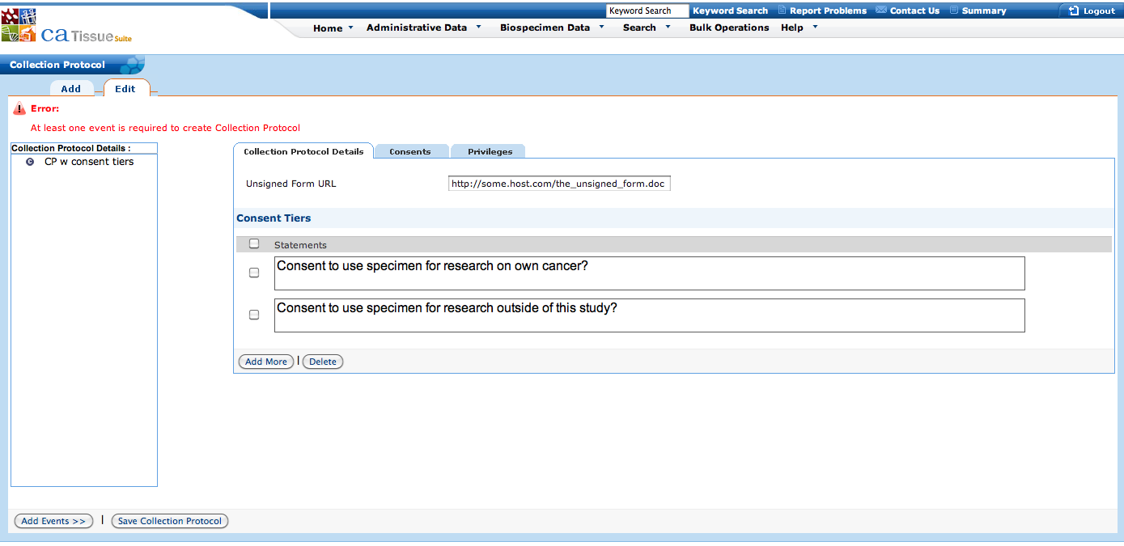
Figure 6: Consent tiers at collection protocol level in caTissue.

Responses to consent tier questions will be managed at the Specimen Collection Group (SCG) level. A SCG corresponds to a Study Calendar Event Point.

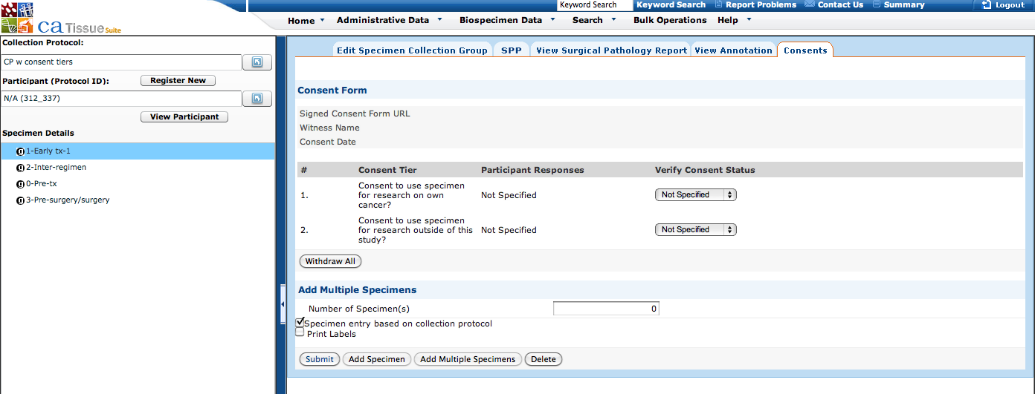
Figure 7: Consent registered at the SCG level in caTissue.

Register Consent Withdrawal

To withdraw consent, the TRANSCEND CDMS should send the same data elements as in the Register Consent scenario, but the value of the consent tier being withdrawn should be set to “Withdrawn”.

Adverse Events
The adverse event management scenarios include:
- Create adverse event
- Update adverse event

Create Adverse Event

The CRA fills out an adverse event form in TRANSCEND CDMS. When all the information has been entered, the CRA submits the form to the Data Coordinating Center (DCC). The DCC reviews the adverse event form. Once the DCC approves the adverse event form, the TRANSCEND CDMS plugin sends the following data elements to iHub, which in turn sends it to caAERS.

- Study Info:
  - Study Identifier: Unique identifier for the study.
- Participant Info:
  - Study Subject Identifier: Unique identifier for the participant on the study.
- Timeframe Info:
  - Reporting Period: The observation period during which a collection of adverse events have been reported.
  - Period Type: A categorical description of the timeframe, corresponding to a specific period in the trial (e.g. screening, treatment, follow-up, etc).
  - Assigned Treatment: The treatment assignment or arm to which the participant was assigned during the reporting period.
- Adverse Event Info (specified separately for each adverse event):
  - Verbatim: What the patient, clinician, or chart indicated as the event.
  - Coded Term: The name of the adverse event using a controlled vocabulary.
  - Grade: The severity of the adverse event.
  - Onset Date: The date the adverse event started.
  - Resolution Date: The date the adverse event ended.
  - Expected: Whether or not the adverse event was anticipated to occur to participants on the specific study arm.
  - Attribution: An indicated of the likely causal relatedness between the adverse event and the study intervention(s).
  - Serious Reason(s): The specific reason(s) why an adverse event was deemed serious (e.g. hospitalization, fatal, life-threatening / disabling, etc.).

caAERS Mapping

The following mappings describe the create / update fields available in the caAERS adverse event form. The Study and Participant information must already be entered into caAERS. The available treatments (i.e. arms) must also already be entered into caAERS.
- Study Info: Study, Subject, & Course/Cycle > Select Study
- Participant Info: Study, Subject, & Course/Cycle > Select Subject

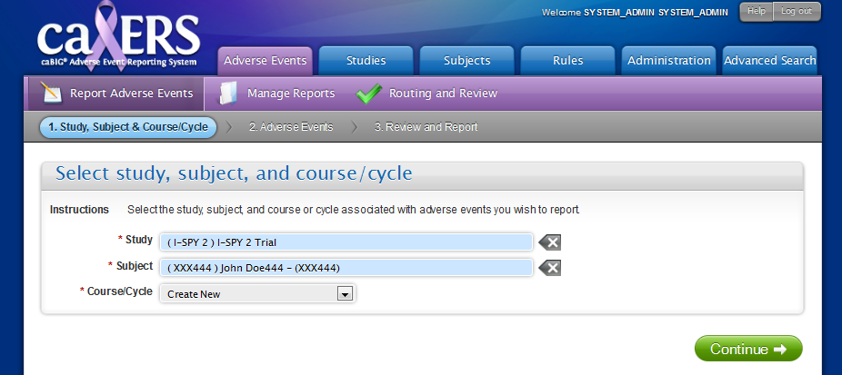
Figure 8: Select Study, Subject, and Course screen in caAERS.

- Timeframe Info: Course / Cycle Information
  - Reporting Period:
    - Start date of this course / cycle
    - End date of this course / cycle
  - Period Type: Treatment type
  - Assigned Treatment: Treatment Assignment

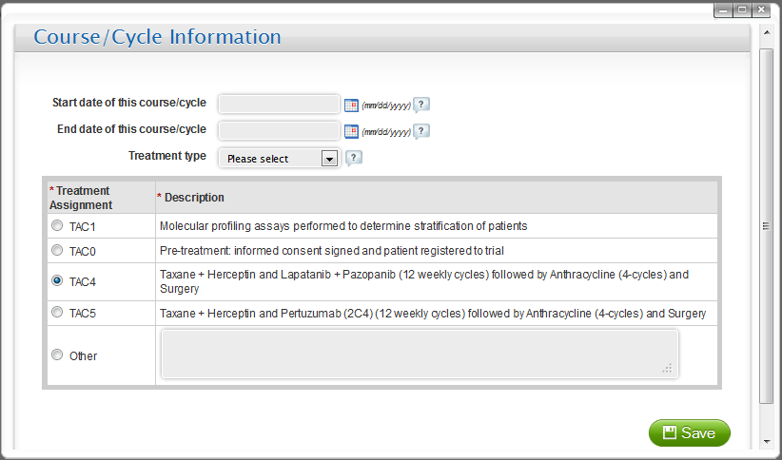
Figure 9: Course / Cycle information screen in caAERS.

- Adverse Event Info (specified separately for each adverse event):
  - Verbatim: Adverse Events > Verbatim
  - Coded Term: Adverse Event
  - Grade: Adverse Events > Grade
  - Onset Date: Adverse Events > Start date
  - Resolution Date: Adverse Events > End date
  - Expected: Adverse Events > Expected?
  - Attribution: Adverse Events > Attribution to study intervention
  - Serious Reason(s): Adverse Events > Outcome(s)

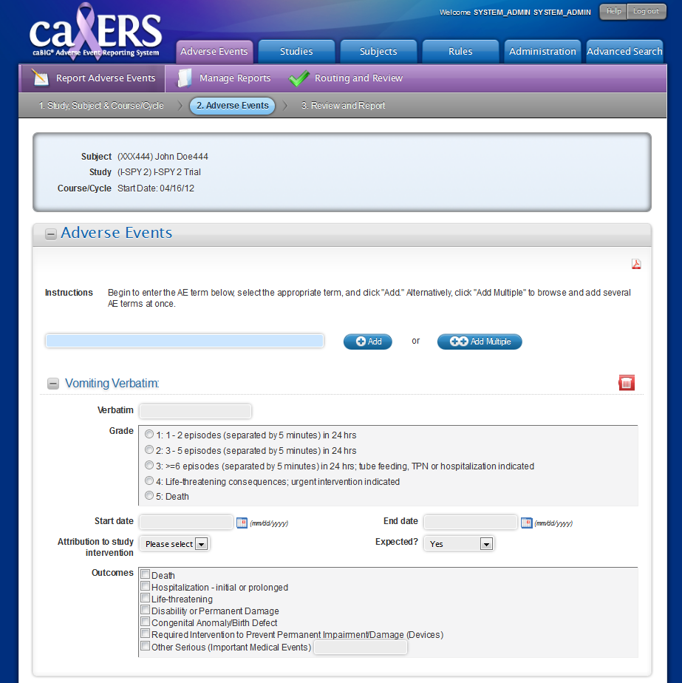
Figure 10: Adverse event entry screen in caAERS.

Update Adverse Event

In the event that a serious adverse event occurs, a CRA will enter the serious adverse event into caAERS directly using the adverse event entry screens. The CRA will then use caAERS to aid in the generation and submission of a safety report, as appropriate. The CRA will later enter the serious adverse event into Tolven using the adverse event form. As described in section 2.3.1, the CRA will submit the form to the DCC for review and approval, after which the adverse event elements (described in section 2.3.1.1) will be sent to iHub and then onto caAERS. In caAERS, the serious adverse event will already exist. As there is no primary identifier for adverse events that is shared between Tolven and caAERS, caAERS will produce a reconciliation report to allow a CRA to confirm or reject updates, additions, and/or deletions of adverse events.

Physical Contract

iHub will act as a mediator between TRANSCEND CDMS and the target systems – caTissue and caAERS (and others). iHub will be responsible for message transformation, routing, and transmission, and transaction management.

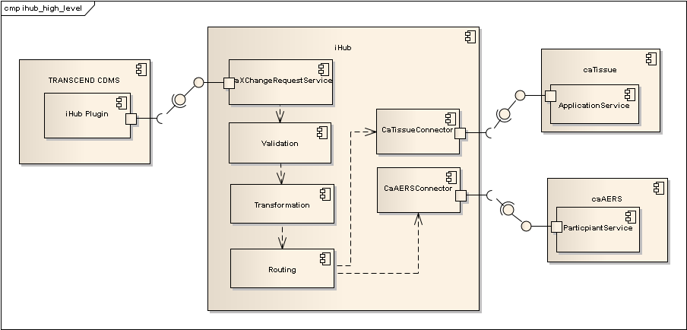

Related Documents

- CaXchangeRequestService WSDL: This document defines the CaXchangeRequestService web service interface that iHub will expose to the TRANSCEND CDMS.
- CDA Mapping Spreadsheet (iHub_Data_Exchange_CDA_Mapping.xlsx): This document describes how TRANSCEND data elements are mapped into CDA documents. Example CDA documents as well as the associated XML schemas have been provided here.
- Data Mapping Spreadsheet (transcend_data_mapping.xls): This document describes how CDA elements are mapped into the caTissue and caAERS models. In the case of caTissue, the CDA elements are mapped directly into the caTissue object model. In the case of caAERS, they are mapped to XML elements defined in WSDLs of the relevant caAERS web services. The relevant schemas have been provided here.
- Error Mapping Spreadsheet: This document defines codes that will be returned for various error conditions.

iHub Operations

The CDMS will transmit messages to iHub using the existing caXchange request message format, as defined in the CaXchangeRequestService WSDL. From the perspective of the CDMS, iHub will be a service that supports the following operations:
- Create Participant Registration
- Update Participant Registration
- Create Biospecimen
- Update Biospecimen
- Register Consent
- Create Or Update Adverse Event

These operations support all of the various TRANSCEND use cases. Details of how each operation supports those use cases is described in the sub sections below.

The operationName element of the caXchange request’s metadata element, will indicate which operation is being invoked. The serviceType will always be “IHUB”. For example, the metadata element for the Create Participant Registration operation will be as follows.
<metadata>
<transactionControl>PROCESS</transactionControl>
<serviceType>IHUB</serviceType>
<operationName>Create Participant Registration</operationName>
<externalIdentifier>12345</externalIdentifier>
</metadata>

Registration

iHub Operations to Use Case Mappings

Use Case | Operation
Create Registration | Create Participant Registration
Update Registration | Update Participant Registration
Randomize/Go Off-Study | Update Participant Registration: To indicate that the patient if off study, the Activity Status should be set to Closed.

The detailed semantic of these operations are described in the following sub sections.

Create Participant Registration

This operation enables the creation of a new registration for a participant.

Pre-conditions
- The client is successfully authenticated to iHub.
- The study exists.
- The study site exists.

Inputs
- A caXchange request message, whose message payload contains a Participant Registration CDA document.

Outputs
- A caXchange response message containing either a Success Message, or an Error Message.

Post-conditions
- If the Participant did not exist, it is created.
- Participant is registered to the Study at the Site.

Data Model

Refer to the Data Mapping Spreadsheet for details. There will exactly one registration message in the input.

Success Message

A successful response will always contain a status of SUCCESS.

<caXchangeResponseMessage
xmlns=”http://caXchange.nci.nih.gov/messaging”>
<responseMetadata>
<!-- The same as given in the request. -->
<externalIdentifier>12345<externalIdentifier>
<caXchangeIdentifier>56789</caXchangeIdentifier>
</responseMetadata>
<response>
<responseStatus>SUCCESS</responseStatus>
<targetResponse>
<targetServiceIdentifier>IHUB</targetServiceIdentifier>
<targetServiceOperation>
Create Participant Registration
</targetServiceOperation>
<targetMessageStatus>RESPONSE</targetMessageStatus>
<targetBusinessMessage>
<xmlSchemaDefinition
type=”http://caXchange.nci.nih.gov/messaging”/>
</targetBusinessMessage>
</targetResponse>
</response>
</caXchangeResponseMessage>

Error Message

Error messages will always contain a status of FAILURE.

<caXchangeResponseMessage
xmlns=”http://caXchange.nci.nih.gov/messaging”>
<responseMetadata>
<!-- The same as given in the request. -->
<externalIdentifier>12345<externalIdentifier>
<caXchangeIdentifier>56789</caXchangeIdentifier>
</responseMetadata>
<response>
<responseStatus>FAILURE</responseStatus>
<caXchangeError>
<errorCode>${errorCode}</errorCode>
<errorDescription>${errorMessage}</errorDescription>
</caXchangeError>
</response>
</caXchangeResponseMessage>

The set of error codes that may be returned for this operation is documented in the Error Code Mapping document.

Business Rules

- If no participant exists with the given Subject ID, create the participant.
- Validation rules as defined in the Error Code Mapping document.

Update Participant Registration

This operation enables 1) attributes of the participant and/or registration to be updated; and 2) the registration to be inactivated or activated. A registration will be inactivated when the participant is taken off the study.

Pre-conditions
- The client is successfully authenticated to iHub.
- The study exists.
- The study site exists.
- The participant exists.
- The registration exists.

Inputs
- A caXchange request message, whose message payload contains a Participant Registration CDA.

Outputs
- A caXchange response message containing either a Success Message, or an Error Message.

Post-conditions
- Participant and registration attributes are updated according to the provided Participant Registration TRIM.

Data Model

Refer to the Data Mapping Spreadsheet.

Success Message

<caXchangeResponseMessage
xmlns=”http://caXchange.nci.nih.gov/messaging”>
<responseMetadata>
<!-- The same as given in the request. -->
<externalIdentifier>12345<externalIdentifier>
<caXchangeIdentifier>56789</caXchangeIdentifier>
</responseMetadata>
<response>
<responseStatus>SUCCESS</responseStatus>
<targetResponse>
<targetServiceIdentifier>IHUB</targetServiceIdentifier>
<targetServiceOperation>
Update Participant Registration
</targetServiceOperation>
<targetMessageStatus>RESPONSE</targetMessageStatus>
<targetBusinessMessage>
<xmlSchemaDefinition
type=”http://caXchange.nci.nih.gov/messaging”/>
</targetBusinessMessage>
</targetResponse>
</response>
</caXchangeResponseMessage>

Error Message

Same as for the Create Participant Registration operation.

Business Rules

- The Study Subject Identifier and Study Identifier will be used to locate the registration.
- The data elements in the given registration CDA will overwrite all existing data elements.
- All data elements except Study Subject Identifier, and Study Identifier may be updated.
- Validation rules as defined in the Error Code Mapping document.

Biospecimen

iHub Operations to Use Case Mappings

Use Case | Operation
Create Biospecimen | Create Biospecimen
Update Biospecimen | Update Biospecimen
Register Consent | Register Consent
Register Consent Withdrawal | Register Consent

The detailed semantic of these operations are described in the following sub sections.

Create Biospecimen

This operation enables the creation of a new biospecimen for a participant.

Pre-conditions
- The client is successfully authenticated to iHub.
- The participant exists and has been registered to the study.
- The study exists.
- The study site exists.

Inputs
- A caXchange request message, whose message payload contains a Biospecimen CDA.

Outputs
- A caXchange response message containing either a Success Message, or an Error Message.

Post-conditions
- A new biospecimen is created for the participant under the given study calendar event point.

Data Model

Refer to the Data Mapping Spreadsheet.

Success Message

A successful response will always contain a status of SUCCESS.

<caXchangeResponseMessage
xmlns=”http://caXchange.nci.nih.gov/messaging”>
<responseMetadata>
<!-- The same as given in the request. -->
<externalIdentifier>12345<externalIdentifier>
<caXchangeIdentifier>56789</caXchangeIdentifier>
</responseMetadata>
<response>
<responseStatus>SUCCESS</responseStatus>
<targetResponse>
<targetServiceIdentifier>IHUB</targetServiceIdentifier>
<targetServiceOperation>
Create Biospecimen
</targetServiceOperation>
<targetMessageStatus>RESPONSE</targetMessageStatus>
<targetBusinessMessage>
<xmlSchemaDefinition
type=”http://caXchange.nci.nih.gov/messaging”/>
</targetBusinessMessage>
</targetResponse>
</response>
</caXchangeResponseMessage>

Error Message

Error messages will always contain a status of FAILURE.

<caXchangeResponseMessage
xmlns=”http://caXchange.nci.nih.gov/messaging”>
<responseMetadata>
<!-- The same as given in the request. -->
<externalIdentifier>12345<externalIdentifier>
<caXchangeIdentifier>56789</caXchangeIdentifier>
</responseMetadata>
<response>
<responseStatus>FAILURE</responseStatus>
<caXchangeError>
<errorCode>${errorCode}</errorCode>
<errorDescription>${errorMessage}</errorDescription>
</caXchangeError>
</response>
</caXchangeResponseMessage>

The set of error codes that may be returned for this operation is documented in the Error Code Mapping document.

Business Rules

- Validation rules as defined in the Error Code Mapping document.
- If the creation of any one specimen in caTissue fails, then no specimen will be created.

Register Consent

This operation enables registering or withdrawing consent on one or more specimens.

Pre-conditions
- The client is successfully authenticated to iHub.
- The participant exists and has been registered to the study.
- The study exists.
- The study site exists.
- The specimen(s) exists.

Inputs
- A caXchange request message, whose message payload contains a Consent CDA.

Outputs
- A caXchange response message containing either a Success Message, or an Error Message.

Post-conditions
- A consent is created or updated for the given specimen.

Data Model

Refer to the Data Mapping Spreadsheet.

Success Message

A successful response will always contain a status of SUCCESS.

<caXchangeResponseMessage
xmlns=”http://caXchange.nci.nih.gov/messaging”>
<responseMetadata>
<!-- The same as given in the request. -->
<externalIdentifier>12345<externalIdentifier>
<caXchangeIdentifier>56789</caXchangeIdentifier>
</responseMetadata>
<response>
<responseStatus>SUCCESS</responseStatus>
<targetResponse>
<targetServiceIdentifier>IHUB</targetServiceIdentifier>
<targetServiceOperation>
Register Consent
</targetServiceOperation>
<targetMessageStatus>RESPONSE</targetMessageStatus>
<targetBusinessMessage>
<xmlSchemaDefinition
type=”http://caXchange.nci.nih.gov/messaging”/>
</targetBusinessMessage>
</targetResponse>
</response>
</caXchangeResponseMessage>

Error Message

Error messages will always contain a status of FAILURE.

<caXchangeResponseMessage
xmlns=”http://caXchange.nci.nih.gov/messaging”>
<responseMetadata>
<!-- The same as given in the request. -->
<externalIdentifier>12345<externalIdentifier>
<caXchangeIdentifier>56789</caXchangeIdentifier>
</responseMetadata>
<response>
<responseStatus>FAILURE</responseStatus>
<caXchangeError>
<errorCode>${errorCode}</errorCode>
<errorDescription>${errorMessage}</errorDescription>
</caXchangeError>
</response>
</caXchangeResponseMessage>

The set of error codes that may be returned for this operation is documented in the Error Code Mapping document.

Business Rules

- Validation rules as defined in the Error Code Mapping document.
- If the creation of any one consent in caTissue fails, then no consent will be created.

Adverse Events

iHub Operations to Use Case Mappings

Use Case | Operation
Create Adverse Events | Create Or Update Adverse Events
Update Adverse Events | Create Or Update Adverse Events

The detailed semantic of these operations are described in the following sub sections.

Create Or Update Adverse Events

This operation enables the creation or update of one or more adverse events in caAERS. caAERS will internally determine whether an adverse event exists or not.

Pre-conditions
- The client is successfully authenticated to iHub.
- The participant exists and has been registered to the study.
- The study exists.

Inputs
- A caXchange request message, whose message payload contains an Adverse Event CDA message.

Outputs
- A caXchange response message containing either a Success Message, or an Error Message.

Post-conditions
- All adverse events are either created or updated.

Data Model

Refer to the Data Mapping Spreadsheet.

Success Message

A successful response will always contain a status of SUCCESS.

<caXchangeResponseMessage
xmlns=”http://caXchange.nci.nih.gov/messaging”>
<responseMetadata>
<!-- The same as given in the request. -->
<externalIdentifier>12345<externalIdentifier>
<caXchangeIdentifier>56789</caXchangeIdentifier>
</responseMetadata>
<response>
<responseStatus>SUCCESS</responseStatus>
<targetResponse>
<targetServiceIdentifier>IHUB</targetServiceIdentifier>
<targetServiceOperation>
Create Biospecimen
</targetServiceOperation>
<targetMessageStatus>RESPONSE</targetMessageStatus>
<targetBusinessMessage>
<xmlSchemaDefinition
type=”http://caXchange.nci.nih.gov/messaging”/>
</targetBusinessMessage>
</targetResponse>
</response>
</caXchangeResponseMessage>

Error Message

Error messages will always contain a status of FAILURE.

<caXchangeResponseMessage
xmlns=”http://caXchange.nci.nih.gov/messaging”>
<responseMetadata>
<!-- The same as given in the request. -->
<externalIdentifier>12345<externalIdentifier>
<caXchangeIdentifier>56789</caXchangeIdentifier>
</responseMetadata>
<response>
<responseStatus>FAILURE</responseStatus>
<caXchangeError>
<errorCode>${errorCode}</errorCode>
<errorDescription>${errorMessage}</errorDescription>
</caXchangeError>
</response>
</caXchangeResponseMessage>

The set of error codes that may be returned for this operation is documented in the Error Code Mapping document.

Business Rules

- Validation rules as defined in the Error Code Mapping document.
- If the creation or update of any one adverse fails, then no adverse event will be created/updated.

