caBIG Integration Hub Itinerary Routing Use Case
Version No: 2.0
Last Modified: 10/07/2009

Author : Harsh Marwaha
Team : caBIG Integration Hub

Client : National Cancer Institute - Center for Bioinformatics,
National Institutes of Health,
US Department of Health and Human Services

Document History

Document Location
The most current version of this document is located in Subversion.

Revision History
Version Number | Revision Date | Author | Summary of Changes
1.0 | 9/5/2008 | Harsh Marwaha | Initial
2.0 | 10/7/2009 | Harsh Marwaha | Updated to change the name to caBIG Integration Hub

Review
Name | Team/Role | Version | Date Reviewed | Reviewer Comments

Related Documents
More information can be found in the following related documents:
Document Name
caBIG Integration Hub Interface Specification

Table of Contents
caBIG Integration Hub Itinerary Routing Use Case 1
Document History 2
Table of Contents 3
1 Description 3
2 Actors 4
3 Priority 4
4 Assumptions 4
5 Pre-Conditions 4
6 Trigger Event 4
7 Basic Flow 4
7.1 Dynamic routing using caBIG Integration hub. 4
8 Alternate Flows 7
8.1 Query Target Endpoints. 7
8.2 Configure a new Target endpoint. 7
9 Exception Flows 8
9.1 Routing information is not valid. 8
9.2 Target services return a fault. 8
10 Post-Conditions 8

Description
This use case describes the requirements for caBIG Integration Hub to route messages dynamically to a predefined set of end points. Current caBIG Integration Hub routing mechanisms allow for static routing of messages. For example for CCTS caBIG Integration Hub routes the Register Subject message to the following four defined endpoints:
- PSC
- caAERS
- C3D
- Lab Viewer

This routing can be reconfigured to add or remove new endpoints. However all Register Subject messages will be routed to configured endpoints. This requirement is to enable caBIG Integration Hub to include routing information in the caBIG Integration Hub request and caXchange to route messages to the endpoints included in the caBIG Integration Hub request.

Actors
- Administrator – caBIG Integration Hub Administrator configures caBIG Integration Hub to add additional end points.
- Client – Sends a request to caBIG Integration Hub for processing.
- Inbound Service – The caBIG Integration Hub Inbound Grid Service that serves as a proxy interface to caBIG Integration Hub for processing incoming requests.
- Hub – The caBIG Integration Hub ESB software that routes messages to the target services and routes responses from target services to the client.

Priority
Normal

Assumptions
- The Inbound Service is implemented as a caGrid service.

Pre-Conditions
- caBIG Integration Hub is up and running.
- Inbound Service is up and running.

Trigger Event

Client sends a request for processing to the Inbound services.

Basic Flow

Dynamic routing using caBIG Integration hub.

Client – Client creates a caBIG Integration Hub request message with the service type defined for routing messages dynamically. The client sends this request to the Inbound service for processing. The client request includes the following information:
- Routing Information: Routing information for caBIG Integration Hub to the target endpoints. For each end point the name of the operation to be invoked is included.
- Payload: Payload for invoking the target services.

Inbound service –Inbound service forwards the request for processing to caBIG Integration Hub.

caBIG Integration Hub – caBIG Integration Hub uses the message service type to route the request to the component configured to process requests of this service type.

caBIG Integration Hub – caBIG Integration Hub routes the message as per the routing information included in the message. The routing could be invoking a single group of services. For example the client may require invoking two services in order. Following image depicts how caBIG Integration Hub will invoke these services:

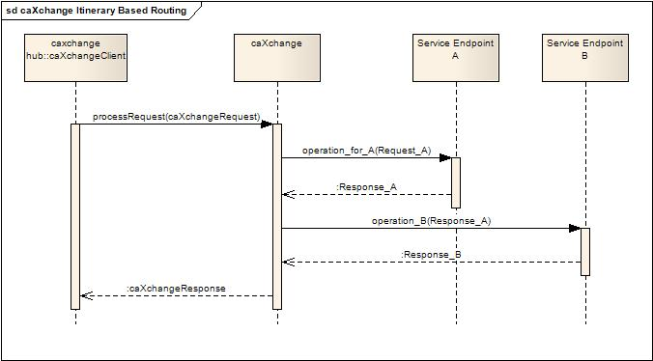
Figure 1 An example of caBIG Integration Hub Itinerary Based Routing invoking a single group of services.

caBIG Integration Hub client can also request routing to multiple groups of services. For example the client can request invoking the following two groups in parallel:
- service A and use the response to invoke service B.
- service C and use the response to invoke service D.

caBIG Integration Hub can route messages to multiple such routes in parallel. The response from all the routes is aggregated to create a caBIG Integration Hub response message. Following image depicts an example of routing in parallel to a number of service endpoints:

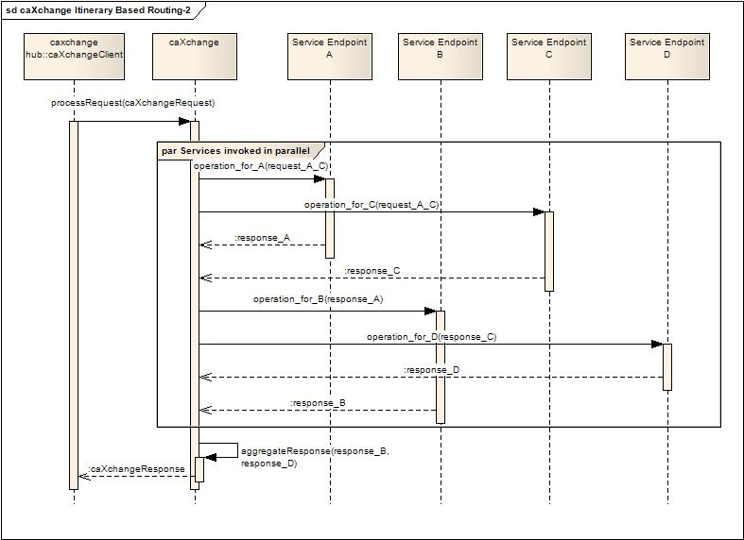
Figure 2 An example of caXchange Itinerary based routing invoking multiple groups of services.

caBIG Integration Hub – caBIG Integration Hub routes the response to the Inbound Service.

Inbound service –Inbound service makes the response available to the client.

Alternate Flows

Query Target Endpoints.

Client – Client creates a caXchange request message with the service type defined for requesting available target end points. Client sends this request to the Inbound service for processing.

Inbound service –Inbound service forwards the request for processing to the Hub.

Hub – The Hub uses the message service type to route the request to the component configured to process requests of this service type.

Hub – The Hub queries the endpoints configured for dynamic routing and constructs a response to the client. Following information is included for each configured endpoint:
- Id: A unique identifier for the end point.
- URI: A uri configured for the end point.

Hub – The Hub routes the response to the Inbound Service.

Inbound service – Inbound service makes the response available to the client.

Configure a new Target endpoint.
I am not sure if this is needed for C3PR. It has to be clarified whether they need dynamic configuration? or can all the sites be pre-configured once.

Client – Client creates a caXchange request message with the service type defined for adding a new target end point. The client sends this request to the Inbound service for processing. The client request includes the following information:
- Id(optional): Id needs to be specified if this is an update to an existing end point.
- URI: A uri for invoking the target end point.
- Target Grid Service Client: Information about the client for invoking the target service.

Inbound service –Inbound service forwards the request for processing to the Hub.

Hub – The Hub uses the message service type to route the request to the component configured to process requests of this service type.

Hub – The Hub adds the configuration for the new endpoint. caBIG Integration Hub creates a unique identifier for the endpoint configuration. A caXchange response message is created with the following information:

- Id: A unique identifier for the end point.

Hub – The Hub routes the response to the Inbound Service.

Inbound service –Inbound service makes the response available to the client.

Exception Flows

Routing information is not valid.

caBIG Integration Hub sends a response – caBIG Integration Hub sends a response with the responseStatus as described in the caBIG Integration Hub Interface Specification indicating a FAILURE. Additionally the caXchangeError field in the response is populated with the validation error details.

Target services return a fault.

caBIG Integration Hub sends a response – caBIG Integration Hub sends a response with the responseStatus as described in the caBIG Integration Hub Interface Specification indicating a FAILURE. Additionally the caXchangeError field in the response is populated with the validation error details.

Post-Conditions
Client gets a response from caBIG Integration Hub.

