Mail Notification Framework Use Cases
Version No: 2.0

Author : Harsh Marwaha
Team : caBIG Integration Hub

Client : National Cancer Institute - Center for Bioinformatics,
National Institutes of Health,
US Department of Health and Human Services

Document History

Document Location
The most current version of this document is located in Subversion.

Revision History
Version Number | Revision Date | Author | Summary of Changes
1.0 | 07/25/2009 | Harsh Marwaha | Initial
2.0 | 10/06/2009 | Harsh Marwaha | Updated for rebranding of caXchange and additional edits.

Review
Name | Team/Role | Version | Date Reviewed | Reviewer Comments

Related Documents
More information can be found in the following related documents:
Document Name
caBIG Integration Hub Interface Specification

Table of Contents
Mail Notification Framework Use Cases 1
Document History 2
Table of Contents 3
1 Description 3
2 Actors 3
3 Priority 4
4 Assumptions 4
5 Pre-Conditions 4
6 Trigger Event 4
7 Basic Flow 4
7.1 Mail Notifications on failure. 4
7.2 Multiple tries before mail notifications on failure. 6
7.3 Mail notifications in a specified format. 8
8 Exception Flows 10
8.1 Sending Mail Notification Fails. 10
8.2 Transformation component Fails. 10
9 Post-Conditions 10

Description
caBIG Integration Hub (also referred to as the Hub in this document) provides client the ability to invoke target services. Clients can invoke caBIG Integration Hub asynchronously and let it handle the interaction with target services. The target service invocations from the Hub can fail for a number of reasons. Some of the reasons include:

- The target service is down when the Hub invokes it.
- The target service returns a business error when the Hub invokes it.

The client in the case of failure may require notifications. The client may not care for a notification if their request is sent successfully to the target service. They may additionally want to configure the Hub to try out the target service multiple times until a success is achieved.

This use case describes the requirements for implementing a notification component in the Hub. This use case is similar to the implementation of the fire and forget enterprise integration pattern using caBIG Integration Hub.

Actors
- Client – Sends a request to caBIG Integration hub for processing.
- Inbound Service – The Inbound Service that serves as a proxy interface to the caBIG Integration Hub for processing incoming requests.
- Hub – The caBIG Integration Hub ESB software that routes messages to the target services and routes responses from target services to the client.

Priority
Normal

Assumptions
- The Inbound Service is implemented as a caGrid service.

Pre-Conditions
- caBIG Integration Hub is up and running.
- Inbound Service is up and running.

Trigger Event
Client sends a request for processing to the Inbound grid services.

Basic Flow

Mail Notifications on failure.
Client sends a message asynchronously to the caBIG Integration Hub. The request is for a service type that is configured to send mail notifications on failure.

Client sends request to Inbound service – Client sends a request to the Inbound service for processing. The client uses the processRequestAsynchronously operation to send the request asynchronously.

Inbound service forwards the request to the Hub – Inbound service forwards the request for processing to the Hub. Inbound service returns an Endpoint Reference to the client. The client can use this end point reference to get the status of their request.

Client – The client proceeds with their processing. The client does not care for a response from the target service if the delivery of the request succeeds to the target service.

The Hub uses routing metadata to route the request – The Hub determines the service type from the request metadata. It uses the service type to determine the target services and the routing information for the request.

The Hub invokes the Target Service with the request payload – The Hub invokes the target service using the request payload.

Target Service Invocation Succeeds – The Hub updates the Inbound Service with any response received from the target service.
- Target Service Invocation Fails – The Hub routes the request to the mail notification component. The mail notification component emails the request to the configured email.

caBIG Integration Hub finishes processing the request.

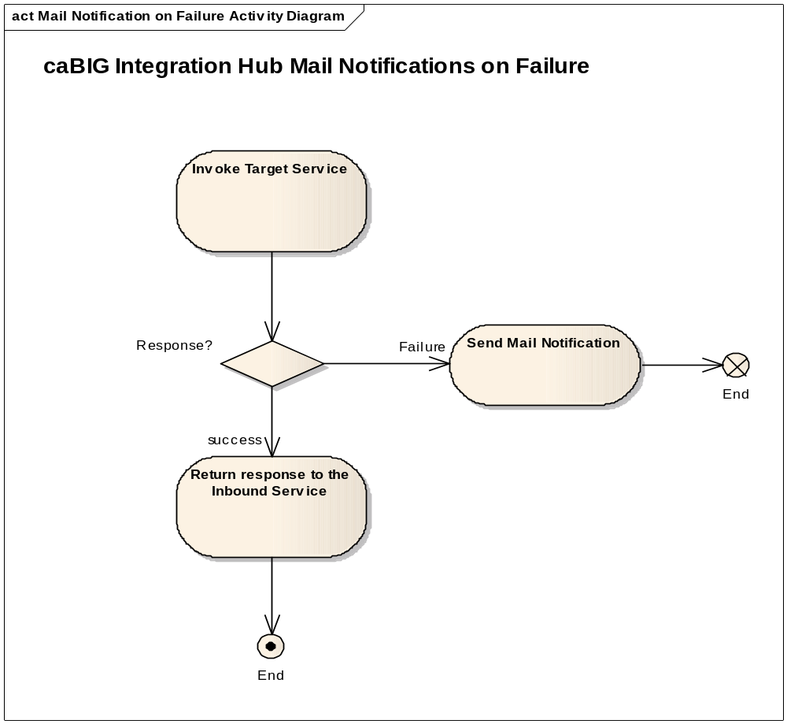

Multiple tries before mail notifications on failure.
Client sends a message asynchronously to the caBIG Integration Hub. The request is for a service type that is configured for multiple tries before sending mail notifications on failure. The Hub can be configured for the number of retries and a wait time between retries before invoking the Target Service.

Client sends request to caBIG Integration Hub – Client sends a request to the Inbound service for processing. The client uses the processRequestAsynchronously operation to send the request asynchronously.

Inbound service forwards the request to the Hub – Inbound service forwards the request for processing to the Hub. Inbound service returns an Endpoint Reference to the client. The client can use this end point reference to get the status of their request.

Client – The client proceeds with their processing. The client does not care for a response from the target service if the delivery of the request succeeds to the target service.

The Hub uses routing metadata to route the request – The Hub determines the service type from the request metadata. It uses the service type to determine the target services and the routing information for the request.

The Hub invokes Target Service – The Hub extracts the request payload and invokes the target service.

Target Service Invocation Succeeds – The Hub updates the Inbound Service with any response received from the target service.
- Target Service Invocation Fails – The Hub waits for a preconfigured amount of time and retries the target service. The target service is tried a preconfigured number of times. If the invocation succeeds then the response if any is sent to the Inbound service, otherwise after the number of retries have been exhausted a mail notification is sent to the configured email.

caBIG Integration Hub finishes processing the request.

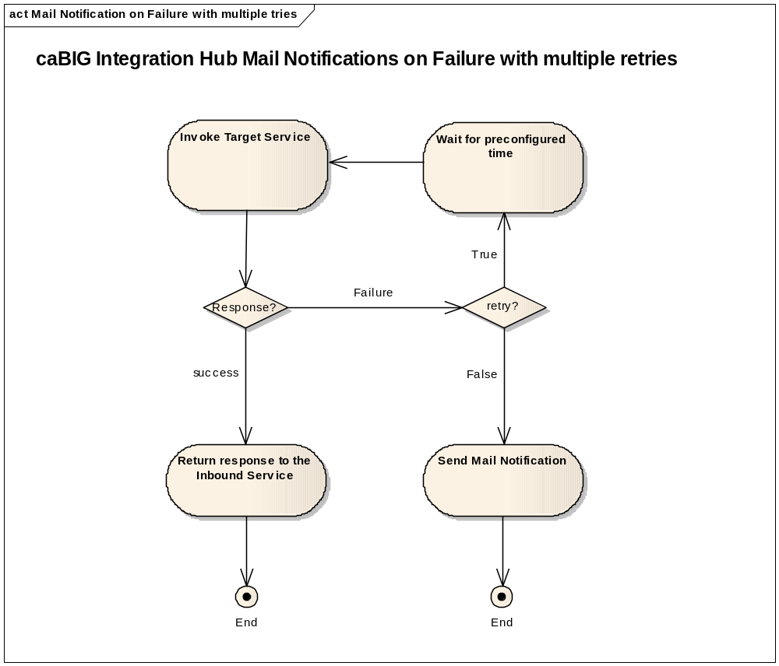

Mail notifications in a specified format.
Client sends a message asynchronously to the caBIG Integration Hub. The request is for a service type that is configured to send mail notifications on failure. However the client has a requirement to format the mail notification. The format can for example require a subject and a text message providing details of the failure.

Client sends request to caBIG Integration Hub – Client sends a request to the Inbound service for processing. The client uses the processRequestAsynchronously operation to send the request asynchronously.

Inbound service forwards the request to the Hub – Inbound service forwards the request for processing to the Hub. Inbound service returns an Endpoint Reference to the client. The client can use this end point reference to get the status of their request.

Client – The client proceeds with their processing. The client does not care for a response from the target service if the delivery of the request succeeds to the target service.

The Hub uses routing metadata to route the request – The Hub determines the service type from the request metadata. It uses the service type to determine the target services and the routing information for the request.

The Hub invokes the Target Service – The Hub extracts the request payload and invokes the target service.

Target Service Invocation Succeeds – The Hub updates the Inbound Service with any response received from the target service.
- Target Service Invocation Fails – The Hub routes the request to a transformation component. The transformation component converts the business payload into the preconfigured format. The formatted payload is then forwarded to the mail notification component. The mail notification component emails the request to the configured email.

caBIG Integration Hub finishes processing the request.

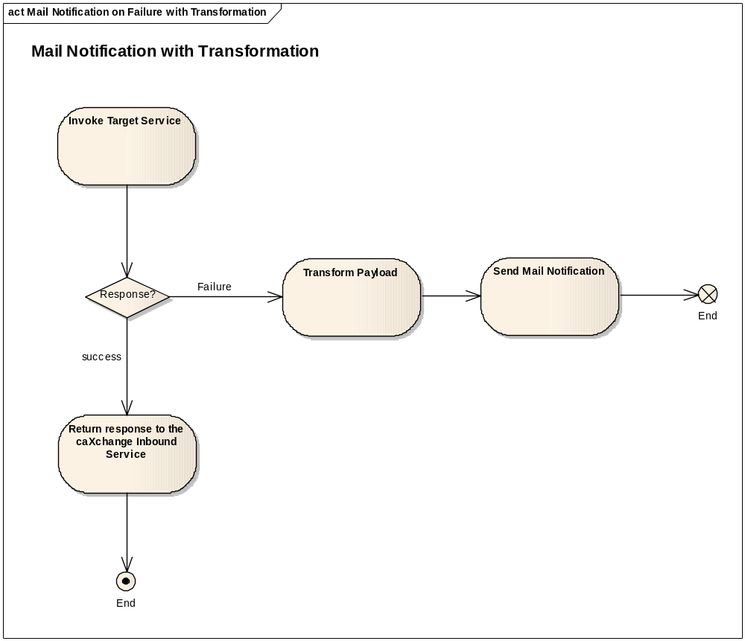

Exception Flows

Sending Mail Notification Fails.

caBIG Integration Hub logs the message – caBIG Integration Hub will audit and log failures of mail notifications with the complete details of the message. These details can be analyzed to determine whether messages need to be resent.

Transformation component Fails.

caBIG Integration Hub logs the message – caBIG Integration Hub will audit and log failures of mail notifications with the complete details of the message. These details can be analyzed to determine whether messages need to be resent.

Post-Conditions
Either the request is processed successfully or an email notification is sent to the client.

