caBIG Integration HubTransformation Framework Use Cases
Version No: 2.0
Last Modified: 10/05/2009

Author : Harsh Marwaha
Team : caBIG Integration Hub

Client : National Cancer Institute - Center for Bioinformatics,
National Institutes of Health,
US Department of Health and Human Services

Document History

Document Location
The most current version of this document is located in Subversion.

Revision History
Version Number | Revision Date | Author | Summary of Changes
1.0 | 07/31/2009 | Harsh Marwaha | Initial
2.0 | 10//5/2009 | Harsh Marwaha | Updated for rebranding to caBIG Integration Hub

Review
Name | Team/Role | Version | Date Reviewed | Reviewer Comments

Related Documents
More information can be found in the following related documents:
Document Name
caBIG Integration Hub Interface Specification

Table of Contents
caBIG Integration HubTransformation Framework Use Cases 1
Document History 2
Table of Contents 3
1 Description 3
2 Related Documents 3
3 Actors 4
4 Priority 4
5 Assumptions 4
6 Pre-Conditions 4
7 Trigger Event 4
8 Basic Flow 4
8.1 Transformation required for a Target Service 4
8.2 Business Services using transformations 6
9 Exception Flows 7
9.1 Transformation component Fails. 7
10 Post-Conditions 7

Description
caBIG Integration Hub (also referred to as the Hub) provides clients the ability to invoke target services. Clients can invoke caBIG Integration Hub synchronously or asynchronously and let the Hub handle the interaction with target services. The Hub decouples this interaction and lets the clients and target services evolve separately. This decoupling allows target services and/or clients to update their models without concern about compatibility with each other. caBIG Integration Hub needs to provide services that ensures that this compatibility is maintained across different versions of target services and clients.

This use case describes the requirements for implementing a transformation component in caBIG Integration Hub. This component can transform messages from clients to conform to schemas as expected by target services and vice versa.

Actors
- Client – Sends a request to caBIG Integration Hub for processing.
- caBIG Integration Hub Inbound Service – This is the caGrid Service that serves as a proxy interface to caBIG Integration Hub for processing incoming requests.
- caBIG Integration Hub – The Hub ESB software that routes messages to the target services and routes responses from target services to the client.
- caBIG Integration Hub Administrator – Administrator responsible for configuring the Hub.

Priority
Normal

Assumptions
- The caBIG Integration Hub Inbound Service is implemented as a caGrid service.

Pre-Conditions
- caBIG Integration Hub is up and running.
- caBIG Integration Hub Inbound Service is up and running.

Trigger Event
Client sends a request for processing to the caBIG Integration Hub Inbound grid service.

Basic Flow

Transformation required for a Target Service
A Target Service requires a transformation of the client request. The caBIG Integration Hub Administrator creates an XSL transform to transform the client message to the schema required for the Target Service. The caBIG Integration Hub Administrator configures the routing for the service to invoke the XSL transformation prior to invoking the Target Service. The flow of the client request through caBIG Integration Hub is described in the steps below.

Client sends request to caBIG Integration hub – Client sends a request to the caBIG Integration Hub Inbound service for processing. The client sends the request either synchronously or asynchronously.

Inbound service forwards the request to the Hub –Inbound service forwards the request for processing to the Hub.

The Hub uses routing metadata to route the request – The hub determines the service type from the request metadata. caBIG Integration Hub determines the target services and the routing information for the request.

The Hub invokes transformation – caBIG Integration Hub invokes the configured transformations for invoking target services.

The Hub invokes the Target Service – caBIG Integration Hub invokes the Target Service with the transformed payload.

The Hub invokes transformation – caBIG Integration Hub transforms the response from the target service to the client schema.

caBIG Integration Hub finishes processing the request.

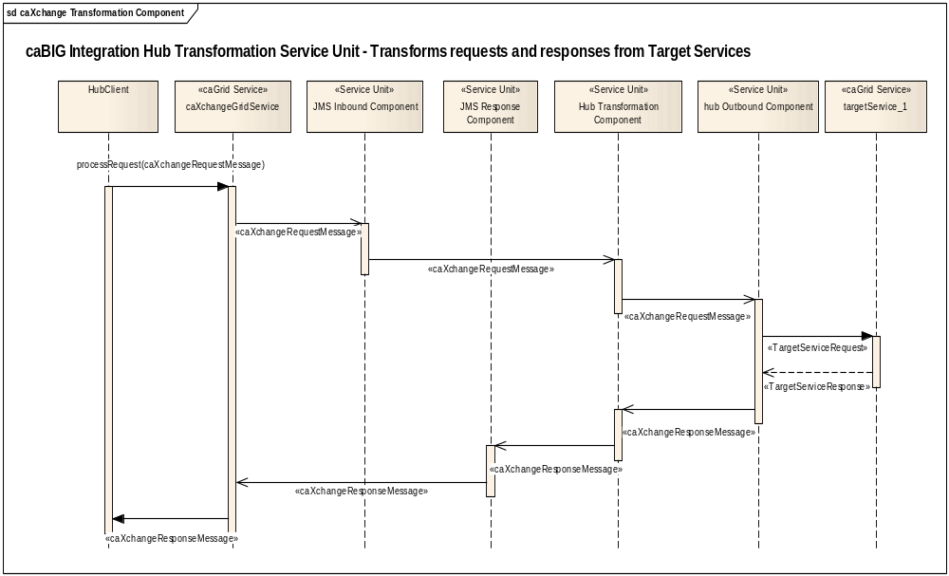
Figure 1 Transformation of request and response payloads.

Business Services using transformations
A client requires an implementation of a business service which involves multiple invocations of Target Services and payload transformations. The caBIG Integration Hub Administrator configures caBIG Integration Hub for the new business service. For example routing is configured to Target Service A. The response from Target Service A is configured to be routed to a transformation component. The XSL transform to convert the response from Target Service A to the request for Target Service B is created. Routing is configured from the transformation component to the Target Service B. The flow of the client request through the Hub is described in the steps below.

Client sends request to the Inbound Service – Client sends a request to the Inbound service for processing. The client sends the request either synchronously or asynchronously.

Inbound service forwards the request to the Hub –Inbound service forwards the request for processing to the Hub.

The Hub uses routing metadata to route the request – The Hub determines the service type from the request metadata. The Hub determines the target services and the routing information for the request.

The Hub invokes Target Service A with the request payload – The Hub invokes the target service using the request payload.

The Hub transforms the response from Target Service A – The Hub transforms the response from Target Service A to the request for Target Service B.

The Hub invokes Target Service B – The Hub invokes the Target Service B with the transformed payload. Response from the Target Service B is returned to the client.

caBIG Integration Hub finishes processing the request.

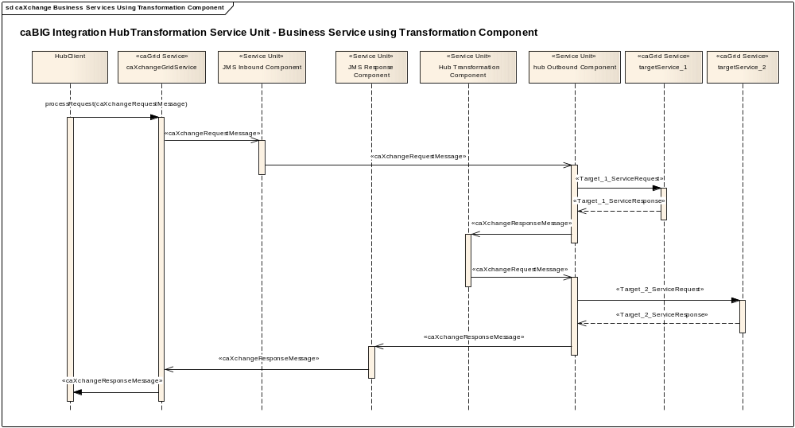
Figure 2 caBIG Integration Hub business service using transformation component

Exception Flows

Transformation component Fails.

caBIG Integration Hub logs the message – The Hub will audit and log the failure. An error response is returned to the client.

Post-Conditions
Either the request is processed successfully or an email notification is sent to the client.

