Specification of WG23 Abstract Metadata

Bernard Gibaud
4 february 2008

Foreword
This document proposes a data structure for representing Abstract Metadata in the WG23 API standard.

It is based on previous proposals discussed in previous WG23 meetings and Tcons.

The document is composed of 3 parts:
- a UML class diagram explaining the whole structure, with a number of comments referring to previous discussions
- an open issues section
- a tentative translation into RELAX NG syntax,

and an ANNEX with draft lists of codes to be used.

1. UML Class diagram

This is a tentative UML diagram representing the structure of the Abstract Metadata.
The naming of the entities did not significantly change since previous presentations to the group.
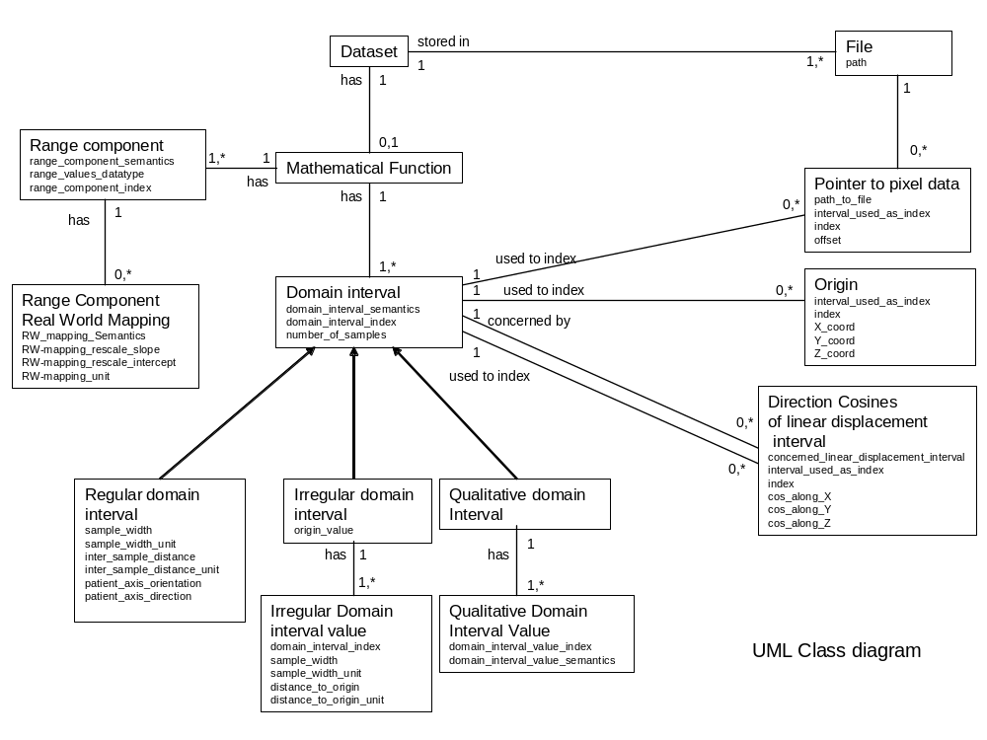
Figure 1 UML class diagram

We recall that this model is supposed to be valid to represent any kind of image Dataset that corresponds to a function I (x,y,z,t,..). Such a function may be either scalar (one single value at each sampling point), or vectorial (several). In the former case, there is a single Range component whereas in the latter there are several. We define an order on Range components using the range_component_index attribute. The attribute range_component_semantics refers to a code for e.g. “T1weightedMRSignalIntensity”. Ideally such concepts should be defined in an ontology (to rely on a well formalized “is-a” relationship”).

The domain of the function is defined by several variables called (for the time being) Domain intervals. Domain intervals refer to space variables that sample space (rows, columns, Z), time, or any other like energy, etc. We define an order on Domain intervals using the domain_interval_index attribute. The attribute domain_interval_semantics includes a code referring to e.g. “LinearDisplacement”, or “Time”. Similarly, such concepts should ideally be defined in an ontology (for the same reason).

We introduced 3 sub-types of Domain intervals, to address :
- the case of Regular domain intervals (usually used for space : rows, columms, Z, angle), of a quantitative nature (i.e. we can define a total order relation on the samples)
- the case of Irregular domain intervals (for example to index 2D images or volumes obtained at irregular times)
- the case of Qualitative domain intervals, that may be used to index, e.g. metabolites in spectro MR, e.g. Ch, NAA, Cr etc. (see open issue concerning potential redundancy between multiple range components and use of qualitative variables)

- In the case of Regular domain intervals with semantics related to a “LinearDisplacement” (i.e. rows, columns or Z), it may be relevant to associate a patient orientation and direction. This is provided by the patient_axis_orientation and patient_axis_direction attributes, that refer to codes denoting the semantics or the axis (“Right_Left”, “Head_Foot”, “Anterior_Posterior”) and corresponding directions (“Right_To_Left”, “Left_To_Right”, “Head_To_Foot”, “Foot_To_Head”, “Anterior_To_Posterior”, “Posterior_To_Anterior”), respectively.

We have integrated the notion of Range component real world mapping (a Range component may be associated to zero or more Range component Real world mappings) ; however we limited our selves to the case of linear transformations (based on slope / intercept).

We also have integrated the notion of Pointer to pixel data in files. Such a pointer is defined by a path (to a file) and an offset. However, we limited this notion of pointer to one indexing Domain interval only, namely to the index that varies the most slowly (with highest domain_interval_index value). It means, for example, that if we have a time series of volumes in fMRI, we will have pointers to individual volumes only.

We took into account the need to associate an Origin to the Dataset. This Origin can either be fixed for the whole Dataset, or change according to a particular Domain interval ; in this case the various values of the Origin are indexed by an index, based on a particular Domain interval. (see below the example of the 2D ultrasound use case).

Similarly, we took into account the need to define the Direction cosines associated to the Domain intervals referring to space (linear displacements in space). Note that the attribute concerned_linear_displacement_interval must refer to a Domain interval with semantics “LinearDisplacement” (such as rows, columns ou Z). Such direction cosines can either be constant for the whole Dataset, or vary, based on a particular Domain interval. (see below the same example of the 2D ultrasound use case).

2D ultrasound use case
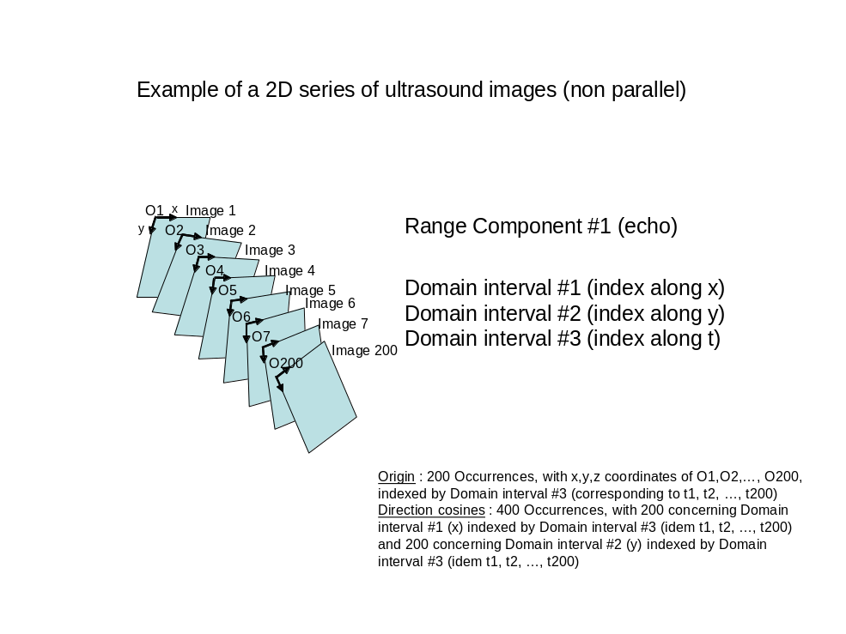
Figure 2 : example of 2D ultrasound

- In this particular case, we have three intervals, numbered #1 for displacements along X, #2 for displacements along Y, and #3 to index the time series ; if we have 200 images along time, we will then have 400 occurrences of the Direction cosines of linear displacement interval entity, all indexed by the interval_used_as_index attribute which will have in this case value #3 (referring to time). The 200 first occurrences will have the attribute concerned_linear_displacement_interval with value #1 (to specify direction cosines along the X axis) and will be indexed by the attribute index varying from 1 to 200, and the 200 following occurrences will have the attribute concerned_linear_displacement_interval with value #2 (to specify direction cosines along the Y axis), and will also be indexed by the attribute index varying from 1 to 200.

- Similarly, in this example we will have 200 occurrences of the Origin entity, all indexed by the interval_used_as_index attribute which will take in this case value #3, and of course by the attribute index varying from 1 to 200.

2. Open issues

1. Representation using multiple Range components versus use of an additional Qualitative domain interval
- As shown on the example below, our model provides two different ways to represent the same thing, either using several Range components, or with a single Range component, but using an additional Qualitative domain interval
- So the question is : should we keep those two ways ? or make a choice for a single way of doing, and which one ?
- Personally, I am a bit reluctant to get rid of multiple Range components, because in case of, e.g., displacement fields (for 3D deformable registration) or Diffusion tensors, it would be good to keep in mind that we manipulate vectors or tensors, although from a syntactic point of view those can be encoded using just an additional indexing variable.
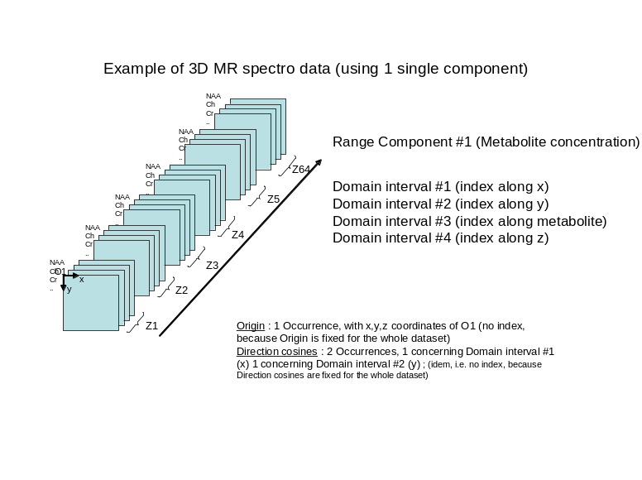
Figure 3 – example with Spectro MR using a single Range component

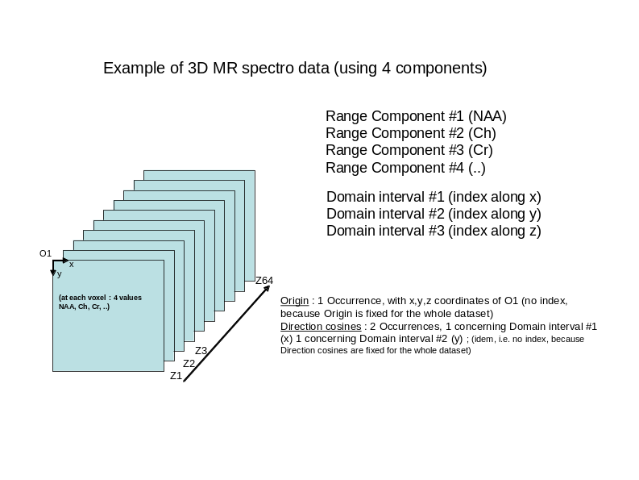
Figure 4 - Example with Spectro MR using several Range components

3. Creation of a Relax NG structure

I am not familiar with Relax NG. I tried to derive a Relax NG structure from the previous UML class diagram. There are certainly in WG23 people that can improve it or redo it entirely if not relevant or simply wrong.
Especially, I represented all leaf elements as text, for the time being. Of course, this has to be improved, especially to refer to predefined lists of values, or refer to an element somewhere else in the element tree (this is needed for instance to refer to the concerned_linear_displacement_interval in the Direction Cosines element.

Please find below the .RNG file (in XML syntax) and the corresponding .RNC file (in compact syntax), computed from the former using the Trang tool

Remark : The Mathematical function entity was not included

<?xml version="1.0" encoding="UTF-8"?>
<grammar xmlns="http://relaxng.org/ns/structure/1.0" ns="">
<start>
<ref name="Dataset_abstract_metadata"/>
</start>
<define name="Dataset_abstract_metadata">
<element name="Dataset_abstract_metadata">
<oneOrMore>
<element name="Range_component">
<element name="Range_component_index">
<text/>
</element>
<element name="Range_values_datatype">
<text/>
</element>
<element name="Range_component_semantics">
<text/>
</element>
<zeroOrMore>
<element name="Range_component_real_word_mapping">
<element name="RW_mapping_semantics">
<text/>
</element>
<element name="RW_mapping_rescale_slope">
<text/>
</element>
<element name="RW_mapping_rescale_intercept">
<text/>
</element>
<element name="RW_mapping_unit">
<text/>
</element>
</element>
</zeroOrMore>
</element>
</oneOrMore>
<oneOrMore>
<element name="Domain_interval">
<element name="Domain_interval_index">
<text/>
</element>
<element name="Domain_interval_semantics">
<text/>
</element>
<element name="Number_of_samples">
<text/>
</element>
<choice>
<element name="Regular_domain_interval">
<element name="Sample_width">
<text/>
</element>
<element name="Sample_width_unit">
<text/>
</element>
<element name="Inter_sample_distance">
<text/>
</element>
<element name="Inter_sample_distance_unit">
<text/>
</element>
<optional>
<element name="Patient_axis_orientation">
<text/>
</element>
</optional>
<optional>
<element name="Patient_axis_direction">
<text/>
</element>
</optional>
</element>
<element name="Irregular_domain_interval">
<element name="Origin_value">
<text/>
</element>
<oneOrMore>
<element name="Irregular_domain_interval_value">
<element name="Domain_interval_index">
<text/>
</element>
<element name="Sample_width">
<text/>
</element>
<element name="Sample_width_unit">
<text/>
</element>
<element name="Distance_to_origin">
<text/>
</element>
<element name="Distance_to_origin_unit">
<text/>
</element>
</element>
</oneOrMore>
</element>
<element name="Qualitative_domain_interval">
<oneOrMore>
<element name="Qualitative_domain_interval_value">
<element name="Domain_interval_value_index">
<text/>
</element>
<element name="Domain_interval_value_semantics">
<text/>
</element>
</element>
</oneOrMore>
</element>
</choice>
<zeroOrMore>
<element name="Pointer_to_pixel_data">
<element name="Index">
<text/>
</element>
<element name="Offset">
<text/>
</element>
<element name="Path_to_file">
<text/>
</element>
</element>
</zeroOrMore>
<zeroOrMore>
<element name="Origin">
<element name="Index">
<text/>
</element>
<element name="X_coord">
<text/>
</element>
<element name="Y_coord">
<text/>
</element>
<element name="Z_coord">
<text/>
</element>
</element>
</zeroOrMore>
<zeroOrMore>
<element name="Direction_cosines_of_linear_displacement_interval">
<element name="Index">
<text/>
</element>
<element name="Concerned_linear_displacement_interval">
<text/>
</element>
<element name="Cos_along_X">
<text/>
</element>
<element name="Cos_along_Y">
<text/>
</element>
<element name="Cos_along_Z">
<text/>
</element>
</element>
</zeroOrMore>
</element>
</oneOrMore>
</element>
</define>
</grammar>

Compact representation
default namespace = ""

start = Dataset_abstract_metadata
Dataset_abstract_metadata =
element Dataset_abstract_metadata {
element Range_component {
element Range_component_index { text },
element Range_values_datatype { text },
element Range_component_semantics { text },
element Range_component_real_word_mapping {
element RW_mapping_semantics { text },
element RW_mapping_rescale_slope { text },
element RW_mapping_rescale_intercept { text },
element RW_mapping_unit { text }
}*
}+,
element Domain_interval {
element Domain_interval_index { text },
element Domain_interval_semantics { text },
element Number_of_samples { text },
(element Regular_domain_interval {
element Sample_width { text },
element Sample_width_unit { text },
element Inter_sample_distance { text },
element Inter_sample_distance_unit { text },
element Patient_axis_orientation { text }?,
element Patient_axis_direction { text }?
}
| element Irregular_domain_interval {
element Origin_value { text },
element Irregular_domain_interval_value {
element Domain_interval_index { text },
element Sample_width { text },
element Sample_width_unit { text },
element Distance_to_origin { text },
element Distance_to_origin_unit { text }
}+
}
| element Qualitative_domain_interval {
element Qualitative_domain_interval_value {
element Domain_interval_value_index { text },
element Domain_interval_value_semantics { text }
}+
}),
element Pointer_to_pixel_data {
element Index { text },
element Offset { text },
element Path_to_file { text }
}*,
element Origin {
element Index { text },
element X_coord { text },
element Y_coord { text },
element Z_coord { text }
}*,
element Direction_cosines_of_linear_displacement_interval {
element Index { text },
element Concerned_linear_displacement_interval { text },
element Cos_along_X { text },
element Cos_along_Y { text },
element Cos_along_Z { text }
}*
}+
}

ANNEX

Toward a list of values for Range_Component_Semantics
- TissueRelaxationTimeT1
- TissueRelaxationTimeT2
- TissueProtonDensity
- TissueRelaxationTimeT2Star
- MeanDiffusivity
- SpinTaggingPerfusionMRSignalIntensity
- SpectroscopyMRSignalIntensity
- VelocityEncodedAngioMRSignalIntensity
- ContrastAgentAngioMRSignalIntensity
- TimeOfFlightAngioMRSignalIntensity
- ProtonDensityWeightedMRSignalIntensity
- T2StarWeightedMRSignalIntensity
- T2WeightedMRSignalIntensity
- T1WeightedMRSignalIntensity
- FractionalAnisotropy
- RelativeAnisotropy
- RegionalCerebralBloodFlow
- RegionalCerebralBloodVolume
- BloodOxygenationLevelDependentContrast
- NuclearMedicineProjectionActivity
- NuclearMedicineTomoActivity
- EEGPotential
- SpatialDisplacement
- Apparent DiffusionCoefficient
- FieldMapMRSignalIntensity
- DiffusionWeightedMRSignalIntensity
- MetaboliteConcentration
- MetabolitesConcentrationRatio
- Pressure
- Hemodynamic resistance
- Indexed hemodynamic resistance
- AttenuationCoefficient

Toward a list of values for Real_World_Mapping_Units

- Hounfield Unit ; CT
- counts ; PET
- unitless ; PET
- millilitre**2 ; PET
- percent ; PET
- counts/second ; PET
- Becquerels/millilitre ; PET
- milligram/minute/millilitre ; PET
- micromole/minute/millilitre ; PET
- millilitre/minute/gram ; PET
- millilitre/gram ; PET
- 1/millilitre ; PET
- micromole/millilitre ; PET
- proportional to counts ; PET
- proportional to counts/sec ; PET
- millilitre/minute/milliliter ; PET
- millilitre/millilitre ; PET
- grams/millilitre ; PET
- standard deviations ; PET

Toward a list of values for Domain_Interval_Semantics
- LinearDisplacement
- Energy
- Time ; Consider further detailing things like Echo time, etc.
- Angle ; same further analysis required, such as Tilt angle

List of values for Patient_Axis_Direction
- Right_Left
- Head_Foot
- Anterior_Posterior

Toward a list of values for Patient_Axis_Orientation
- Right_To_Left
- Left_To_Right
- Head_To_Foot
- Foot_To_Head
- Anterior_To_Posterior
- Posterior_To_Anterior

Toward a list of values for UCUM_Units
- cm, centimeter ; linear measurement
- mm, millimetre ; linear measurement
- um, micrometer ; linear measurement
- cm2, Square centimetre ; area measurement
- mm2, Square millimeter ; area measurement
- um2, Square micrometer ; area measurement
- dm3, Cubic decimetre ; volume measurement
- cm3, Cubic centimeter ; volume measurement
- mm3, Cubic millimeter ; volume measurement
- um3, Cubic micrometer ; volume measurement
- s, second ; time
- min, minute ; time
- h, hour ; time
- d, Day ; time
- wk, Week ; time
- mo, Month ; time
- a, Year ; time
- 11, [hnsf’U], Hounsfield Unit ; attenuation coefficient
- {counts}, Counts ; activity
- 13, {counts}/s, Counts per second ; activity
- 14, {SUVbw}g/ml, Standardized Uptake Value body weight ;
- 15, {SUVlbm}g/ml, Standardized Uptake Value lean body mass ;
- 16, {SUVbsa}cm2/ml, Standardized Uptake Value body surface area ;
- 17, [arb’U], arbitrary unit
- 18, cm/s, centimeter/second
- 19, dB, decibel
- Cel, degrees Celsius
- {H.B.}/min, Heart beat per minute
- Hz, Herz
- J, Joule
- kHz, kiloHerz
- kOhm, kiloOhm
- km/h, kilometer per hour
- kPa, kiloPascal
- l/min, liter per minute
- MHz, megaHerz
- [MET], Metabolic equivalent
- uV, microvolt
- [mi_i]/h, mile per hour
- ml/min, milliliter per minute
- ml/s, milliliter per second
- mm[Hg], millimeter of mercury
- mV, millivolt
- mm/s, mm/s
- %, percent
- 1, unary
- V, volt
- W, Watt
- mm[Hg], mmHg ; pressure
- Kpa, kPa ; pressure
- 12,[PRU], Wood units ; hemodynamic resistance
- dyn.s.cm-5, dyn.s.cm-5 ; hemodynamic resistance

Toward a list of values for Range_Values_Data_Type
- UnsignedChar8
- SignedChar8
- UnsignedInt16
- SignedInt16
- UnsignedInt32
- SignedInt32
- Float32
- DoublePrecisionFloat64

