ISO Datatype Mapping Specification

Version No: 0.2
Last Modified: 3/23/2010

Team : caCORE SDK
Client : National Cancer Institute -
Center for Bioinformatics and Information Technology,
National Institutes of Health,
US Department of Health and Human Services

Document History

Revision History
Version Number | Revision Date | Author | Summary of Changes
0.1 | 3/8/2010 | Satish Patel | Initial Draft
0.2 | 3/23/2010 | Satish Patel | Added examples for AD, DSET, EN etc. Revised content

Review
Name | Team/Role | Version | Date Reviewed | Reviewer Comments

Related Documents
More information can be found in the following related documents:

Document Name

Table of Contents
1 Introduction 4
2 UML Modeling 4
2.1 Logical Model 4
2.2 Data Model 7
3 Model Mapping Specifications 8
3.1 Mapping Simple Attributes 8
3.2 Elements of Complex Data Types 8
3.2.1 Constants in Complex Attributes 8
3.2.2 NullFlavors in Complex Types 9
3.2.3 Simple Attributes in Complex Types 10
3.3 Datatype Mapping 11
3.3.1 Mapping Complex Datatypes with Simple Attributes 11
3.3.2 Mapping Complex Datatypes with Simple and Complex Attributes 13
3.3.3 Mapping Complex Datatypes with Collection Attributes 15
3.3.4 Mapping Collection of Complex Datatypes 17
3.3.5 Mapping Collection of Complex Datatypes with Collection Attributes 20
Appendix A – Datatype to O/R Mapping Strategy Table 24
Appendix B – Tag Value Reference Table 26

Introduction
The purpose of this document is to identify following
- UML Modeling rules for ISO 21090 complex datatypes based system
- UML Tag Values to be used to perform the mapping between the Logical Model and the Data Model for ISO 21090 complex datatype based system

UML Modeling
The caCORE SDK uses the UML model components in order to generate the entire caCORE like system. The SDK reads 1) Logical Model, 2) Data Model, 3) UML Tag values (GME, documentation etc), and 4) Model Mapping information (tag values). As ISO 21090 complex datatypes are used, the SDK will need to recognize changes in the UML model and provide specifications to the users on how to create the UML models.

Logical Model
The Logical Model part of the UML model defines the object structure of the domain. Currently SDK supports following UML elements in the logical model
- UML Class
- UML Attribute
- UML Interface
- UML Association
- UML Generalization
- UML Dependency
- UML Tag Value

Example:
The diagram below shows the basic UML elements as supported by the SDK.
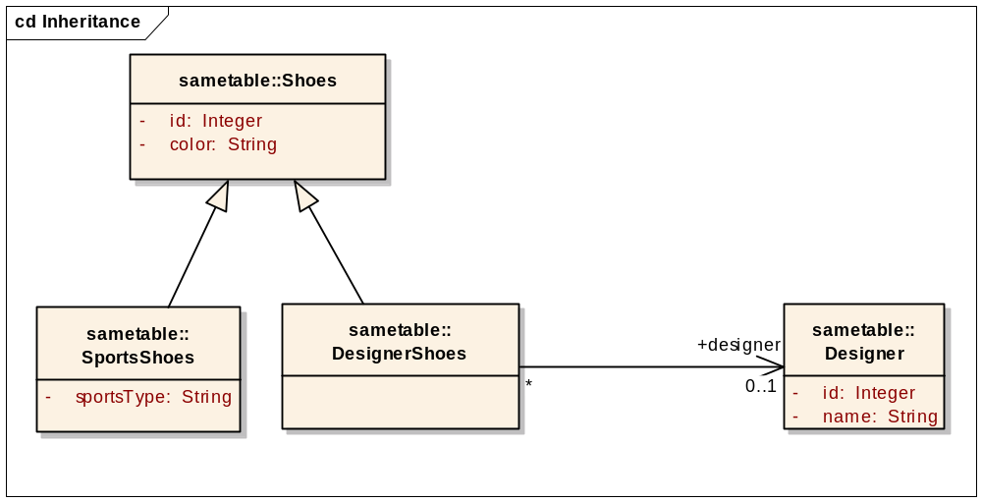
As the caCORE SDK starts supporting ISO 21090 complex datatypes, it needs to specify the UML model format for the same. Currently, the datatypes are specified in SDK in two ways
- Specify attribute type as a String in the “Type” input box in the Attribute dialog box as shown in the screenshot below
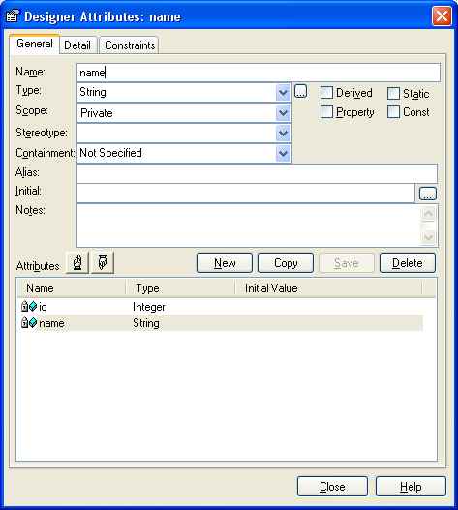
- Specify the attribute type by selecting another UML class from the same model as shown in the screenshot below.
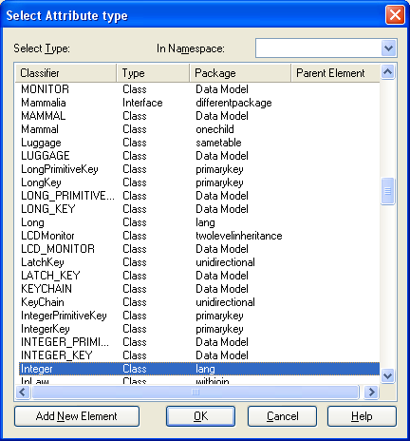
In order to use the complex datatypes in the SDK, both the semantics will be supported.
When the user is using the ISO 21090 complex datatypes, the user will be required to either manually create the ISO 21090 datatype model in the logical model section, or the user will be required to import the ISO 21090 model from the SDK’s model template.
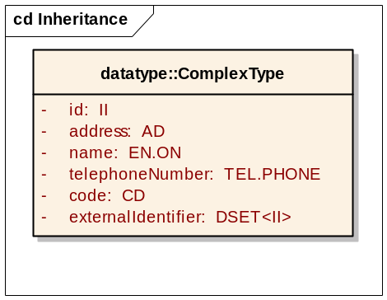
As shown in the diagram above, when creating the logical model, the user will be able to specify the complex datatype as one of the valid datatype for the attribute of the class.

Data Model
The user of the SDK creates the data model in the UML. While creating the data model, one has to consider the mapping ability of the model with the logical model. The SDK currently supports a limited set of structures to map the logical model to the data model. The structures are limited to
- Table per each class
- Column per each attribute in the same table as the parent class
- One to One association with foreign key in the source table
- One to One association with join table
- One to Many association
- One to Many association with join table
- Many to Many association
- Table per class inheritance mapping
- Table per class inheritance mapping with no table for the root classes
- Table per hierarchy inheritance mapping
- Implicit inheritance mapping
- Collection of primitives

As the complex data types are supported in the SDK, additional data model structures will be required specific for each datatype. The detail for each of the structure will be provided in the remaining of the document.

Model Mapping Specifications

Mapping Simple Attributes
Simple datatype includes the Java primitives and wrapper types. The simple attributes based attributes are mapped to a single column in the table corresponding to the parent class. The SDK identifies the column corresponding to the attribute by reading following UML tag value:
Tag Value Key: mapped-attributes
Value: fully qualified name of the attribute
Example: gov.nih.nci.cacoresdk.domain.oher.datatype.AllDataType.longValue
In this example, the AllDataType is one of the classes in the SDK’s test model and longValue is one of the attributes within the same class.

Elements of Complex Data Types
Complex datatypes contains one or more attributes which are based on simple datatypes or other complex datatypes. The complex attributes can be mapped to one or more columns in the table corresponding to the parent class or in a separate class. This subsection specifies the mechanism in which the SDK will identify the complex datatype mapping to the relational database.
At minimum, the nullFlavor constant must be specified at the Global level in the UML model. This constant will be used when SDK will encounter null values coming from the database and being returned to the user.

Constants in Complex Attributes
The constants in the model will be specified at two places: 1) At global level and 2) At the local level. The global constant is applied any time when the value is not mapped to the database and there does not exist corresponding local constant value. Whereas the local constant is applied anytime the user has not mapped corresponding attribute to the database. The SDK will check the local constant prior to the global constant.

Mapping Global Constant
The global level constants will be specified in the logical model of the datatype. The user will specify the constant value using following tag:
Tag Value Key: mapped-constant
Value: <fully qualified name of the complex sub-attribute>:constant value
Example: “II.root:2.16.12.123.456” specified against the “root” attribute in the “II” datatype class
Note 1: In case of collection, the fully qualified name of the sub-attribute will be derived as <fully qualified name of attribute>.<name of collection>[index].name of sub-attribute
Note 2: For examples of constants look at the section 3.3.x

Mapping Local Constant
The local level constants will be specified in the logical model or data model. The user will specify the constant value using following construct against the complex attribute in the logical model or data model:
Tag Value Key: mapped--constant
Value: <fully qualified name of the complex sub-attribute>:constant value
Example: “gov.nih.nci.cacoresdk.domain.oher.datatype.ComplexType.id.root:2.16.12.123.456” specified against the “id” attribute in the “ComplexType” class
Note 1: In case of collection, the fully qualified name of the sub-attribute will be derived as <fully qualified name of attribute>.<name of collection>[index].name of sub-attribute
Note 2: For examples of constants look at the section 3.3.x

NullFlavors in Complex Types
While converting the database resultset into corresponding object structure, the SDK will need to identify the null values from the database and convert them in corresponding NullFlavor.
If the user has mapped the nullFlavor sub-attribute then SDK will use the value coming from that column as a NullFlavor of choice. In the case where the nullFlavor attribute is not mapped to the database, the SDK will use the constant value specified by the user.

Simple Attributes in Complex Types
The elements nested within the complex datatypes can be of simple type of can be of other complex types. Following types are considered simple types
- String
- Boolean
- Integer
- Real (Not REAL)
- XML
- Uid
- Code
- Uri
- Enumerations
  - NullFlavor
  - AddressPartType
  - PostalAddressUse
  - Compression
  - IntegrityCheckAlgorithm
  - IdentifierReliability
  - IdentifierScope
  - UncertainityType
  - TelecommunicationAddressUse
  - EntityNamePartQualifier
  - EntityNameUse
  - EntityNamePartType
The simple datatype embedded in a complex attribute will be mapped to the relational database in a manner similar to the mapping of simple datatype without a complex attribute. The SDK will identify the destination type and select the appropriate Hibernate UserType needed to convert values from the database type to the object type.

Datatype Mapping

Mapping Complex Datatypes with Simple Attributes
Following complex datatypes has simple nested sub-attributes. These datatypes will be mapped to the data model as described in the description that follows the datatype list.
- BL
- BL.NONNULL
- ST
- ST.NT
- II
- TEL
- TEL.PERSON
- TEL.URL
- TEL.PHONE
- TEL.EMAIL
- ED
- ED.TEXT

In this scenario of mapping, the nested elements within the complex datatypes are of simple types. Any datatype which is not of simple type is considered complex type structure. Following tag values will be placed on the database column corresponding to the complex sub-attribute:
Tag Value Key: mapped-attributes
Value: fully qualified name of the attribute within the complex structure

Example
package com.abc;
public class Person implements Serializable
{
private II iiValue;.
}
Person.java

CREATE TABLE PERSON (
ID NUMBER(8) NOT NULL,
II_EXTENSION VARCHAR2(50),
)
PERSON Table

No | Tag Location |  |  | Tag Key | Tag Value
No | Object Type | Object Name | Attribute Name | Tag Key | Tag Value
1 | Table | PERSON | II_EXTENSION | mapped-attributes | com.abc.Person.iiValue.extension
2 | Class | Person | iiValue | mapped-constant: com.abc.Person.iiValue.nullFlavor | NI
3 | Class | Person |  | mapped-constant | com.abc.Person.iiValue.root: 2.16.116.123.32
4 | Class | Any | nullFlavor | mapped-constant | Any.nullFlavor: INV
Tag Values in UML

In the example above, the Person class is mapped to the PERSON table. In the Person class, the “iiValue” is one of the attribute with datatype as “II”. This II datatype has only one attribute named “extension” mapped to a column named II_EXTENSION in the PERSON table. The root attribute and nullFlavor attribute has been mapped to the constant values. As the NullFlavor has been specified at the Global and Local level both, the local value will be used during the implementation.

Mapping Complex Datatypes with Simple and Complex Attributes
Following complex datatypes have simple as well as complex nested sub-attributes. These datatypes will be mapped to the database as described in the description that follows the datatype list.
- CD
- SC
- INT (Nested uncertainty sub-attribute is always of type INT)
- TS (Nested uncertainty sub-attribute is always of type TS)
- PQV (Nested uncertainty sub-attribute is always of type PQV)
- REAL (Nested uncertainty sub-attribute is always of type REAL)
- PQ (Nested uncertainty sub-attribute is always of type PQ)
- IVL<TS> (Nested width sub-attribute is always of type <TBD>)
- IVL<PQ> (Nested width sub-attribute is always of type <TBD>)
- IVL<INT> (Nested width sub-attribute is always of type <TBD>)
- IVL<REAL> (Nested width sub-attribute is always of type <TBD>)
- IVL<PQV> (Nested width sub-attribute is always of type <TBD>)

The nested elements within the complex datatypes can be of simple types or can be of other complex types. Any datatype which is not of simple type is considered complex type structure. The complex type structure will be recursively mapped to the columns of the same table where other sub-attributes of the parent complex type are mapped.

Following tag values will be placed on the database column corresponding to the complex sub-attribute:
Tag Value Key: mapped-attributes
Value: fully qualified name of the attribute within the complex structure

Example
package com.abc;
public class Person implements Serializable
{
private SC scValue;.
}
Person.java

CREATE TABLE PERSON (
ID NUMBER(8) NOT NULL,
SC_VALUE VARCHAR2(50),
SC_CODE_CODE VARCHAR2(50)
)
PERSON Table

No | Tag Location |  |  | Tag Key | Tag Value
No | Object Type | Object Name | Attribute Name | Tag Key | Tag Value
1 | Table | PERSON | SC_VALUE | mapped-attributes | com.abc.Person.scValue.value
2 | Table | PERSON | SC_CODE_VALUE | mapped-attributes | com.abc.Person.scValue.code.value
3 | Class | Any | nullFlavor | mapped-constant | Any.nullFlavor: INV
Tag Values in UML

In the example above, the Person class is mapped to the PERSON table. In the Person class, the “scValue” is one of the attribute with datatype as “SC”. This SC datatype has two attributes mapped to the database columns. The “value” attribute is mapped to the SC_VALUE column. The “code” attribute nested within the SC datatype which has “code” sub-attribute is also mapped to the database column. As the NullFlavor has been specified as constant at the Global only, the global value will be used during the implementation.

Mapping Complex Datatypes with Collection Attributes
Following complex datatypes has nested collection of attributes. These datatypes will be mapped to the database as described in the description that follows the datatype list.
- AD
- EN
- EN.ON
- EN.PN

The nested elements within the complex datatypes are a collection of complex types in this mapping case. The collection of complex type structure will be iteratively mapped to the columns of the same table where other sub-attributes of the parent object are mapped. Following tag values will be placed on the database column corresponding to the collection of complex sub-attribute:
Tag Value Key: mapped-attributes
Value: fully qualified name of the attribute within the complex structure.
The fully qualified name of the sub-attribute is derived as <fully qualified name of attribute>.<name of collection>[index].name of sub-attribute

Example
package com.abc;
public class Person implements Serializable
{
private EN name;
}
Person.java

CREATE TABLE PERSON (
ID NUMBER(8) NOT NULL,
FAMILY_NAME VARCHAR2(50),
GIVEN_NAME VARCHAR2(50)
)
PERSON Table

No | Tag Location |  |  | Tag Key | Tag Value
No | Object Type | Object Name | Attribute Name | Tag Key | Tag Value
1 | Table | PERSON | FAMILY_NAME | mapped-attributes | com.abc.Person.name.part[0].value
2 | Class | Person | name | mapped-constant | com.abc.Person.name.part[0].type:FAM
3 | Table | PERSON | GIVEN_NAME | mapped-attributes | com.abc.Person.name.part[1].value
4 | Class | Person | Name | mapped-constant | com.abc.Person.name.part[1].type:GIV
5 | Class | Any | nullFlavor | mapped-constant | Any.nullFlavor: INV
Tag Values in UML

In the example above, the Person class is mapped to the PERSON table. In the Person class, the “name” is one of the attribute with datatype as “EN”. This EN datatype contains collection of ENXP. Each ENXP instance represents the small part of the entity name. In this example, the individual element of the ENXP collection has been given the name as “part” followed by “[” followed by “index location” followed by “]” where index location starts at “0” and increments by “1” for each element.

Mapping Collection of Complex Datatypes
Following complex datatypes represent the collection of other complex datatypes. These datatypes will be mapped to the database as described in the description that follows the datatype list.
- DSET<II>
- DSET<TEL>
- DSET<CD>

Here the datatype itself is a collection of other complex datatypes in this mapping case. The complex type structure will be iteratively mapped to the columns of the collection table where other elements of the collection will be mapped.
Following tag values will be placed on the logical model corresponding to the collection attribute:
Tag Value Key: mapped-collection-table
Value: <fully qualified name of the attribute>.<collection attribute name>
Following tag value will be placed on the database column corresponding to the foreign key column:
Tag Value Key: mapped-attributes
Value: <fully qualified name of the attribute>.<collection attribute name>

Following tag value will be placed on the database column corresponding to the attributes of collection elements:
Tag Value Key: mapped-attributes
Value: <fully qualified name of the attribute>.<collection attribute name>.<name of sub-attribute>

Example
package com.abc;
public class Person implements Serializable
{
private DSET<CD> codes;
}
Person.java

CREATE TABLE PERSON (
ID NUMBER(8) NOT NULL,
)

CREATE TABLE CODES (
PERSON_ID NUMBER(8) NOT NULL,
CODE VARCHAR2(50);
)
PERSON and CODES Table

No | Tag Location |  |  | Tag Key | Tag Value
No | Object Type | Object Name | Attribute Name | Tag Key | Tag Value
1 | Class | Person | codes | mapped-collection-table | CODES
2 | Table | CODES | PERSON_ID | mapped-attributes | com.abc.Person.codes.part
3 | Table | CODES | CODE | mapped-attributes | com.abc.Person.codes.part.code
4 | Class | Person | codes | mapped-constant | com.abc.Person.codes.part.codeSystem:  2.16.32.123
5 | Class | Any | nullFlavor | mapped-constant | Any.nullFlavor: INV
Tag Values in UML

In the example above, the Person class is mapped to the PERSON table. In the Person class, the “codes” is one of the attribute with datatype as “DSET<CD>”. This DSET<CD> datatype contains collection of CD. The elements of the CD will be stored in a separate table called CODES. PERSON_ID column in the CODES table is the foreign key to the PERSON table which needs to be identified as a column to be used for joining the tables. The CODE column of the CODES table represents the “code” attribute for each CD element in the DSET. The CD element in the DSET is also using a local constant for codeSystem which is specified in the logical model.

Mapping Collection of Complex Datatypes with Collection Attributes
Following complex datatypes represent the collection of other complex datatypes with each element of the Collection having a collection of elements. These datatypes will be mapped to the database as described in the description that follows the datatype list.
- DSET<AD>

Here the datatype itself is a collection of other complex datatypes which contains another collection. In other words, it’s a collection of collection. The complex type structure will be iteratively mapped to the columns of the collection table where other elements of the collection will be mapped.
Following tag values will be placed on the logical model corresponding to the collection attribute:
Tag Value Key: mapped-collection-table
Value: <fully qualified name of the attribute>.<collection attribute name>

Following tag values will be placed on the logical model corresponding to the collection attribute:
Tag Value Key: mapped-collection-element-type
Value: <fully qualified name of the attribute>.<collection attribute name>.[index]:<target type>

Following tag value will be placed on the database column corresponding to the foreign key column:
Tag Value Key: mapped-attributes
Value: <fully qualified name of the attribute>.<collection attribute name>

Following tag value will be placed on the database column corresponding to the attributes of collection elements:
Tag Value Key: mapped-attributes
Value: <fully qualified name of the attribute>.<collection attribute name>.[index].<name of sub-attribute>

Example
package com.abc;
public class Person implements Serializable
{
private DSET<AD> contacts;
}
Person.java

CREATE TABLE PERSON (
ID NUMBER(8) NOT NULL,
)

CREATE TABLE ADDRESS (
PERSON_ID NUMBER(8) NOT NULL,
ADDRESS_LINE1 VARCHAR2(50),
CITY VARCHAR2(50),
STATE VARCHAR2(50),
ZIP VARCHAR2(50)
)
PERSON and ADDRESS Table

No | Tag Location |  |  | Tag Key | Tag Value
No | Object Type | Object Name | Attribute Name | Tag Key | Tag Value
1 | Class | Person | contacts | mapped-collection-table | ADDRESS
2 | Table | ADDRESS | PERSON_ID | mapped-attributes | com.abc.Person.contacts.part
3 | Table | ADDRESS | ADDRESS_LINE_1 | mapped-attributes | com.abc.Person.contacts.part.part.[0].value
4 | Table | ADDRESS | CITY | mapped-attributes | com.abc.Person.contacts.part.part.[1].value
5 | Table | ADDRESS | STATE | mapped-attributes | com.abc.Person.contacts.part.part.[2].value
6 | Table | ADDRESS | ZIP | mapped-attributes | com.abc.Person.contacts.part.part.[3].value
7 | Class | Person | contacts | mapped-collection-element-type | com.abc.Person.contacts.part.part.[0]:ADXP.AL
8 | Class | Person | contacts | mapped-collection-element-type | com.abc.Person. contacts.part.[1]:ADXP.CTY
9 | Class | Person | contacts | mapped-collection-element-type | com.abc.Person.name.part.[2]:ADXP.STATE
10 | Class | Person | contacts | mapped-collection-element-type | com.abc.Person.name.part.[3]:ADXP.ZIP
11 | Class | Any | nullFlavor | mapped-constant | Any.nullFlavor: INV
Tag Values in UML
In the example above, the Person class is mapped to the PERSON table. In the Person class, the “contacts” is one of the attribute with datatype as “DSET<AD>”. This DSET<AD> datatype contains collection of AD. The elements of the DSET<AD> will be stored in a separate table called ADDRESS.
This AD datatype contains collection of ADXP. Each ADXP instance represents the small part of the address. In this example, the individual element of the ADXP collection has been given the name as “part” followed by “.” followed by “[” followed by “index location” followed by “]” where index location starts at “0” and increments by “1” for each element.

Appendix A – Datatype to O/R Mapping Strategy Table

No | Datatype | Complex Datatype with Simple Attributes  (1) | Complex Datatype with Simple and Complex Attributes  (2) | Complex Datatype with Collection Attributes  (3) | Collection of Complex Datatypes  (4) | Collection of Complex Datatypes with Collection Attributes  (5)
1 | BL | X
2 | BL.NONNULL | X
3 | ST | X
4 | ST.NT | X
5 | II | X
6 | TEL | X
7 | TEL.PERSON | X
8 | TEL.URL | X
9 | TEL.PHONE | X
10 | TEL.EMAIL | X
11 | ED | X
12 | ED.TEXT | X
13 | CD |  | X
14 | SC |  | X
15 | INT |  | X
16 | REAL |  | X
17 | TS |  | X
18 | PQV |  | X
19 | PQ |  | X
20 | IVL<TS> |  | X
21 | IVL<PQ> |  | X
22 | IVL<PQV> |  | X
23 | IVL<REAL> |  | X
24 | IVL<INT> |  | X
25 | AD |  |  | X
26 | EN |  |  | X
27 | EN.ON |  |  | X
28 | EN.PN |  |  | X
29 | DSET<II> |  |  |  | X
30 | DSET<TEL> |  |  |  | X
31 | DSET<CD> |  |  |  | X
32 | DSET<AD> |  |  |  |  | X

Appendix B – Tag Value Reference Table

No | Tag Value | Complex Datatype with Simple Attributes  (1) | Complex Datatype with Simple and Complex Attributes  (2) | Complex Datatype with Collection Attributes  (3) | Collection of Complex Datatypes  (4) | Collection of Complex Datatypes with Collection Attributes  (5)
1 | mapped-attributes | F1 | F1 | F3 | F1 | F6
2 | mapped-constant | F2 | F2 | F4 | F1 | F7
3 | mapped-collection-table |  |  |  | F5 | F5
4 | mapped-collection-element-type |  |  |  |  | F8

Format | Tag Key | Tag Value | Tag Location
F1 | mapped-attributes | <<Fully Qualified Name of the Attribute>> | Column
F2 | mapped-constant | <<Fully Qualified Name of the Attribute>>:<<constant value>> | Attribute
F3 | mapped-attributes | <<Fully Qualified Name of the Attribute>>>.<<name of collection>>[index].<<name of sub-attribute>> | Column
F4 | mapped-constant | <<Fully Qualified Name of the Attribute>>>.<<name of collection>>[index].<<name of sub-attribute>>:<<constant value>> | Attribute
F5 | mapped-collection-table | <<name of the collection element table>> | Attribute
F6 | mapped-attributes | <<Fully Qualified Name of the Attribute>>>.<<name of collection>>.[index].<<name of sub-attribute>> | Column
F7 | mapped-constant | <<Fully Qualified Name of the Attribute>>>.<<name of collection>>.[index].<<name of sub-attribute>>:<<constant value>> | Attribute
F8 | mapped-collection-element-type | <<Fully Qualified Name of the Attribute>>>.<<name of collection>>.[index].<<name of sub-attribute>>:<<element type>> | Attribute

